



Agent Manual

# Table of Contents

Table of Contents 2

1. Introduction 5

1.1 What is Elision Dialer? 5

1.2 How does the agent screen work 5

2. Overview of agent client screen function 6

2.1 UNIVERSAL FEATURES 6

2.2 PROPER LOGIN AND LOGOUT PROCEDURES 6

2.3 Pause Codes 9

2.4 Logging Out 9

2.5 Script Tag 9

2.6 Form Tab 10

2.7 Call Recording 10

2.8 Web Form 10

2.9 CRM Pop up Login 10

2.10 Park Call 11

2.11 Transfer Conference 11

2.12 Transfer Conference Type 11

2.13 Voice Mail Message 13

2.14 Presets-DTMF AND Number To Call 13

2.15 Agent Choose Caller ID 14

2.16 Using Hotkeys 14

2.17 Volume Control 14

2.18 Comments 15

2.19 Call Notes 15

2.20 Dispositioning a Call 15

Minimize to see customer details 15

Open web form after dispositioning 15

Wrapup Time After Call 16

2.21 Pre – Call Work 16

2.22 CALLS IN THE SESSION, AND FORCED HANGUPS 16

2.23 CALLS IN QUEUE, AND TAKE CALL 16

2.24 AGENTS VIEW SIDEBAR 16

2.25 CALLBACKS 17

Setting a Callback 17

Receiving a Callback 17

Agent-only Callbacks 17

Callback Alert Type 18

2.26 AGENT CALL LOG 18

2.27 AGENT BLIND MONITORING ALERT 19

2.28 AGENT LEAD SEARCH 19

NEW LEAD, SEARCH LEAD MANUAL DIALING, AND FAST DIAL 19

2.29 Manual Dial 19

2.30 Fast Dial 19

2.31 Group Alias Select 19

2.32 SESSION WARNING MESSAGES 20

2.33 MANUAL DIALING MODE 20

2.34 PREVIEW DIALING 20

2.35 MULTIPLE NUMBER-PER-LEAD DIALING 20

2.36 TERRITORY DIALING 21

2.37 CALL TIME MISMATCH ALERT 21

2.38 AGENT INTERFACE ALERT 21

2.39 AUTO-DIAL MODE 21

2.40 CALL CONTROL 21

2.41 PAUSE AND RESUME PROCEDURE 21

2.42 MULTIPLE NUMBER-PER-LEAD DIALING 21

2.43 INBOUND AND CLOSER FEATURES 22

2.44 LOGIN SELECT GROUPS MENU 22

2.45 DISPLAY AND CALL INFO 22

2.46 Ring All 22

2.47 IN-GROUP MANUAL DIAL 22

2.48 INBOUND CAMPAIGN LEAD SEARCH 22

2.49 PHONE ISSUES AND OPTIONS 23

2.50 EXTERNAL USER ISSUES 23

2.51 MANAGER FUNCTIONS 23

2.52 CLOSING 24

2.53 FREQUENTLY ASKED QUESTIONS(FAQ) 24

Document Revision History

|  |  |  |  |
| --- | --- | --- | --- |
| **Version** | **Date** | **Author** | **Description of change** |
| 1.0 | 20/04/2018 | Radhika Solgama | Agent Manual |

1. Introduction

This manual is meant as a resource for Call Centre Agents and Managers to help them to better understand how the Elision Dialer web client works, and to learn how to use all of it's features correctly as well as answer questions as to why things work the way they do within the Elision Dialer Call Centre Suite.

## What is Elision Dialer?

Simply put, Elision Dialer is a call centre software package that sends calls to an agent and allows an agent to place calls. It can run in an inbound, out-bound (as predictive or manual dialling) or blended capacity (handling inbound and outbound calls in the same agent session). There is also the ability to allow for Interactive Voice Response (IVR) applications interacting with customers' calls.

## How does the agent screen work

The Elision Dialer agent screen is basically an interactive web page. It allows the agent to interface with the system during the process of a call and do things such as add or modify information about the customer, conference in other parties, transfer the call, record and many other functions necessary in a call centre. The next few chapters will go over how to operate as a call centre agent within Elision Dialer and will go into detail about how all of the agent features work.

1. Overview of agent client screen function

## UNIVERSAL FEATURES

First we will go over the features that are accessible for all Elision Dialer users, whether predictive, manual dialling or inbound campaigns.

## PROPER LOGIN AND LOGOUT PROCEDURES

Depending on how your Manager has set up the Elision Dialer web link, you may be opening a web browser and clicking on a bookmark, or you may have an icon that you can click on your desktop that says Elision Dialer. Open up Elision Dialer and you will see the login screen (see Figure 1). If you have a login for your phone first (it will show "Phone Login" and "Phone Password" fields) then enter the values in that your manager gave you for those fields. Then you will see the "User Login" "User Password" and "Campaign" fields in the form for you to fill out. Once these fields are filled in and your campaign selected, click on the "SUBMIT" button to login.

After you click SUBMIT, your phone should ring (unless you are dialling into the system or using an integrated web phone). Pick the phone up (or answer it if you are using a soft-phone on your computer). When you answer the phone, you'll hear the system announce, “you are the only one in this session” indicating the connection is successful. From now on you should not hang up your phone unless you log out of Elision Dialer.

If your phone does not ring and you do not see the active screen, then something is wrong. There are two messages that may appear on your screen: There are no leads in the hopper for this campaign, or you may see an error message in the campaign pull-down message. If there are no leads in the hopper, tell your manager, if you see an ERROR message then you should double-check your login and password and try logging in again.

At this point you are logged in to Elision Dialer (see Figure 1) and you are PAUSED. Most of the buttons will not be activated until you are on a call, you may also see an INBOUND GROUP selection screen, which we will discuss further on in the manual. At the top of your screen you will see the ID of the phone you are currently connected through, as well as your user ID and name, clock showing the current system time and your session ID, which you may need to reference later. On the right side there may be a link to active Agent-only callbacks, if enabled with a bell icon. Below that, in the grey section, is the Status line which will show important information as calls are placed and received. Towards the bottom, below the Comments section, on the left side, you may see your dialing status and a count of the calls being dialed in your campaign at this moment as well as the number of dialable leads in your campaign (This is only useful in Autodial mode and may not appear on every screen). Next to that, you may see an ENTER A PAUSE CODE link. Below these you may see links to manually dial a customer (MANUAL DIAL and FAST DIAL) with a MUTE button on the far right. At the bottom is a link to show the calls that are in your session. Clicking this link toggles the display on and off. There are also similar links to show you Agent View (status of other agents on your system) and Calls In Queue View (shows the inbound calls in queue that you are able to take) Farther on the right at the bottom is where the HOT KEYS activation section will appear if your campaign has Hot Keys activated.

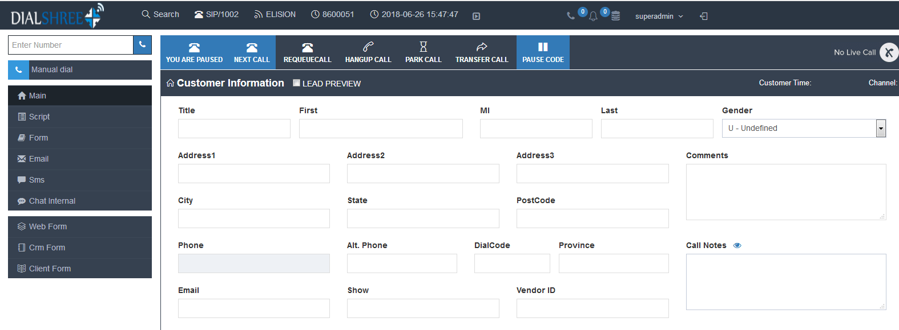

**Figure 1 Elision Dialer Agent PAUSED**

If you are in Manual dial mode you will see a “Dial Next Number” button in place of the green PAUSE and RESUME buttons (these show up in auto-dial, inbound and blended modes). These are found in the top left corner of the grey section (In INBOUND-MAN mode you will have both a Dial-Next-Number button and pause/resume buttons). In this mode you may also see a check box to enable you to preview leads before dialing them (This us unavailable in auto-dial mode). In either dialing mode you may also see a check box below these buttons that allows you to dial alternate numbers if your manager has enabled that feature on the campaign you are currently logged into. To begin taking calls in Auto-dial and INBOUND-MAN modes you will need to press the RESUME button. This alerts the system that you ready and available to take calls. Once the dialer connects a customer call with you, you'll hear a short “Bloop” sound, and then the customer is on the line. In MANUAL DIAL click the “Dial Next Number” button to trigger the system to call the next lead.

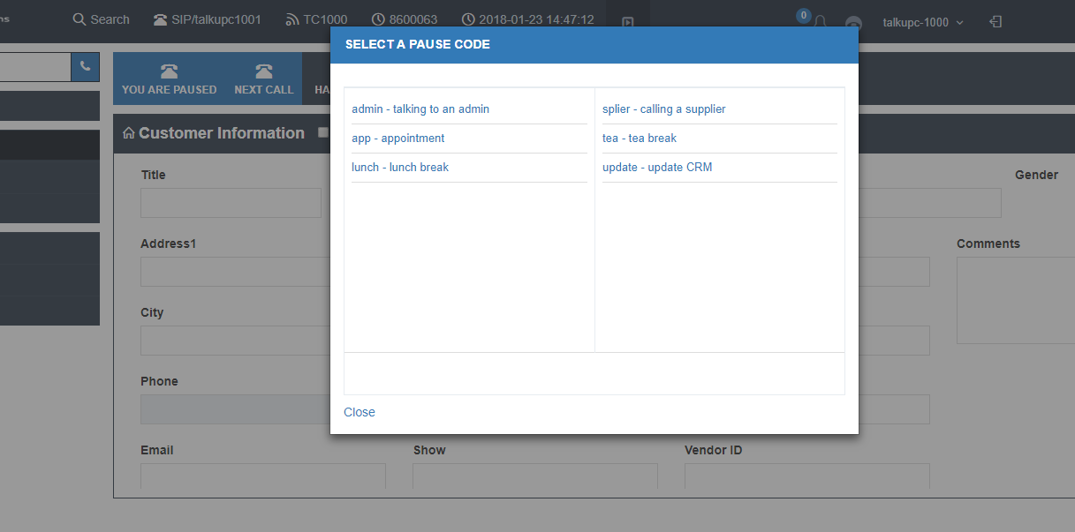**Figure 2 Selecting a Pause Code**

## Pause Codes

When you go on a break, your manager may want you to remain logged-in to the dialer, and simply go into PAUSE mode. This allows you to use a PAUSE CODE to show what kind of break you are on. To select a PAUSE CODE, just click on the icon labeled “PAUSE CODE” and a screen will appear with choices of Pause Codes to enter for your Pause time (see Figure 3). Just click on one to select it, and you will immediately go back to the main screen.

Even if you do not use a specific Pause Code, you should stay logged- in to the dialer in PAUSE mode until you start calling again, after your break has ended. Make sure to not hang up your phone at this time. A manager can also set pause code selection to be mandatory for every pause time you have.

## Logging Out

When you are done with your shift, click your name then click on the "Log out" button in the upper right corner of the Elision Dialer screen. This will hangup your phone and show you a re-login link. If you click on the re-login link, all of the login information that you entered when you logged-in will show up on the screen and you can just click "SUBMIT" to log in again without having to fill it all in again.

**NOTE:** At NO TIME should you press the BACK or FORWARD buttons in your web browser, thismay log you out without you knowing. Also, DO NOT close your browser with the "X" at the top of the window. That may lead to your session not ending properly, you may not be logged out and may result in your losing clocked-in time on your Elision Dialer time-sheet.

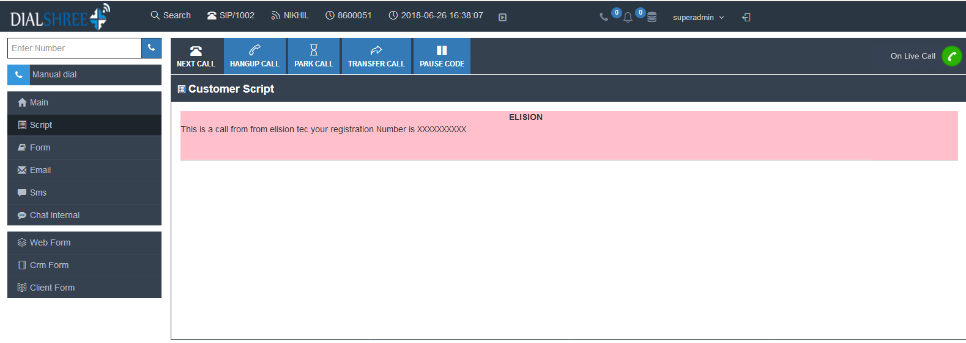

**Figure 3 Elision Dialer Script Tab**

## Script Tag

When you login to Elision Dialer you will see several tabs at the top, left corner of the screen. The Elision Dialer Main tab is furthest to the left, followed by the SCRIPT tab. Elision Dialer is the main screen that shows all customer information in the system as well as a call timer, the name of the line your call is connected on and the local time where your customer is located. The SCRIPT tab's purpose is to show the agent a script to read with the customer's information put into the script or to open a website inside the SCRIPT tab that may show your company's CRM or ordering system. Your manager can define that the customer's name, address and other information are automatically put into the script for each call (see Figure 4). If it is set up by your manager, the SCRIPT tab may pop up when a call comes to you, otherwise you can get to the SCRIPT tab by just clicking on the tab portion at the left of your screen and you can go back to the main Elision Dialer screen by clicking on the MAIN tab at the left.

## Form Tab

When a customer's record is shown from a list that contains Custom Fields, the FORM tab will appear. It's found just to the right of the SCRIPT tab, at the top of the agent's screen. The FORM tab's purpose is to display all of the Custom Fields created for this lead. Your manager will have created the fields for 2 reasons. They can pre-load the Custom Fields with detailed data about the customer not contained on the MAIN tab. Custom Fields can also be used to prompt you to ask the customer specific questions, while allowing you to retain their answers. The Custom Field types consist of either multiple choices selections, or text boxes for open ended questions. Your manager can also provide brief instructions for each field, which can be accessed by clicking the “help” link beside the field.

## Call Recording

The first button below your call control buttons ("Dial Next Number", "PAUSE", "RESUME") is the "START RECORDING" button. This button will initiate an audio recording of your session. If your campaign is set up to do so, recording may be started at the beginning of every call you receive automatically without you needing to start it. This button may also be disabled if your manager has defined that in the campaign.

Above the recording button you will see the filename of the recording which may contain things like the time, your ID number, the customer's phone number or other information. Also, the system recording ID will be displayed above the recording button. You may want to keep track of this number because it is the easiest way to retrieve the recording in the future if needed.

## Web Form

This button will take all of the information about the call and the customer and send it to a new web browser window that has been set by the manager for this campaign. This allows for such things as the easy lookup of a customer's information in a company database or even a longer sales or survey form that can contain many fields. Your manager can also set the web form to open automatically when a new call arrives at your session. There is also an option for a second web form button that goes to a different webpage if your manager has enabled it.

## CRM Pop up Login

This feature pops open a new window as soon as you first log into the campaign, directing you to the accompanying CRM login page. It allows you to quickly login to the CRM while the dialer loads the agent window. This saves additional steps and ensures that when you are ready to take calls both systems will be available to you. This is an optional feature that is enabled by your manager. If this has been set for your campaign, make sure you do not have “popup blockers” enabled on your web browser, or it will not work correctly.

## Park Call

The next button is the PARK CALL button and it allows you to send a customer that is in your session to a music-on-hold waiting area. Once you send the customer to park you can retrieve them by clicking on the button again. The park button can be set to a custom message by your manager if a recording has been setup for this campaign. When you click on the button to park a call, a timer above the button will start that lets you know how long the call has been on park.

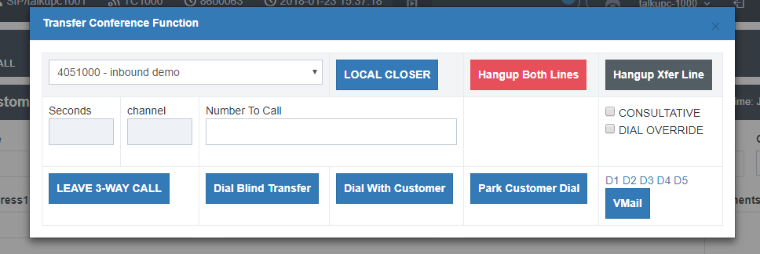

**Figure 4 Transfer Conference**

## Transfer Conference

This button opens a form that allows the agent to transfer the call or add a third party(Figure 4). There are 8 different kinds of conferences and transfers, 4 agent to agent, 3 agent to outside line, and Quick Transfer (which works for both). They are each explained below, by type. Once a conference has been created, you can exit it in one of 3 possible ways (indicated by 3 large buttons on the bottom left of your agent screen).

**HANGUP XFER LINE**

This button disconnects the conference, and leaves you and the customer still connected.

**HANGUP BOTH LINES**

This button disconnects everyone from the conference.

**LEAVE 3-WAY CALL**

This button allows you to drop from the conference leaving the customer and the other party still connected.

## Transfer Conference Type

Agent to Agent, Blind Transfer

When you want to immediately send the call over to an agent or In-group, without notifying the recipient or staying on the line with the customer.

Click the “TRANSFER-CONF” button on the left side agent screen

Select the In-group in the pull-down menu

Click the “LOCAL CLOSER” button to send the call

Agent to Agent, Consultative Transfer

When you want to transfer or conference a call to another agent or In-group, while you and the customer wait together. You can converse with the customer while waiting for the agent or In-group to pick up. When they do, all 3 of you will be on the line together.

Click the “TRANSFER-CONF” button on the left side agent screen

Select the In-group in the pull-down menu

Select the “CONSULTATIVE” box

Click the “DIAL WITH CUSTOMER” button to send the call

Agent to Agent, Parked Transfer

When you want to transfer or conference a call to another agent or In-group, but you wish to talk to them privately without the customer being on the line. This allows you to place the call while the customer is hold and speak with the other agent as long as you like before bringing the customer back on the line with all 3 of you.

Click the “TRANSFER-CONF” button on the left side agent screen

Select the In-group in the pull-down menu

Select the “CONSULTATIVE” box

Click on the “PARK CUSTOMER DIAL” button on the left side, directly above the “TRANSFER-CONF” button. This will both park the customer's call and initiate the consultative transfer to the selected In-group.

You can bring the customer back on the line by selecting the “UNPARK CALL” button (this was labelled as the “PARK CALL” button prior to the Agent selecting “PARK

CUSTOMER DIAL”)

Re-Queue Call

This feature needs to be enabled on the campaign. You will have a “RE-QUEUE CALL” button on the left side of your screen just below the “QUICK TRANSFER” button. It allows you to take your current live call and transfer it to an AGENTDIRECT queue for you to answer at a later time. This will send the customer right back to you if you do not pause immediately (the campaign can be set to pause after every call). The purpose of this feature is to allow you the ability to click “GRAB CALL” that may appear in the “CALLS IN QUEUE” frame at the bottom of the screen when there are calls waiting.

Agent to Outside Line, Blind Transfer

You want to transfer or conference the call to a phone number (rather than an agent or In-group).

Click the “TRANSFER-CONF” button on the left side agent screen

Enter the phone number in the “NUMBER TO CALL” field

Press the “BLIND TRANSFER” button to send the call

Agent to Outside Line, Consultative Transfer

When you want to transfer or conference a call to a phone number (rather than another agent or In-group) while you and the customer are on the line together. You can converse with the customer while waiting for the phone number to pick up. When they do, all 3 of you will be on the line together.

Click the “TRANSFER-CONF” button on the left side agent screen

Enter the DID in the “NUMBER TO CALL” field

Press the “DIAL WITH CUSTOMER” button directly below, to place the call.

Agent to Outside Line, Park Customer Transfer

When you want to transfer or conference a call to a phone number (rather than another agent or In-group), but you wish to talk to them privately without the customer being on the line. This allows you to place the call while the customer is hold and speak with the other party as long as you like before bringing the Customer back on the line with all 3 of you.

Click the “TRANSFER-CONF” button on the left side agent screen

Enter the DID in the “NUMBER TO CALL” field

Press the “PARK CUSTOMER DIAL” button (below & to the right). The customer will immediately be put on hold (Park) while the dialer places the call. Once the call completes to the phone number, you can talk to the 3rd party as long as you wish.

You can bring the customer back on the line by selecting the “UNPARK CALL” button (this was labeled as the “PARK CALL” button prior to you selecting “PARK CUSTOMER DIAL”)

Quick Transfer

This feature needs to be enabled on the campaign. When this is active, there will be a “QUICK TRANSFER” button on the main agent screen, just below the “TRANSFER-CONF” button. This is the only transfer that does not require starting with the “TRANSFER-CONF” button. Your manager has pre-programmed either an In-group or phone number to that button. To initiate this transfer, press the “QUICK TRANSFER” button and the dialer immediately blind transfers the call to the preset location.

AGENTDIRECT Transfers

The AGENTDIRECT transfer is a special type of Agent to Agent Transfer. It allows you to transfer (or queue) a call for only one specific agent. If you select the AGENTDIRECT entry from the Local Closer pull-down menu, an “AGENTS” link will appear to the right of the number to call field. You can click on this link to see a list of the available agents that you can send an AGENTDIRECT transfer to. Simply click on one select it. From here you can either select the CONSULTATIVE checkbox and click “Dial with Customer” for a Consultative Transfer, or click on the “Local Closer” button to send the call as a Blind Transfer (See above for more detail).

## Voice Mail Message

This is an option feature, set up by your manager. When you reach a voicemail or answering machine, this allows you to send the call to a pre-recorded message specific to your campaign. Open the transfer-conference frame and select the VM button (with a picture of a phone in the lower right side of the frame) to send the call. The pre-recorded message will play for the answering machine or voicemail and you will be sent to the Disposition screen.

## Presets-DTMF AND Number To Call

F If your campaign is set up for it, you may have up to two presets in the Transfer-Conf frame for filling in the "Send DTMF" and "Number to Call" fields. These presets are small text links in the middle row of the Transfer-Conf frame on the far right that are labeled "D1" through "D5". When clicked, they will fill in values in the "Send DTMF" field and/or the "Number to Call" field.

SENDING DTMF DIGITS

Because of how Elision Dialer is setup, DTMF digits(the sound a key-press makes on your phone) are sometimes blocked from being played to other callers in your session. To send these DTMF digits you will need to enter them into the field next to the "SEND DTMF" button. If you want to add a pause between digits just add a comma ",". For multiple pauses just add more commas in a row.

TRANSFER PRESETS – List of Preset Phone Numbers

If your campaign is set up for it, you may have a button in the bottom right hand corner of main screen labeled “Presets”. Once clicked it will display a list of phone numbers that can be dialed. Depending on how your campaign has been configured this list will have the phone number & a corresponding name as an indicator, or just the name. By clicking on the name in the list, it places the phone number in the Transfer-conference section's “Number to Dial” field.

## Agent Choose Caller ID

If the manager has enabled this feature, there will be an “Agent Choose” field in the Transfer-conference frame. This allows you to select, on a per call basis, which of several caller ID options you will display when placing a call to a third party. Your choices are:

**Campaign**: displays the default caller ID for the campaign you are currently logged into

**Customer**: displays the phone number of the customer you currently have on the line

**Agent Phone**: displays the default caller ID for your agent extension

**Custom**: displays the unique caller ID assigned to this lead

## Using Hotkeys

Hotkeys are a way of reducing the time it takes to hang-up and disposition a call if the customer is unavailable. This feature is set up by your manager. Hotkeys work by assigning a Call Disposition to the number keys (1- 9) on your keyboard. This feature is activated when your mouse pointer is on top of the orange Hotkeys button at the bottom of your screen. When the mouse is over the Hotkeys button you'll see the list of Call Dispositions available and their corresponding number on your keypad. When you are ready to end the call, press the number for the disposition you've chosen for that call. The call will immediately be hung-up, dispositioned automatically, and you will be able to take your next call immediately. To use Hotkeys, it needs to be activated by your manager for your user login and for the campaign that you are using.

## Volume Control

You have the ability on most systems to control the volume level of the customer as well as being able to mute yourself by clicking on buttons at the bottom of the agent screen. The customer volume control buttons are directly below the Send DTMF button. There is a button with a red UP arrow to raise the customer volume and a button below that with a blue DOWN arrow to lower the customer volume. On the right side of the screen there is a MUTE button that allows the agent to mute themselves. When clicked, this button will change to UNMUTE that will allow you to turn off muting when it is clicked. For the customer volume control, after the call is over the next call will be a normal volume level. There are also volume control buttons available for every connected caller in the “Show conference call channel information” panel at the bottom of the screen.

## Comments

This field appears below the customer's information on the MAIN tab. The Comments field allows you to add additional remarks regarding the call or customer, beyond the general information provided on the MAIN tab.

## Call Notes

This is an optional feature that can be enable by your manager. This field appears below the “Comments” field on the Main tab, and the Disposition screen (allowing you to add remarks even after you have hung up the call). Unlike Comments, these notes are permanently saved on the lead. Optionally (If you manager has enabled) you can see the previous Call Notes from other agents that have spoken to this customer. The notes will each be stamped with the date & time of the previous call, along with the User ID of each agent.

## Dispositioning a Call

After a customer call is hung-up, the green Disposition screen will appear (see Figure 17). Here you can select the appropriate status for the call you've just completed. To select a status, you can either double click the link, or click the link once and then select the SUBMIT link at the bottom. If you are in auto-dial mode and want to go into PAUSE before receiving your next call, select the PAUSE AGENT DIALING checkbox before selecting your status. This assures you will be in PAUSE after dispositioning the call, and you do not immediately get another call.

If you need to take written down notes, such as a log sheet, and you forget to write down the customer information before you select the hang-up button, you can click on the 'minimize' button at the top of the Disposition screen to move the disposition frame out of the way. This allows you to see the customer data below. At this point, the data can not be edited, because it has already been committed to the system once you pressed the hang-up button.

Customer is still on the line

If a customer is still on the phone after you have arrived at the Disposition screen, you can click on the "Hangup Again" link at the top of the screen to attempt to hangup the call again (You can only click this link once per call). This should be an infrequent problem. If the call still does not hang up, you should be able to hang it up from the "conference call channel information" link list at the bottom of your agent screen after Dispositioning the call.

### Minimize to see customer details

If you need to see the information on the screen about the customer you just talked to, you can click on the "minimize" link at the top of the screen to view the customer information again. Any editing of this information will be discarded since the customer information is committed to the system as soon as you click on the "Hangup Customer" button.

### Open web form after dispositioning

If your manager instructs you to, you can click on the "Web Form Submit" link on the Disposition screen to open up a web form window at the time you submit your chosen call disposition. This web form window will also be sent the disposition that you just selected for the previous call.

### Wrapup Time After Call

If your campaign is set up for it, you might have a set amount of time after you hangup and disposition a call, during which you can complete other call wrapup work before you are able to receive another call. You will see a green Wrapup screen after dispositioning a call. It contains a countdown indicating how many seconds of wrapup time remain before the green wrapup screen disappears and you can take another call. There is also a “Finish Wrapup and Move On” link that you can click to bypass the wrapup time and immediately go on to the next call.

## Pre – Call Work

This manager enabled feature is available in Auto-dialing mode. This setting will automatically place you in PAUSE when you have selected any of the following functions that would require you to be paused; such as: *Manual Dial, Fast Dial, Lead Search, Call Log View, Callbacks Check, Enter Pause* *Code*.

## CALLS IN THE SESSION, AND FORCED HANGUPS

To see the participants in your session at any time, click on the "Show conference channel information" link at the bottom of your screen(see Figure 18). A frame will appear at the bottom that will list the channels in your session including your channel. If you have a problem where a channel does not get hung up properly when you have clicked a hangup button, you can click on the channel's HANGUP link in this frame and it will be released.

Also in this frame will be volume control buttons allowing you to raise, lower and mute the volume on any call in your session.

## CALLS IN QUEUE, AND TAKE CALL

To see the waiting calls, in the queues available to you, click on the "Show Calls In Queue" link at the bottom of your screen(see Figure 19). A frame will appear (at the bottom of the screen) that will list calls from the In-groups currently assigned to you. This listing will show you the phone number of the caller, the name, if there is one, the amount of time the caller has been waiting in queue, the agent the call came from or the number that the customer dialed to get to the queue, the color of the In-group, the name of the In-group and whether the call is inbound or outbound.

To take a call you need to be paused. Then click on the TAKE CALL link to have the call sent to you. There may be a delay of a few seconds, if the customer is listening to a place-in-line prompt or other non-transfer prompt.

## AGENTS VIEW SIDEBAR

To see the agents that are logged in on your system (or just the agents logged into your campaign or user group) you can click on the “Agents View +” link on the bottom right side of your screen. This will bring up the agents view sidebar, showing the agents with a color (blue for READY, purple for INCALL and yellow for PAUSED) and optionally the amount of time the agent has been in that state.

## CALLBACKS

The Call-back feature allows you to set a date and time for leads so that they can be removed from active dialling, until that date and time have arrived. Call-backs default to allow any agent to receive the call when the customer is called back (ANYONE Call-backs). Additionally, if it is enabled for your account, an agent can select to have the call-back be restricted to only their login (AGENT ONLY Call-backs). When an agent receives a call that was last set as a CALLBK, there will be a message showing up next to the "Customer Information" header of the Elision Dialer screen that will say "PREVIOUS CALLBACK" so that the agent will know that this lead was set as a call-back the last time it was called. Agent Only Call-backs will trigger a pop-up alert on the screen.

### Setting a Callback

When setting a Call-back for a specific date and time, the agent will hang-up the call as usual and select the CALLBK status in the disposition screen. Once chosen, a new calendar screen displaying the next 12 months will pop up (see Figure 21). The agent needs to choose a day from the calendar and then select a time (hour, half hour and AM/PM menus at the top of the screen) for that lead to be contacted back. There is also a field for comments about the call-back, if necessary. Once a call-back date and time are set, click on the SUBMIT button to go on to the next call. The manager can also limit how far in advance a call-back may be set. If you are unable to set a call-back for the desired date, contact your manager to see if that feature has been enabled.

Call-backs are reactivated and put back into the system at the date and time specified by the agent. The call will not happen immediately and by default the agent that set it may not necessarily get that call-back call. It is important to note that managers have the ability to see what call-backs were set by each agent and when the agent set them. Managers also have the ability to override agent call-backs by changing them to anyone call-backs or assigning them to another agent.

### Receiving a Callback

If you receive a call that had been last dispositioned as a CALLBK, either ANYONE or AGENTONLY, you will see a box appear with information about the call-back record including the date of the last call, the scheduled call-back date and time along with any call-back comments that were entered by the agent that set the call-back.

### Agent-only Callbacks

If your manager has activated this feature, it will display a "MY CALLBACK ONLY" checkbox under the date fields in the call-back screen (If you have dispositioned calls as CALLBK). This checkbox, if selected by the agent, will save the call-back to only be accessible by the agent that set it.

If you have set an agent-only call-back, you will see a text link under the comments on your main screen that will show "1 ACTIVE CALLBACKS". If you click on this link you will see a screen that has a list of all ACTIVE and LIVE call-backs for the campaigns that you are currently logged into (see Figure 22). An ACTIVE call-back is one that has yet to be triggered, while a LIVE call-back is one that has passed its call-back trigger date and time. For agent-only call backs you can call both ACTIVE and LIVE call-backs. If you click on one of the call-backs listed in this screen the call-back record will be changed to INACTIVE, removed from the list, and you will go to the main screen in manual dial mode where you can see the customer details. From here you can call the customer by clicking on the "DIAL LEAD" link at the top of the screen. After the call is over you can HANGUP CUSTOMER as usual and disposition it. If you want to set it to call-back again, another call-back record will be added and you will need to pick a new date and time.

### Callback Alert Type

Your manager can also enable Call-back Alerts, which differ from the standard status line. The alerts range from red, blinking, or blinking red. In addition, each of those alerts also has a DEFER option which will stop blinking and/or displaying in red when you check the call-backs, until the number of call-backs changes. Select the “close” or “Close Call Log” link to go back top the Main tab.

## AGENT CALL LOG

If this feature has been configured by your manager, you will see the “View Call Log” link in the drop down menu of your username. Once selected. It allows you to see a list of the calls you have handled. It displays the *Date/Time, Length, Status, Phone Number, Customer Name, Campaign,* *inbound/outbound, Alternate Phone Number, and Hang-up* data. You can click the “INFO” link to viewthe lead itself, or “DIAL” to manually dial the customer. The default setting displays only the current day's calls, but changing the Date field, at the top of the page, allows you to view previous day’s calls.

## AGENT BLIND MONITORING ALERT

This optional feature allows your manager to send a popup alert to all agents on the same campaign.

This can be used to advise important information that needs to be seen immediately.

## AGENT LEAD SEARCH

If your manager has enabled this feature on the campaign, you can search for a specific customer lead while in Pause. You can search by using either the Main, Alternate or Address3 phone number, and any combination of the following data : *Lead ID, Vendor ID, First Name, Last Name, City, State, and* *Postal Code*. We recommend Main phone number, Lead ID, or Vendor ID, as they yield the fastestresults. These fields do not allow for wildcard or partial search terms. Once you click Submit, the system will display a results page showing the lead or leads that meet the given criteria. From that page you can click the “INFO” link to view the lead itself, or “DIAL” to manual dial the customer.

### NEW LEAD, SEARCH LEAD MANUAL DIALING, AND FAST DIAL

If your manager has activated this feature, you will see a MANUAL DIAL text link and a FAST DIAL text link below the comments field of your main Elision Dialer screen. These features allow you to add a new lead to the database manually or search for an existing lead by phone number and call that number.

## Manual Dial

If you click on the MANUAL DIAL link, you will go to a green screen allowing you to specify the customer number you want to call. When the "NEW MANUAL DIAL LEAD" screen appears you will see instructions at the top along with the campaign's dial prefix that your system may use to get to an outside line, a Dial Code field and a Phone Number field. You do not require to add a dial code when you are dial within Australia. Once you have entered in a phone number you can click on the “Search Existing” checkbox to see if this phone number is already in the system and bring up its record. An option feature (enable by your manager) allows you to see the Comments or Call Notes from previous calls. You can click the "Dial Now" link and go to the main screen, ready to dial the lead. Once on the main screen you may choose to enter or modify the lead data in the "Customer Information" fields, before clicking the "DIAL LEAD" button to place the call. From the Manual Dial screen, you can also place a call to any extension by entering it in the "Dial Override" field. After the call is finished and you have selected “Hangup Customer”, you will disposition the call as usual and go into the next call.

## Fast Dial

The FAST DIAL link is very similar to the Manual Dial link, except to use it all you have to do is enter a phone number in to the main Customer Information “phone number” field and click on the FAST DIAL text link to start dialling that number. There are not as many options with this feature, but it is much faster to use with less steps.

## Group Alias Select

The optional Group Alias Select link allows you to select the callerID number that is sent out with manual dial and transfer conferences 3-way calls

## SESSION WARNING MESSAGES

If your agent phone is hungup while you are logged into Elision Dialer, you will be sent to a blue screen with an message stating that “No one is in your session”. If you accidentally hung up your phone, you can return your session by dialing the session ID that is at the top of your screen or you can have the dialer call you back by clicking the "Call Agent Again" link on the screen.

If your customer hung up, and you have not clicked on the HANGUP CUSTOMER button, you may see the "Customer is no longer in your session" message appear on your screen (see Figure 27). To remove this message, hangup the call as normal through your Elision Dialer screen. You can also click on the "Finish and Disposition Call" link which will take you directly to the Disposition screen.

If your manager has logged you out, you may see a blue screen with the message “Your session has been disabled” along with a LOGOUT link. If this happens, make sure you click on the LOGOUT link so that your Elision Dialer timesheet will be accurate.

One other message that you may see pop up is a warning that your session has been paused. This can happen sometimes when you having internet connection issues. If this persists, inform your manager.

## MANUAL DIALING MODE

Manual dialling mode is when the agent controls when a call to a customer is dialed by clicking on the green "Dial Next Number" button in the top left of the screen. In this mode, you will hear the ringing of the phone, you hang it up at any time manually, the system will not start another call until you click the button to dial again.

## PREVIEW DIALING

Clicking on the LEAD PREVIEW checkbox directly below the green DIAL NEXT NUMBER button activates this feature. This allows for the agent to be able to see the lead information before the call is placed (see Figure 28). This is desired for example if the agent just wants to open a WEB FORM with more information about the customer before dialling them. This feature is available in Manual dialling mode only. When you are ready to call the customer, simply click the “DIAL LEAD” link at the top of the screen. An optional feature places a “SKIP LEAD” link just to the right of DIAL LEAD. This allows you to skip over the current lead already on your screen, and preview the next lead available in the system. Keep in mind Elision Dialer logs and displays every lead skipped in your Agent Stats.

## MULTIPLE NUMBER-PER-LEAD DIALING

Clicking on the ALT PHONE DIAL checkbox directly below the LEAD PREVIEW checkbox activates this feature. This allows for you to dial the alternate phones numbers on the customer lead, if they can not be reached at their main number. These additional numbers can be located in the “alternate phone number” and/or “address3” fields. Nothing will change on the Elision Dialer screen until the call has been hung up. At this point the screen would normally go to the lead disposition screen, but in Alternate number dialling mode, the status area (at the top of the purple section) will change, displaying links that will allow you to dial the main customer number again, the alternate phone number, or the address3 field phone number (see Figure 29). When you have finished all of the calls you wanted to place for this lead, simply click on the FINISH LEAD link to go to the disposition screen.

## TERRITORY DIALING

This Manual Dial only feature allows you to dial a sub-set of leads in the campaign that are designed specifically for you or your group. The Territories are created by your manager, and the customer leads are assigned a Territory. When you login, a green screen will display the Territory (or Territories) available to you. You can even select to be in more than one Territory at a time. After choosing your Territory and completing your login, you will be presented with leads from the Territory you selected.

## CALL TIME MISMATCH ALERT

A Manual Dial only feature, that pops up an alert to advise when the timezone of the phone number does not match the timezone for the postal code on the customer lead. This manager enabled feature is a security measure to ensure the customer is called at the desired time for their current location.

## AGENT INTERFACE ALERT

This Manual Dial alert advises that the disposition of your last call did not complete correctly. You will not be able to dial another lead. This alert is rare and indicates a potential problem on the network connection. Please alert you manager.

## AUTO-DIAL MODE

Auto- Dialling mode is when you are only sent calls that have been answered. You will not receive *Busy, Disconnected, Invalid number* or *Ring-no-Answer* calls. Optionally, Elision Dialer can also avoidsending most answering machine and voicemail answered calls. Because of this, you will not hear ringing of the phone. You will simply hear a quick “bloop” sound when the customer is connected to your session.

## CALL CONTROL

The PAUSE and RESUME buttons at the top left of the screen are known as the call control buttons. When you log into a campaign in auto-dial or inbound/closer mode, the PAUSE button will be gray and the RESUME button will be green, indicating are in Pause. This is known as the “paused state”. Once you click on the RESUME button, you are available to start taking calls. When you are ready to pause, just click on the PAUSE button to stop receiving calls. You may also select the PAUSE AGENT DIALING checkbox on the disposition screen to PAUSE to Pause yourself immediately after submitting the disposition for that call.

## PAUSE AND RESUME PROCEDURE

If wish to go on a break or log out at the end of your shift, you will need to be Paused to click on the LOGOUT button in the top right corner. If you haven't done this and leave from disposition screen or just close the web window, your login time may not be recorded accurately. In addition calls may still be made for several minutes because the system is not aware you have logged out. If you are experiencing a high call volume, or you have no delay between when you hangup one call and receive the next, it would be a good idea to use the “PAUSE AGENT DIALING” checkbox on the call disposition screen.

## MULTIPLE NUMBER-PER-LEAD DIALING

This is another feature that must be activated by your manager. Clicking on the ALT PHONE DIAL checkbox directly below the PAUSE and RESUME dial buttons activates this feature. This allows for the agent to be able to dial the alternate phone number or the address3 field as a phone number after a call has been received by the agent. This feature is described in more detail in the manual dial section.

## INBOUND AND CLOSER FEATURES

If you will be working on an inbound closer, email, or blended inbound/outbound campaign, you will need to login to an inbound enabled campaign. Depending on how the campaign is set up, you will be able to take calls from many different sources. Unlike campaigns (where you can only be in one at a time) you can staff multiple In-groups and/or email groups all at the same time. The call control procedure (pause/resume) is the same for inbound and closer campaigns is the same as it is for outbound auto-dial campaigns.

## LOGIN SELECT GROUPS MENU

When you log into a CLOSER-type campaign (depending on how your manager has configured it) you will see a green screen that will show a list of inbound and closer groups to select from. This will determine which inbound or closer groups you wish to take calls from (see Figure 31). The ability to choose may also be disabled. In this case your manager has already preselected the groups you will receive calls from. Also on this screen is the option to select the “BLENDED CALLING” checkbox. This box allows to be able to take outbound calls, when not on an inbound call. Ask your managers whether you should click on BLENDED or not when you log in.

## DISPLAY AND CALL INFO

Inbound and Closer campaigns have some special display features that are not in regular auto-dial campaigns. When you receive an inbound call, you will see the color and In-group name associated with that call in the status bar (toward the top of the screen). If the call is a closer call from a fronter agent on another Elision Dialer campaign, the status line can be setup to show their name and User ID number for tracking purposes.

## Ring All

In most cases, the inbound call notification is identical to an outbound Auto-dial campaign. You would hear an alert, and the customer is immediately transferred to you session. However, you manager can alternately enable the “RING ALL” feature. When a call is received, all the phones in the In-group will ring. The first person to answer gets the call.

## IN-GROUP MANUAL DIAL

This feature allows you the ability place manual dial outbound calls that are logged as In-group calls assigned to a specific In-group. Depending on how your manager has configured this feature, the options may differ. It can allow you to place phone calls out through an In-group and back to yourself. Optionally, it may allow you to log time on a call that does not exist, as if it were a real call) most often used for logging email or faxing time). It can also be setup to allow both of the above.

## INBOUND CAMPAIGN LEAD SEARCH

If your manager has enabled this feature on the campaign, you can search for a specific customer lead while in the middle of an inbound call. Once you select “LEAD SEARCH” it is identical to the Paused lead search. You can search by using either the Main, Alternate or Address3 phone number, and any combination of the following data : *Lead ID, Vendor ID, First Name, Last Name, City, State, and* *Postal Code*. We recommend Main phone number, Lead ID, or Vendor ID, as they yield the fastestresults. These fields do not allow for wildcard or partial search terms. Once you click Submit, the system will display a results page showing the lead or leads that meet the given criteria. From that page you will select the customer lead and that information will replace the data that was previously on your screen.

## PHONE ISSUES AND OPTIONS

Using Elision Dialer remotely gives you a lot of flexibility, including what kind of phone you use. Depending on what your manager allows, you will either be able to use your home land line phone, a computer soft-phone, a VOIP hard-phone or even possibly your cell phone. If you are using your home phone or cell phone, you only need to give your manager the 10-digit phone number of the phone you want to use remotely. If you will be using a VOIP hard-phone, you should be receiving a phone that is already setup by your manager and that you just need to plug into a broadband Internet connection to get it to work. If you will be using a soft-phone, your manager will probably give you a set of instructions to set it up on your computer and some possible suggestions for microphone headsets to use with your computer.

No matter what kind of phone you will be using, it is important that you get the Phone Login and Phone Password from your manager when they have set your phone up so that you will be able to log in properly.

Elision Dialer has built in WEBRTC support, which means you no longer require using a soft phone. The call will come through your web browser. This is an optional feature.

## EXTERNAL USER ISSUES

While using Elision Dialer from a remote location like your home, another office or a hotel offers a great amount of flexibility, there are some issues to be aware of. Foremost is the quality of your Internet connection. Many home broadband Internet connections like DSL or Cable use a shared architecture, meaning that you do not have guaranteed bandwidth or consistent speed at any given time. This means that if several people in your area are using a lot of bandwidth, you many have problems with your Elision Dialer operations like crackly audio, dropped calls or even the Elision Dialer.php webpage failing to load properly. When you have that kind of problem, especially in a home environment, there isn't always a lot you can do aside from calling your Internet provider and complaining.

## MANAGER FUNCTIONS

Managers of a Elision Dialer system have a great deal of information that they can look at involving agent operations, stats and current status. A manager can tell how long an agent was paused, how long they waited, how long they talked and how long the took to disposition each individual call. They also have access to login/logout times and the status of every disposition of every call an agent has ever made. Managers have the ability to listen in on all conversations, barge into those conversations and talk, hang up an agent at any time and grab the customer they are talking to, and deactivate the agent account at any time. Also, in some setups a manager will have access to recordings of agents when they are logged in, including pause, wait, talk and disposition time.

## CLOSING

Elision Dialer is a very flexible contact centre solution that is user-friendly and highly configurable. If you run into any problems while using it, you should contact your manager or system administrator.

## FREQUENTLY ASKED QUESTIONS(FAQ)

* I logged in and there was already an agent in my session, what happened?

Usually this happens when that other agent did not log out correctly or did not hangup their phone. Tell your manager what session ID you have and they can lookup who the other agent is and hang up their extension.

* How much delay is there before a customer gets to my phone?

This depends on several things. If you have been waiting for a call for more than 3 seconds, there is a good chance that there was less than a second of delay while the customer was transferred to you. If it was a very quick transfer after you just logged in or dispositioned a previous call, then there is a good chance that the customer may have waited two or more seconds before you(the next available agent) was able to take their call. The exception to these is if your system has Answering Machine Detection(AMD) enabled. If that is the case, there can be a one-half to two second delay on all calls getting to an agent. Your manager should know if you have AMD enabled for your campaign.

* What about Answering Machines and detecting them?

As mentioned in the question above, Answering Machine Detection adds a delay to the customer getting to you. Some managers may disable this so that there is no delay. One other option that they may use to reduce the number of Answering Machines sent to agents is to set the ring time to 4 rings, which will eliminate over half of the Answering Machines and Voicemail boxes that would normally be sent to agents.

* What Internet web browsers work with Elision Dialer?

We recommend, Latest google [chrome](https://support.google.com/chrome/answer/95464?co=GENIE.Platform%3DDesktop&hl=en) [in incognito mode](https://support.google.com/chrome/answer/95464?co=GENIE.Platform%3DDesktop&hl=en). Agent must close the web browser at the end of the shift.

In order to open from an icon on the desktop, copy a chrome shortcut to your desktop. Right click and open properties. Then append the following to the end of the Target field.

-incognito -o "https://demo.elisiontec.com /elision-dialer/agent/index.php?pl=phone1username&pp=phone1pass"

Change phone1username and phone1passas as per the phone login and phone password that you received from the manager. Then rename the shortcut to “Elision cc interface”. This should directly open the Elision dialer in icognito and will not ask for the phone username and phone password.

Following is a screenshot of where you have to append the above command.

