
Widget-CRM transfer Options



Table of Contents
Table of Contents 2
1. Transfer options in Widget 4

Document Revision History

Version | Date | Author | Description of change
1.0 | 17/03/2018 | Radhika Solgama | Technical Document

- Transfer options in Widget
There are three types of transfer options are available in widget.

- External transfer
- Internal transfer
- Agent transfer

  - External Transfer: To transfer the call on external number Click on the Transfer call Button - > enter the number in External number and then -> click on Dial with customer button

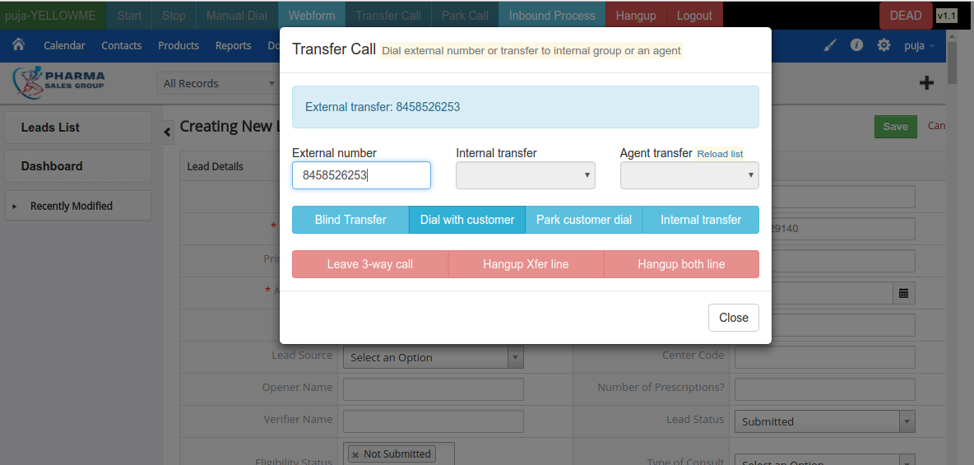

And second option is Park customer dial

For example agent calls to one agent on 8586598547 number and now agent wants to park this agent and call to third number 9569856958 to do this simply calling on number 8586598547 press the Transfer call button and enter the external number 9569856958 and click on the Park customer dial button so number 8586598547 goes to park and the agents and external numbers communication will continue.Now user want to three way communication then simply click on the greb customer.

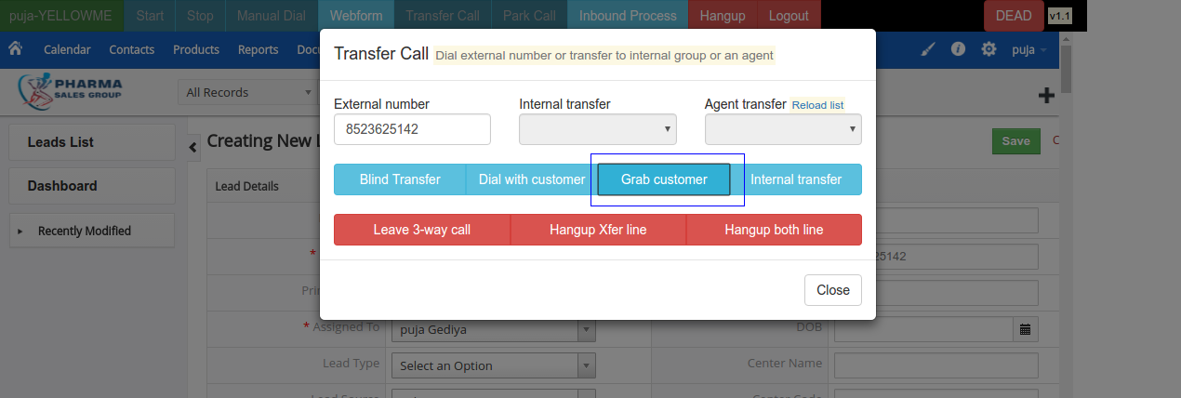

Here three options are available
1) Leave three way call
2) Hang-up Xfer line
3) Hang-up both the line

By click on leave three way call button agent leave from conference call.
By click on Hang-up xfer line agent hangup the transfer number (external number).
By clicking on the Hang-up both the line conference will be hang-up.

2) Internal Transfer:

By using internal transfer options user can transfer the number to selected in-groups agent.
Select the In group in internal transfer and click on the internal transfer using this feature agent leave this communication and call will be blindly transfer on selected ingroup.

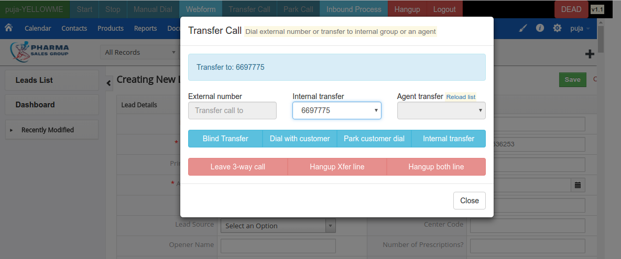
And after click on the internal transfer button agent see the disposition selection page
In this option below options are also available. And it is explain above

1) Leave three way calls
2) Hang-up Xfer line
3) Hang-up both the line

3) Agent Transfer: By using this feature user can transfer the call agent to agent
To use this feature there are some campaign side configuration
Agent have to check mark AGENT DIRECT in Allowed Ingroup and Allowed Transfer Groups
And when user login in widget CRM user have to select the AGENT DIRECT in ingroup selection.
After this configuration user can transfer the call to another agent

