



User Manual; Dialshree Admin Panel

# Table of Contents

Table of Contents 2

1. Login process 4

2. Create User Group 5

3. Create User 8

3.1 Copy Users 9

3.2 Agent Interface options 10

4. Create Campaign 12

4.1 Copy Campaign 14

5. Create List &Upload List 15

Document Revision History

This table holds record of signification changes made to the document.

|  |  |  |  |
| --- | --- | --- | --- |
| **Version** | **Date** | **Author** | **Description of change** |
| 1.0 | 04/12/2017 | Radhika Solgama | Admin Panel Manual |

1. Login process

* Login in to the admin Panel Click on the Manager login From Landing page.

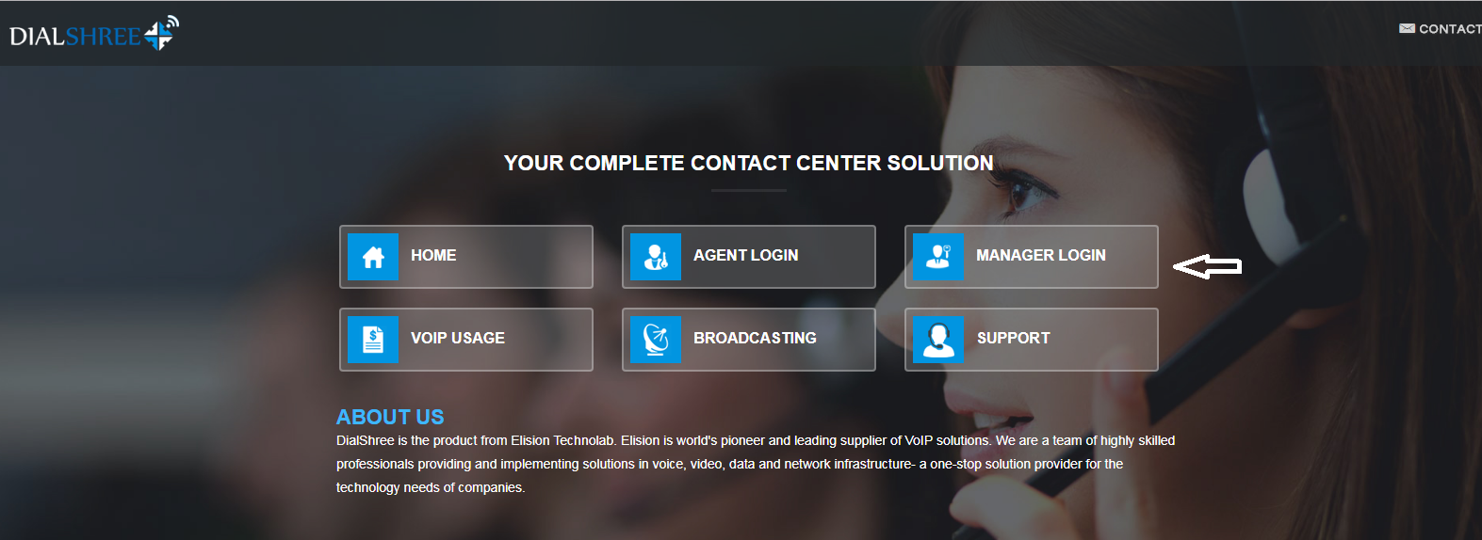

* After click on the Manager Login User can see the Login Page.
* Use Your Credentials to login in to the admin panel and click on the Login Button.

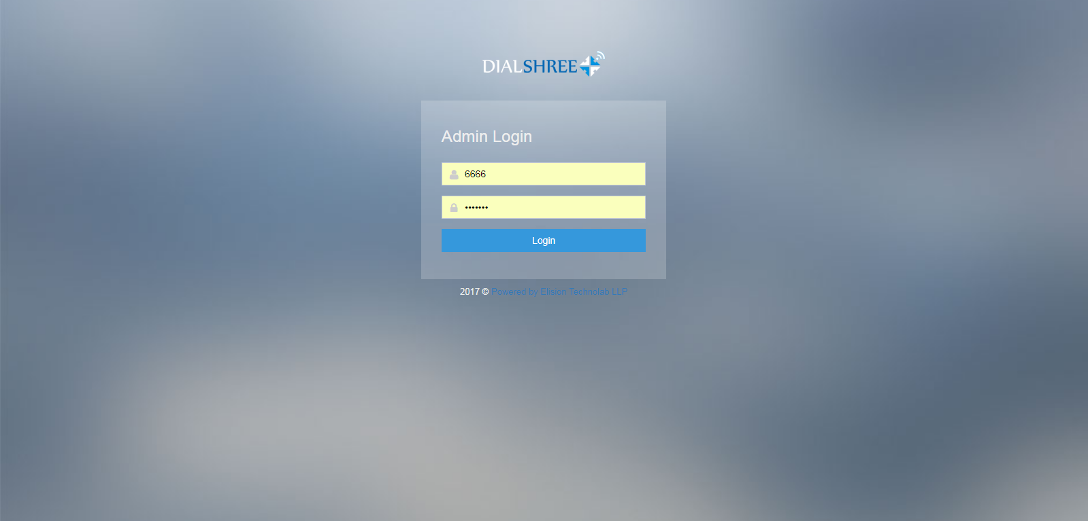

* After click on the Login Button user can see the below page and Start his /Her Work.

1. Create User Group

* You need to create a DialShree user group to put your agents into.
* Click on the User Groups link from the sidebar to get to the User Groups section,

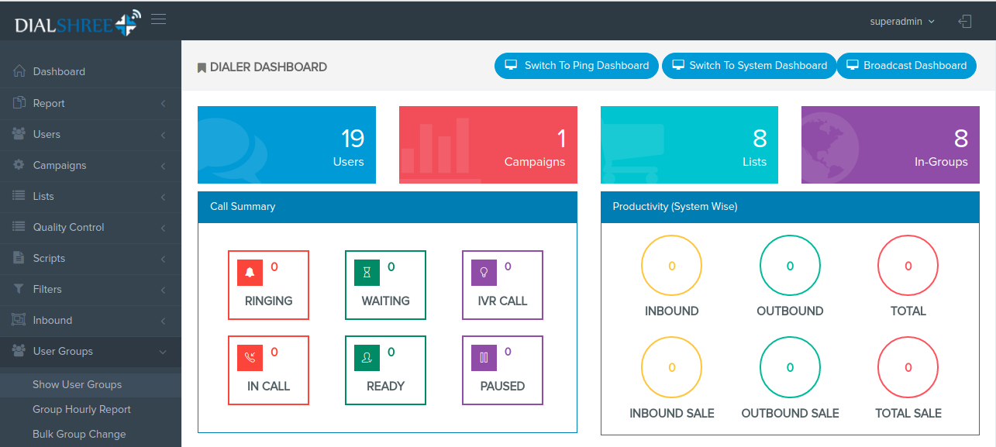

* After click on the user group and then click on the Show user Groups, user can see all created user groups from here and also user can create the new user group from here.

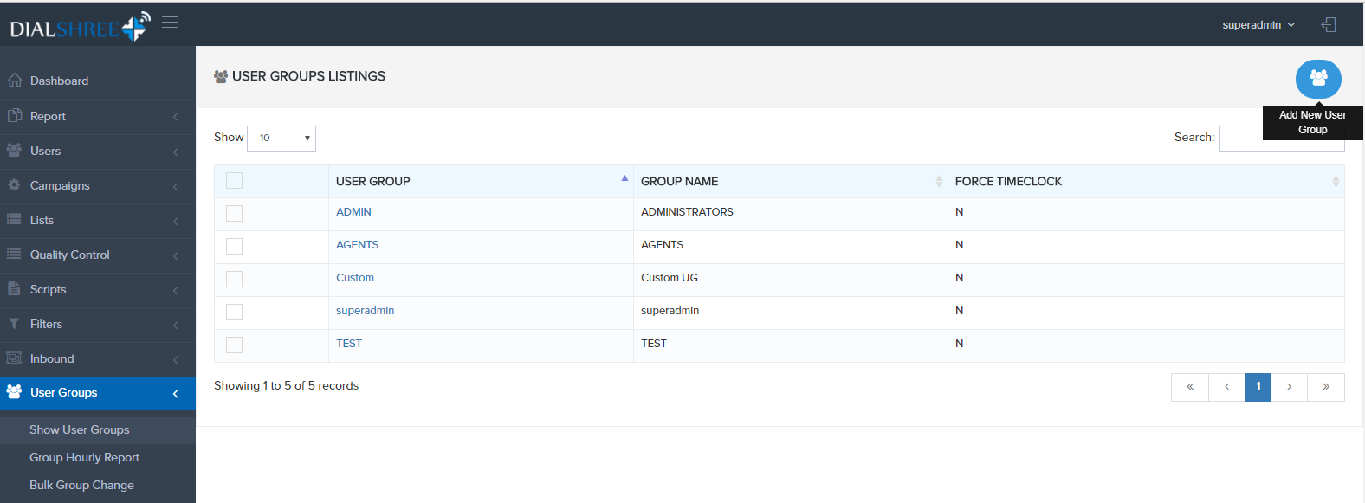

* On the above screen shot user can see the user icon on the top right side
* To create the User Group just clicks on the user icon.
* To modify the User Group just click on the User Group from listing. And User can modify the particular user group from here.
* FOR EXAMPLE
* Group: AGENTS
* Description: DIALSHREE AGENT
* Then click submit to add the user group and after click on user Groups user will see the user group listing. To modify the details of user groups just click on the user group from listing. After clicking on the user group user can see the modify section of user group. User will leave the “Allowed Campaigns” section with only ALL CAMPAIGNS checked. Now that you have successfully created an agent user group, you need to create some DialShree user accounts to allow agents to login to the DialShree client application and place calls
* User can set allowed campaigns, allowed Reports, and allowed modules Permission for particular user group.

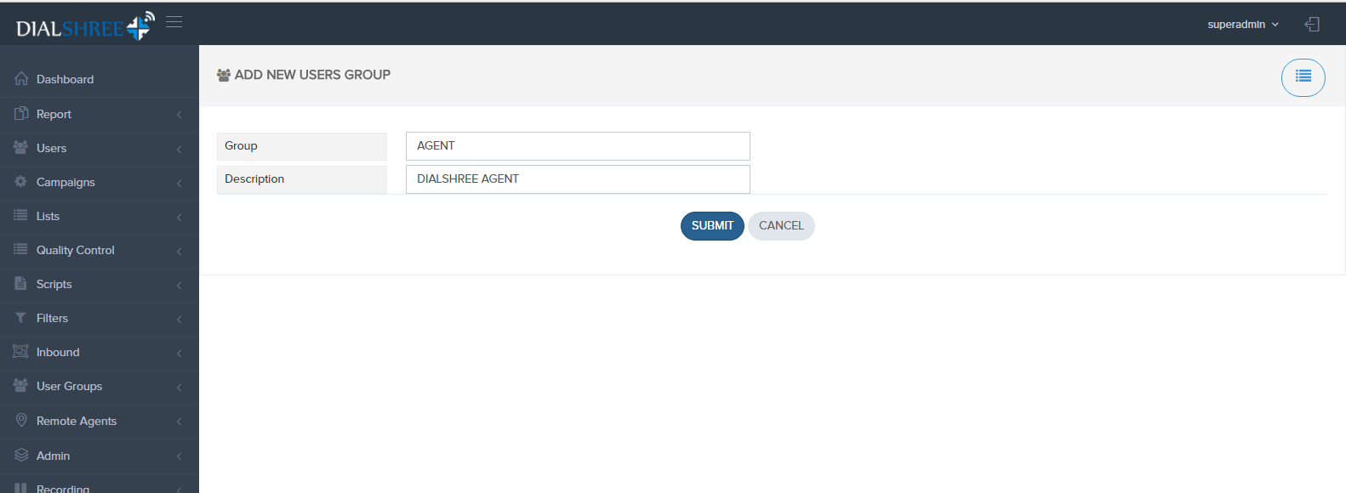

1. Create User

* To Create the User click on the user link from side bar.
* Then click on the User Listing. User can see the below page.

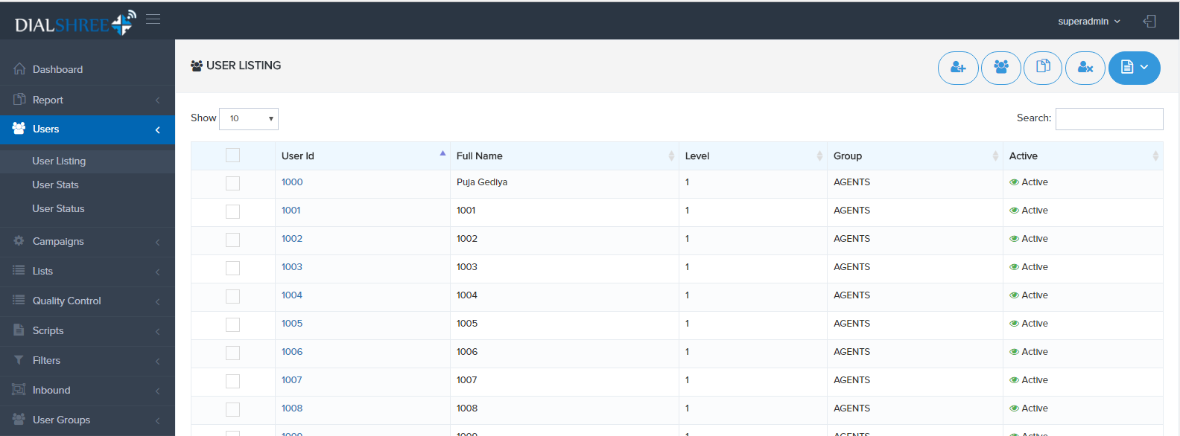

* To create new User Click on the User icon this is shown in the top of right side.

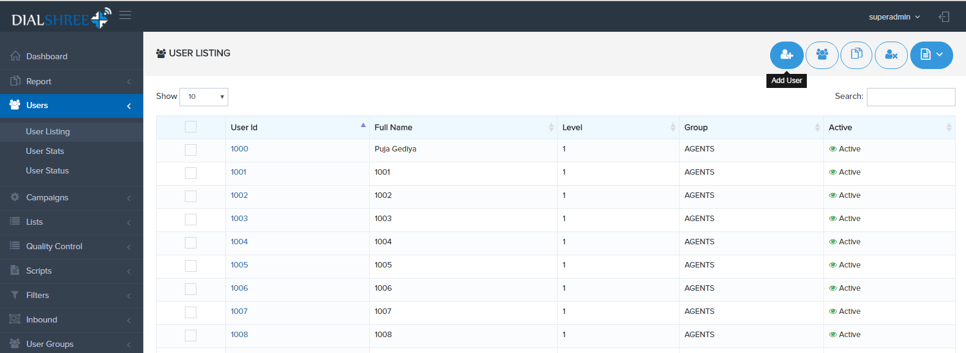

* For an example we will fill in the following add user fields with these values:
* User Number: 7777
* Password: test
* Full Name: test agent
* User Level: 1
* User Group: AGENTS
* we will leave phone login and phone password blank for this tutorial>

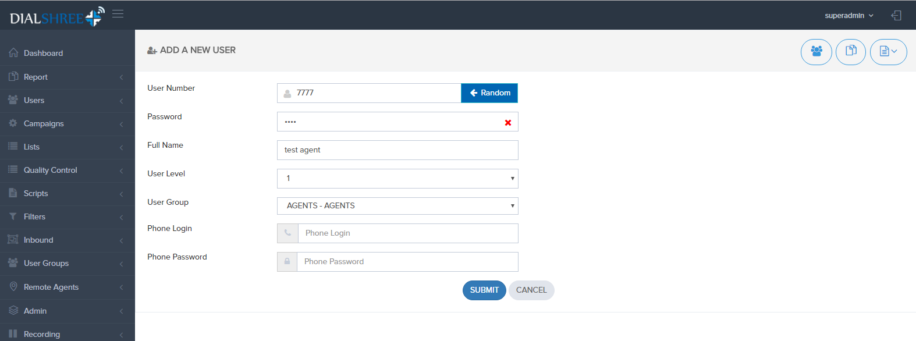

* After filling all the details click on the submit button.

## Copy Users

* To copy the user Click on the copy icon from top of the right side.

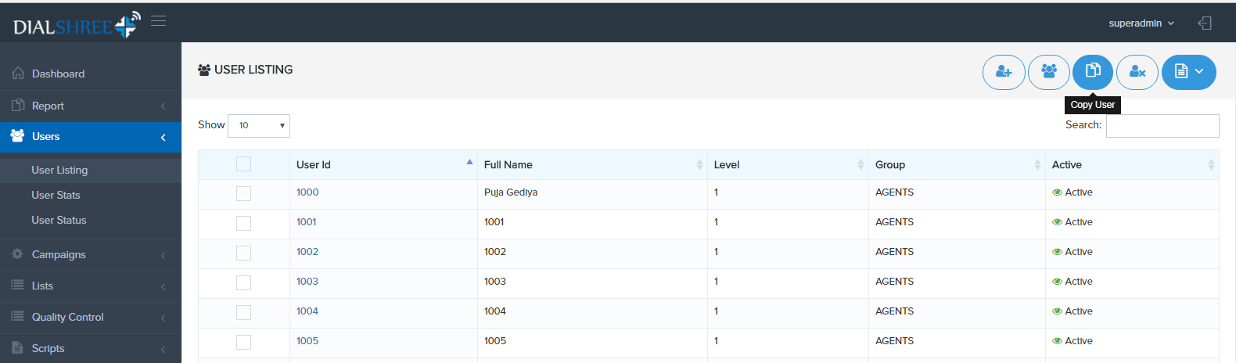

* After click on the copy icon user will see the below page

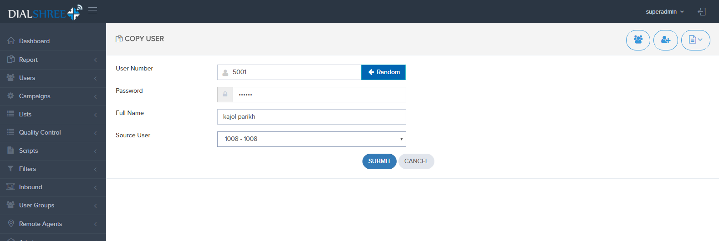

* For example I copy one user 5001 and I Select source user as 1008.
* Now 5001 user is the copy user of 1008.

User Number: 5001

Password: 123456

Full Name: Kajol Parikh

Source User: 1008-1008

## Agent Interface options

* In admin Panel Here is some options to give the some permission to user on agent panel side.
* To activate these feature click on the User ID -> click on the AGENT INTERFACE OPTIONS.

**Agent Choose Blended:**

* This option is set to 1 to allows to user to choose the user group that they will receive calls from when user login into INBOUND OR CLOSER CAMPAIGN otherwise the manager will need to set this in their user details.

**Hot Heys Active:**

* This option is set to 1 for quick-dispositioning the call.

**Scheduled Call Back:**

* This option allows an agent to disposition a call as a CALL BACK and choose the date and time at which the lead will be re-activated.

**Agent Only Call Back**

* This option allows an agent to set a call back so that they are the only agent that can call the customer back. This also allows the agent to see their call back listing and call them back any time they want to.

**Agent Call Manual**

* This option allows an agent to manually enter a new lead into the system and call them. This also allows the calling of any phone number from their agent screen and puts that call into their session.

1. Create Campaign

* To Create Campaigns Click on the Campaigns Link from the sidebar. Then click on the Campaign Main.

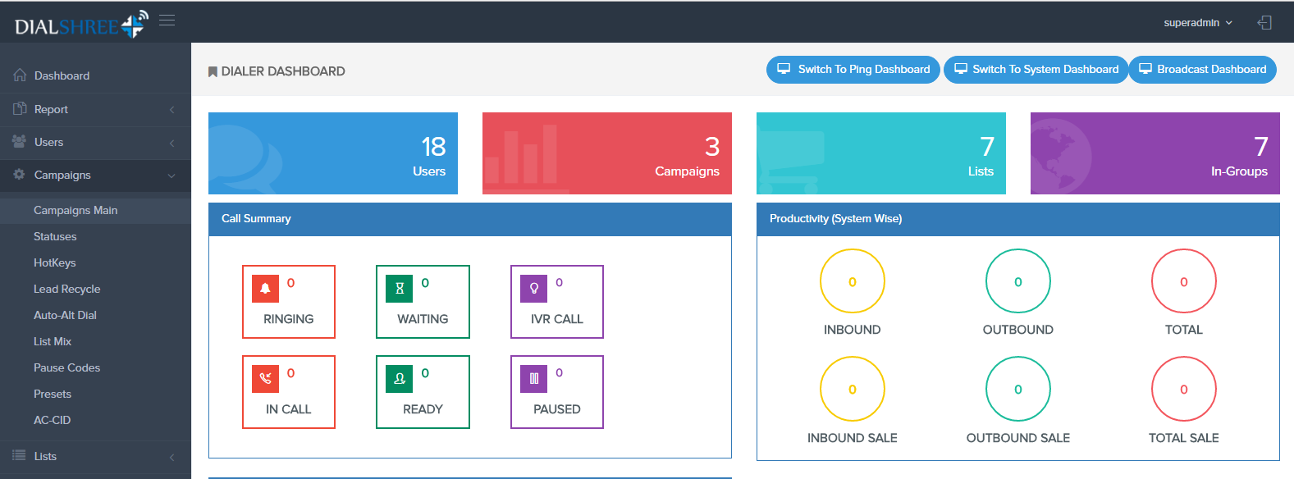

* User can see the below page after clicking on the Campaign Main.

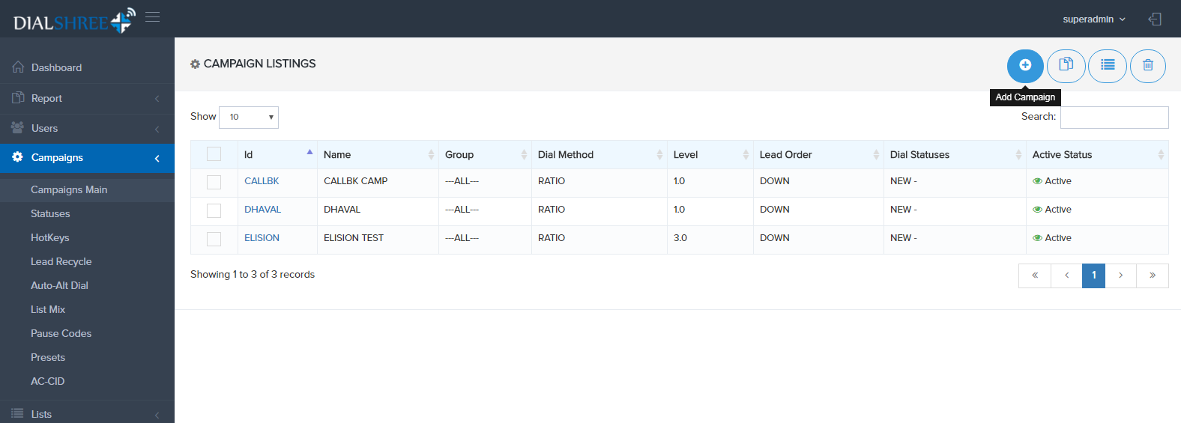

* To add the new campaign click on the plus icon from the top of the right side this is shown in the above screen shot.
* Note: When adding a new campaign you must make sure that you set the campaign ID and campaign name otherwise the submission will not be accepted. Also, please make sure that the campaign ID you have chosen does not have any spaces or punctuation, only letters or numbers, and you cannot use the same ID for a campaign and an in-group. Once you create a campaign you will not be able to change that campaign ID unless you delete the campaign and re-create it again with a different campaign ID. You cannot have duplicate campaign IDs in the system, and campaign IDs must be between 2 and 8 characters in length.
* To create new Campaigns add Below Details.
* Campaign ID: TESTCAMP
* Campaign Name: Test campaign for DialShree
* Active: Y
* Allow Closers: Y
* Hopper Level: 100
* Dial Method: Ratio (To run the campaign in Predictive Mode)
* Auto Dial Level: 1.5
* Next Agent Call: oldest call finish
* Local Call Time: 24hours -default 24 hours calling

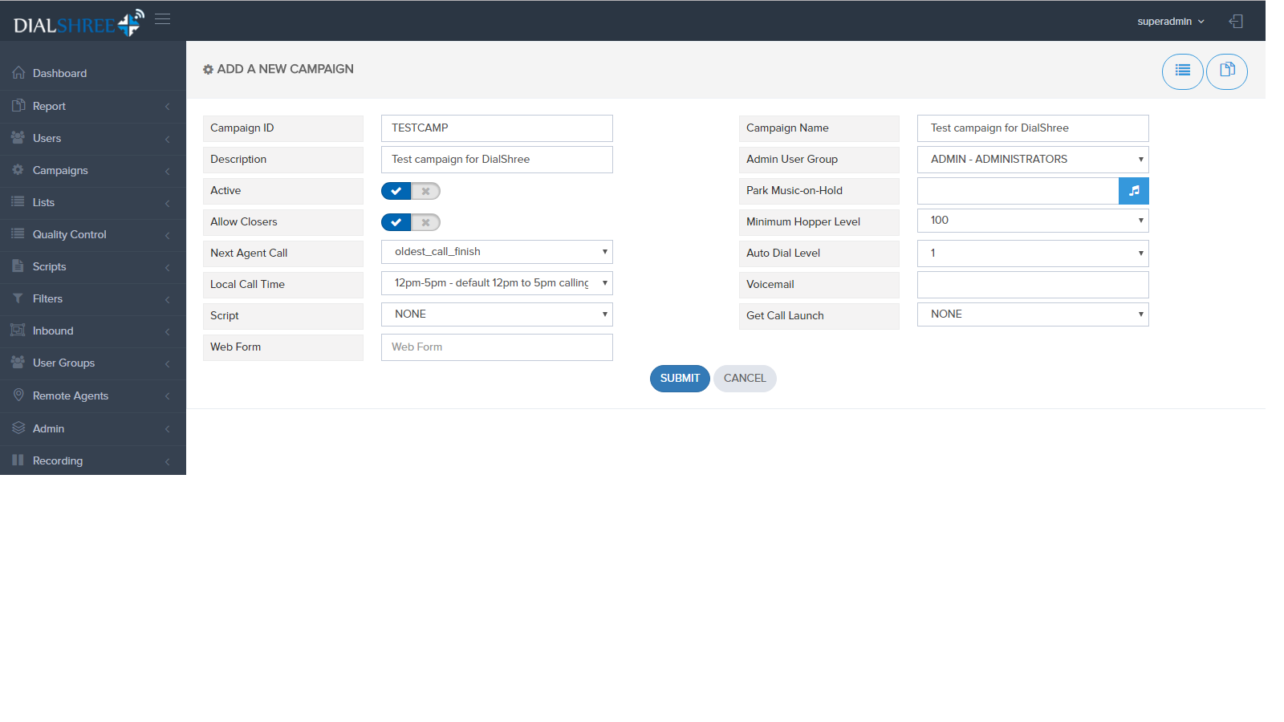

* Click submit to create this new campaign (Now that the campaign TESTCAMP has been created, you can see the Detail View of the Campaign Modification screen with many more options that can be set for the campaign )

## Copy Campaign

* Copy a campaign option will copy all settings from master campaign you select.
* To copy campaign click on the copy icon.

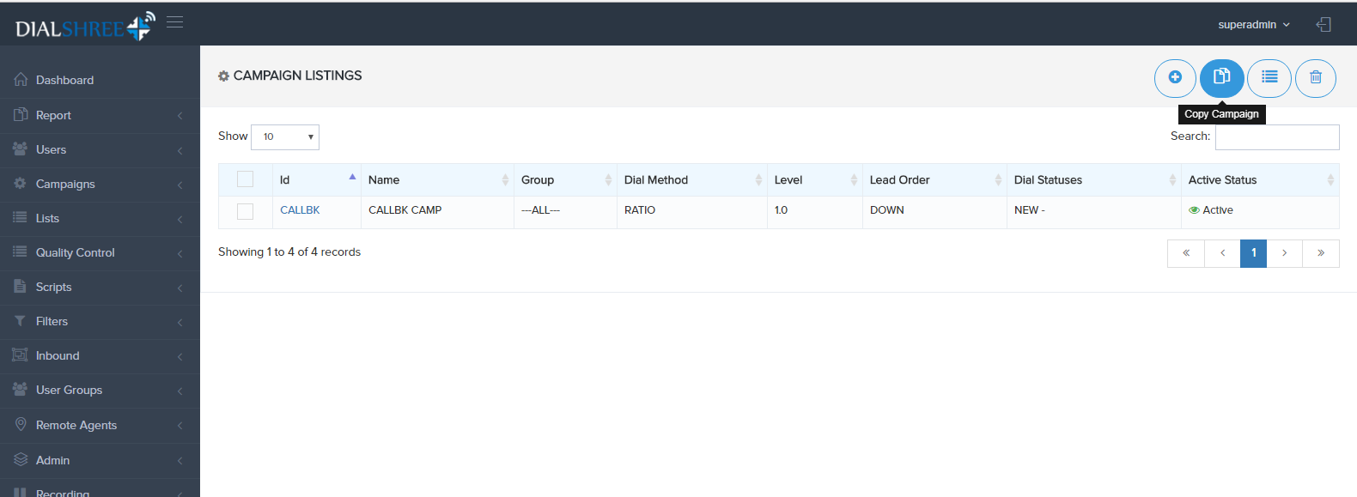

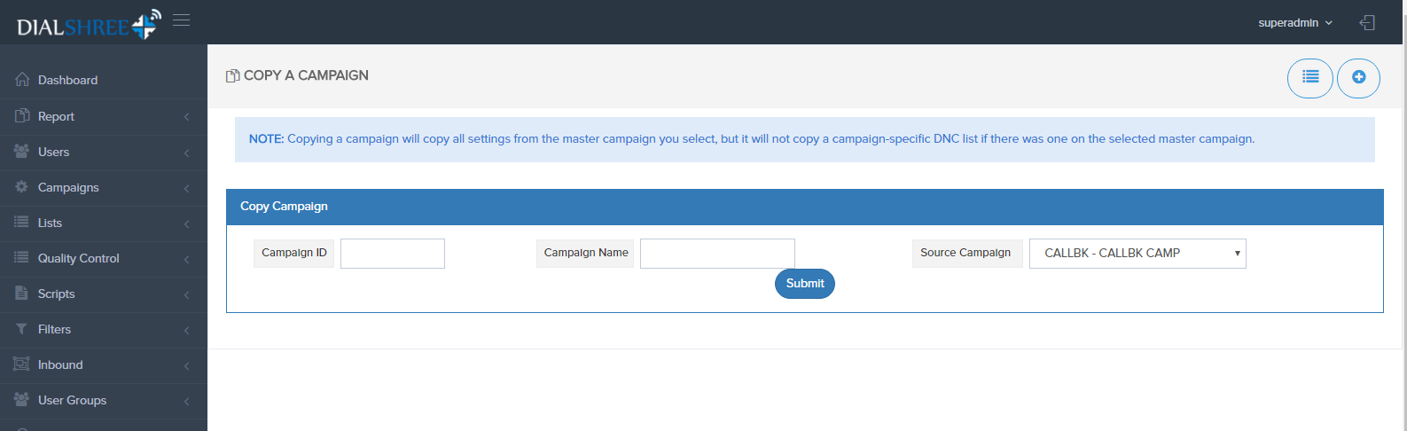

1. Create List &Upload List

* To Create List click on the list link from the side bar.

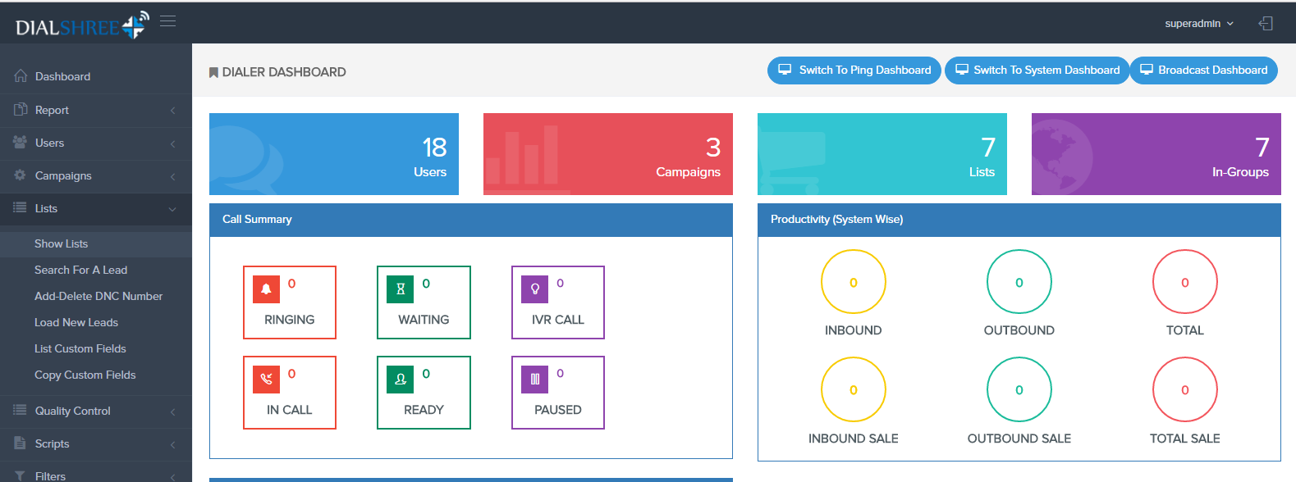

* Click on the Show Link.
* After clicking on the Show List link from side bar user can see the below page
* User can add the new list by clicking on the top right 2nd icon.

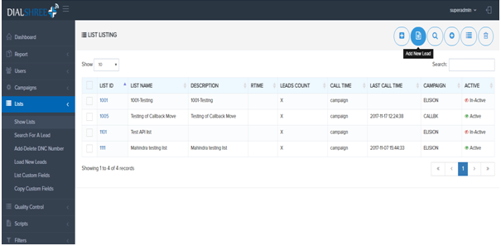

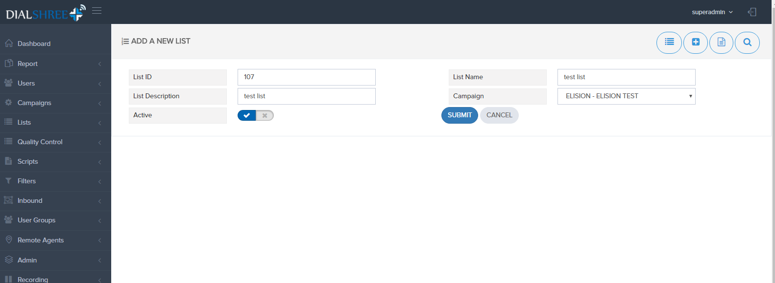

* For example we will fill in the following add list fields with these values:
* List ID: 107
* List Name: test list
* Campaign: ELISION-ELISIONTEST
* Active: Y
* Next Step is to Load leads in the list created and map it to respective Campaign
* To load leads in the List follow the steps :
* To get to the lead New lead page, click on the LISTS link from side bar, and then click on the LOAD NEW LEADS link to get to the basic lead loader. From here you can import leads in the basic text pipe-delimited a CSV file or a simple Excel spreadsheet. NOTES: For the web-based lead loader, a pipe delimited text file must end with a CSV (Comma Separated Values) file must end with “.csv” and an Excel file must end with “.xls”.

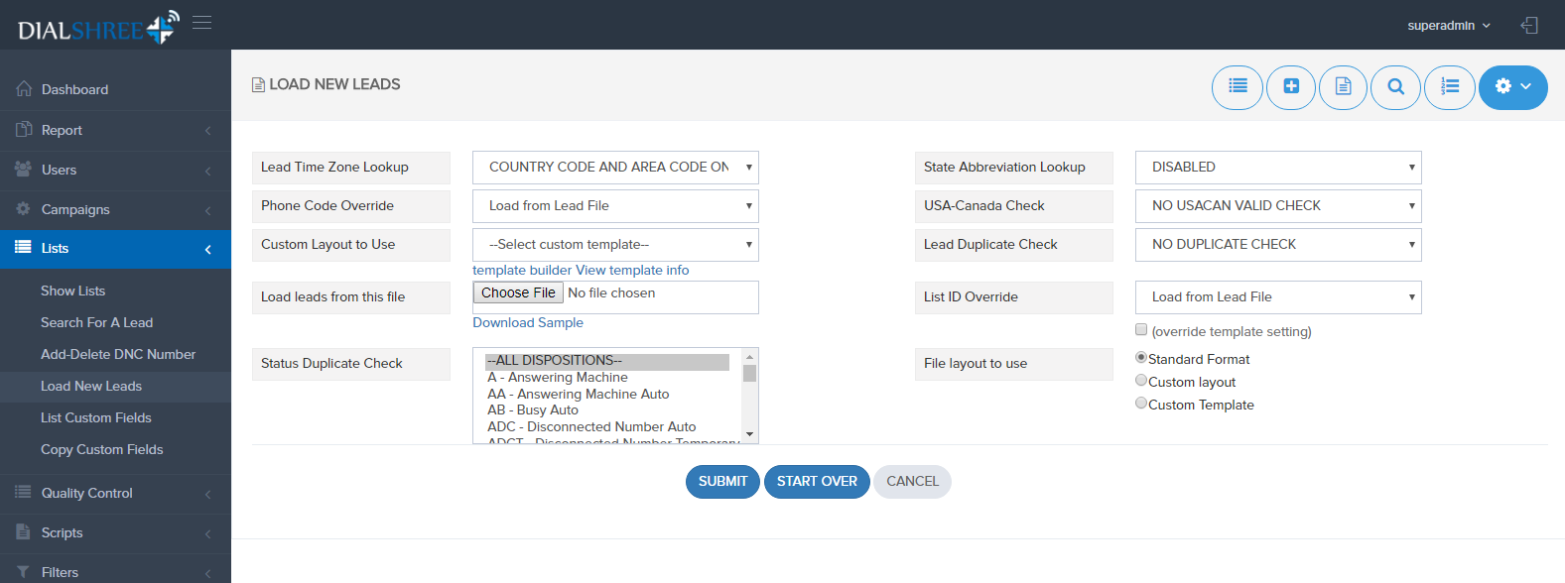

* User Can Download The Sample File From Here
* To download the sample file Just click on the Donnload Sample link
* Click on the “Browse” button on the lead import page and select the file to import on your computer then click submit.
* Enter the List Id which we have created.
* If you are using the standard DialShree field order as mentioned above, then you should select the “Standard DialShree” file layout option. If you need to map the fields before importing the leads then you should select the “Custom Layout” option.
* If you would like the lead-loader to check for and remove duplicate records as it is loading, then select the “CHECK FOR DUPLICATES BY PHONE IN LIST ID” option in the Lead Duplicate Check menu.
* If the leads loaded properly you will see a count of the number of leads imported in a green font at the bottom of the page.
* Now that we have users added, Campaign created, Leads Uploaded we need to check that there are leads to dial in the hopper for the campaign.
* Go to the CAMPAIGNS screen and click on the link to the TESTCAMP campaign modification screen. Toward the bottom of the screen you should see a count of leads in the hopper. If there are no leads in the hopper, something is either wrong with the leads you loaded or there is something wrong with your hopper loading script and you should contact to us.

