# 01.jpg

Elision_SRFS Document

Document Revision History

This table holds record of signification changes made to the document.

|  |  |  |  |
| --- | --- | --- | --- |
| **Version** | **Date** | **Author** | **Description of change** |
| 6.5.0 | 20/09/2017 | Puja Gediya | Development Document |

# Table of Contents

Table of Contents 3

1. Company Details 4

2. Project & Client Details 5

3. Initial Requirement 6

1.1 Installed Vtiger on client Server 6

1.2 Develop Form as per client requirement 7

1.3 Sending SMS functionality 8

1.4 Need 6 alternative number tabs with the Shortcut key D, Which get dialed automatically by clicking on D. (Click To Dial) 9

1.5 Need a call history option below on the same page to see the all last conversations. 10

1.6 All data supposed to be exported from CRM to excel sheet. 11

1.7 A Calling script in the CRM. 12

1.8 In the call history option one more column stating to whom the agent talked and below maintained sub-tabs ……………………………………………………………………………………………………………………………………………………….13

1. Company Details
2. Project & Client Details
3. Initial Requirement

## Installed Vtiger on client Server

Install Vtiger version 6.5.0 on client's server.

## Develop Form as per client requirement

* We have designed new form on lead details page as per client requirement.
* For click on lead tab in Vtiger CRM and the go to particular lead and click on Edit button you will get custom form on this page as per client requirement.

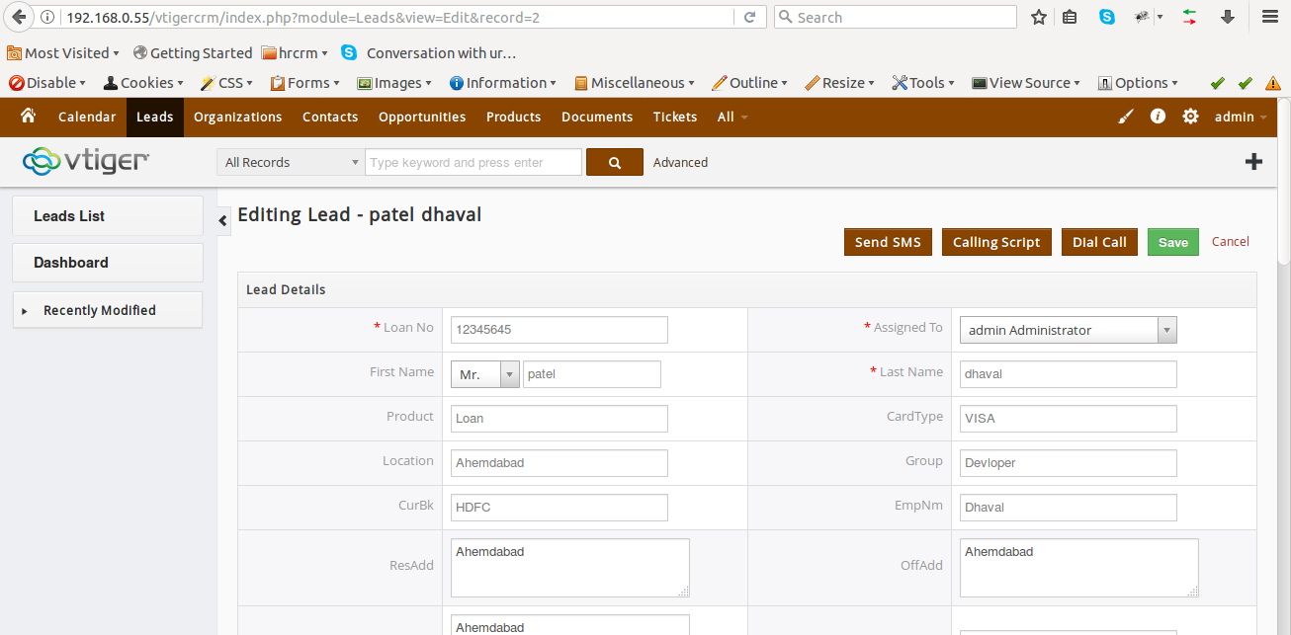

## Sending SMS functionality

In this functionality we are able to send SMS to the customer from Vtiger CRM.

For sanding SMS form Vtiger click on lead tab in Vtiger CRM and the go to particular lead and click on Edit button now on top-right side there is one button name send SMS. By clicking n that button you will get one popup as shown below,

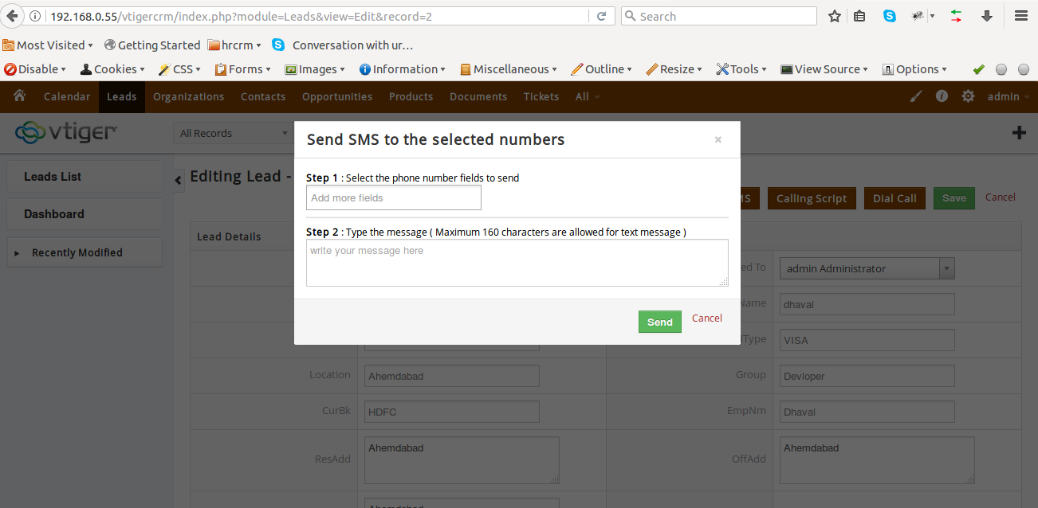

Now select any number on which you want to send SMS and enter the SMS text and click on send button.

## Need 6 alternative number tabs with the Shortcut key D, Which get dialed automatically by clicking on D. (Click To Dial)

When we click on Dial Call Button one call will generate on Vtiger user's extension when

User answer the call second call will generate on customer's mobile number is customer will

Not answer the call next call will generate on his/her second number , the second number also

Not answer then third number will dial and if third number will also not get answer then call

Will generate on forth and then fifth and then sixth until call successfully connected to client's any one of six numbers.

After finishing call the status and phone number and call second will update in CRM.

## Need a call history option below on the same page to see the all last conversations.

For call history click on any lead and then click on call history button you will get all the calls related to that lead ,

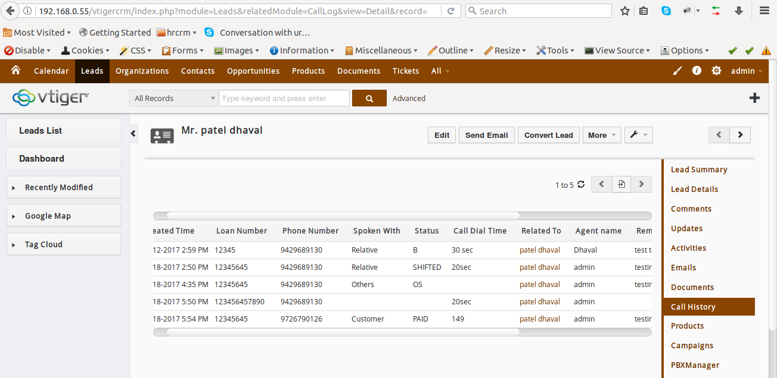

## All data supposed to be exported from CRM to excel sheet.

We can export data form Vtiger CRM. For export data select leads and then click on action and

Then click on export button and then click on export lead you can download lead.csv file.

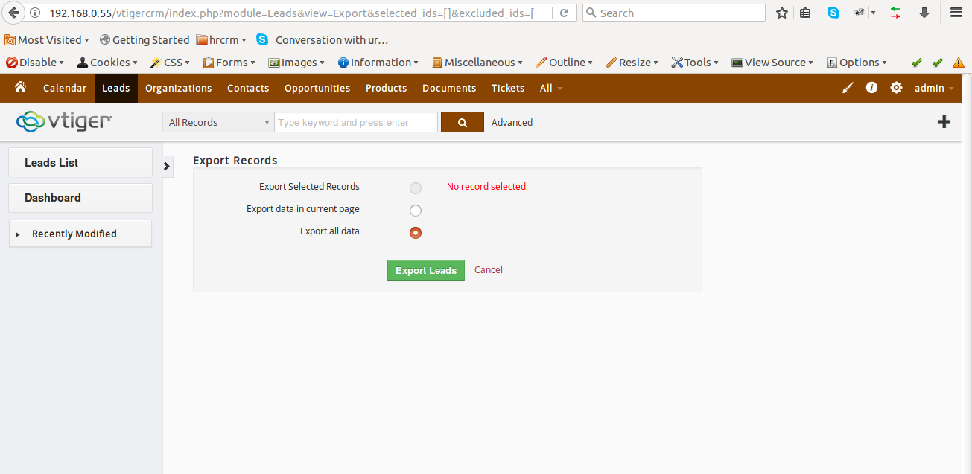

## A Calling script in the CRM.

When agents are on call and want to show any script this functionality is use.

For this click on any lead and then click on edit page now click on Calling Script button on new window will open as shown below ,

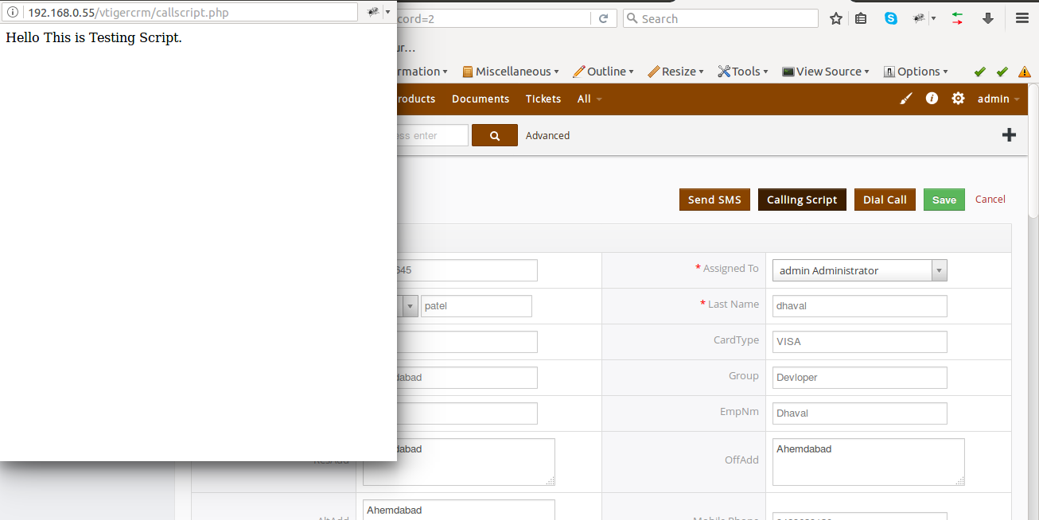

## In the call history option one more column stating to whom the agent talked and below maintained sub-tabs

Same as point 5.

## 

i. Phone number - Number of customer with whom he/she talked

ii. Agent Name - Name of agent

iii. Spoken With - He/she select with whom he talked

iv. Call Dial time - How much time agent talk with customer

v. Loan Number - loan number

vi. Disposition - disposition

vii. Remarks



