# 01.jpg

Client management module Document

Document Revision History

This table holds record of signification changes made to the document.

|  |  |  |  |
| --- | --- | --- | --- |
| **Version** | **Date** | **Author** | **Description of change** |
| Client management module | 08/09/2017 | Radhika Solgama | Development Document |

# Table of Contents

Table of Contents 3

1. Company Details 4

2. Project & Client Details 5

3. Initial Requirement 6

1.1 Installed Vtiger on client Server 6

1.2 Develop Form as per client requirement 7

1.3 Sending SMS functionality 8

1.4 Need 6 alternative number tabs with the Shortcut key D, Which get dialed automatically by clicking on D. (Click To Dial) 9

1.5 Need a call history option below on the same page to see the all last conversations. 10

1.6 All data supposed to be exported from CRM to excel sheet. 11

1.7 A Calling script in the CRM. 12

1.8 In the call history option one more column stating to whom the agent talked and below maintained sub-tabs ……………………………………………………………………………………………………………………………………………………….13

1. Explanation of client management module

* Using this module we can manage the Elision’s clients and client’s details . and also create a users and give the different permission like Add , Edit .
* Only Super admin create users and give the permission to show the details of clients to the users
* To set a user’s permission as super admin permission add the username in $superadmin array in superadmin.php

1. Login page of client management module

* Login Page of Client-management tool is look like this
* Please enter Username, Password , Extension to login into the client-management tool (**here Username ,Password field is mandatory if you not enter extension or you enter wrong extension then also user can login into the client-management tool but user cannot use the click 2 call functionality of client-management tool** )

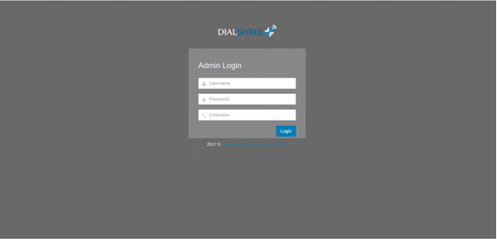

1. Dashboard

* After Successfully login into the tool user see the dashboard page.
* When user login without extension, popup will display in Dashboard page to inform to the user (**You have not entered the phone extension. Hence Click to call functionality wont be available to you**)

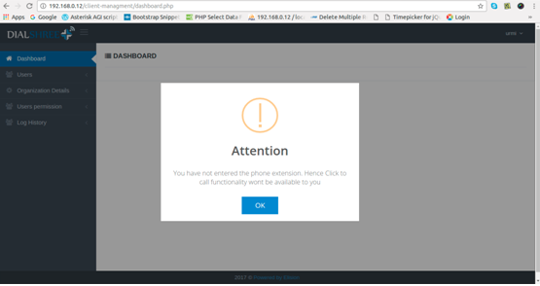

1. User management page

* When user click on the sidebar’s user tab and then click on the User listing tab , user can access the user Management Page.
* From here only Super admin can add, edit, and delete the users from listing.
* TO edit any user’s details and permission(add, edit permission) simply click on the pencil tag  shown in to the listing page of users and edit the data and simply click on the save button

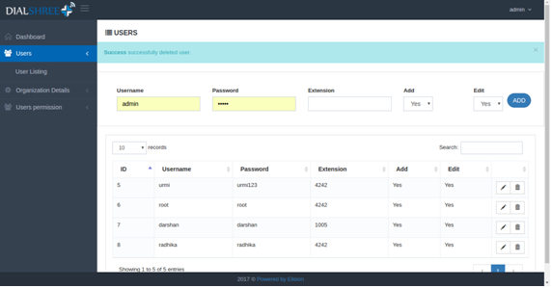

1. Organization Management

* TO see the organization listing click on the Organization Details and then click on the organization Listing tab from side bar menu.

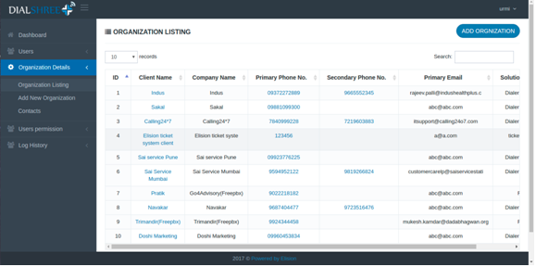

* To call a particular organization click on the “Primary Phone No.” or “Seondary Phone No.”
* To Add new Organization  click on the “ADD ORGANIZATION” button from Organization Listing Page
* User can also add new organization from clicking on Organization Details and then click on “Add New Organization” Tab from Side bar Menu.

* To edit the Organization details and to see the server details of particular organization click on the “Client Name” from table listing.
* if user wants to edit the organization details, then click on the “Client Name” from organization listing page and then page will be redirect on “Organization Details Page” to edit details simply click on the “organization Name  like (Indus)” and edit the details and click on the “SUBMIT” button . But only those users can edit the details that have a permission of edit. User can see their permission from “User Listing Page”.

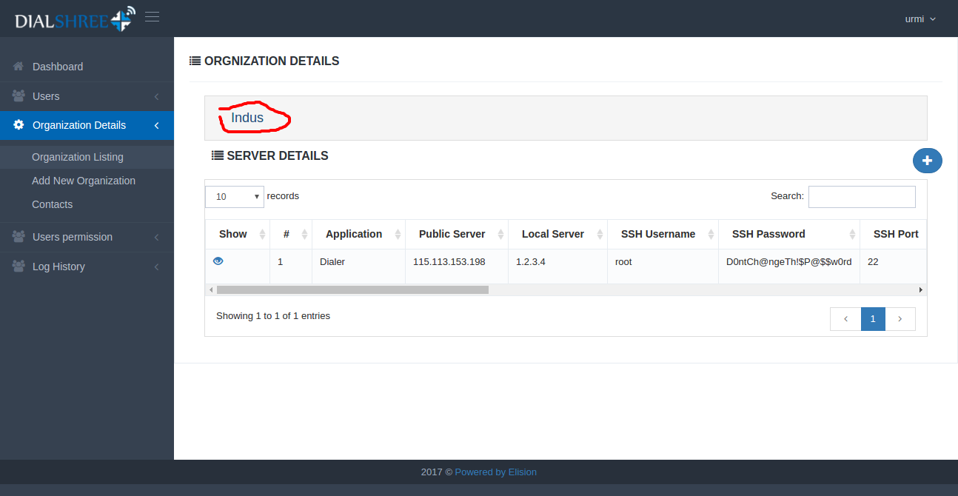

* User also see that particular organization’s server details from “Organization details page” If user want to edit the server details then simple click on the “eye-icon” to edit and after edit the details click on the “Save” button.

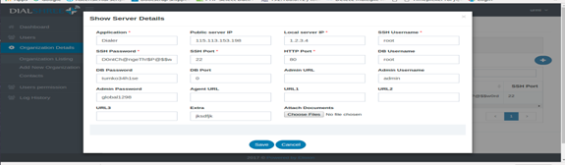

* User also inline edit the details,  to inline edit simply click on the “pencil-icon”and edit the details and then click on the save button.

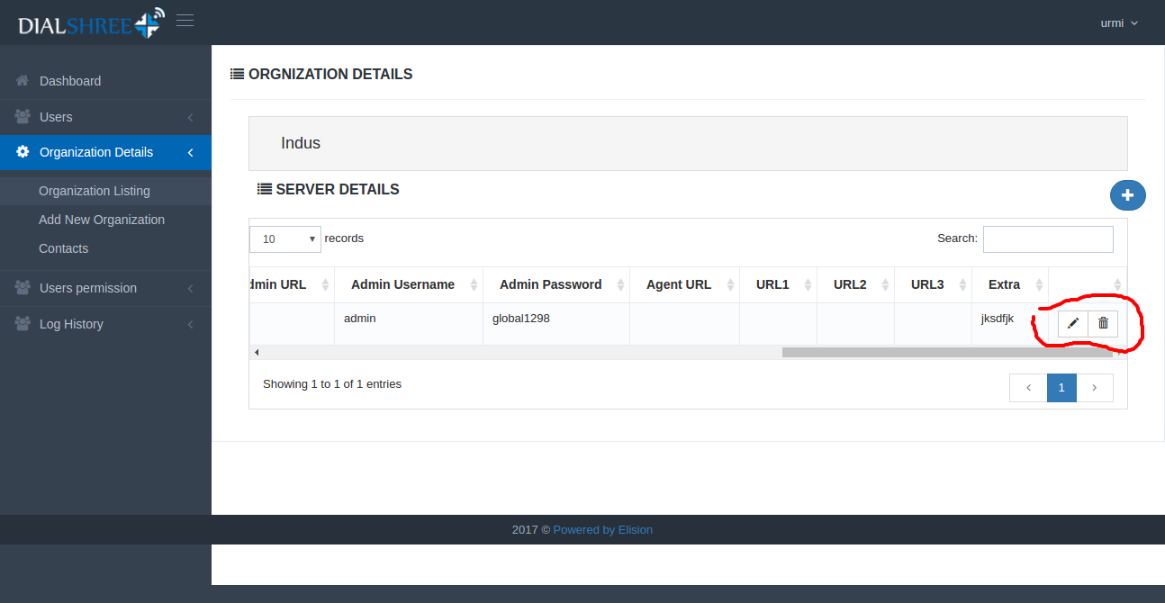

* Only super admin can delete the server details. To delete the server details simply click on the “delete-icon” which is nearby pencil-icon.
* To add a new server details simply click on the “Plus-icon”.
* After click on the plus-icon to add a server details pop-up will open and user can insert server details from here and click on the “SUBMIT” button.

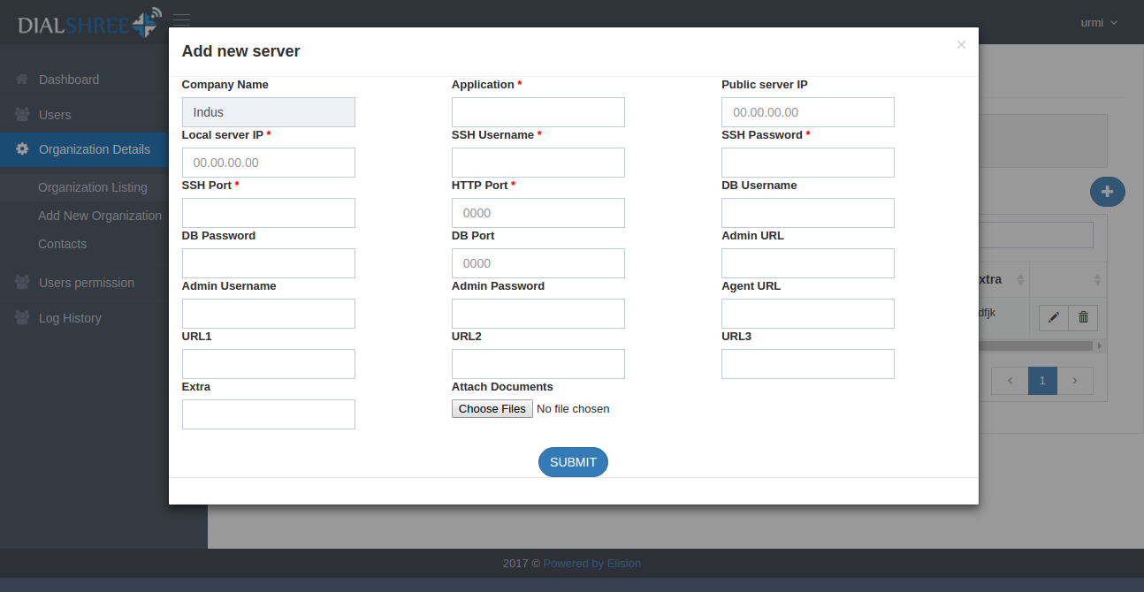

* User can also attach the Document from here.

1. Contact

* Trytry
* On this page we list out the client names and their Organization names and the phone number
* From this page we can contact the client by clicking on the Dial button.
* When user login with right extension than and then only user can use this Dial button for call to client. Otherwise dial functionality will not work.

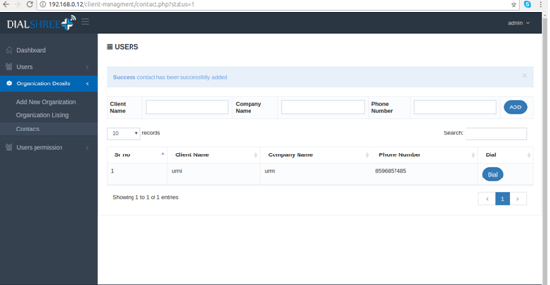

1. User Permission

* This page is only accessible for super admin.
* TO access this page click on the user permission menu and then click on the user permission sub menu from sidebar.
* Using this page Super admin can give the organizations permission to a particular user.
* When user login in client management module, user can see only that organization which organizations permission is set by super admin.
* Super admin can see all organization
* Super admin can also delete the permission from here. Super admin can delete the single record and multiple records.
* To delete the multiple record click on the check box and click on the “Delete” button.
* To delete the single record click on the “Delete-icon”.

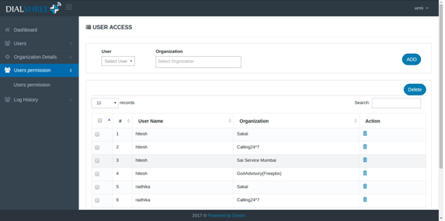

1. Log History

* To access this Report  click on the Log History menu then click on the Log History submenu from sidebar
* BY accessing this page user can see the inserted, updated, deleted record.
* All user can access this Report.
* User can see the Log History of particular Date Range, particular user, particular Action, particular Section.



 



