



Madico: Technical Document

# Table of Contents

Table of Contents 2

1. Company Details 4

2. Project & Client Details 5

3. Git Repository 6

4. Roles And Responsibility 7

5. Initial Requirement 8

5.1 Elision Lead Upload Module 8

5.2 Directory Structure Description 13

6. Additional Requirement 15

Document Revision History

|  |  |  |  |
| --- | --- | --- | --- |
| **Version** | **Date** | **Author** | **Description of change** |
| 1.0 | 22/01/2018 | Radhika Solgama | Technical Document |

1. Company Details

Company name: MedicoRx Specialty Pharmacy

City:

State:

Country: U.S.A

Address: MedicoRx Specialty Pharmacy

7039 Valjean Ave.

Van Nuys, CA 91406

1. Project & Client Details

**Clients Details**:

**Client Name:** Joe O’Mara

**Contact Person:** Joe O’Mara

**Mobile:**

**Phone:** 818-650-2623

**Project Details:**

1. Git Repository

**Server:** 64.31.98.220:8443

**Link:** https://64.31.98.220:8443/admin/config.php

**Git clone link:**

1. Roles And Responsibility

|  |  |  |
| --- | --- | --- |
| **Sr No.** | **Role** | **Responsibility** |
| 1 | installation | Client |
| 2 | testing | Nikhil Nimje |
| 3 | New broadcast module work | Vinay Solanki |
| 4 | Call generate work | Radhika Solgama |
| 5 | Dial Plan and Backend work | Pratik Prajapati |

1. Initial Requirement

## Elision Lead Upload Module

* As per client requirement we create the module to upload the multiple leads in table and do the calls on that leads. We integrate this module in FREE PBX.
* Client can upload the leads using our created module or using backend process.(he/she can upload the data using .sql file in directly database)
* We create the two tables to manage the data of clients(leads). Name of table is as below:

1. elision_batch_header
2. elision_batch_details

* In elision_batch_header we create the list id and upload the leads list id wise. Field description are as below:

1. list_id = we set auto increment on this column, auto increment start from 10001.
2. list_name = for list name.
3. channel = By default it’s value is 1 user can edit the channel value.
4. lead_count = in this column we set total lead count of particular list ID.
5. recorded_file = we set .wav file name which we play when call iniciate.
6. Call_status = by default its value is 0. Its value is change according to start and stop calling action.

* After creating the list we upload the leads in elision_batch_details table fields description is as below:

1. lead_id = we set auto increment on this column, auto increment start from 1.
2. entry_date = we set the current time stemp on this column.
3. modify_date = Column type is DATETIME we update this field when call is initiate.
4. status = By default we set the value "NEW".
5. user = We set user ID in this field.
6. source_id = Set source id.
7. list_id = list_id which is available in elision_batch_header.
8. phone_code = Set phone code.
9. phone_number = Set phone number.
10. first_name = First name of person.
11. last_name = last name of person.
12. date_of_birth = DOB of person.
13. recording_file_name = Recording file(.wav) conversation of executive and agent.
14. call_duration = call duration of call (answered duration + call ringing duration).
15. answered_call_duration = only answered call duration.

* Upload the leads using backend process

To upload the leads using back end process. Follow the below points:

* Create the list id in elision_batch_header table. (by Accessing database). Here list_id field is auto increment.
* After creating the list id user upload the data leads in particular list id wise
* Upload the leads using our created module

To upload the leads using elision’s created “**Elision Lead Upload module**”. Follow the below points:

* Click on the FreePBX Administration. As shown in below image:

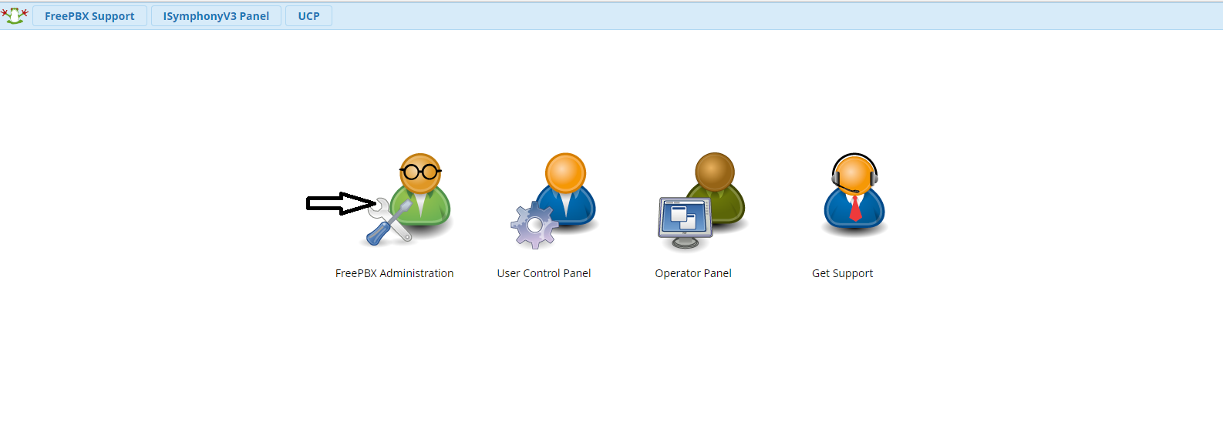

* After successfully login, click on the Development -> Elision Lead Upload from header

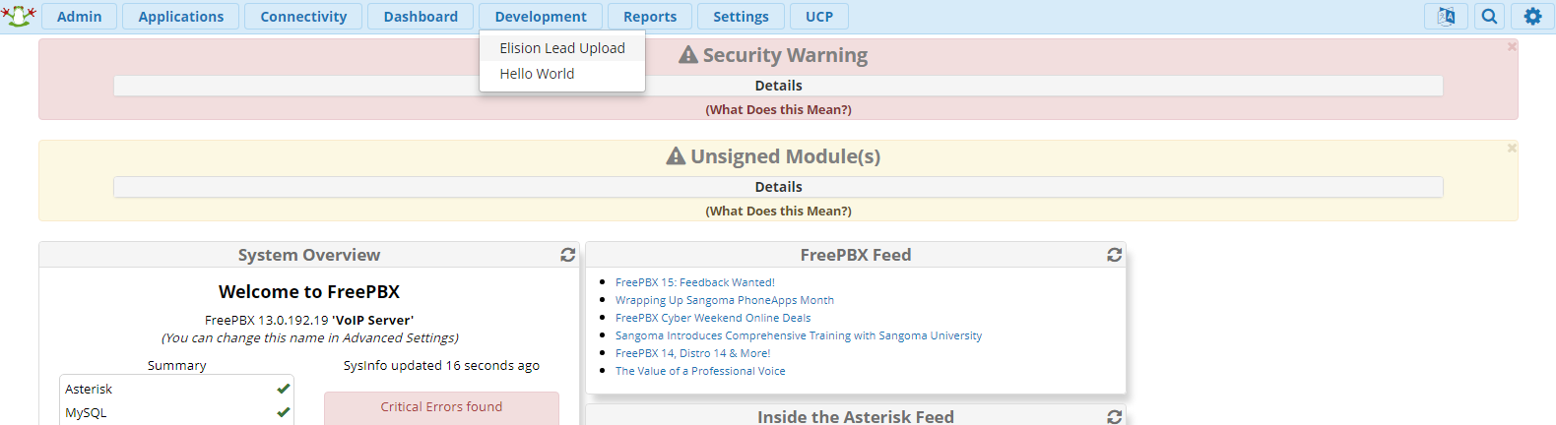

* Now user can Access the module to upload the leads.
* To upload the leads first create the list ID.
* To create the list id click on the Add Batch. As it is show in below image:

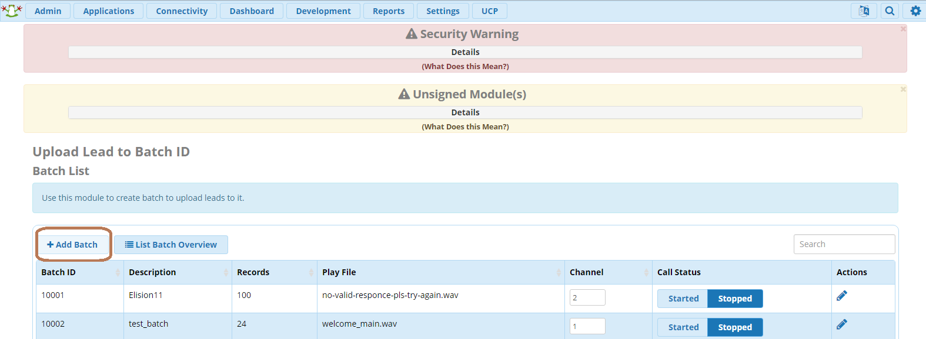

* After clicking on the Add batch button user can see the below form:

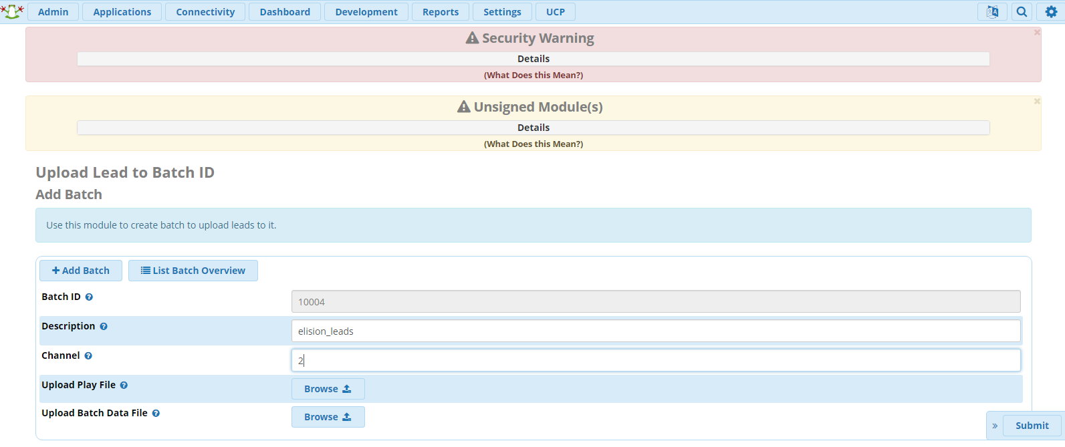

* Here first field is Batch Id and it is auto increment field.
* Second Field is Description of batch Id.
* Third Field is channel if user can not enter any value then by default its value is set to 1.
* Next field is Upload Play File; here we choose the recording file to play when call is initiates.
* Upload Batch Data File; please select the .csv file in specified format to upload the data (leads).
* Below is the format of .csv file:

|  |  |  |  |  |  |
| --- | --- | --- | --- | --- | --- |
| source_id | phone_code | phone_number | first_name | last_name | date_of_birth |
| Elision | 91 | 9714208570 | Vinay | Solanki | 06-10-1993 |

* After uploading the file click on the submit button.
* Now user can see the list id with uploaded list count in listing. As shown in below image:

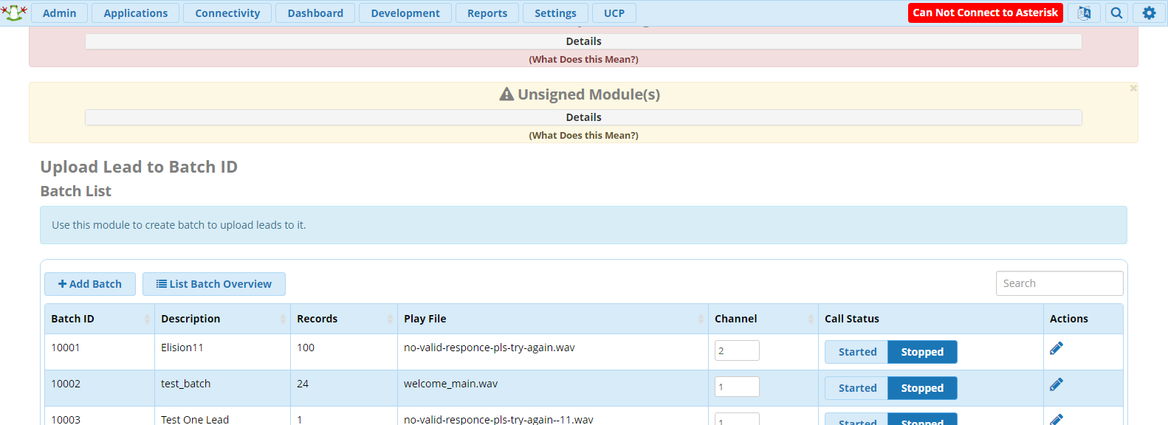

* User can see the batch Id (list Id) Description, Records (count of leads), Play file Name, channel, call status.
* User can edit the Description, Play file channel value by clicking on pencil icon.
* To initiate the calls user can click on the start button and according to the channel value call will be fired. If channel’s value is 2 then at a time 2 call will be fired.
* In backend process if channel value is 2 then 2 call file will be generated and we update the call status to in call and according to the call status you can see the value of call_status in elision_batch_header is changed.
* If any one delete the play file from it’s specified path then user can see the blank value in play file.
* When user edit the records by clicking on the pencil icon. User can see the below page:

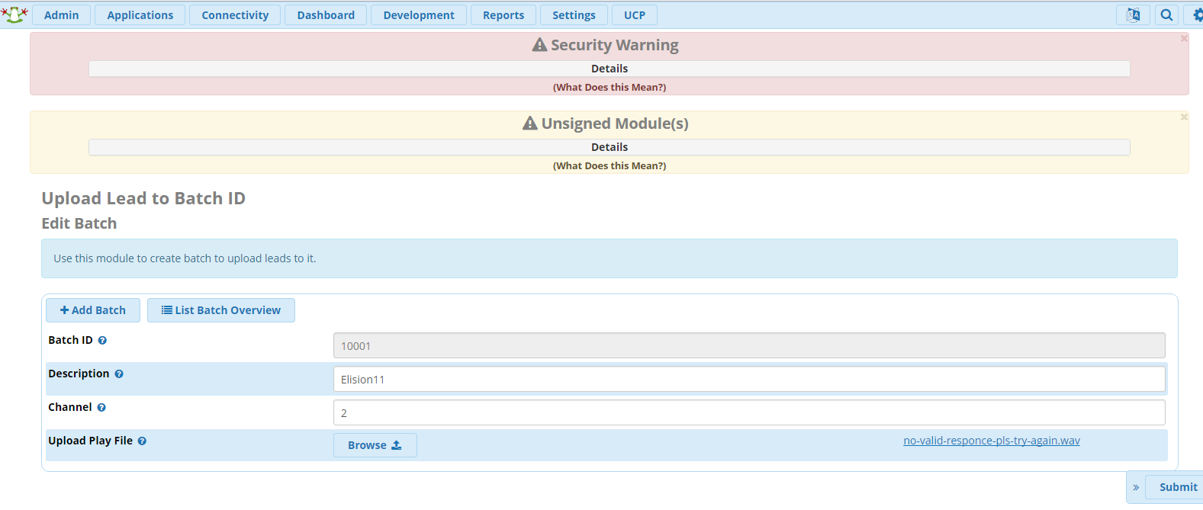

* User can download the play file by clicking on the link if it is available on predefined path.

## Directory Structure Description

Below is the Directory structure Description:

* Module directory should be created in /<webroot>/admin/modules, See [**structure**](https://wiki.freepbx.org/display/FOP/FreePBX+Development):

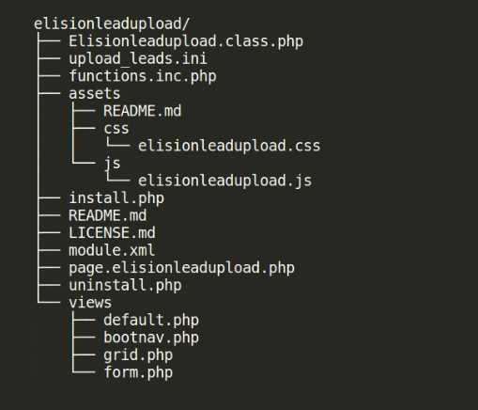

1. elisionleadupload - This Should be the name of your module.
2. elisionleadupload/Elisionleadupload.class.php
   1. This is your primary class and is essentially your module. All the magic happens here.
   2. The standard here is first letter capitalized.
   3. Required methods (even if you don't use them) - This is the minimum methods allowed. There are other methods but these are mandatory.
      1. public function install() {} - replaces install.php
      2. public function uninstall() {} - clean up after yourself
      3. public function backup() {} - FUTURE: generate an array that can be used to restore
      4. public function restore($backup) {}
         1. FUTURE: this will be given the array you generated prior which you should parse and make things the way they were.
      5. public function doConfigPageInit($page) {}
         1. Without this you will get an error. This will process $_REQUEST
3. elisionleadupload/upload_leads.ini - This is custom file, now it is not in use
4. elisionleadupload/functions.inc.php
5. assets - Contains your CSS and Java Script files in their respective folders.
6. elisionleadupload/install.php - This will do actions like Table Creation etc.
7. elisionleadupload/module.xml
   1. This is your module definition and is the same as previous FreePBX versions.
   2. For more visit [**link**](https://wiki.freepbx.org/display/FOP/module.xml#module.xml-Module.xmlSetup).
8. elisionleadupload/page.elisionleadupload.php
9. elisionleadupload/uninstall.php - This will drop table details and other details of module.
10. views - Contains the html page views. These files should generally not contain any logic.

References:

* <https://wiki.freepbx.org/display/FOP/FreePBX+Development>
* <https://wiki.freepbx.org/display/FOP/Developer+Corner+Home>
* [FreePBX Big Module Object (BMO)](https://wiki.freepbx.org/pages/viewpage.action?pageId=19498386)
* [FreePBX / helloworld](https://github.com/FreePBX/helloworld)

1. Additional Requirement

