



Go-autodial User Manual

# Table of Contents

Table of Contents 2

1. Login process 4

2. Create User 5

3. Create Campaign 9

4. Dialling 13

Document Revision History

|  |  |  |  |
| --- | --- | --- | --- |
| **Version** | **Date** | **Author** | **Description of change** |
| 1.0 | 19/04/2018 | Radhika Solgama | User Guideline Manual |

1. Login process

* To login in to the go autodial admin panel fill the username and password field and click on the login button.
* Please see the below screenshot for login:

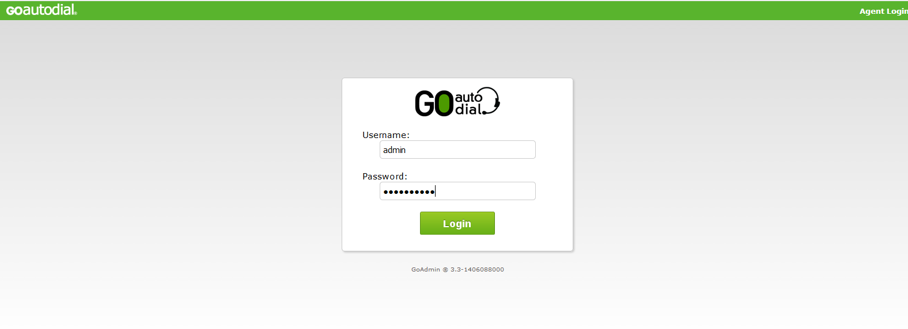

* After successfully login in to go autodial user can see the dashboard page.

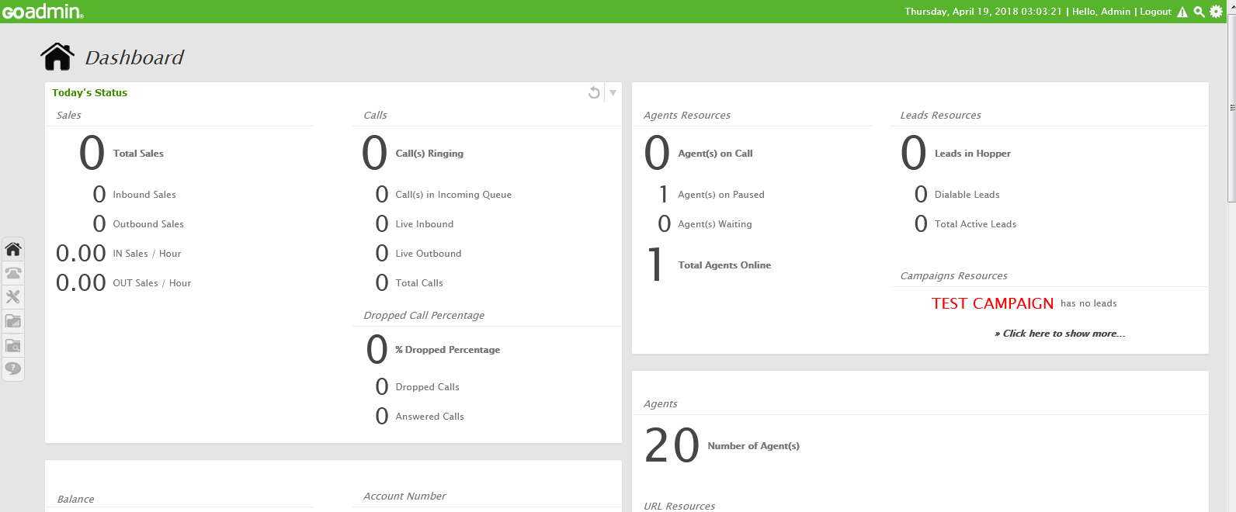

1. Create User

* To create the user click on the telephone icon from dashboard. And then click on the User link which is highlighted in brown box in below screen shot.

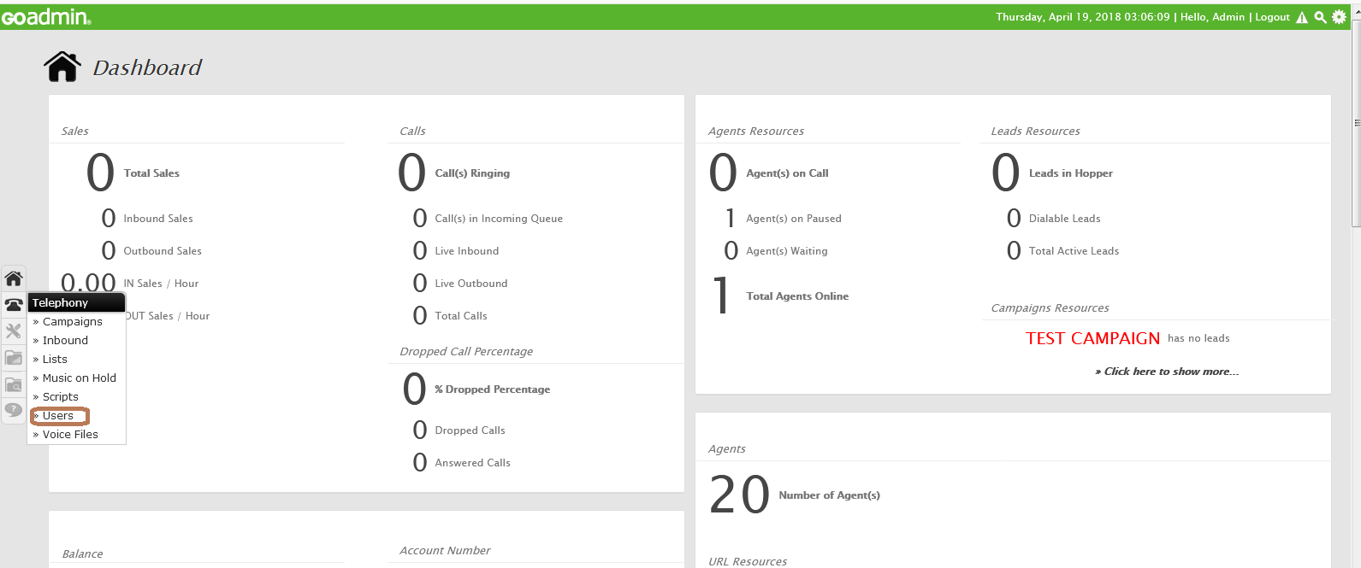

* After click on the User link, user can see the user listing. Please see the below screen shot:

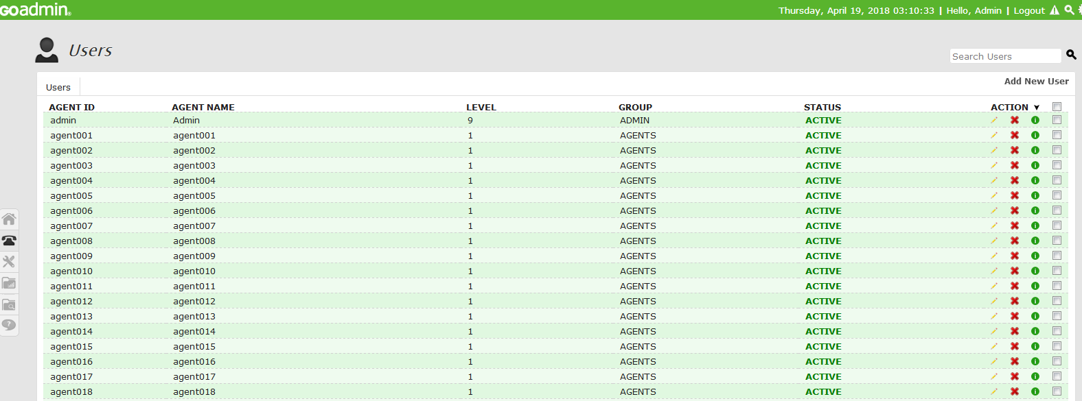

* To create the New User click on the Add New User Link which is highlighted with brown box in below screenshot:

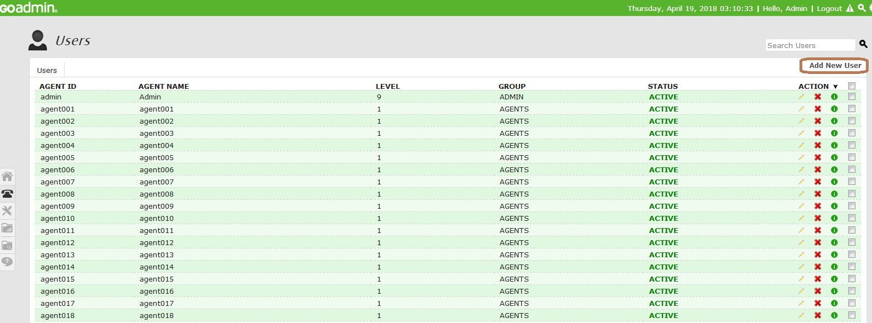

* There are three steps to create the user
* After clicking on the Add New User link Below Screen Will be Display:

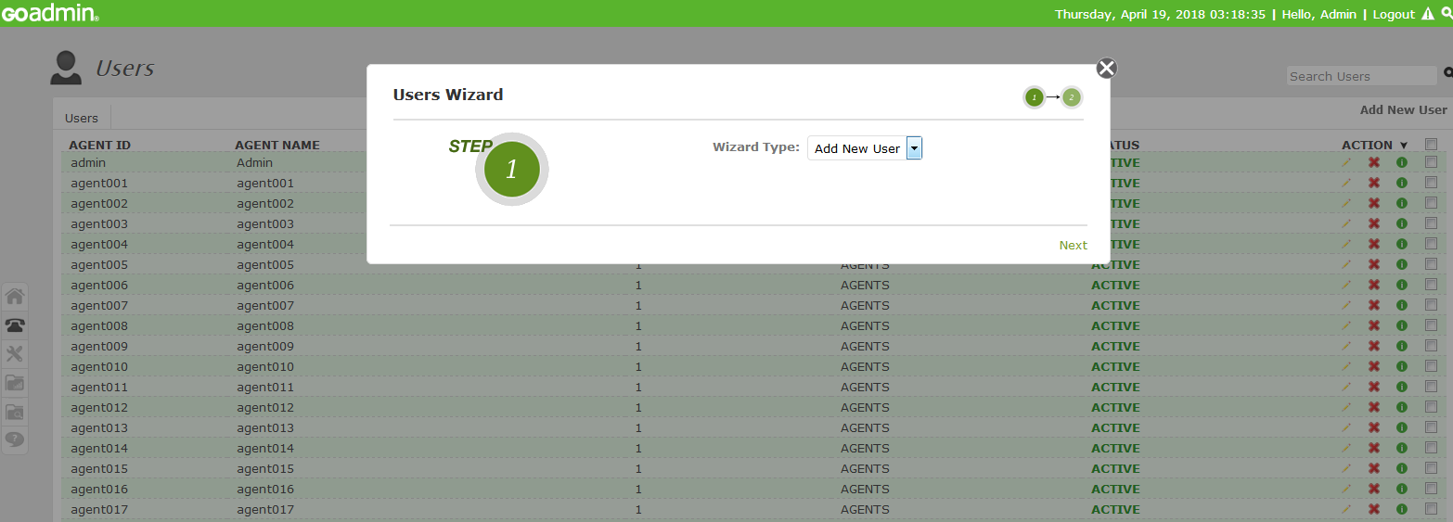

* Select Wizard Type = Add New User and then click on Next Button.
* After clicking on the next button below screen will be display

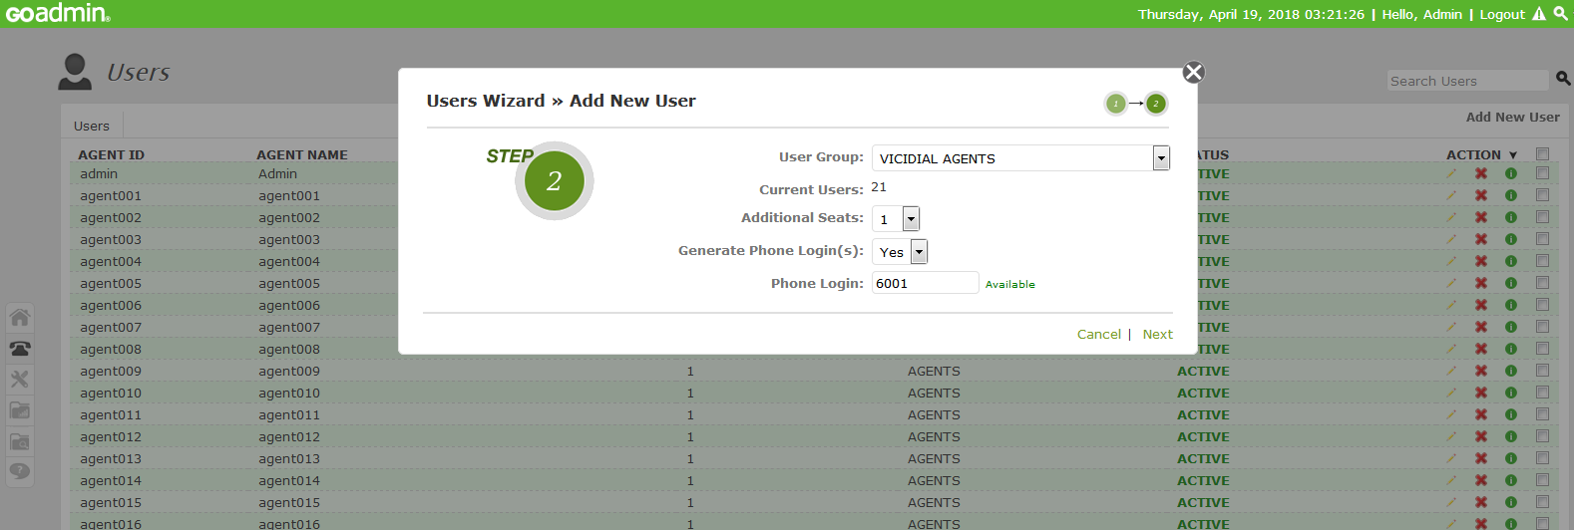

* Select the Yes In Generate Phone Login(s) and then click on the next button.
* And then user can see the third step

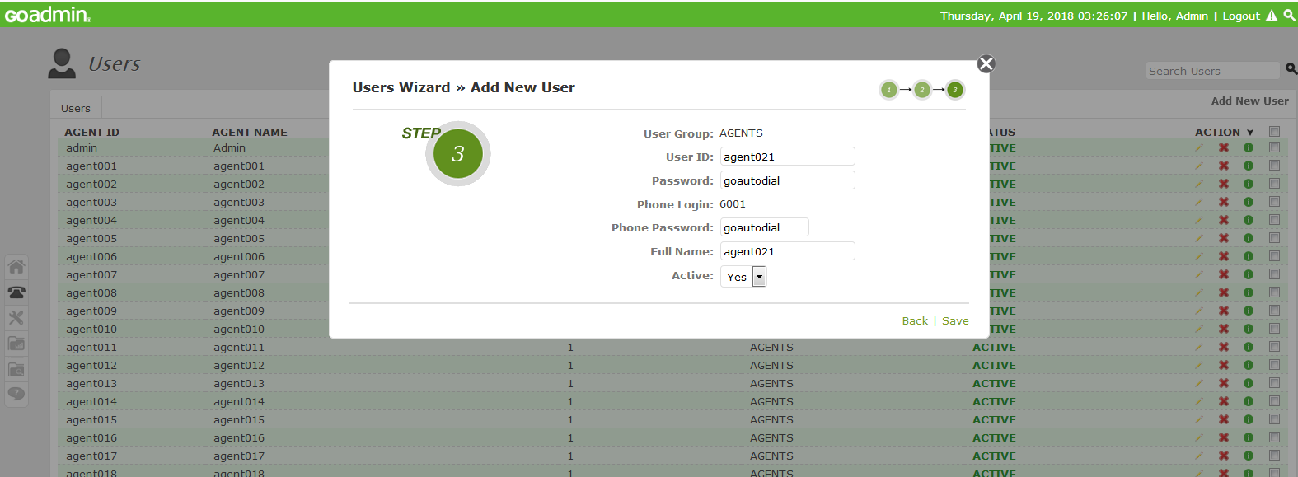

* Click on the Save Button. After following above steps user is created successfully. User can see the below alert of successfully created user:

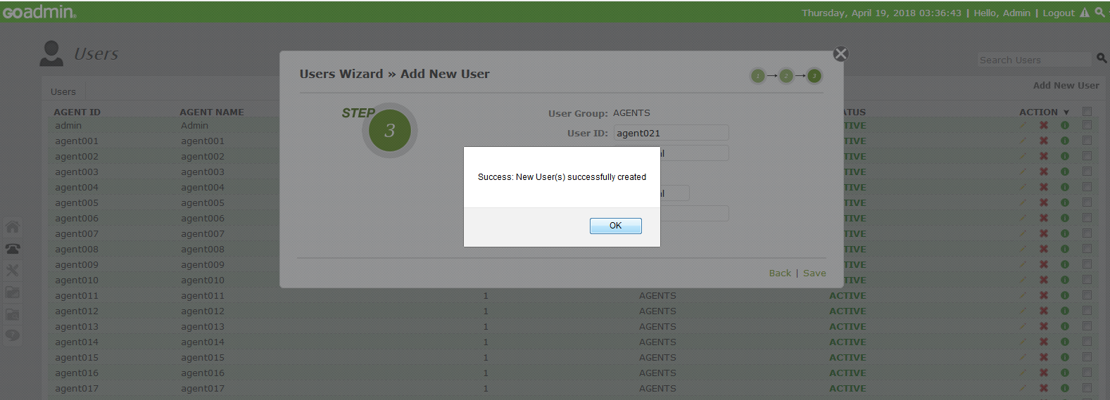

1. Create Campaign

* To create new campaign click on the telephone icon from sidebar. as shown in below screen shot:

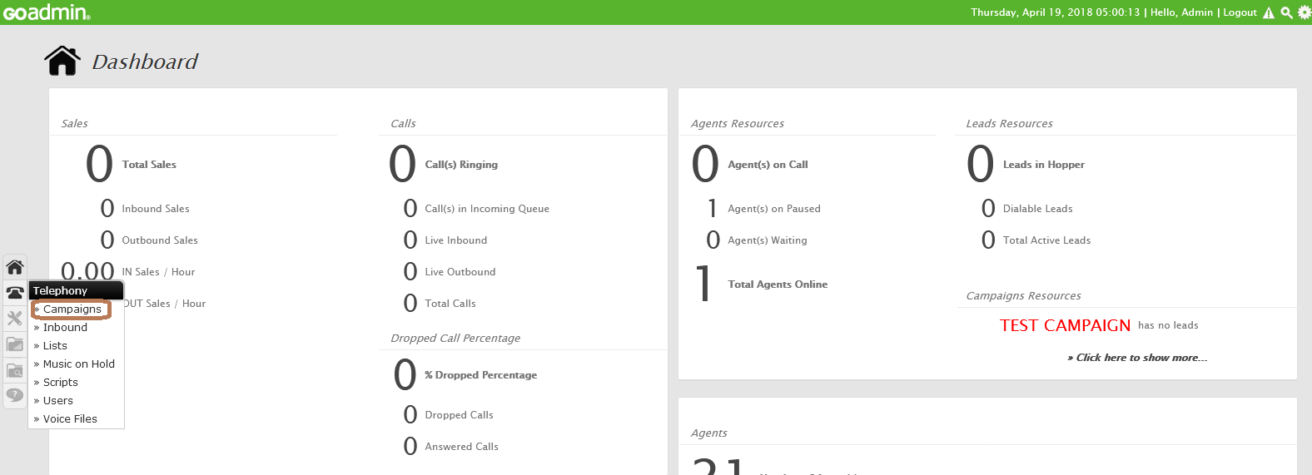

* And then click on the Campaigns Link which is shown in brown box in above screen shot.
* After clicking on the campaigns link user can see the listing of campaigns. to create the new campaigns click on the Add New Campaigns link from top of the right side as shown in below screen shot:

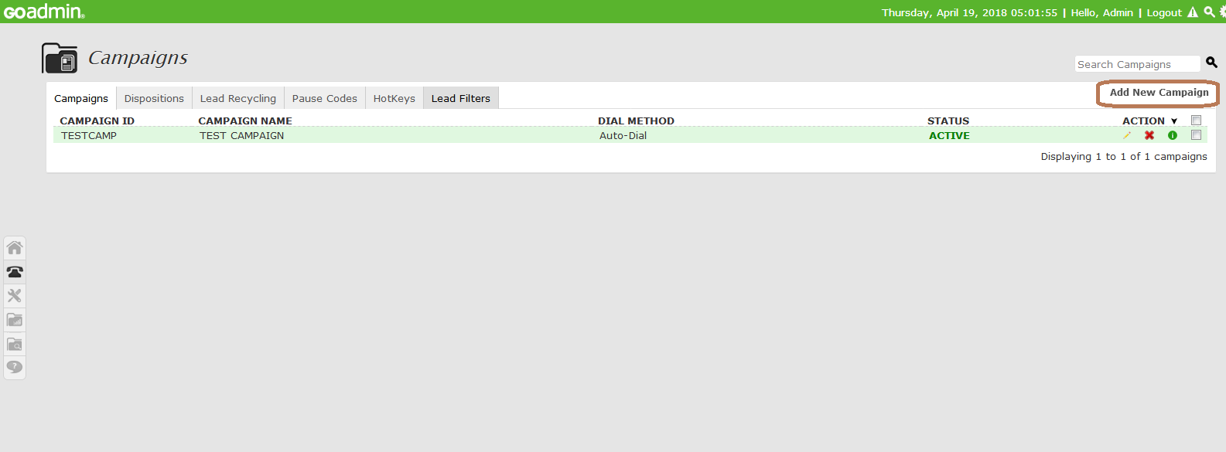

* After clicking on the Add New Campaigns link user have to follow the three steps to create the new campaign:
* User can see the below screen after clicking on the Add New Campaign link:

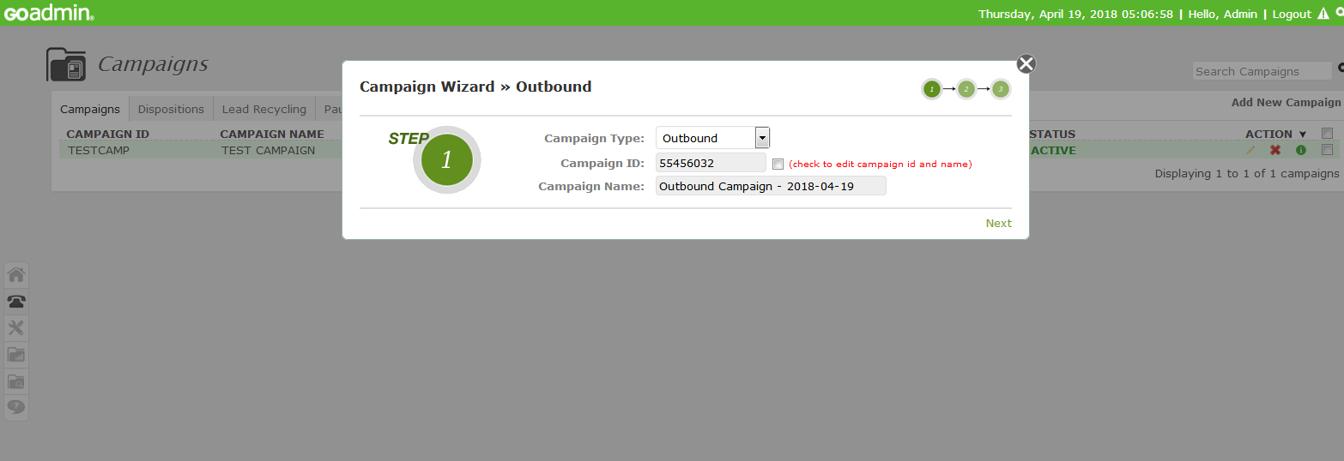

* As shown in below screen shot there are many different campaign type values are available user can copy the campaign. As of user’s need user can select the campaign type.

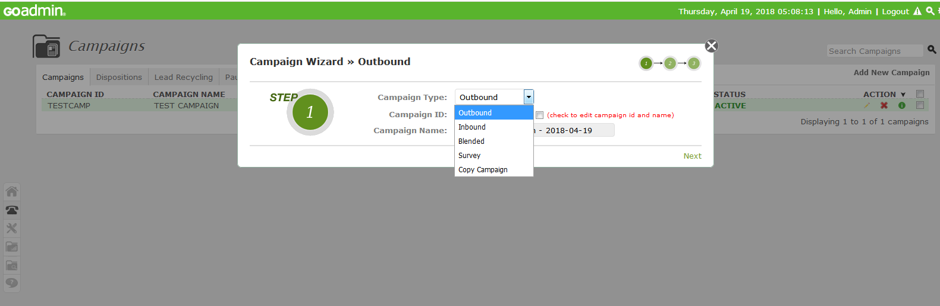

* As shown in above screen shot one check box is present besides campaign id if user want to edit campaign id and name in future then check mark the checkbox. And click on the Next Button.
* After clicking on the Next button User can see the below screen :

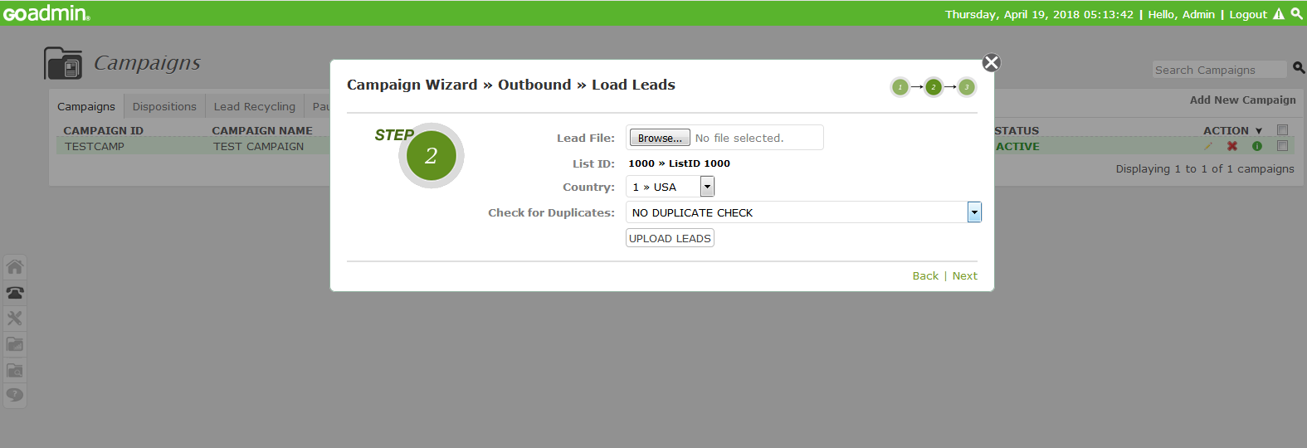

* In step – 2 user can upload leads in this campaign, To upload the leads select the File in Excel format (xls, xlsx) or in Comma Separated Values (csv). And click on the UPLOAD LEADS button. And click on the Next Button.

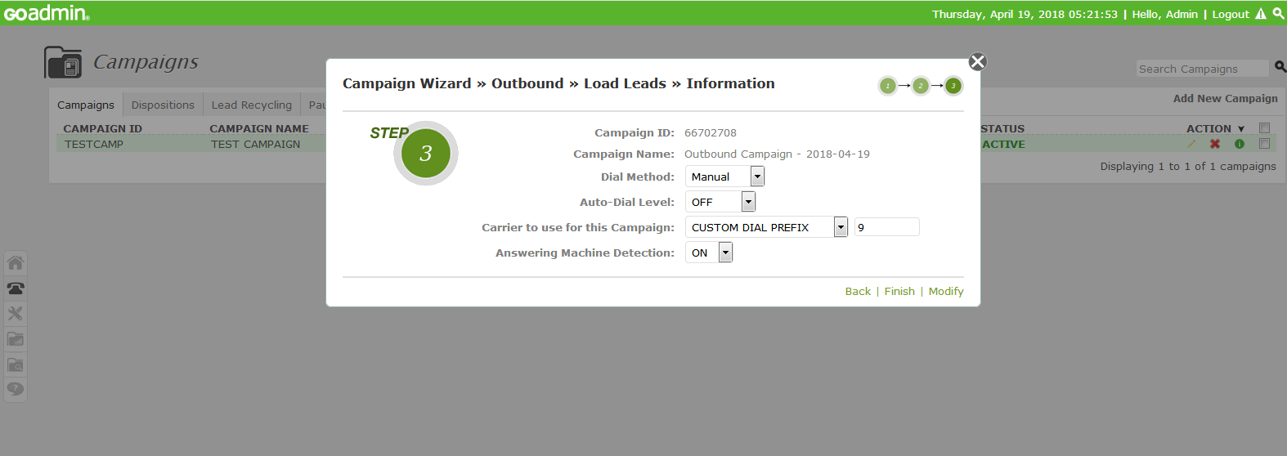

* After clicking on the next button user can see the above screen from mhere user can select the dial method auto-dial level after doing required changes click on the finish button.
* After clicking on the finish button user can see the created campaign in campaign listing.

1. Dialling

* For dialing login in to the agent panel as shown in below screen shot:

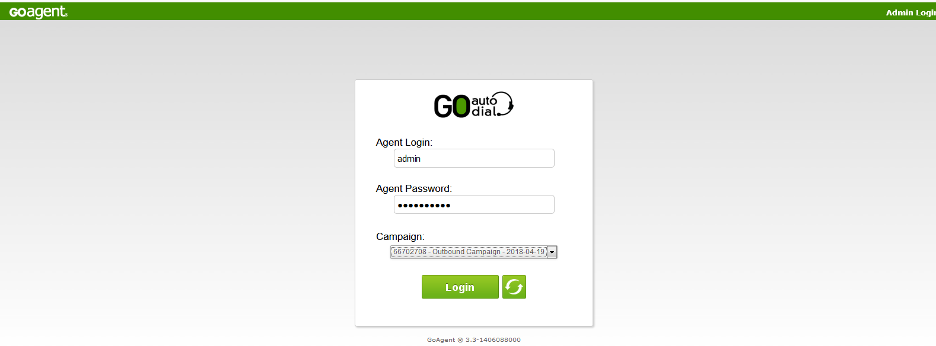

* After login in the agent panel user can see the Below screen:

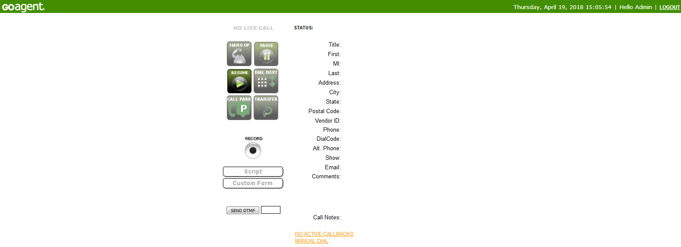

* To do the manual call click on the Manual Dial Button as shown in below Screen shot:

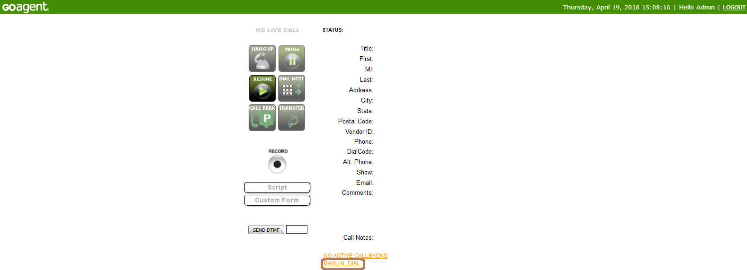

* After click on the manual Dial Link User can see the below screen:

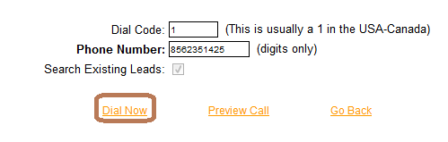

* To do the manual call type the number and click on the Dial Now button

