# 01.jpg

Widget & Vtiger document

Zwischenplus

Document Revision History

This table holds record of signification changes made to the document.

|  |  |  |  |
| --- | --- | --- | --- |
| **Version** | **Date** | **Author** | **Description of change** |
| 1.0 | 13/08/2018 | Puja Gediya | Technical Document |

# Table of Contents

1

Table of Contents 3

1. Company Details 4

2. Project & Client Details 5

3. Initial Requirement 6

1.1 User will be created in CRM and it should get created in VICIdial 6

1.2 Campaign and list will be created in CRM &it should get created in VICIdial 7

1.3 On LIVE call of Inbound or Outbound, CRM screen will pop up with the customer details 8

1.4 Export to Dialer from CRM to VICIdial 9

1.5 Call log status will be updated in the CRM dialed from VICI dial 11

1.6 Click 2 Call 12

1.7 Vicidial Widget in the CRM 13

1.8 Create widget of VICIdial agent screen which will be placed on the top portion of the CRM screen as a frame 14

1.9 All the Function of the VICIdial agent panel will be available in this widget 15

1.10 Whenever an agent will do manual call or auto calls relevant lead will be opened in the CRM screen so that the agent will come to know to whom he is speaking with 18

4. Change Request 19

5. Git Repository 20

6. Roles And Responsibility 21

7. Testing 22

1. Company Details

**Company name**: Zwischenplus

**City**:

**State**:

**Country**: Germany

**Address**:

1. Project & Client Details

Clients Details:

**Client Name:** Deniz Kaya

**Contact Person:** Deniz Kaya

Project Details:

We provide dialer widget with vtiger CRM. Dialer widget is placed on the top portion of vtiger. Dialer widget has all the feature of vicidial agent panel. We also provide user synchronization between vtiger CRM and vicidial. Also when we create list in vtiger CRM list will create in vicidial.

1. Initial Requirement

## User will be created in CRM and it should get created in VICIdial

* When we create user in Vtiger CRM and click on save button this feature automatically create same user in VICIdial with same username and password.
* When we edit user in Vtiger CRM then also using this feature we are able to update the edited information into VICIdial.

Feature requirement

* When we want to login into widget firstly we have to login into Vtiger and using vtiger's login credential we are able to login in to widget. So, for that vtiger's and vicidial's users has to be in sync. So, by using this feature we are able to get user synchronization between Vtiger and VICIdial.

## Campaign and list will be created in CRM &it should get created in VICIdial

* When we create list from Vtiger CRM It should get created in VICIdial.

Feature requirement

* This feature is used when we want to export data from Vtiger to VICIdial into any particular list. So, using this feature we can create list from Vtiger and upload data into that list.

## On LIVE call of Inbound or Outbound, CRM screen will pop up with the customer details

* When we dial inbound or outbound call from widget relevant lead of that customer should open in Vtiger CRM screen.
* In this feature when we dial any number from widget if any information related to that number is already available in CRM then lead information page of that number is open in edit mode or if there is no information of that number in CRM then new lead page is open in edit mode.

Feature requirement

* When Agents dial any inbound or outbound call from widget and they want to store customer's information given by them then they have to open lead manually. So, with this feature we resolved that problem.
* By using this feature when agent will dial any number from widget if any information related to that number is already available in CRM then lead information page of that number is open in edit mode so agent can easily get customers details and also can edit that details.
* If there is no information of that number in CRM then new lead page is open and agent can easily fill details of customers.
* In Below screen shot you can see when we get live call relevant lead page is getting open.

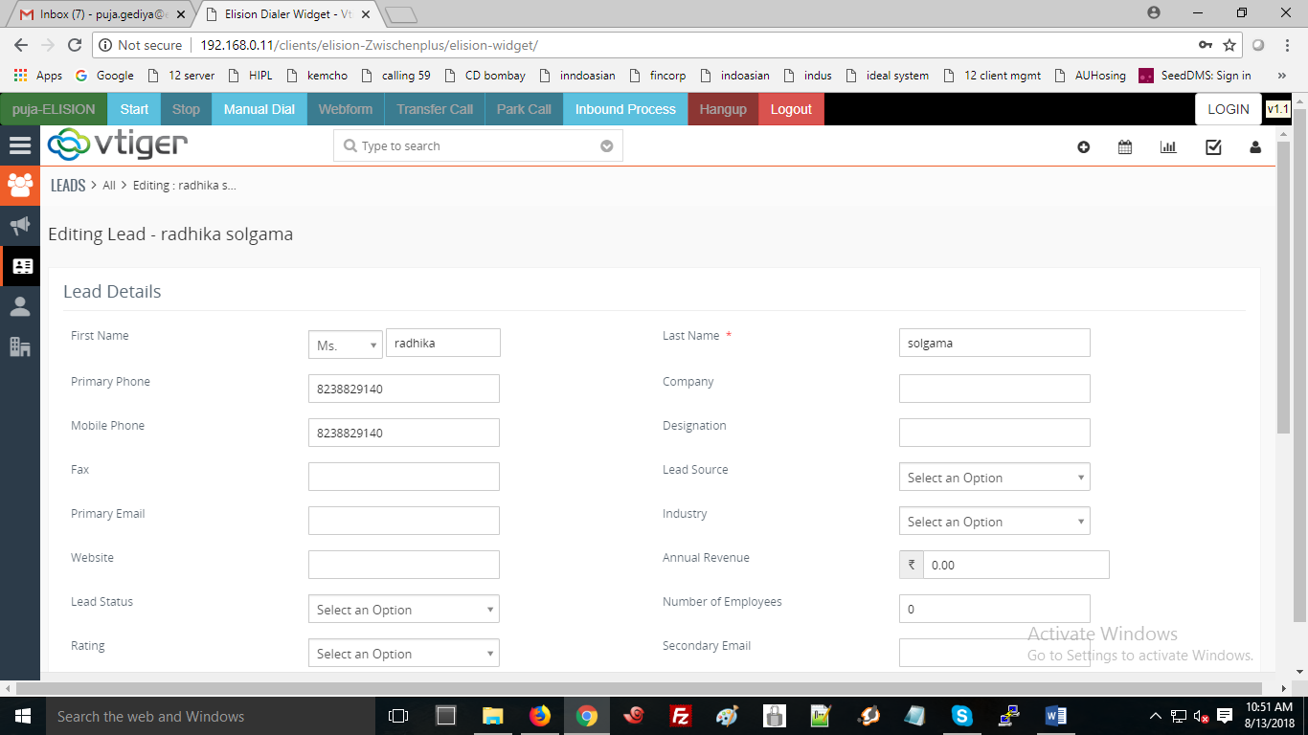

## Export to Dialer from CRM to VICIdial

* When data to be uploaded in CRM screen and then it can be pushed to Dialer via Export to Dialer function.
* We can select data from CRM which we want to export to vicidial using Export to Dialer functionality.
* For that we have to go into lead menu into CRM then go into action and click on export to dialer. You will get below screen ,

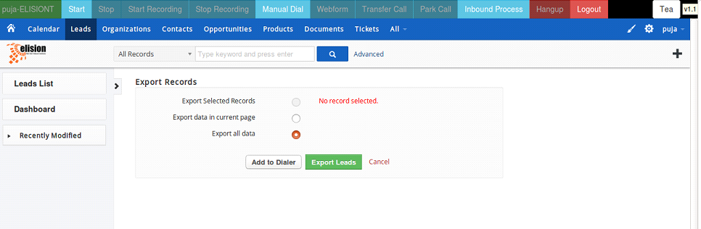

* Now click on Add to Dialer Button you will get below given screen ,

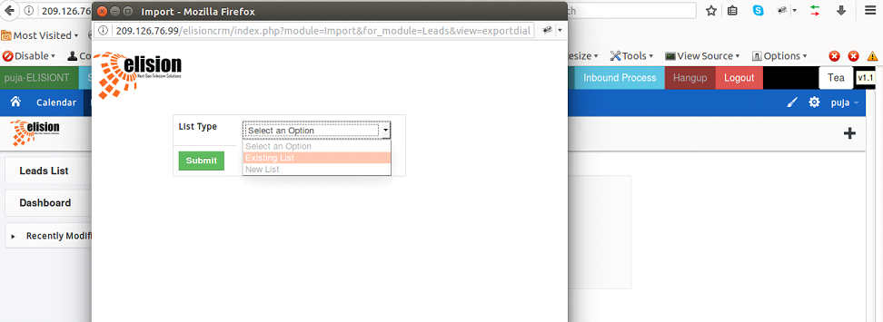

* Now if you want to export data into existing list id then select that option you will find all existing lists available in VICIdial now select any list and then click on submit button. Now check in VICIdial you will get exported leads into list id you were selected.
* Now if you want to export data into new list id the click on new list you will get below information ,

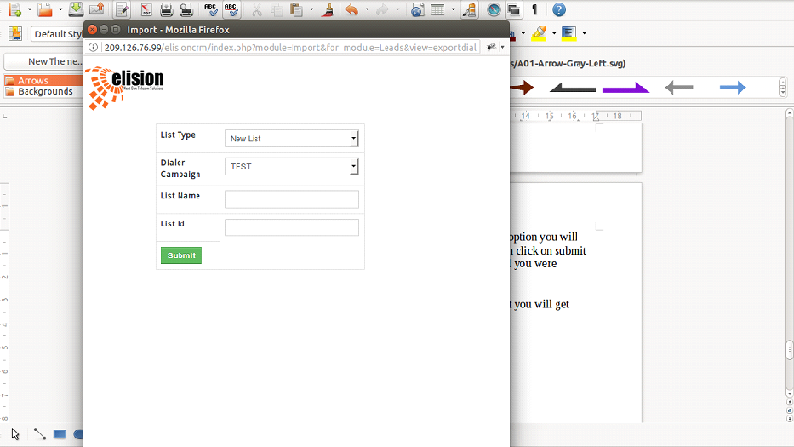

* Now select any campaign and add list name and list id and click on submit button. Now check in VICIdial you find list id which you had created.

Feature requirement

* This feature is used when we want to export data from Vtiger to VICIdial into any particular list. So, using this feature we can create list from Vtiger and upload data into that list.

## Call log status will be updated in the CRM dialed from VICI dial

* When we dial call from widget and we want log of all calls dialed from widget then using this feature we are able to get logs.
* For logs click on lead whose logs you want to check. Now click on call log you will get below screen ,

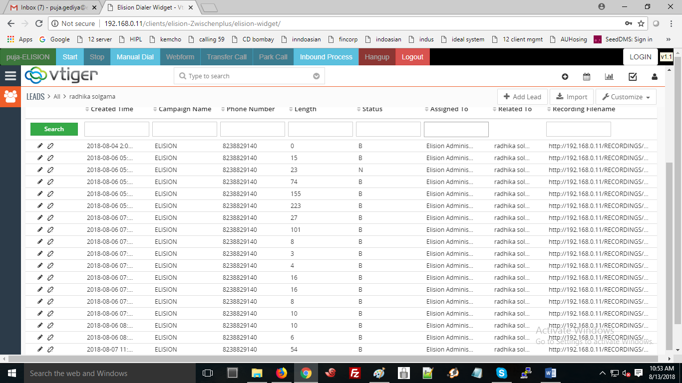

* In log you will get details like how many times perticular lead was dialed from which campaign and you will also get call length , status , recording file of that lead.

Feature requirement

* So using this feature one can get details of calls i.e. logs of calls and other information like campaign, call length, and lead status and recording file.

## Click 2 Call

* This feature is used to do call directly from Vtiger CRM.
* For click 2 call you have to open lead page and then click on Headphone button as shown below ,

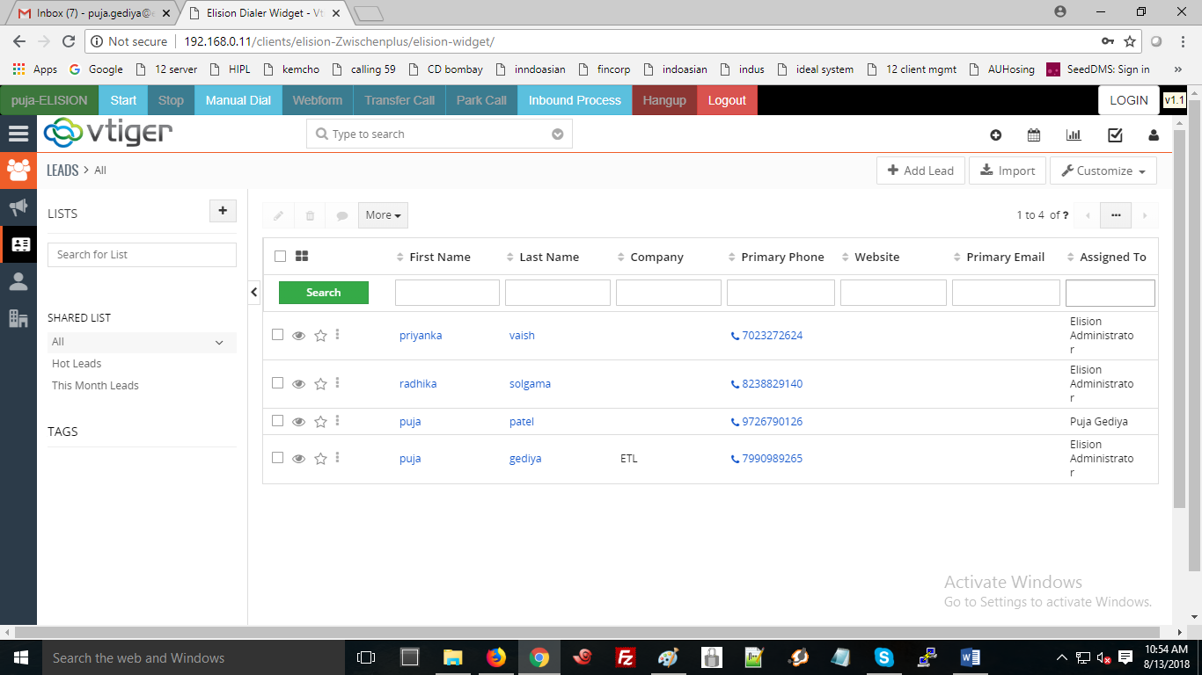

* By clicking that one call will lend to widget and other call will generate on customer number.

Feature requirement

* When customer's phone number is already there into Vtiger CRM and agent want to call on that number just by clicking headphone button they are able to call that number.

## Vicidial Widget in the CRM

* In this you will get widget which has all the feature of agent panel on the top of Vtiger CRM screen.

Feature requirement

* Purpose of this is agents do not have to toggle form CRM to agent screen or from agent screen to CRM. They both are in same screen so both can communicate easily.

## Create widget of VICIdial agent screen which will be placed on the top portion of the CRM screen as a frame

* In this you will get widget which has all the feature of agent panel on the top of Vtiger CRM screen.

Feature requirement

* Purpose of this is agents do not have to toggle form CRM to agent screen or from agent screen to CRM. They both are in same screen so both can communicate easily.

## All the Function of the VICIdial agent panel will be available in this widget

* All the feature of VICIdial agent panel like manual dial , auto dial , pause/resume ,
* Park, transfer, hang up disposition selection are available in dialer widget.
* Manual Dial: It is used for dial any number manually.
* Click on manual dial button
* Enter phone number with country code and click on dial button

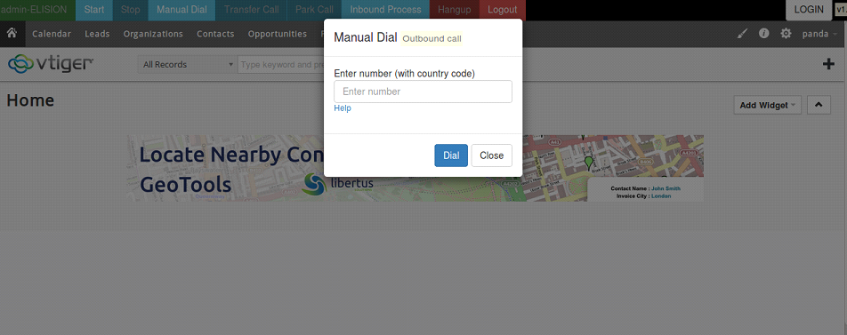

* Auto Dial: This is used to automatically dial phone numbers.
* Click on start button it will staring dialing numbers automatically.
* When you want to stop auto calling click on stop button you will get pause code screen as below, by selecting any pause code you auto dialing will stop.

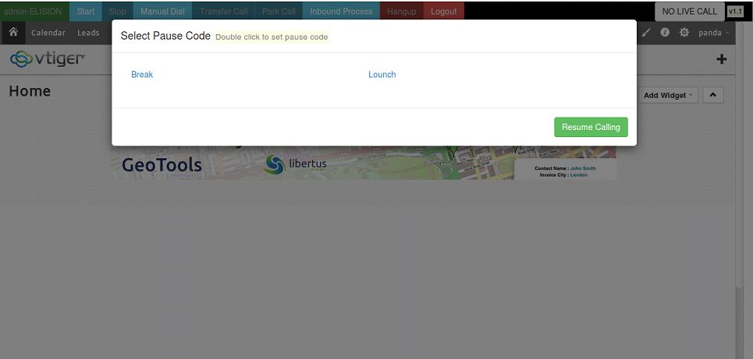

* Transfer Call: This is used to transfer any call to other number or other agent.
* Click on transfer call
* Transfer call pop-up open
* Select any option from External number, Internal transfer, Agent transfer
* After that select hang up call from leave 3 way-call , hang-up both line ,hang-up Xfer line

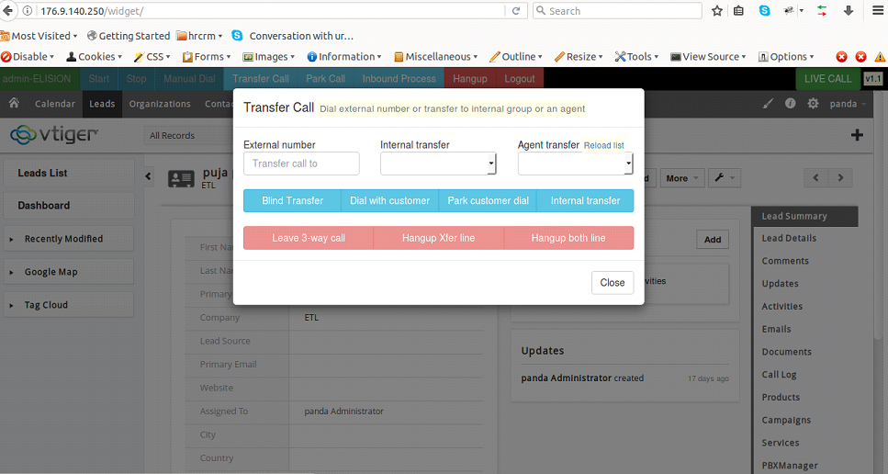

* Park: If you want to park customer you can park customer by clicking on Park button. When you want to grab parked call you can grab it from clicking grab button.
* Hang up: After call finish click on hang up button .By clicking that you will get disposition pop-up select any disposition by clicking that disposition.

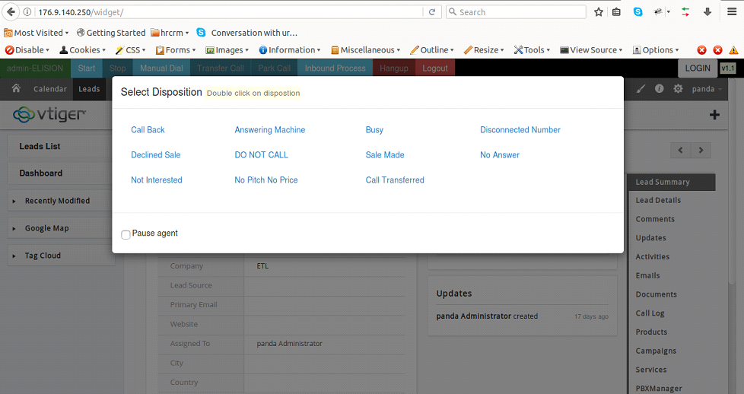

* Inbound process: when you want to select any inbound process click on inbound process button you will get below screen,

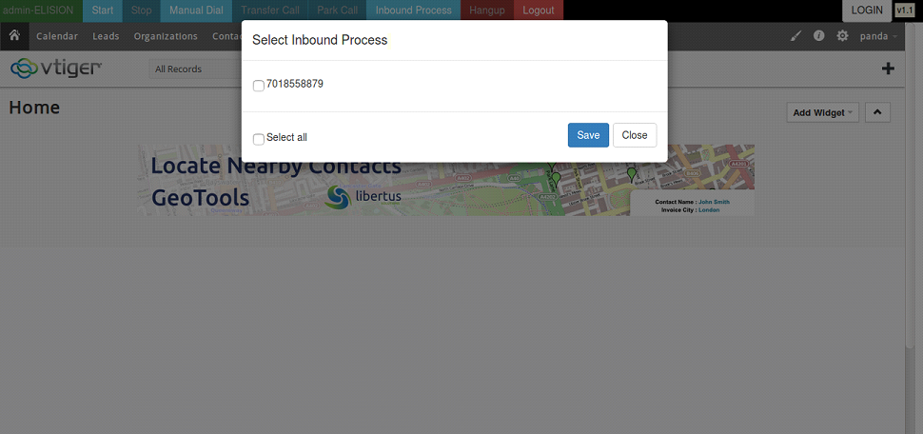

## Whenever an agent will do manual call or auto calls relevant lead will be opened in the CRM screen so that the agent will come to know to whom he is speaking with

* Same as Point 1.3

1. Change Request

1. Git Repository

Server: 192.168.0.11

Widget Git clone link: git clone git@gitlab.com: elision-Zwischenplus /elision-widget.git

Crm Git clone link: git clone git@gitlab.com: elision-Zwischenplus /elision-crm.git

Dialer Git clone link: git clone git@gitlab.com: elision-Zwischenplus /elision-dialer.git

1. Roles And Responsibility

|  |  |  |
| --- | --- | --- |
| **Sr No.** | **Role** | **Responsibility** |
| 1 | Analysis and feasibility check | Urmi Lakkad |
| 2 | Deployment of widget | Puja Gediya |
| 3 | customization of CRM | Puja Gediya |
| 4 | Testing | Radhika Solgama |

1. Testing

|  |  |  |  |  |
| --- | --- | --- | --- | --- |
| **Sr. No.** | **Particulars** | **Status** | **Comments** | Tested By Support |
|  |  |  |  |  |
| 1 | User will be created in CRM & it should get created in VICIdial | Done |  | Done |
| 2 | List will be created in CRM & it should get created in VICIdial | Done |  | Done |
| 3 | At LIVE call of Inbound or Outbound, CRM screen will pop up with the customer details | Done | Outbound/manual both working fine | Done |
| 4 | Data to be uploaded in CRM screen and then it can be pushed to Dialer via Export To Dialer function Export To Dialer from CRM to VICIdial | Done |  | Done |
| 5 | Call log Status will be updated in the CRM dialed from VICIdial | Done | Requirement - We have to set the Dispo URL. 10.1.0.17/vicidial/crm_status.php?phone=--A--phone_number--B--&leadstatus=--A--dispo--B--&leadid=--A--vendor_lead_code--B--&recording=--A--recording_filename--B--&campaign=--A--campaign--B--&sec=--A--talk_time--B--&dialer_id=--A--lead_id--B-- | Done |
| 6 | Click2Call | Done |  | Done |
| 7 | VICIdial Widget In the CRM | Done |  | Done |
| 8 | Create Widget of VICIdial Agent Screen which will be placed on the top portion of the CRM screen as a frame | Done |  | Done |
| 9 | All functions of the VICIdial as mentioned will be available in this widget: a. Pause/ Resume (i. Selection of Pause call) b. Park c. Transfer Call d. Hang-up e. Disposition (i. Selection of Disposition) f. Manual Dial | Done |  | Done |
| 10 | Whenever an agent will do manual call or auto calls relevant lead will be opened in the CRM screen so that the agent will come to know to whom he is speaking with | Done |  | Done |



