
cview manual

Cview version 2.0

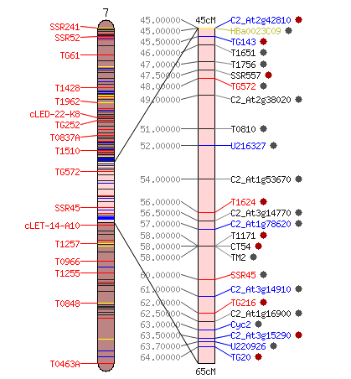

Table of Contents
1. License 3
Acknowledgments 4
2. Installation 4
2.1 Preparing your system 4
2.2 Downloading and unpacking the source files 6
2.3 Installing the Perl modules and scripts 6
2.4 Configuring Apache 6
2.5 Setting up the database back-end 6
2.6 Importing map data 6
3. Using Cview 7
3.1 The Map Overview page 7
3.2 The chromosome view 9
3.3 The map comparison view 10

1. License

The software created by SGN in this package is licensed under the following terms, excluding any software that has been obtained from third parties and which may be subject to other restrictions and licenses:

Copyright © 2003-2007 Sol Genomics Network and Cornell University.

Permission is hereby granted, free of charge, to any person obtaining a copy of this software and associated documentation files (the "Software"), to deal in the Software without restriction, including without limitation the rights to use, copy, modify, merge, publish, distribute, sublicense, and/or sell copies of the Software, and to permit persons to whom the Software is furnished to do so, subject to the following conditions:

The above copyright notice and this permission notice shall be included in all copies or substantial portions of the Software.

THE SOFTWARE IS PROVIDED "AS IS", WITHOUT WARRANTY OF ANY KIND, EXPRESS OR IMPLIED, INCLUDING BUT NOT LIMITED TO THE WARRANTIES OF MERCHANTABILITY, FITNESS FOR A PARTICULAR PURPOSE AND NONINFRINGEMENT. IN NO EVENT SHALL THE AUTHORS OR COPYRIGHT HOLDERS BE LIABLE FOR ANY CLAIM, DAMAGES OR OTHER LIABILITY, WHETHER IN AN ACTION OF CONTRACT, TORT OR OTHERWISE, ARISING FROM, OUT OF OR IN CONNECTION WITH THE SOFTWARE OR THE USE OR OTHER DEALINGS IN THE SOFTWARE.

Acknowledgments
This software was created in part with funding from the U.S. National Science Foundation.

2. Installation
This section describes installation on UNIX platforms, most of which should be compatible with the cview code. The code itself has been tested on Linux (Debian, but it should be trivial to make it work on other distributions), and MacOSX. The software may also run on Windows, but it has not been tested and some modifications to the code base may be required.

2.1 Preparing your system

The following system software needs to be installed on the computer before cview can be installed:
Perl 5.8 (other versions of Perl may also work)
Apache 1.3x with mod_perl, (other modules?).
postgresql 8.1 with a perl-dbi adapter

The following Perl modules, from CPAN (http://www.cpan.org/ ), need to be installed on the system:
enum
Array::Compare
Cache::File
Digest::Crc32;
Digest::MD5
Digest::MD5;
File::Basename
File::Basename;
File::Copy
File::Copy;
File::Find;
File::Glob
File::NFSLock
File::NFSLock;
File::Path
File::Path;
File::Spec
File::Spec;
File::Temp
File::Temp;
FileHandle;
FindBin
HTML::Entities;
HTML::TreeBuilder;
JSAN::ServerSide;
List::Util
POSIX
Test::Exception;
Test::More
Test::More;
Test::Simple
Tie::Function;
Tie::UrlEncoder;
URI::Escape;
URI::ToDisk;
DBI
Apache::DBI
Apache::Cookie
GD
a complete installation of BioPerl
Bio::DB::GFF

(the following modules should be part of the standard Perl distribution: File::Basename, File::Spec, File::Temp and Test::More ).

2.2 Downloading and unpacking the source files
Download the following compressed tar archives from the SGN FTP site:
ftp://ftp.sgn.cornell.edu/programs/cview.tar.gz
ftp://ftp.sgn.cornell.edu/programs/sgn/schema/SGN.schema.tar.gz

INSTALLATION
Note: the installation of the Perl libraries will go with the standard Perl libraries. The directories /data/local/website/cview will be created. The cgi code will be copied to /data/local/website/cview/cgi-bin. If these directories are already present for other systems, conflicts may occur.

Requirements:
apache 1.3 with mod_perl installed.
postgresql 8.1
Perl library dependencies:
GD.pm
DBI.pm

2.3 Installing the Perl modules and scripts
The cview_release.tar.gz will expand into a directory called cview_release, which contains the code library, a database dump, helper files, and a cgi-bin subdirectory. The make file needs to be generated using the Makefile.PL perl script, and then make can be run as usual. It will copy the code libraries into the system Perl libraries, create some directories for the website scripts, and create a directory with configuration informat. It will then attempt to create the database and load the schema. Obviously, postgresql needs to be installed for this to work.

- Unpack the archive:
tar xvf cview_release.tar
- cd into the cview_release directory.
- build and install the distribution
perl Makefile.PL
make
sudo make install

- run the script post_install.sh as superuser:
sudo ./post_install.sh
- install the database, if required
- edit the configuration files and adapt for your needs

2.4 Configuring Apache
A sample configuration file for the virtual server is given in conf/vhosts.conf . Add this file (or its contents) to your apache virtual server configuration setup. The file may require some tweaking.

2.5 Setting up the database back-end
Uncompress the schema, and then load it in the database.
$tar zxvf SGN.schema.tar.gz

2.6 Importing map data
Some loading scripts are available to load map data into the SGN database. Please contact SGN.

3. Using Cview

The comparative viewer is a tool for displaying, browsing, and comparing map information on SGN. It consists of three major parts: The map overview page, the chromosome view, and the map comparison view.

3.1 The Map Overview page

When choosing a map from the map menu, the map overview page will be displayed. It shows some overview information about the map and allows the map to be queried with marker names. The basic elements on this page are:

- A small overview graph with all the chromosomes in the map that illustrates the marker density of each linkage group. The glyphs are clickable and will open the clicked chromosome in chromosome detail view.
- A text box that can be used to locate markers on the map - you can highlight multiple markers by entering marker names separated by spaces.
- Size increase/decrease, to change the display size of the map.
- The abstract gives more details about the origins, submitters, and methodologies of the map.
- A list of chromosomes in the map along with the number of markers located on the map.
- Statistics about the marker collections, such as COSII markers.
- Statistics about the different assay protocols that were used to construct the map, such as RFLP markers or CAPS markers.
- User comments. Any logged in user can leave a comment about the map displayed. The comment feature is not available on all maps.

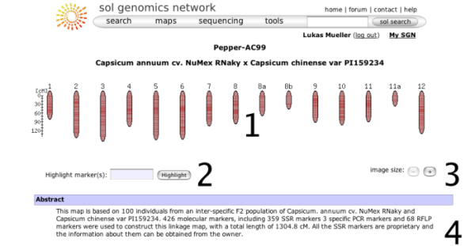
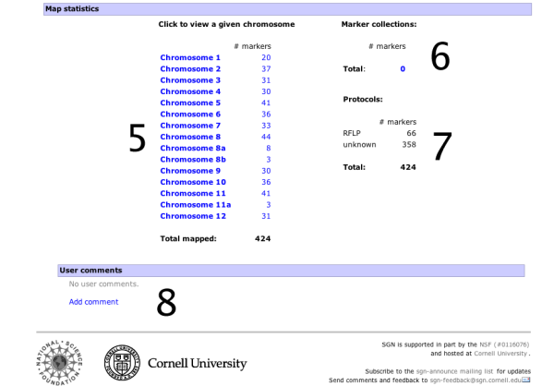

3.2 The chromosome view

Clicking on one of the chromosome glyphs on the overview page will bring up the chromosome view. In this view, a chromosome is displayed in its entirety, but most of the marker names will be hidden because on most maps there are too many markers to be displayed. To see all the markers, the map can be zoomed into by clicking on a point of interest. This will bring up a zoomed-in view alongside the chromosome. The chromosome can also be compared to another chromosome of another map by choosing a comparison chromosome from the list.

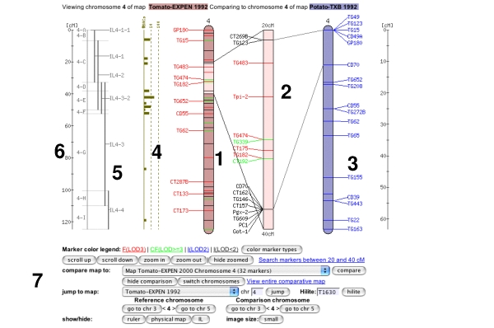

A typical screen from a chromosome view is shown in the figure above (the exact rendering of the buttons will depend on the platform and browser used). The different screen elements are:

1 The reference chromosome, always shown in red. The chromosome number is given on the top and approximately a dozen selected markers are drawn according to their map position. The other markers on the chromosome are only identified by tickmarks. They can be viewed by clicking anywhere in the chromosome reference chromosome, which brings up the zoomed-in map (2), in which all markers are displayed in the given interval. For certain maps, the reference chromosome can have additional information displayed, such as IL line information, a ruler, and physical map.
2 The zoomed in map displays a section of the reference chromosome, showing all markers at the current score cutoff. The marker names can be clicked to reach the marker detail page. A gray dot next to the marker names means that an overgo probe has been developed for this marker. A red dot means that BACs have been anchored to the overgo developed from this marker. Clicking on the red dot shows all the anchored BACs and which FPC contigs they fall into.
3 The comparison chromosome. It can be selected using the pulldown menu in the toolbar (7), and then clicking 'compare'. Only markers that are on the reference map are displayed with their names, the other markers are shown by a tick mark only. The marker names can be clicked to view the corresponding marker detail page. If all markers are of interest in the comparison chromosome, the button 'switch chromosomes' can be clicked. The comparison chromosome takes the place of the reference chromosome and vice versa.
4 If the physical button is clicked in the toolbar (7), the physical map is displayed, which shows how many BACs have been anchored to the genetic map using the overgo process. The physical map can presently only be viewed for the Tomato EXPEN2000 and Tomato EXPEN 1992 maps.
5 If the IL button in the toolbar (7) is pressed, the chromosome sections of the corresponding IL lines are displayed. The IL lines can currently only be viewed for the Tomato EXPEN 1992 map.
6 Rulers can be activated by pressing the ruler button in the toolbar (7).
7 The Toolbar, which is divided into five sections:
- The marker coloring options. This line contains a button for changing the coloring either according to score of the marker or by marker type. The different LOD scores can be clicked and markers of lower LOD scores will be hidden.
- Scrolling and Zooming. This line contains buttons for scrolling up and down, zooming in and out, and toggling between hide and show zoomed. It also contains a link that will perform a database search for all markers on the zoomed-in chromsome section.
- Compare map to: A pulldown menu allows the selection of a map that shares markers with the current reference map. The pulldown menu is sorted such that the topmost entry has to most shared markers. Clicking the 'compare' button will display the selected comparison map.
- Jump to different map or chromosome. Also contains a input box to hilite markers on the chromosome. This only hilites markers on the currently shown chromosome.
- show/hide functions: Allows the toggling of the rulers, ILs, and physical map, and to select the image size. The smaller image size is ideal for smaller screen, such as laptop screens.

3.3 The map comparison view

Clicking on the "view entire map" link in the chromosome view displays the map comparison view. In total, three maps can be compared at the same time. Below is a screenshot of a comparison of tomato and potato. The pulldown menus on the top of the screen are used to select the maps to view.

