Schema schema_xmlprodukt.xsd

element Detail – Innehåller ingående produkter ifall produkten är en paketprodukt
diagram | 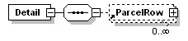
properties
  content | complex
children | ParcelRow
used by
  element | Product
source | <xs:element name="Detail">  <xs:complexType>  <xs:sequence>  <xs:element ref="ParcelRow" minOccurs="0" maxOccurs="unbounded"/>  </xs:sequence>  </xs:complexType>  </xs:element>

element EnProductDescription – Produktbeskrivning på engelska
diagram | 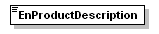
type | xs:string
properties
  content | simple
used by
  element | Product
source | <xs:element name="EnProductDescription" type="xs:string"/>

element Expired – Anger om produkten har utgått (true/false)
diagram | 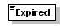
type | xs:Boolean
properties
  content | Simple
used by
  element | Product
source | <xs:element name="Expired" type="xs:boolean"/>

element IncludedProductNo – Nummer på produkt som ingår ifall det rör sig om en paketprodukt
diagram | 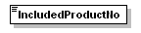
type | xs:string
properties
  content | simple
used by
  element | ParcelRow
source | <xs:element name="IncludedProductNo" type="xs:string"/>

element OrderCount – Den beställningsvolym som används som standard vid inköp via inköpsförslag.
diagram | 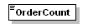
type | xs:string
properties
  content | simple
used by
  element | Product
source | <xs:element name="OrderCount" type="xs:string"/>

element OrderPoint – Beställningspunkt. Den lagernivå som skall initiera en ny beställning
diagram | 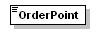
type | xs:string
properties
  content | simple
used by
  element | Product
source | <xs:element name="OrderPoint" type="xs:string"/>

element ParcelRow – Representerar en produktrad i en paketprodukt
diagram | 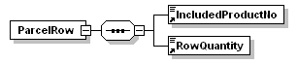
properties
  content | complex
children | IncludedProductNo RowQuantity
used by
  element | Detail
source | <xs:element name="ParcelRow">  <xs:complexType>  <xs:sequence>  <xs:element ref="IncludedProductNo"/>  <xs:element ref="RowQuantity"/>  </xs:sequence>  </xs:complexType>  </xs:element>

element Product – Produktelementet. Innehåller all data för en produkt
diagram | 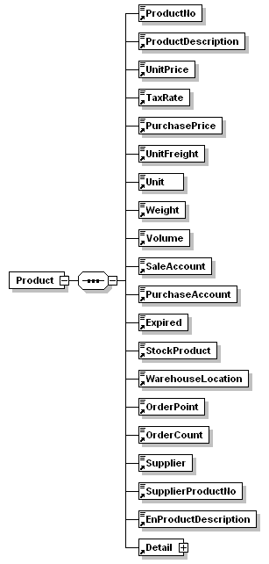
properties
  content | complex
children | ProductNo ProductDescription UnitPrice TaxRate PurchasePrice UnitFreight Unit Weight Volume SaleAccount PurchaseAccount Expired StockProduct WarehouseLocation OrderPoint OrderCount Supplier SupplierProductNo EnProductDescription Detail
used by
  element | Products
source | <xs:element name="Product">  <xs:complexType>  <xs:sequence>  <xs:element ref="ProductNo"/>  <xs:element ref="ProductDescription"/>  <xs:element ref="UnitPrice"/>  <xs:element ref="TaxRate"/>  <xs:element ref="PurchasePrice"/>  <xs:element ref="UnitFreight"/>  <xs:element ref="Unit"/>  <xs:element ref="Weight"/>  <xs:element ref="Volume"/>  <xs:element ref="SaleAccount"/>  <xs:element ref="PurchaseAccount"/>  <xs:element ref="Expired"/>  <xs:element ref="StockProduct"/>  <xs:element ref="WarehouseLocation"/>  <xs:element ref="OrderPoint"/>  <xs:element ref="OrderCount"/>  <xs:element ref="Supplier"/>  <xs:element ref="SupplierProductNo"/>  <xs:element ref="EnProductDescription"/>  <xs:element ref="Detail"/>  </xs:sequence>  </xs:complexType>  </xs:element>

element ProductDescription – Beskrivning av produkten
diagram | 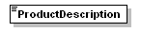
type | xs:string
properties
  content | simple
used by
  element | Product
source | <xs:element name="ProductDescription" type="xs:string"/>

element ProductNo – Produktens nummer (Både bokstäver och siffror)
diagram | 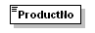
type | xs:string
properties
  content | simple
used by
  element | Product
source | <xs:element name="ProductNo" type="xs:string"/>

element Products – Rotelementet! Innehåller samtliga produkter I filen
diagram | 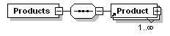
properties
  content | complex
children | Product
source | <xs:element name="Products">  <xs:complexType>  <xs:sequence>  <xs:element ref="Product" maxOccurs="unbounded"/>  </xs:sequence>  </xs:complexType>  </xs:element>

element PurchaseAccount – Standardkonto vid skapande av leverantörsfakturor
diagram | 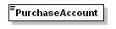
type | xs:string
properties
  content | simple
used by
  element | Product
source | <xs:element name="PurchaseAccount" type="xs:string"/>

element PurchasePrice – Inköpspris
diagram | 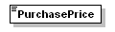
type | xs:string
properties
  content | simple
used by
  element | Product
source | <xs:element name="PurchasePrice" type="xs:string"/>

element RowQuantity – Antal enheter av en produkt som en paketprodukt ska innehålla.
diagram | 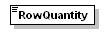
type | xs:string
properties
  content | simple
used by
  element | ParcelRow
source | <xs:element name="RowQuantity" type="xs:string"/>

element SaleAccount – Standardkonto vid skapande av kundfakturor
diagram | 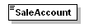
type | xs:string
properties
  content | simple
used by
  element | Product
source | <xs:element name="SaleAccount" type="xs:string"/>

element StockProduct – Lagervara (true/false) Anger om produkten ska lagerföras
diagram | 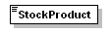
type | xs:string
properties
  content | simple
used by
  element | Product
source | <xs:element name="StockProduct" type="xs:string"/>

element Supplier - Huvudleverantör
diagram | 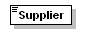
type | xs:string
properties
  content | simple
used by
  element | Product
source | <xs:element name="Supplier" type="xs:string"/>

element SupplierProductNo – Leverantörens produktnummer
diagram | 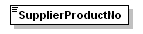
type | xs:string
properties
  content | simple
used by
  element | Product
source | <xs:element name="SupplierProductNo" type="xs:string"/>

element TaxRate – Momssats i % (t.ex. 25)
diagram | 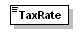
type | xs:string
properties
  content | simple
used by
  element | Product
source | <xs:element name="TaxRate" type="xs:string"/>

element Unit – Enhet (t.ex. st)
diagram | 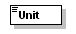
type | xs:string
properties
  content | simple
used by
  element | Product
source | <xs:element name="Unit" type="xs:string"/>

element UnitFreight - Enhetsfrakt
diagram | 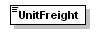
type | xs:string
properties
  content | simple
used by
  element | Product
source | <xs:element name="UnitFreight" type="xs:string"/>

element UnitPrice - Försäljningspris
diagram | 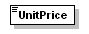
type | xs:string
properties
  content | simple
used by
  element | Product
source | <xs:element name="UnitPrice" type="xs:string"/>

element Volume – Produktens enhetsvolym
diagram | 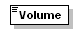
type | xs:string
properties
  content | simple
used by
  element | Product
source | <xs:element name="Volume" type="xs:string"/>

element WarehouseLocation - Lagerplats
diagram | 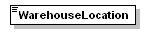
type | xs:string
properties
  content | simple
used by
  element | Product
source | <xs:element name="WarehouseLocation" type="xs:string"/>

element Weight – Produktens enhetsvikt
diagram | 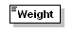
type | xs:string
properties
  content | simple
used by
  element | Product
source | <xs:element name="Weight" type="xs:string"/>

XML Schema documentation generated by XMLSpy Schema Editor http://www.altova.com/xmlspy

