Schema schema_xmlkund.xsd

element BgNo – Kundens bankgironummer
diagram | 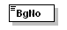
type | xs:string
properties
  content | simple
used by
  element | Customer
source | <xs:element name="BgNo" type="xs:string"/>

element CompanyNo – Kundens organisationsnummer
diagram | 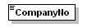
type | xs:string
properties
  content | simple
used by
  element | Customer
source | <xs:element name="CompanyNo" type="xs:string"/>

element CreditLimit – Kundens kreditgräns
diagram | 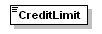
type | xs:string
properties
  content | simple
used by
  elements | Customer Customer
source | <xs:element name="CreditLimit" type="xs:string"/>

element CurrencyCode – Kundens valuta. SEK, EUR, USD etc.
diagram | 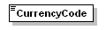
type | xs:string
properties
  content | simple
used by
  element | Customer
source | <xs:element name="CurrencyCode" type="xs:string"/>

element Customer – Kundelementet. Innehåller all information om kunden
diagram | 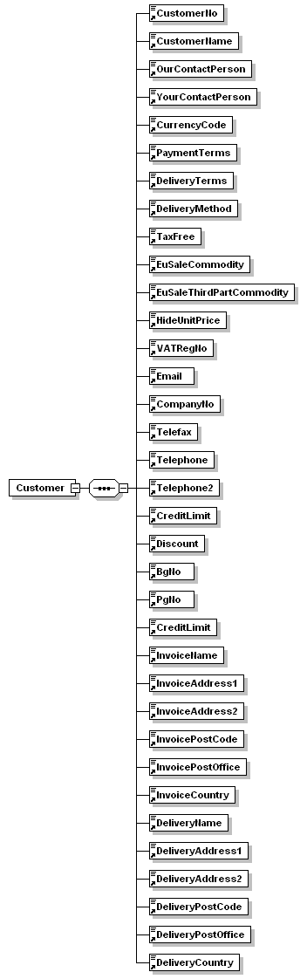
properties
  content | complex
children | CustomerNo CustomerName OurContactPerson YourContactPerson CurrencyCode PaymentTerms DeliveryTerms DeliveryMethod TaxFree EuSaleCommodity EuSaleThirdPartCommodity HideUnitPrice VATRegNo Email CompanyNo Telefax Telephone Telephone2 CreditLimit Discount BgNo PgNo InvoiceName InvoiceAddress1 InvoiceAddress2 InvoicePostCode InvoicePostOffice InvoiceCountry DeliveryName DeliveryAddress1 DeliveryAddress2 DeliveryPostCode DeliveryPostOffice DeliveryCountry
used by
  element | Customers
source | <xs:element name="Customer">  <xs:complexType>  <xs:sequence>  <xs:element ref="CustomerNo"/>  <xs:element ref="CustomerName"/>  <xs:element ref="OurContactPerson"/>  <xs:element ref="YourContactPerson"/>  <xs:element ref="CurrencyCode"/>  <xs:element ref="PaymentTerms"/>  <xs:element ref="DeliveryTerms"/>  <xs:element ref="DeliveryMethod"/>  <xs:element ref="TaxFree"/>  <xs:element ref="EuSaleCommodity"/>  <xs:element ref="EuSaleThirdPartCommodity"/>  <xs:element ref="HideUnitPrice"/>  <xs:element ref="VATRegNo"/>  <xs:element ref="Email"/>  <xs:element ref="CompanyNo"/>  <xs:element ref="Telefax"/>  <xs:element ref="Telephone"/>  <xs:element ref="Telephone2"/>  <xs:element ref="CreditLimit"/>  <xs:element ref="Discount"/>  <xs:element ref="BgNo"/>  <xs:element ref="PgNo"/>  <xs:element ref="CreditLimit"/>  <xs:element ref="InvoiceName"/>  <xs:element ref="InvoiceAddress1"/>  <xs:element ref="InvoiceAddress2"/>  <xs:element ref="InvoicePostCode"/>  <xs:element ref="InvoicePostOffice"/>  <xs:element ref="InvoiceCountry"/>  <xs:element ref="DeliveryName"/>  <xs:element ref="DeliveryAddress1"/>  <xs:element ref="DeliveryAddress2"/>  <xs:element ref="DeliveryPostCode"/>  <xs:element ref="DeliveryPostOffice"/>  <xs:element ref="DeliveryCountry"/>  </xs:sequence>  </xs:complexType>  </xs:element>

element CustomerName – Kundens namn
diagram | 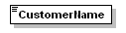
type | xs:string
properties
  content | simple
used by
  element | Customer
source | <xs:element name="CustomerName" type="xs:string"/>

element CustomerNo - Kundnummret
diagram | 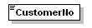
type | xs:string
properties
  content | simple
used by
  element | Customer
source | <xs:element name="CustomerNo" type="xs:string"/>

element Customers – Rotelementet! Innehåller alla kunder
diagram | 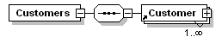
properties
  content | complex
children | Customer
source | <xs:element name="Customers">  <xs:complexType>  <xs:sequence>  <xs:element ref="Customer" maxOccurs="unbounded"/>  </xs:sequence>  </xs:complexType>  </xs:element>

element DeliveryAddress1 – Adress 1 för leveransadressen
diagram | 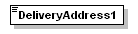
type | xs:string
properties
  content | simple
used by
  element | Customer
source | <xs:element name="DeliveryAddress1" type="xs:string"/>

element DeliveryAddress2 – Adress 2 för leveransadressen
diagram | 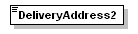
type | xs:string
properties
  content | simple
used by
  element | Customer
source | <xs:element name="DeliveryAddress2" type="xs:string"/>

element DeliveryCountry – Land för leveransadressen
diagram | 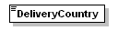
type | xs:string
properties
  content | simple
used by
  element | Customer
source | <xs:element name="DeliveryCountry" type="xs:string"/>

element DeliveryMethod - Leveranssätt
diagram | 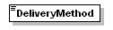
type | xs:string
properties
  content | simple
used by
  element | Customer
source | <xs:element name="DeliveryMethod" type="xs:string"/>

element DeliveryName – Namn för leveransadressen
diagram | 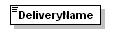
type | xs:string
properties
  content | simple
used by
  element | Customer
source | <xs:element name="DeliveryName" type="xs:string"/>

element DeliveryPostCode – Postnummer för leveransadressen
diagram | 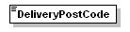
type | xs:string
properties
  content | simple
used by
  element | Customer
source | <xs:element name="DeliveryPostCode" type="xs:string"/>

element DeliveryPostOffice – Ort för leveransadressen
diagram | 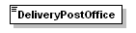
type | xs:string
properties
  content | simple
used by
  element | Customer
source | <xs:element name="DeliveryPostOffice" type="xs:string"/>

element DeliveryTerms - Leveransvillkor
diagram | 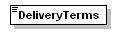
type | xs:string
properties
  content | simple
used by
  element | Customer
source | <xs:element name="DeliveryTerms" type="xs:string"/>

element Discount – Rabatt för kunden
diagram | 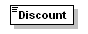
type | xs:string
properties
  content | simple
used by
  element | Customer
source | <xs:element name="Discount" type="xs:string"/>

element Email – Kundens E-postadress
diagram | 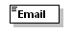
type | xs:string
properties
  content | simple
used by
  element | Customer
source | <xs:element name="Email" type="xs:string"/>

element EuSaleCommodity – Eu-försäljning
diagram | 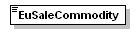
type | xs:string
properties
  content | simple
used by
  element | Customer
source | <xs:element name="EuSaleCommodity" type="xs:string"/>

element EuSaleThirdPartCommodity – Eu-försäljning tredjepart
diagram | 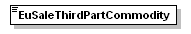
type | xs:string
properties
  content | simple
used by
  element | Customer
source | <xs:element name="EuSaleThirdPartCommodity" type="xs:string"/>

element HideUnitPrice – Gömma enhetspris på följesedeln?
diagram | 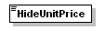
type | xs:boolean
properties
  content | simple
used by
  element | Customer
source | <xs:element name="HideUnitPrice" type="xs:boolean"/>

element InvoiceAddress1 – Adress 1 för fakturaadressen
diagram | 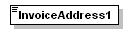
type | xs:string
properties
  content | simple
used by
  element | Customer
source | <xs:element name="InvoiceAddress1" type="xs:string"/>

element InvoiceAddress2 – Adress 2 för fakturaadressen
diagram | 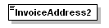
type | xs:string
properties
  content | simple
used by
  element | Customer
source | <xs:element name="InvoiceAddress2" type="xs:string"/>

element InvoiceCountry – Land för fakturaadressen
diagram | 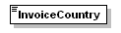
type | xs:string
properties
  content | simple
used by
  element | Customer
source | <xs:element name="InvoiceCountry" type="xs:string"/>

element InvoiceName – Namn för fakturaadressen
diagram | 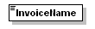
type | xs:string
properties
  content | simple
used by
  element | Customer
source | <xs:element name="InvoiceName" type="xs:string"/>

element InvoicePostCode – Postnummer för fakturaadressen
diagram | 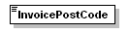
type | xs:string
properties
  content | simple
used by
  element | Customer
source | <xs:element name="InvoicePostCode" type="xs:string"/>

element InvoicePostOffice – Ort för fakturaadressen
diagram | 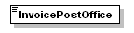
type | xs:string
properties
  content | simple
used by
  element | Customer
source | <xs:element name="InvoicePostOffice" type="xs:string"/>

element OurContactPerson – Vår kontaktperson
diagram | 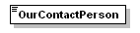
type | xs:string
properties
  content | simple
used by
  element | Customer
source | <xs:element name="OurContactPerson" type="xs:string"/>

element PaymentTerms - Betalningsvillkor
diagram | 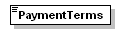
type | xs:string
properties
  content | simple
used by
  element | Customer
source | <xs:element name="PaymentTerms" type="xs:string"/>

element PgNo – Kundens plusgiro-nummer
diagram | 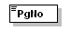
type | xs:string
properties
  content | simple
used by
  element | Customer
source | <xs:element name="PgNo" type="xs:string"/>

element TaxFree - Skattefri
diagram | 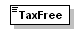
type | xs:string
properties
  content | simple
used by
  element | Customer
source | <xs:element name="TaxFree" type="xs:string"/>

element Telefax – Kundens faxnummer
diagram | 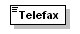
type | xs:string
properties
  content | simple
used by
  element | Customer
source | <xs:element name="Telefax" type="xs:string"/>

element Telephone – Kundens telefonnummer
diagram | 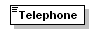
type | xs:string
properties
  content | simple
used by
  element | Customer
source | <xs:element name="Telephone" type="xs:string"/>

element Telephone2 - Kundens telefonnummer 2
diagram | 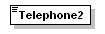
type | xs:string
properties
  content | simple
used by
  element | Customer
source | <xs:element name="Telephone2" type="xs:string"/>

element VATRegNo – Kundens momsregisteringsnummer
diagram | 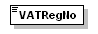
type | xs:string
properties
  content | simple
used by
  element | Customer
source | <xs:element name="VATRegNo" type="xs:string"/>

element YourContactPerson – Er kontaktperson för kunden
diagram | 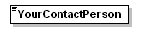
type | xs:string
properties
  content | simple
used by
  element | Customer
source | <xs:element name="YourContactPerson" type="xs:string"/>

XML Schema documentation generated by XMLSpy Schema Editor http://www.altova.com/xmlspy

