Schema Orderlista.xsd

schema location:
attribute form default:
element form default:

Elements
ArticleDescription
ArticleRow
CompanyNo
CurrencyCode
CustomerName
CustomerNumber
DelayInterest
DeliveryAddress1
DeliveryAddress2
DeliveryCountry
DeliveryMethod
DeliveryName
DeliveryPostCode
DeliveryPostOffice
DeliveryTerms
Detail
Email
EuSaleCommodity
EuSaleThirdPartCommodity
InvoiceAddress1
InvoiceAddress2
InvoiceCountry
InvoiceName
InvoicePostCode
InvoicePostOffice
Order
OrderDate
Orders
OurContactPerson
PaymentTerms
QuantityOrdered
SellerArticleNo
SellerOrderNo
SumOfLine
TaxFree
TaxRate1
TaxRate2
TaxRate3
Telefax
Telephone
Telephone2
Text
TotalLineDiscountPercent
Unit
UnitPrice
VATPercentage
VATRegNo
YourContactPerson

element ArticleDescription - Produktbeskrivning
diagram | 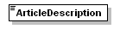
type | xs:string
properties
  content | simple
used by
  element | ArticleRow
source | <xs:element name="ArticleDescription" type="xs:string"/>

element ArticleRow – Representerar en artikelrad i ordern
diagram | 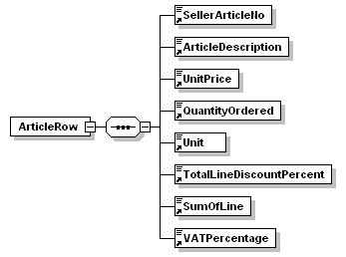
properties
  content | complex
children | SellerArticleNo ArticleDescription UnitPrice QuantityOrdered Unit TotalLineDiscountPercent SumOfLine VATPercentage
used by
  element | Detail
source | <xs:element name="ArticleRow">  <xs:complexType>  <xs:sequence>  <xs:element ref="SellerArticleNo"/>  <xs:element ref="ArticleDescription"/>  <xs:element ref="UnitPrice"/>  <xs:element ref="QuantityOrdered"/>  <xs:element ref="Unit"/>  <xs:element ref="TotalLineDiscountPercent"/>  <xs:element ref="SumOfLine"/>  <xs:element ref="VATPercentage"/>  </xs:sequence>  </xs:complexType>  </xs:element>

element CompanyNo – Organisationsnummer för kunden
diagram | 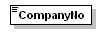
type | xs:string
properties
  content | simple
used by
  element | Order
source | <xs:element name="CompanyNo" type="xs:string"/>

element CurrencyCode – Valutakod. SEK, EUR, USD etc
diagram | 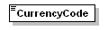
type | xs:string
properties
  content | simple
used by
  element | Order
source | <xs:element name="CurrencyCode" type="xs:string"/>

element CustomerName – Namn på kunden
diagram | 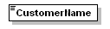
type | xs:string
properties
  content | simple
used by
  element | Order
source | <xs:element name="CustomerName" type="xs:string"/>

element CustomerNumber – Kundnummer. Måste finnas med!
diagram | 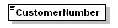
type | xs:string
properties
  content | simple
used by
  element | Order
source | <xs:element name="CustomerNumber" type="xs:string"/>

element DelayInterest - Dröjsmålsränta
diagram | 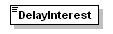
type | xs:string
properties
  content | simple
used by
  element | Order
source | <xs:element name="DelayInterest" type="xs:string"/>

element DeliveryAddress1 – Adress 1 för leveransadress
diagram | 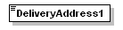
type | xs:string
properties
  content | simple
used by
  element | Order
source | <xs:element name="DeliveryAddress1" type="xs:string"/>

element DeliveryAddress2 – Adress 2 för leveransadress
diagram | 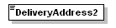
type | xs:string
properties
  content | simple
used by
  element | Order
source | <xs:element name="DeliveryAddress2" type="xs:string"/>

element DeliveryCountry - Land för leveransadress
diagram | 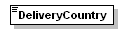
type | xs:string
properties
  content | simple
used by
  element | Order
source | <xs:element name="DeliveryCountry" type="xs:string"/>

element DeliveryMethod - Leveranssätt
diagram | 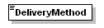
type | xs:string
properties
  content | simple
used by
  element | Order
source | <xs:element name="DeliveryMethod" type="xs:string"/>

element DeliveryName – Namn för leveransadress
diagram | 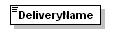
type | xs:string
properties
  content | simple
used by
  element | Order
source | <xs:element name="DeliveryName" type="xs:string"/>

element DeliveryPostCode – Postnummer för leveransadress
diagram | 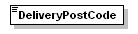
type | xs:string
properties
  content | simple
used by
  element | Order
source | <xs:element name="DeliveryPostCode" type="xs:string"/>

element DeliveryPostOffice – Ort för leveransadress
diagram | 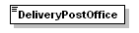
type | xs:string
properties
  content | simple
used by
  element | Order
source | <xs:element name="DeliveryPostOffice" type="xs:string"/>

element DeliveryTerms - Leveransvillkor
diagram | 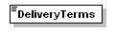
type | xs:string
properties
  content | simple
used by
  element | Order
source | <xs:element name="DeliveryTerms" type="xs:string"/>

element Detail – Innehåller samtliga artikelrader
diagram | 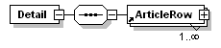
properties
  content | complex
children | ArticleRow
used by
  element | Order
source | <xs:element name="Detail">  <xs:complexType>  <xs:sequence>  <xs:element ref="ArticleRow" maxOccurs="unbounded"/>  </xs:sequence>  </xs:complexType>  </xs:element>

element Email – Kundens E-postadress
diagram | 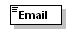
type | xs:string
properties
  content | simple
used by
  element | Order
source | <xs:element name="Email" type="xs:string"/>

element EuSaleCommodity – EU-försäljning
diagram | 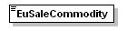
type | xs:string
properties
  content | simple
used by
  element | Order
source | <xs:element name="EuSaleCommodity" type="xs:string"/>

element EuSaleThirdPartCommodity – EU-försäljning 3e part
diagram | 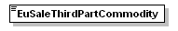
type | xs:string
properties
  content | simple
used by
  element | Order
source | <xs:element name="EuSaleThirdPartCommodity" type="xs:string"/>

element InvoiceAddress1 – Adress 1 för fakturaadress
diagram | 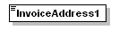
type | xs:string
properties
  content | simple
used by
  element | Order
source | <xs:element name="InvoiceAddress1" type="xs:string"/>

element InvoiceAddress2 – Adress 2 för fakturaadress
diagram | 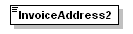
type | xs:string
properties
  content | simple
used by
  element | Order
source | <xs:element name="InvoiceAddress2" type="xs:string"/>

element InvoiceCountry – Land för fakturaadress
diagram | 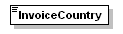
type | xs:string
properties
  content | simple
used by
  element | Order
source | <xs:element name="InvoiceCountry" type="xs:string"/>

element InvoiceName – Namn för fakturaadress
diagram | 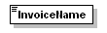
type | xs:string
properties
  content | simple
used by
  element | Order
source | <xs:element name="InvoiceName" type="xs:string"/>

element InvoicePostCode – Postnummer för fakturaadress
diagram | 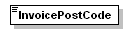
type | xs:string
properties
  content | simple
used by
  element | Order
source | <xs:element name="InvoicePostCode" type="xs:string"/>

element InvoicePostOffice – Ort för fakturaadress
diagram | 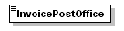
type | xs:string
properties
  content | simple
used by
  element | Order
source | <xs:element name="InvoicePostOffice" type="xs:string"/>

element Order – Representerar en order
diagram | 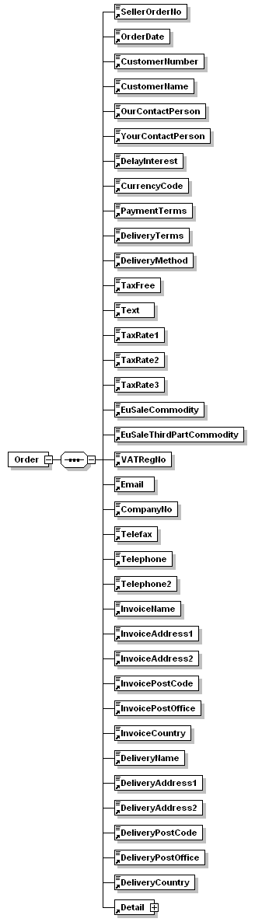
properties
  content | complex
children | SellerOrderNo OrderDate CustomerNumber CustomerName OurContactPerson YourContactPerson DelayInterest CurrencyCode PaymentTerms DeliveryTerms DeliveryMethod TaxFree Text TaxRate1 TaxRate2 TaxRate3 EuSaleCommodity EuSaleThirdPartCommodity VATRegNo Email CompanyNo Telefax Telephone Telephone2 InvoiceName InvoiceAddress1 InvoiceAddress2 InvoicePostCode InvoicePostOffice InvoiceCountry DeliveryName DeliveryAddress1 DeliveryAddress2 DeliveryPostCode DeliveryPostOffice DeliveryCountry Detail
used by
  element | Orders
source | <xs:element name="Order">  <xs:complexType>  <xs:sequence>  <xs:element ref="SellerOrderNo"/>  <xs:element ref="OrderDate"/>  <xs:element ref="CustomerNumber"/>  <xs:element ref="CustomerName"/>  <xs:element ref="OurContactPerson"/>  <xs:element ref="YourContactPerson"/>  <xs:element ref="DelayInterest"/>  <xs:element ref="CurrencyCode"/>  <xs:element ref="PaymentTerms"/>  <xs:element ref="DeliveryTerms"/>  <xs:element ref="DeliveryMethod"/>  <xs:element ref="TaxFree"/>  <xs:element ref="Text"/>  <xs:element ref="TaxRate1"/>  <xs:element ref="TaxRate2"/>  <xs:element ref="TaxRate3"/>  <xs:element ref="EuSaleCommodity"/>  <xs:element ref="EuSaleThirdPartCommodity"/>  <xs:element ref="VATRegNo"/>  <xs:element ref="Email"/>  <xs:element ref="CompanyNo"/>  <xs:element ref="Telefax"/>  <xs:element ref="Telephone"/>  <xs:element ref="Telephone2"/>  <xs:element ref="InvoiceName"/>  <xs:element ref="InvoiceAddress1"/>  <xs:element ref="InvoiceAddress2"/>  <xs:element ref="InvoicePostCode"/>  <xs:element ref="InvoicePostOffice"/>  <xs:element ref="InvoiceCountry"/>  <xs:element ref="DeliveryName"/>  <xs:element ref="DeliveryAddress1"/>  <xs:element ref="DeliveryAddress2"/>  <xs:element ref="DeliveryPostCode"/>  <xs:element ref="DeliveryPostOffice"/>  <xs:element ref="DeliveryCountry"/>  <xs:element ref="Detail"/>  </xs:sequence>  </xs:complexType>  </xs:element>

element OrderDate – Datum för ordern
diagram | 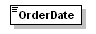
type | xs:string
properties
  content | simple
used by
  element | Order
source | <xs:element name="OrderDate" type="xs:string"/>

element Orders – Rotelementet! Innehåller samtliga ordrar.
diagram | 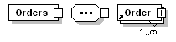
properties
  content | complex
children | Order
source | <xs:element name="Orders">  <xs:complexType>  <xs:sequence>  <xs:element ref="Order" maxOccurs="unbounded"/>  </xs:sequence>  </xs:complexType>  </xs:element>

element OurContactPerson – Vår kontaktperson för kunden
diagram | 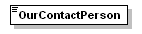
type | xs:string
properties
  content | simple
used by
  element | Order
source | <xs:element name="OurContactPerson" type="xs:string"/>

element PaymentTerms - Betalningsvillkor
diagram | 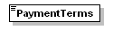
type | xs:string
properties
  content | simple
used by
  element | Order
source | <xs:element name="PaymentTerms" type="xs:string"/>

element QuantityOrdered – Antal beställda artiklar. Endast heltal
diagram | 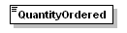
type | xs:string
properties
  content | simple
used by
  element | ArticleRow
source | <xs:element name="QuantityOrdered" type="xs:string"/>

element SellerArticleNo – Säljarens produktnummer. Måste finnas med!
diagram | 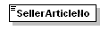
type | xs:string
properties
  content | simple
used by
  element | ArticleRow
source | <xs:element name="SellerArticleNo" type="xs:string"/>

element SellerOrderNo – Säljarens ordernummer
diagram | 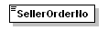
type | xs:string
properties
  content | simple
used by
  element | Order
source | <xs:element name="SellerOrderNo" type="xs:string"/>

element SumOfLine – Summa för en artikelrad på ordern
diagram | 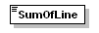
type | xs:string
properties
  content | simple
used by
  element | ArticleRow
source | <xs:element name="SumOfLine" type="xs:string"/>

element TaxFree – Skattefri
diagram | 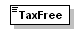
type | xs:string
properties
  content | simple
used by
  element | Order
source | <xs:element name="TaxFree" type="xs:string"/>

element TaxRate1 – Momskod 1
diagram | 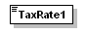
type | xs:string
properties
  content | simple
used by
  element | Order
source | <xs:element name="TaxRate1" type="xs:string"/>

element TaxRate2 – Momskod 2
diagram | 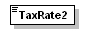
type | xs:string
properties
  content | simple
used by
  element | Order
source | <xs:element name="TaxRate2" type="xs:string"/>

element TaxRate3 – Momskod 3
diagram | 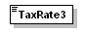
type | xs:string
properties
  content | simple
used by
  element | Order
source | <xs:element name="TaxRate3" type="xs:string"/>

element Telefax – Kundens faxnummer
diagram | 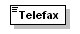
type | xs:string
properties
  content | simple
used by
  element | Order
source | <xs:element name="Telefax" type="xs:string"/>

element Telephone – Kundens telefonnummer
diagram | 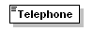
type | xs:string
properties
  content | simple
used by
  element | Order
source | <xs:element name="Telephone" type="xs:string"/>

element Telephone2 – Kundens telefonnummer 2
diagram | 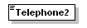
type | xs:string
properties
  content | simple
used by
  element | Order
source | <xs:element name="Telephone2" type="xs:string"/>

element Text - Ordertext
diagram | 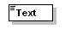
type | xs:string
properties
  content | simple
used by
  element | Order
source | <xs:element name="Text" type="xs:string"/>

element TotalLineDiscountPercent – Rabatt på artikelraden i procent
diagram | 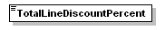
type | xs:string
properties
  content | simple
used by
  element | ArticleRow
source | <xs:element name="TotalLineDiscountPercent" type="xs:string"/>

element Unit - Enhet
diagram | 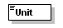
type | xs:string
properties
  content | simple
used by
  element | ArticleRow
source | <xs:element name="Unit" type="xs:string"/>

element UnitPrice – Enhetspris
diagram | 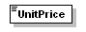
type | xs:string
properties
  content | simple
used by
  element | ArticleRow
source | <xs:element name="UnitPrice" type="xs:string"/>

element VATPercentage – Moms i procent på artikelraden
diagram | 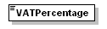
type | xs:string
properties
  content | simple
used by
  element | ArticleRow
source | <xs:element name="VATPercentage" type="xs:string"/>

element VATRegNo – Kundens VATnummer
diagram | 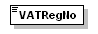
type | xs:string
properties
  content | simple
used by
  element | Order
source | <xs:element name="VATRegNo" type="xs:string"/>

element YourContactPerson – Kundens kontaktperson
diagram | 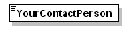
type | xs:string
properties
  content | simple
used by
  element | Order
source | <xs:element name="YourContactPerson" type="xs:string"/>

XML Schema documentation generated by XMLSpy Schema Editor http://www.altova.com/xmlspy

