Here is the er diagram of database

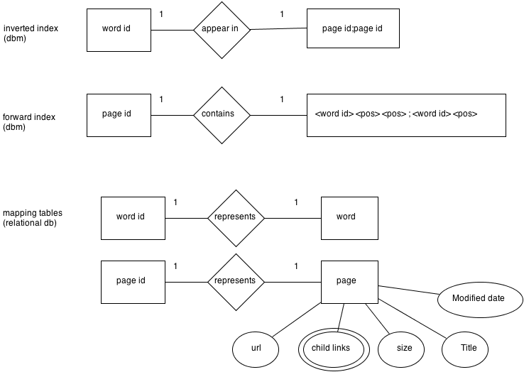

For the mapping tables, we store data in relational database(sqlite3). The reason is that relational database allow us to get word id from word, vice versa.

For the inverted index and forward index, we store data in dbm, which is a key-value database with hashtree. The reason is that dbm can retrieve data faster than relational database.

For this instance, inverted and forward index is storing a large array, which can be improve into mapping for further improvement.