**EXTR: A USER FRIENDLY MOBILE APPLICATON FOR**

**MONITORING AND MANAGING FINANCES**

**EXPENSES FOR ENHANCED BUDGETING**

____________________

IT-ELDROID1

84128, WED 10:30 AM-12:30 PM

84155, FRI 7:30-10:30 AM

____________________

by

**FRANZ RUIE MORADA ALVIN JOHN ARANETA**

**KENNETH JAMES MACAS JAYR OLORES**

**EDZ HENISSEY SON**

**ENTITY RELATIONSHIP DIAGRAM (ERD)**

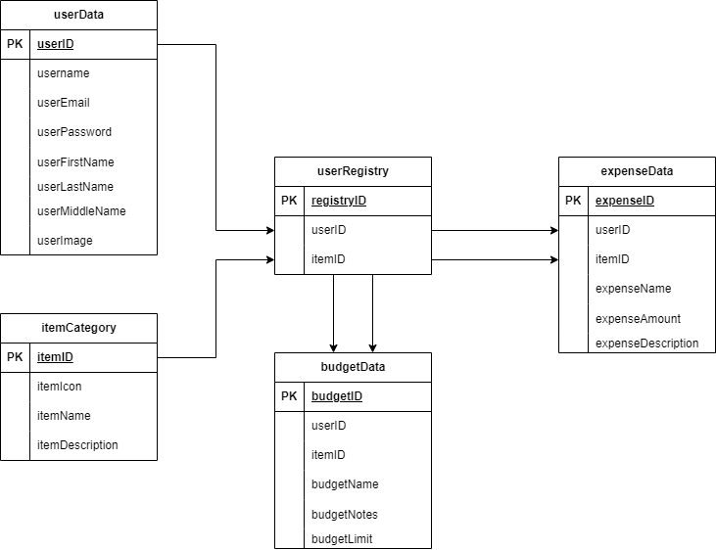

**USE CASE DIAGRAM**

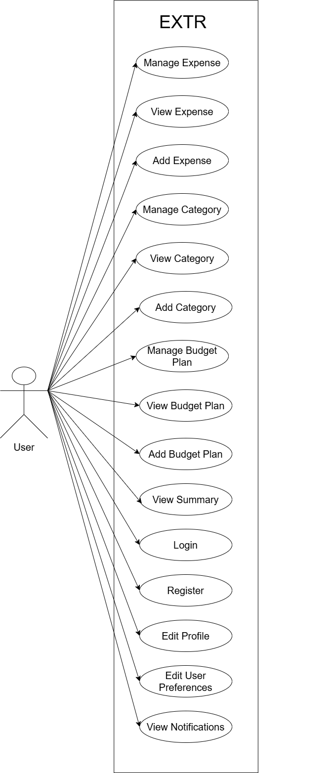

Figure 2 illustrates the use case diagram for the EXTR application, detailing the actor and their interactions within the system. The diagram includes the user and their available functions, categorized into expense management, category management, and budget planning, among other system features. Users can manage expenses by adding, viewing, and editing them. Similarly, they can perform actions such as managing and adding expense categories. The application also allows users to handle budget plans, providing options to add, view, and manage these plans. Additional features include viewing summaries, logging in, registering, editing profiles, modifying user preferences, and viewing notifications. These interactions define the scope of user engagement within the EXTR system.

**USER INTERFACE (UI) DESIGN**

|  |  |  |
| --- | --- | --- |
| **Login Screen** | | |
|  | | |
|  | **Description** | **Parameter, Datatype, and VariableName[Size]** |
| App Logo | EXTR App Image Logo |  |
| Login Text | Login Word Text Display |  |
| Login Description Text | Login Description Text Display |  |
| Username Text | Username Label Input Text Display |  |
| Username Input | Username Input Edit Text | String username[50] |
| Password Text | Password Label Input Text Display |  |
| Password Input | Password Input Edit Text | String password[32] |
| Forgot Password Text | Clickable Forgot Password Text Display |  |
| Login Button | Signing in the user to use the Application Features |  |
| Terms and Condition Text | Terms and Condition Text |  |

|  |  |  |
| --- | --- | --- |
| **Register Screen** | | |
|  | | |
|  | **Description** | **Parameter** |
| Register Text | Register Word Text Display |  |
| Register Text Description | Register Description Text Display |  |
| Email Text | Email Label Input Text Display |  |
| Email Input | Username Input Edit Text | String email[60] |
| Username Text | Username Label Input Text Display |  |
| Username Input | Username Input Edit Text | String username[50] |
| Password Text | Password Label Input Text Display |  |
| Password Input | Password Input Edit Text | String password[32] |
| Existing Account Text | Clickable Existing Account Text Display |  |
| Register Button | Registers the user with Form information |  |

|  |  |  |
| --- | --- | --- |
| **Forgot Password Screen** | | |
|  | | |
|  | **Description** | **Parameter** |
| Forgot Password Text | Forgot Password Text Display |  |
| Forgot Password Text Description | Forgot Password Text Description Display |  |
| Email Text | Email Label Input Text DIsplay |  |
| Email Input | Email Input Edit Text | String email[60] |
| Go Back Text | Clickable Go Back Text Display |  |
| Send Button | Sends mail to the email for forgot password |  |

|  |  |  |
| --- | --- | --- |
| **Verification Screen** | | |
|  | | |
|  | **Description** | **Parameter** |
| Verify Email Text | Verify Email Label Text Display |  |
| Verify Email Text Description | Verify Email Input Edit Text |  |
| Go Back Button | Goes Back to Login Screen |  |

|  |  |  |
| --- | --- | --- |
| **Basic Summary Screen** | | |
|  | | |
|  | **Description** | **Parameter** |
| Profile Image | User Profile Image Display |  |
| Expense Summary Text | Expense Summary Label Text Display |  |
| Expense Summary Value | Expense Summary Total Value Display |  |
| Display Expense Value Image | Shows/Hides the Current Total Expense Summary Value |  |
| Budget Button | Redirects to the Budget Planning Screen when clicked |  |
| Expense Button | Redirects to the Expense Screen when clicked |  |
| Category Button | Redirects to the Category Screen when clicked |  |
| Report Generation Text | Report Generation Label Text Display |  |
| Report Text Switcher | Switches to Daily/Weekly/Monthly Outputs |  |
| Home Button | Redirects to Basic Summary Screen |  |
| Expense Button | Redirects to Expense Screen |  |
| Profile Button | Redirects to Profile Screen |  |
| Settings Button | Redirects to Settings Screen |  |
| Logout Button | Prompts User with Logout Message and Closes the application |  |
| Expense Card View | Expense Display with Information |  |
| Expense Title Text (Card View) | Title of the Card |  |
| Expense RecyclerView (Card View) | List of Expenses Created |  |
| Edit Expense Button (Card View) | To edit the value of the expenses created |  |
| Delete Expense Button (Card View) | To remove the expense created |  |

|  |  |  |
| --- | --- | --- |
| **Budget Planning Screen** | | |
|  | | |
|  | **Description** | **Parameter** |
| Back Button | Returns Back to Basic Summary Screen |  |
| Budget Planning Text | Title of the Screen Displayed |  |
| Total Budget Text | Total Budget Label Text Display |  |
| Total Budget Value | Displays the current total budget of the user |  |
| Add Button | Add a budget plan on a specific expenses |  |
| Manage Button | Edits the budget plan on a specific expenses |  |
| Overview Text | Overview Label Text Display |  |
| Plan Text Switcher | Switches to the available plan created by the user |  |
| Report Text Switcher | Switches to Daily/Weekly/Monthly Budget |  |
| Plan Budget Card View | Displays the Budget Plan Created by the User |  |
| Current Expense Card View | Displays the Expenses by the User |  |
| Warning Text | Displays only when the user exceeds the amount budget relative to expense |  |
| Add Plan Title | Add Plan Label Text Display |  |
| Category Spinner | Dropdown List of Created Categories |  |
| Budget Value | User defined value for a budget | Float userbudget[99,999,999.99] |
| Add Button | Adds the budget plan |  |
| Edit Plan Title | Edit Plan Label Text Display |  |
| Current Budget Value | User defined value for a budget | Float userbudget[99,999,999.99] |
| Edit Button | Saves the budget plan changes |  |

|  |  |  |
| --- | --- | --- |
| **Expense Screen** | | |
|  | | |
|  | **Description** | **Parameter** |
| Expenses Title Text | Screen Display Text Title |  |
| Ad Image | Displays Expense Related Advertisement |  |
| Expense Name Text | Expense Label Text Display |  |
| Expense Name Input | Expense Value Edit Text | String expensename[30] |
| Category  Text | Category Label Text Display |  |
| Category Spinner | Dropdown List of Category created by the user |  |
| Amount Text | Amount Label Text Display |  |
| Amount Value | Amount Value Edit Text | Float userexpenset[99,999,999.99] |
| Date Text | Date Label Text Display |  |
| Date Value | Date Input Edit Text | Date dateexpended [MM-dd-yyyy] |
| Description Text | Description Label Text Display |  |
| Description Value | Description of the Expense Created | String expensesdesc[200] |

|  |  |  |
| --- | --- | --- |
| **Category Screen** | | |
|  | | |
|  | **Description** | **Parameter** |
| Category Text | Screen Title Text Display |  |
| Your Categories Text | Categories Created Label Text Display |  |
| Categories Button | Categories Displayed |  |
| Category Name Text | Category Label Text View |  |
| Category Value | Category Input Edit Text | String category[30] |
| Category Description Text | Category Label Text View |  |
| Category Description Value | Category Input Edit Text | String categorydesc[200] |
| Submit Button | Creates a new category |  |

|  |  |  |
| --- | --- | --- |
| **Profile Screen** | | |
|  | | |
|  | **Description** | **Parameter** |
| Profile Title Text | Screen Title Text Display |  |
| Profile Image | User Profile Image Display | String profileimageresource[Max] |
| User Information Text | User Information Label Text Display |  |
| Username Text | Username Label Text Display |  |
| Username Value | Username Input Edit Text | String username[50] |
| Email Text | Email Label Text Display |  |
| Email Value | Email Input Edit Text | String email[60] |
| Password Text | Password Label Text Display |  |
| Old Password Value | Old Password Input Edit Text | String password[32] |
| New Password Value | New Password Input Edit Text | String newpassword[32] |
| Confirm Password Value | Confirm New Password Input Edit Text | String newpassword[32] |

|  |  |  |
| --- | --- | --- |
| **Settings Screen** | | |
|  | | |
|  | **Description** | **Parameter** |
| Settings Title Text | Screen Title Text Display |  |
| Dark Mode Text | Dark Mode Label Text Display |  |
| Dark Mode Switch | Switches to Dark Mode and Light Mode |  |

**TEST CASES AND RESULT**

|  |  |  |  |  |  |
| --- | --- | --- | --- | --- | --- |
| **FRONTEND TEST CASES** | | | | | |
| **Task #** | **Task Title** | **Action** | **Expected Result** | **Current Outcome** | **Status** |
| **1** | Validate Login screen Visibility | 1. Launch the app | User is navigated to Login screen and visible | User is navigated to Login screen and visible | **PASSED** |
| 2. Navigate to Login screen |
| **2** | No username and password Login input | 1. Click the Login button without input | An error message will display | Error message displayed “Username is required” and “Password is required” | **PASSED** |
| **3** | Register Email Invalid email | 1. Navigate to Register Screen | An error message will display | Error message displayed “Invalid email address” | **PASSED** |
| 2. Input invalid@ |
| 3. Input the rest of fields |
| 4. Click register button |
| **4** | Existing Account Text | 1. Click on "Already Have An Account" link. | Redirects back to the Login screen. | User redirects to Login screen | **PASSED** |
| **5** | Forgot Email Send Button | 1. Click the Send button after entering an email. | Sends reset email and shows email sent toast | User redirects to Login screen together with a toast message | **PASSED** |
| **6** | Click Go Back Text in Forgot Password Screen | 1. Click on "Go Back" link. | Returns to the Login screen. | User navigated back to the Login screen. | **PASSED** |
| **7** | Click Go back button in Verify Email Screen | 1. Click the Go Back button. | Returns to the Login screen. | User navigated back to the Login screen. | **PASSED** |
| **8** | Login state function frontend | 1. Exit the app directly | Returns to Home | User is navigated directly to Home | **PASSED** |
| 2. Relaunch the app |
| **9** | Navigation of Budget Button | 1. Click the Budget button. | Redirects to the Budget Planning screen. | Redirects user to the Budget Planning screen. | **PASSED** |
| **10** | Navigation of Expense Button | 1. Click the Expense button. | Redirects to the Expense screen. | Redirects user to the Expense screen. | **PASSED** |
| **11** | Navigation of Category Button | 1. Click the Category button. | Redirects to the Category screen. | Redirects user to the Category screen. | **PASSED** |
| **12** | Navigation of Profile Button | 1. Click the Profile button. | Redirects to the Profile screen. | Redirects user to the Profile screen. | **PASSED** |
| **13** | Logout Button | 1. Click the Logout button. | Prompts user with a logout confirmation message. | Prompt the user a confirmation dialog message | **PASSED** |
| **14** | Expense Card View | 1. Click on an expense card. | Opens overlay displaying detailed expense information. | Opens overlay displaying detailed expense information. | **PASSED** |
| **15** | Edit Expense Button (Card View) | 1. Click the Edit Expense button on a card. | Opens overlay to edit expense details. | Opens overlay to edit expense details. | **PASSED** |
| **16** | Delete Expense Button (Card View) | 1. Click the Delete button on a card. | Prompts for confirmation before deletion. | Prompts for confirmation before deletion. | **PASSED** |
| **17** | Add Button | 1. Click the Add button. | Opens overlay to add a new budget plan. | Opens overlay to add a new budget plan. | **PASSED** |
| **18** | Manage Button | 1. Click the Manage button. | Opens overlay to edit an existing budget plan. | Opens overlay to edit an existing budget plan. | **PASSED** |
| **19** | Category Spinner | 1. Click the Category Spinner | Shows all created categories by the user and the default value must be none. | Display all the categories fetched by userId | **PASSED** |
| **20** | Date Value | 1. Clicks the Edit Text | Displays a Calendar View and Outputs a Date Value on the Edit Text | Displays a Calendar View and Outputs a Date Value on the Edit Text | **PASSED** |
| **21** | Description Value | 1. Input a long text | The Edit Text should wrap the text input with a maximum line of 5 | The Edit Text should wrap the text input with a maximum line of 5 | **PASSED** |
| **22** | Submit Button | 1. Click Submit button with Category Name Value | Displays the new Category Created by the user | Displays the new Category Created by the user | **PASSED** |
| **23** | Username Value | 1. Edit Username with 2 characters | Display an error message | Displays an error message stating “Username must be at least 3 characters” | **PASSED** |
| **24** | Email Value | 1. Edit email with invalid input | Display an error message | Error message displayed “Invalid email address” | **PASSED** |
| **25** | Old Password Value | 1. Clicks Submit Button on Profile Screen | Should validation error the input value if its the same with the current user password | Should validation error the input value if its the same with the current user password | **PASSED** |
| **26** | New Password Value | 2. Clicks Submit Button on Profile Screen | Should validation error that the password input is not the same with the previous password | Should validation error that the password input is not the same with the previous password | **PASSED** |
| **27** | Confirm New Password Value | 3. Clicks Submit Button on Profile Screen | Should validation error that the password is the same with the new password value | Should validation error that the password is the same with the new password value | **PASSED** |

|  |  |  |  |  |  |
| --- | --- | --- | --- | --- | --- |
| **BACKEND TEST CASES** | | | | | |
| **Auth Management** | | | | | |
| **Task #** | **Task Title** | **Action** | **Expected Result** | **Current Outcome** | **Status** |
| **1** | User Registration | 1. Input valid email | Display toast stating “User registered successfully…” and navigated to Verify Email Screen | Display toast stating “User registered successfully…” and navigated to Verify Email Screen | **PASSED** |
| 2. Input valid username |
| 3. Input password with a minimum of 6 characters |
| 4. Click Registration Button |
| **2** | User Login Failed | 1. Login with non-existent username | An error message will display | Error message displayed “Username not found” | **PASSED** |
| 2. Click Login button |
| **3** | Forgot Password Send Email Failed | 1. Input non-existent email | An error message will display | Error message displayed “Email not found” | **PASSED** |
|  |
| 2. Click Send Button |  |
|  |
| **4** | Forgot Email Send Button | 2. Click the Send button after entering an email. | Sends reset email and shows email sent toast | User redirects to Login screen together with a toast message | **PASSED** |  |
| **Category Management** | | | | | |  |
| **1** | Add Duplicate Category Entry | 1. Add a category with the same entry | An error message will display | Error message displayed “Category Already Exists.” handle by toast | **PASSED** |  |
| 2. Click submit button |  |
| **2** | Add a category entry | 1. Add a unique category entry | A success message will display | Success message displayed “Category added successfully!.” handle by toast and the added category is displayed in the recycler view | **PASSED** |  |
| 2. Click submit button |  |
| **3** | Edit a category entry | 1. Click the item list | A success message will display | Success message displayed “Category edited successfully!” handle by toast and the added category is displayed in the recycler view | **PASSED** |  |
| 2. Input a new valid value |  |
| 3. Click save |  |
| **4** | Delete a category entry | 1. Click the item list | A success message will display and dis | Success message displayed “Category deleted successfully!” handle by toast and the remove category in the recycler view | **PASSED** |  |
| 2. Click delete |  |
| **Expense Management** | | | | | |  |
| **1** | Add Expense with valid data including expense name, description, category title, amount, and date | 1. Navigate to Add expense screen | A success message will display | Success message displayed handle by toast and the added expense is displayed in a list | **PASSED** |  |
|  |
| 2. Add valid data |  |
|  |
| 3. Click submit button |  |
|  |
| **2** | Retrieve Expense | 1. Navigate to Basic Summary Screen | It will render the budget added by the user | It will render the budget added by the user | **PASSED** |  |
|  |
| **3** | Update an Expense | 1. Navigate to Basic Summary Screen | It will render a the updated expense for the user and a success message will display |  | **PENDING** |  |
| 2. Click a specific expense card |  |
| 3. Click the edit icon and submit |  |
| **4** | Delete an Expense | 1. Navigate to Basic Summary Screen | It will remove the specific expense for the user and a success message will display |  | **PENDING** |  |
| 2. Click a specific expense card |  |
| 3. Click the trash icon and submit |  |
| **Budget Management** | | | | | |  |
| **1** | Add Budget | 1. Navigate to budget planning screen | A success message will display and the budget will be updated in the views | A success message will display and the budget will be updated in the views | **PASSED** |  |
|  |
| 2. Click the add button |  |
|  |
| 3. Choose a specific category and add a specific budget |  |
| 4. Click the Add button |  |
| **2** | Retrieve Budget data and display it on a card | 1. Navigate to budget planning screen | It will render the budget added by the user | Render the total budget amount of the user | **PASSED** |  |
|  |
| **3** | Update Budget on a specific category | 1. Navigate to budget planning screen | It will render a the updated budget for the user and a success message will display |  | **PENDING** |  |
|  |
| 2. Click the manage button |  |
|  |
| 3. Choose a specific category and update a specific budget |  |
| 4. Click the Edit button |  |
|  |
|  |
|  |
|  |
|  |
|  |
| **4** | Delete Budget on a specific category | 1. Navigate to budget planning screen | It will remove the specific budget for the user and a success message will display |  | **PENDING** |  |
|  |
| 2. Click the manage button |  |
|  |
| 3. Choose a specific category and update a specific budget |  |
| 4. Click the Delete button |  |
|  |
|  |
|  |
|  |
|  |
|  |
|  |
|  |
|  |
|  |
|  |
|  |
|  |
|  |
| **Profile Management** | | | | | |  |
| **1** | User updates the username | 1. Navigate to Profile screen | Username will be updated and a success message will display | Username updates successfully and a success message handled by a toast stating “Successfully updated user details” | **PASSED** |  |
|  |
| 1. Inputs the new username at the username input field |  |
|  |
| 1. Click the submit button |  |
|  |
| **2** | User updates the email | 1. Navigate to Profile screen | Email will be updated and a success message will display, In the DB on the other hand the verification will be reverted to false | Email updates successfully and a success message handled by a toast stating “Successfully updated user details” and sent a verification email | **PASSED** |  |
|  |
| 1. Inputs the new username at the username input field |  |
|  |
| 1. Click the submit button |  |
|  |
| **3** | User updates the password | 1. Navigate to Profile Screen | Password will be updated and a success message will display | Password updates successfully and a success message handled by a toast stating “Successfully updated user details” | **PASSED** |  |
| 1. Input the old password and the new password in the field |  |
| 1. Click the submit button |  |
|  |  |  |  |  |
|  |  |  |  |  |
|  |  |  |  |  |

**SEQUENCE DIAGRAM**

**POST/login**

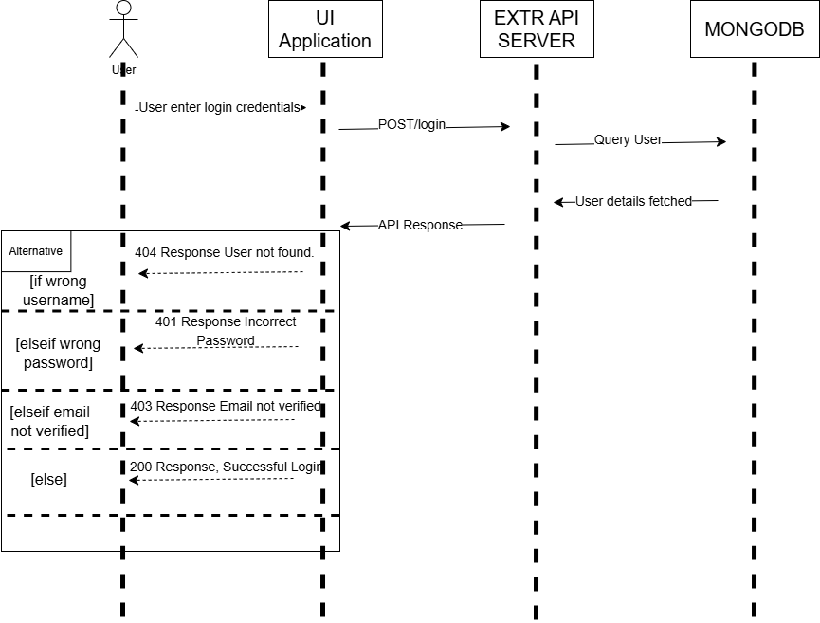

**POST/register**

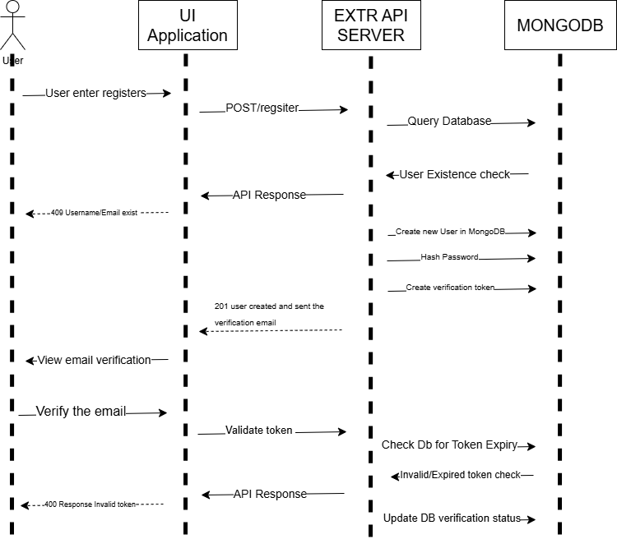

**POST/forgotPassword**

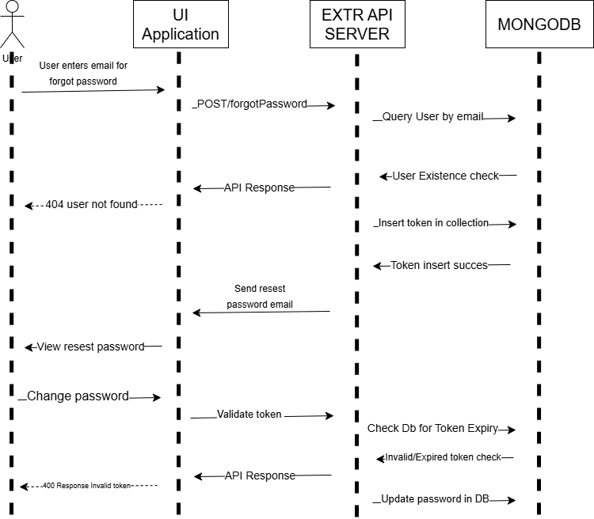

**GET/userCategories and POST/addCategory/{categoryTitle}**

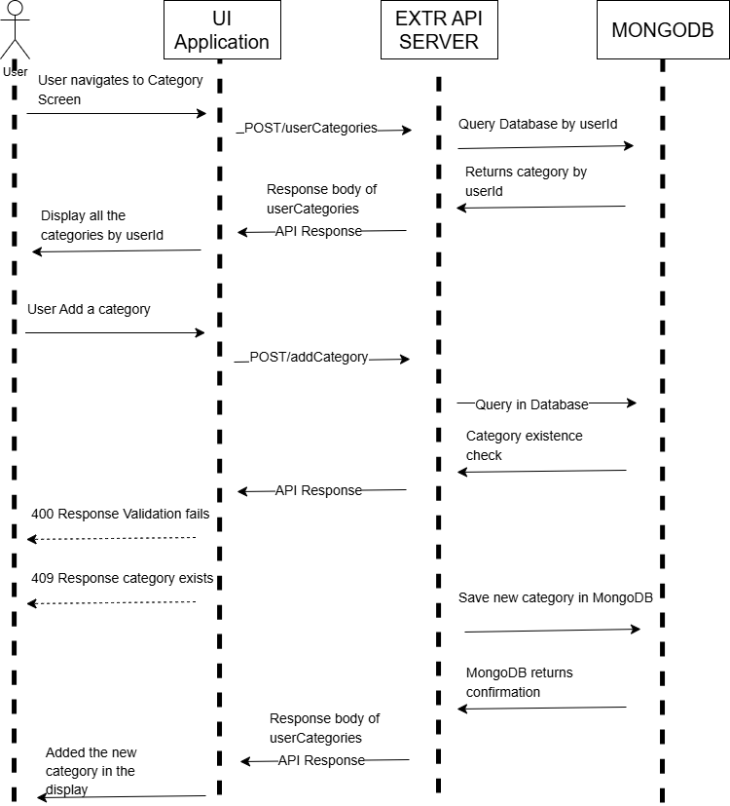

**PATCH/updateCategory/{categoryTitle} and DELETE/deleteCategory/{categoryTitle}**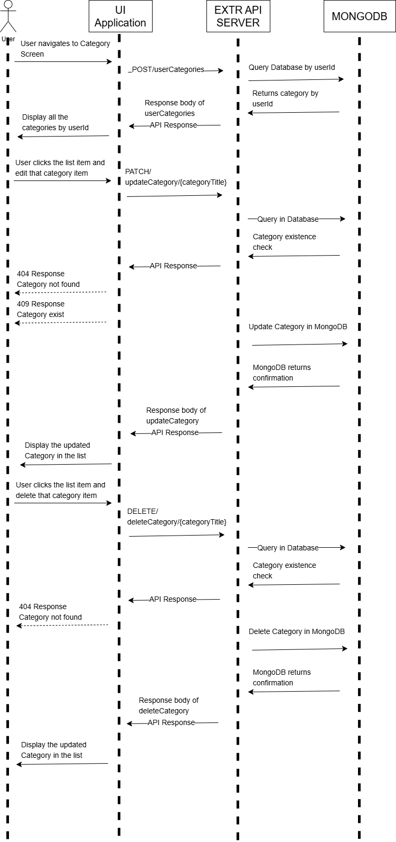

**GET/userExpenses and POST/addExpense**

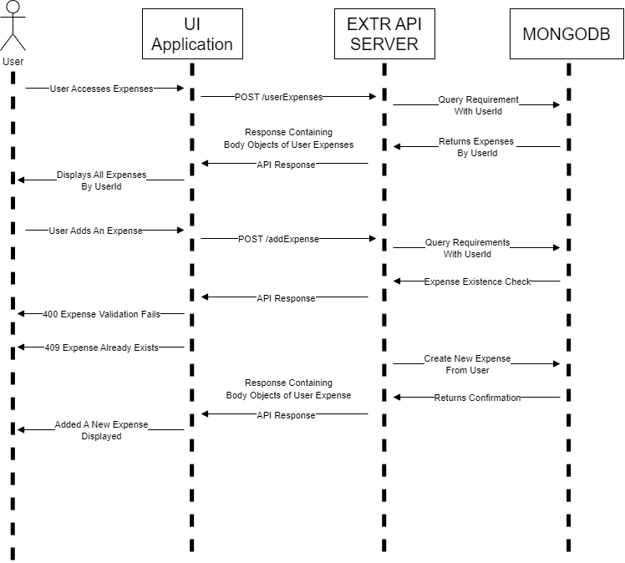

**PATCH/updateExpense/{ExpenseName} and DELETE/deleteExpense/{ExpenseName}**

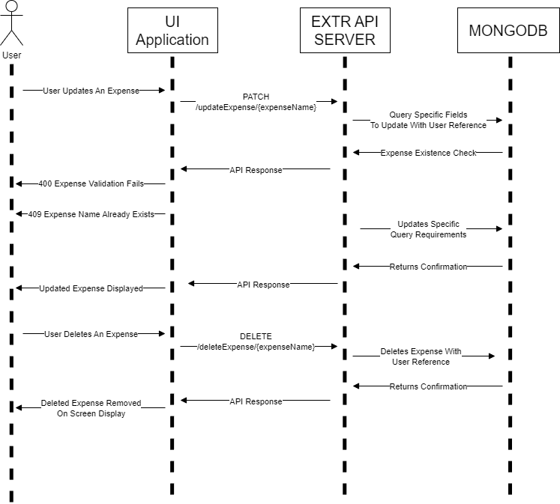

**GET/userBudgets and POST/addBudget**

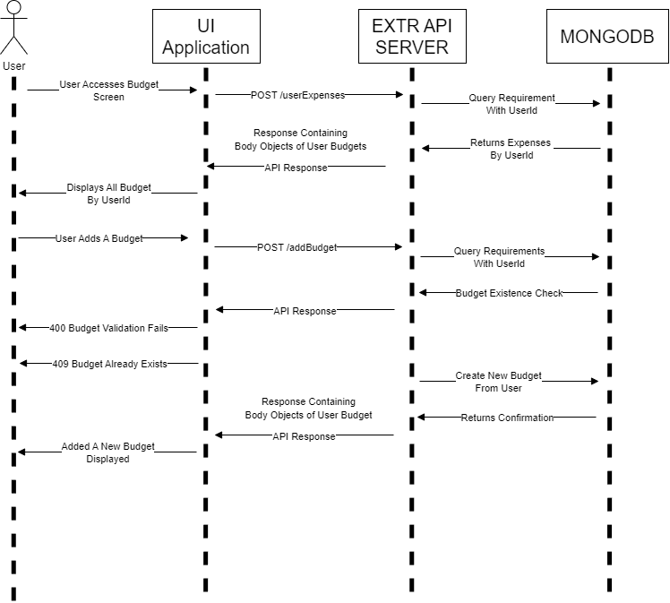

**PATCH/updateBudget/{categoryTitle} and DELETE/deleteBudget/{categoryTitle}**

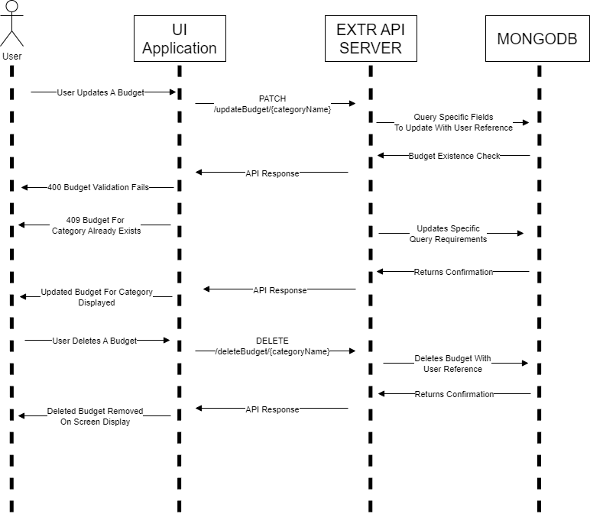

**POST/updateUser/{userId}?_method=PATCH**

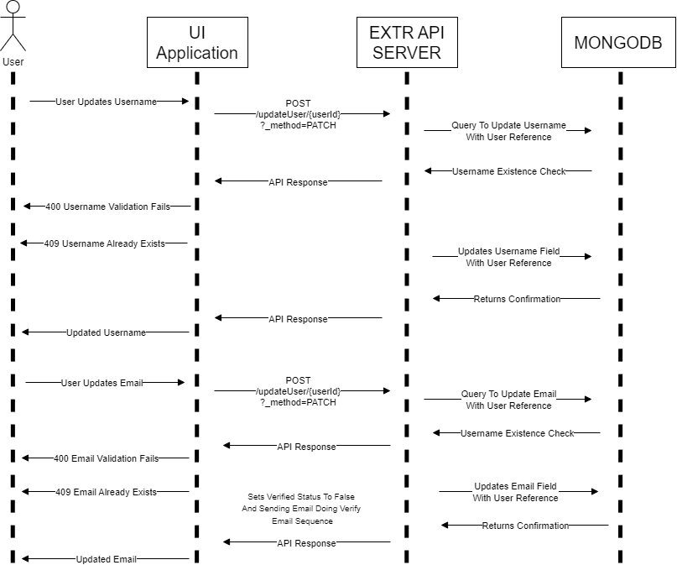

**POST/updateUser/{userId}?_method=PATCH**

