**What is a Web development Framework?**A web framework is library of features and templates designed to reduce a developer’s workload making the development cycle more efficient. Frameworks exist to save the developer from inventing the necessities, providing features that can be customised to meet the requirements. (WebMonkeyStaff, 2010)  
Within the web development environment there are several different frameworks designed for different areas of a website design. One of the main topics that developers currently face is how they can target the mobile device audience.   
With the number of mobile users, who currently navigate the internet, now overtaking those who use desktop devices, huge emphasis is placed on optimising the user experience for those users. Typically, a mobile device will display a full site where the user has to zoom and drag the page while reading content, which for the user can become quite frustrating.

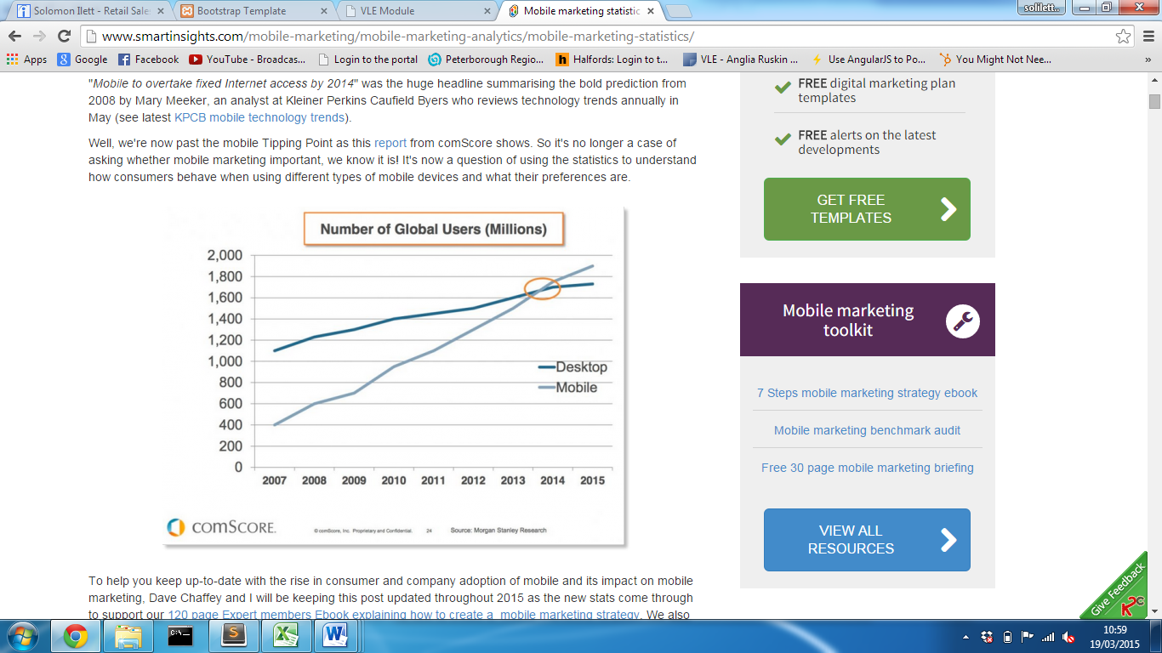

(Figure 1 - Perez, 2015)

In order to combat this, many websites are now adopting some kind of technique in order to provide the best experience for each user.   
Progressive Enhancement (PE) is a web design strategy that makes an effort to create a website that is accessible for all devices, following a layered approach with a set of core principles emphasising the accessibility of content and functionality. (Parker, 2010)

**Bootstrap**

Bootstrap today has become one of the popular frameworks for creating websites and web applications, (Meanpath.com, 2015) offering a collection of free tools to ‘kick-start’ the front-end development. The bootstrap site describes bootstrap as a ‘sleek, intuitive and powerful mobile first front-end framework for faster and easier web development’. (Mark Otto, 2015)  
The framework was originally developed for Twitter application by twitter’s team of developers and was later made open-source on Friday 19th August 2011. There have since been several updates, with one of the most substantial, responsive design. (Bootstrap, 2015)  
Responsive web design, originally defined by Ethan Marcotte, incorporates design techniques that allow a website to respond to the need of users or device viewport. (Web Fundamentals, 2015) Typically, a website will detect the user’s device viewport and either display a desktop or mobile version of that site; responsive website design provides a structured layout that adapts to the screen size providing one site for all device screen sizes.   
The framework has become so popular that even Microsoft has begun integrating bootstrap within Visual Studio 2013 ASP.NET development environment. Due to the popularity of framework and the amount it is currently used, the main artefact will implement this framework as guidance and support is readily available. For this reason the following section describes how bootstrap can be used and implemented within a project.  
Bootstrap framework provides a grid based system that allows a developer a fast and easy solution to create a site layout following a row and column design. When the viewport/screen size changes each column will resize and stack to fit the screen.

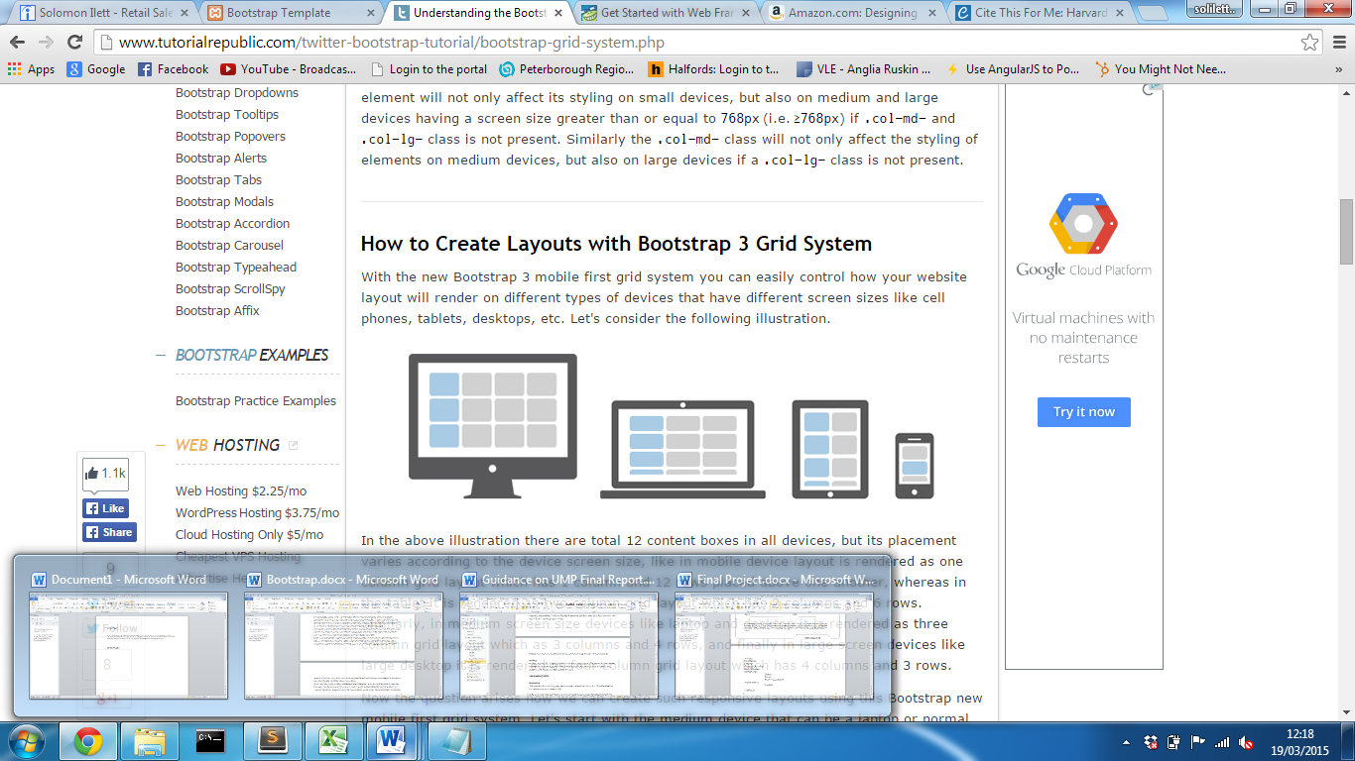

(Figure taken from …)

A typical desktop site can be split into 12 columns where a column can be defined by adding a class to an element.  
 i.e:  
  
<div class="row">

<div class="col-xs-12 col-sm-6 col-md-4 col-lg-3"> Column 1</div>  
<div class="col-xs-12 col-sm-6 col-md-4 col-lg-3"> Column 2</div>  
<div class="col-xs-12 col-sm-6 col-md-4 col-lg-3"> Column 3</div>  
<div class="col-xs-12 col-sm-6 col-md-4 col=-lg-3"> Column 4</div>

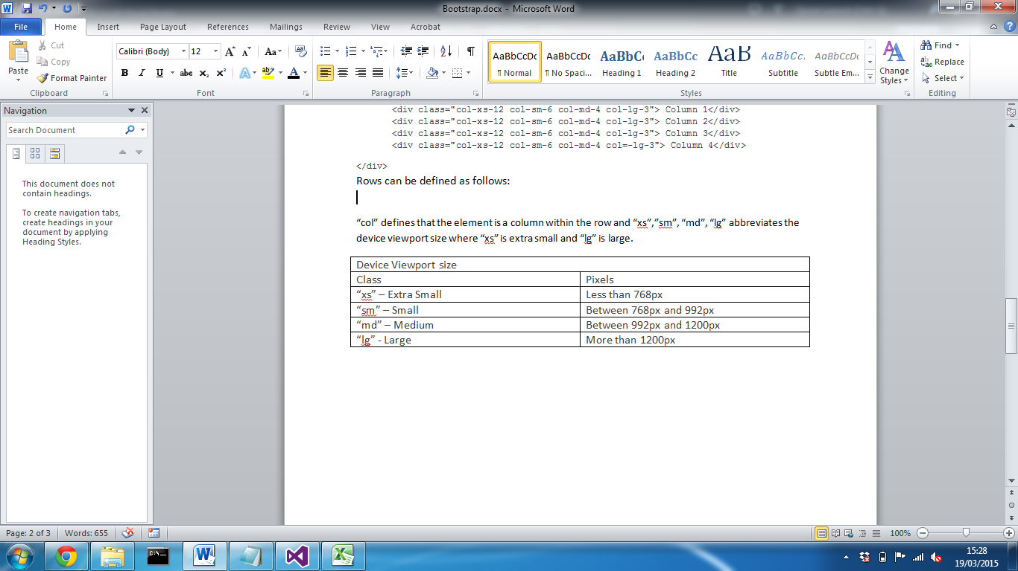</div>  
Rows can be defined as follows:

“col” defines that the element is a column within the   
 “md” abbreviates the device viewport size (see below).

|  |  |
| --- | --- |
| Device Viewport size | |
| Class | Pixels |
| “xs” – Extra Small | Less than 768px |
| “sm” – Small | Between 768px and 992px |
| “md” – Medium | Between 992px and 1200px |
| “lg” – Large | More than 1200px |

(Boostrap, 2015)

“4” defines the amount of the screen that the column will be allocated.

Any content contained within the column will then automatically respond based on the screen size. This means that the developer doesn’t have to create CSS media queries, they can simple define the class and the framework will do the rest.   
  
Following the same principles of assigning an element a class, bootstrap can also transform other elements by adding CSS styling to make them more professional and reduce the amount of work for the developer.   
  
<button class=”btn btn-success”> Button1 </button>

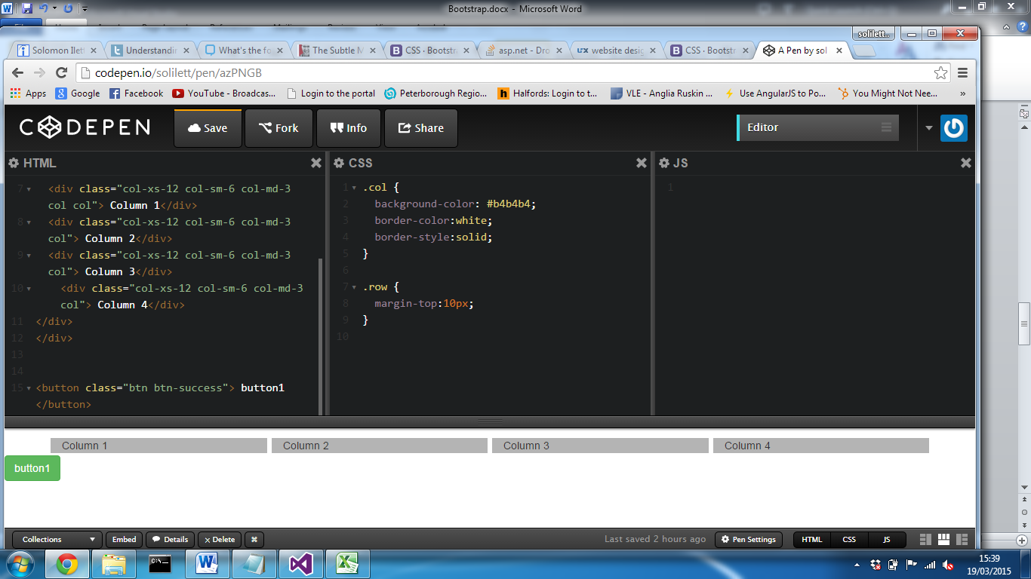  
  
  
This applies styling to the button changing background colour, fore colour, font-family as well as its hover behaviours. This provides styling that may exceed an amateur web developer’s ability, but also reduces a lot of time for an experienced user. All bootstrap elements require containers to wrap content; this can either be fixed width; by default this places a 100px margin on both the left and right. The second is fluid which takes full advantage of the screen size and stretches to with a minimal margin.

**Foundation**

While bootstrap currently may be the most popular framework, there are also alternatives available. Foundation, created by an organisation called ZURB, an interaction design company founded in 1988. (Crunchbase.com, 2015) The framework originated from their ZURB style guide and in 2011, Foundation was released which including Global CSS, jQuery plugins, common elements and best practices to enable rapid prototyping. (Zurb,2015) Very much like bootstrap, ZURB realised that mobile design was becoming more popular and more important; this lead to Foundation becoming the first open-source framework to be responsive and the first to be mobile first. (Zurb,2015)  
Foundation claim to be the “most advanced, responsive front-end framework in the world”, so, how does it compare to bootstrap.  
Foundation and Bootstrap offer very similar tools, both are responsive, both use a grid system and both offer a huge array of components. Of the two frameworks, foundation was the first to release a grid system, (reference) however, bootstrap caught up and designed their own version,

**References**

Meanpath.com, (2015). *meanpath - The Web Search API*. [online] Available at: https://meanpath.com/ [Accessed 20 Feb. 2015].

Mark Otto, a. (2015). *Bootstrap · The world's most popular mobile-first and responsive front-end framework.*. [online] Getbootstrap.com. Available at: http://getbootstrap.com/ [Accessed 20 Feb. 2015].

Web Fundamentals, (2015). *Responsive Web Design Basics — Web Fundamentals*. [online] Available at: https://developers.google.com/web/fundamentals/layouts/rwd-fundamentals/ [Accessed 20 Feb. 2015].

(get bootsrap reference)

Perez, S. (2015). *Majority Of Digital Media Consumption Now Takes Place In Mobile Apps*. [online] TechCrunch. Available at: http://techcrunch.com/2014/08/21/majority-of-digital-media-consumption-now-takes-place-in-mobile-apps/ [Accessed 19 Mar. 2015].

Parker, T. (2010). *Designing with progressive enhancement*. Berkeley, CA: New Riders.  
  
Staff, W. (2010). *Get Started with Web Frameworks - Webmonkey*. [online] Webmonkey. Available at: http://www.webmonkey.com/2010/02/get_started_with_web_frameworks/ [Accessed 19 Mar. 2015].

Crunchbase.com, (2015). *ZURB | CrunchBase*. [online] Available at: https://www.crunchbase.com/organization/zurb [Accessed 25 Mar. 2015].

ZURB, i. (2015). *Foundation | About Foundation and The Empire*. [online] Foundation.zurb.com. Available at: http://foundation.zurb.com/learn/about.html [Accessed 25 Mar. 2015].