 | Name | ID | Department
1- | سليمان رجب سليمان محمد | 20210419 | General
-2 | مينا شحاته فؤاد شحاته | 202000971 | IS
-3 | محمد حسين محمد ابراهيم | 20210763 | IS
-4 | عمار محمود محمود السقا | 202000581 | IS
-5 | عبدالرحمن خالد فؤاد محمد | 20210502 | IS
-6 | بهاء عبدالعظيم خليل | 202000207 | IS
-7 | محمود أحمد محمد حسن | 20180550 | IS

shared folder (Github): https://github.com/solimanragab/solveing-VRP

Project idea for Genetic Algorithm :

This Thesis Work will concentrate on a very interesting problem, the Vehicle Routing
Problem (VRP). In this problem, customers or cities have to be visited and packages have to be transported to each of them, starting from a basis point on the map. The
goal is to solve the transportation problem, to be able to deliver the packages
- on time for the customers,
- enough package for each Customer,
- using the available resources
- and – of course - to be so effective as it is possible.
Although this problem seems to be very easy to solve with a small number of cities or
constraints, for example opening hours, package delivery times, truck capacities,
etc. This makes this problem a so called Multi Constraint Optimization Problem
(MCOP). What’s more, this problem is intractable with current amount of grow, the calculations to be done grows exponential fast, because all constraints have to be solved for each customers and it should not be forgotten that the goal is
to find a solution, what is best enough, before the time for the calculation is up.
This problem is introduced in the first chapter: form its basics, the Traveling Salesman Problem, using some theoretical and mathematical background it is shown, why is it so hard to optimize this problem, and although it is so hard, and there is no best algorithm known for huge number of customers, why is it a worth to deal with it. Just think about a huge transportation company with ten thousands of trucks, millions of customers: how much money could be saved if we would know the optimal path for all our packages.
Although there is no best algorithm is known for this kind of optimization problems, we are trying to give an acceptable solution for it in the second and third chapter, where two algorithms are described: the Genetic Algorithm and the Simulated Annealing. Both of them are based on obtaining the processes of nature and material science. These algorithms will hardly ever be able to find the best solution for the problem, but they are able to give a very good solution in special cases within acceptable calculation time.
In these chapters (2nd and 3rd) the Genetic Algorithm and Simulated Annealing is described in details, from their basis in the “real world” through their terminology and finally the basic implementation of them. The work will put a stress on the limits of these algorithms, their advantages and disadvantages, and also the comparison of them to each other.
Finally, after all of these theories are shown, a simulation will be executed on an artificial environment of the VRP, with both Simulated Annealing and Genetic Algorithm. They will both solve the same problem in the same environment and are going to be compared to each other. The environment and the implementation are also described here, so as the test results obtained.
Finally the possible improvements of these algorithms are discussed, and the work will try to answer the “big” question, “Which algorithm is better?”, if this question even exists.
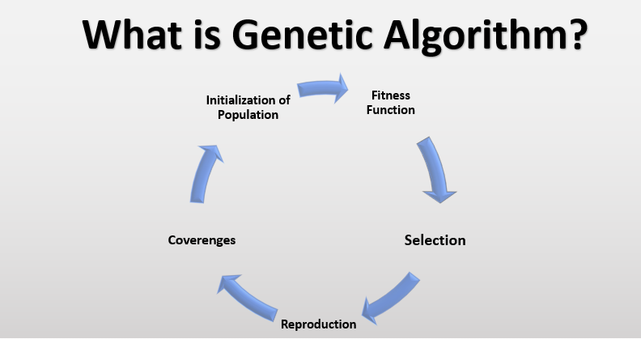

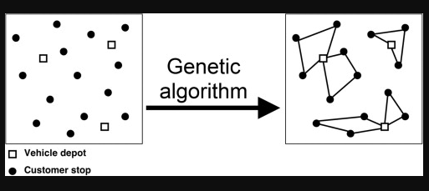
Project idea for Differential Algorithm :

In this paper, the vehicle routing problem with fuzzy demands (VRPFD) is considered, and a fuzzy chance constrained program model is designed, based on fuzzy credibility theory. Then stochastic simulation and differential evolution algorithm are integrated to design a hybrid intelligent algorithm to solve the fuzzy chance constrained program model. Moreover, the influence of the dispatcher preference index on the final objective of the problem is discussed using stochastic simulation, and the best value of the dispatcher
preference index is obtained. A technique based on the reduction of order for solving differential equations is employed to investigate a generalized nonlinear Boussinesq wave equation. The compacton solutions, solitons, solitary pattern solutions, periodic solutions and algebraic travelling wave solutions for the equation are expressed analytically under several circumstances. The qualitative change in the physical structures of the solutions is highlighted.
In this paper, we prove the existence and uniqueness of the solution to a class of doubly perturbed neutral stochastic functional equations (DPNSFEs in short) under some non-Lipschitz conditions. The solution is constructed by successive approximation. Furthermore, we give the continuous dependence of the solution on the initial value by means of the corollary of Bihari inequality.
This work concerns analysis and error estimates for optimal control problems related to implicit parabolic equations. The minimization of the tracking functional subject to implicit parabolic equations is examined. Existence of an optimal solution is proved and an optimality system of equations is derived. Semi-discrete (in space) error estimates for the finite element approximations of the optimality system are presented. These estimates are symmetric and applicable for higher-order discretizations. Finally, fully-discrete error estimates of arbitrarily high-order are presented based on a discontinuous Galerkin (in time) and conforming (in space) scheme. Two examples related to the Lagrangian moving mesh Galerkin formulation for the convection–diffusion equation are described.
This work concerns analysis and error estimates for optimal control problems related to implicit parabolic equations. The minimization of the tracking functional subject to implicit parabolic equations is examined. Existence of an optimal solution is proved and an optimality system of equations is derived. Semi-discrete (in space) error estimates for the finite element approximations of the optimality system are presented. These estimates are symmetric and applicable for higher-order discretizations. Finally, fully-discrete error estimates of arbitrarily high-order are presented based on a discontinuous Galerkin (in time) and conforming (in space) scheme. Two examples related to
the Lagrangian moving mesh Galerkin formulation for the convection–diffusion equation are described
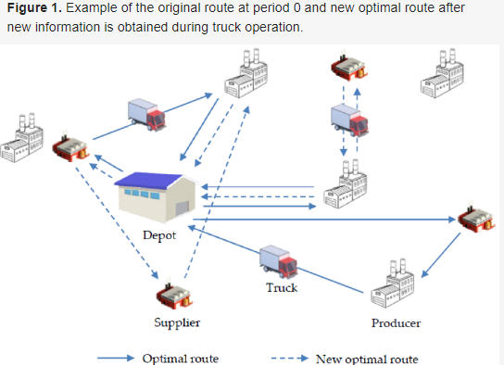

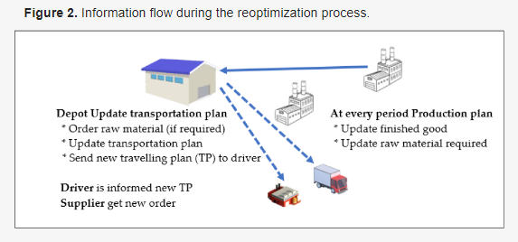

Details of the genetic algorithm :
A genetic algorithm is a search-based algorithm used for solving optimization problems in machine learning. This algorithm is important because it solves difficult problems that would take a long time to solve. It has been used in various real-life applications such as data centers, electronic circuit design, code-breaking, image processing, and artificial creativity.
This article will take the reader through the basics of this algorithm and explains how it works. It also explains how it has been applied in various fields and highlights some of its limitations

Advantages of genetic algorithm
- It has excellent parallel capabilities.
- It can optimize various problems such as discrete functions, multi- objective problems, and continuous functions.
- It provides answers that improve over time.
- A genetic algorithm does not need derivative information

How genetic algorithms work
Genetic algorithms use the evolutionary generational cycle to produce high-quality solutions. They use various operations that increase or replace the population to provide an improved fit solution.
The genetic algorithm starts by generating an initial population. This initial population consists of all the probable solutions to the given problem. The most popular technique for initialization is the use of random binary strings.

Fitness assignment
The fitness function helps in establishing the fitness of all individuals in the population. It
assigns a fitness score to every individual, which further determines the probability of
being chosen for reproduction.
The higher the fitness score, the higher the chances of being chosen for reproduction

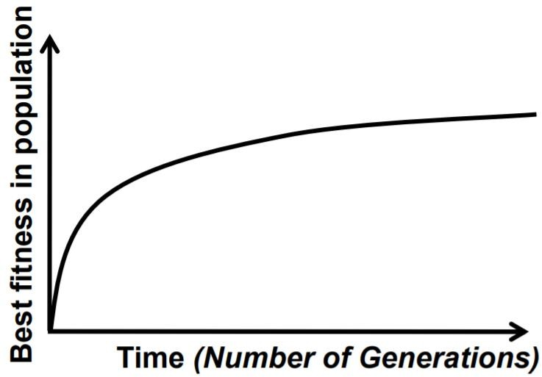

Average performance of individuals in a population is expected to increase, as good individuals are preserved and bred and less fit individuals die out
Selection
n this phase, individuals are selected for the reproduction of offspring. The selected individuals are then arranged in pairs of two to enhance reproduction. These individuals pass on their genes to the next generation.
The main objective of this phase is to establish the region with high chances of generating the best solution to the problem (better than the previous generation). The genetic algorithm uses the fitness proportionate selection technique to ensure that useful solutions are used for recombination

Reproduction
This phase involves the creation of a child population. The algorithm employs variation operators that are applied to the parent population. The two main operators in this phase include crossover and mutation
- Crossover: This operator swaps the genetic information of two parents to reproduce an offspring. It is performed on parent pairs that are selected randomly to generate a child population of equal size as the parent population.
- Mutation: This operator adds new genetic information to the new child population. This is achieved by flipping some bits in the chromosome. Mutation solves the problem of local minimum and enhances diversification. The following image shows how mutation is done.
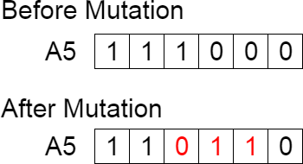

another example :

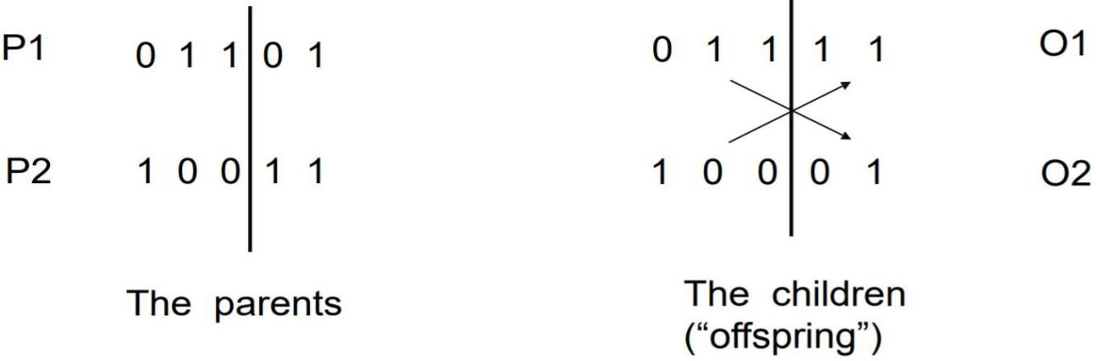

General Scheme of Genetic Algorithms
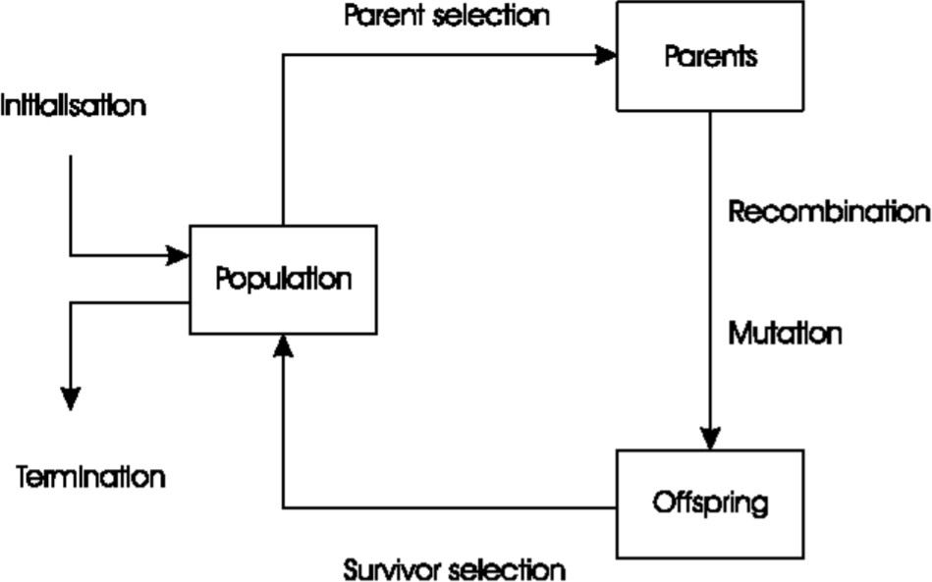

- Flow chart for (GE)

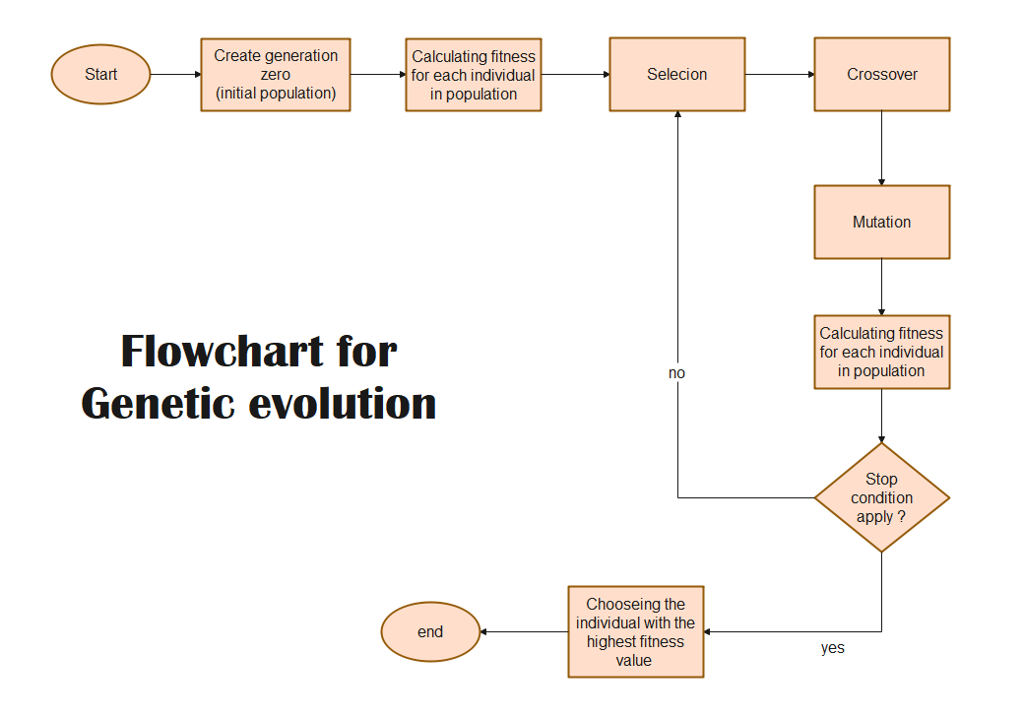

- Pseudocode for a Typical Genetic Algorithm

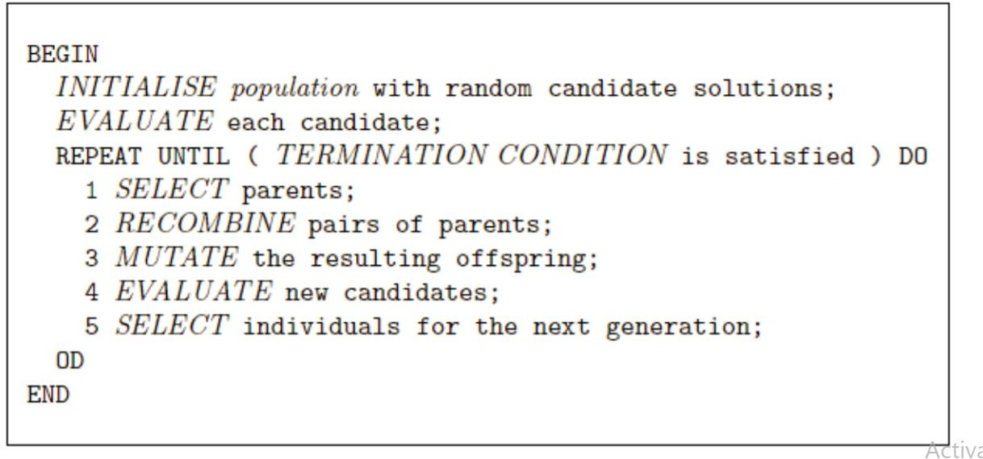

- The Evolutionary Cycle

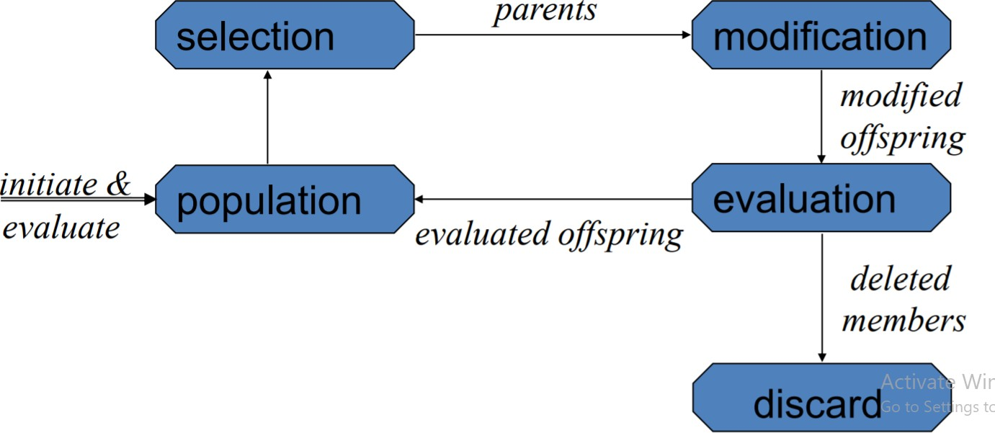

Differential Evolution (DE)
Differential evolution is a heuristic approach for the global optimisation of nonlinear and non- differentiable continuous space functions.
The differential evolution algorithm is a floating-point encoded evolutionary algorithm for global optimization over continuous spaces. The algorithm has so far used empirically chosen values for its search parameters that are kept fixed through an optimization process. The objective of this paper is to introduce a new version of the Differential Evolution algorithm with adaptive control parameters
– the fuzzy adaptive differential evolution algorithm, which uses fuzzy logic controllers to adapt the search parameters for the mutation operation and crossover operation. The control inputs incorporate the relative objective function values and individuals of the successive generations. The emphasis of this paper is analysis of the dynamics and behavior of the algorithm. Experimental results, provided by the proposed algorithm for a set of standard test functions, outperformed those of the standard differential evolution algorithm for optimization problems with higher .

Advantages of (DE)
  - Global optimisation is necessary in fields such as engineering, statistics and finance
  - But many practical problems have objective functions that are nondifferentiable, non-continuous, non-linear, noisy, flat, multi- dimensional or have many local minima, constraints or stochasticity
  - Such problems are difficult if not impossible to solve analytically
  - DE can be used to find approximate solutions to such problems

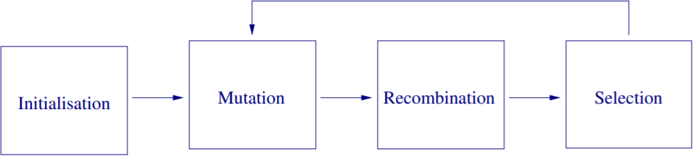
Steps of (DE)

Applications of (DE) :
- Design of digital filters
- Optimisation of strategies for checkers
- Maximisation of profit in a model of a beef property
4. Optimisation of fermentation of alcohol
- flow chart for (DE)

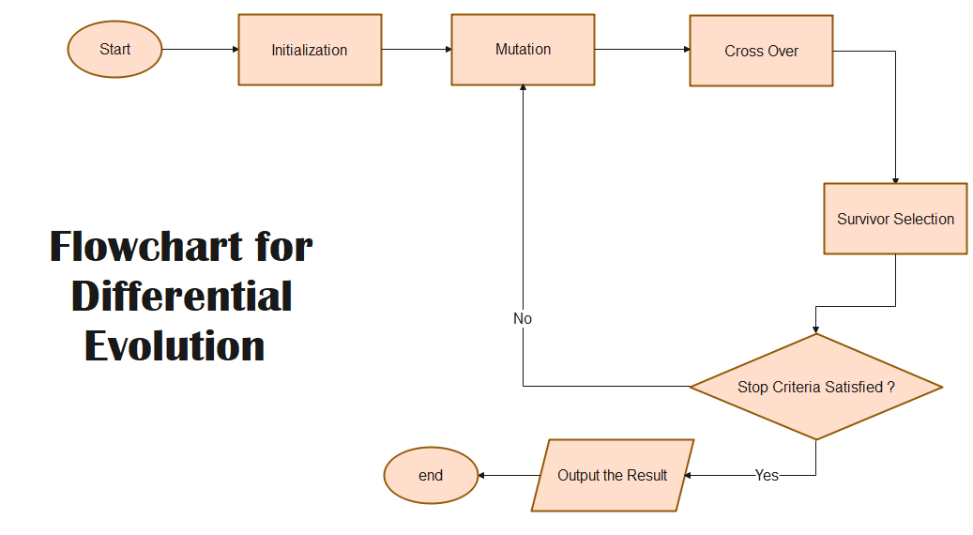

- differential evolution vs genetics algorithm

after we test the two ways in our project :
We find the genetic algorithm is the best way to find the right result Especially genetic algorithm bounded

Genetic algorithms keep pretty closely to the metaphor of genetic reproduction. Even the language is mostly the same-- both talk of chromosomes, both talk of genes, the genes are distinct alphabets, both talk of crossover, and the crossover is fairly close to a low-level understanding of genetic reproduction, etc.

Differential evolution is in the same style, but the correspondences are not as exact. The first big change is that DE is using actual real numbers (in the strict mathematical sense-- they're implemented as floats, or doubles, or whatever, but in theory they're ranging over the field of reals.) As a result, the ideas of mutation and crossover are substantially different. The mutation operator is modified so far that it's hard for me to even see why it's called mutation, as such, except that it serves the same purpose of breaking things out of local minima.

On the plus side, there are a handful of results showing DEs are often more effective and/or more efficient than genetic algorithms. And when working in numerical optimization, it's nice to be able to represent things as actual real numbers instead of having to work your way around to a chromosomal kind of representation, first. (Note: I've read about them, but I've not messed extensively with them so I can't really comment from first hand knowledge.

Use-case :

