Genteral Strategy and overal process:

- Opened Weka.
- Clicked on Simple CLI and type: “java -Xmx1000M -jar weka.jar” in command line in order to make the JVM memory larger.
- Typed “java weka.core.converters.CSVLoader e:\DM\train.csv > e:\DM\train.arff” in command line to convert .csv file into .arff file.
- Entered “Explorer” and choose “open file” to open the .arrf file. (train.arff)
- Deleted the attributed that I don’t want. I kept “age” and “Principle Dx-Code”.
- Chose the tab of cluster and chose the simple k-mean algorithm
- Set some parameters for the algorithm such as the number of iterations and so on.
- Started clustering and analyzed the output.

Description of clustering algorithm and parameters:

I used simple K-means clustering algorithm. The number of iterations is 500. The number of cluster centroids is 4. Seed is 10. Similarity metric is Euclidean distance . I chose k-means with an Euclidean distance because it is very simple and it is suitable for clustering the instances with two attributes that I selected.

Output:

=== Run information ===

Scheme: weka.clusterers.SimpleKMeans -N 4 -A "weka.core.EuclideanDistance -R first-last" -I 500 -S 10
Relation: train-weka.filters.unsupervised.attribute.Remove-R1-2-weka.filters.unsupervised.attribute.Remove-R1-3,5-12,14-77
Instances: 99999
Attributes: 2
Age
Principal-Dx-Code
Test mode: evaluate on training data

=== Model and evaluation on training set ===

kMeans
======

Number of iterations: 12
Within cluster sum of squared errors: 1455.502761807219
Missing values globally replaced with mean/mode

Cluster centroids:
Cluster#
Attribute Full Data 0 1 2 3
(99999) (38942) (16761) (32881) (11415)
==========================================================================
Age 72.7984 80.9953 53.6463 73.3314 71.4208
Principal-Dx-Code 26999.5876 4436.6232 7632.6481 44003.4955 83429.7877

Clustered Instances

0 38942 ( 39%)
1 16761 ( 17%)
2 32881 ( 33%)
3 11415 ( 11%)

Visualization:

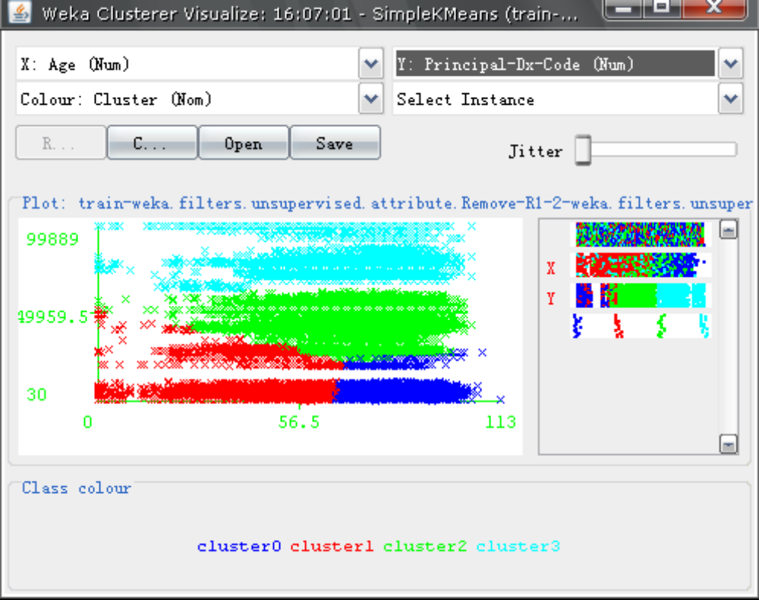

Summary:

As for the result of visualization, we can see the 4 clusters. X axis presents the attricute of “age” and Y axis stands for the attribute of “Priciple diagnosis code”. The instances are divided in to 4 clusters. Since different ages are corresponding to different principle diagnosis code, we are trying to find a relationship between the age and principle diagnosis code by 4 clusters. This kind of clustering can help us to find which people(which age) are apt to have which kind of disease.

