|  |  |  |
| --- | --- | --- |
| **TIME** | **ACTIVITIES** | **CONDUCTORS** |
| **FRIDAY** | | |
| 6PM – 6: 30PM | ARRIVAL / REGISTRATION | COMFORT OKECHI & ESTHER KALU |
| 7:00 – 7: 30 PM | WORSHIP / OPENING PRAYER | CELENA JAMES |
| 7: 30 – 7: 40 PM | HYMNS |  |
| 7: 40 – 8: 10 PM | OPENING CHARGE | REV. MRS. NGOZI IROH |
| 8: 10 – 8: 30 PM | PRAISE SESSION | VICTOR OKPO, BLESSING |
| 8: 30 – 9: 10PM | MINISTRATION | MIN. WISDOM |
| 9: 10 – 10: 00PM | DINNER |  |
| 10: 00 – 10: 45PM | BUILDING CAPACITY | REV. EMMANUEL ANYAERU |
| 10: 45 – 11: 15PM | PRAYER |  |
| 11: 15 – 12: 15 PM | CONGRESS MEETING |  |
| **SATURDAY** | | |
| 3: 00 – 4: 30AM | WAKE UP / MORNING BATH |  |
| 4: 30 – 6: 00AM | MORNING CRY |  |
| 6: 00 – 7:00AM | GENERAL CLEANUP |  |
| 7: 00 – 8:00AM | BIBLE STUDY |  |
| 8:00 – 8: 20AM | PRAISE / WORSHIP |  |
| 8: 20 – 8: 30AM | HYMNS |  |
| 8: 30 – 9:30AM | BUILDING FINANCIAL WALLS | PST. STEVE OGWO |
| 9: 30 – 10: 30AM | THE ALTAR OF PRAYER |  |
| 10: 30 – 11: 30AM | OPPORTUNITIES IN THE TECH INDUSTRY | BRO. SOLOMON ADULE |
| 11: 30 – 12: 30PM | BROTHERS AND SISTERS FORUM |  |
| 12: 30 – 1:30PM | PRAYER / BREAKING OF FAST |  |
| 1: 30 – 2: 30PM | WISDOM FOR LIVING SINGLE | MRS. MERCY EZERA |
| 2:30 – 4: 00PM | GAMES |  |
| 4: 00 – 6: 00PM | REST / REHEARSALS |  |
| 6: 00 – 7: 00PM | OPENING / WORSHIP |  |
| 7: 00 – 7: 10PM | HYMNS |  |
| 7: 10 – 7: 40PM | PRAISES |  |
| 7: 40 – 8: 10PM | DRAMA MINISTRATION | DRAMA DPEARTMENT |
| 8: 10 – 8: 25PM | CHOIR MINISTRATION | PACESETTER CHOIR |
| 8: 25 – 9: 40 | THE WORD / PRAYER |  |
| 9: 40 – 10: 00 | DINNER |  |

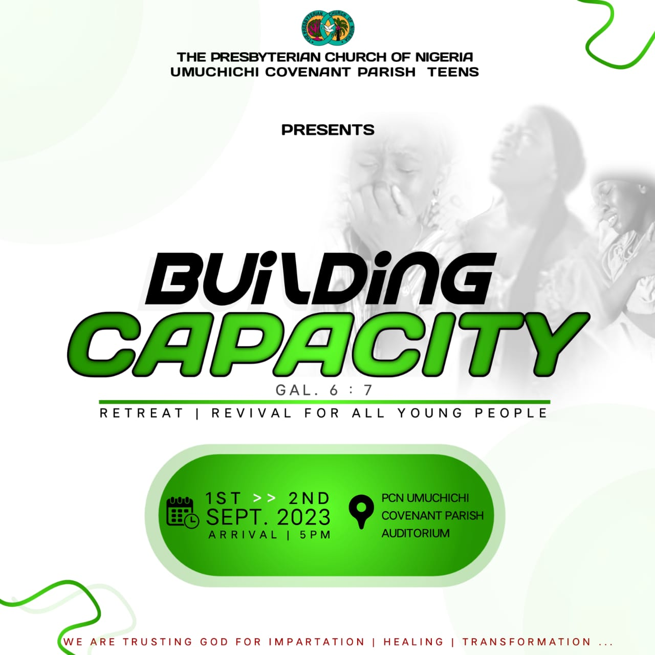B

--- BIBLE STUDY WILL BE TYPED HERE ---

(THE FONT CAN BE AS SMALL AS POSSIBLE, BUT IT SHOULD ALL CONTAIN HERE)

**“Be not deceived, God is not mocked for whatever a man sows, that shall he also reap**

**Galatians 6:7**