[[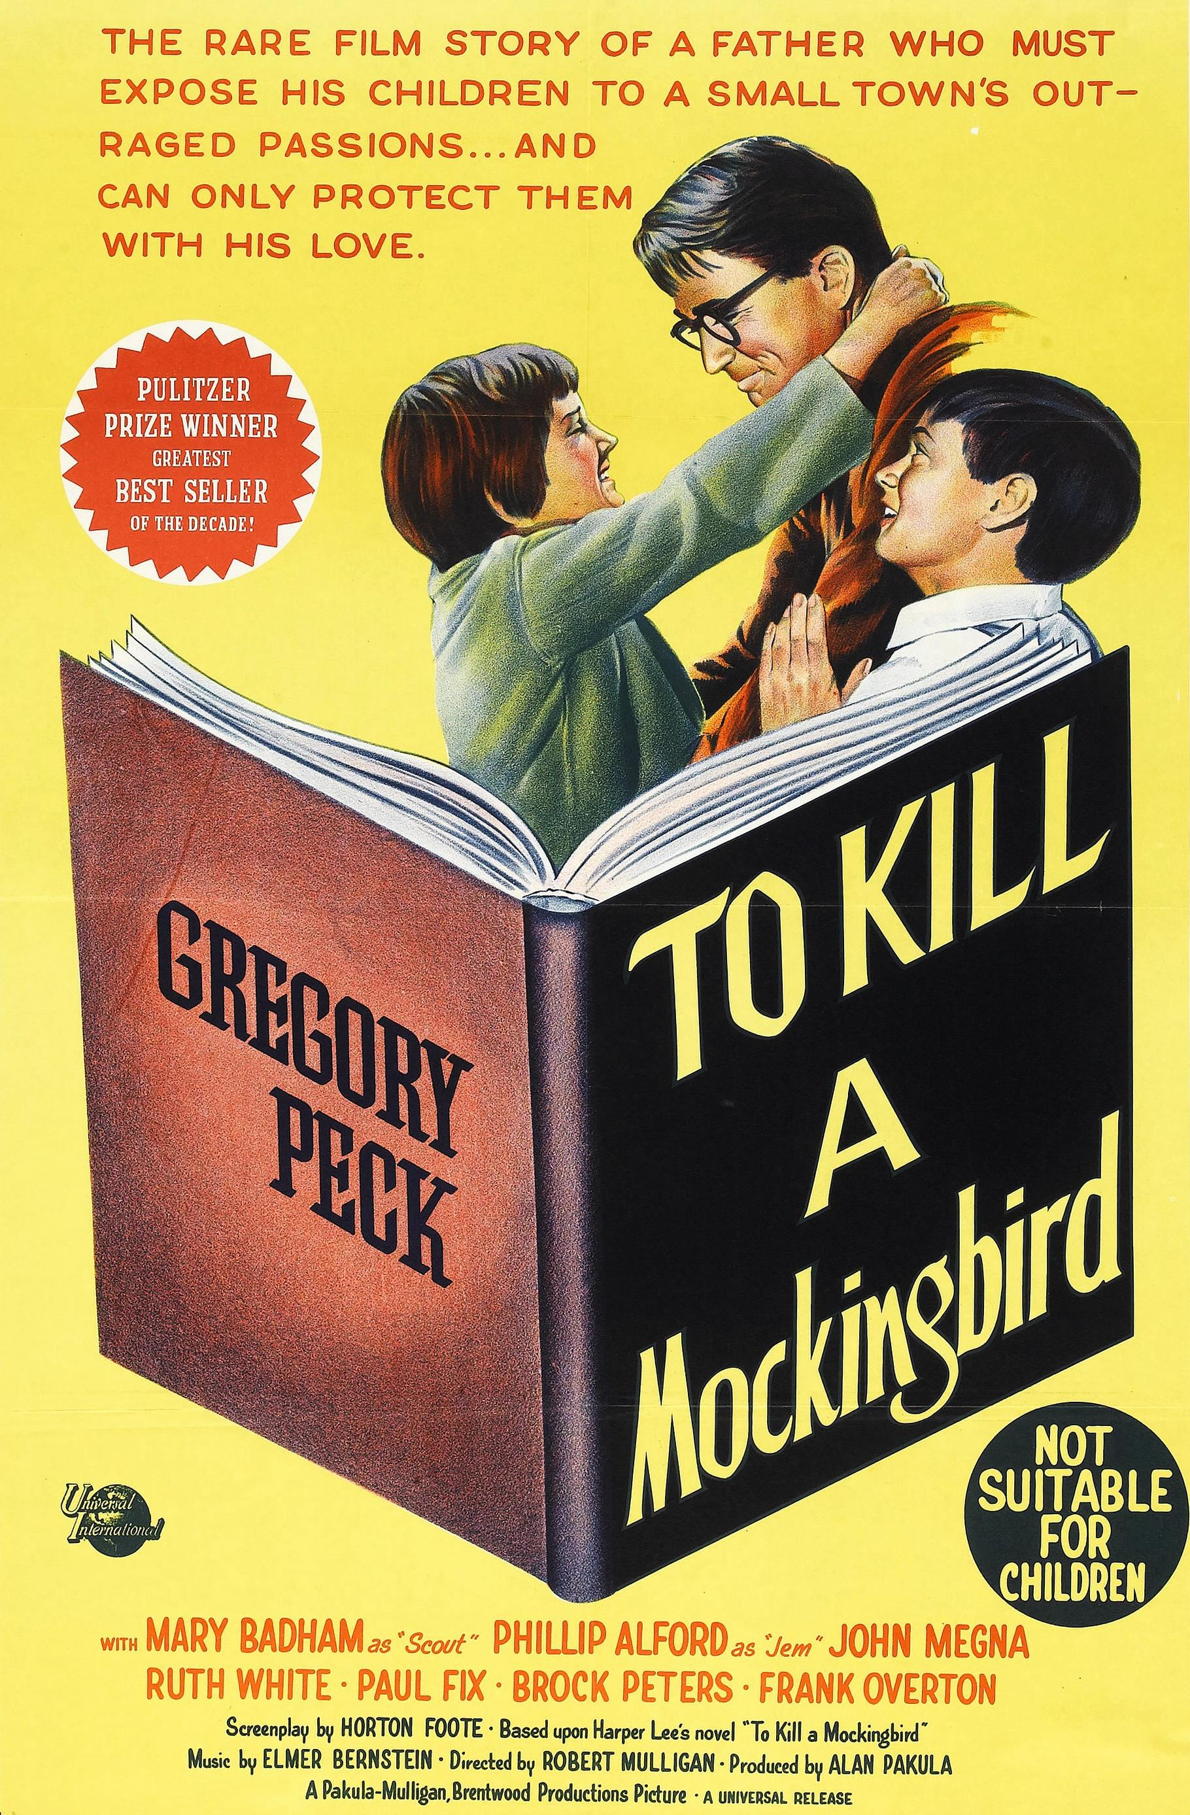](http://localhost:5000/books/books.html)](http://localhost:5000/books/books.html)

[BY: HARPER LEE | 1960](http://localhost:5000/books/books.html)

**TO KILL A MOCKING BIRD**

Set in the fictional town of Maycomb, Alabama, "To Kill a Mockingbird" follows the Finch family, primarily through the eyes of young Scout Finch. Her father, Atticus Finch, is a respected lawyer known for his integrity and his willingness to defend a black man, Tom Robinson, who is falsely accused of raping a white woman. The novel covers a period of three years, during which Scout and her brother Jem experience a series of events that challenge their understanding of the world and reveal the deeply rooted racial prejudices of their society. They befriend Dill, a young boy, and together they become captivated by the enigmatic figure of Boo Radley, a reclusive neighbor rumored to be mentally unstable.

"To Kill a Mockingbird" is a classic novel written by Harper Lee and first published in 1960. It is set in the fictional town of Maycomb, Alabama, during the Great Depression, and it explores themes of racial injustice, moral growth, and the loss of innocence.

Here's some more information about the novel:

**Plot**: The story is narrated by Scout Finch, a young girl, and it follows her experiences growing up in the racially segregated Southern United States. Her father, Atticus Finch, is a lawyer who is appointed to defend Tom Robinson, a Black man accused of raping a white woman, Mayella Ewell. The novel revolves around the trial of Tom Robinson and the impact it has on the Finch family and the town of Maycomb.

**Characters**: The novel features memorable characters, including Scout Finch, her brother Jem, Atticus Finch, Boo Radley (a reclusive neighbor), and Calpurnia (the Finch family's Black housekeeper), among others.

**Themes**: "To Kill a Mockingbird" addresses several important themes, including:

- **Racial Injustice**: The novel exposes the deeply ingrained racism and prejudice in Southern society during the 1930s. It highlights the unjust treatment of Black individuals and the unfairness of the legal system.

- **Moral Growth**: Scout and Jem witness the complexities of human nature and learn important moral lessons throughout the story. Their understanding of right and wrong evolves as they confront the prejudices of their community.

- **Loss of Innocence**: The novel depicts the loss of childhood innocence as Scout and Jem confront the harsh realities of racism and social injustice.

**Impact**: "To Kill a Mockingbird" is considered one of the most important works of American literature. It has had a significant impact on discussions of race and justice in the United States. The novel has been widely taught in schools and has been adapted into a successful film.

**Author**: Harper Lee, born Nelle Harper Lee in 1926, was an American novelist. "To Kill a Mockingbird" was her only published novel during her lifetime. It won the Pulitzer Prize for Fiction in 1961.

**Legacy**: In 2015, a sequel to "To Kill a Mockingbird" titled "Go Set a Watchman" was published, though it was actually written before "To Kill a Mockingbird." The sequel explores the same characters but is set 20 years later.

"To Kill a Mockingbird" continues to be a widely read and studied work, and its themes of justice, empathy, and racial inequality remain relevant today. It is considered a classic of American literature and a powerful commentary on the human condition.