[[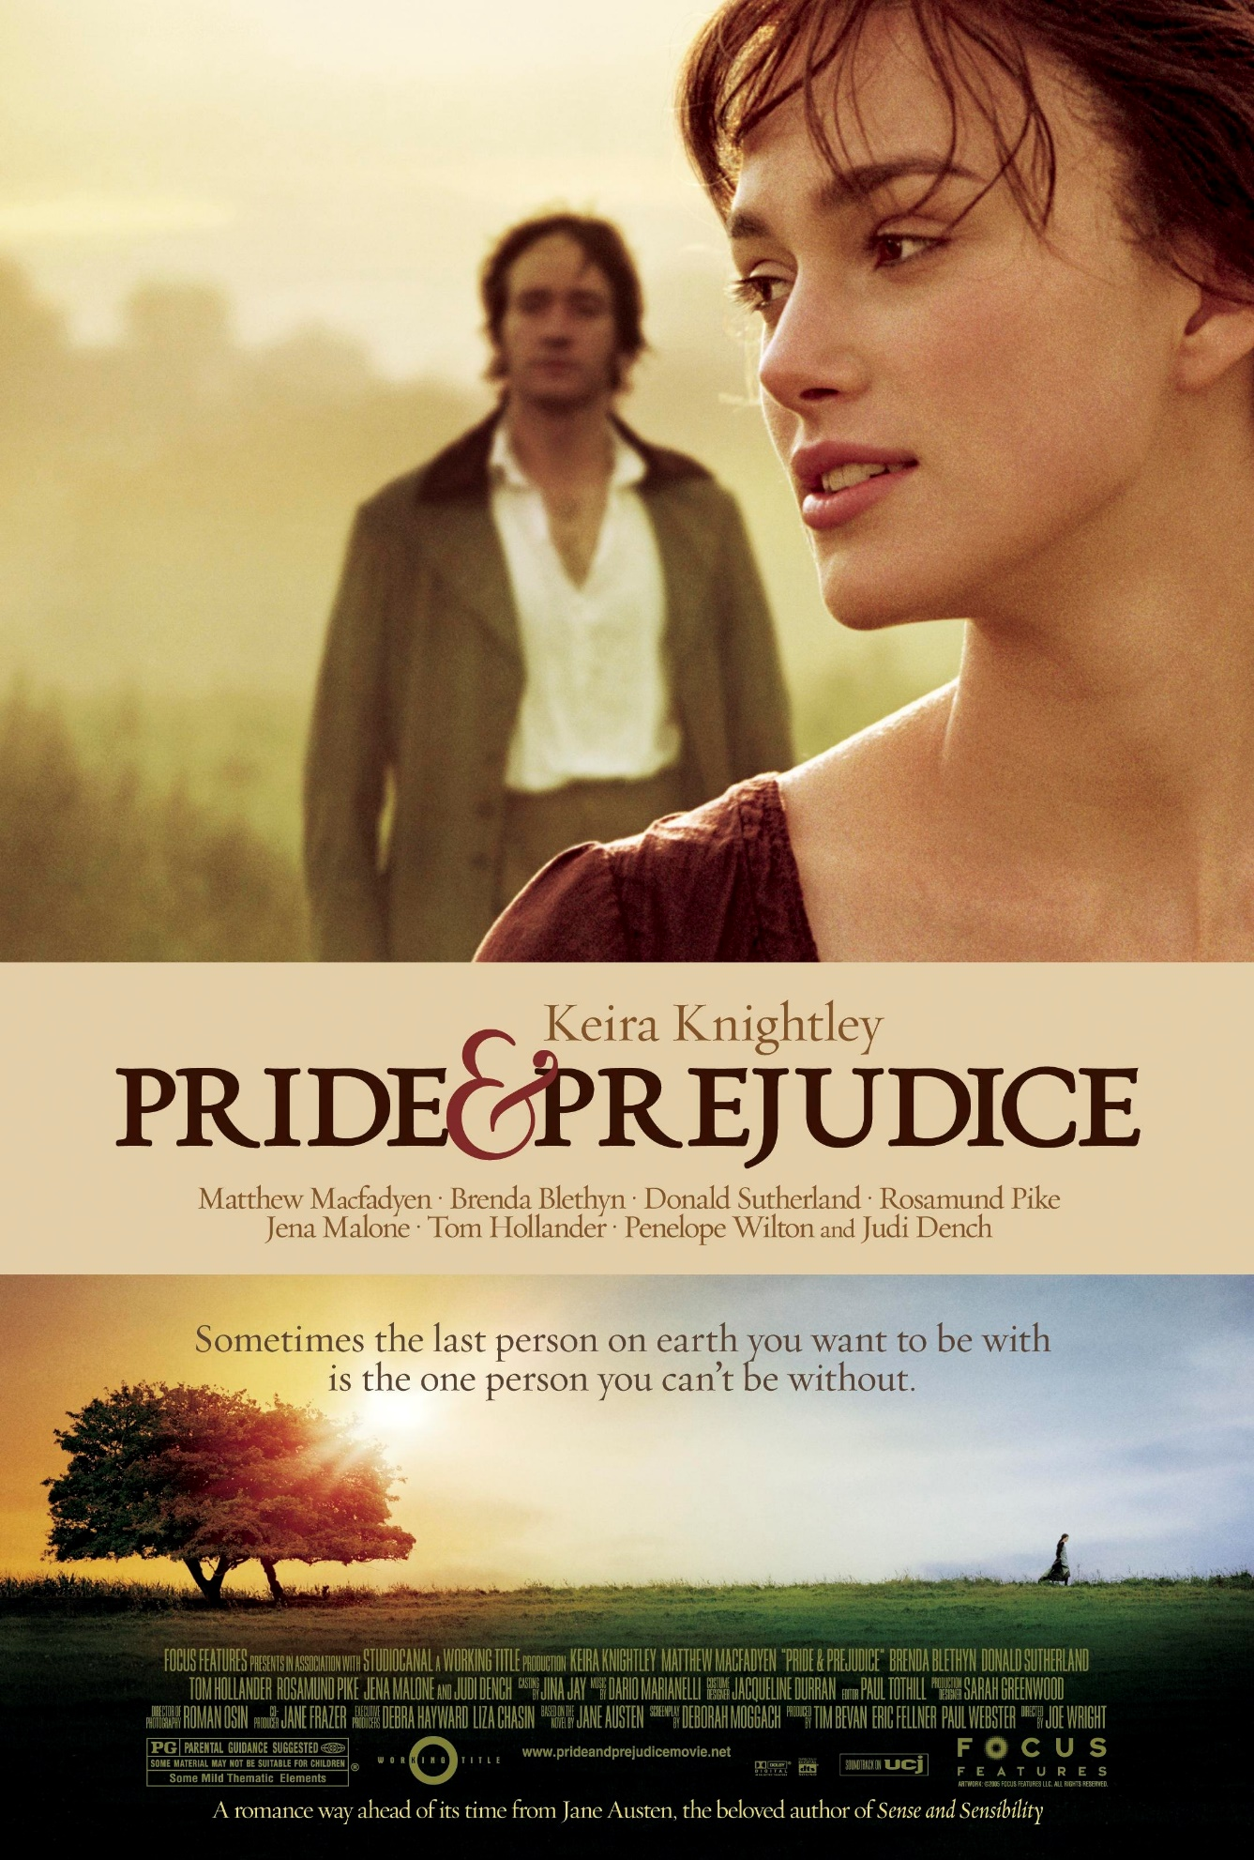](http://localhost:5000/books/books.html)](http://localhost:5000/books/books.html)

[BY: JANE AUSTEN | 1813](http://localhost:5000/books/books.html)

**PRIDE AND PREJUDICE**

"Pride and Prejudice" by Jane Austen is a Regency-era novel focusing on Elizabeth Bennet and her family. Mrs. Bennet seeks suitable husbands for her daughters, especially wealthy matches. When Mr. Bingley and Mr. Darcy enter their lives, romance and misunderstandings ensue. Elizabeth's initial prejudice against Darcy evolves as they confront societal norms and personal biases. The novel critiques class distinctions and emphasizes personal growth and genuine connections. Austen's wit and insight into human nature make "Pride and Prejudice" a timeless exploration of love and social commentary.

"Pride and Prejudice" is a classic novel written by Jane Austen, first published in 1813. It is one of Austen's most famous and enduring works, known for its wit, social commentary, and exploration of themes such as love, class, and marriage in early 19th-century England.

Here's some more information about the novel:

**Plot**: "Pride and Prejudice" is set in rural England and follows the Bennet family, particularly the five Bennet sisters: Elizabeth, Jane, Mary, Catherine (Kitty), and Lydia. The story primarily focuses on Elizabeth Bennet, the second eldest daughter, and her complex relationship with the wealthy and enigmatic Mr. Fitzwilliam Darcy. The plot revolves around the challenges and misunderstandings that arise between the two main characters, as well as the romantic entanglements of the Bennet sisters.

**Characters**: The novel features a rich cast of characters, including:

- **Elizabeth Bennet**: The intelligent, independent, and quick-witted protagonist who values integrity and refuses to settle for a loveless marriage.

- **Mr. Fitzwilliam Darcy**: A wealthy and proud aristocrat who initially appears aloof and arrogant but later reveals his true character.

- **Mr. Bennet**: The father of the Bennet sisters, known for his dry humor and detachment from his family's affairs.

- **Mrs. Bennet**: The mother of the Bennet sisters, obsessed with finding husbands for her daughters, particularly wealthy ones.

- **Jane Bennet**: The eldest Bennet sister, known for her beauty and gentleness.

- **Mr. Bingley**: Darcy's amiable and wealthy friend, who becomes romantically involved with Jane Bennet.

**Themes**: "Pride and Prejudice" explores various themes, including:

- **Love and Marriage**: The novel delves into the complexities of love and marriage, emphasizing the importance of mutual respect, understanding, and compatibility.

- **Social Class**: It scrutinizes the rigid social hierarchy and the consequences of marrying outside one's class.

- **Prejudice and Misunderstanding**: The title itself reflects the central theme of the novel, highlighting how preconceived notions and judgments can cloud one's perception of others.

**Austen's Writing Style**: Jane Austen is celebrated for her satirical and witty writing style. She uses irony, humor, and keen observations of society to comment on the manners and morals of her time.

**Enduring Popularity**: "Pride and Prejudice" has remained immensely popular and influential since its publication. It has been adapted into numerous film and television adaptations, stage productions, and literary retellings. The characters of Elizabeth Bennet and Mr. Darcy have become iconic figures in literature.

**Feminist Interpretations**: The novel has also been analyzed from feminist perspectives, with Elizabeth Bennet often seen as a strong and independent female character challenging societal norms.

**Legacy**: Jane Austen's works, including "Pride and Prejudice," continue to be widely read and studied, and her novels remain a significant part of the English literary canon.

"Pride and Prejudice" is not only a timeless love story but also a social commentary that explores the complexities of human relationships and the constraints of societal expectations in the 19th century. It continues to captivate readers and scholars alike for its enduring themes and memorable characters.