[[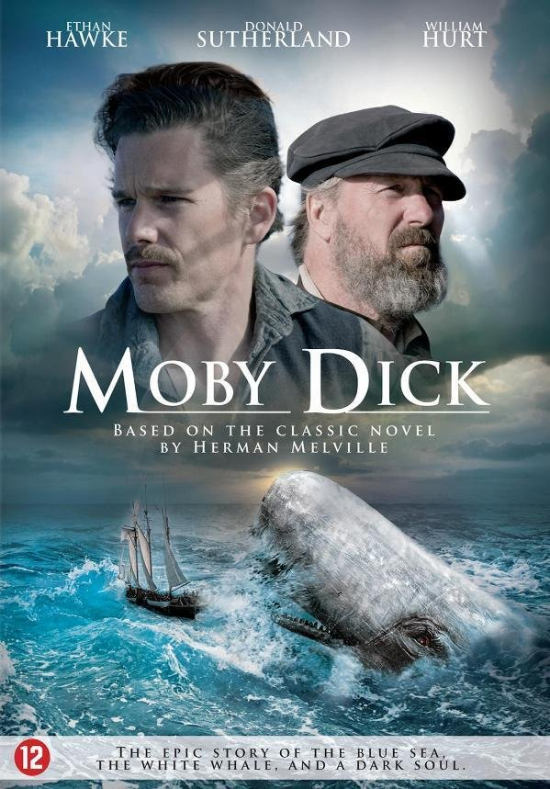](http://localhost:5000/books/books.html)](http://localhost:5000/books/books.html)

[BY: HERMAN MELVIELLE | 1851](http://localhost:5000/books/books.html)

**MOBY-DICK**

Moby-Dick" by Herman Melville is an American classic set in the 19th century. It follows Ishmael, a sailor, and his obsession with Captain Ahab's quest for revenge against the white whale, Moby Dick, who had maimed Ahab. The novel delves into themes of fate, revenge, and man's relationship with nature. As the crew of the Pequod sets out on a whaling voyage, Ahab's relentless pursuit of the whale consumes him and leads to tragedy. The narrative is rich with symbolism and philosophical exploration, examining the human psyche and the primal forces of the sea. "Moby-Dick" is celebrated for its layered storytelling, iconic characters, and exploration of existential themes.

"Moby-Dick," written by Herman Melville and first published in 1851, is a novel often considered one of the greatest works of American literature. It is an epic tale of adventure, obsession, and the relentless pursuit of an enigmatic and vengeful white whale. Here are some key details and insights about "Moby-Dick":

**Plot**: The story is narrated by Ishmael, a young sailor who signs up for a whaling voyage on the Pequod, a whaling ship commanded by the charismatic but megalomaniacal Captain Ahab. Ahab is obsessed with hunting down and killing a giant white sperm whale named Moby-Dick, which had previously bitten off his leg. The novel chronicles the voyage of the Pequod, its diverse crew, and Ahab's single-minded quest for vengeance against the whale.

**Characters**: The novel features a diverse and memorable cast of characters, including Ishmael, Captain Ahab, the harpooners Queequeg and Tashtego, and the mysterious and prophetic figure of Fedallah, among others. But it is Captain Ahab and Moby-Dick who are the central figures, with Ahab representing man's obsession and Moby-Dick symbolizing the unknowable and uncontrollable forces of nature.

**Themes**: "Moby-Dick" explores a range of themes and ideas, including:

- **Obsession**: The novel delves into the destructive power of obsession, as Ahab's relentless pursuit of Moby-Dick leads to tragedy and destruction.

- **Nature vs. Man**: It examines the elemental and indifferent nature of the world, where humans are pitted against the vastness and power of the sea.

- **Symbolism**: The novel is rich in symbolism, with Moby-Dick often interpreted as a symbol of the unknowable and the sublime, while the white whale's color represents both purity and evil.

- **Whaling Industry**: Melville provides a detailed and realistic portrayal of the whaling industry in the 19th century, including its dangers, economics, and the global impact of the trade.

**Narrative Style**: "Moby-Dick" is known for its rich and varied narrative style. It combines elements of adventure, philosophy, encyclopedic detail, and symbolism. The novel features chapters that read like essays on topics ranging from the anatomy of whales to the symbolism of the color white.

**Literary Significance**: While "Moby-Dick" was not a commercial success during Melville's lifetime, it has since gained recognition as a literary masterpiece. Its complexity, symbolism, and philosophical depth have made it a subject of extensive critical analysis and interpretation.

**Influence**: The novel has had a lasting impact on American literature and culture. It has been adapted into various forms, including films, plays, and art. It continues to be studied and revered for its exploration of the human condition and its themes of obsession, fate, and the mysteries of existence.

"Moby-Dick" is a novel that challenges readers with its depth and complexity. It is a work of enduring significance that explores the depths of human nature and the vastness of the natural world, making it a timeless and thought-provoking classic in American literature.