Instead of using this markdown link format for the in-document links:



Can we please use this format:



When the individual markdown documents are merged together, the links work fine.

<https://www.benjaminwuethrich.dev/2020-05-04-everything-pandoc-markdown.html#headings>

The link must match the heading name exactly. The headings must be unique.

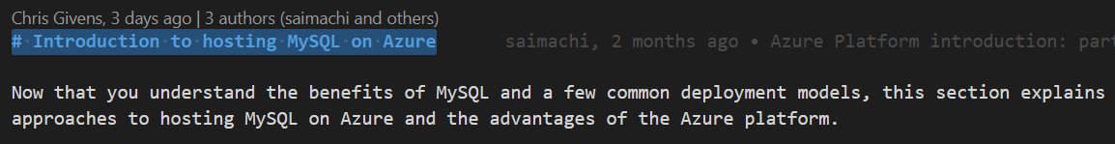

When Pandoc converts to Word, the in document links will work.

