**ASSIGNMENT FOR FULL STACK DEVELOPER**

This assignment should be able to be solved in approx. 3-4 hours. It's not a big deal if it takes you longer. The goal is to get a clear overview of how you think and work.

**OVERVIEW**

[FEN](https://en.wikipedia.org/wiki/Forsyth%E2%80%93Edwards_Notation) is a standard notation for describing a particular board position of a chess game.

Here is a FEN for a starting position in chess:

|  |
| --- |
| **rnbqkbnr/pppppppp/8/8/8/8/PPPPPPPP/RNBQKBNR w KQkq - 0 1** |

Note that there are 7 forward slash (/) that separate the 8 rows on a chessboard. Each row indicates via letters which columns have which pieces, or a number indicating the number of consecutive empty columns in that row. Uppercase letters represent the white pieces. For this assignment, you can ignore everything after the first whitespace in the FEN string.

Here is an example of a FEN string a bit further into the match:

|  |
| --- |
| **rnbqkbnr/pp1ppppp/8/2p5/4P3/5N2/PPPP1PPP/RNBQKB1R b KQkq - 1 2** |

and the associated position of the pieces:

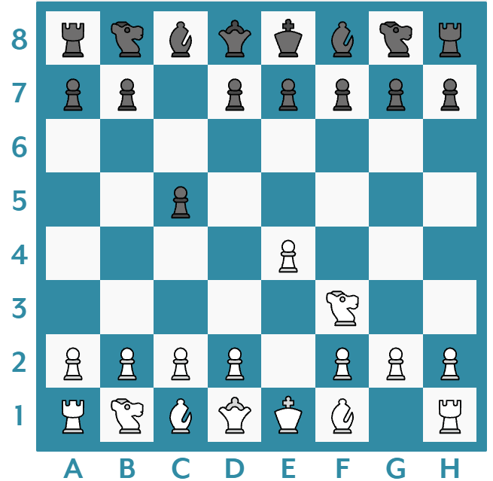

**INSTRUCTIONS**

A git repo with the solution must be submitted via the Laravel framework / PHP / jQuery / Javascript. Please include instructions in the form of a README file for how to view the solution. The solution can be submitted as a zip file or a URL to a public archive on an Internet-based git-hosting solution (github, bitbucket, etc.).

**THE ASSIGNMENT**

**Functionality:**

Via the Laravel framework, you must create a view that can:

* Display a chessboard with a correct positional layout based on a GET URL-parameter containing a FEN string:

|  |
| --- |
| **http://localhost/?fen=[FEN]** |

* If you access the page without a FEN string or the URL "/ rand", the chessboard must show a random positional arrangement among the following FEN strings that must come from a database. Laravel's migration and seed files for the table must be included in the solution.

|  |
| --- |
| **rnbqkbnr/pppppppp/8/8/8/8/PPPPPPPP/RNBQKBNR**  **rnbqkbnr/pppppppp/8/8/4P3/8/PPPP1PPP/RNBQKBNR**  **rnbqkbnr/pp1ppppp/8/2p5/4P3/8/PPPP1PPP/RNBQKBNR**  **rnbqkbnr/pp1ppppp/8/2p5/4P3/5N2/PPPP1PPP/RNBQKB1R** |

* If you press the "New FEN" button, the chessboard must show a random positional layout from the FEN table using javascript / JQuery.

**Design:**

We expect an accurate reproduction of the responsive design as shown below. The chess pieces are found in the corresponding pieces.zip

|  |  |
| --- | --- |
| Desktop 960px | Mobile 375px |

Your code will be tested in Google Chrome.

Good luck!