The java icon has been replaced with a loaf of bread. A login page has been added before you can get to the bakery GUI. After a succesful login the login information retrieved from the user and the SQL database are cleared from memory for security purposes.

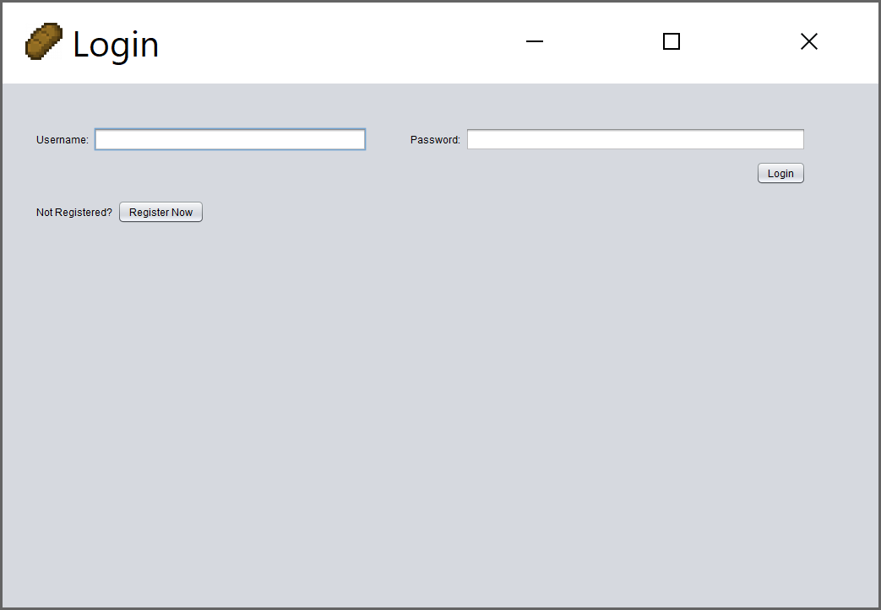

The login checks to see if the user has entered a correct, registered username and password, and prompts the user if the information they have entered is incorrect or does not exist. 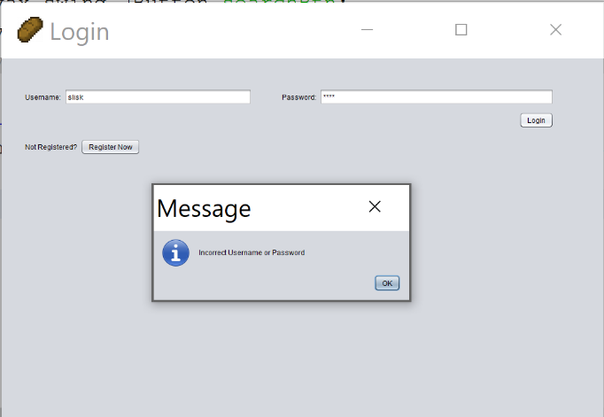

The login page also has a registration link for the customers to register to be able to login. This ensures that a customer cannot place an order without being a registered customer. The customer page has been redesigned to no longer have a registration form, as it has been moved to the registration GUI. Each page opens its own separate JFrame to allow ease of use for the users.

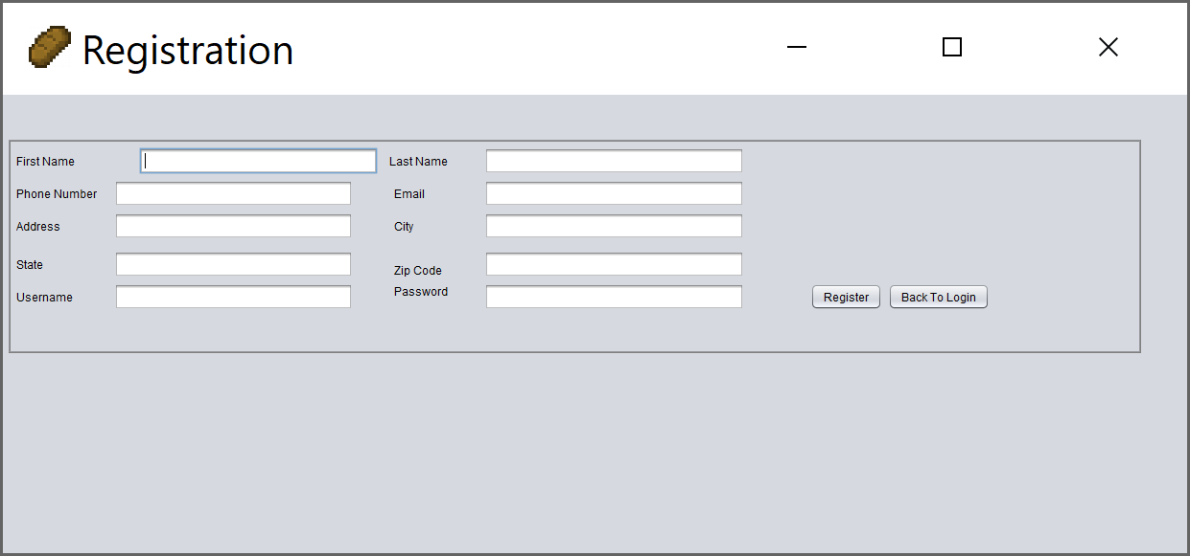

The Customer search tab allows the user to search the customers SQL table and returns the customer’s ID, last name, first name, city, state, zip, phone number, email, and their username. The password is not returned for security reasons.

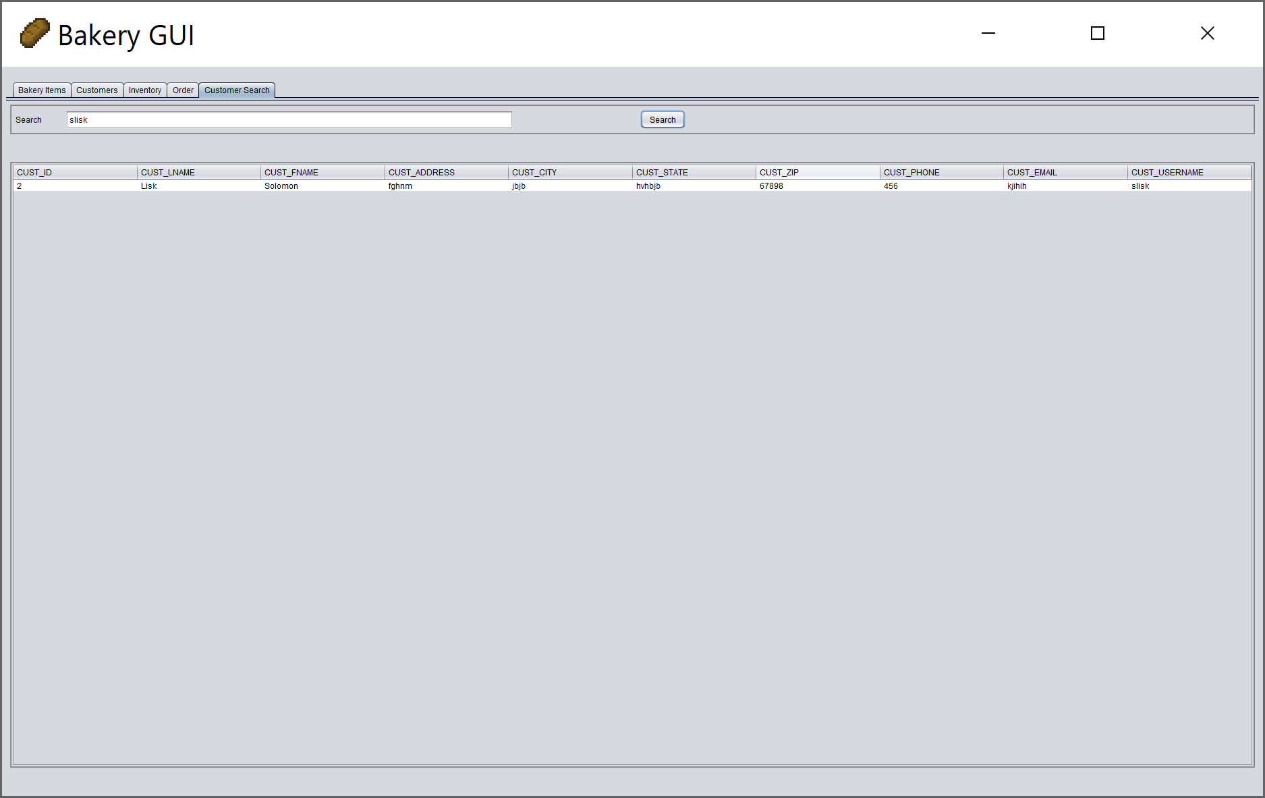

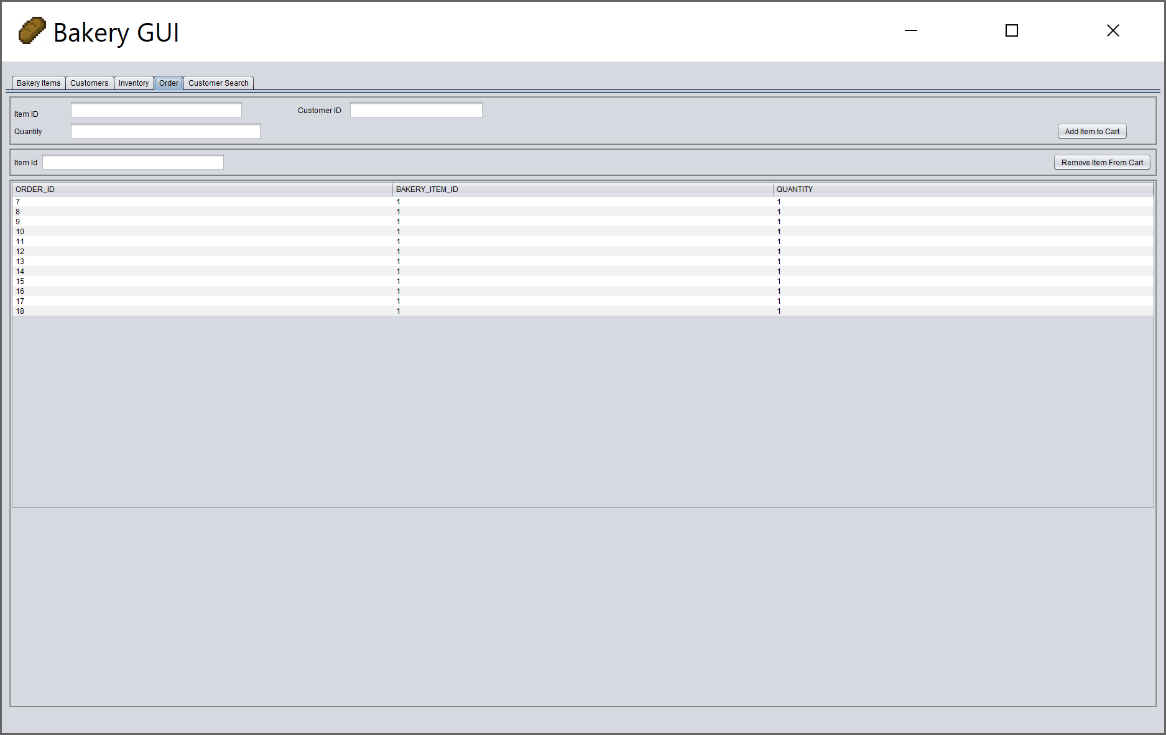

The orders tab allows the user to make an order then displays the order id, bakery item id, and the quantity.