Assignment 2 Writeup
Name : M V S S Manish
Roll No: P2CSN17021

File : Assignment2.jpg

When we do a file on this jpg it shows it contains data but when we binwalk it we can see some files hidden in it we can directly unzip this one. After unzip I found four files. Two were wav files so I started with them.

New1.wav : This sounded like morse when I played it then I opened this with audacity and started reading it’s spectrogram which gave the morse code. This was taking way too long so I used an online tool which converts audio morse to text which gave a leet S 3 E 4 U D 1 O C H A 1 1 3 N G 3 S 4 R 3 E 4 5.

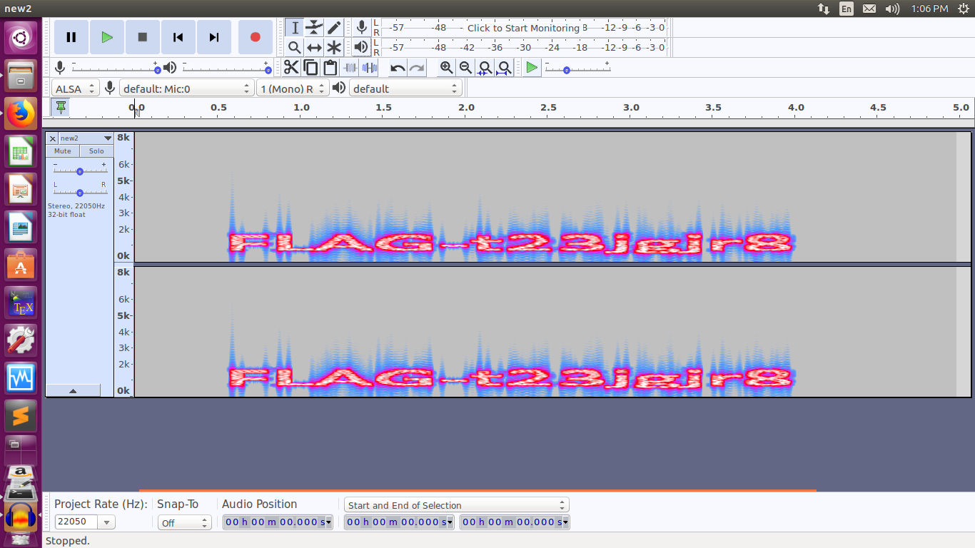

New2.wav : This sounded like nothing when played so I used audacity in spectrogram mode which gave me the flag.

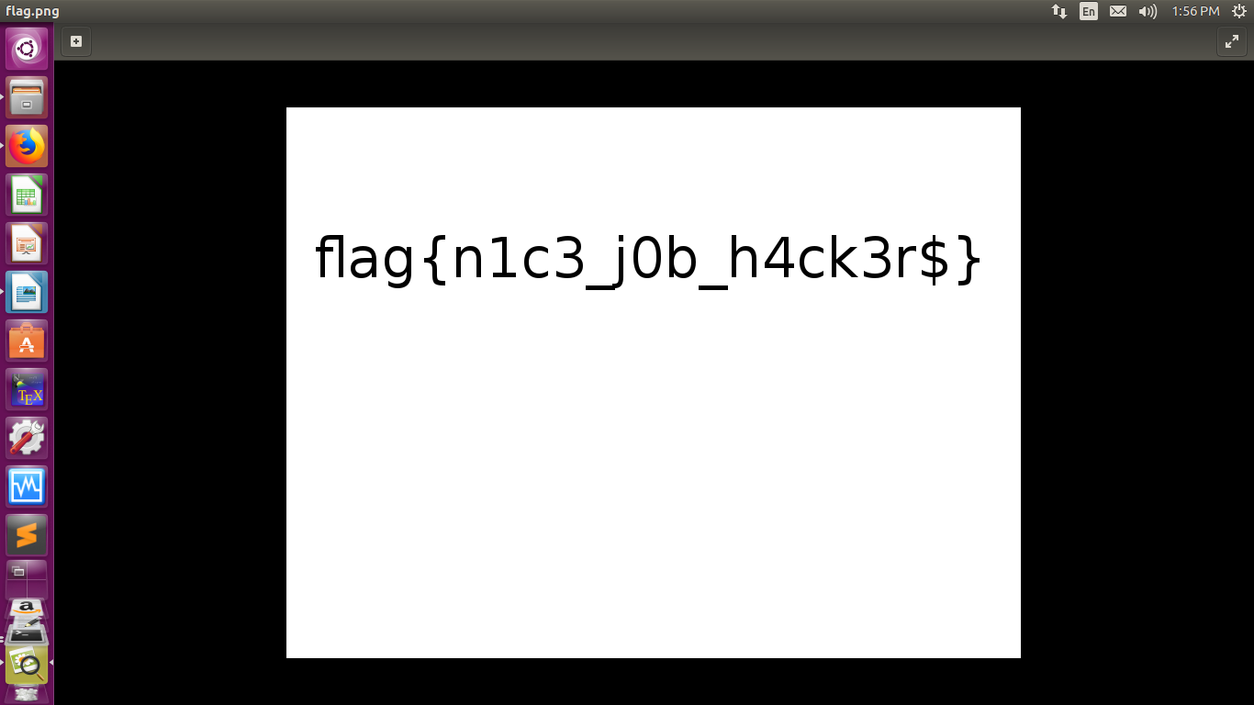
The next file is cover.tar we untar it we get a flag.zip file unzipping it throws an error saying file length too long using zipdetails we can see the file name has some garbage values also and the file length is 00 FF which is way too long than given in the zip specification now we change this 00FF to 0008 as specified by the zip file documentation. Which is 8 bytes in length. Now the file opens normally.

Next we have the evidence file which on file command gave nothing and when ran using strings it gave out IEND and IDHR chunk data in a reverse format so I understood that the file is reversed so I used a script to reverse the file

file1 = open("evidence", "r")
inp = file1.read() #read the file
rev = inp[::-1] # reverse it
out = open("output","w")
out.write(rev) # write into new file
