visNormSC user guidance

Comma separated values (csv) format file can be edited in Microsoft Excel and then saved as csv file.

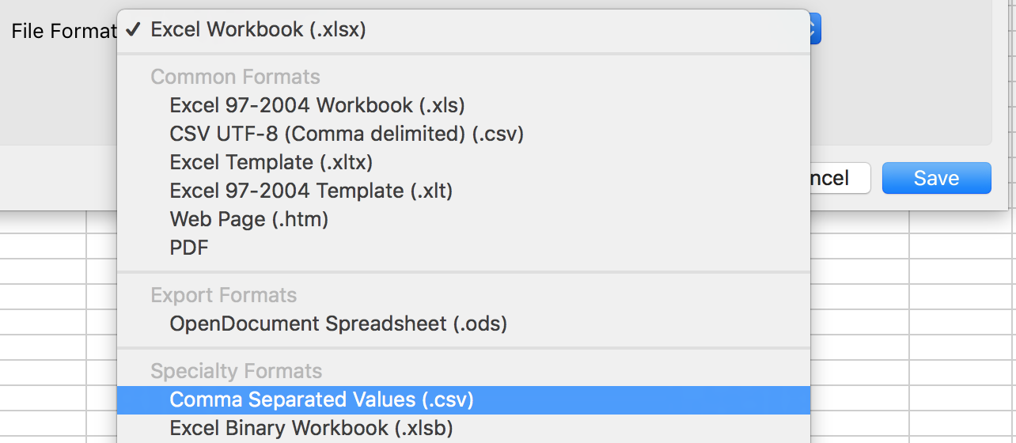

Input data: a comma delimited csv file. The first row shows columns names and first column shows row names. Each column represents a cell and each row represents a gene.

Example_input_data.csv

|  |  |  |  |  |  |
| --- | --- | --- | --- | --- | --- |
|  | Cell_1 | Cell_2 | Cell_3 | Cell_4 | Cell_5 |
| Gene_1 | 9 | 2 | 16 | 0 | 4 |
| Gene_2 | 4.98 | 2.99 | 2.28 | 0 | 3.2 |
| Gene_3 | 0 | 0 | 0 | 0 | 0 |
| Gene_4 | 4 | 11 | 1 | 1 | 2 |
| Gene_5 | 82 | 65 | 110 | 308.52 | 71 |
| Gene_6 | 0 | 3.72 | 4.53 | 0 | 0 |
| Gene_7 | 9 | 0 | 0 | 0 | 0 |

condition file: this file shows what condition each cell in the input data belongs to. It is a single column csv file, without column and row names. Rows map to cell columns in the input data.

Example_condition_file.csv

|  |
| --- |
| Cond1 |
| Cond1 |
| Cond2 |
| Cond3 |
| Cond3 |

Normalize

Number gene groups (K)

- Default: None

- Custom: e.g., cond1: 10, cond2: 6, cond3: 8, this means cond1 has 10 groups, cond2 has 6 groups and cond3 has 8 groups. The number of gene groups should be an integer of > 0. The condition names (e.g., cond1, cond2, and cond3) given here should match the condition names given in the condition file.