TurbineCount, Explained Simply
Every from-scratch piece of the project, in plain English

This guide explains, with no math and no jargon, every tool the project built by hand to find wind turbines in free satellite pictures. You do not need any technical background. Each section opens with a one-line summary, then a short, friendly explanation built around an everyday analogy.

The 30-second big picture
Wind turbines are spread across the country, and there is no fast, free, up-to-date map of which ones are actually spinning. This project tries to spot them in Sentinel-2 satellite images, which are free and refreshed every few days. The catch is resolution: in these images each pixel covers a 10-meter square of ground, so a whole turbine is only a few dots wide. The team built their own image-analysis tools from scratch (rather than using off-the-shelf libraries) and tested them honestly. Below is each of those from-scratch ideas, in plain language. The headline tools are the classic building blocks (edges, corners, lines, shape-matching), a brightness clue, a genuinely new motion clue (the star of the project), and a careful way of grading themselves.

1. The shared engine: sliding a stamp, and softening the picture
In one line: The basic move behind every tool is sliding a little stamp across the image. A first gentle blur cleans up speckle so the real shapes show.

Convolution: sliding a stencil over a picture
Imagine taking a small square stamp and pressing it down on one spot of a photo, then sliding it one step to the right and stamping again, over and over until you have covered the whole picture. That is convolution. The little stamp is called a kernel, just a tiny grid of numbers. At each spot, the tool looks at the handful of pixels under the stamp, multiplies each one by the matching number in the stamp, adds the results into a single new value, and writes that value into the same spot of a fresh image. Slide, blend, write, repeat, and you have transformed the entire picture one neighborhood at a time.
Depending on what numbers you put in the stamp, this one move can soften an image, sharpen it, or highlight its edges. That is why it matters here: this single sliding-window engine is the shared foundation that every other tool in the turbine detector is built on, so getting it right once means everything downstream works. One nice touch in the code is reflect padding: when the stamp hangs off the edge of the photo, the tool mirrors the real edge pixels outward instead of pretending the outside is black, so it never invents a fake dark border that would fool the turbine search.

Gaussian blur: softening the picture
Picture looking at a photo through frosted glass: the sharp speckles melt away and only the larger shapes remain. That is a Gaussian blur. It uses the sliding stamp from above, but the stamp's numbers are weighted so the center pixel counts most and neighbors count less the farther away they sit, gently averaging each pixel with the ones around it. The spread is set by one knob called sigma, and the tool reaches out about three times that far before the weights fade to nothing.
This matters because raw satellite pixels are jittery with random noise, and since a wind turbine is only a few pixels wide, that speckle can drown it out. Smoothing first lets the genuine shapes stand out, and it is the necessary first step before the team hunts for edges and corners. The clever detail is that the blur is separable, meaning instead of one slow pass with a big square stamp, the code does two cheap passes, one across the rows and one down the columns, getting the identical result with far less work.

2. Sobel edges: finding where brightness changes
In one line: Finds outlines, the places where the picture jumps from dark to light. This was the most useful of the classic hand-built tools at 10 meters.
Imagine setting a coin on a sheet of paper and tracing its rim with a pencil. The line you draw sits exactly where the dark coin meets the bright paper. That boundary is what people in image work call an edge: a spot where the picture suddenly shifts from light to dark or back again. Our eyes find these instantly, but a computer just sees a grid of brightness numbers, so it needs a trick to spot the jumps.
Sobel is that trick. It slides a small three-by-three pattern across the image, one pixel at a time, and at each stop it asks how fast the brightness is changing right here. A steep jump from dark to light produces a big number; a smooth, even patch produces almost nothing. It measures this twice, once looking left-to-right and once up-and-down, then blends the two into a single edge strength for every pixel. The result is a map that glows along outlines and stays dark everywhere flat.
This matters for turbines because at 10 meters per pixel a turbine is tiny, but it still casts edges: the bright hub, the slender tower, and the thin shadows of the blades striped across the field. In this project, the average edge strength near a patch's center turned out to be the most useful of all the hand-built classic tools at this resolution, while the others mostly fell flat. A nice touch from the code: it records not just how strong each edge is, but which direction it points.

3. Harris corners: spotting distinctive points
In one line: Picks out distinctive spots, like the bright hub at a turbine's center. A minor helper here, and largely redundant with simply measuring brightness.
Imagine looking through a tiny window cut out of a piece of paper, sliding it across a picture. On a blank wall, nudge the window any direction and you see the same flat nothing; there is nothing to grab onto. Along the straight edge of a ruler, you can slide the window along the line and the view barely changes, so you cannot pin down exactly where you are. But the tip of a star sticker is unmistakable: shift your gaze even slightly in any direction and the view changes. That tip is a corner, a spot that looks different no matter which way you nudge it.
Harris corner detection automates exactly this test. At every pixel it asks, if I shifted my little viewing window a bit in every direction, would the picture change a lot? Flat areas barely change, so they get a low score. Edges change in only one direction, so they get a middling score. True corners change in all directions, so they get a high score. The result is a corner-score map highlighting the standout points.
Why care for turbines? Each turbine has a bright, compact hub at its center that pops against the smooth surrounding field, giving a corner-like signal. Honestly though, Harris was only a minor helper here, weaker than the edge detector and mostly redundant with just measuring brightness, which is a fair and interesting finding in itself. One nice touch: it gently blurs the gradient information first, so a single noisy pixel cannot fake its way into looking like a corner.

4. Hough transform: finding straight lines by voting
In one line: Hunts for straight lines by letting edge pixels vote. The honest result: at 10 meters it did not work, the clearest dead end in the project.
Imagine a crowd of people scattered across a town, each standing somewhere on some road. You ask everyone: which roads could you possibly be standing on? Each person raises a hand for every road that runs through their spot. Most roads get a stray hand or two, but a real road, packed with people, collects a huge pile of votes. Count the hands, and the roads with the biggest tallies are almost certainly real. That counting game is the Hough transform.
Here is what the tool actually does. First it marks the edge pixels, the spots where brightness changes sharply. Then each edge pixel votes for every straight line that could pass through it, and lines that collect many votes are declared real. One nice safety detail: a big flat blank patch could flood the tally with meaningless votes, so the code only lets genuinely strong edge pixels raise their hands.
Why turbines? The team hoped a turbine's spinning blades would cast short straight shadows that this voter would catch. Here is the honest result: in these free satellite images, where each pixel covers 10 meters, a whole turbine is only a few pixels wide. The blades simply are not clean, resolvable lines at that scale, so there is nothing crisp to vote on, and the method scored about as well as flipping a coin. Explaining a method that failed, and exactly why, is real science too.

5. Template matching: looking for a known shape
In one line: Slides a small cut-out of the bright hub across the image to find where it fits best. A modest helper, since it mostly re-measures brightness.
Imagine you are hunting through a giant crowd photo for one specific face, and you have a small cut-out picture of it in your hand. You slide that cut-out across the big photo, and at every spot you ask, does this little patch look like my cut-out? Where it clicks into place, like a puzzle piece settling into its slot, you have found your target. That is template matching.
Here, the cut-out is a tiny bright blob standing for the turbine's hub (the chunky center of the windmill, called the nacelle). The program slides that template across the whole satellite image, and at every position it scores how well the patch underneath matches. A bright, compact spot scores high; a flat, empty field scores low.
Now the interesting design choice. There are two flavors of this trick. One, the normalized version, deliberately ignores how bright things are and only judges the shape, which is handy when lighting keeps changing. The team chose the other, simpler version, called a matched filter, which does react to brightness. Why keep brightness? Because a turbine hub really is a bright little spot, so brightness is the very clue they are chasing; tossing it out would mean discarding the best hint. That is a tidy lesson in picking a tool that fits the problem. The honest result: this hand-built hub detector worked, but at 10 meters it added little beyond simply measuring brightness, so it was a modest helper, not the star.

6. Salience: does the center stand out from its surroundings?
In one line: Measures how much the middle of a patch differs from the ring around it. The best of the simple appearance clues, and it explains the project's core challenge.
Imagine glancing at an apartment building at night and noticing one lit window in a wall of dark ones, or spotting a single coffee stain on a white tablecloth. What catches your eye is not how bright or dark the thing is on its own. It is how much the middle differs from everything around it.
That is exactly what this tool measures. It looks at a small patch of satellite image, takes the brightness right at the center, and compares it to the ring of ground around it. It asks: given how bright that surrounding ring usually is, and how much that brightness normally wobbles, how unusual is the center? The answer is a z-score, which is just a tidy way of saying how many normal wobbles away from average the center is. A big number means the middle really pops out; a small number means it blends in.
This brightness salience score turned out to be the strongest of the simple appearance clues. It also exposes the project's core difficulty. On plain, calm ground a turbine stands out nicely. But on bright or busy, textured terrain, the surroundings are already jumpy, so the turbine no longer looks unusual and the clue quietly fails. That failure is exactly what the next idea was built to rescue.

7. Band-parallax: reading the blur of a spinning blade
In one line: The new idea and the star of the project: it reads the faint rainbow smear a spinning blade leaves, so it can tell whether a turbine was actually turning, even where the turbine is invisible by looks.
Picture a photo of a race car taken with an old camera. The car moves so fast that it comes out smeared, sometimes with a faint rainbow edge where the colors do not line up. That little rainbow streak is the heart of this idea. We can use the same smear to catch a wind turbine in the act of spinning, from space.
Here is the trick. A color satellite image is not one photo. It is three photos stacked together: a blue one, a green one, and a red one. On the Sentinel-2 satellite these three are not snapped at the same instant. The blue is taken first, the green about a third of a second later, and the red about one full second later. For anything sitting still, a building, a field, a parked turbine, this does not matter; all three colors line up perfectly, like three tracings of the same drawing.
But a spinning turbine blade is not sitting still. In that one-second gap, the blade tip races tens of meters across the ground, so it lands in a slightly different spot in each color photo. When you stack them, you get a tiny rainbow fringe right at the turbine, a faint red-versus-blue smear that a still object simply cannot produce.
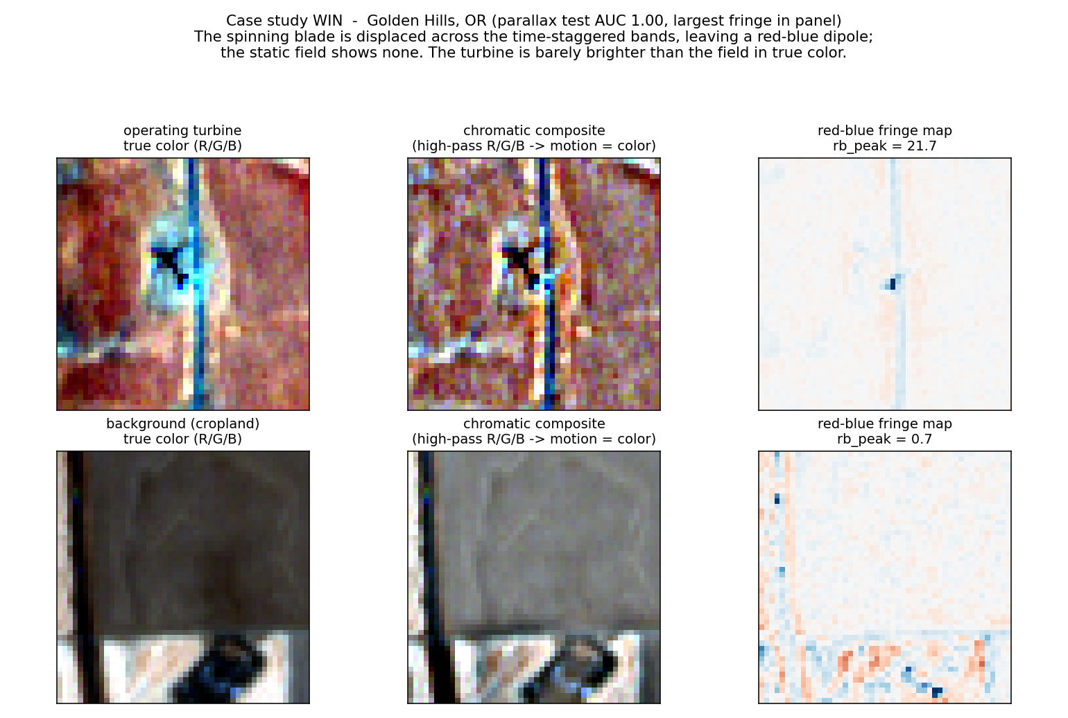
A real example. Top: a spinning turbine leaves a sharp red-and-blue dipole even though it is barely brighter than the field. Bottom: an empty field shows no such fringe.
The team turned that fringe into about 19 careful measurements. A few examples. How strong is the red-minus-blue color clash at the center? How far apart are the brightest extra-red spot and the brightest extra-blue spot? Think of a tiny magnet with a plus end and a minus end, what they call a dipole; the gap between those two poles tells you how far the blade traveled. They also run a consistency check: since red lags blue more than green does, the red fringe should be bigger than the green one, in proportion to those time gaps. A real spinning blade obeys this physics; a random color glitch does not.
Why is this special? Because it keys on motion, it tells you whether a turbine was actually spinning, which is a stand-in for whether it was generating power, not just whether one is bolted to the ground. It is the single best clue on bright or busy ground, where a turbine is too small and pale to spot by looks alone. And the team proved this is genuinely about movement, not a sneaky way of measuring brightness: they stripped out brightness and contrast, and the motion signal still shone through.
The honest catch: a turbine standing idle, with no wind or under maintenance, leaves no fringe at all. To this clue, a still turbine is invisible. It sees the dance, not the dancer.

8. Testing honestly: not fooling yourself
In one line: How the team made sure their results were real and not self-deception, which is as important as any single tool.
The truly impressive part is how carefully the team avoided fooling themselves. Three habits stand out.
First, they kept whole wind farms together when splitting their data into a practice pile and a final-exam pile. Otherwise the computer could study one turbine, then get quizzed on its near-identical neighbor from the same farm, like an exam made of slightly reworded homework. Keeping each farm entirely on one side prevents that kind of cheating, which is called data leakage.
Second, they touched the final-exam data exactly once, at the very end, after every choice was locked in. That stops the tempting habit of quietly retrying until a lucky score appears.
Third, they reported an honest scoreboard. The main number, called AUC, measures how well the method ranks real turbines above empty land, where 1.0 is perfect and 0.5 is a coin flip. They paired it with a confidence range showing how much that score might wobble if different farms had happened to be chosen. Because of this honesty, they also reported where the method was weak, not just where it shone, which is exactly why this guide can tell you plainly that the Hough line tool failed and that the new motion clue is blind to idle turbines.

