TurbineCount v2
A band-parallax (blade-motion) wind-turbine detector for Sentinel-2
Significance, an apples-to-apples SOTA comparison, and a rigorous results / ablation deep-dive

Prepared for: Sophie | Scope: turbinecount_v2/ | Date: 31 May 2026
All figures and numbers in this report were regenerated in-session from the cached feature matrix (artifacts/s2_matrix.npz), the frozen model (artifacts/best_s2_model.joblib), and four Sentinel-2 chips re-fetched live from AWS Earth Search. The held-out test split was scored exactly as in the project's locked evaluation. New ablation traces are saved under artifacts/ablations/ and case-study chips under artifacts/casestudy/.

Executive summary
The project turns a physical side-effect of how Sentinel-2 builds an image into a working detector. Sentinel-2's visible bands are exposed at slightly different times (green about 0.324 s after blue, red about 1.005 s after blue), so a spinning blade sits at displaced pixels across the color bands and leaves a localized rainbow fringe that a static object does not. The project engineers 19 interpretable features from that fringe, from scratch, and shows the cue carries real motion information that is separable from simple brightness or contrast.
On a clean, leakage-free, project-grouped split of 173 US wind projects across 35 states, scored once on 33 held-out projects, the headline numbers reproduce exactly:
Detector (held-out test) | pooled AUC | per-project AUC | AP
CS131 primitives only (old fallback) | 0.787 | 0.792 | 0.777
Static salience (z-score + CS131) | 0.956 | 0.948 | 0.954
HOG + linear SVM (appearance baseline) | 0.933 | 0.938 | 0.928
Band-parallax / motion only (novel) | 0.963 | 0.952 | 0.946
Headline: random forest, parallax + static | 0.984 | 0.971 | 0.985
Headline per-project AUC 95% project-bootstrap CI [0.928, 0.995], n = 33. The motion cue on its own beats both the static-appearance model and a standard HOG+SVM detector, and it is the single most robust family on the bright, textured terrain that defeated the original project.
The honest counterweight. That 0.971 is a classification AUC on a task where the negatives are random background (empty fields), not hard look-alikes (towers, bright rooftops, crop shadows). When the same frozen model is run as a real detector (dense sliding window, non-max suppression, threshold frozen on train), the object-level result drops to micro F1 0.39 (precision 0.37, recall 0.42) and the per-project count fit R-squared is 0.13. That detection number, not the AUC, is what compares to the published detection literature, and on it the project is not competitive with the 10 m onshore state of the art. Both readings are kept in view throughout this report.

Contents

1. Significance: what was detected, and why anyone would care
The detection is not a turbine. Static turbines are detectable from appearance alone and many groups already map them. What this project detects is rotation, the inter-band displacement signature of a blade that was actually turning at the instant of acquisition. That distinction is the whole point, and it is where the value sits.

1.1 Rotation is a generation proxy, not an inventory
A static inventory answers "is a turbine installed here?". The parallax cue answers a different and, for several users, more valuable question: "was this turbine turning when the satellite passed?". Rotation is a direct physical proxy for whether the machine was generating. An installed-but-idle turbine (low wind, curtailment, maintenance, fault) produces no fringe and is, correctly, invisible to the cue. For a power-market or grid use case that is a feature rather than a bug: the signal tracks what is actually spinning, not what is merely built.

1.2 The alternative-data / nowcasting thesis
Operational wind capacity is reported through slow official channels. The USGS turbine database and EIA Form 860 update on long lags, and the high-resolution aerial imagery (NAIP) that the original project used as a rescue is flown only every two to three years, so it cannot nowcast. Sentinel-2 is free, global, and revisits every five days. A cue that rides on free Sentinel-2 and keys on rotation is, in principle, a way to nowcast operating wind activity between official releases. For an analyst tracking renewable build-out, merchant-power supply, or carbon and ESG accounting, a free five-day-cadence read on which fleets are turning is the kind of signal that official statistics do not provide in real time.

1.3 It attacks the exact failure mode of the appearance approach
The original project's honest headline was a limitation: at 10 m, turbines on bright or textured ground are spatially resolved but not locally salient, so an appearance detector fails on most scenes. That collapsed the original experiment to a one-scene train / one-scene test setup. The parallax cue does not depend on the static structure being locally salient; it depends on the blade moving. As Part 3 shows, it is the most salience-robust single family on precisely the low-salience terrain that broke the appearance detector (per-project AUC 0.928 vs 0.909 for static on the bright-terrain half of the test set). It narrows the bright-terrain gap rather than erasing it, and it does so with a transparent, hand-built feature instead of a black box.

1.4 A clean methodological contribution
Independently of the application, the work demonstrates that a geometric artifact of the sensor (detectors physically offset on the focal plane, exposed at staggered times) can be converted into a discriminative, interpretable computer-vision feature, and then shown by controlled tests to carry information beyond brightness and contrast. That is a genuine contribution relative to every static turbine detector, and relative to the one prior motion-based attempt, which only showed the effect qualitatively.
How much to claim. The significance is real but bounded. This is candidate-point classification, not a deployed counter; the object-level detection result is weak (Section 3.7); and the cue has a structural recall ceiling because idle turbines are invisible. The fair framing is a rigorous proof-of-concept that free Sentinel-2 parallax is a usable, contrast-independent, operational-turbine signal, which narrows the bright-terrain gap the original project identified. It is not yet a counting or capacity product.

2. Apples-to-apples: where this sits versus the literature
This section is deliberately skeptical. The project does not need to win; it needs to be placed honestly. An independent literature pass re-fetched each primary source and fact-checked the project's own related-works file (full detail in artifacts/related_works_verified.md). The central discipline is metric comparability.

2.1 Why the headline AUC is not comparable to the detection literature
Our headline is ROC-AUC / AP on candidate-point classification with random-background negatives. The classifier is asked to separate "turbine vs empty field". Object detectors are asked to separate "turbine vs tower / road / bright building / crop shadow" across an entire scene, where false positives scale with image area and hard negatives dominate. The two numbers are not on the same scale. ROC-AUC is additionally inflated on sparse-positive grids, a point the Mandroux papers make explicitly about their own near-perfect ROC. So the project's 0.971 should never be quoted against an object F1 or a count R-squared. The only object-level number the project owns is its detection-mode F1 of 0.39, and that is the figure that belongs next to the detection literature.

2.2 The field, by regime, with exact published metrics
Work | Imagery / GSD | Task | Region | Headline metric (from source)
GRW (Microsoft, 2025) | PlanetScope / 4.7 m | seg to count | Global onshore | obj P 90.8 / R 81.6 / F2 83.3; count r2 0.932
Satlas (ICCV 2023) | S2 + NAIP | count | Global | count r2 0.978 vs IRENA
Mandroux multi (ISPRS 2022) | S2 / 10 m, B02 only | detection | Onshore | mAP 0.939 (favorable); 40-60% large-scale recall
Mandroux single (IPOL 2022) | S2 / 10 m, B02 only | detection | Onshore | F1 ~ 0.9 (central-chip)
Nahrstedt CNN (2023) | S2 / 10 m | classification (spin) | Germany | ~99.4% in-dist val acc (no AUC/F1/AP/test)
Offshore geometry-aware (2025) | S2 / 10 m | detection | Offshore | F1 ~0.95-0.97 (ranking verified)
DeepOWT (ESSD 2022) | S1 SAR / ~10 m | detection | Offshore | PR / AP per class
WT-YOLO (2023) | Google Earth / 0.6-5.4 m | detection | Onshore | AP +5.9 to +15.4% vs priors
Ours (classification) | S2 / 10 m | cand-point class., easy negs | Onshore US | per-proj AUC 0.971; AP 0.985
Ours (detection mode) | S2 / 10 m | sliding window + NMS | Onshore US | micro F1 0.39; count fit-R2 0.13
Sources fetched and verified in artifacts/related_works_verified.md. GSD = ground sample distance.

2.3 The only two genuine head-to-head comparisons
For the cue itself, Nahrstedt et al. (2023) is the only true match: same imagery, same 10 m GSD, same inter-band motion physics, same binary classification. They report a single in-distribution validation accuracy of about 99.4% with a degenerate negative class (110 standing turbines), no AUC, F1, AP, held-out test, or grouped split. The honest claim is therefore not "we beat them" (there is no comparable number to beat) but "first rigorous, contrast-controlled quantification of the same cue": a project-grouped frozen split, a single locked test, residual-after-orthogonalization controls, and 19 interpretable features instead of an opaque net.
For detection, Mandroux multi-date (2022) is the right yardstick: same Sentinel-2, same 10 m, onshore, real object-level metrics. Their mAP is 0.939 on a favorable hand-picked scene and their realistic large-scale recall is 40-60%. Our detection-mode F1 is 0.39. On this apples-to-apples comparison we are clearly not competitive yet. Notably, Mandroux deliberately use the blue band B02 only,
"to avoid blurring effects due to rotating blades" (verbatim, in both their papers). In other words, the dominant 10 m classical detector throws away exactly the signal this project is built on. That is the cleanest statement of the project's novelty.

2.4 Honest verdict on who is SOTA, and where we stand
- Global onshore object-level product: Microsoft GRW (P 90.8 / R 81.6 / F2 83.3 at 4.7 m, IRENA-validated).
- Count-level capacity agreement: Satlas (onshore wind r2 0.978), just ahead of GRW (0.932).
- Sentinel-2 10 m onshore detection: Mandroux multi-date (mAP 0.939 favorable; 40-60% real-world recall).
- Offshore: geometry-aware Sentinel-2 models and DeepOWT (SAR), both over water, a far easier background.
- Where we are genuinely novel: the engineered, interpretable, contrast-separable parallax cue. No prior work has shown the parallax signal is separable from contrast.
- Where we are clearly not SOTA: object-level detection and counting (our F1 0.39, count R-squared 0.13). The cue also cannot fire on idle turbines, a structural recall ceiling against installed-count ground truth.

2.5 Corrections the fact-check surfaced (diligence notes)
The project's own related-works file is largely accurate, and its strongest claims (the B02-only quote; the Nahrstedt critique; the metric-comparability caveat) survive scrutiny. Four issues to fix before any external use:
- A "Sentinel-1 Shandong" result cited as SAR evidence (P 96.58 / R 91.59 / F1 94.02) is actually a Sentinel-2 optical paper. The numbers are right, the imagery attribution is wrong, so it does not support a SAR point.
- The offshore F1 decimals (0.947 / 0.958 / 0.961 / 0.966) sit in an image-rendered table that could not be read as text; the model ranking and the roughly 1-2% spread are confirmed, the exact decimals are not independently verified.
- The "hub detector fires on 1.6% of pixels" stat belongs to the multi-date paper, not the single-date paper; and the cited Nahrstedt download link is dead (a working mirror exists).
- Missing but directly relevant: He et al. 2025 (Sentinel-2 onshore China mapping), Heiselberg 2019 (the seminal Sentinel-2 parallax method), and Dunnett et al. 2020 (GRW's label source).
One more sourcing note: the fine inter-band timings (0.324 s green; 2.6 s full spread) are physically consistent but appear to be project-derived from focal-plane geometry rather than quoted from one citable spec. The 1.005 s blue-to-red offset is the value that is directly confirmed. Cite the ESA detector-timing specification for the finer numbers.

3. In-depth results and ablations
Everything in this section was rerun from the cached artifacts with strict leakage controls: model development and cross-validation use the train split only, with GroupKFold so a wind farm is never split across folds; standardization is fit on training folds only; the held-out test split is scored once per configuration. Single-feature "AUC" is the model-free univariate AUC, with the feature's sign fixed on train. Reproduction of the four headline detectors matched the locked evaluation to three decimals (CS131 0.787 / static 0.956 / parallax 0.963 / fused 0.984 pooled), confirming the cached matrix and model are faithful.

3.1 What each feature finds on its own
Ranking every non-HOG feature by its standalone held-out test per-project AUC separates the workhorses from the passengers. Three features do almost all of the single-feature work, and they come from two different physical stories (brightness salience and red-blue motion fringe), which is why fusing them helps:
Top single features (of 29 non-HOG) | family | test per-proj AUC | what it measures
stat_zbright | salience | 0.920 | center-vs-surround brightness z-score
plx_rb_peak | parallax | 0.919 | peak red-blue band-difference fringe
stat_zabs | salience | 0.909 | max of bright/dark z-score
plx_rb_ptp | parallax | 0.906 | red-blue fringe peak-to-peak
plx_chroma_disp_peak | parallax | 0.901 | peak chromatic dispersion across R/G/B
cv131_sobel_center | CS131 | 0.779 | mean Sobel gradient magnitude, center
cv131_harris | CS131 | 0.681 | max Harris corner response
cv131_template | CS131 | 0.635 | matched-filter to a bright nacelle bump
cv131_hough | CS131 | 0.520 | Hough short-line support (near chance)
The single best motion feature (plx_rb_peak, 0.919) is statistically tied with the single best appearance feature (stat_zbright, 0.920). The red-blue pair dominates the parallax family exactly as the physics predicts: red lags blue by the most (about 1.005 s), so it carries the largest blade displacement and the strongest fringe.

3.2 The effect of each CS131 primitive (the requested ablation)
The four from-scratch CS131 primitives are the documented fallback, and as a group they remain weak at 10 m (family test per-project AUC 0.792, the same as the published fallback). The ablation pins down which primitive carries the family and which are dead weight. Solo separability, leave-one-out within the family, and a greedy add are saved to artifacts/ablations/cs131_primitive_effect.json.
CS131 primitive | solo test AUC | AUC drop if removed from family | verdict
cv131_sobel_center | 0.779 | 0.114 | carries the family; only real contributor
cv131_harris | 0.681 | 0.010 | small, partly redundant with Sobel
cv131_template | 0.635 | 0.003 | negligible at 10 m
cv131_hough | 0.520 | 0.004 | near chance; blades are not resolvable lines
Reading. The whole CS131 family at 10 m is essentially one feature, the center Sobel gradient energy. Removing it collapses the family from 0.792 to 0.678; removing any of the other three barely moves it. A greedy build confirms this: Sobel is picked first (CV 0.776), Harris adds a little (CV peaks at 0.795), and Hough and the matched template add nothing afterward. Hough at 0.520 is the clearest negative result in the project: at 10 m a turbine is a few pixels, its blades are not straight, resolvable line segments, so the Hough line-support primitive has no signal. The matched template (a small bright Gaussian nacelle proxy) and Harris (corner response) capture only that a turbine is a small bright textured blob, which the salience z-score already captures better.
Consistent with that, the CS131 family adds almost nothing on top of the better cues: layered onto the salience features it lifts per-project AUC by only +0.012, and onto the parallax features by only +0.005. The primitives are a faithful from-scratch baseline that behaves like a baseline; the strength of the system comes from the salience z-score and, above all, from the parallax family.

3.3 Family ablation: which family is load-bearing
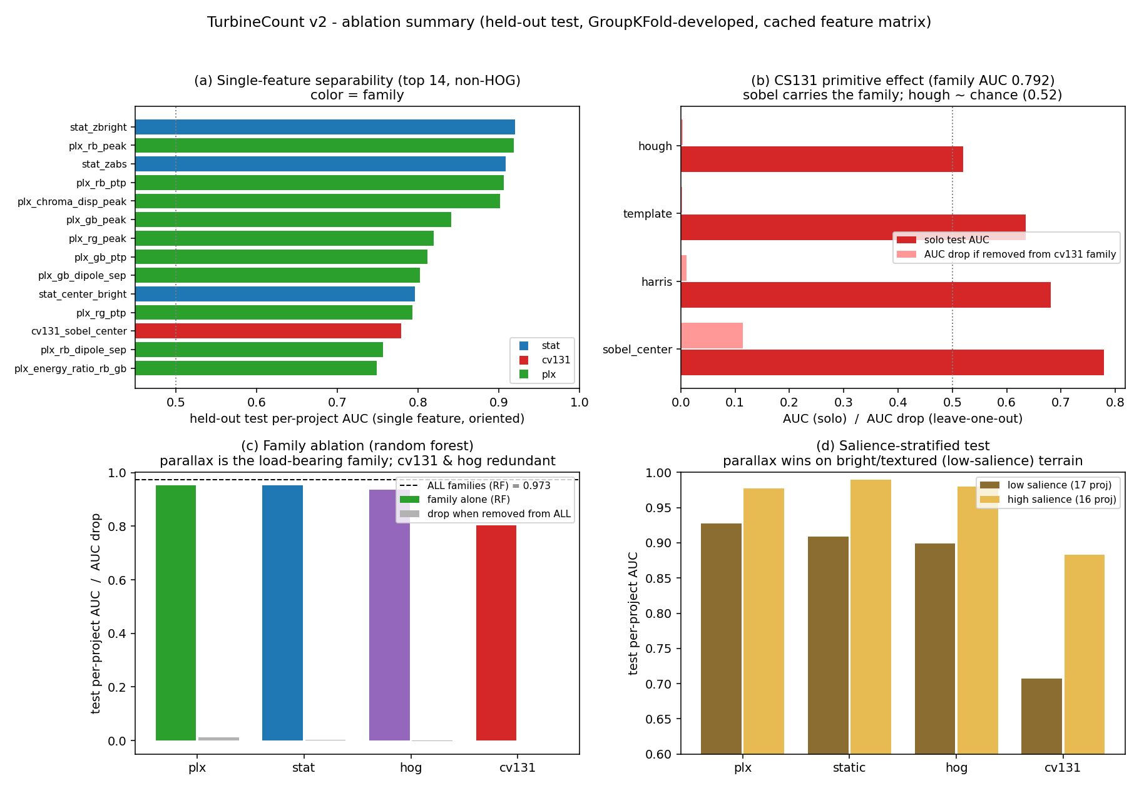
Figure 1. Ablation summary (held-out test). (a) Single-feature separability by family. (b) CS131 primitive solo AUC and leave-one-out drop. (c) Family ablation: each family alone (random forest) and the AUC drop when removed from the full model. (d) Salience-stratified per-family AUC.
Run as families inside the random forest, parallax and static salience are each strong alone (test per-project AUC 0.952 and 0.953), HOG is close behind (0.937), and the CS131 family is far back (0.804). The leave-one-family-out test on the full model is the decisive view: removing the parallax family costs 0.013 AUC, the largest drop; removing static costs 0.002; removing the CS131 family costs essentially nothing; and removing HOG actually improves the held-out number by 0.003. So in the fused model the parallax family is the load-bearing one, static salience is a useful complement, and the CS131 and HOG families are redundant given the other two. This is why the project's chosen headline model uses parallax + static and drops HOG.

3.4 Permutation importance: what the fused model leans on
Permutation importance on the frozen random forest (parallax + static), measured as the drop in held-out pooled AUC when a feature is shuffled, agrees with the single-feature and family views and is saved to artifacts/ablations/perm_importance.json:
Feature | test AUC drop when permuted | family
stat_zbright | 0.0109 | salience
stat_zabs | 0.0058 | salience
plx_rb_peak | 0.0037 | parallax
stat_contrast | 0.0034 | salience
stat_center_bright | 0.0018 | salience
plx_gb_dipole_sep | 0.0015 | parallax
plx_chroma_disp | 0.0013 | parallax
The single most important feature is the brightness z-score, with the red-blue fringe peak the most important parallax term, exactly the descriptors the physics predicts. The two stories are complementary, not substitutes: the model uses salience to nail the easy bright scenes and the fringe to rescue the hard ones (Section 3.6).

3.5 Is the parallax cue real motion, or re-encoded contrast?
This is the project's most important internal risk, and it is handled well. A bright, high-contrast turbine produces a large band-difference even with still blades, and the fringe peak does correlate with the salience cue (r about 0.4 to 0.47). Two controls (artifacts/disentangle.json, train, GroupKFold) test whether anything survives once contrast is removed:
- Orthogonalization. Regress every parallax feature on the static features inside each fold and keep only the residual. The residual parallax still scores per-project AUC 0.763 (pooled 0.777). Most of the parallax signal is orthogonal to static contrast.
- Within-contrast-bin AUC. Bin all patches into deciles of the salience cue, holding contrast roughly constant inside a bin. The best parallax feature still separates turbines from background at mean within-bin AUC 0.759 (0.82 to 0.90 in the mid-contrast bins), while the salience cue itself falls to 0.527, essentially chance, inside the same bins.
A label-shuffle control collapses cross-validated AUC to 0.490, confirming no leakage. Together these show the parallax family carries genuine inter-band motion information beyond local contrast. This contrast-separability test is the project's defensible novelty, and it is exactly what the only prior motion-based detector never did.

3.6 Where each cue wins: salience stratification
Splitting the 33 test projects at the median appearance-salience makes the complementarity explicit (artifacts/ablations/salience_stratified.json):
Regime | parallax | static | HOG | CS131
Low-salience (17 proj, bright / textured terrain) | 0.928 | 0.909 | 0.899 | 0.707
High-salience (16 proj) | 0.977 | 0.990 | 0.980 | 0.883
On exactly the bright-terrain regime that defeated the original appearance detector, the motion cue is the most robust single family and beats the appearance baseline (+0.02 over static, +0.03 over HOG). On easy high-salience scenes static appearance is best and parallax is marginally behind. The CS131 family collapses to 0.707 on low-salience terrain, a direct re-demonstration of the original failure mode. The margin for parallax on low-salience terrain is real but modest, which is why the honest framing is "more salience-robust", not "detects where appearance is at chance".

3.7 The detection-mode reality check
To get a number that compares to the detection literature, the frozen model was run as a real detector: dense sliding window at 80 m stride, non-max suppression at 60 m, operating threshold frozen by maximizing micro-F1 on the train projects, then applied once to the test projects. The result is far weaker than the classification AUC and is the honest object-level read:
Detection-mode metric (34 test projects, frozen threshold) | value
Micro precision / recall / F1 | 0.37 / 0.42 / 0.39
Macro precision / recall / F1 | 0.38 / 0.42 / 0.37
Count fit R-squared (calibrated) / identity R-squared | 0.13 / -1.26
Count slope / MAPE | 0.54 / 58%
Total detected vs true | 1406 vs 1260
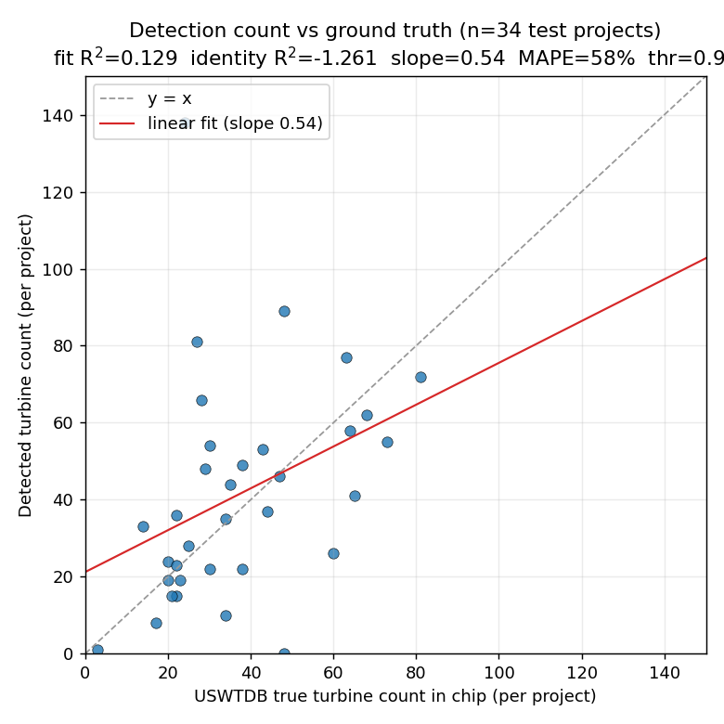
Figure 2. Detection-mode counts vs USWTDB ground truth, 34 held-out projects. Points scatter widely about the identity line (slope 0.54, MAPE 58%); the calibrated count R-squared is only 0.13. This is the honest object-level performance, not the classification AUC.
The gap between AUC 0.98 and detection F1 0.39 is not a contradiction; it is the difference between ranking pre-placed candidate points and committing to discrete detections across a whole scene with a single global threshold. Per-project F1 ranges from 0.00 (Shamrock TX, Roundhouse WY, Chevelon Butte AZ) to 0.69 (Stetson ME), and the failures are concentrated where the cue is physically absent (idle fleets, Section 3.8). It also exposes a counting hazard: bright-terrain projects over-detect badly (North Hurlburt OR returns 117 false positives for 24 turbines, recall 0.88 but precision 0.15), because every bright field pixel clears the threshold.

3.8 Case studies from real Sentinel-2 imagery
To verify the cue on actual pixels rather than only in the feature matrix, four projects were re-fetched live from Sentinel-2 (0% cloud scenes, summer 2024) and the parallax pipeline was recomputed from raw bands. The measured turbine-vs-background fringe reproduces the matrix to two decimals, validating both the fetch and the feature code. The four were chosen to span the cue's best and worst behavior.
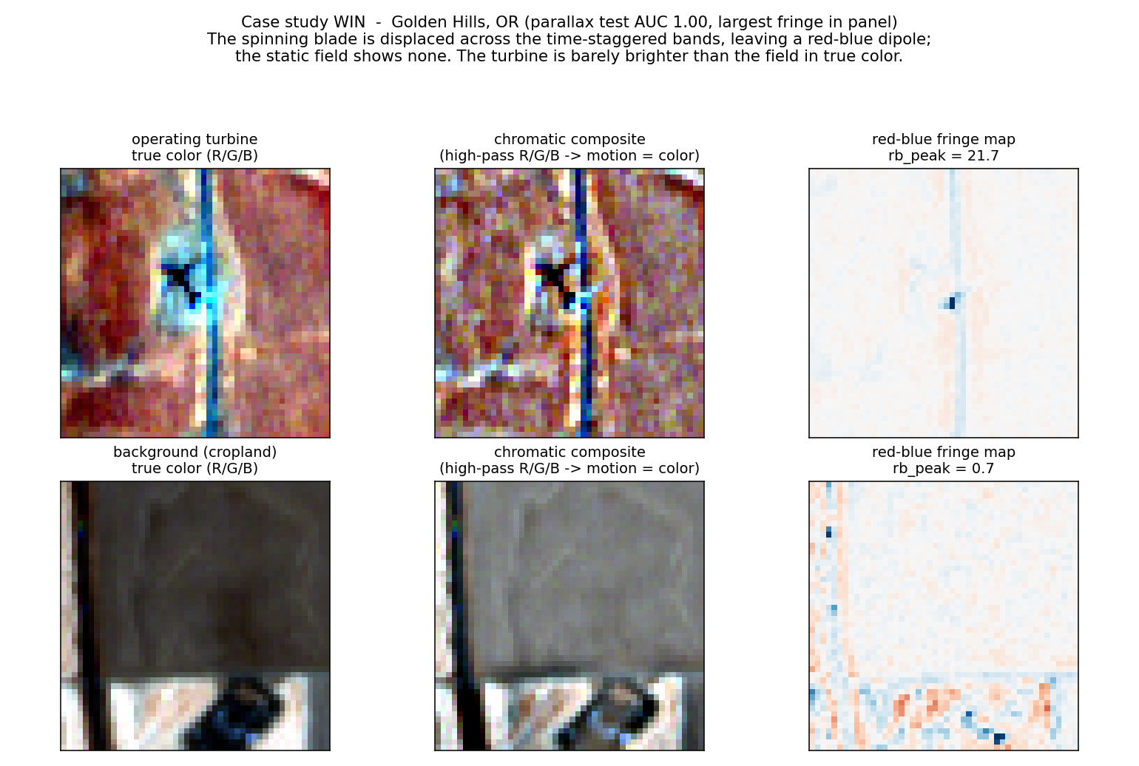
Figure 3. WIN case, Golden Hills OR (parallax test AUC 1.00, largest fringe in the panel). Top: an operating turbine. In true color the turbine is barely brighter than the field, yet the spinning blade leaves a bright displaced smear and a sharp red-blue dipole (rb_peak 21.7). Bottom: a background field shows no central fringe (rb_peak 0.7).
Golden Hills is the cleanest demonstration of the mechanism. The turbine is not especially bright in true color, so a pure appearance detector has little to grab; but the blade is displaced across the time-staggered bands and leaves an unmistakable red-blue dipole at the hub. Across all 34 of its turbines the fringe peak averages 12.5 versus 2.5 for background, and the parallax model separates them perfectly.
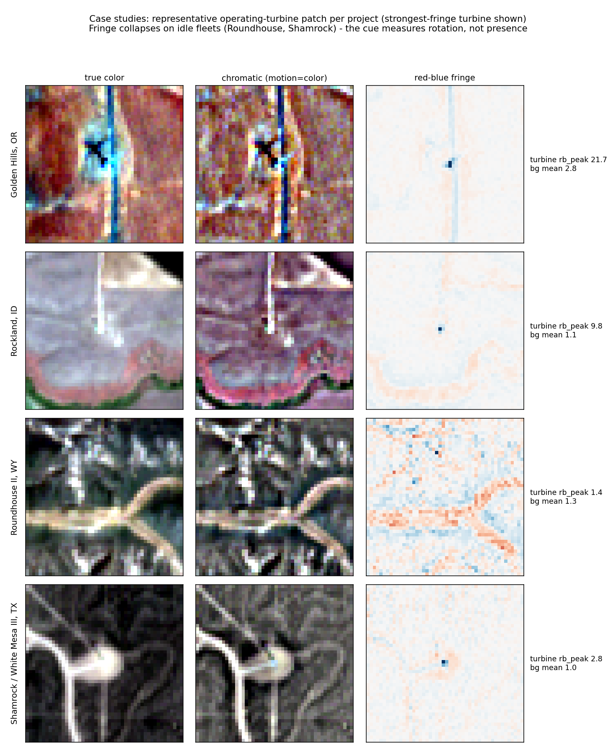
Figure 4. Representative turbine per project (strongest-fringe turbine shown): true color, chromatic high-pass composite, and red-blue fringe map. The fringe is strong at Golden Hills, modest at Rockland (low-salience terrain), and collapses at Roundhouse and Shamrock, where the turbines are plainly visible in true color but were not spinning.
Rockland ID is the instructive win on hard terrain: the scene is low-salience (the turbines are not bright blobs), yet a clear central red-blue dipole survives (turbine fringe 3.9 vs background 1.4), which is why the parallax model holds at AUC 0.96 where the CS131 appearance primitives would struggle.
Roundhouse II WY is the project's most honest failure. The parallax model scores it at AUC 0.292, worse than chance. The re-fetched pixels explain why: the turbines' mean fringe peak (1.08) is actually lower than the surrounding background (1.71). The turbines were idle at acquisition, so there is no blade motion to leave a fringe, while the textured terrain produces incidental band-differences everywhere. The cue does not just fail to fire, it ranks idle turbines below noisy ground. Detection-mode F1 here is 0.00.
Shamrock / White Mesa III TX is the recall-ceiling case at scale. Forty-eight modern, large-rotor (126 m) turbines, all plainly visible in true color as white towers with shadows, yet the average fringe peak is only 1.58 and not one cleared the detector's operating threshold (0 detected, F1 0.00). A static or shadow-based detector would find these easily; the motion cue cannot, because the fleet was not turning. This is the structural limit of the approach stated in a single picture.
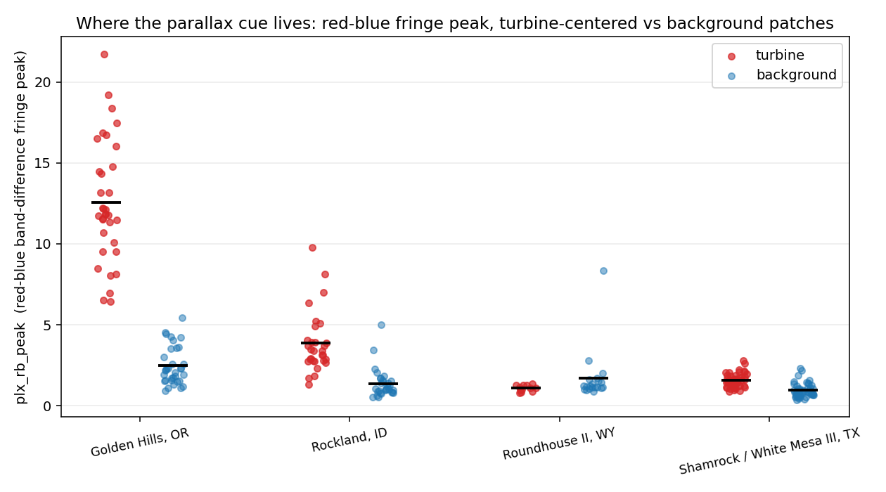
Figure 5. Red-blue fringe peak, turbine-centered vs background patches, for the four case projects. Separation is large at Golden Hills, clear at Rockland, and gone (or inverted) at Roundhouse and Shamrock. The cue measures rotation, not presence.

3.9 Strengths and pitfalls, by method
Method / feature | Strength | Pitfall
plx_rb_peak / rb_ptp (red-blue fringe) | Strongest motion feature; physics-aligned; separable from contrast | Zero on idle turbines; sensitive to scene texture noise
plx_chroma_disp_peak | Independent confirmation of inter-band disagreement | Correlated with the rb terms; lower marginal value
plx_xcorr_offset / xcorr_peak | Intended as a direct shift estimate | Near useless: static ground dominates the global alignment, ~0 for both classes
stat_zbright / zabs (salience) | Best single appearance cue; wins on easy bright scenes | Collapses on bright/textured terrain (the original failure)
cv131_sobel_center | Carries the entire CS131 family at 10 m | Only ~0.78 AUC; just "small textured blob"
cv131_hough | Sound primitive in principle | Near chance (0.52): blades unresolvable as lines at 10 m
cv131_template / harris | From-scratch nacelle / corner detectors | Negligible marginal value; redundant with salience
HOG + linear SVM | Solid generic appearance baseline (0.94) | Adds nothing over engineered cues; slightly hurts fused model
The whole-patch cross-correlation offset deserves a specific call-out as a documented dead end: the intuition (estimate the blade's pixel shift between blue and red directly) fails because the static background dominates the alignment, so the estimated offset is about zero for turbines and background alike. The usable signal lives in the localized fringe energy, not in a global shift. The feature was kept for completeness and carries almost no weight, which the permutation importance confirms.

4. Bottom line and what to fix next
The project earns its central claim: free Sentinel-2 inter-band parallax is a real, interpretable, contrast-separable signal of an operating turbine, and it is the most salience-robust single cue on the bright terrain where appearance detection fails. That is a clean, well-controlled result and a genuine contribution relative to both the static 10 m detectors (which discard this signal) and the one prior motion attempt (which showed it only qualitatively).
It does not earn a detection or counting claim. The honest object-level number is F1 0.39 with a count R-squared of 0.13, far from the 10 m detection state of the art, and the cue has a hard recall ceiling because idle turbines are invisible. The strongest single statement that is fully defensible: this is the first rigorous, contrast-controlled quantification of the Sentinel-2 blade-parallax cue, not a counting product.
Highest-value next steps, in order:
- Add hard negatives (buildings, towers, roads, bright rooftops) to the training pool. The current AUCs are optimistic precisely because negatives are random cropland; the parallax cue is hypothesized to resist building confusers (no blade, no fringe) but that is currently untested.
- Build a true count benchmark against USWTDB and EIA-860, reporting count R-squared, and fuse the spinning-only parallax cue with a static detector to cover idle turbines, then quantify the residual undercount. This is the metric that the nowcasting thesis lives or dies on.
- Stratify by wind speed at acquisition (reanalysis data) to characterize the idle-turbine recall ceiling directly, turning the Roundhouse / Shamrock failures into a quantified operating-vs-idle curve.
- Use multi-date Sentinel-2 (five-day revisit) to recover idle turbines on a later pass, which both lifts recall and, by design, produces the nowcast time series the application needs.
- Fix the four sourcing issues in the related-works file (Section 2.5) before any external circulation.

Appendix: reproduction and artifacts
New traces written this session (all under turbinecount_v2/artifacts/):
- ablations/single_feature_auc.csv: every non-HOG feature, train-CV and test univariate AUC, ranked.
- ablations/cs131_primitive_effect.json: per-primitive solo AUC, leave-one-out, greedy add, add-on lift.
- ablations/family_ablation.json: each family alone and leave-one-family-out (LR and RF).
- ablations/perm_importance.json: permutation importance, RF parallax+static, on the held-out test.
- ablations/salience_stratified.json and ablations/ablations_summary.json: machine-readable roll-up.
- casestudy/*.npz and casestudy/separation_stats.json: re-fetched Sentinel-2 chips plus turbine-vs-background fringe stats.
- related_works_verified.md: independent literature review with primary-source fact-check.
- Figures: fig_ablation_summary.png, fig_casestudy_hero.png, fig_casestudy_grid.png, fig_casestudy_separation.png (new); fig_count_scatter.png (detection mode).
Scripts added: ablate.py (phased ablations), casestudy.py (fetch), render_casestudy.py (case-study figures), fig_ablations.py (ablation figure). Reproduce ablations with: python ablate.py all. The held-out test split is read only by the locked evaluation; nothing here retrained on test.
Selected sources (full list with URLs in related_works_verified.md): GRW (arXiv:2503.14860); Mandroux multi-date (ISPRS 2022); Nahrstedt band-motion CNN; USGS USWTDB.

