2.3 Forms

This section will guide you to:

Build forms in Bootstrap which have the following features:

* Form Controls
* Sizing
* Checkboxes and Radios
* Inlines
* Form Grids
* Disabling forms
* Validations

This guide has three subsections, namely:

2.3.1 Building a form using Bootstrap in your code editor

2.3.2 Viewing the results in your local browser

2.3.3 Pushing the code to Github repositories

**Step 2.3.1:** Building a form using Bootstrap in your code editor

* Open Visual Studio Code.
* Right clickon the **File menu** of the code editor -> Select *New File.*
* Enter the below code resolving the warning and errors due to compatibility-related issues.
* Right clickon the **File menu** of the code editor -> Select *Save as* -> Enter the filename (form.html) -> Click *Save.*

**<!DOCTYPE html>**

**<html lang="en">**

**<head>**

**<title>Web Development Blog</title>**

**<meta charset="utf-8">**

**<meta name="viewport" content="width=device-width, initial-scale=1">**

**<link rel="stylesheet" href="https://stackpath.bootstrapcdn.com/bootstrap/4.3.3/css/bootstrap.min.css" integrity="sha384-MCw98/SFnGE8fJT3GXwEOngsV7Zt27NXFoaoApmYm81iuXoPkFOJwJ8ERdknLPMO" crossorigin="anonymous">**

**</head>**

**<body>**

**<form class="needs-validation" novalidate>**

**<div class="form-row">**

**<div class="col-md-4 mb-3">**

**<label for="validationCustom01">First name</label>**

**<input type="text" class="form-control" id="validationCustom01" placeholder="First name" required>**

**<div class="valid-feedback">**

**Looks good!**

**</div>**

**</div>**

**<div class="col-md-4 mb-3">**

**<label for="validationCustom02">Last name</label>**

**<input type="text" class="form-control" id="validationCustom02" placeholder="Last name" required>**

**<div class="valid-feedback">**

**Looks good!**

**</div>**

**</div>**

**<div class="col-md-4 mb-3">**

**<label for="validationCustomUsername">Username</label>**

**<div class="input-group">**

**<div class="input-group-prepend">**

**<span class="input-group-text" id="inputGroupPrepend">@</span>**

**</div>**

**<input type="text" class="form-control" id="validationCustomUsername" placeholder="Username" aria-describedby="inputGroupPrepend" required>**

**<div class="invalid-feedback">**

**Please choose a username.**

**</div>**

**</div>**

**</div>**

**</div>**

**<div class="form-row">**

**<div class="col-md-6 mb-3">**

**<label for="validationCustom03">City</label>**

**<input type="text" class="form-control" id="validationCustom03" placeholder="City" required>**

**<div class="invalid-feedback">**

**Please provide a valid city.**

**</div>**

**</div>**

**<div class="col-md-3 mb-3">**

**<label for="validationCustom04">State</label>**

**<input type="text" class="form-control" id="validationCustom04" placeholder="State" required>**

**<div class="invalid-feedback">**

**Please provide a valid state.**

**</div>**

**</div>**

**<div class="col-md-3 mb-3">**

**<label for="validationCustom05">Zip</label>**

**<input type="number" class="form-control" id="validationCustom05" placeholder="Zip" required>**

**<div class="invalid-feedback">**

**Please provide a valid zip.**

**</div>**

**</div>**

**</div>**

**<div class="col-md-3 mb-3">**

**<label for="disabledInput">Topics I like to read about:</label>**

**<input class="form-control" id="disabledInput" type="text" placeholder="Web Development" disabled>**

**</div>**

**<p> Where did you find us? </p>**

**<div class="form-check form-check-inline">**

**<input class="form-check-input" type="radio" id="inlineRadio1" value="option1">**

**<label class="form-check-label" for="inlineRadio1">Facebook</label>**

**</div>**

**<div class="form-check form-check-inline">**

**<input class="form-check-input" type="radio" id="inlineRadio2" value="option2">**

**<label class="form-check-label" for="inlineRadio2">LinkedIn</label>**

**</div>**

**<div class="form-check form-check-inline">**

**<input class="form-check-input" type="radio" id="inlineRadio3" value="option3">**

**<label class="form-check-label" for="inlineRadio3">Google Search</label>**

**</div>**

**<div class="form-group">**

**<div class="form-check">**

**<input class="form-check-input" type="checkbox" value="" id="invalidCheck" required>**

**<label class="form-check-label" for="invalidCheck">**

**Agree to terms and conditions**

**</label>**

**<div class="invalid-feedback">You must agree before submitting.</div>**

**</div>**

**</div>**

**<button class="btn btn-primary" type="submit">Submit form</button>**

**</form>**

**<script>**

**// Example starter JavaScript for disabling form submissions if there are invalid fields**

**(function() {**

**'use strict';**

**window.addEventListener('load', function() {**

**// Fetch all the forms we want to apply custom Bootstrap validation styles to**

**var forms = document.getElementsByClassName('needs-validation');**

**// Loop over them and prevent submission**

**var validation = Array.prototype.filter.call(forms, function(form) {**

**form.addEventListener('submit', function(event) {**

**if (form.checkValidity() === false) {**

**event.preventDefault();**

**event.stopPropagation();**

**}**

**form.classList.add('was-validated');**

**}, false);**

**});**

**}, false);**

**})();**

**</script>**

**<script src="https://code.jquery.com/jquery-3.3.3.slim.min.js" integrity="sha384-q8i/X+965DzO0rT7abK41JStQIAqVgRVzpbzo5smXKp4YfRvH+8abtTE1Pi6jizo" crossorigin="anonymous"></script>**

**<script src="https://stackpath.bootstrapcdn.com/bootstrap/4.3.3/js/bootstrap.min.js" integrity="sha384-ChfqqxuZUCnJSK3+MXmPNIyE6ZbWh2IMqE241rYiqJxyMiZ6OW/JmZQ5stwEULTy" crossorigin="anonymous"></script>**

**</body>**

**</html>**

**Step 2.3.2:** Viewing the results in your local browser

* Navigate to the directory where form.html is stored using the File Explorer.
* Double-click the form.html file to open it in your default browser.

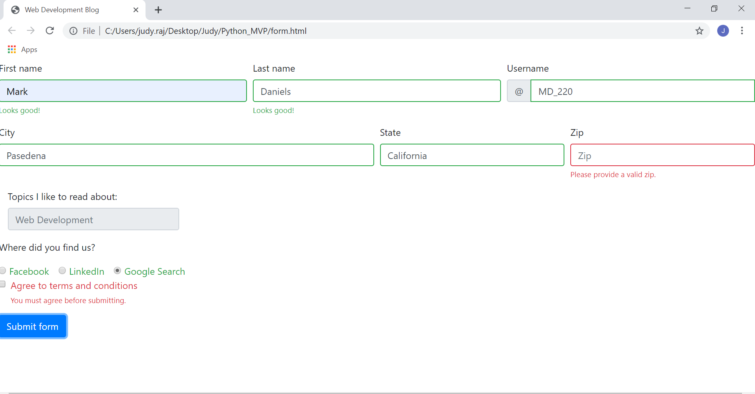

**Step 2.3.3:** Pushing the code to your GitHub repositories

Open your command prompt and navigate to the folder where you have created your files

cd <folder path>

Initialize your repository using the following command:

git init

Add all the files to your git repository using the following command:

git add .

Commit the changes using the following command:

git commit . -m “Changes have been committed.”

Push the files to the folder you initially created using the following command:

git push -u origin master