Khmelnytskyi National University
Department of Computer Engineering and Information Systems
Report
Laboratory work No. 1
Discipline: «Software Construction»
Topic: «Software development stages under the structured approach. The «Technical Specification» stage»
Completed by: 3rd-year student, group IPZs-24-1 S. Kovalchuk
Checked by: N. Pravorska
Khmelnytskyi — 2026

PURPOSE
To become familiar with the rules for writing a technical specification and to develop a technical specification for a software product in accordance with GOST 19.106-78.

TASK
1. Study the theory on the rules and procedure of the «Technical Specification» stage.
2. Develop a technical specification for the software product according to the assigned variant; format the work in accordance with GOST 19.106-78.
3. Prepare the report and answer the control questions.

TASK COMPLETION

1 Problem statement
Subject area — accounting and documentary recording of materiel expenditure (unmanned aerial vehicles and munitions) in a field unit.
Problem. Write-off reports are compiled by hand. One document takes 20–30 minutes, the wording and grammatical cases differ between reports, and reconciliation with warehouse records is difficult. Existing tools do not cover the task: general document-management systems require configuration for the domain, and cloud generators do not work offline and do not consolidate data over a period.
Solution. A desktop application for the commander. The operator submits sortie data through an electronic form; the application imports the responses, consolidates the episodes for a selected period and produces a finished report in .docx format from a template. Errors are fixed by marking a record as cancelled rather than deleting it. Directories and the «Status» column can be written back to the external table.
Constraints: the operating system is Windows; the report must be formatted in Times New Roman 14 pt with 1.5 line spacing and A4 margins 30/10/20/20 mm; all demonstration data are fictional and the System is treated as a means of accounting for the consumable materiel of a field unit.

2 Technical specification (GOST 19.106-78)
A technical specification for the software product was developed. Its sections, terms and appendices follow. The list of terms is given in Table 1, the technology stack in Table 2, the development schedule in Table 3, the risk analysis in Appendix A, and the screen prototype in Appendix B.

List of terms and abbreviations
Table 1 — Terms and abbreviations
Term / abbreviation | Definition
UAV | Unmanned aerial vehicle.
Report (document) | A service document of the established form on the use (expenditure) of materiel over a reporting period.
Operator | A user who submits sortie data through the electronic form.
Commander (signatory) | A user who compiles the consolidated report for the period and signs it.
Episode (submission) | One form submission: one sortie or one operator working day.
Reference | A table that maps a short name (shown in the form) to a full name (inserted into the report text).
Consolidation | Computing the summary lists of UAVs, munitions and targets for the selected period.
Template tag | A placeholder string in the template document (e.g. {{DATE_FROM}}) that the program replaces with a computed value.
Google Forms | Google's cloud service for building electronic data-collection forms.
Google Sheets API | Google's programming interface for reading and writing spreadsheets.
OAuth 2.0 | An authorization protocol that grants an application access to a user's data without passing the password.
SQLite | An embedded relational database stored in a single file.
EF Core | Entity Framework Core, an object-relational mapping library for .NET.
OpenXML | The Office Open XML (.docx) format and a library for producing Word documents programmatically.
MVVM | Model-View-ViewModel, an architectural pattern that separates presentation logic from the view.
WPF | Windows Presentation Foundation, a technology for building desktop interfaces on Windows.
USPD | Unified System of Program Documentation (GOST 19.xxx).
SP | Software product.

Introduction
The Technical Specification (hereinafter — TS) sets the requirements for the software product «System for Generating Reports on the Use of UAVs and Munitions» (hereinafter — the System, SP): its purpose, function set, operating conditions, development stages and acceptance procedure. The TS follows GOST 19.106-78.
The System serves the accounting and documentary recording of materiel expenditure — unmanned aerial vehicles and munitions — in a field unit. The unit periodically reports the used materiel with a write-off report.
Reports are now written by hand. A document takes 20–30 minutes, gives inconsistent wording and grammatical cases, and complicates reconciliation with warehouse records. General document-management systems do not know the domain references and need lengthy configuration. Cloud document generators do not work offline and do not consolidate data over a period. The System removes the manual text work: the operator submits data through an electronic form, and the commander gets a finished report in Word format from a single request.
Note. The data in this document and in the demo mode of the System are fictional. The System is treated as a means of accounting for the consumable materiel of a field unit.

1 NAME AND FIELD OF APPLICATION
Full name: «System for Generating Reports on the Use of UAVs and Munitions».
Conventional (working) designation: ReportsWpf.
Field of application — accounting and documentary recording of materiel expenditure in a unit, automation of write-off report preparation. The System is intended for the commander's desktop workstation; operators interact with the System indirectly, through the data-collection electronic form.

2 BASIS FOR DEVELOPMENT
The basis for development is the curriculum of the discipline «Software Construction» and the assignment for laboratory work No. 1.
The document that defines the assignment is approved by the department of the Khmelnytskyi National University.
Name of the development topic: «Development of a software system for accounting and generating reports on the use of a unit's materiel».

3 PURPOSE OF DEVELOPMENT

3.1 Functional purpose
The System collects the episodes of materiel use submitted by the operator, consolidates them for the selected period and generates a report in Word format from a template.

3.2 Operational purpose
Mode of use — daily work. The commander generates reports as needed: typically 2–4 times a month, with the peak at the end of the reporting period. Operators submit data after each sortie.
Two user roles are defined:
– operator — submits sortie data from a mobile device through the electronic form; needs no special training;
– commander (administrator) — maintains the references, generates and signs the consolidated report, configures the System; qualification — a confident PC user.

4 TECHNICAL REQUIREMENTS FOR THE SOFTWARE PRODUCT

4.1 Requirements for functional characteristics

4.1.1 Set of functions performed
The software product shall provide the following functions:
1. Maintaining the references of UAVs, target types, munitions, settlements and people: adding, editing and deleting records. Each reference record holds a short name (shown to the operator in the form) and a full name (inserted into the report text); for the target reference the full name is stored in the genitive case, for the settlement reference the second column holds the region.
2. Retrieving data from an external source — importing the electronic form responses through the Google Sheets API. Columns are located by their headings rather than by ordinal number, so reordering the form questions does not break the import. A repeated import creates no duplicates because each source row has a stable key.
3. Cancelling an erroneous submission — the record is not deleted but marked with the status «CANCELLED» and is then excluded from consolidation; the trace of the submission remains.
4. Consolidating data for a period — selecting episodes within the date bounds and by optional filters (by operator, by settlement); summing the UAV count by type; building the unique lists of munitions and target types; substituting regions from the settlement reference.
5. Previewing the report text before the document file is created.
6. Generating the report document in .docx format by replacing the tags in a template document with the computed values.
7. Keeping a log of generated reports (generation date, period, signatory, episode count, file path).
8. Uploading back to the external table — appending new reference entries, new people and the values of the «Status» column; existing rows are neither changed nor deleted.
9. Configuring the System: document details (classification stamp, addressee, resolution, unit name, default combat order), data-source parameters, file folders, connection check with the external table.
10. Demo mode — operation on built-in fictional data without Internet access.

4.1.2 Organization of input and output data
Input data:
– electronic form responses — timestamp, sortie date (optional; if absent, the submission date is used), operator email address, settlement, UAV type, target type, UAV count, up to three munitions, record status;
– references — four blocks on a single sheet of the external table (UAVs, targets, munitions, places), data from the third row; the left column of a block is the short name, the right one is the full name;
– people reference — email, surname and initials, rank, position.
Internal data is stored in a local SQLite database (tables of submissions, target engagements, munition uses, references, people and the report log).
Output data:
– the report file in .docx format, formatted per subsection 4.8;
– an entry in the log of generated reports;
– rows appended to the external table (new reference entries, people, values of the «Status» column).

4.1.3 Timing characteristics
– report generation for a period up to 30 days — no more than 5 seconds;
– synchronization of an external table of up to 5000 rows — no more than 30 seconds over a stable connection.

4.2 Reliability requirements
For reliable operation the SP shall:
– check the correctness of input data: a value absent from a reference does not interrupt the import but moves the record to the «needs attention» state;
– prevent a repeated import of the same submission through a unique source-row key;
– allow error correction without deleting data (the «CANCELLED» status);
– record unhandled exceptions in an error log file;
– keep working when the external service is unavailable: report generation runs from the local database;
– show the user clear messages instead of service exceptions (including an explanation of the cause by the external service response code).
Recovery time after a failure — restarting the application; saved data is not lost.

4.3 Operating conditions
The System is operated by one responsible user (the commander) at a workstation. Operators work only with the electronic form and need no special training. The responsible user's qualification is confident command of a personal computer.
Servicing the System consists of periodically checking the references and backing up the data folder. Ambient conditions are those of an ordinary office personal computer; special requirements for temperature and humidity are not imposed.

4.4 Requirements for the composition and parameters of technical means
The System requires a personal computer with the following technical means:
– an x64 processor, at least 2 cores;
– RAM — at least 4 GB;
– free disk space — at least 500 MB;
– a monitor with a resolution of at least 1280×800;
– an Internet connection — only for synchronization with the external table.
The operator's device is a smartphone with a web browser and an Internet connection.

4.5 Requirements for information and software compatibility
Programming language — C#. The software product runs on the .NET 8 platform under Windows 10 or Windows 11 (x64). The technology stack is given in Table 4.1.
Table 4.1 — Technology stack of the System
Layer | Technology | Purpose
Platform | .NET 8, Windows 10/11 x64 | runtime environment
Interface | WPF (MVVM), WPF-UI 3 library | windows, styling, light and dark themes
Database | SQLite, Entity Framework Core 8 | local data storage
Documents | DocumentFormat.OpenXml 3.1 | producing .docx without Microsoft Word
Integration | Google Sheets API v4, OAuth 2.0 | data exchange with the external table

– output document format — Office Open XML (.docx), compatible with Microsoft Word 2007 and later;
– exchange format with the external table — A1-notation ranges of Google Sheets;
– OAuth credentials are stored locally in the user profile folder and are not included in the source code repository.

4.6 Requirements for marking and packaging
Not imposed. The software product is delivered in electronic form.

4.7 Requirements for transportation and storage
The software product is delivered on a USB drive or through a version control system. Program documentation is delivered in electronic form. Transportation and storage conditions for the media are those ordinary for electronic media; the storage period is not limited.

4.8 Special requirements
– the generated report shall be formatted in Times New Roman 14 pt, with 1.5 line spacing, margins 30/10/20/20 mm, on A4 sheets;
– the report template is a separate .docx document with tags; the System keeps no information about formatting and only replaces the tags, so the template can be re-laid out without changing the program code;
– the user interface is in Ukrainian, aimed at a user of average qualification;
– the System supports light and dark themes;
– the domain logic is separated from the interface and the database, which makes it possible to extend the System (including a move to a dedicated server) without rewriting the core.

4.9 Requirements for program documentation
The composition of the program documentation is defined by the USPD (GOST 19.xxx) and includes:
– a user manual;
– a programmer manual;
– a system programmer manual;
– an application description.

5 TECHNICAL AND ECONOMIC INDICATORS
The effect comes from shortening the report preparation time: manual compilation takes 20–30 minutes, automatic — up to 1 minute. Inconsistent wording also disappears and reconciliation with the warehouse becomes simpler.
Estimated need — one unit, 2–4 reports a month. The System needs no configuration for the domain and works without the Internet in demo mode.
Development cost is zero: .NET, SQLite, WPF-UI, DocumentFormat.OpenXml and the Google Sheets API within the free quotas are distributed free of charge.

6 STAGES OF DEVELOPMENT
Development proceeds in stages; the stages are aligned with the laboratory works of the discipline. The schedule is given in Table 6.1.
Table 6.1 — Development schedule
Stage | Timeframe | Stage output
Development of the Technical Specification | Lab 1 | an approved Technical Specification
Draft design: data-flow, entity-relationship and state-transition diagrams; network schedule | Lab 2 | the «Draft Design» document
Technical design: structure and function charts, Constantine and Jackson structure charts, module specifications | Lab 3 | the «Technical Design» document
Implementation and debugging of the software product; preparation of program documentation | Lab 4 | a working SP, a set of USPD documentation
Project estimation: LOC and FP metrics, the COCOMO II model, object-oriented metrics | Labs 5-7 | calculations and quality conclusions

Further development stages (beyond the coursework): a move from the external table to a dedicated server with a database; offline data submission by the operator with later synchronization; an electronic signature of the report; munition-count accounting and automatic reconciliation with warehouse records.

7 CONTROL AND ACCEPTANCE PROCEDURE
Types of testing:
– checking that every function of subsection 4.1 is performed;
– an end-to-end test of the processing chain: seeding the database → importing data → consolidating for a period → generating the .docx → writing to the log.
Acceptance criteria:
– every function of subsection 4.1 is performed;
– the generated document meets the formatting requirements (subsection 4.8);
– no unreplaced tags remain in the generated report text;
– a repeated import of the same data creates no duplicates;
– cancelled records are excluded from consolidation.
The customer may test the delivered module for seven days. Based on the test results the customer accepts the work for the stage or gives a written justified reason for refusal; in case of a justified refusal the developer reworks the module.

APPENDIX A (INFORMATIVE). DEVELOPMENT RISKS AND MITIGATION STRATEGIES
Risk | Level | Mitigation strategy
Change in the external form structure (renamed or reordered questions) | Medium | columns are located by heading, not by ordinal number
Unavailability of the external Google service | Medium | report generation runs from the local database; demo mode
Operator error in quantity or type | High | the record is marked «CANCELLED» and resubmitted
Duplicate submissions (double form send) | Medium | a unique source-row key on import
Concurrent editing of the table by an external script and the System | Medium | the upload only appends; existing rows are not changed
Storing operational data in a cloud service | High | demonstration on fictional data; the prospect of a self-hosted deployment

APPENDIX B (INFORMATIVE). SCREEN PROTOTYPE
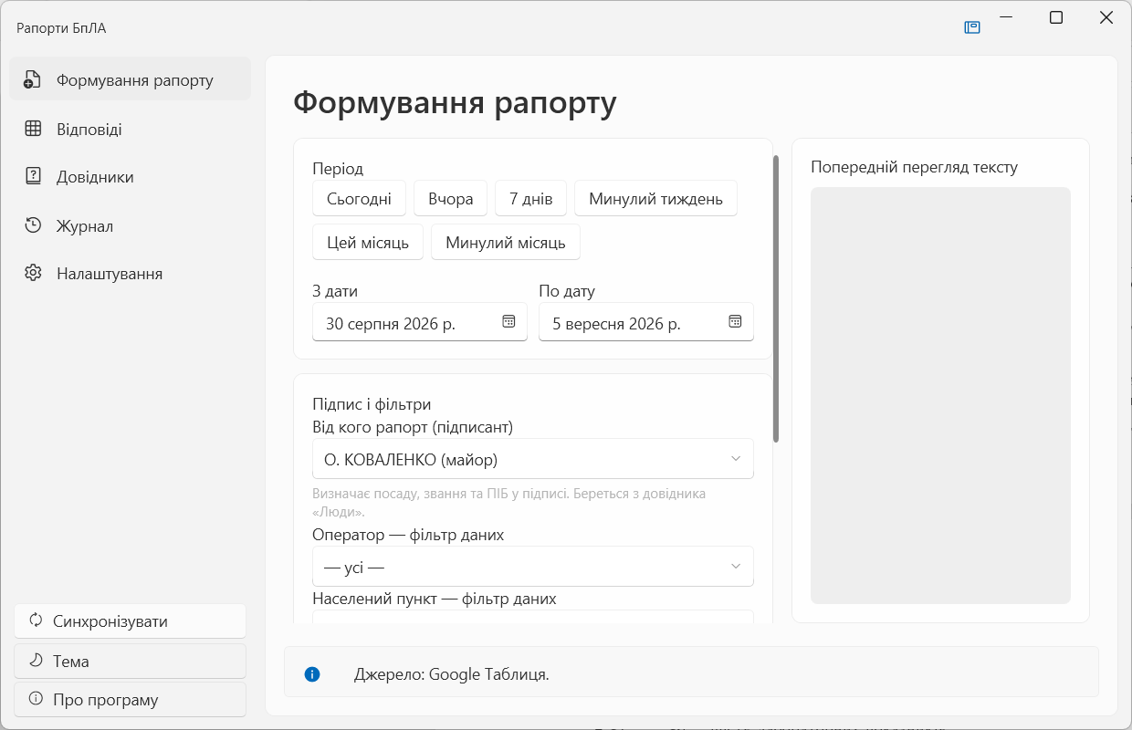
Figure B.1 — The «Report generation» screen
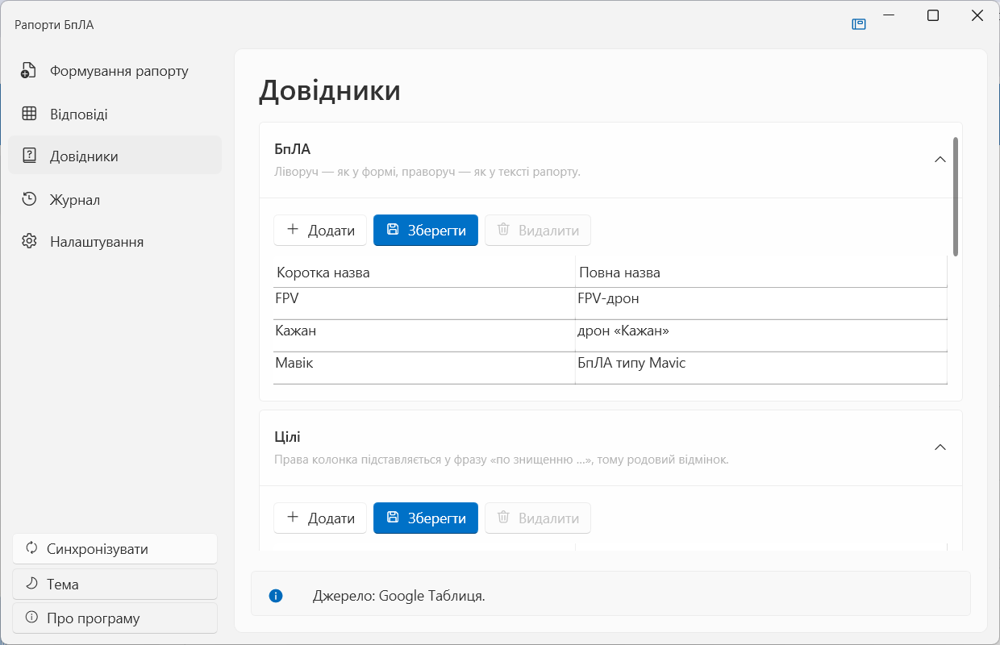
Figure B.2 — The «References» screen
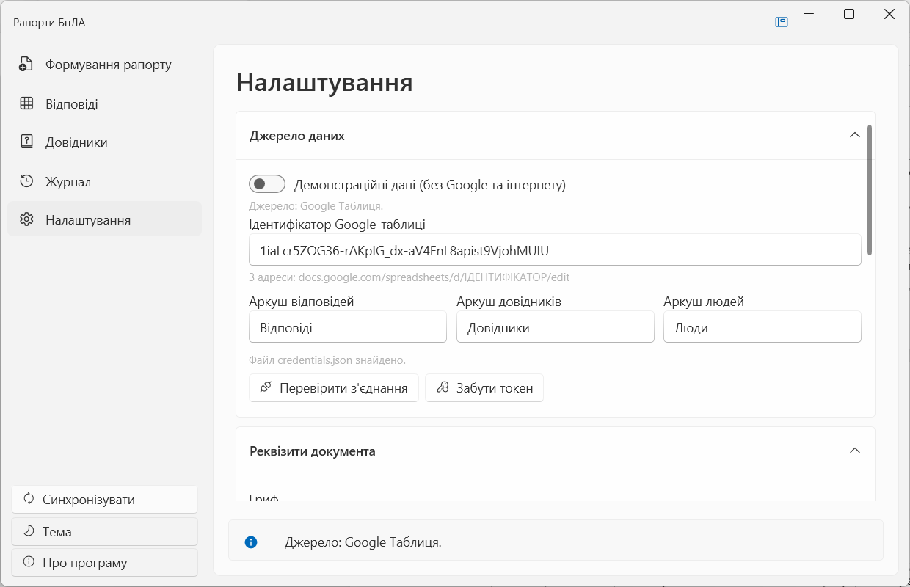
Figure B.3 — The «Settings» screen

CONCLUSIONS
During the work I studied the rules and structure of the «Technical Specification» stage and developed a technical specification for the software product «System for Generating Reports on the Use of UAVs and Munitions» in accordance with GOST 19.106-78. The specification defines the name and field of application, the basis and purpose of development, the functional and non-functional requirements, the information and software compatibility, the technical and economic indicators, the development stages and the control and acceptance procedure. The set of functions, the input and output data, the technology stack, the development schedule and the risk analysis are described. The resulting document is the basis for the next stages of the work: the draft design (Lab 2) and the technical design (Lab 3).

CONTROL QUESTIONS
1. What are the stages of software development?
Problem statement and pre-design research; technical specification; draft design; technical design; implementation and debugging; testing and attestation; operation and maintenance.
2. What does the problem statement and pre-design research contain?
A description of the subject area and the object where the product will be used; the problem to be solved; the set of functions and the input and output data; the environment (hardware, operating system, related software); the constraints. The pre-design research analyses existing solutions and the requirements of the customer.
3. List the functional and operational requirements for a software product.
Functional requirements describe the set of functions performed, the organization of input and output data and the timing characteristics. Operational requirements describe the mode of use, the user roles and their qualification, the operating conditions, servicing and recovery after a failure.
4. List the rules for developing a technical specification.
The TS is drawn up on A4 sheets in accordance with GOST 19.106-78. The title page and the approval sheet are formatted per the standard. Sheets are numbered above the text. Changes and additions on later stages are issued as supplements and approved in the same way as the TS itself. If a requirement is not imposed, the corresponding place states «Not imposed».
5. Name the main sections of a technical specification.
Introduction; name and field of application; basis for development; purpose of development; technical requirements for the software product (functional characteristics, reliability, operating conditions, technical means, information and software compatibility, marking and packaging, transportation and storage, special requirements); technical and economic indicators; stages of development; control and acceptance procedure; appendices.

