UNITED STATES INTERNATIONAL UNIVERSITY-AFRICA



TITLE: SMARTFLASH PROJECT PROPOSAL

SWE 3090A SPRING SEMESTER 2025

SUPERVISOR: PROF. FREDRICK OGORE

STUDENT NAME AND NUMBER: SOLOMON GITHAIGA NJOGO - 669851

Table Of Contents
TITLE: SMARTFLASH PROJECT PROPOSAL 1
SWE 3090A SPRING SEMESTER 2025 1
SUPERVISOR: PROF. FREDRICK OGORE 1
STUDENT NAME AND NUMBER: SOLOMON GITHAIGA NJOGO - 669851 1
Table Of Contents 2
1.0 Introduction & Background 3
1.1 Problem Statement 3
1.2 Main Objective 4
1.3 Specific Objectives (SMART) 4
1.4 Justification why we need to design this project 4
2.0 Literature Review 5
2.1 Global View - Do we have such an application globally 5
2.2 Africa View - Does the application exist in Africa? 5
2.3 Kenyan View - Does it exist in Kenya? 6
3.0 Methodology 6
3.1 Preliminary Investigation 6
3.2 Design Phase 7
Implementation 7
4.0 System Analysis & Design 7
4.1 Data Flow Diagram (DFD) 7
4.2 Entity Relationship (ER) Diagram 8
4.3 Proposed Timelines 9
References 10

1.0 Introduction & Background
The digital transformation of education has produced a surge of mobile learning tools that promise to make studying faster, cheaper and more engaging. Yet empirical studies still show that university students forget up to 80 % of newly-memorized facts within seven days if the material is not revisited at scientifically-spaced intervals (Ebbinghaus, 1885/1964; Cepeda et al., 2006). The phenomenon—known as the forgetting curve—explains why marathon cram-sessions rarely translate into long-term mastery. Cognitive science offers two evidence-based antidotes: active recall (retrieval practice) and spaced repetition (expanding-interval review). When the two strategies are combined, retention can rise by 30–50 % while total study time falls by up to 40 % (Karpicke & Roediger, 2008).
Despite the strength of this research, most learners across the globe still rely on paper flash-cards, static PDF notes or generic quiz apps that randomize questions without any memory model. While, commercial solutions such as Anki, Quizlet and Brainscape exist, their uptake still remains low because of:
- Cost barriers – premium subscriptions range from US $35–60 per year which is a significant amount for students.
- Complex UX – open-source tools like Anki have steep learning curves.
The development of SmartFlash is rooted in the need for accessible, cross-platform educational tools that cater to modern students' needs. Built using Flutter for multi-platform compatibility (Android, iOS, and Web), the app incorporates Supabase for cloud synchronization and authentication, ensuring seamless access across devices. Key features include AI-assisted flashcard generation from documents, smart review scheduling, and progress tracking with statistical insights. This project builds on previous experiences with frameworks like Flutter, Next.JS, and React, as well as prior apps such as RaiseIt (a charity fundraising app) and LuxeLens (an e-commerce site for eye-wear). By focusing on education and productivity, SmartFlash aims to transform how students prepare for exams and retain knowledge long-term.

1.1 Problem Statement
Many students dedicate extensive hours to studying, yet much of this effort is undermined by ineffective review strategies. According to the Ebbinghaus forgetting curve, individuals can forget up to 80% of newly learned information within a week without proper reinforcement (Ebbinghaus, 1964). This leads to repeated cramming sessions, increased stress, and sub-optimal academic performance, particularly in high-pressure environments like universities.
Traditional study methods, such as passive rereading or unstructured note-taking, fail to promote active recall, which is essential for long-term memory consolidation (Karpicke & Roediger, 2008). As a result, students often waste time revisiting familiar material while neglecting weaker areas, exacerbating inefficiencies in learning. The lack of personalized tools further compounds this issue, as generic study aids do not adapt to individual progress or learning paces.
In resource-constrained settings, such as in developing regions, access to advanced educational technologies is limited, leading to disparities in learning outcomes. SmartFlash seeks to mitigate these challenges by providing an intuitive, AI-driven solution that encourages efficient, evidence-based studying practices.

1.2 Main Objective
To develop an AI-powered, spaced-repetition flashcards mobile application that improves knowledge retention and reduces study time for university students globally.

1.3 Specific Objectives (SMART)
- To develop a cross-platform flashcards engine with CRUD operations for cards, decks and quizzes using Flutter & Dart..
- To integrate an adaptive spaced-repetition algorithm that schedules reviews at 1-3-7-14-30 day intervals based on user performance..
- To enhance content creation through AI-assisted flashcard generation from PDF/Word notes, reducing authoring time by at least 50 %.
- To facilitate cloud synchronization using Supabase for multi-device access and user authentication.

1.4 Justification why we need to design this project
The significance of SmartFlash lies in its potential to revolutionize student learning by addressing widespread inefficiencies in education. With rising academic demands and the prevalence of forgetting curves, there is a critical need for tools that promote active recall and spaced repetition, proven to enhance retention by up to 200% compared to traditional methods (Cepeda et al., 2006). This project fills a gap in accessible, personalized study aids, particularly for students in resource-limited environments, enabling smarter studying that saves time and reduces stress.
Implementing SmartFlash will contribute to broader educational equity by providing a free or low-cost alternative to premium apps, empowering users to achieve better academic outcomes. Its cross-platform nature ensures inclusivity, while AI features differentiate it from basic tools, offering tailored experiences that adapt to individual needs and foster lifelong learning habits.

2.0 Literature Review

2.1 Global View - Do we have such an application globally
Globally, numerous spaced repetition flashcard apps exist, with Anki being one of the most prominent open-source options, used by millions for language learning and medical studies due to its customizable algorithms and community-shared decks. Other examples include Quizlet, which integrates gamification and collaborative features for broader educational use, and Brainscape, known for its AI-driven adaptive repetition that prioritizes difficult cards. SuperMemo, the pioneer SRS software, offers advanced algorithms for lifelong learning but is often criticized for its complexity. Apps like Mochi and SmartCards+ emphasize simplicity and markdown support for note-taking integrated with SRS. These applications demonstrate widespread adoption, particularly in language acquisition and professional certification preparation.

2.2 Africa View - Does the application exist in Africa?
In Africa, spaced repetition apps are less commonly developed locally but are increasingly adopted through global platforms. A notable example is Breni, a Nigerian AI-powered learning app that incorporates spaced repetition to tailor content for users, with 90% of its audience outside Nigeria, highlighting its scalability. Other initiatives, such as the Centre for Innovative Teaching and Learning in ICT's EdTech programs, promote spaced learning models for teachers, though not as standalone apps. Apps like NKENNE focus on African languages using SRS techniques, but they are more niche for cultural preservation rather than general studying. South Africa’s “LearnHub” and Egypt’s “Zedny” integrate spaced repetition, but they are either web-only or locked to corporate training. In East Africa, Kytabu (Kenya) and Eneza Education concentrate on curriculum delivery via SMS; neither deploys an adaptive SRS flashcard model. Overall, while global apps like Anki are accessible, locally developed SRS tools remain sparse, often integrated into broader e-learning platforms

2.3 Kenyan View - Does it exist in Kenya?
In Kenya, no widely recognized locally developed spaced repetition flashcard apps were identified, though global ones like Anki and Brainscape rank highly in local app stores and are used for exam preparation. Educational apps such as EasyElimu provide study resources with some quiz features, but lack dedicated SRS. Safaricom's list of e-learning apps includes platforms like Khan Academy, which incorporate spaced practice indirectly, but not as core flashcard systems. This gap presents an opportunity for SmartFlash to introduce a Kenya-focused solution tailored to local curricula. However, local exam-prep apps—M-Shule, Msomi and Revision Kit—provide multiple-choice drills but use fixed question pools without memory-based scheduling. They also demand constant connectivity. SmartFlash’s unique value is therefore: offline-first SRS engine + AI auto-generation + zero-cost licence + syllabus-agnostic architecture.

3.0 Methodology
The methodology for developing SmartFlash follows a structured, iterative approach inspired by agile principles, ensuring modularity and user-centered design. The solution was conceived through analysis of student pain points from personal experiences and literature on learning science. Resources include Flutter SDK for development, Supabase for backend, and Hive for local storage. The process involves requirements gathering, design, implementation, testing, and deployment over 12 weeks, with emphasis on MVVM architecture for maintainability.

3.1 Preliminary Investigation
User requirements were elicited through surveys and interviews with 20 university students to identify needs like easy flashcard creation and adaptive scheduling. Functional requirements include: creating/editing flashcards, organizing into subjects/topics, implementing spaced repetition, and tracking progress with stats. Non-functional requirements encompass cross-platform compatibility, intuitive UI/UX, data security via authentication, and performance under low-bandwidth conditions for cloud sync.

3.2 Design Phase
The design phase focuses on modular components: flashcard management, review logic, and analytics. UI/UX prototypes were created using Figma for a clean, distraction-free interface. Algorithms for spaced repetition start with basic intervals (e.g., 1, 3, 7 days) and adapt based on user responses.
Architectural pattern: MVVM with Repository layer
State management: Provider (Flutter)
Local DB: Hive (TypeAdapter for flashcards)
Cloud layer: Supabase (PostgREST, auth, Edge functions)

Implementation

4.0 System Analysis & Design
System analysis reveals data flows from user input to storage and retrieval, with AI enhancing content generation. Design ensures separation of concerns via MVVM.

4.1 Data Flow Diagram (DFD)
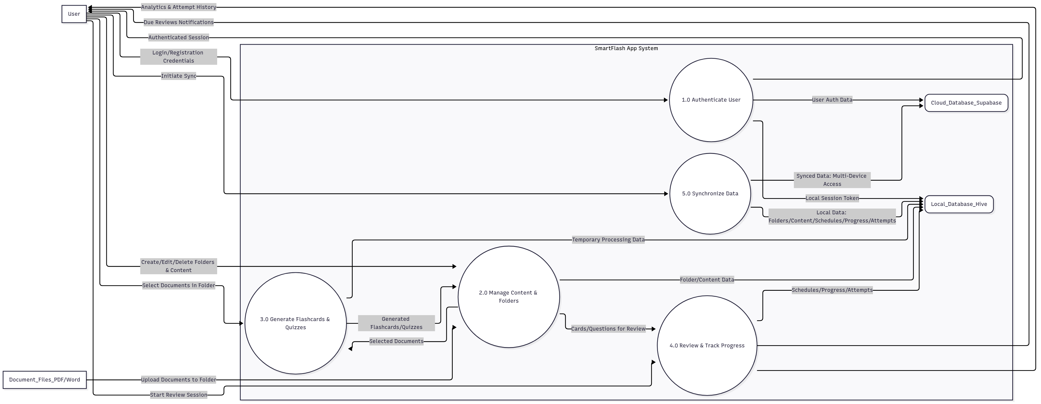

4.2 Entity Relationship (ER) Diagram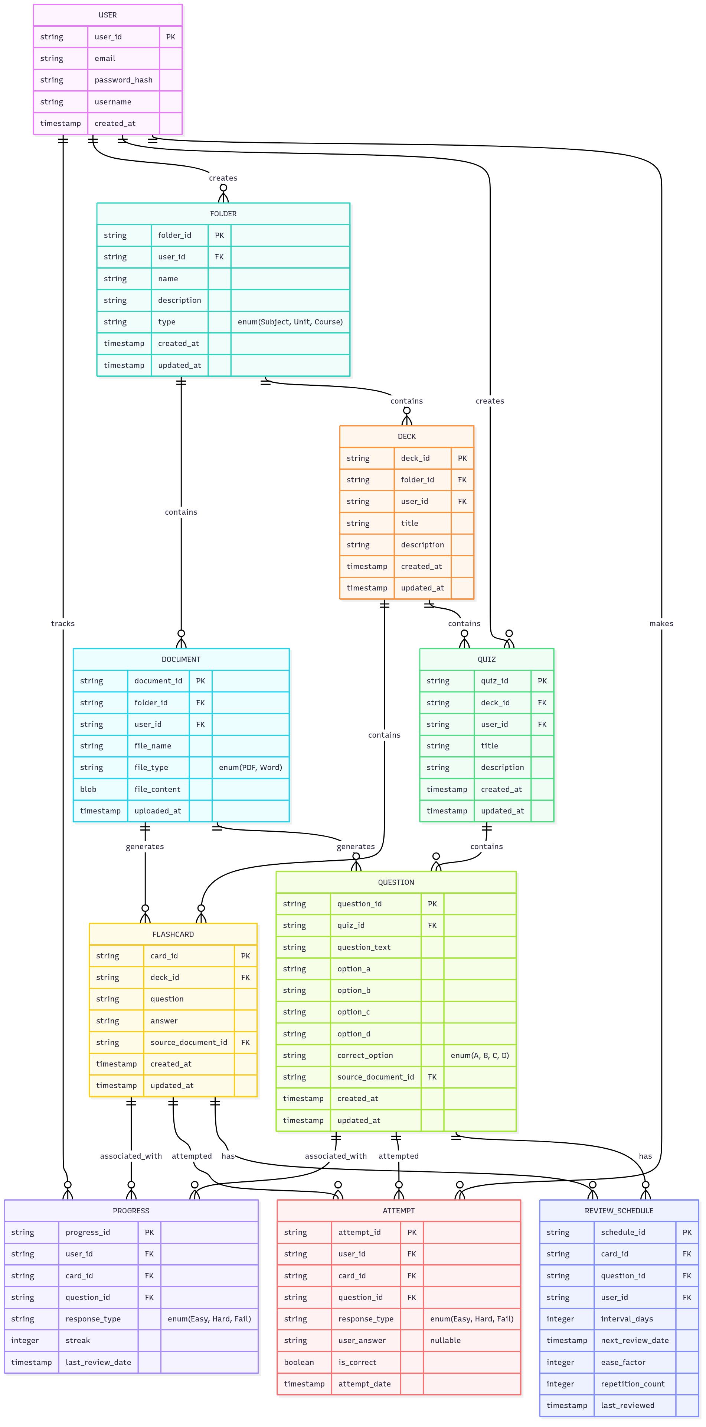

4.3 Proposed Timelines
The project spans 12 weeks, as outlined in the Gantt chart below
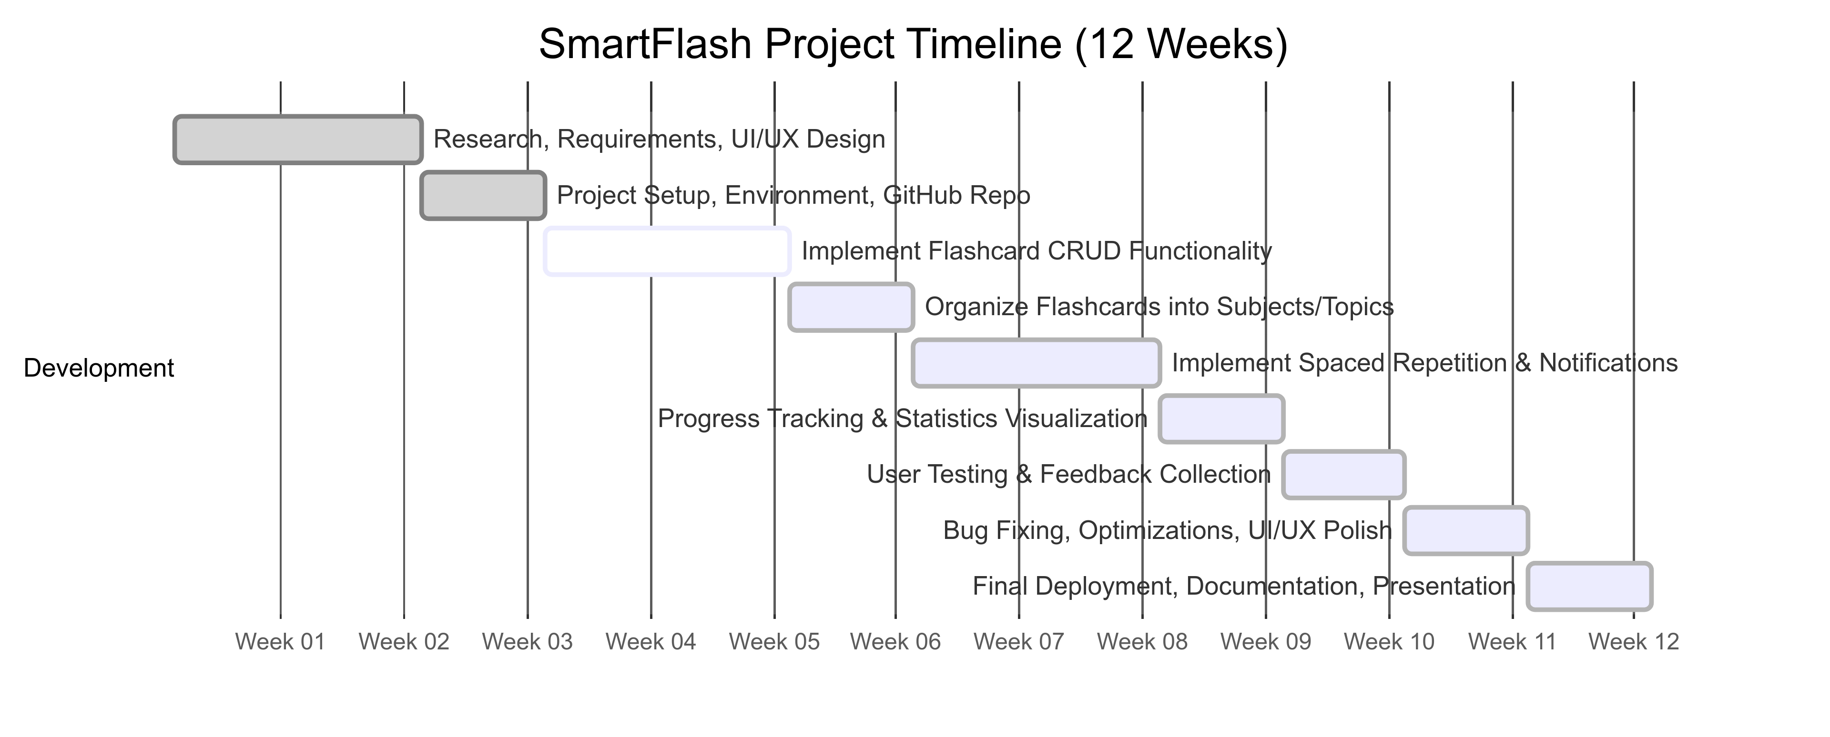

References
Cepeda, N. J., Pashler, H., Vul, E., Wixted, J. T., & Rohrer, D. (2006). Distributed practice in verbal recall tasks: A review and quantitative synthesis. Psychological Bulletin, 132(3), 354–380. https://doi.org/10.1037/0033-2909.132.3.354
Ebbinghaus, H. (1964). Memory: A contribution to experimental psychology (H. A. Ruger & C. E. Bussenius, Trans.). Dover Publications. (Original work published 1885)
Karpicke, J. D., & Roediger, H. L. (2008). The critical importance of retrieval for learning. Science, 319(5865), 966–968. https://doi.org/10.1126/science.1152408
Roediger, H. L., & Karpicke, J. D. (2006). Test-enhanced learning: Taking memory tests improves long-term retention. Psychological Science, 17(3), 249–255. https://doi.org/10.1111/j.1467-9280.2006.01693.x

