ASSIGNMENT-15

1. FIRST WE WRITE THE FLASK CODE WHICH IS GIVEN BY MOHIT SIR AND THEN RUN IT

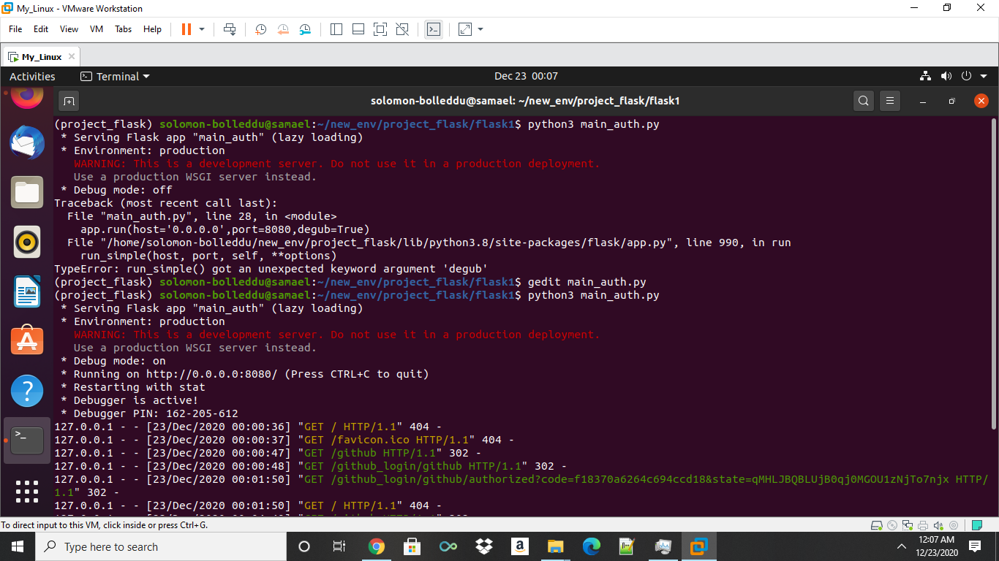

1. AFTER LAUCHING IT WE GO TO THE BROWERS AND TYPE 127.0.0.1:8080//github

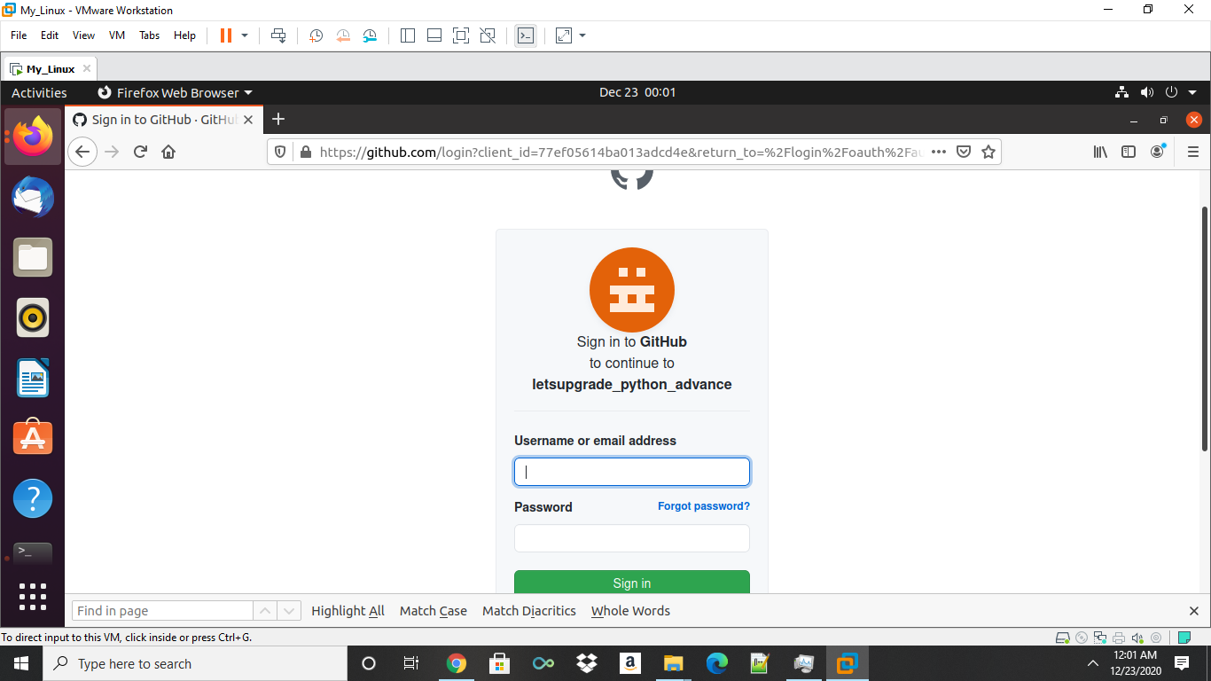

1. Then enter the credentials the viola.. done

