Analysis of the American Recovery and Reinvestment Act of 2009

In 2009, towards the very end of the Great Recession, President Obama signed ARRA into law, an economic development and stimulus package worth $787 billion. The bill was created with the purpose of increasing spending through Keynesian economic theory, and passed through the House of Representatives with a 100% Democrat vote of 244-188.
Per the bill itself, the overall stated goals were “To preserve and create jobs and promote economic recovery,” “To assist those most impacted by the recession,” “To provide investments needed to increase economic efficiency by spurring technological advances in sciences and health,” “To invest in transportation, environmental protections, and other infrastructure that will provide long-term economic benefits,” and “To stabilize State and local government budgets, in order to minimize and avoid reductions in essential services and counterproductive state and local tax codes.” The package set out to achieve these goals through allocating $288.8 billion to tax relief, $111 B to infrastructure and science, $144 B to state and local fiscal relief, with the remaining $357 B going towards miscellaneous federal programs, including infrastructure, research, and unemployment benefits.
Initially, there were (very) mixed opinions by economists; economists such as Martin Feldstein and Joseph Stiglitz (a Nobel Prize winner in Economic Sciences) were strongly for the act, also recommending a larger package. However, there were worries over the soundness of the bill after President Obama included tax cuts to secure bipartisan support and the lack of a direct addressal of unemployment and consumer spending.
Seven years have passed since the bill was instated, enough time to see the effects. In a 2014 poll run by the IGM Chicagobooth Forum, 82% of polled economists (97% when adjusted for confidence) from the IGM Economic Experts Panel responded “Agree” or “Strongly Agree” to the statement “Because of the American Recovery and Reinvestment Act of 2009, the U.S. unemployment rate was lower at the end of 2010 than it would have been without the stimulus bill.” Similarly, 56% (75% adjusted) responded “Agree” or “Strongly Agree” to the question “Taking into account all of the ARRA’s economic consequences — including the economic costs of raising taxes to pay for the spending, its effects on future spending, and any other likely future effects — the benefits of the stimulus will end up exceeding its costs.” This shows that, among a panel of (supposedly) expert economists, there is resounding support for ARRA and its programs. As well, a number of macroeconomic firms estimated in 2010 that the stimulus “has added 1.6 million to 1.8 million jobs so far and that its ultimate impact will be roughly 2.5 million jobs.”
However, looking at a graph of the predicted nationwide unemployment rate (Q1 2009 – Q1 2014) overlayed with the actual unemployment rate (Q1 2007 – Q3 2011), we can see that this is not quite the case:
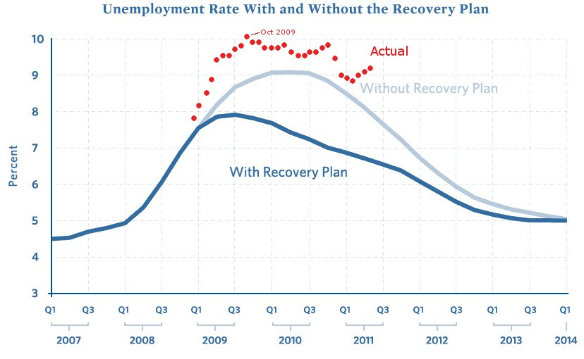
Fig. 1
It is clear that the nationwide unemployment rate shot up much faster and leveled out much later than expected/predicted at the time, with ARRA not having as many short term benefits as possibly expected. However, this is not a refutation to the success of ARRA, with it successfully lowering the U.S’s unemployment faster than was predicted in the event of its absence.
If I were a congressman that helped vote ARRA into law, I would be extremely willing to defend my vote. Overall, we’ve seen renowned economists praise ARRA and its effects, both before and after it was signed into law. The act has (arguably) reduced the unemployment rate in the US in the years following the Great Recession of 2007-09, helped retain and create over 1.5 million U.S. jobs, and is said to have done more good than bad on the U.S. economy as a whole — all characteristics of a successful economic stimulus package.

http://www.hitechanswers.net/about/about-arra/
http://www.nytimes.com/2009/01/29/us/politics/29obama.html?hp
https://en.wikisource.org/wiki/American_Recovery_and_Reinvestment_Act_of_2009#Sec._3.
http://appropriations.house.gov/pdf/PressSummary02-13-09.pdf
http://news.morningstar.com/all/ViewNews.aspx?article=/DJ/200901141002DOWJONESDJONLINE000637_univ.xml
http://www.bostonherald.com/business/general/view/2009_01_30_Harvard_prof_slams_stimulus_plan:_Dems___800b_%E2%80%98mistake_
http://www.igmchicago.org/igm-economic-experts-panel/poll-results?SurveyID=SV_5bfARfqluG9VYrP
http://www.igmchicago.org/igm-economic-experts-panel/poll-results?SurveyID=SV_5bfARfqluG9VYrP
https://upload.wikimedia.org/wikipedia/commons/c/c6/ARRA_Unemployment_Rate_Graph_2011-05.jpg

