Parameter Dynamics of a Thermal Power Plant for Process Control
or
Steam Generation Process: Nonlinear Dynamic and Statistical Signal Analysis

¹School of Electrical and Computer Sciences
²School of Minerals, Metallurgical & Materials Engineering
³AI and High-Performance Computing Research Center (AHRC)
Indian Institute of Technology Bhubaneswar, Argul, Khordha, Odisha, 752050, India

Correspondence to: Chinmoy Raj Hota, Email: a23ec09007@iitbbs.ac.in
Solomon Khess, Email: 21mm02001@iitbbs.ac.in

Abstract
Flexi power management with optimum power generation efficiency is the key goal of a thermal power plant. Steam temperature needs to be controlled for safe and efficient plant operations. However, a boiler has multiple interrelated parameters that dynamically change with time. This makes it a complex dynamical system. Signal analysis of this system is performed to determine key system characteristics, and the important variables to control have been identified. A dynamical system-based analysis reveals interesting state indicators that could be useful for control. Steam temperature prediction using regression is presented. This analysis work shall be extended to a control strategy as a subsequent work. This approach, followed in analysing a core complex process, could be cross-applied to other areas.

Keywords
thermal, power, steam, boiler, furnace, chaos, dynamics, prediction

1. Introduction

A boiler is a complex dynamical system. There are multiple process parameters that change dynamically with time. These parameters have interdependencies among them. Due to flexi-power needs, the load could vary with time, thereby changing the dynamics of the systems. The process needs to be controlled to improve the power generation efficiency.

The signals in the said system are non-stationary. However, in general, the signal analysis methods, e.g., FFT, expect the signal to be stationary. Methods based on non-linear dynamics select the embedding dimension and time lag as the base parameters to proceed. The changing dynamics in the boiler lead to a changing time lag of the signal when analysed over subsequent windows. Hence, popular methods like Lyapunov Exponent, which uses time lag, might not be effective in determining the chaos in the system. Alternate approaches to accommodate such non-stationary, chaotic signals are needed.

Chaotic systems are sensitive to initial conditions. In the context of the boiler, how well it performs after the change of the load could be very different based on the state of the parameters before the load was changed. Hence, the parameters condition now, if controlled effectively, would make the outcome later favourable. The caution, however, is that chaos-based control is recommended for the short term.

In this work, the data from a thermal power plant has been considered. The plant generates power under two modes – normal load (500MW) and low load (300MW). The focus of the current work is to analyze the data and identify potential system characteristics. As a subsequent work, these characteristics shall be used to develop a control method for flexible power demand management. As this work focuses on the parameters related to a core steam generation process, the insights thus generated are relevant to any other thermal power plant.

< Add further fundamentals of a boiler system as needed >
< Add an analysis of the other methods (work by others) used for real-time boiler control >

A context diagram, a brief explanation of the process, details about the data, and selection of the key parameters for analysis are provided in Section 2. Section 3 covers signal analysis using nonlinear dynamics, identifies key parameters that could be useful for control, and generates insights into the behaviour of the system. Section 4 covers signal analysis using statistical analysis methods, identifies key parameters to control, and show results for prediction of steam temperature. Each sub-section in Sections 3 and 4 is dedicated to a particular topic, specifying the details on the specific data used, the method deployed, and the results obtained in one place. Inferences from results are discussed in Section 5, followed by a summary in the conclusion section (Section 6). Notes for some of the interchangeably used terms and the full form of acronyms are provided in Appendix 1.

2. Context, Data, Key Parameters

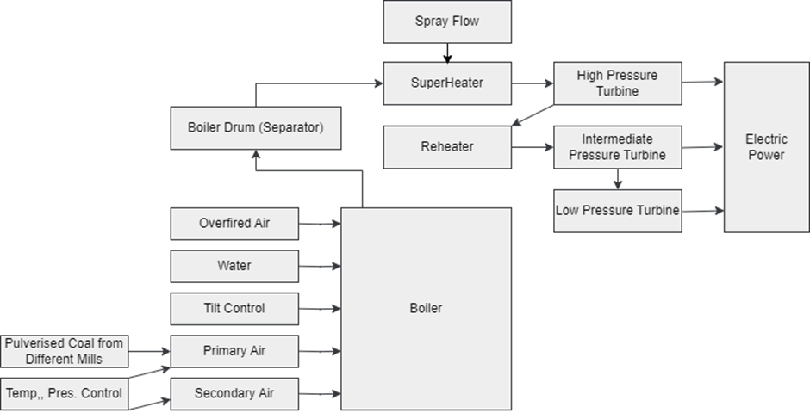

Figure 1 Context Diagram

Figure 1 depicts a block diagram of the system and the key process aspects to build a context for the data analysis. Different mills generate the pulverised coal, which is carried by the primary air into the boiler. Secondary air provides the oxygen for combustion. The temperature and pressure of the primary and secondary air are controlled for the desired combustion performance. The tilt control provides an option for different angles for the entry of the air and pulverised coal into the boiler. The combustion of the coal heats up the water on the walls, converting it to steam. The overfired air ensures Nitrogen Oxide (NOx) is not formed. The boiler drum separates the vapour from the liquid and controls the mass of steam fed to the superheater (SH). Superheater heats up the steam to the desired temperature. Spray flow is exercised to control the temperature of the steam when needed. The high-pressure turbine generates power using the heated steam from the superheater. The steam with reduced pressure is fed back to the reheater to increase the temperature of the steam for subsequent stages of the turbines.

The data available is for a duration of one month (31 days). The data contains information about the 96 parameters of the plant (also referred to as signals or features in this work). The data has been sampled at a rate of 1 sample per 30 seconds. There are 89291 data points (entire duration) for each parameter.

Considering the steam temperature of the superheater (SH Steam Temperature Line-A, also referred to as steam temperature in this work) as the outcome to be controlled (dependent variable), the key 13 of the total 96 parameters (independent variables) are identified as below:
- Total Coal Flow – primary fuel input driving the heat.
- Total Air Flow – key for combustion control.
- Sofa-Flow – affects combustion staging and flame profile.
- Total Secondary Air Flow – air used for combustion.
- Burner Tilt-Average - alters flame shape and the heat zone.
- SH Spray Flow Line-A - directly controls SH steam temperature.
- Throttle Pressure Actual - affects steam enthalpy and turbine inlet.
- Furnace Pressure - indicates furnace stability and combustion conditions
- Wind Box Pressure (LHS, RHS) - secondary air distribution indicators.
- Secondary Air Temp (LHS, RHS) - air heat content for combustion.
- Total Mainstream Steam Flow - Steam flow entering the superheater
Note: LHS = Left Hand Side. RHS = Right Hand Side.

The mass of the steam is controlled per the power demand and monitored using the Total Mainstream Steam Flow. The pressure of the steam is controlled using the Throttle Pressure Setpoint and is monitored using the Throttle Pressure Actual, e.g., 170KSC/130KSC for 500/300MW, respectively. The temperature of the steam (SH Steam Temperature Line-A) is desired to be maintained around 540°C.

A brief summary of the rationale for the parameters not considered:
- Superheater Line-B (since the focus is on Superheater Line-A)
- Reheater parameters (since reheater is a stage post SH, focus is on SH)
- Mills-related parameters (total air flow covers for them)
- Oxygen economizer and Chimney related (are outputs)

3. Signal Analysis I
In this section, the parameters have been analyzed by various nonlinear dynamics techniques to generate information about the system characteristics. The specific data section considered is mentioned in the respective sub-sections.

3.1 Stationarity

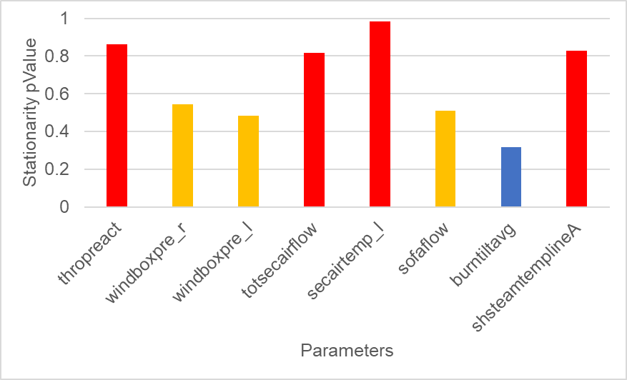

Figure 2 Stationarity

A signal whose statistical properties (mean, standard deviation) do not change with time is called stationary (and has a p-value less than 0.05). The stationarity test of some of the signals (datapoints 1000:2000) is performed using the Augmented Dickey-Fuller function supported in MATLAB (adftest) [1]. The stationarity p-value varies – four signals are well above 0.5 (red), three near 0.5 (yellow), one less than 0.5 (blue) – Figure 2. As all the signals have a p-value above 0.05, the signals are non-stationary.

< We could check the non-stationarity in normal and low load separately >
< Here we have 8. If required, we can do for the 13 signals + steam temp >

3.2 Time Lag

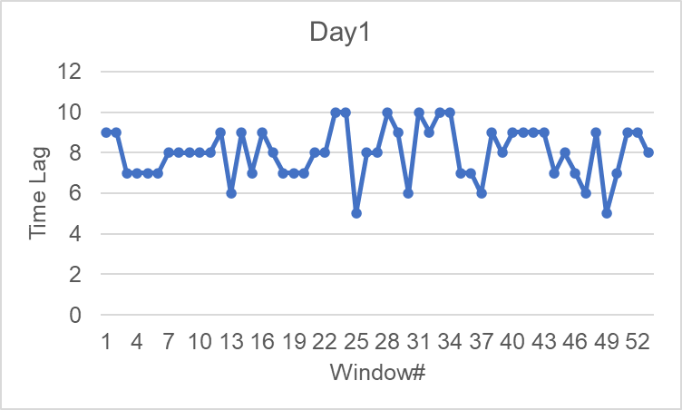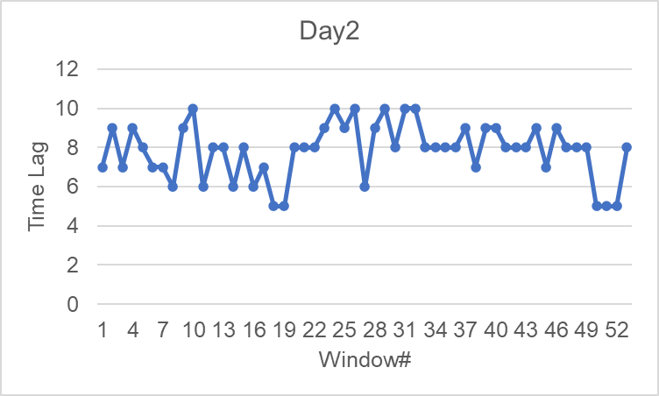

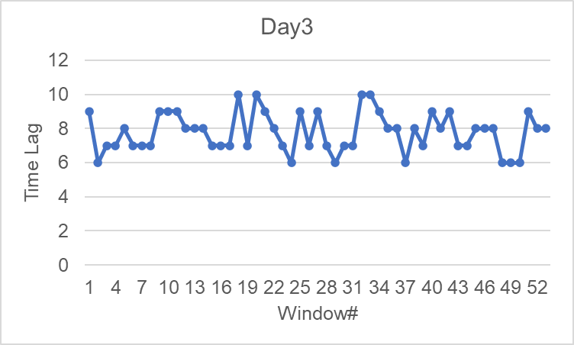

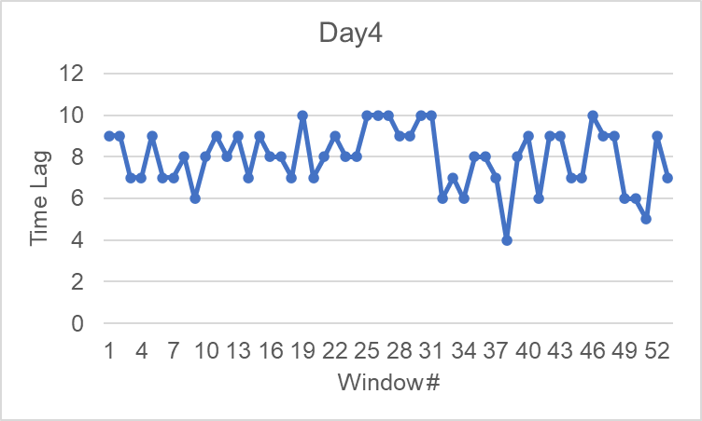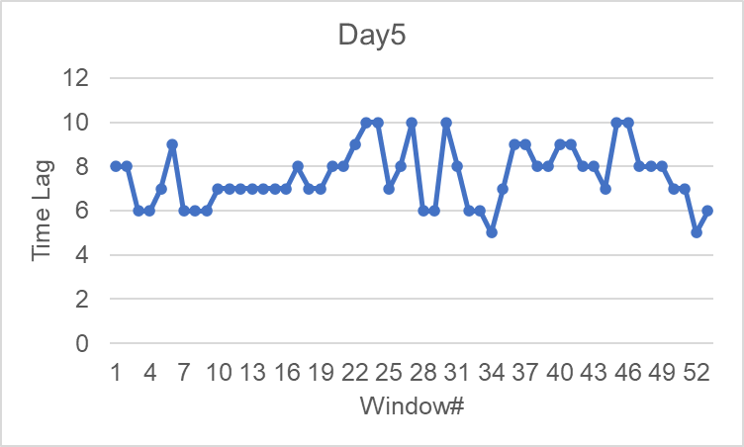

Figure 3 Time Lag (Steam Temperature)

Embedding dimension and Time Lag are the base parameters used in many nonlinear dynamic analysis methods. Figure 3 considers the datapoints for the first five days (Day1-5) for SH Steam Temperature Line-A. A sliding window length of 250 samples with a sliding step of 50 samples is considered, which results in 53 windows for each day. The time lag for each window has been estimated using the Phase Space Reconstruction function supported in MATLAB (phasespacereconstruction) [2]. As can be observed, the time lag of the signal (steam temperature) is continuously changing through the successive windows.

3.3 Hurst Exponent

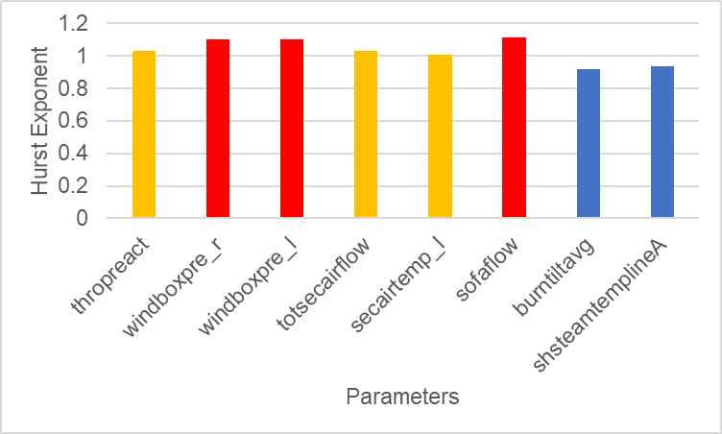

Figure 4 Hurst Exponent - Multiple Parameters

The Hurst exponent of a signal, less than 0.5, 0.5, greater than 0.5, indicates anti-persistence, random walk, and persistence, respectively. Hurst Exponent of some of the signals (datapoints 1000:2000) is greater than 0.5 (Figure 4). Hence, the signals are persistent. For the Hurst exponent calculation, 5 points (each point corresponding to 2,4,8,16,32 chunks) have been considered for the total signal length of 1001 samples.

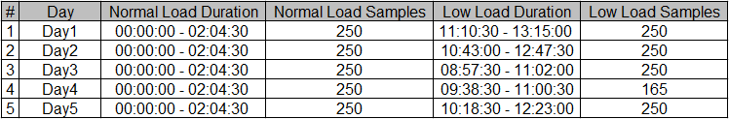
Table 1 Hurst Exponent - Steam Temperature - Duration, Samples

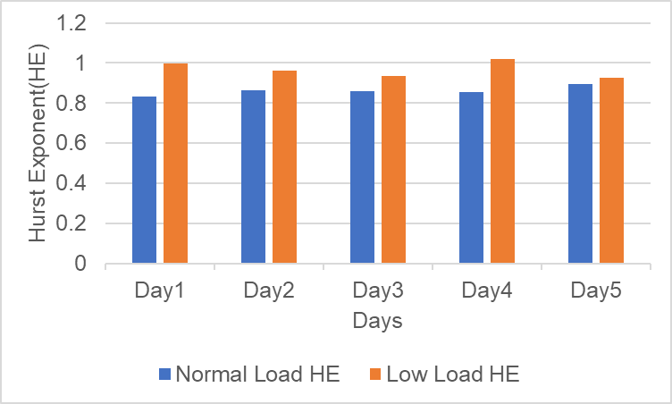

Figure 5 Hurst Exponent - Steam Temperature

To understand a shorter duration behavior, the number of samples was reduced to 250. 5 points (each point corresponding to 2,4,8,16,32 chunks) have been considered for the Hurst exponent. Table 1 shows the durations of normal and low loads considered for five days (one of the days has a short low-load duration). Figure 5 shows the Hurst exponent for steam temperature for normal and low load. As can be seen, the Hurst exponent is greater than 0.5 in either case, with the low load always higher than the normal load. This indicates that there is persistence in the steam temperature signal.

3.4 Furnace Pressure

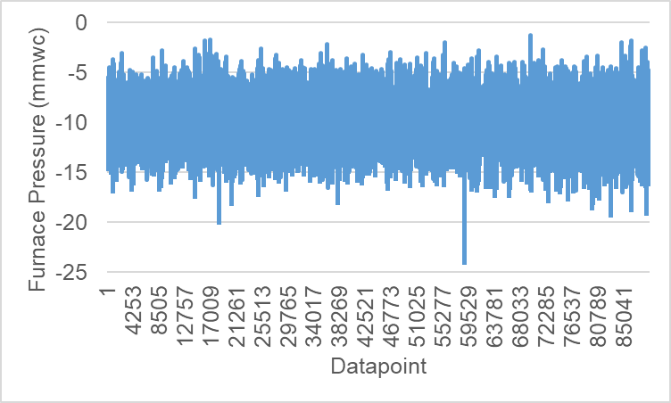
Figure 6 Furnace Pressure

Figure 6 shows the furnace pressure for the entire duration (89291 data points). The mean +/- standard deviation) furnace pressure is -10.1513 +/- 1.6437 mmwc. However, the furnace pressure is frequently crossing -5 mmwc and -15 mmwc, indicating there is a variation in the process.

3.5 Burner Tilt

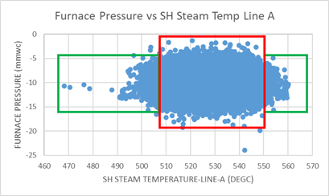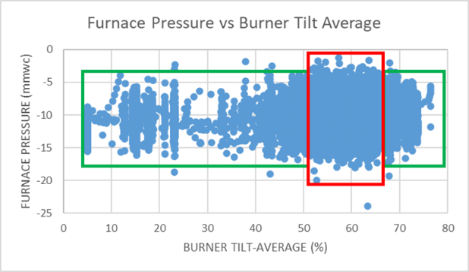

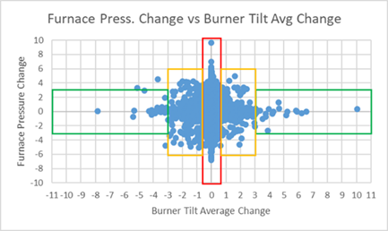

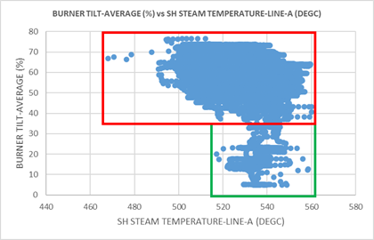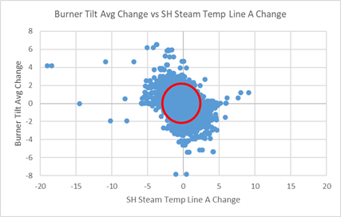

Figure 7 Burner Tilt

Figure 7 shows the scatter plots for the combination of various parameters (furnace pressure, steam temperature, burner tilt) for the entire data (89291 data points). The plots with “change” refer to the difference between the “current value” and the “previous value” of the parameter considered. The furnace pressure variation is lower at lower burner tilt. When there is approximately no change in the burner tilt, there is a higher change in the furnace pressure. The steam temperature is higher for a lower burner tilt. It appears burner tilt could be an important parameter to control.

3.6 Throttle Pressure Setpoint

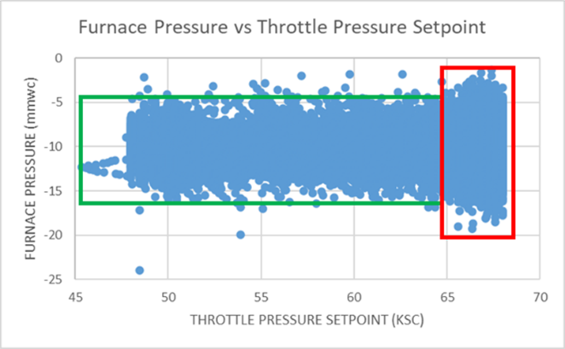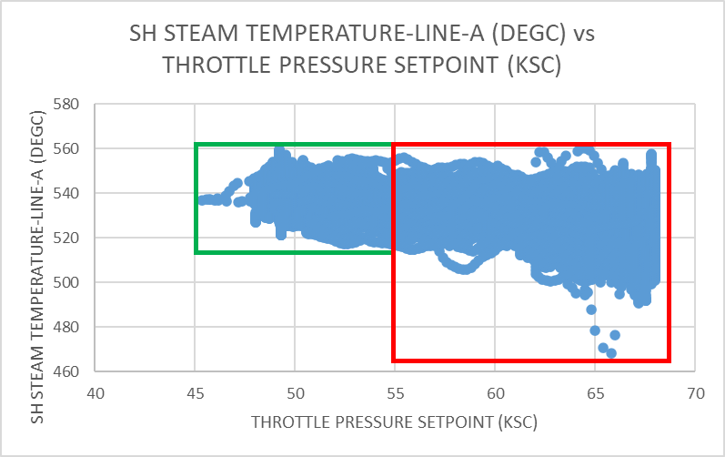

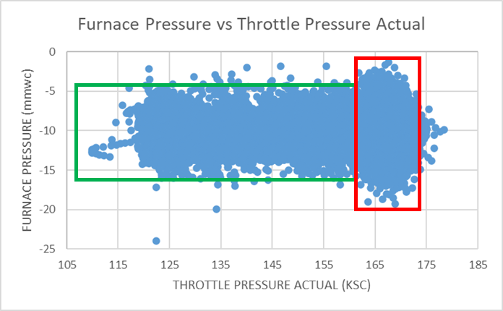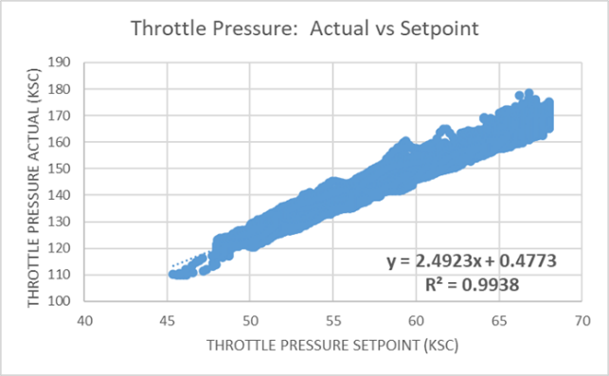
Figure 8 Throttle Pressure Setpoint

Figure 8 shows the scatter plots for the combination of various parameters (furnace pressure, throttle pressure setpoint, steam temperature, throttle pressure actual) for the entire data (89291 data points). The furnace pressure variation is lower at a lower throttle pressure setpoint. Steam temperature is higher at a lower throttle pressure setpoint. The actual throttle pressure is generally ~2.5 times the setpoint.
3.7 Steam Temperature

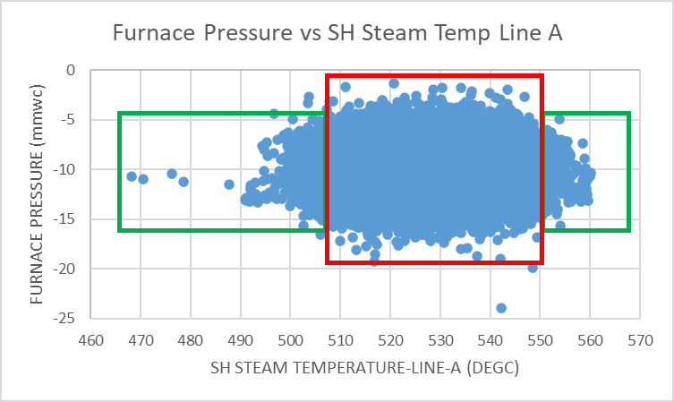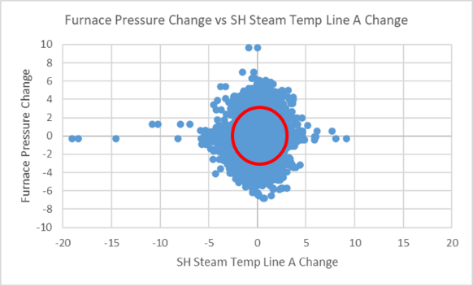

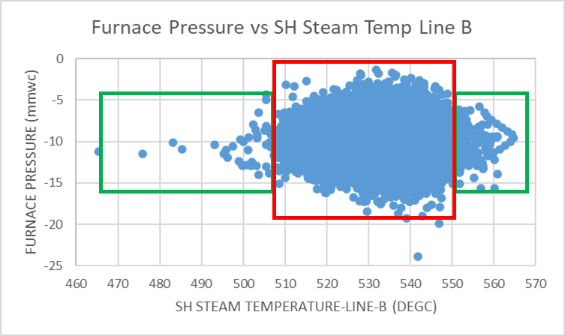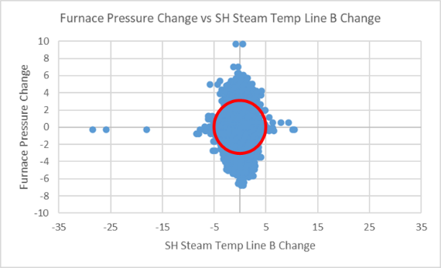
Figure 9 Steam Temperature

Figure 9 shows the scatter plots for the combination of various parameters (furnace pressure, SH steam temperature line-A, SH steam temperature line-B) for the entire data (89291 data points). The plots with “change” refer to the difference between the “current value” and the “previous value” of the parameter considered. Line B SH steam temperature appears to be more controlled than Line A.

3.8 Special Event

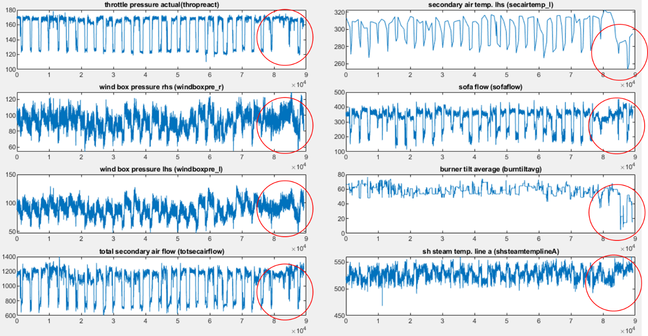

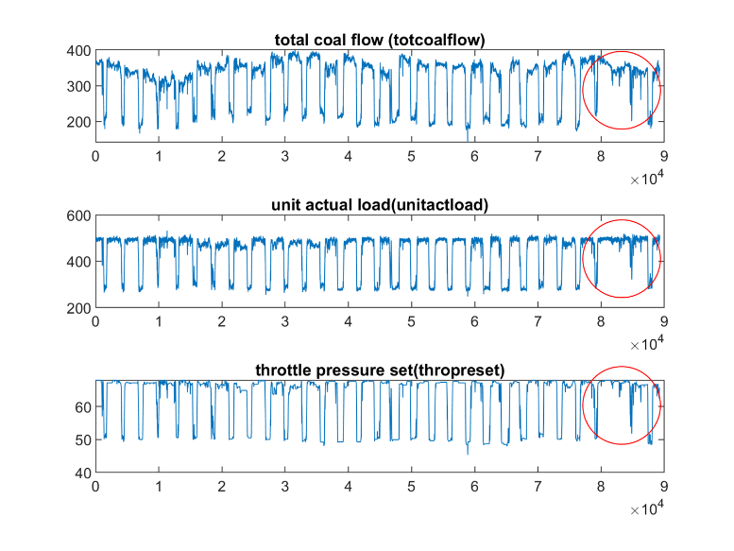
Figure 10 Special Event

Figure 10 shows the time domain plot of the various signals for the entire data (89291 data points). There is a special event observed at the end of the one-month data where the waveforms look different (low-going pulse not observed) from the earlier days.

3.9 Transition and Low Load Duration

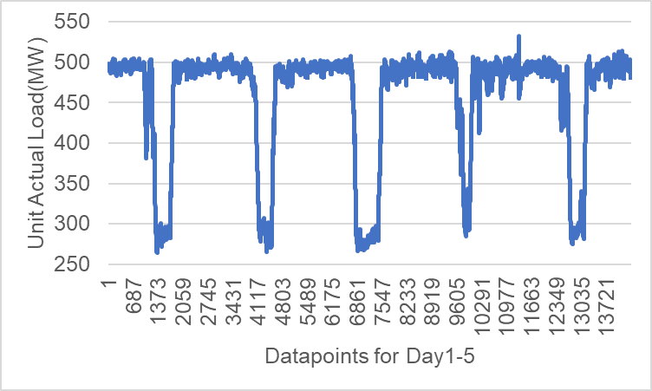

Figure 11 Unit Actual Load (Day1-5)

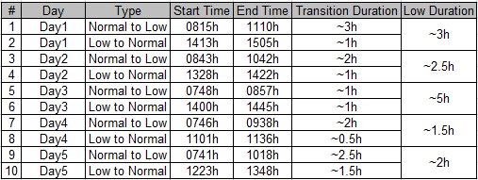

Table 2 Transition and Low Load Duration (Day1-5)

Figure 11 shows the unit actual load waveform, and Table 2 shows the transition and low load durations for the first five days (Day1-5). The normal, transition, and low-load sections have been determined based on the unit's actual load values and its waveform. It appears that the transition duration varies; however, the “low to normal” is generally shorter than the “normal to low” duration. The low load duration varies.
3.10 Key Parameters with Load

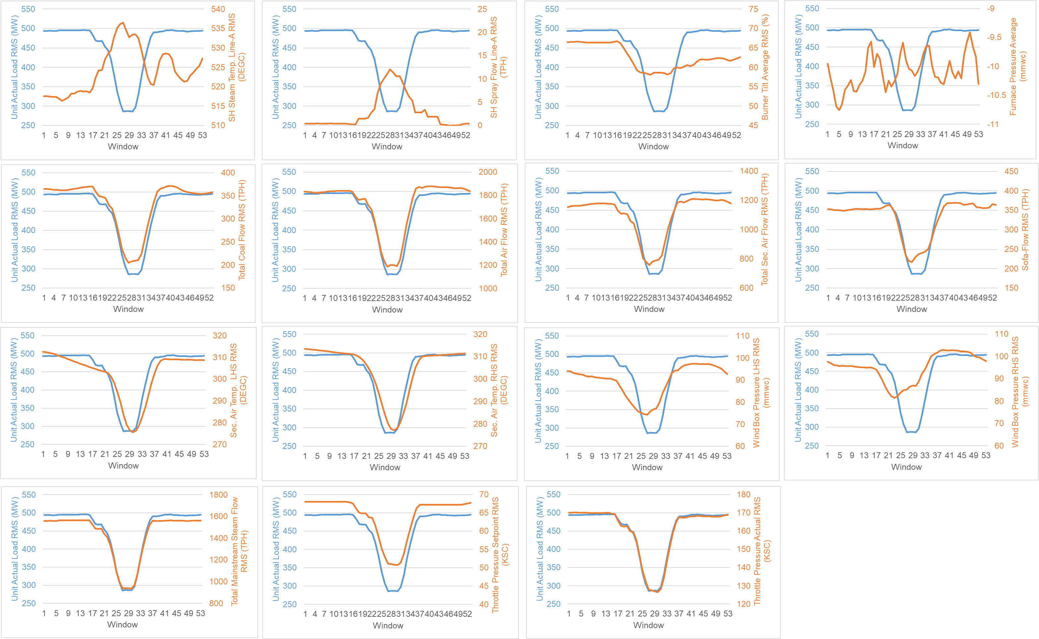
Figure 12 Key Parameters with Load (Day 1)
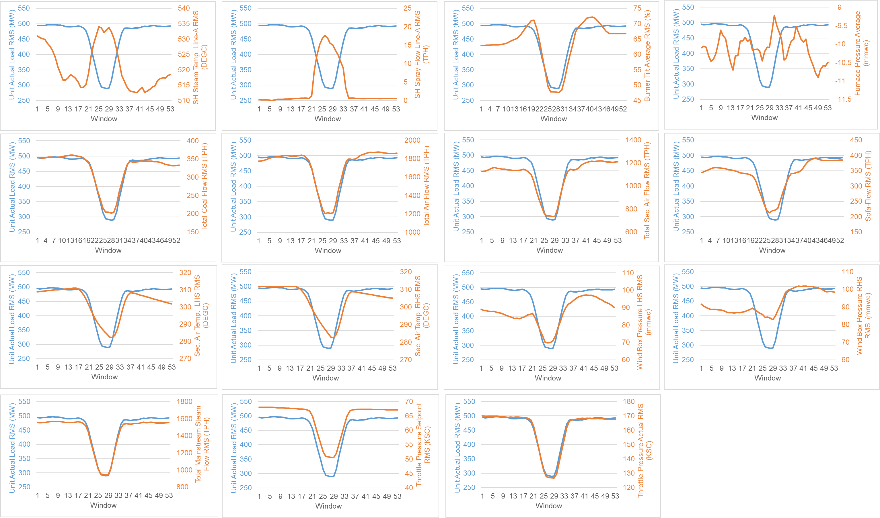

Figure 13 Key Parameters with Load (Day 2)

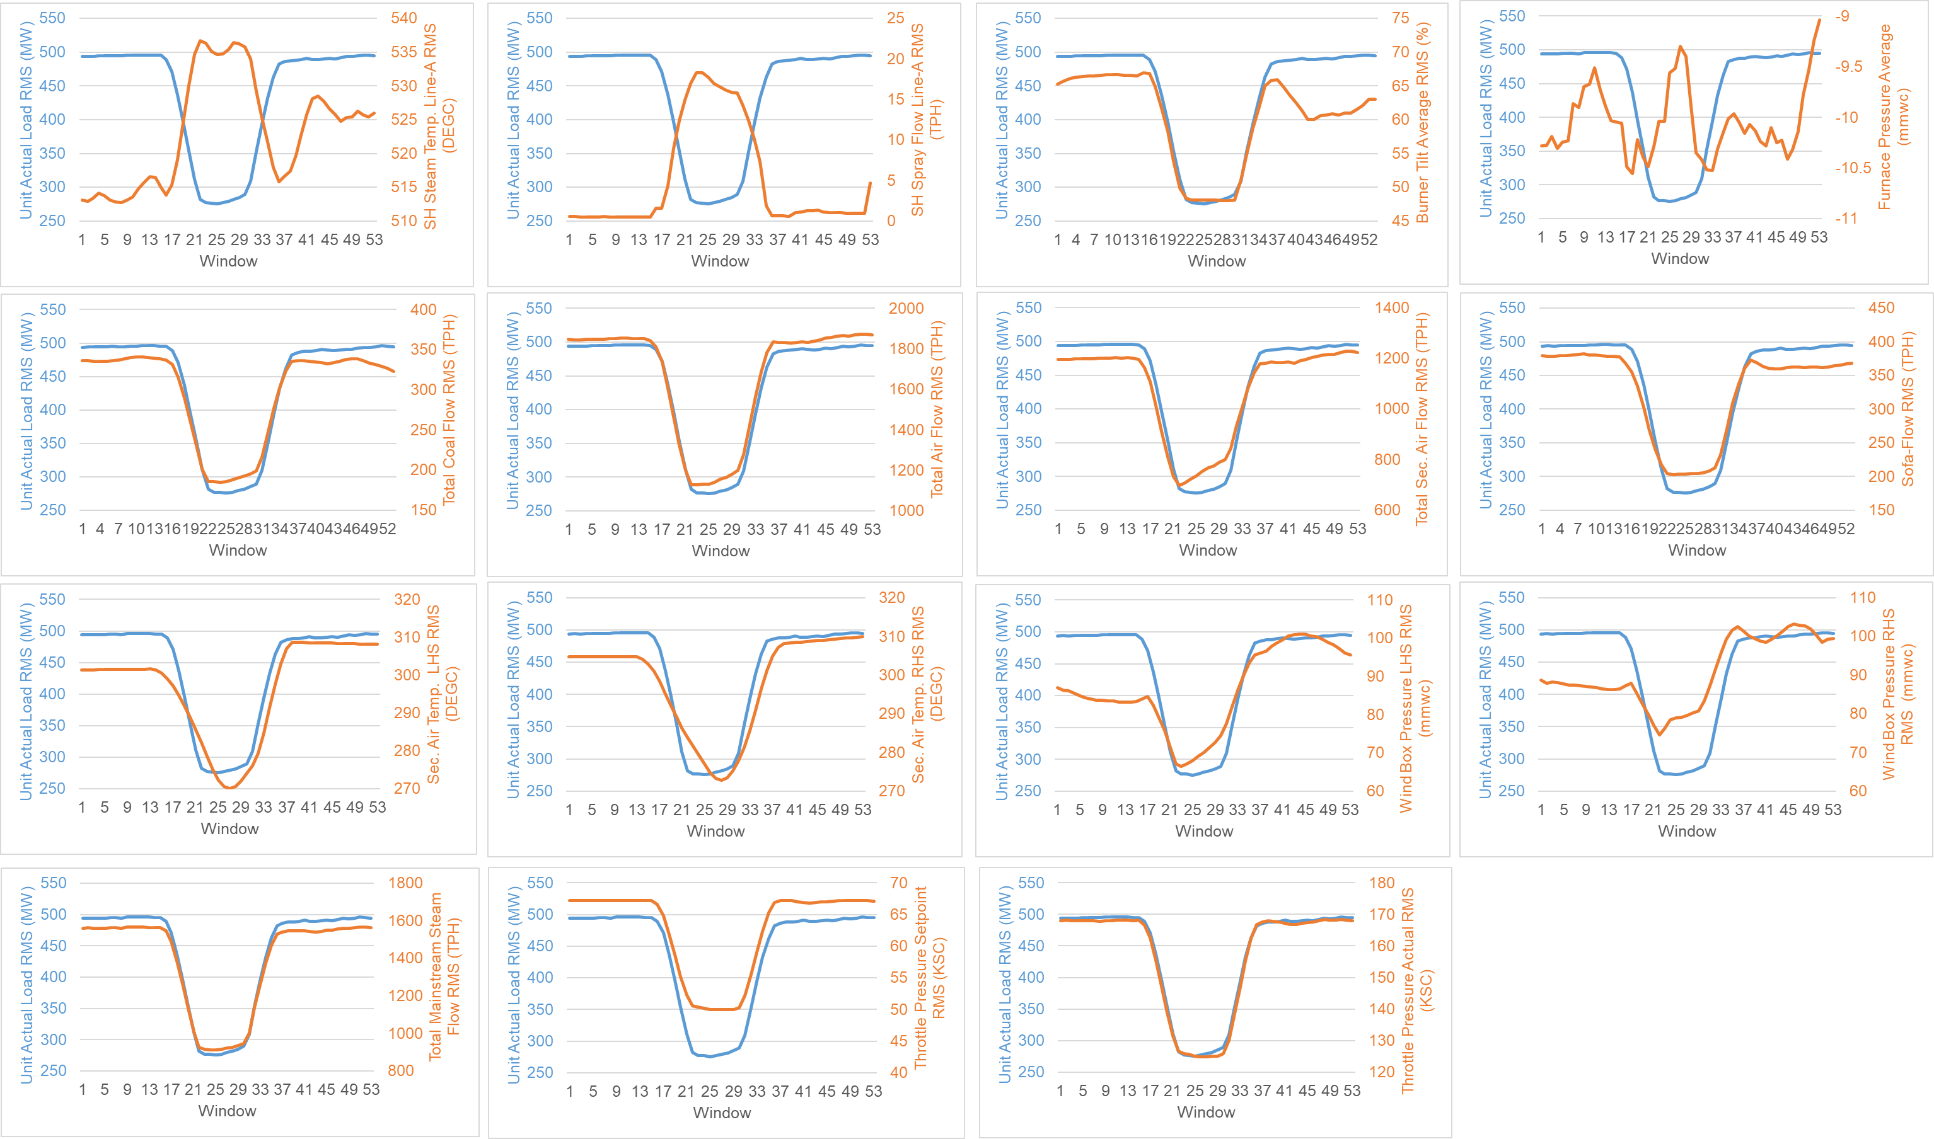

Figure 14 Key Parameters with Load (Day 3)

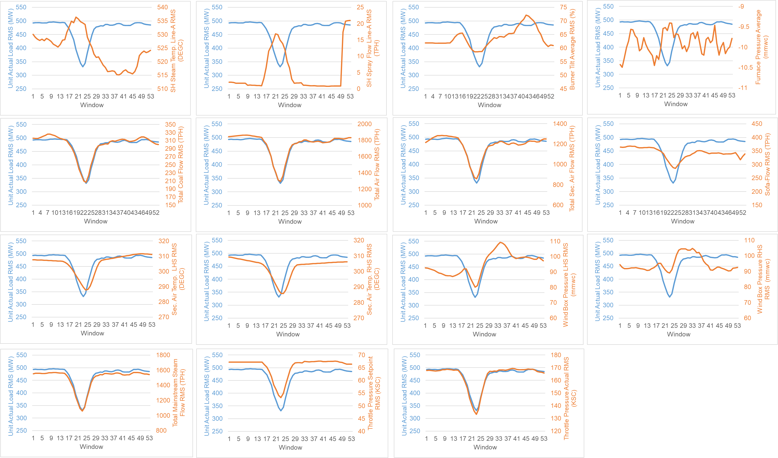

Figure 15 Key Parameters with Load (Day 4)

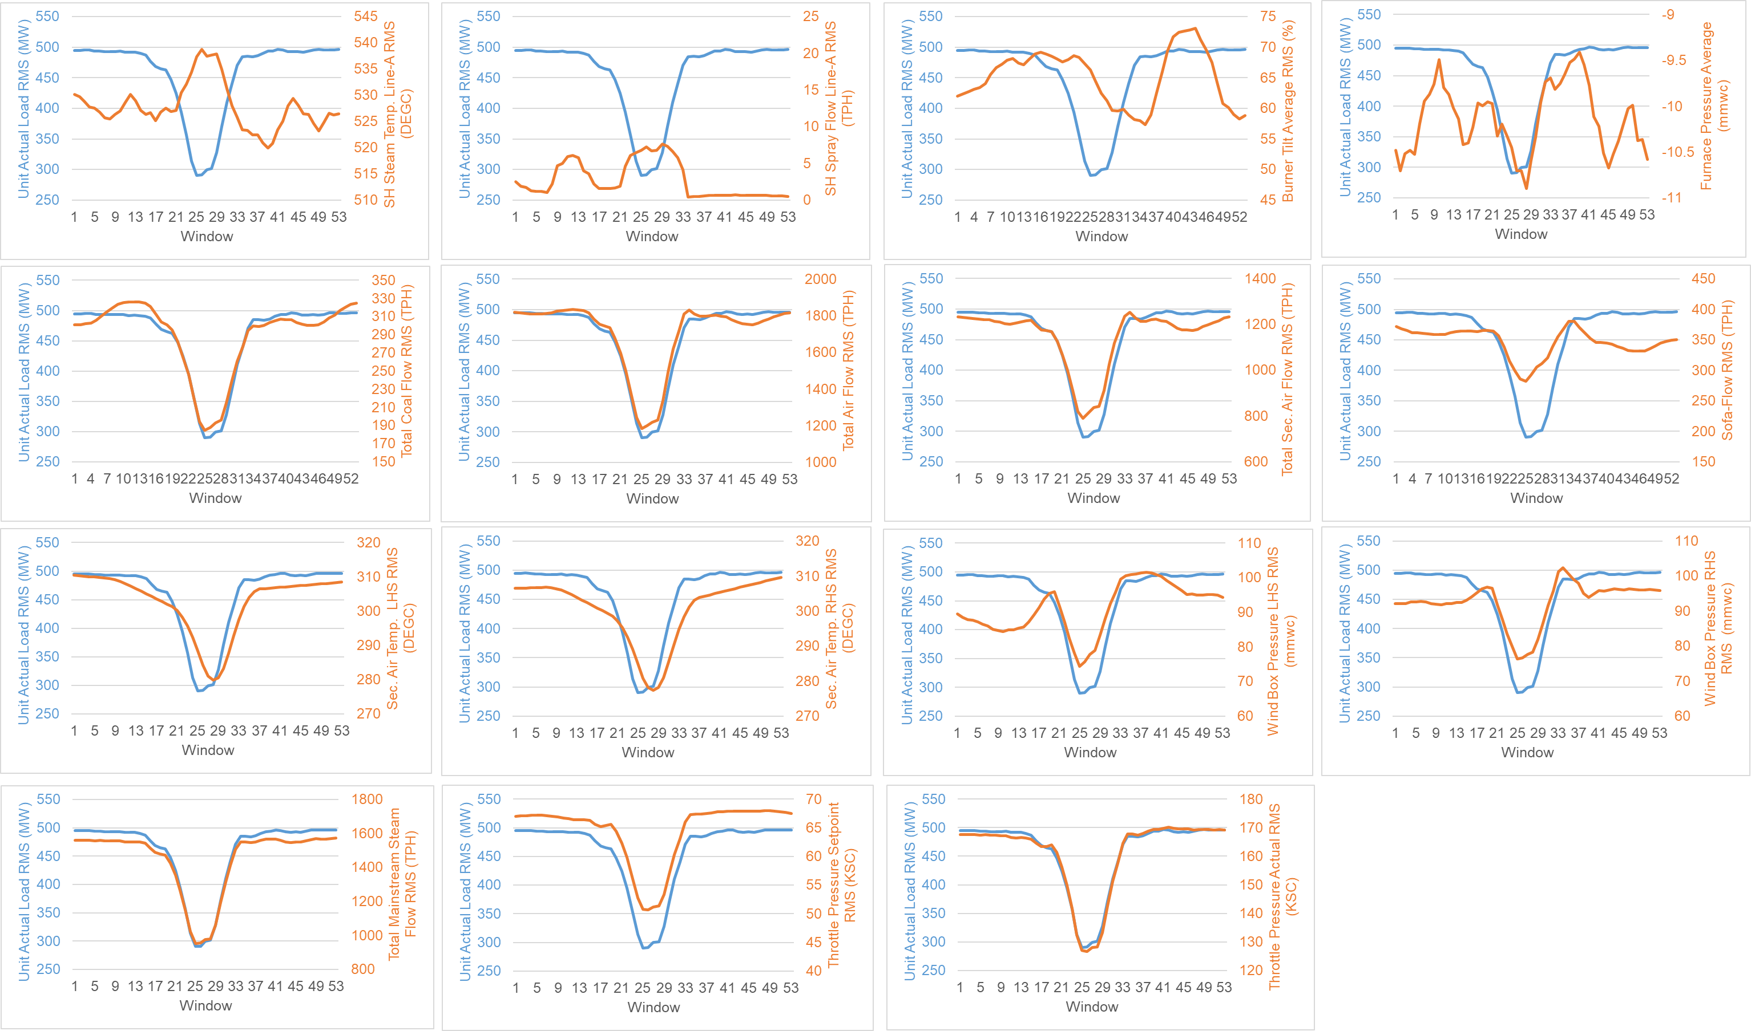

Figure 16 Key Parameters with Load (Day 5)

Figure 12-16 considers the datapoints for the first five days (Day 1-5). A sliding window root mean square (RMS) of the signals is done for a sliding window of length 250 samples. The sliding step is of 50 samples. Note, RMS might suppress the instantaneous changes; however, it provides an overall view of things. RMS was done for all key features (Section 2) except for Furnace Pressure. As the values of furnace pressure are negative, the average was taken there.

The steam temperature increases as the load decreases, and later decreases as the load transitions to normal. Most of the key parameters follow the load trend except spray flow (e.g., Day 5), burner tilt (e.g., Day 1,4,5), and in some cases, wind box pressure RHS (e.g., Day1-4), sofa-flow (e.g., Day 4,5). Furnace pressure varies continuously. The parameters for Day 3 are better synchronized with the load trend as compared to the rest of the four days.

3.11 Key Parameters – State Space

This section considers three windows of a particular day (Day 3) – normal before low load (Window 7), low load (Window 25), and normal after low load (Window 51). The state space of key signals has been considered to show that they are related to each other. The sliding windows considered are of length 250 samples with a sliding step of 50 samples. The time domain plots consider root mean square values of the signal in the respective windows (excluding the furnace pressure for which average has been considered).

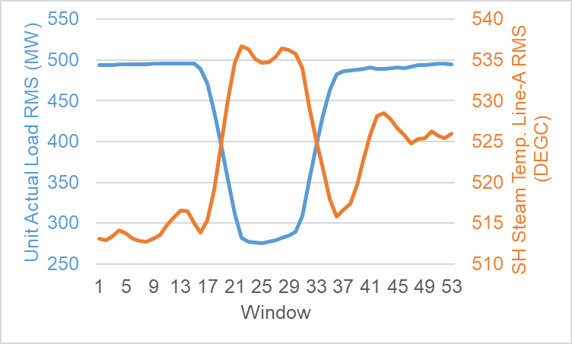

Figure 17 Steam Temperature and Load – Time Domain - Day 3

Figure 18 Steam Temperature – State Space - Day 3 (Window 7,25,51)

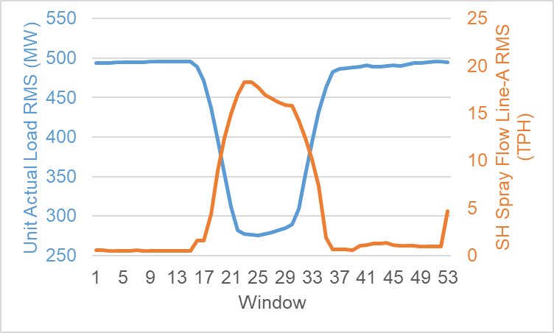

Figure 19 Spray Flow and Load – Time Domain - Day 3

Figure 20 Spray Flow – State Space - Day 3 (Window 7,25,51)

Refer to Figure 17,18. As the load reduces, the steam temperature increases and shifts up in the state space. As the load increases, the steam temperature decreases and settles to a middle location in the state space. Refer to Figure 19,20. The spray flow is exercised during the low load condition (when the steam temperature increases). Accordingly, the spray flow moves up in its state space during low load and later comes down once load transitions to normal.

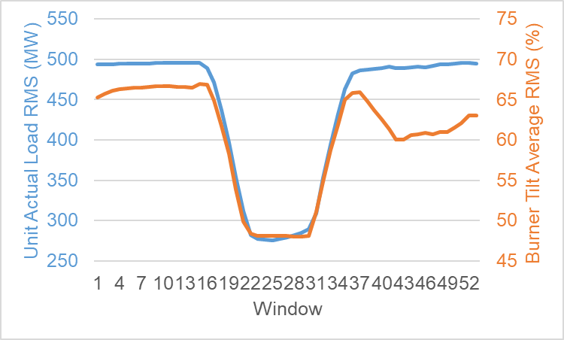
Figure 21 Burner Tilt and Load – Time Domain - Day 3

Figure 22 Burner Tilt - State Space - Day 3 (Window 7,25,51)
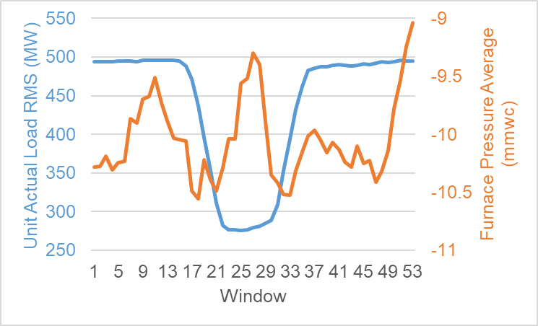
Figure 23 Furnace Pressure and Load - Time Domain - Day 3

Figure 24 Furnace Pressure - State Space - Day 3 (Window 7,25,51)

Refer to Figure 21,22. The burner tilt is fairly the same in the “normal before low load” and “low load”, hence the state space is concentrated at a fixed location, respectively. However, in the “normal after low load”, the burner tilt is being varied, and hence the movement in the state space can be observed. Refer to Figure 23,24. The furnace pressure variation in the “normal after low load” appears to have more movement in the state space as compared to “normal before low load” and “low load”. This could be so as the burner tilt is varied in the “normal after low load” period.

3.12 Steam Temperature as a Dynamical System

Steam temperature is dynamically changing with time. The days considered here are the first five days (Day 1-5). The sliding windows of steam temperature considered are of length 250 samples with a sliding step of 50 samples, which leads to a total of 53 windows for a single day. The signal (steam temperature) values are imposed onto a dynamical system. Dynamics Similarity Index (DSI) and Chaotic Dynamics Marker (CDM) are calculated for each window, which together represent the state of the system in that window [4].

Figure 25 3D Plot - CDM, DSI, Windows – Day1-5

Figure 26 CDM, DSI – Day1-5

Figure 25 shows a 3D plot of CDM, DSI, and Window number. This shows a change in the state of the system with time (increasing window numbers in the vertical direction). Figure 26 is a 2D view (CDM, DSI) of Figure 25, where the time (Window number) component has been collapsed. The load conditions are indicated on the left and right sides in both Figures 25 and 26 to build intuition for the 2D view.

Figure 27 DSI vs CDM - Scatter Plot - Day 1-5

Figure 28 Steam Temperature - State Space - Specific Day, Window

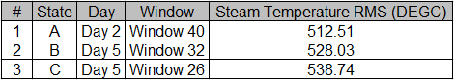

Table 3 Steam Temperature RMS Value - Specific Day, Window

Figure 27 is a plot of DSI vs CDM (it is a scatter plot representation of Figure 26). Three extreme points (states A, B, and C) are identified to correlate with the time domain and state space of the signal (steam temperature). The day, window, and the root mean square value of the steam temperature corresponding to the three states are indicated in Table 3. The signal (steam temperature)’s movement in the state space can be observed in Figure 28. The steam temperature values increase from state A to B to C (Table 3), the position moves from bottom left to middle to top right in the signal’s state space (Figure 28), and these correspond to leftmost, middle, rightmost, respectively, on the DSI-CDM graph (Figure 27).

4. Signal Analysis II
This section has an analysis of the data using statistical techniques, followed by the prediction of the steam temperature using Multiple Linear Regression (MLR) and Artificial Neural Network (ANN). The data section considered for analysis is described in the respective subsections.

4.1. Data Section Labels

Figure 29 Data Section Labels

Figure 29 considers the load data for the first five days (Day 1-5). The normal and low load data sections have been identified using the load value and the respective waveform. The data sections have been labelled (described below). Subsequent sub-sections in this document analyze the parameters in these data sections and shall refer to the respective labels accordingly.

Each day has three sections:
- Normal load before transition to Low load (Dx_P1)
- Low load (Lx)
- Normal load after transition from Low load (Dx_P2)
(D represents Day, x represents day number).

There is a total of six normal load sections for the five days considered – denoted as Nx, where x represents the number of such sections - N1, N2, N3, N4, N5, N6. The mapping of normal load sections to the day-specific parts is listed below:
- N1: Day1 (D1_P1)
- N2: Day1 (D1_P2) and Day2 (D2_P1)
- N3: Day2 (D2_P2) and Day3 (D3_P1)
- N4: Day3 (D3_P2) and Day4 (D4_P1)
- N5: Day4 (D4_P2) and Day5 (D5_P1)
- N6: Day6 (D5_P2)
Note: When there is a time continuity between “normal load after transition from low load” of the previous day and “normal load before transition to low load” for the current day, the sections are referred to together as a normal load section (N2, N3, N4, and N5). “Combined” for normal load implies all six normal load data sections (N1, N2, N3, N4, N5, N6) are considered together.

There is a total of five low-load sections for the five days considered – denoted as Lx, where x represents the number of such sections - L1, L2, L3, L4, L5. “Combined” for low load implies all five low load data sections (L1, L2, L3, L4, L5) are considered together.

4.2. t-values

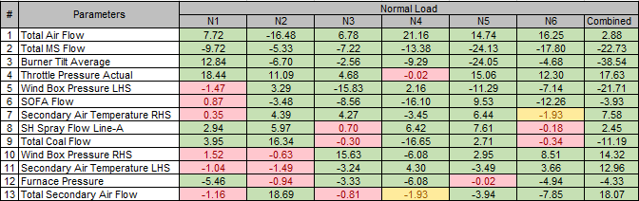
Table 4 t-values - Normal Load

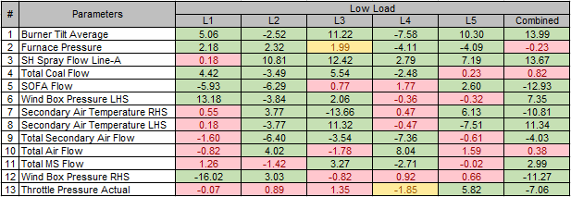
Table 5 t-values - Low Load

The t-values for the key parameters with steam temperature as the target variable are shown in Table 4 (Normal Load Data Sections) and Table 5 (Low Load Data Sections). The t-values have been obtained using Ordinary Least Squares (OLS) Regression using Python’s statsmodels library [5]. Section 4.1 has the details on the data section labels used (N1-6, L1-5). “Combined” refers to considering “N1, N2, N3, N4, N5, and N6” and “L1, L2, L3, L4, and L5” together respectively for normal and low load condition. The colour coding for the t-value is as follows: green (>= |2|), red (< |1.8|), yellow (the values between |1.8| and |2|). The parameter rows have been ordered with the ones having more greens to the top of the table.

The parameters with high |t| value are significantly different than the steam temperature, hence, have more information that could be used for steam temperature prediction.

For both normal and low load conditions - Burner Tilt is a consistent significant parameter that affects steam temperature; Spray Flow and Secondary Air Temperature (esp. RHS) are the other significant ones.

Total Air Flow and Total Mainstream Steam Flow are consistently significant for normal load, but they are not so for the low load.

The significant parameters vary through the data sections, relatively more for low load as compared to normal load.

Priyanshu:
- “statistical t-test formula” vs “t-test based on regression coefficients” – Are they the same? Check.
- Share the “p-value” and “degrees of freedom (if supported)” for each case.

4.3. Minimum Redundancy Maximum Relevance (mRMR)

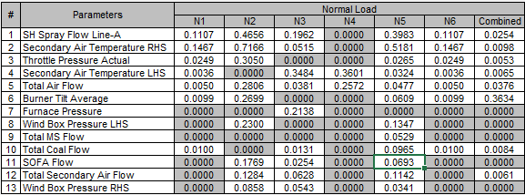

Table 6 mRMR - Values - Normal Load

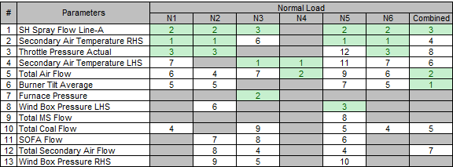
Table 7 mRMR - Rank - Normal Load

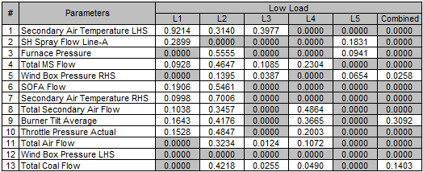

Table 8 mRMR - Values - Low Load

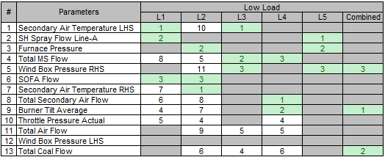

Table 9 mRMR - Rank - Low Load

Minimum Redundancy Maximum Relevance (mRMR) maximizes the relevance of the predictor variables for the target variable by minimizing the redundancy among them, and results in a rank for each predictor variable. mRMR of the key variables (predictor) with steam temperature (target variable) has been performed using the MATLAB function fsrmrmr [6]. Table 6 and 7 show the mRMR values and ranks, respectively, for the predictor variables in the normal load condition. Table 8 and 9 show the mRMR values and ranks, respectively, for the predictor variables in the low load condition. Section 4.1 has the details on the data section labels used (N1-6, L1-5). “Combined” refers to considering “N1, N2, N3, N4, N5, and N6” and “L1, L2, L3, L4, and L5” together respectively for normal and low load condition. The predictor variables with ranks 1,2,3 for the given data section are highlighted in green in Table 7 and 9. The parameter rows have been ordered with the rows having rank within 1-3 more times to the top of the table (Table 6-9).

For both normal and low load, Secondary Air Temperature (considering both RHS, LHS) and Spray Flow are observed to be significant predictor variables for steam temperature; between the two, Secondary Air Temperature has higher significance than Spray Flow.

Burner Tilt could be considered for both load conditions - maintains a rank within 5 (3 of 6 cases for normal load; 2 of 5 cases for low load).
Total Mainstream Steam Flow appears not significant for normal load; however, it could be considered for low load – maintains a rank of within 5 (3 of 5 cases for low load).

Total Air Flow could still be considered – maintains a rank within 5 (2 of 6 cases for normal load, 2 of 5 cases for low load).

4.4. Covariance

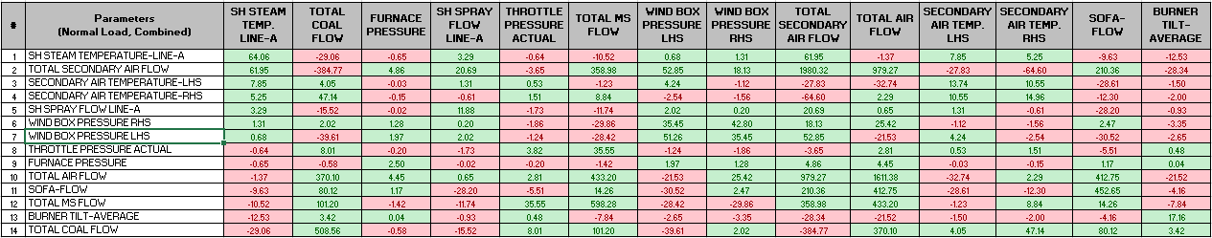
Table 10 Covariance Matrix - Normal Load

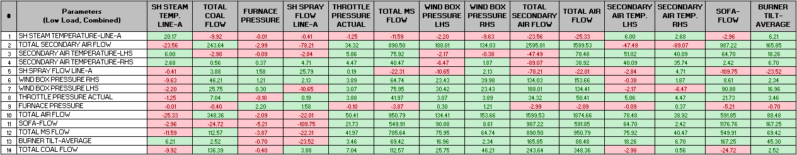
Table 11 Covariance Matrix - Low Load

Tables 10 and 11 show the covariance matrix for the fourteen variables (thirteen predictors and steam temperature as the target) for the “Combined” data section for normal and low load, respectively. “Combined” refers to considering “N1, N2, N3, N4, N5, and N6” and “L1, L2, L3, L4, and L5” together respectively for normal and low load condition. Microsoft Excel’s Covariance function has been used [7]. Section 4.1 has the details on the data section labels used (N1-6, L1-5). The colour coding used is green (positive covariance) and red (negative covariance). The parameter rows in the normal load (Table 10) are ordered using the predictor’s covariance with the target variable (steam temperature), i.e., using column 1, where the positive covariance values are to the top and
negative covariance values to the bottom. The order in Table 11 is maintained the same as in Table 10 to aid in comparison between normal and low load conditions. The ones whose covariance changes from positive (normal load) to negative (low load) are – total secondary air flow, spray flow, and wind box pressure. The ones whose covariance changes from negative (normal load) to positive (low load) are the burner tilt.

4.5. Akaike Information Criteria (AIC)

Figure 30 AIC - Normal Load

Figure 31 AIC - Low Load

The key variables are Total Coal Flow, Total Air Flow, Sofa-Flow, Total Secondary Air Flow, Burner Tilt-Average, SH Spray Flow Line-A, Throttle Pressure Actual, Furnace Pressure, Wind Box Pressure (LHS, RHS), Secondary Air Temp (LHS, RHS), and Total Mainstream Steam Flow. t-values of the key variables for a given data section are determined using Ordinary Least Squares (OLS) Regression using Python’s statsmodels library [5], considering steam temperature as the target variable.

The parameters for the given data section are then used for stepwise AKAIKE Information Criteria (AIC). The parameters used at each step are in decreasing order of their t-values. Figures 30 and 31 show the AIC plots for the Normal and Low Load, respectively.

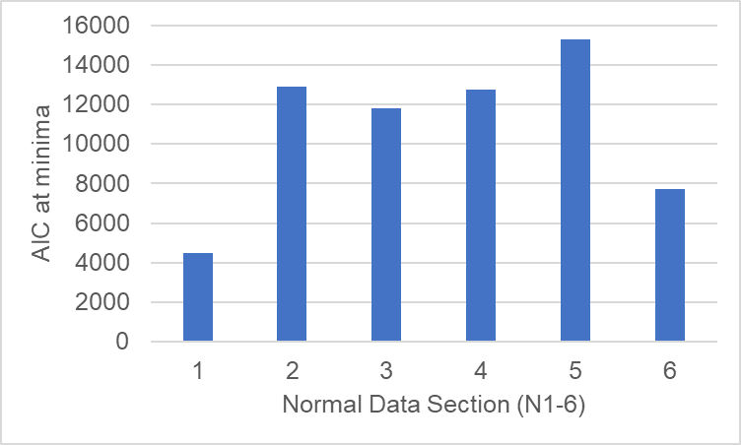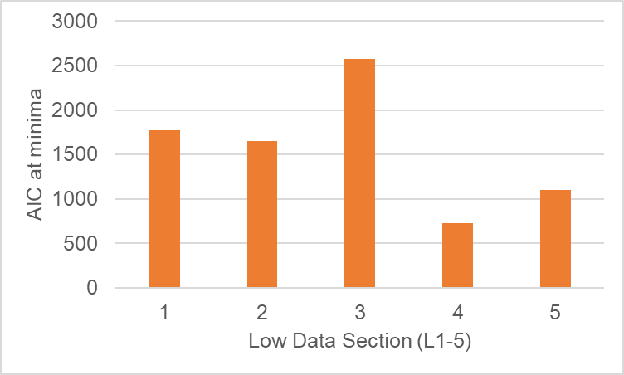
Figure 32 AIC - Minima - Normal Load (Left), Low Load (Right)

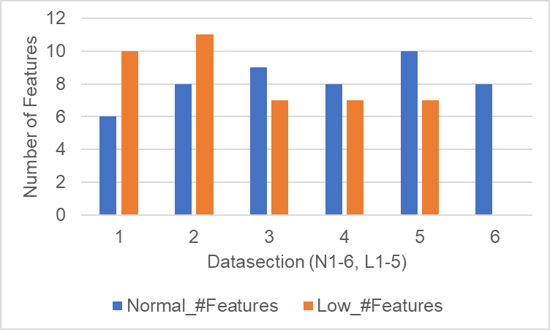

Figure 33 AIC - Minima - Number of Features

The minima of the AIC after the AIC value stabilizes are identified for each data section. Figure 32 shows the AIC values at minima for the normal and low load data sections. Figure 33 shows the number of features (considered in the stepwise AIC) at the identified minima.

At minima, the minimum AIC value for low load is less than that for normal load. The number of features at the minima varies between the data sections.

<Priyanshu
- Check about the minima approach for comparison.
- Check about the sensitivity of AIC to length.
- Explore doing the AIC for a length of 250 samples instead of the whole data section?
>

4.6. Longer Prediction Length with Fixed Variables – Normal Load

This section includes a longer prediction length (1000 samples) with a fixed set of input variables for the normal load condition. A Multiple Linear Regression (MLR) based model and an ANN-based model are considered for the prediction of steam temperature. The libraries used are mentioned in the reference section [8]. The common parts are explained first, followed by specific parts for the MLR and ANN.

< add a figure showing the N1, N2, train, test(past), test(future) section of the load >
Figure 34 Data Section - Long Term Prediction

The length of the data section considered is 3000 samples. The 3000 samples correspond to a combination of N1 and N2 data sections (Section 4.1). 1000:1999 samples are used for training the model. The model is then made to predict for the past (0:999) and future (2000:2999).

The key variables are Total Coal Flow, Total Air Flow, Sofa-Flow, Total Secondary Air Flow, Burner Tilt-Average, Throttle Pressure Actual, Furnace Pressure, Wind Box Pressure (LHS, RHS), Secondary Air Temp (LHS, RHS), and Unit Actual Load. t-values of the key variables for the train data section are determined using Ordinary Least Squares (OLS) Regression using Python’s statsmodels library [5].

Sofa-Flow, Total Secondary Air Flow, Burner Tilt-Average, Throttle Pressure Actual, Wind Box Pressure RHS, Secondary Air Temp LHS, and Total Mainstream Steam Flow are the variables that have |t| > 2. These variables, which have |t| > 2, are considered for model training. The model is then made to predict steam temperature for the test sections (past, future).

The evaluation metrics used are R² and Mean Absolute Error (MAE). R² is calculated as the square of the Pearson correlation coefficient of the predicted values with the actual values. Pearson correlation coefficient is calculated using the pearsonr function (scipy.stats library) in Python. MAE is calculated using the sklearn library in Python.

Multiple Linear Regression (MLR)

Figure 35 MLR - Train - 1000:1999

Figure 36 MLR - Test - 0:999(left), 2000:2999(right)

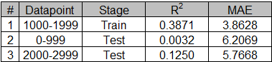
Table 12 MLR - Metrics

Figures 35,36 show the predicted versus actual steam temperature MLR plots for train, test (past), and test(future) sections. Table 12 shows the evaluation metrics for the train and test sections.

Artificial Neural Network (ANN)

The model consists of 1 hidden layer (6 neurons with ReLU as the activation function). The input values are scaled using the StandardScaler in Python. For the training phase, an 80:20 split of the data is used for the training and validation periods.

Figure 37 ANN - Train - 1000:1999

Figure 38 ANN - Test - 0:999(left), 2000:2999(right)

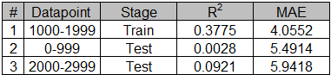
Table 13 ANN - Metrics

Figures 37,38 show the predicted versus actual steam temperature ANN plots for train, test (past), and test(future) sections. Table 13 shows the evaluation metrics for the train and test sections.

R² is higher for future prediction as compared to past prediction in both MLR and ANN. However, the R² is low. 1000 samples is a longer duration (considering the sampling rate as 1 sample/30 seconds), and the signal being dynamic could be affecting the prediction.

Priyanshu: Share the figure aligned with the data section explanation.
Priyanshu: SH Spray Flow Line-A, Total Mainstream Steam Flow from the key 13 is not considered. Unit Actual Load (out of key 13) is considered. Review and confirm that the text captures the key parameters correctly.
Priyanshu: Share the context + images for the selection of the number of neurons in the hidden layer.
Priyanshu: Confirm the scaler used in StandardScaler and not MinMaxScaler.
Priyanshu: Check if the optimizer, loss function, epochs, etc need to be added.
Team: One option to improve the R²could be to reduce the prediction length to 500.

4.7. Shorter Prediction Length with Dynamic Variables – Normal and Low Load

This section includes a shorter prediction length with a dynamic set of input variables for normal and low load conditions. A Multiple Linear Regression (MLR) based model is considered for the prediction of steam temperature. The libraries used are mentioned in the reference section [8]. The common aspects are explained first, followed by specific aspects for normal and low load conditions.

A sliding window mechanism is considered to support dynamic selection of the input variables for model training. An example of a training window length (TL) of 250 samples, a sliding step (Step) of 50 samples, and a prediction window length (PL) of 50 samples is described below:
- The model is trained on a 250-sample window (index 1:250) and is made to predict the 50 samples following the window (index 251:300).
- The sliding step for the window selection is 50 samples. The model gets trained on the next 250 samples window (index 51:300) and predicts the next 50 samples (index 301:350), and so on.
The sliding window length, sliding window step, and the prediction length considered for the load conditions are mentioned in the respective section.

The key variables are Total Coal Flow, Total Air Flow, Sofa-Flow, Total Secondary Air Flow, Burner Tilt-Average, SH Spray Flow Line-A, Throttle Pressure Actual, Furnace Pressure, Wind Box Pressure (LHS, RHS), Secondary Air Temp (LHS, RHS), Total Mainstream Steam Flow.

t-values of the key variables for the sliding window are determined using Ordinary Least Squares (OLS) Regression using Python’s statsmodels library [5].

The variables with |t-value| > 2 are considered for model training. These variables selected for training vary from one window to the next (as the signals change dynamically), and thus adapt the model better to predict the future samples.

The evaluation metrics used are R² and Mean Absolute Error (MAE). R² is calculated as the square of the Pearson correlation coefficient of the predicted values with the actual values. Pearson correlation coefficient is calculated using the pearsonr function (scipy.stats library) in Python. MAE is calculated using the sklearn library in Python.

In order to gain further insights from varying R² and MAE for the predicted windows, a set of derived metrics has been calculated as described below. A threshold value of 0.025 has been considered for the R² to identify windows with very small R values.

- “R ≈ 0 (%)”
  - The intent is to determine the percentage of predicted windows with very small R values closer to zero.
  - “R ≈ 0 (%)” = $\frac{number of predicted windows with R^{2}< Threshold}{total number of predicted windows}$ * 100
- “R Min (R² ≥ Threshold)”
  - The intent is to determine the lower limit of R (excluding the predicted windows that satisfy “R ≈ 0 (%)”)
  - R Min (R² ≥ Threshold) = square root of the R² corresponding the predicted window having minimum R²(excluding the predicted windows that satisfy “R ≈ 0 (%)”)
- “R Max”
  - The intent is to determine the upper limit of R.
  - R Max = square root of the R² corresponding the predicted window having maximum R²
- “MAE ≤ 10 (%)”
  - The intent is to determine the percentage of predicted windows with small MAE (i.e., <= 10).
  - “MAE ≤ 10 (%)” = $\frac{number of predicted windows with MAE<10}{total number of predicted windows }$ * 100
- “MAE > 10 (%)”
  - The intent is to determine the percentage of predicted windows with large MAE (i.e., > 10).
  - “MAE > 10 (%)” = $\frac{number of predicted windows with MAE>10}{total number of predicted windows }$ * 100

Normal Load
The data section considered here is the normal load data sections (N1, N2, N3, N4, N5, and N6) (Section 4.1). The number of predicted windows in each data section (N1, N2, N3, N4, N5, and N6) shall depend on the total length of the respective data section, e.g., (N1, N2) could have lesser as they correspond to a shorter duration as compared to (N2, N3, N4, N5).
The sliding window configuration used is: training window length (TL) = 250 samples, sliding step (Step) = 50 samples, prediction length (PL) = 50 samples

Figure 39 Sliding Window (TL=250, Step=50, PL=50) - MLR - N1 – Metrics

Figure 40 Sliding Window (TL=250, Step=50, PL=50) - MLR - N2 – Metrics

Figure 41 Sliding Window (TL=250, Step=50, PL=50) - MLR - N3 – Metrics

Figure 42 Sliding Window (TL=250, Step=50, PL=50) - MLR – N4 – Metrics

Figure 43 Sliding Window (TL=250, Step=50, PL=50) - MLR – N5 – Metrics

Figure 44 Sliding Window (TL=250, Step=50, PL=50) - MLR – N6 – Metrics

Figure 39-44 shows the R² and MAE plots for the predicted windows for the respective normal load data sections. R² shows substantial fluctuations within each data section, ranging from near zero to maximum around 0.8. MAE values vary widely as well, typically staying below 10, but with occasional spikes greater than that.

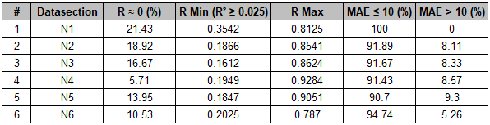
Table 14 Sliding Window (TL=250, Step=50, PL=50) - MLR - Normal - Derived Metrics

Table 14 shows the derived metrics for the normal load data sections. In general, for ~80% of the windows, the predicted values are correlated with the actual values in the range of 0.16 to 0.93. Less than 10% of the windows have an MAE greater than 10.

Low Load
The data section considered here is the low-load data section - L1, L2, L3 (Section 4.1). The number of predicted windows in each data section (L1, L2, L3) shall depend on the total length of the respective data section. The L4 and L5 low-load data section length is less than or equal to 250 samples, and hence they have not been considered.
Considering the signal temperature to be more dynamic in the low-load data section and the length of the low-load data sections being shorter, three values of sliding step and prediction window length have been considered in the section below to see the prediction performance.

Low Load - #1
The sliding window configuration used is: training window length (TL) = 250 samples, sliding step (Step) = 50 samples, prediction window length (PL) = 50 samples.

Figure 45 Sliding Window (TL=250, Step=50, PL=50) - MLR – L1 – Metrics

Figure 46 Sliding Window (TL=250, Step=50, PL=50) - MLR – L2 – Metrics

Figure 47 Sliding Window (TL=250, Step=50, PL=50) - MLR – L3 – Metrics

Figure 45-47 shows the R² and MAE plots for the predicted windows for the respective low-load data sections. Considering L3 (as it has more predicted windows), R² shows substantial fluctuations within each data section, ranging from near zero to a maximum of around 0.6. MAE values vary widely as well, typically staying below 10, but with occasional spikes greater than that.

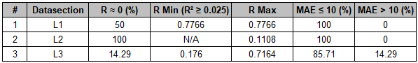

Table 15 Sliding Window (TL=250, Step=50, PL=50) - MLR - Low - Derived Metrics

Table 15 shows the derived metrics for the low-load data sections. Considering L3, for ~85% of the windows, the predicted values are correlated with the actual values in the range of 0.18 to 0.72. Less than 15% of the windows have an MAE greater than 10.

Low Load - #2
The sliding window configuration used is: training window length (TL) = 250 samples, sliding step (Step) = 25 samples, prediction window length (PL) = 25 samples.

Figure 48 Sliding Window (TL=250, Step=25, PL=25) - MLR – L1 – Metrics

Figure 49 Sliding Window (TL=250, Step=25, PL=25) - MLR – L2 – Metrics

Figure 50 Sliding Window (TL=250, Step=25, PL=25) - MLR – L3 – Metrics

Figure 48-50 shows the R² and MAE plots for the predicted windows for the respective low-load data sections. R² shows substantial fluctuations, ranging from near zero to a maximum of around 0.8. MAE values vary widely as well, typically staying below 10, but with occasional spikes greater than that.

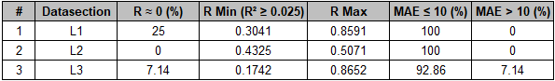
Table 16 Sliding Window (TL=250, Step=25, PL=25) - MLR - Low - Derived Metrics

Table 16 shows the derived metrics for the low-load data sections. In general, for ~75% of the windows, the predicted values are correlated with the actual values in the range of 0.18 to 0.87. Less than 10% of the windows have an MAE greater than 10.

Low Load - #3
The sliding window configuration used is: training window length (TL) = 250 samples, sliding step (Step) = 12 samples, prediction window length (PL) = 12 samples.

Figure 51 Sliding Window (TL=250, Step=12, PL=12) - MLR – L1 – Metrics

Figure 52 Sliding Window (TL=250, Step=12, PL=12) - MLR – L2 – Metrics

Figure 53 Sliding Window (TL=250, Step=12, PL=12) - MLR – L3 – Metrics

Figure 51-53 shows the R² and MAE plots for the predicted windows for the respective low-load data sections. R² shows substantial fluctuations, ranging from near zero to a maximum of around 0.8. MAE values vary widely as well, typically staying below 10, but with occasional spikes greater than that.

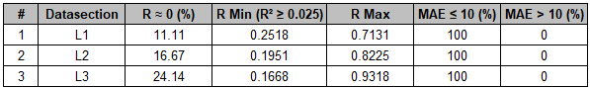
Table 17 Sliding Window (TL=250, Step=12, PL=12) - MLR - Low - Derived Metrics

Table 17 shows the derived metrics for the low-load data sections. In general, for ~75% of the windows, the predicted values are correlated with the actual values in the range of 0.17 to 0.94. None of the windows has an MAE greater than 10.

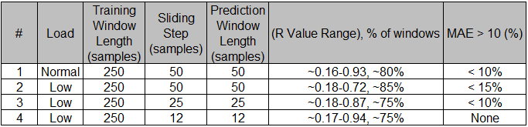

Table 18 Sliding Window Configurations - MLR - Derived Metrics Summary

Table 18 provides a summary of the inferences from the derived metrics for the sliding window configurations and load. For low load, reducing the sliding step and the prediction window length improves MAE and brings the R value range in the same order as the normal load.

Priyanshu: Share the plots for N3, N6, L3-50 (without the y-scale limit fixed for MAE) – we will put that in the Appendix.

5. Discussion

This section has a summary of the inferences and discussion related to the results obtained in Section 3. The applicable sub-section number of Section 3 is mentioned along with the points for traceability. The key inferences are as listed below:

Signal Analysis I
- The signals are non-stationary (Section 3.1). FFT might not be suitable for analysis as it expects the signal to be stationary.
- The time lag of the steam temperature is changing in successive sliding windows (Section 3.2). Lyapunov Exponent is one of the popular methods to determine chaos in the system, and uses time lag as an argument. Considering the time lag varies between the windows, the Lyapunov Exponent might not be suitable for this system.
- The signals (Section 3.3) are persistent, i.e., if there is an increase (decrease) in the value, it is more likely to follow the trend in the next sample with an increase (decrease). The steam temperature signal has a higher persistence during low load as compared to normal load. It implies that the steam temperature signal has a trend in it and could be useful for prediction.
- The variation in the furnace pressure indicates the process has variation (Section 3.4). Reducing the variation in the furnace pressure could help reduce the variation in the steam temperature (Section 3.7).
- Burner tilt could be an important parameter to control the furnace pressure variation and steam temperature (Section 3.5). Furnace pressure change is less when the burner tilt average % change is within |2| to |3|. A continuous small change in the burner tilt average % change could be explored. This could help with better heat exchange and, hence, better combustion.
- Another parameter that could be useful is the throttle pressure setpoint (Section 3.6). However, being a setpoint, it must already be in practice at the plant.
- The steam temperature variation is less and is around 540°C, when – (a) burner tilt average% is below 30% (b) throttle pressure setpoint is below 55KSC (Section 3.5 and 3.6). These need to be reviewed with the Standard Operating Procedure (SOP), and opportunities (if any) could be explored.
- The normal-to-low load transition and back to normal load happen once every day. This special event (Section 3.8) could be a day when the low-load transition did not occur.
- The transition and low load durations vary over the days (Section 3.9). The control strategy needs to account for this.
- The steam temperature increases as the load decreases, and later decreases as the load transitions to normal (Section 3.10). The reduced mass of steam at low load might be getting heated up faster in the superheater, which results in an increase in temperature. The temperature stabilizes as the mass of steam increases with the transition to normal load.
- Most of the key parameters are synchronized with the load trend. However, spray flow and burner tilt waveforms are less synchronized on certain days (Section 3.10). As the load decreases, the steam temperature increases, and the spray flow is applied to the superheater to ensure the steam temperature does not increase excessively. Burner tilt alters the flame shape and the heat zone. Hence, the spray flow and burner tilt emerge as key parameters to control for improved efficiency.
- The signal movement in the state space relates to the time domain changes and reveals that the parameters are interrelated (Section 3.11).
- Considering the signals (parameters) are non-stationary, the parameters are dynamically changing and interrelated; a non-linear dynamical system-based approach is more suitable. Chaos-based systems are recommended for short-term predictions. If need be, higher sampling rate data could be explored.
- The state of the system in the DSI-CDM graph relates to the time domain and state space of the signal (Section 3.12). DSI-CDM can be used to understand the state of the system and control it to suitable operating zones.
- The steam temperature prediction using multiple linear regression provides better results than ANN. t-Test could be used as a potential dynamic parameter selection criterion for the control strategy (Section 3.13).

Signal Analysis II

Secondary Air Temperature, Spray Flow, and Burner Tilt are significant parameters for steam temperature prediction. Further, Total Mainstream Steam Flow and Total Air Flow could also be considered.

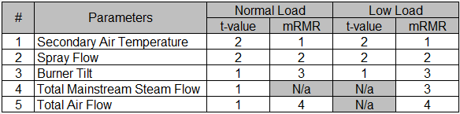
Table 19 Significant Parameters Priority

Table 14 shows the priority for the parameters for different load conditions based on t-value and mRMR values (Section 4.2 and 4.3).

The parameters that undergo change in the sign of covariance as the load condition changes between normal and low load are - Burner Tilt, Spray Flow, Total Secondary Air Flow, and Wind Box Pressure (Section 4.4). Special attention needs to be given to these parameters where the load changes.

At minima, the minimum AIC value for low load is less than that for normal load. The number of features at the minima varies between the data sections (Section 4.5).

Correlation of predicted and actual steam temperature is low for longer duration (1000 samples) and fixed input variables configuration – for both MLR, ANN (Section 4.6). As the process variables are changing dynamically, the variables selected for model training should also update dynamically to improve the prediction.

A sliding window mechanism with dynamic selection of variables based on the |t-value| > 2 improves the steam temperature prediction. The sliding step and prediction window length should be preferably shorter for low load as compared to normal load, as the signal dynamics are different (refer to Section 3.3, low load has higher persistence than normal load). There are certain sliding windows for which the prediction vs actual correlation is very low. This could be scenarios where the process is having turbulence. A regression with a fixed set of core variables could be performed in parallel to help in such situations.
Some of the other potential parameters that could be considered for modelling are:
- De-Superheater Temperature – This is the temperature of the steam at a stage before Spray Flow is applied to control the Superheater Steam Temperature Line A. Hence, this could give an early indication of the future steam temperature. This could help minimize the use of spray flow and, hence, save energy.
- Flue Gas Temperature – This is the temperature of the gas that heats up the steam in the Superheater. As this is the source driving the heating, which is later controlled using spray flow, flue gas temperature can be one of the target variables to be controlled.
- Oxygen Economiser – This indicates the amount of oxygen left post-combustion. This could be used as a feedback signal for the model.

< Brahma Sir’s idea: Let us check the state space of the signal for the window where R² is becoming near to zero – the system must be entering into the chaotic zone there.>

5. Conclusion
Signal analysis has revealed interesting boiler system characteristics. There are multiple parameters; they change dynamically with time and are interrelated. This makes the boiler a complex dynamical system. The signals are non-stationary and persistent. The time lag of the steam temperature varies. These aspects could pose a challenge with popular methods, e.g., FFT, Entropy, Lyapunov Exponent. A chaotic dynamical system-based approach could be more suitable.
Secondary Air Temperature, Spray Flow, and Burner Tilt are potential parameters to control for an optimum steam temperature. Burner Tilt, Spray Flow, Total Secondary Air Flow, and Wind Box Pressure are significant parameters to consider for managing load transition. The state and trajectory of the steam temperature signal can be understood by the dynamical system approach presented. This, combined with steam temperature prediction using regression or equivalent methods and fuzzy logic, can be used to control the process.
This work focused on the system analysis part, and the subsequent work would be on the control strategy for flexi power management. As the analysis is around a core complex process (steam generation), the approach and learnings could be cross-applied to other areas too.

References
< to be further updated based on the introduction section >
- Augmented Dickey Fuller Test – MATLAB Function – adftest - https://in.mathworks.com/help/econ/adftest.html
- Phase Space Reconstruction – MATLAB Function – phasespacereconstruction - https://in.mathworks.com/help/predmaint/ref/phasespacereconstruction.html
- Rickles' paper on chaos and complexity.
- Control signal processing device for raising and lowering of lance and a process thereof; Patent number 366467, year 2021.
- Python Libraries
  - statsmodels – Oridinary Least Squares(OLS) Regression, t-values
  - scipy.stats - pearsonr function for Pearson correlation coefficient
  - sklearn - Mean Absolute Error
- Minimum Redundancy Maximum Relevance (mRMR) – MATLAB function – fsrmrmr - https://www.mathworks.com/help/stats/fsrmrmr.html
- Covariance – Microsoft Excel – Data Analysis – Covariance Function
- MLR, ANN – Python Libraries - Pandas, NumPy, Matplotlib, Scikit-learn, Statsmodels, TensorFlow/Keras

Appendix 1

Notes for some of the terms that have been used interchangeably in the work are listed below:

- “Steam temperature” refers to the target variable to be controlled,i.e., “SH Steam Temperature Line-A.”
- “burner tilt” indicates the action that results in the alteration of the flame shape and heat zone. However, the data available is for the burner tilt average percentage.
- “load” and “unit actual load” mean the same.
- “signal”, “feature” used in the context of boiler or steam generation process means the parameters of the thermal power plant.
- “system” has been used in the context of indicating an overall larger unit which could include the effect of multiple parameters, e.g., for a scenario where, multiple parameters affect the boiler’s performance in terms of steam temperature, the boiler would be the intended system.

# | Acronym | Full Form
1 | ANN | Artificial Neural Network
2 | CDM | Chaotic Dynamics Marker
3 | DEGC | degree centigrade (°C)
4 | DSI | Dynamics Similarity Index
5 | FFT | Fast Fourier Transform
6 | KSC | kilogram-force per square centimetre
7 | LHS | Left Hand Side
8 | MLR | Multiple Linear Regression
9 | mmwc | millimetres of water column
10 | MS Flow | mainstream steam flow
11 | MW | Mega Watt
12 | NOx | Nitrogen Oxide
13 | RHS | Right Hand Side
14 | RMS | root mean square
15 | SH | Super Heater
16 | Sofa Flow | Separated OverFire Air
17 | SOP | Standard Operating Procedure
18 | TPH | tonne per hour
Table 20 Acronyms - Full Form

The full form of the acronyms is provided in Table 20.

Discuss
- Proposed control strategy not included – as that will be subsequent work.
- DSI-CDM of spray flow and burner tilt not included, as that would expose more info.
- For now, retained the normal and load together in the DSI-CDM as (a) shows continuity of transition. (b) low load data length is small, we will get very few sliding windows meeting criteria of 250 samples, we will have to reduce the sliding step.
- Do we need to make the data accessible?

