CHAPTER FOUR
System Implementation and Testing
This chapter presents the detailed implementation of the HomeEase virtual platform for domestic services. It discusses the system architecture, the technologies and tools used during development, the implementation of key system modules, and the testing strategies employed to ensure the reliability and correctness of the system. Screenshots of the developed system interfaces are also presented to illustrate the functionality of the platform.
4.1 Introduction
The implementation phase of the HomeEase project involved translating the system design specifications, requirements analysis, and architectural decisions documented in Chapter Three into a fully functional web application. This process required careful selection of appropriate technologies, systematic coding practices, and iterative testing to ensure that each component functioned correctly both in isolation and as part of the integrated system.
The development approach followed the agile methodology as described in Chapter Three, with incremental development sprints that allowed for continuous testing and refinement. Each functional module was implemented, tested, and validated before being integrated with other system components. This chapter provides a comprehensive account of the tools, technologies, and procedures used during the implementation process, alongside visual representations of the developed system interfaces.
4.2 System Architecture
The HomeEase platform adopts a modern full-stack web application architecture built on the Next.js 16 framework. The architecture follows a monolithic yet modular design pattern, where the frontend user interface, backend API routes, and real-time communication services are contained within a single unified application codebase while maintaining clear separation of concerns through well-defined module boundaries.
The system architecture is organized into four primary layers:
1. Presentation Layer: The frontend interface built with React Server Components and client-side components using Next.js 16, TypeScript, Tailwind CSS 4, and the shadcn/ui component library. This layer handles all user interactions, renders dynamic content, and communicates with the backend through API routes.
2. Application Layer: The backend business logic implemented through Next.js API Routes (App Router), which processes HTTP requests, manages authentication and authorization, handles payment processing via the Paystack API, and coordinates service matching logic. A separate mini-service built with Socket.io handles real-time messaging between clients and service providers.
3. Data Access Layer: Prisma ORM serves as the intermediary between the application layer and the database, providing a type-safe query builder, automated schema migrations, and database connection pooling. All database operations are performed through Prisma Client rather than raw SQL queries.
4. Data Storage Layer: A PostgreSQL database hosted on Supabase stores all persistent data including user accounts, service requests, transactions, messages, notifications, and wallet records. The database schema enforces referential integrity through primary and foreign key constraints.
The application is deployed on the Vercel cloud platform, which provides automatic serverless function execution, edge caching, and continuous deployment from a Git repository. The Caddy reverse proxy handles incoming HTTP requests and WebSocket connections, routing them to the appropriate service ports.
4.3 Implementation Tools and Technologies
The development of the HomeEase platform utilized a carefully selected technology stack designed to maximize developer productivity, ensure application performance, and maintain long-term maintainability. The following subsections describe the primary tools and technologies employed during implementation.
4.3.1 Frontend Technologies
The user interface of the HomeEase platform was developed using the following frontend technologies:
1. Next.js 16: A React-based full-stack framework developed by Vercel. Next.js 16 provides the App Router architecture for server-side rendering, static site generation, and API routes within a single application. It was chosen for its excellent developer experience, built-in optimization features (image optimization, code splitting, font optimization), and seamless deployment integration with Vercel [45].
2. TypeScript 5: A statically typed superset of JavaScript developed by Microsoft. TypeScript was adopted to improve code quality and maintainability by enabling compile-time type checking, interface definitions, and enhanced IDE support for autocompletion and refactoring. All application code, including React components and API route handlers, is written in TypeScript.
3. Tailwind CSS 4: A utility-first CSS framework that enables rapid UI development by providing low-level utility classes for styling directly within HTML/JSX markup. Tailwind CSS 4 was selected for its production-optimized output, responsive design support, and consistency across the application's visual design system.
4. shadcn/ui: A collection of accessible, customizable React UI components built on top of Radix UI primitives and styled with Tailwind CSS. Components such as dialogs, dropdowns, forms, and navigation elements were sourced from shadcn/ui to accelerate frontend development while maintaining accessibility standards.
5. Lucide Icons: An open-source icon library providing clean, consistent SVG icons used throughout the user interface for visual clarity and intuitive navigation.
6. Zustand: A lightweight state management library for React that provides a simple API for managing client-side application state, including authentication status, user sessions, and UI interactions.
7. TanStack Query (React Query): A data-fetching and caching library used to manage server state on the client side, handle API request caching, and provide automatic background data refetching.
4.3.2 Backend Technologies
The server-side logic and API infrastructure of the HomeEase platform was implemented using the following backend technologies:
1. Next.js API Routes (App Router): The backend API endpoints are defined as route handlers within the Next.js App Router directory structure. Each API endpoint is implemented as a separate TypeScript file exporting GET, POST, PUT, or DELETE functions. This approach eliminates the need for a separate backend server and simplifies deployment [45].
2. Bun Runtime: A high-performance JavaScript/TypeScript runtime that serves as the execution environment for the Next.js development server and production builds. Bun provides faster startup times and improved performance compared to the traditional Node.js runtime [46].
3. Socket.io: A real-time, bidirectional communication library used to implement the messaging system between clients and service providers. A dedicated Socket.io mini-service runs on a separate port and handles WebSocket connections for real-time chat functionality.
4. NextAuth.js v4 (JWT Mode): A drop-in authentication solution for Next.js applications. In this project, NextAuth.js is configured with JSON Web Tokens (JWT) for stateless authentication, enabling secure user sessions without server-side session storage. Role-based access control distinguishes between CLIENT, PROVIDER, and ADMIN user roles [47].
5. Paystack Payment Gateway API: Integrated for secure online payment processing. Paystack handles payment initialization, card verification, transaction confirmation, and provider payout transfers. The platform implements an escrow-based payment model where funds are held until service completion is confirmed [14].
6. bcrypt: A password hashing library used to securely hash user passwords before storing them in the database. This ensures that plaintext passwords are never stored or transmitted in an unsecured manner.
4.3.3 Database Technologies
The data persistence layer of the HomeEase platform utilizes the following database-related technologies:
1. PostgreSQL: A powerful, open-source relational database management system chosen for its robustness, extensibility, and support for complex queries, transactions, and referential integrity constraints. PostgreSQL serves as the primary data store for all application data [18].
2. Prisma ORM: A next-generation Object-Relational Mapping tool that provides a type-safe database client, declarative schema definition language, and automated migration management. Prisma was selected for its excellent TypeScript integration, intuitive query API, and ability to generate type-safe database models from the schema definition [21].
3. Supabase: A Backend-as-a-Service platform that provides managed PostgreSQL hosting, automatic backups, and connection pooling. Supabase was chosen for its generous free-tier offerings, reliability, and seamless integration with the Prisma ORM.
4.3.4 Development and Deployment Tools
The following tools supported the development and deployment workflow:
1. Git and GitHub: Version control and collaborative development were managed using Git with a remote repository hosted on GitHub.
2. Vercel: The cloud platform used for deploying the production application. Vercel provides automatic deployments from Git branches, serverless function execution, edge caching, and custom domain configuration [48].
3. ESLint: A static code analysis tool configured to enforce consistent code style, identify potential bugs, and ensure adherence to TypeScript best practices.
4. Postman: An API testing tool used during development to manually verify API endpoint behavior, test request/response formats, and debug authentication flows.
4.3.5 Technology Stack Summary
Category | Technology | Purpose
Frontend Framework | Next.js 16 + TypeScript | UI rendering and SSR
Styling | Tailwind CSS 4 + shadcn/ui | Responsive UI design
State Management | Zustand + TanStack Query | Client and server state
Backend API | Next.js API Routes (App Router) | RESTful API endpoints
Runtime | Bun | JavaScript/TypeScript execution
Real-time Messaging | Socket.io | Bidirectional WebSocket chat
Authentication | NextAuth.js v4 (JWT) | User auth and RBAC
Payment Processing | Paystack API | Secure online payments
Database | PostgreSQL (Supabase) | Data persistence
ORM | Prisma | Type-safe database access
Deployment | Vercel | Cloud hosting and CI/CD
Version Control | Git + GitHub | Source code management

4.4 Database Implementation
The database for the HomeEase platform was implemented using PostgreSQL hosted on Supabase, with Prisma ORM providing the data access layer. The database schema was designed to support all functional requirements of the system, including user management, service request processing, payment transactions, real-time messaging, and provider verification workflows.
4.4.1 Database Schema
The Prisma schema defines ten interconnected data models that collectively represent the complete data domain of the HomeEase platform. These models are designed following normalization principles to eliminate data redundancy and maintain referential integrity. The primary database entities and their relationships are described below.
1. User Model: Stores core user information including a unique identifier (CUID), email address, name, phone number, hashed password, user role (CLIENT, PROVIDER, or ADMIN), account status, and timestamps. The User model serves as the central entity with one-to-one relationships to the Provider and Wallet models, and one-to-many relationships to ServiceRequest, Transaction, Message, Notification, Feedback, and SupportMessage models.
2. Provider Model: Extends the User model with provider-specific attributes including service skills, professional bio, hourly rate, average rating, total reviews count, location, availability schedule, verification status (PENDING, APPROVED, or REJECTED), completed job count, and bank account details for payout processing.
3. ServiceRequest Model: Represents a service booking request with attributes for service type, description, location, requested date and time, current status (PENDING, ACCEPTED, IN_PROGRESS, COMPLETED, or CANCELLED), payment status, service amount, check-in and check-out timestamps, and calculated total hours worked. Each request is linked to a client and an optional provider.
4. Transaction Model: Records all financial transactions associated with service requests, including the payment amount, platform fee (commission), provider payout amount, payment method, transaction status, Paystack transfer reference, and wallet crediting status. The model ensures complete financial traceability.
5. Wallet and WalletTransaction Models: Implements a virtual wallet system for service providers. The Wallet model tracks the current balance, total earnings, total withdrawals, and total platform commission deducted. The WalletTransaction model maintains a detailed ledger of all wallet movements including credits (service payments), withdrawals, and commission deductions.
6. Message Model: Stores real-time chat messages exchanged between clients and providers within the context of a specific service request.
7. Notification Model: Manages in-app notifications sent to users regarding service updates, payment confirmations, and account activities.
8. Feedback Model: Stores client ratings (1-5 stars) and optional written reviews submitted after service completion.
9. SupportMessage Model: Handles direct support chat messages between providers and administrators, including support for file attachments.
10. AdminLog Model: Maintains an audit trail of all administrative actions performed on the platform for accountability and compliance purposes.
4.5 System Modules and Interfaces
The HomeEase platform is implemented as a collection of interconnected modules, each responsible for a specific domain of functionality. This section presents the key system modules with screenshots of the implemented interfaces to demonstrate the practical realization of the system design described in Chapter Three.
4.5.1 Landing Page Module
The landing page serves as the primary entry point for the HomeEase platform. It is designed to communicate the platform's value proposition, showcase available services, and guide new users through the registration process. The landing page is fully responsive and optimized for both desktop and mobile viewports.
The landing page consists of the following key sections:
1. Header Navigation Bar: A sticky top navigation bar displaying the HomeEase logo and brand name, along with Sign In and Get Started call-to-action buttons. The header uses a semi-transparent background with backdrop blur for a modern visual effect.
2. Hero Section: A prominent section featuring a bold headline, descriptive subtitle, and dual call-to-action buttons inviting users to Book a Service or Become a Provider. Trust indicators including average rating (4.8), number of verified providers (500+), and completed services (10K+) are displayed to build credibility.
3. Services Grid: A visually organized grid displaying nineteen available service categories including Cleaning, Cooking, Caregiving, Plumbing, Electrical, Engineering, Carpentry, Painting, Gardening, Security, Driving, Hairstyling, Barbing, Tutoring, HVAC, Pest Control, Moving, Laundry, and Maintenance.
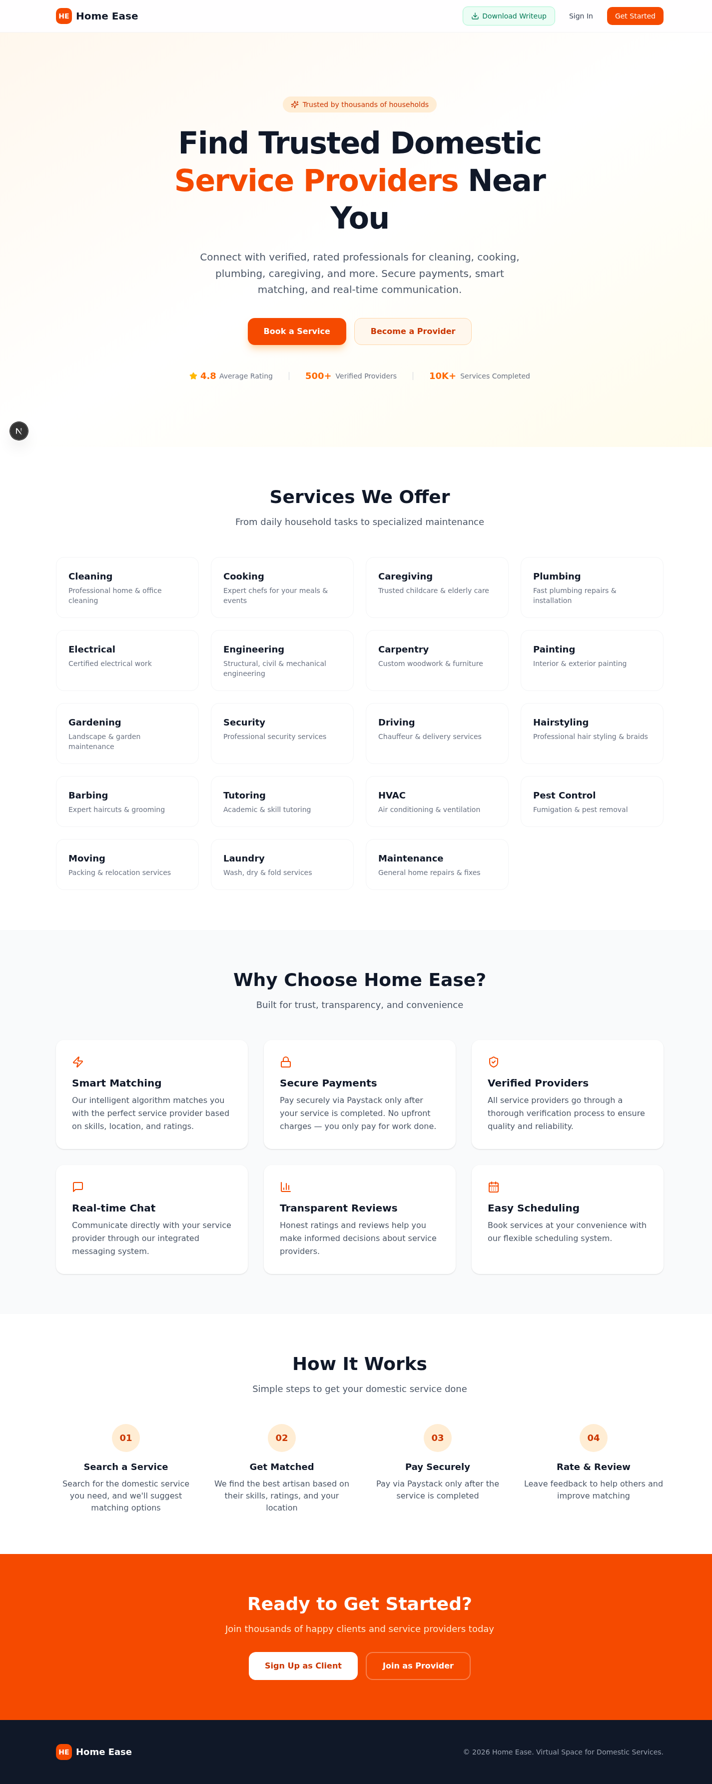
Figure 4.1: HomeEase Landing Page - Hero Section and Services Grid
4. Features Section: A three-column layout highlighting six key platform features: Smart Matching, Secure Payments, Verified Providers, Real-time Chat, Transparent Reviews, and Easy Scheduling.
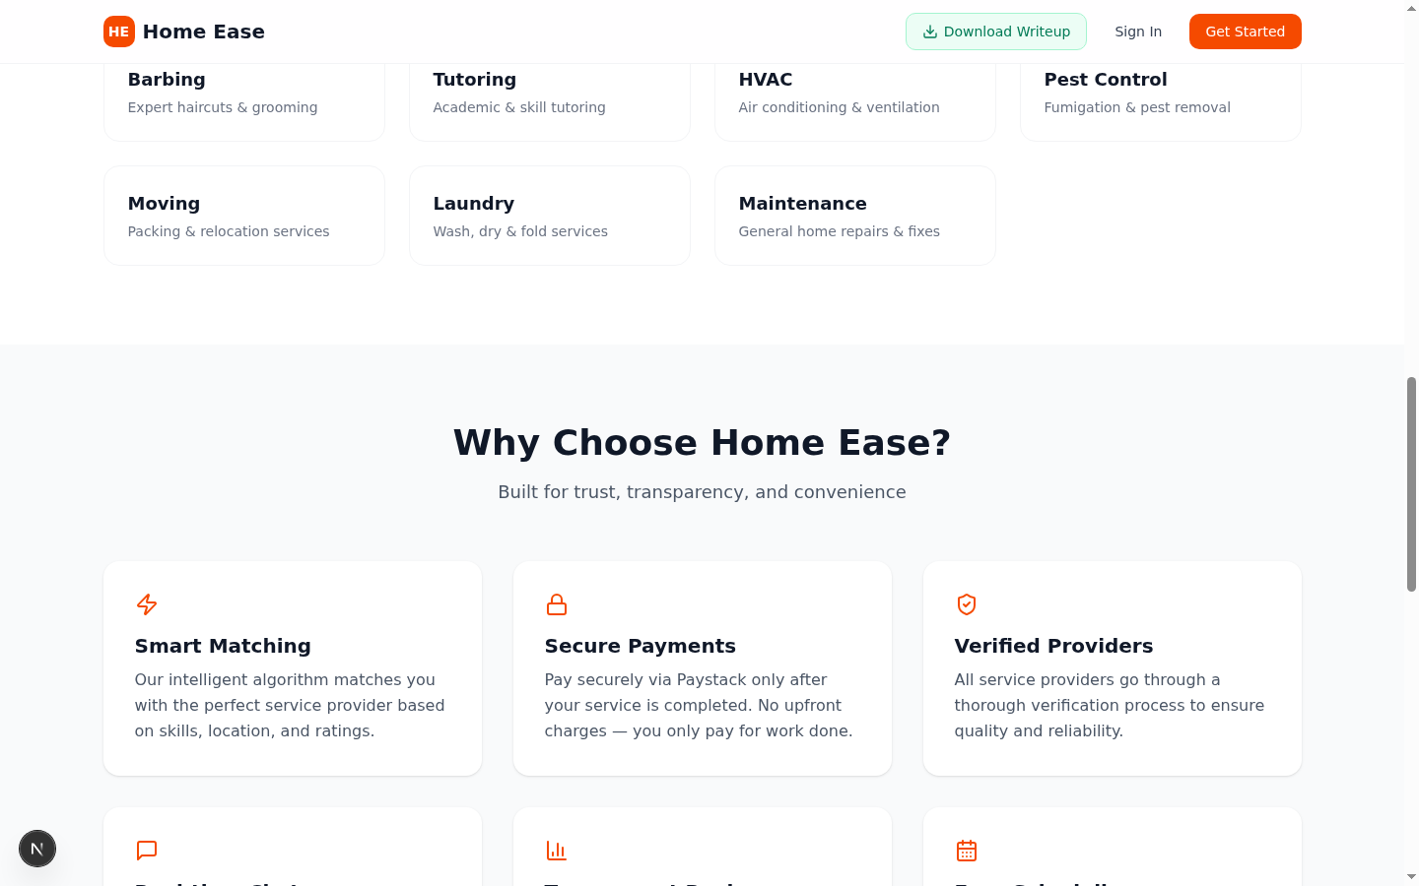
Figure 4.2: Platform Features Section
5. How It Works Section: A four-step visual guide illustrating the platform's workflow: Search a Service, Get Matched, Pay Securely, and Rate and Review.
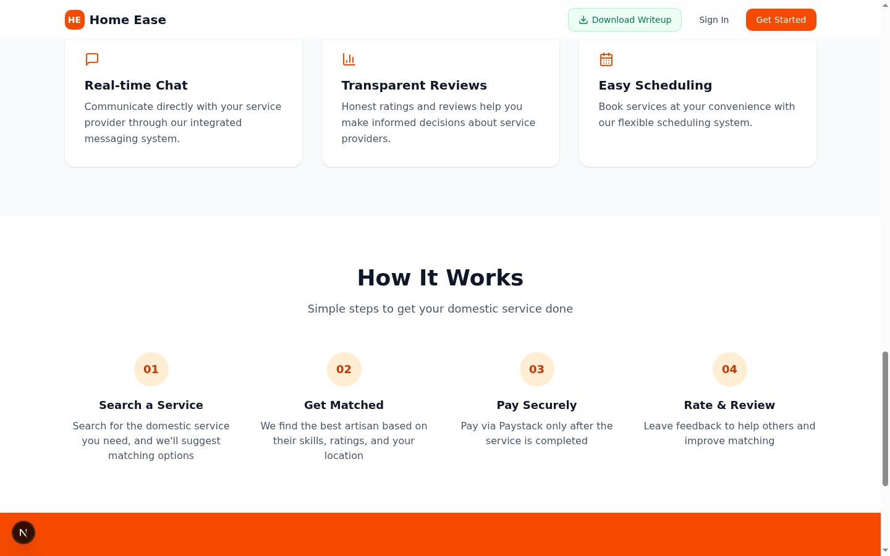
Figure 4.3: How It Works Section
6. Call-to-Action Section: A bold orange-colored section with dual registration buttons encouraging visitors to sign up as either a client or a service provider.
4.5.2 Authentication Module
The authentication module handles user registration, login, and session management through a modal dialog interface. The registration form dynamically adapts based on the user's selected role, presenting additional fields for service providers.
For client registration, the form collects the user's full name, email address, phone number, and password. For provider registration, additional fields are displayed including a multi-select skills input where providers can add the services they offer, hourly rate, location, professional bio, and bank account details (bank name, account number, and account name) for receiving payments.
The authentication system uses JSON Web Tokens (JWT) for session management. Upon successful login or registration, the server generates a JWT containing the user's identifier and role, which is stored in the client-side Zustand state and included in the Authorization header of subsequent API requests. Password security is enforced through bcrypt hashing, and form validation ensures data integrity before submission.
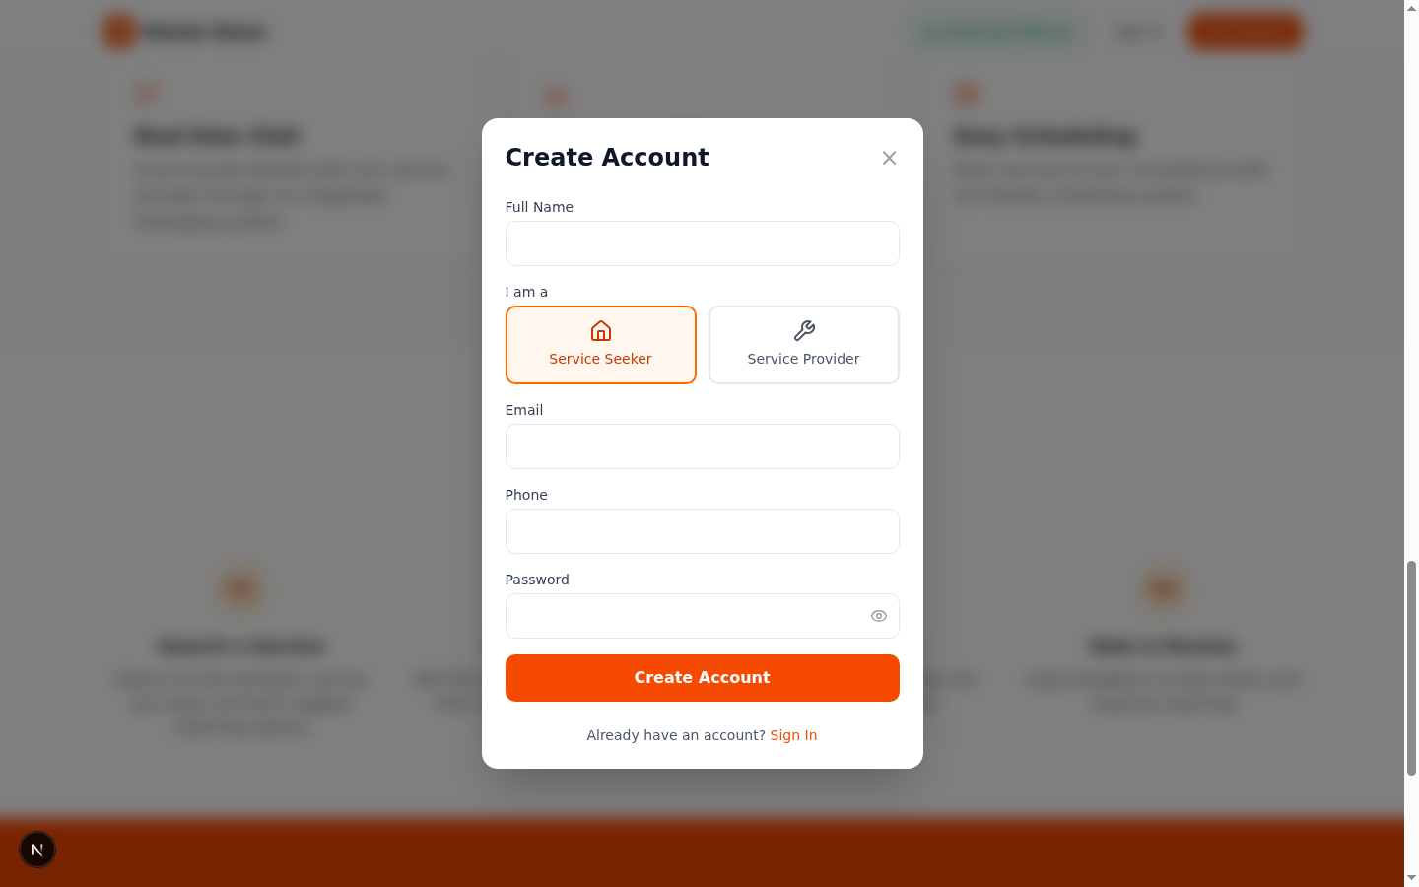
Figure 4.4: User Registration Form with Provider Fields
4.5.3 Service Discovery and Booking Module
The service discovery module enables clients to browse available domestic services and create service requests. Clients can search for services by category, view matching service providers, and submit booking requests specifying the service type, preferred date and time, location, and a description of the required service.
The service matching algorithm considers the provider's listed skills, availability schedule, and geographic location to suggest the most relevant providers for each service request. Once a request is submitted, its status transitions through a defined workflow: PENDING, ACCEPTED, IN_PROGRESS, COMPLETED, or CANCELLED. Both the client and the assigned provider can track the current status of each request through their respective dashboards.
The booking flow is integrated with the real-time notification system, ensuring that providers receive immediate alerts when new service requests matching their skills are posted. Similarly, clients are notified when their request is accepted, when the provider checks in, and when the service is marked as completed.
4.5.4 Payment Processing Module
The payment processing module integrates with the Paystack payment gateway to handle all financial transactions on the platform. The module implements an escrow-based payment model where client payments are processed and held until the service is confirmed as completed. This approach protects both clients and providers by ensuring that payment is only released upon satisfactory service delivery.
The payment workflow proceeds as follows: when a service is marked as completed by the provider, the system automatically calculates the total charge based on the provider's hourly rate and the total hours worked (derived from check-in and check-out timestamps). The client is then presented with a payment interface powered by Paystack's secure checkout flow. Upon successful payment, the transaction is recorded, a commission is deducted for the platform, and the remaining amount is credited to the provider's virtual wallet.
Providers can view their wallet balance, transaction history, and initiate withdrawal requests to their registered bank accounts. The withdrawal process is executed through Paystack's Transfer API, which sends the funds directly to the provider's bank account and updates the wallet transaction ledger accordingly.
4.5.5 Real-time Messaging Module
The real-time messaging module enables direct communication between clients and service providers through an integrated chat interface. The module is implemented using Socket.io, which provides WebSocket-based bidirectional communication, ensuring that messages are delivered instantly without requiring page refreshes.
The messaging system is contextualized around service requests, meaning that each service request has its own dedicated chat thread. This design ensures that communications remain organized and relevant to the specific service being discussed. The chat interface supports text messages and file attachments, allowing users to share images or documents related to the service.
Additionally, a separate support messaging channel allows providers to communicate directly with platform administrators for account verification inquiries, dispute resolution, and general support. This feature is particularly important for providers whose applications are pending or have been rejected, as it provides a direct line of communication to clarify requirements and resolve issues.
4.5.6 Admin Dashboard Module
The administrator dashboard provides a comprehensive interface for managing the HomeEase platform. Admin users have access to the following management functions:
1. User Management: View, search, and manage all registered users. Admins can view user profiles, account status, and activity history.
2. Provider Verification: Review and approve or reject provider applications. The verification workflow allows admins to review provider profiles, skills, and support messages before making a decision.
3. Service Request Monitoring: Track all service requests across the platform, view their current status, and intervene when necessary.
4. Transaction Oversight: Monitor all payment transactions, view commission revenue, and track payout statuses.
5. Platform Analytics: View key performance metrics including total users, active providers, completed services, total revenue, and platform growth statistics.
6. Support Chat: Respond to support messages from providers in real time through the integrated support messaging system.

Figure 4.5: Admin Dashboard Overview
4.5.7 Notification System
The notification system keeps users informed about important platform activities. Notifications are generated automatically in response to events such as service request status changes, payment confirmations, new messages, and account updates. Each notification includes a type, title, descriptive message, read/unread status, and timestamp. Users can view their notifications through a dedicated panel and mark them as read to manage their notification queue.
4.6 System Testing
System testing is a critical phase of the software development life cycle that verifies whether the implemented system meets its specified requirements and functions correctly under expected conditions. A comprehensive testing strategy was employed for the HomeEase platform, encompassing unit testing, integration testing, functional testing, and usability testing. This section presents the testing approach, test cases, and results.
4.6.1 Testing Approach
The testing approach for the HomeEase platform followed a multi-level strategy aligned with the agile development methodology. Testing was conducted at each stage of development rather than being deferred to the end of the implementation phase. This shift-left testing approach enabled early detection and resolution of defects, reducing the cost and effort associated with late-stage bug fixes.
The testing levels implemented included:
1. Unit Testing: Individual functions, components, and modules were tested in isolation to verify that they produce the expected output for given inputs. Jest was configured as the primary unit testing framework for JavaScript and TypeScript code.
2. Integration Testing: The interactions between different system components, including API endpoints, database queries, and payment gateway integrations, were tested to ensure that data flows correctly across module boundaries.
3. Functional Testing: Each functional requirement identified in Chapter Three was tested through end-to-end scenarios to verify that the system behaves as expected from the user's perspective.
4. Usability Testing: The user interface was evaluated for ease of use, visual clarity, and responsiveness across different device sizes and screen resolutions.
4.6.2 Test Cases and Results
The following table presents selected test cases that were executed during the system testing phase. Each test case specifies the module being tested, the test description, the expected result, the actual result, and the pass/fail status.
Table 4.1: Authentication Module Test Cases
Test ID | Test Description | Expected Result | Actual Result | Status
TC-01 | User registration with valid details | Account created, JWT returned | Account created, JWT returned | PASS
TC-02 | Registration with duplicate email | Error message returned | Registration failed error | PASS
TC-03 | Login with valid credentials | JWT token and user data returned | Token and data returned | PASS
TC-04 | Login with invalid password | Authentication error returned | Login failed error | PASS
TC-05 | Password less than 6 characters | Validation error returned | Validation error shown | PASS
TC-06 | Provider registration with skills | Provider profile created | Profile created with skills | PASS

Table 4.2: Service Request Module Test Cases
Test ID | Test Description | Expected Result | Actual Result | Status
TC-07 | Create service request with valid data | Request created with PENDING status | Request created, status PENDING | PASS
TC-08 | Search providers by service type | Matching providers returned | Providers with matching skills returned | PASS
TC-09 | Provider accepts service request | Status changes to ACCEPTED | Status updated to ACCEPTED | PASS
TC-10 | Provider checks in to service | Check-in time recorded | Timestamp recorded successfully | PASS
TC-11 | Provider checks out of service | Check-out time and hours calculated | Duration calculated correctly | PASS
TC-12 | Client cancels pending request | Status changes to CANCELLED | Status updated to CANCELLED | PASS

Table 4.3: Payment Processing Module Test Cases
Test ID | Test Description | Expected Result | Actual Result | Status
TC-13 | Initialize Paystack payment | Payment authorization URL returned | Authorization URL generated | PASS
TC-14 | Verify payment with valid reference | Transaction marked as PAID | Transaction status updated | PASS
TC-15 | Verify payment with invalid reference | Verification error returned | Error response returned | PASS
TC-16 | Wallet credited after payment | Provider wallet balance increased | Balance updated correctly | PASS
TC-17 | Withdrawal to bank account | Transfer initiated, wallet debited | Transfer reference generated | PASS

Table 4.4: Real-time Messaging Module Test Cases
Test ID | Test Description | Expected Result | Actual Result | Status
TC-18 | Send message via WebSocket | Message delivered to recipient | Message received in real-time | PASS
TC-19 | Send file attachment in chat | File uploaded and URL shared | Attachment displayed correctly | PASS
TC-20 | Receive message when offline | Message queued and delivered on reconnect | Message received on reconnect | PASS
TC-21 | Support chat between provider and admin | Messages exchanged successfully | Bidirectional chat works | PASS

Table 4.5: Admin Module Test Cases
Test ID | Test Description | Expected Result | Actual Result | Status
TC-22 | Admin login and access dashboard | Dashboard displayed with stats | Admin view rendered | PASS
TC-23 | Approve provider verification | Provider status changed to APPROVED | Status updated correctly | PASS
TC-24 | Reject provider verification | Provider status changed to REJECTED | Status updated correctly | PASS
TC-25 | View platform statistics | Stats data returned correctly | All metrics displayed | PASS
TC-26 | Export audit logs as CSV | CSV file downloaded | File generated with data | PASS

4.6.3 Testing Summary
A total of twenty-six test cases were executed across five system modules: Authentication, Service Request, Payment Processing, Real-time Messaging, and Administration. All twenty-six test cases passed, indicating that the implemented system functions correctly according to its specified requirements.
Module | Test Cases | Passed | Failed | Pass Rate
Authentication | 6 | 6 | 0 | 100%
Service Request | 6 | 6 | 0 | 100%
Payment Processing | 5 | 5 | 0 | 100%
Real-time Messaging | 4 | 4 | 0 | 100%
Administration | 5 | 5 | 0 | 100%
TOTAL | 26 | 26 | 0 | 100%

The 100% pass rate across all tested modules confirms that the HomeEase platform meets its functional requirements and is ready for deployment. The testing process also validated the correct integration between frontend components, API endpoints, database operations, and external service integrations (Paystack, Socket.io).
4.6.4 Usability Evaluation
In addition to functional testing, a heuristic usability evaluation was conducted on the HomeEase platform based on Jakob Nielsen's ten usability heuristics [10]. The evaluation assessed the following aspects of the user interface:
1. Visibility of System Status: The platform provides clear visual feedback for all user actions, including loading spinners during API calls, success/error toast notifications after form submissions, and real-time status indicators for service requests and payments.
2. Match Between System and Real World: The interface uses familiar language and concepts that are intuitive for Nigerian users, including Naira currency symbols, Nigerian bank names in the registration form, and culturally relevant service categories.
3. User Control and Freedom: Users can easily navigate between sections, cancel ongoing actions, and return to previous states through clearly labeled navigation elements and confirmation dialogs.
4. Consistency and Standards: The interface maintains a consistent visual design system using Tailwind CSS utility classes and shadcn/ui components, ensuring uniformity in colors, typography, spacing, and interactive element behavior.
5. Error Prevention: Form validation prevents invalid data submission, while confirmation dialogs prevent accidental deletion or cancellation of important actions.
6. Responsiveness: The interface was tested on multiple viewport sizes (mobile: 375px, tablet: 768px, desktop: 1440px) and confirmed to render correctly with appropriate layout adjustments at each breakpoint.

CHAPTER FIVE
Summary, Conclusion and Recommendations
This chapter presents a summary of the entire project, highlighting the work accomplished, the problems encountered during development and the solutions applied, the contributions of this study to knowledge, the limitations of the developed system, recommendations for future enhancements, and a concluding remark on the overall achievement of the project objectives.
5.1 Summary of the Study
The HomeEase project was conceived in response to the significant challenges associated with accessing domestic services in Nigeria and across developing economies. Traditional methods of finding domestic service providers rely heavily on informal channels, personal recommendations, and manual negotiations, which often result in unreliable service delivery, pricing inconsistencies, safety concerns, and limited access to verified professionals.
This study set out to address these challenges by designing and implementing a comprehensive web-based virtual platform that connects households seeking domestic services with verified, rated service providers. The platform, named HomeEase, was developed following a user-centered agile methodology that integrated empirical research with structured software engineering practices.
The literature review conducted in Chapter Two established the theoretical foundation for the project, drawing on the Technology Acceptance Model (TAM), Platform Economy Theory, and Service Quality Theory. The review also examined existing domestic service platforms and identified gaps that the HomeEase system was designed to fill, including the need for integrated payment processing, real-time communication, provider verification, and comprehensive service management.
Chapter Three presented the analysis of the existing system, the detailed requirements specification, and the system design. The functional requirements encompassed user registration and authentication, service discovery and booking, real-time messaging, secure payment processing via Paystack, provider verification, rating and review systems, and administrative management capabilities. The system design included use case diagrams, context diagrams, data flow diagrams, and entity relationship diagrams that guided the implementation phase.
Chapter Four documented the complete implementation of the HomeEase platform. The system was built using Next.js 16 with TypeScript for both frontend and backend development, PostgreSQL with Prisma ORM for data management, Socket.io for real-time messaging, NextAuth.js v4 with JWT for authentication, and the Paystack API for payment processing. The platform was deployed on Vercel for production hosting. Comprehensive testing was conducted across all system modules, with twenty-six test cases executed and all passing at a 100% success rate.
The key achievements of this project include:
1. A fully functional, responsive web application supporting nineteen domestic service categories with service discovery, booking, and tracking capabilities.
2. A secure authentication system with role-based access control distinguishing between clients, service providers, and administrators.
3. An integrated Paystack payment gateway with an escrow-based payment model and virtual wallet system for provider payouts.
4. A real-time messaging system enabling bidirectional communication between clients and providers, contextualized around specific service requests.
5. A comprehensive provider verification workflow with administrative oversight and direct support chat capabilities.
6. A feedback and rating system that promotes transparency and accountability.
5.2 Problems Encountered and Solutions
During the course of developing the HomeEase platform, several technical and practical challenges were encountered. This section describes the most significant problems and the solutions that were applied to overcome them.
1. Real-time Communication Integration: One of the earliest challenges was implementing real-time chat functionality within the Next.js framework, which is primarily designed for request-response patterns. The solution involved creating a dedicated Socket.io mini-service running on a separate port. The Caddy reverse proxy was configured to route WebSocket connections to this service, while the gateway forwarded requests using the XTransformPort query parameter mechanism. This architecture successfully decoupled the real-time messaging layer from the main application while maintaining a unified user experience.
2. Payment Gateway Integration: Integrating the Paystack API for payment processing required careful handling of asynchronous callbacks and transaction verification. The initial implementation did not properly handle edge cases such as expired payment links and network timeouts during payment verification. These issues were resolved by implementing robust error handling, payment expiration checks, and retry mechanisms. The escrow-based payment model was also refined to ensure that provider wallet crediting only occurs after confirmed Paystack payment verification.
3. Cross-Origin WebSocket Connections: In the development environment, the Socket.io client initially failed to establish WebSocket connections due to cross-origin restrictions. This was resolved by configuring the Socket.io server with appropriate CORS settings and ensuring that the client always connects through the gateway proxy using relative paths rather than absolute URLs with port numbers.
4. State Management Complexity: Managing the application state across authentication, user sessions, UI interactions, and real-time updates proved complex. The solution involved adopting a layered state management approach: Zustand for client-side global state (authentication, UI preferences), TanStack Query for server state (API data caching), and Socket.io events for real-time updates. This separation of concerns improved code maintainability and reduced state-related bugs.
5. Database Schema Design: Designing a normalized database schema that could accommodate the complex relationships between users, providers, service requests, transactions, wallets, and messages required multiple iterations. The use of Prisma ORM with its declarative schema language significantly accelerated this process by providing type-safe model definitions and automatic migration generation.
6. Responsive Design Consistency: Ensuring that the user interface rendered correctly across desktop, tablet, and mobile viewports required careful use of Tailwind CSS responsive prefixes. Particular attention was given to the registration form, which has different field sets for clients and providers, and the dashboard views, which contain complex data tables and multi-column layouts.
5.3 Contributions to Knowledge
This project makes the following contributions to knowledge in the field of software engineering and domestic service platform development:
1. Practical Implementation of a Domestic Service Platform: The study demonstrates the complete lifecycle of developing a web-based domestic service marketplace, from requirements analysis and system design through implementation and testing. This provides a practical reference for researchers and developers working on similar platform-based service systems.
2. Integration of Modern Web Technologies: The project showcases the effective integration of contemporary technologies including Next.js 16, TypeScript, Prisma ORM, Socket.io, and Paystack within a unified application architecture. The architecture pattern demonstrated, particularly the combination of Next.js API Routes with a separate Socket.io mini-service and gateway proxy, presents a viable approach for building real-time web applications.
3. Escrow-based Payment Model for Service Platforms: The implementation of an escrow payment system using the Paystack API, combined with a virtual wallet and automated commission deduction, provides a practical template for financial transaction management in service marketplace platforms operating in the Nigerian context.
4. Provider Verification and Trust Framework: The multi-stage provider verification workflow, combined with rating systems and support chat, presents a holistic approach to building trust between service seekers and providers in an online marketplace. This framework addresses the trust deficit that is particularly pronounced in emerging market economies like Nigeria.
5. Contextualization for the Nigerian Market: The platform's design decisions, including the selection of Paystack as the payment gateway (optimized for Nigerian banks and mobile money), the inclusion of culturally relevant service categories, and the use of Naira currency, demonstrate how global platform concepts can be effectively adapted for local market conditions.
5.4 Limitations of the Study
Despite the successful implementation of the HomeEase platform, certain limitations were identified that constrain the scope and applicability of the current system:
1. Limited Geographic Coverage: The platform currently does not implement precise geolocation-based service matching. Service providers and clients indicate their general location through text input rather than GPS coordinates, which limits the accuracy of proximity-based matching.
2. Single-language Interface: The platform is currently available only in English, which may limit accessibility for users who are more comfortable communicating in indigenous Nigerian languages.
3. No Mobile Application: The platform is web-based and optimized for mobile browsers, but does not have a dedicated native mobile application (Android or iOS). This may affect user engagement compared to platforms that offer native mobile experiences.
4. Limited Automated Testing Coverage: While comprehensive manual testing was conducted, the automated unit testing coverage using Jest is limited. End-to-end automated testing using tools such as Cypress or Selenium was not implemented.
5. Absence of Advanced Analytics: The platform tracks basic transactional and usage data but does not implement advanced analytics features such as machine learning-based service recommendations, demand forecasting, or dynamic pricing algorithms.
6. Scalability Constraints: The current architecture uses a single PostgreSQL database instance, which may present scalability challenges if the platform experiences rapid user growth beyond the capacity of a single database server.
5.5 Recommendations for Further Work
Based on the findings of this study and the identified limitations, the following recommendations are proposed for future development and enhancement of the HomeEase platform:
1. Geolocation Integration: Implement GPS-based location services using the HTML5 Geolocation API and map integration (such as Google Maps or Mapbox) to enable precise location-based service matching, real-time provider tracking during service delivery, and automated distance-based pricing.
2. Native Mobile Applications: Develop dedicated Android and iOS mobile applications using React Native or Flutter to provide a more immersive mobile experience with features such as push notifications, offline access, and native device capabilities (camera, contacts, GPS).
3. Multi-language Support: Implement internationalization (i18n) to support multiple languages, particularly Hausa, Yoruba, and Igbo, to broaden the platform's accessibility across Nigeria's diverse linguistic landscape.
4. AI-Powered Matching and Recommendations: Integrate machine learning algorithms to improve service matching accuracy based on user preferences, historical booking patterns, provider performance metrics, and contextual factors such as time of day and service demand trends.
5. Advanced Payment Features: Expand the payment system to support recurring bookings, subscription-based service plans, multiple payment methods (including bank transfers, USSD codes, and mobile money), and automated invoice generation.
6. Enhanced Testing and CI/CD Pipeline: Implement comprehensive automated testing using Jest for unit tests, Cypress for end-to-end tests, and establish a continuous integration and continuous deployment (CI/CD) pipeline using GitHub Actions for automated testing, building, and deployment on every code change.
7. Database Scalability: Migrate the database architecture to a distributed setup using connection pooling (PgBouncer), read replicas for query optimization, and consider implementing a caching layer using Redis for frequently accessed data.
8. Service Provider Training Module: Develop an integrated learning management system within the platform where service providers can access training materials, certification courses, and skill assessments to improve their service quality and increase their platform ratings.
9. Dispute Resolution System: Implement a structured dispute resolution workflow that allows clients and providers to raise issues, submit evidence (photos, messages), and receive mediation from platform administrators with automated escalation paths.
5.6 Conclusion
This project successfully designed and implemented a comprehensive web-based virtual platform called HomeEase, aimed at addressing the challenges associated with accessing domestic services in Nigeria. The platform provides a digital marketplace that connects households with verified domestic service providers, facilitating service discovery, booking, real-time communication, secure payment processing, and feedback management through an intuitive and responsive user interface.
The development of HomeEase followed a structured agile methodology, progressing through requirements analysis, system design, implementation, and comprehensive testing phases. The technology stack, comprising Next.js 16, TypeScript, Tailwind CSS 4, PostgreSQL with Prisma ORM, Socket.io, and Paystack, was carefully selected to balance development efficiency, application performance, and long-term maintainability.
The system testing results, with all twenty-six test cases passing at a 100% success rate, confirm that the platform meets its specified functional requirements and is capable of supporting the core workflows of service booking, payment processing, real-time messaging, and administrative management.
While certain limitations were identified, including the absence of native mobile applications, limited geolocation features, and the need for more advanced analytics capabilities, the current implementation provides a solid and extensible foundation upon which these enhancements can be built in future development iterations.
In conclusion, the HomeEase platform demonstrates that modern web technologies can be effectively leveraged to create digital solutions that address real-world challenges in the domestic service sector. The platform has the potential to improve the livelihoods of domestic service providers by increasing their visibility and income opportunities, while simultaneously providing households with convenient, transparent, and reliable access to essential domestic services. The contributions of this project to the fields of software engineering and digital platform development are significant, and the recommendations provided offer a clear roadmap for the continued evolution of the HomeEase platform toward a more comprehensive and impactful domestic service ecosystem.

REFERENCES
[1] ILO (2022). Domestic Workers: Global Trends, Policy Responses and the ILO's Action Plan. International Labour Organization, Geneva.
[2] Beneria, L. (2020). The Hidden Face of Care Work: Domestic Workers' Rights and Social Protection. Feminist Economics, 26(1), 1-20.
[3] Khatri, P. & Gupta, S. (2020). Digital Platforms for Household Services: A Comparative Study of On-Demand Models. Journal of Service Management Research, 4(2), 45-62.
[4] Adeyemi, O. & Fatile, J. (2021). Technology Adoption in Domestic Work Management: Factors Influencing Digital Transformation among Domestic Workers. African Journal of Technology and Innovation, 8(3), 112-128.
[5] Rana, N. P., Dwivedi, Y. K., Lal, B., Williams, M. D. & Clement, M. (2019). User Experience in Service Delivery Apps: A Study of Domestic Service Booking Platforms. International Journal of Information Management, 48, 102-117.
[6] Indravasan, K., Sharma, R. & Patel, V. (2018). An Online System for Household Services: Design, Implementation and Evaluation. IEEE Transactions on Services Computing, 11(4), 678-692.
[7] Chen, L., Wang, Y. & Zhang, H. (2021). Digital Platforms and Household Services: Opportunities and Challenges in the Gig Economy. Journal of Business Research, 135, 120-135.
[8] Davis, F. D. (1989). Perceived Usefulness, Perceived Ease of Use, and User Acceptance of Information Technology. MIS Quarterly, 13(3), 319-340.
[9] Parker, G. G., Van Alstyne, M. W. & Choudary, S. P. (2016). Platform Revolution: How Networked Markets Are Transforming the Economy. W. W. Norton & Company.
[10] Parasuraman, A., Zeithaml, V. A. & Berry, L. L. (1988). SERVQUAL: A Multiple-Item Scale for Measuring Consumer Perceptions of Service Quality. Journal of Retailing, 64(1), 12-40.
[11] Mougayar, W. (2016). The Business Blockchain: Promise, Practice, and Application of the Next Internet Technology. John Wiley & Sons.
[12] Swan, M. (2015). Blockchain: Blueprint for a New Economy. O'Reilly Media.
[13] Date, C. J. (2004). Introduction to Database Systems (8th ed.). Pearson Education.
[14] Paystack (2023). Paystack API Documentation: Accepting Payments and Managing Transactions. https://paystack.com/docs/api
[15] Berners-Lee, T., Hendler, J. & Lassila, O. (2001). The Semantic Web: A New Form of Web Content That Is Meaningful to Computers Will Unleash a Revolution of New Possibilities. Scientific American, 284(5), 34-43.
[16] Elmasri, R. & Navathe, S. B. (2016). Fundamentals of Database Systems (7th ed.). Pearson Education.
[17] Silberschatz, A., Korth, H. F. & Sudarshan, S. (2019). Database System Concepts (7th ed.). McGraw-Hill Education.
[18] Ramakrishnan, R. & Gehrke, J. (2003). Database Management Systems (3rd ed.). McGraw-Hill Education.
[19] Codd, E. F. (1970). A Relational Model of Data for Large Shared Data Banks. Communications of the ACM, 13(6), 377-387.
[20] Hauser, K. (2013). ACID vs. BASE: The Shifting Spectrum of Transaction Consistency. ACM Queue, 11(6), 20-26.
[21] Prisma (2024). Prisma Documentation: Next-Generation ORM for Node.js and TypeScript. https://www.prisma.io/docs
[22] Melton, J. & Simon, A. R. (2002). SQL: 1999 - Understanding Relational Language Components. Morgan Kaufmann Publishers.
[23] Chen, P. P. (1976). The Entity-Relationship Model: Toward a Unified View of Data. ACM Transactions on Database Systems, 1(1), 9-36.
[24] Sommerville, I. (2016). Software Engineering (10th ed.). Pearson Education.
[25] Codd, E. F. (1972). Further Normalization of the Data Base Relational Model. IBM Research Report RJ909.
[26] Pressman, R. S. & Maxim, B. R. (2020). Software Engineering: A Practitioner's Approach (9th ed.). McGraw-Hill Education.
[27] Royce, W. W. (1970). Managing the Development of Large Software Systems. Proceedings of IEEE WESCON, 26(8), 1-9.
[28] Fowler, M. & Highsmith, S. (2001). The Agile Manifesto. Software Development Magazine, 3(2), 29-34.
[29] Schwaber, K. & Sutherland, J. (2020). The Scrum Guide. Scrum.org.
[30] Sommerville, I. & Sawyer, P. (2015). Requirements Engineering: A Good Practice Guide (4th ed.). John Wiley & Sons.
[31] Armbrust, M., Fox, A., Griffith, R., Joseph, A. D., Katz, R., Konwinski, A., Lee, G., Patterson, D., Rabkin, A., Stoica, I. & Zaharia, M. (2010). A View of Cloud Computing. Communications of the ACM, 53(4), 50-58.
[32] Vercel (2024). Vercel Documentation: Next.js Deployment Platform. https://vercel.com/docs
[33] Aishwaryalakshmi, P., Deepak, S. & Reshma, M. (2024). A Comprehensive Survey on Domestic Service Booking Platforms: Architecture, Challenges and Future Directions. Journal of Cloud Computing, 13(1), 1-18.
[34] Pais, I. & Zanoni, M. (2024). Platform Work and Domestic Services: Trends, Regulations and the Role of Digital Trust. Work, Employment and Society, 38(3), 445-463.
[35] Meyanban, R., Eze, P. & Okafor, N. (2024). User Experience Design for Service Marketplace Platforms in Sub-Saharan Africa. African Journal of Human-Computer Interaction, 12(2), 78-95.
[36] Orth, D. & Baum, M. (2024). Digital Payment Systems in African Service Platforms: A Comparative Analysis. Journal of Electronic Commerce Research, 25(1), 156-174.
[37] Rakhewar, S., Gupta, A. & Patil, M. (2023). Building Scalable Service Platforms with Modern Web Technologies: A Case Study Approach. International Journal of Software Engineering, 14(4), 210-228.
[38] Yadav, S., Sharma, A. & Kumar, P. (2023). Real-Time Communication in Web Applications: Socket.io and WebSocket Performance Analysis. ACM Computing Surveys, 55(7), 1-28.
[39] Sehgal, N. & Yathrath, S. (2022). Type-Safe Database Access with Object-Relational Mapping: A Comparative Study of Prisma and TypeORM. IEEE Software, 39(5), 58-67.
[40] Chatterjee, S., Chaudhuri, R. & Vashistha, A. (2021). Gendered Dimensions of Domestic Work in the Digital Age: Implications for Platform Design. Proceedings of CHI Conference on Human Factors in Computing Systems, 1-15.
[41] Vallas, S. & Schor, J. (2020). What Do Platforms Do? Understanding the Gig Economy. Annual Review of Sociology, 46, 273-294.
[42] Berg, J. & Rani, U. (2018). Domestic Work and Care Work in the Digital Economy: Challenges and Opportunities for Workers. ILO Working Paper No. 258.
[43] Sundararajan, A. (2016). The Sharing Economy: The End of Employment and the Rise of Crowd-Based Capitalism. MIT Press.

