CHAPTER FOUR

System Implementation and Walkthrough

HomeEase — A Virtual Space for Domestic Services

4.1 Introduction
This chapter presents a comprehensive, step-by-step walkthrough of the HomeEase system implementation. HomeEase is a web-based domestic service marketplace designed to connect Nigerian households with verified, skilled service providers (artisans) such as electricians, plumbers, cooks, cleaners, and caregivers. The platform supports three distinct user roles: Service Seeker (homeowners/clients), Service Provider (artisans), and Administrator.
The walkthrough is organized into logical sections that mirror the actual user journey through the application. Each section provides detailed descriptions of every screen, form, action, and workflow, accompanied by annotated screenshots that illustrate each step of the process. The objective is to demonstrate that every feature described in the system design has been fully implemented and operates as intended.
The chapter covers the following areas in detail:
- Getting Started — Accessing the platform, creating accounts, and signing in
- Service Seeker Manual — Complete guide for clients seeking domestic services
- Service Provider Manual — Complete guide for artisans offering services
- Administrator Manual — Complete guide for platform administration
- Sample System Run — End-to-end scenario demonstrating the full workflow

4.2 Implementation Environment
The HomeEase system was developed using modern web technologies to ensure reliability, scalability, and ease of maintenance. The following tables detail the hardware and software environments used during development.

4.2.1 Hardware Requirements (Development)
S/N | Component | Specification
1 | Processor | Intel Core i5 / i7 or AMD Ryzen 5 / 7
2 | RAM | 8 GB minimum (16 GB recommended)
3 | Storage | 256 GB SSD minimum
4 | Display | 15-inch monitor (1920 × 1080 minimum)
5 | Network | Broadband Internet connection

4.2.2 Hardware Requirements (Server/Deployment)
S/N | Component | Specification
1 | Hosting Platform | Vercel (Cloud Serverless)
2 | Database | Supabase PostgreSQL (Cloud)
3 | Authentication | NextAuth.js v4
4 | Payment Gateway | Paystack

4.2.3 Software Requirements
S/N | Software | Purpose
1 | Next.js 16 | React framework (App Router)
2 | TypeScript 5 | Type-safe JavaScript
3 | React 19 | UI component library
4 | Tailwind CSS 4 | Utility-first CSS framework
5 | shadcn/ui | Pre-built UI component library
6 | Prisma ORM | Database management
7 | PostgreSQL | Relational database (Supabase)
8 | NextAuth.js v4 | Authentication system
9 | Socket.IO | Real-time messaging
10 | Paystack | Payment processing
11 | Lucide Icons | Icon library
12 | Zustand | Client-side state management
13 | VS Code | Code editor (IDE)
14 | Node.js / Bun | JavaScript runtime
15 | Git / GitHub | Version control

4.3 System Walkthrough

4.3.1 Getting Started
This section covers the initial steps required to access and begin using the HomeEase platform, including accessing the website, selecting a user role, creating an account, and signing in.

4.3.1.1 Accessing the HomeEase Platform
To access the HomeEase platform, open a web browser (Google Chrome, Mozilla Firefox, or Microsoft Edge recommended) and navigate to the application URL. The landing page is displayed as shown in Figure 4.1.
Step 1: Open your preferred web browser.
Step 2: Enter the HomeEase website URL in the address bar.
Step 3: The landing page loads, displaying the homepage with the hero section, featured services, trust indicators, and the "Get Started" call-to-action button.

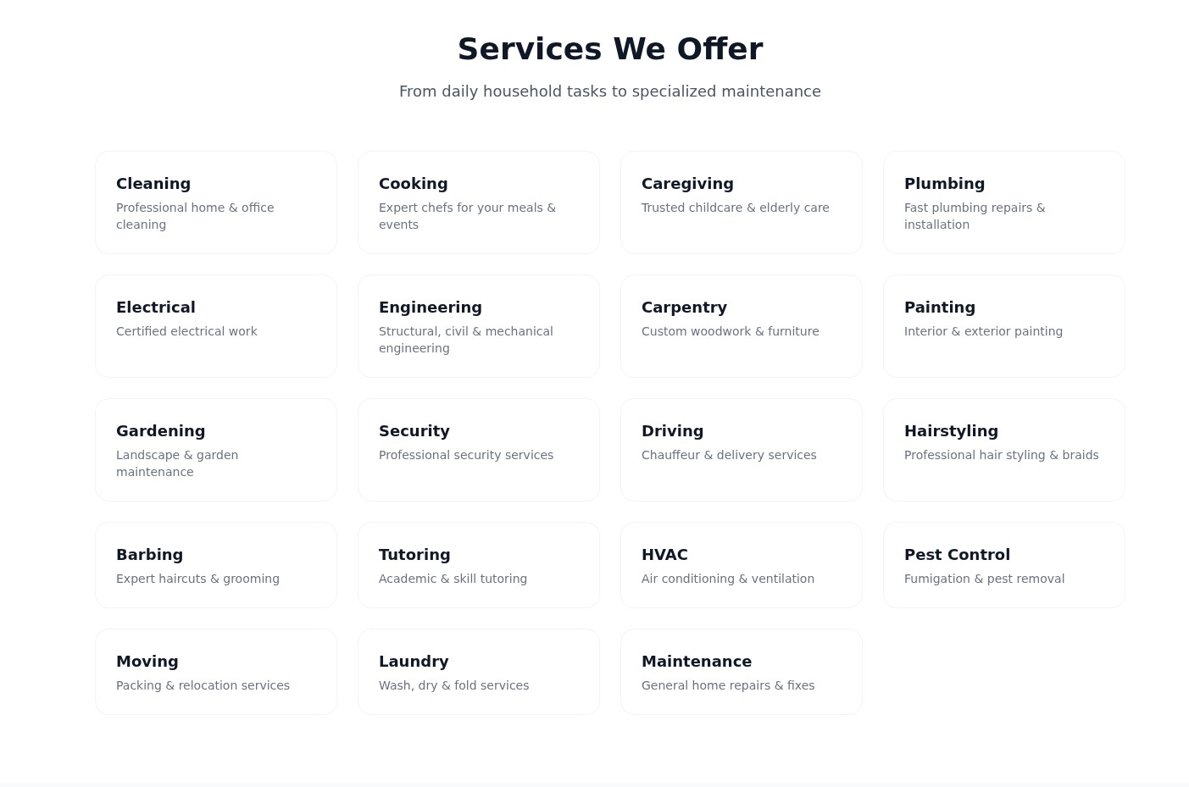
Figure 4.1: HomeEase Landing Page — Hero Section, Services, and Trust Indicators
Figure 4.1 shows the landing page which features the HomeEase branding, a hero section with a compelling call-to-action ("Get Started"), a grid of available service categories (Cleaning, Cooking, Caregiving, Plumbing, Electrical, Laundry), trust metrics (verified providers, completed jobs, etc.), and a footer with copyright information.

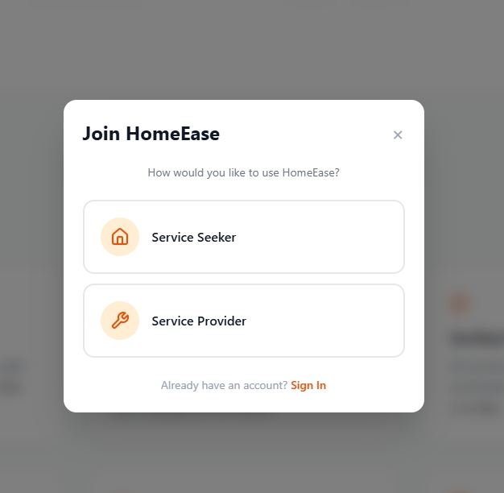
Figure 4.2: HomeEase Features Overview — Services Grid and Trust Metrics
Figure 4.2 displays the features overview section of the landing page, highlighting the available service categories in a clean grid layout and the platform trust metrics that assure users of service quality.

4.3.1.2 Creating an Account
To use the HomeEase platform, users must first create an account. The registration process begins with role selection, followed by filling out the appropriate registration form.
Step 1: On the landing page, click the "Get Started" button located in the hero section.

Step 2: A dialog appears, presenting two role options: "Service Seeker" and "Service Provider". Select the role that applies to you.

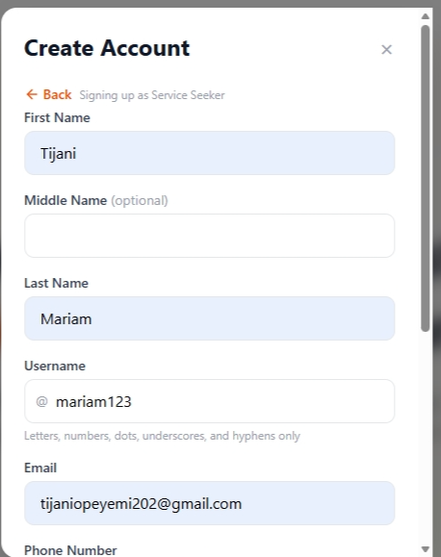
Figure 4.3: Role Selection Dialog — Service Seeker or Service Provider
Figure 4.3 shows the role selection dialog. Users must choose whether they are a Service Seeker (looking to hire domestic workers) or a Service Provider (artisan offering services). This choice determines the registration form fields and the subsequent dashboard experience.

Signing Up as a Service Seeker
To register as a service seeker, follow these steps:
Step 1: In the role selection dialog, click on the "Service Seeker" button.
Step 2: The Service Seeker registration form is displayed. Fill in the required details:
- Full Name — Enter your legal name
- Email Address — Provide a valid email address
- Phone Number — Enter a valid Nigerian phone number
- Password — Create a strong password (minimum 8 characters)
- Confirm Password — Re-enter your password for verification
Step 3: Click the "Sign Up" button to create your account.
Step 4: Upon successful registration, you are automatically signed in and redirected to your Service Seeker dashboard.

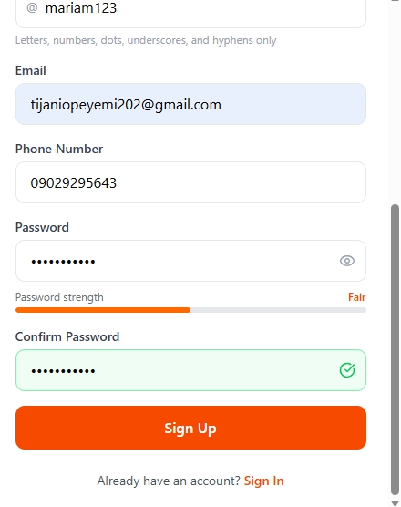
Figure 4.4: Service Seeker Registration Form
Figure 4.4 displays the Service Seeker registration form with input fields for full name, email address, phone number, password, and confirm password. The form includes input validation to ensure all fields are properly filled before submission.

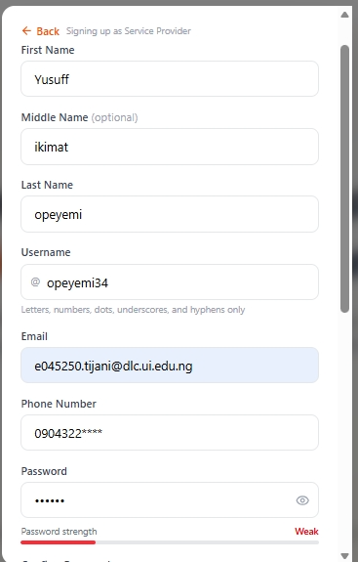
Figure 4.5: Service Seeker Dashboard After Successful Registration
Figure 4.5 shows the Service Seeker dashboard that is displayed immediately after successful registration and automatic sign-in. The dashboard provides an overview of the user's activity, including pending bookings, active requests, and quick-action links to find artisans, view requests, and manage their profile.

Signing Up as a Service Provider
To register as a service provider (artisan), follow these steps:
Step 1: In the role selection dialog, click on the "Service Provider" button.
Step 2: The Service Provider registration form is displayed. Fill in the required details:
- Full Name — Enter your legal name
- Email Address — Provide a valid email address
- Phone Number — Enter a valid Nigerian phone number
- Bio — Write a brief description of your skills and experience
- Bank Details — Provide your bank account information for receiving payments
- Password — Create a strong password (minimum 8 characters)
- Confirm Password — Re-enter your password for verification
Step 3: Click the "Sign Up" button to create your account.
Step 4: Upon successful registration, your account is created with a "Pending Verification" status. You must wait for an administrator to verify your account before you can start accepting jobs.

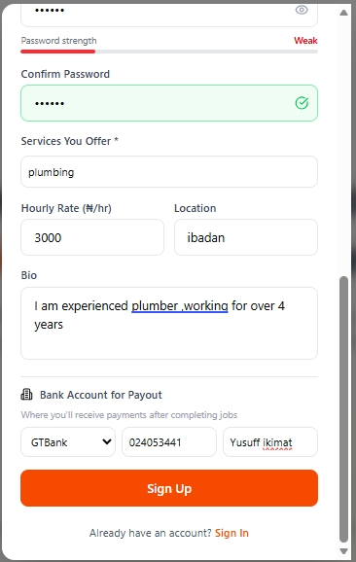
Figure 4.6: Service Provider Registration Form
Figure 4.6 displays the Service Provider registration form. In addition to the standard fields (name, email, phone, password), the form includes a Bio field for the artisan to describe their skills and a Bank Details section for payment settlement purposes.

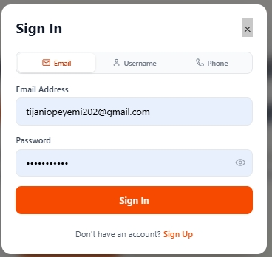
Figure 4.7: Service Provider Registration Confirmation / Dashboard Preview
Figure 4.7 shows the screen displayed after a service provider successfully registers. The provider can see their dashboard but is informed that their account is pending verification by the platform administrator.

4.3.1.3 Signing In to the Platform
Returning users can sign in to the platform using their registered credentials. The sign-in process supports login via email, phone number, or username.
Step 1: On the landing page, click the "Sign In" button in the navigation bar.
Step 2: The sign-in dialog appears. Enter your email address, phone number, or username.
Step 3: Enter your password.
Step 4: Click the "Sign In" button to access your account.
Step 5: Upon successful authentication, you are redirected to your role-specific dashboard.

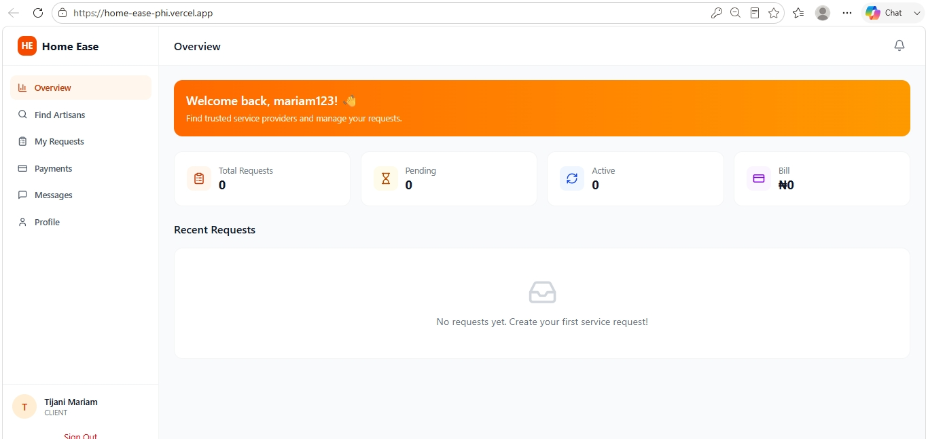
Figure 4.8: Sign In Dialog — Email/Phone/Username and Password Fields
Figure 4.8 displays the sign-in dialog. Users can authenticate using any of three identifiers: email address, phone number, or username. The dialog includes a link to return to the registration form for new users.

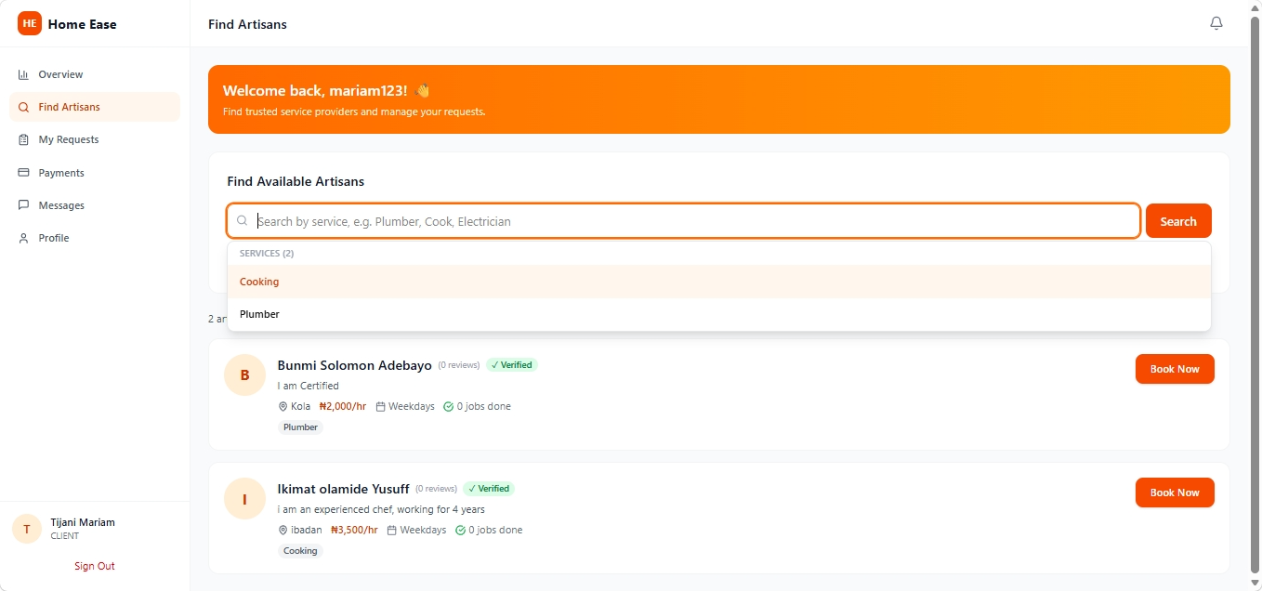
Figure 4.9: Service Seeker Dashboard — Overview After Signing In
Figure 4.9 shows the Service Seeker dashboard after a successful sign-in. The dashboard provides quick access to all key features: Find Artisans, My Requests, Messages, Notifications, and Profile management.

4.3.2 Service Seeker Manual
This section provides a comprehensive guide for Service Seekers — users who are looking to hire domestic service providers (artisans) through the HomeEase platform. Each feature and workflow is described step-by-step with accompanying screenshots.

4.3.2.1 Service Seeker Dashboard
The Service Seeker dashboard serves as the central hub for all activities. After signing in, the dashboard is displayed, showing an overview of the user's account status, recent bookings, pending requests, and available actions.
The dashboard provides navigation to the following key sections:
- Find Artisans — Browse and search for available service providers
- My Requests — View and manage all booking requests
- Messages — Communicate with service providers
- Notifications — View alerts and updates
- Profile — Manage personal information and preferences

Figure 4.10: Service Seeker Dashboard — Main Navigation and Quick Actions

4.3.2.2 Finding and Booking Service Providers
The "Find Artisans" feature allows service seekers to browse available service providers, search by service category, and book appointments. Follow these steps to find and book an artisan:
Step 1: From the dashboard, click on the "Find Artisans" button or navigation link.
Step 2: The Find Artisans page loads, displaying available service categories and a list of verified providers.
Step 3: Use the search bar to filter providers by service type (e.g., Cooking, Plumbing, Caregiving, Electrical, Cleaning, Laundry).
Step 4: Browse through the list of available providers. Each provider card shows their name, service type, rating, and availability status.
Step 5: Click on the "Book Now" button on the desired provider's card.
Step 6: The booking form is displayed. Fill in the required booking details:
- Location — Enter the service location (address)
- Date — Select the preferred service date
- Time — Select the preferred service time
Step 7: Click "Confirm Booking" to submit your booking request.

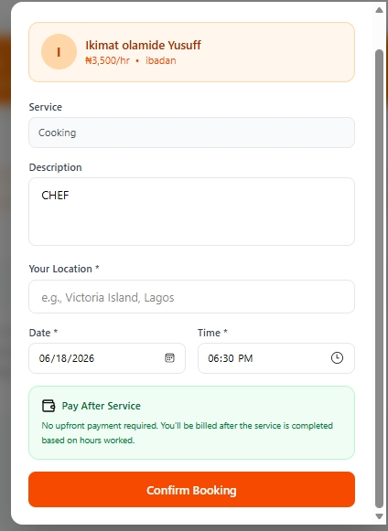
Figure 4.11: Find Artisans Page — Service Categories and Provider Listings
Figure 4.11 shows the Find Artisans page with service category filters and a list of available, verified service providers. Each provider card displays their name, specialty, rating, and a "Book Now" action button.

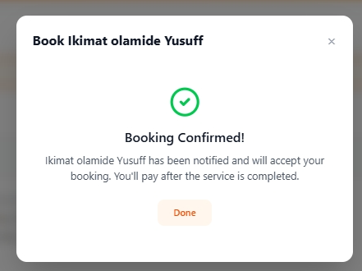
Figure 4.12: Booking Form — Location, Date, and Time Selection
Figure 4.12 displays the booking form that appears when a service seeker clicks "Book Now" on a provider's card. The form collects the service location, preferred date, and preferred time before confirming the booking.

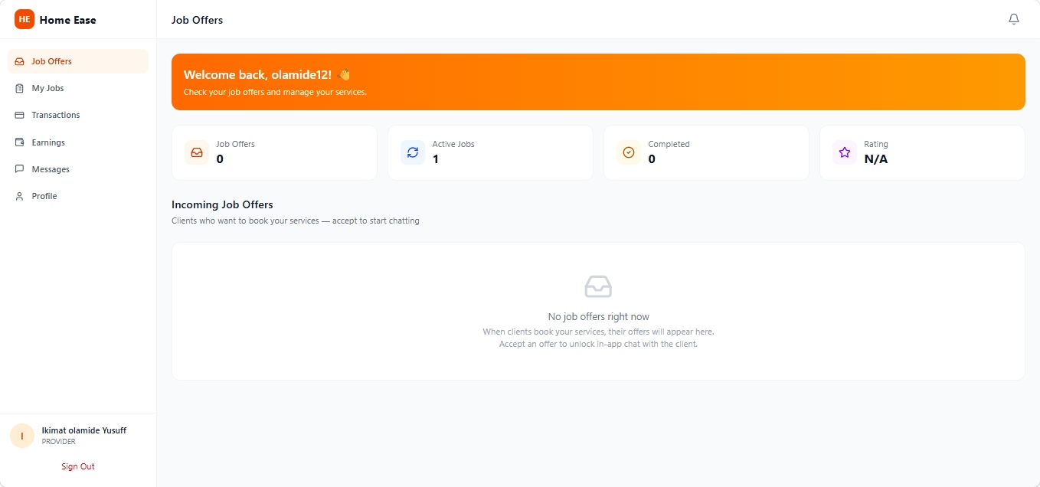
Figure 4.13: Booking Confirmation — Request Successfully Submitted
Figure 4.13 shows the confirmation screen displayed after a booking request is successfully submitted. The service seeker is informed that their request has been sent to the service provider and they will be notified of the response.

4.3.2.3 Managing Booking Requests
The "My Requests" section allows service seekers to track and manage all their booking requests. Users can view the status of each request (Pending, Accepted, In Progress, Completed, Cancelled) and take appropriate actions.
Step 1: From the dashboard, click on "My Requests".
Step 2: A list of all booking requests is displayed, each showing the provider name, service type, scheduled date and time, and current status.
Step 3: Use the filter options to view requests by status (All, Pending, Active, Completed).

The My Requests page also serves as the gateway for making payments after a service provider completes a job and checks out. When a job status changes to "Completed," the service seeker can proceed to make payment directly from this page.

4.3.2.4 Making Payment for Completed Services
Payment is processed through the integrated Paystack payment gateway. After a service provider completes a job and checks out, the service seeker is notified and can make payment.
To make a payment for a completed service:
Step 1: Sign in as a service seeker.
Step 2: Click on "My Requests" to view your booking history.
Step 3: Find the completed job and click on the payment button.
Step 4: The Paystack payment popup appears with the service amount.
Step 5: Select your preferred payment method (Card, Bank Transfer, USSD).
Step 6: Complete the payment process. Upon successful payment, both the service seeker and service provider are notified.
Step 7: After payment, you can rate and review the service provider.

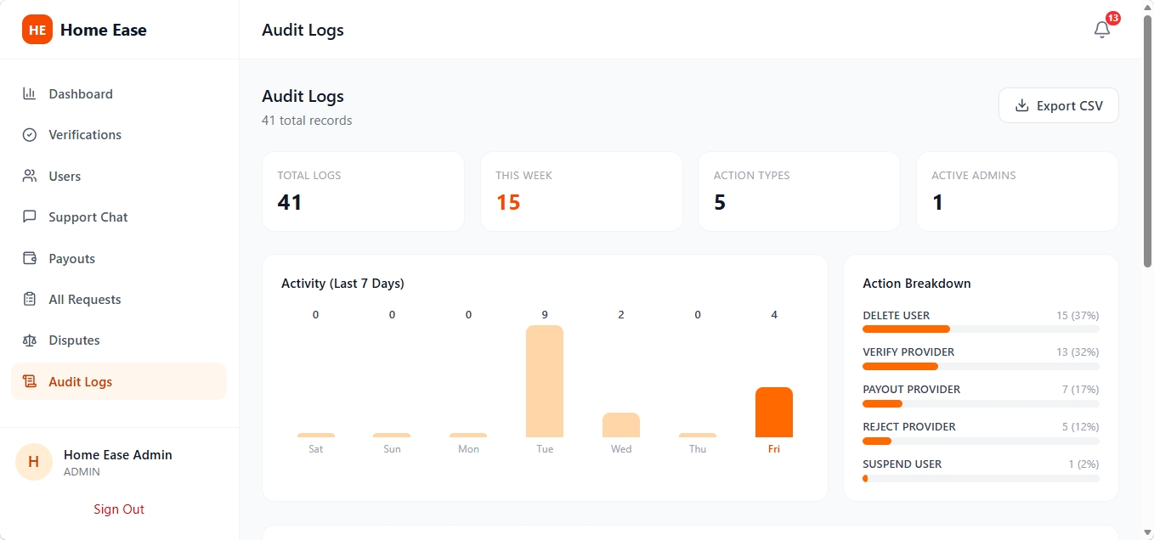
Figure 4.14: My Requests Page — Viewing Completed Jobs for Payment
Figure 4.14 shows the My Requests page where service seekers can view completed jobs and initiate the payment process for services rendered.

4.3.3 Service Provider Manual
This section provides a comprehensive guide for Service Providers — artisans who offer domestic services through the HomeEase platform. It covers account verification, managing job offers, check-in/check-out procedures, payment tracking, and more.

4.3.3.1 Account Verification Process
Newly registered service providers must be verified by an administrator before they can start receiving and accepting job offers. During the verification period, the provider's account status is "Pending Verification" and they have limited access to the platform.
Once an administrator reviews and approves the provider's profile, the status changes to "Verified" and full access to all provider features is granted.

4.3.3.2 Service Provider Dashboard
To sign in and access the provider dashboard:
Step 1: On the landing page, click "Sign In".
Step 2: Enter your email address, phone number, or username.
Step 3: Enter your password.
Step 4: Click "Sign In" to access your dashboard.
Step 5: The service provider dashboard is displayed, showing an overview of pending job offers, active jobs, earnings, and account status.

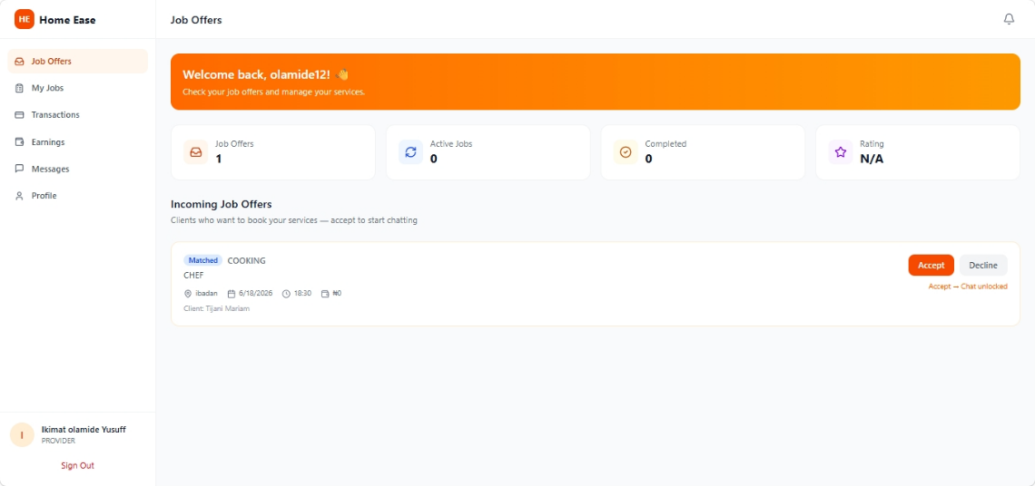
Figure 4.15: Service Provider Dashboard — Overview of Job Offers, Active Jobs, and Earnings
Figure 4.15 displays the Service Provider dashboard. It provides a comprehensive overview of the provider's activity including pending job offers, currently active jobs, total earnings, and quick navigation to job offers, transactions, and profile management.

4.3.3.3 Accepting and Managing Job Offers
When a service seeker books a service, the corresponding job offer appears in the provider's "Job Offers" section. Providers can review the details and choose to accept or reject the offer.
Step 1: Click on "Job Offers" in the navigation menu.
Step 2: A list of incoming job requests is displayed, each showing the seeker's name, service type, location, date, time, and service charge.
Step 3: Review the job details carefully.
Step 4: Click "Accept" to confirm the booking, or "Reject" to decline.
Step 5: Upon acceptance, the job status changes to "Accepted" and appears in your active jobs list.

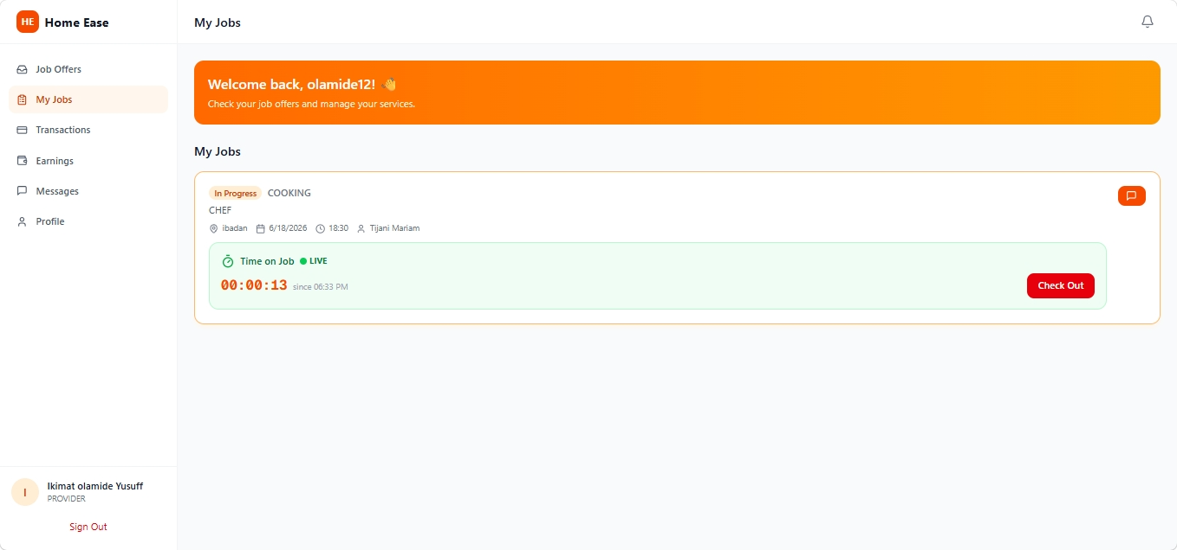
Figure 4.16: Job Offers Page — Viewing and Accepting/Rejecting Incoming Requests
Figure 4.16 shows the Job Offers page where service providers can review incoming booking requests. Each job card displays the service seeker's details, the requested service, location, and schedule. The provider can accept or reject each offer using the action buttons.

4.3.3.4 Checking In After Accepting an Offer
After accepting a job offer, the service provider must check in when they arrive at the service location. This action notifies the service seeker that the provider has arrived and work is about to begin.
Step 1: After arriving at the service seeker's location, open the app and navigate to your active jobs.
Step 2: Click on the "Check In" button for the accepted job.
Step 3: The system records the check-in time and updates the job status to "In Progress."
Step 4: The service seeker receives a notification that the provider has checked in.

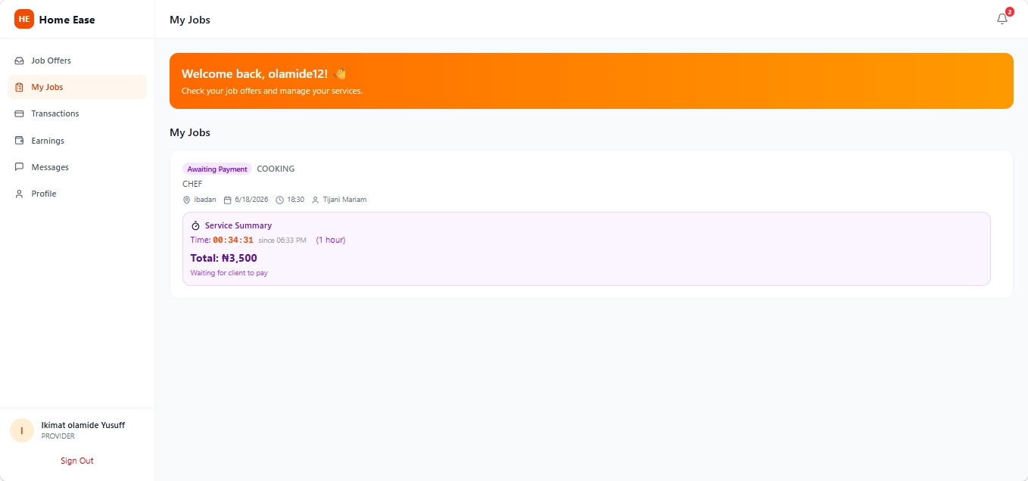
Figure 4.17: Check-In Screen — Provider Checks In Upon Arrival at Service Location
Figure 4.17 displays the check-in interface. The service provider clicks "Check In" to record their arrival time. This timestamp is stored in the system for transparency and dispute resolution.

4.3.3.5 Checking Out After Work Completion
When the service provider has completed the work, they must check out. This action signals to the service seeker that the job is done and payment is now expected.
Step 1: After completing the service, click on the "Check Out" button for the active job.
Step 2: The system records the check-out time and updates the job status to "Completed."
Step 3: The service seeker receives a notification that the job has been completed and payment is pending.
Step 4: The provider now waits for the service seeker to process the payment.

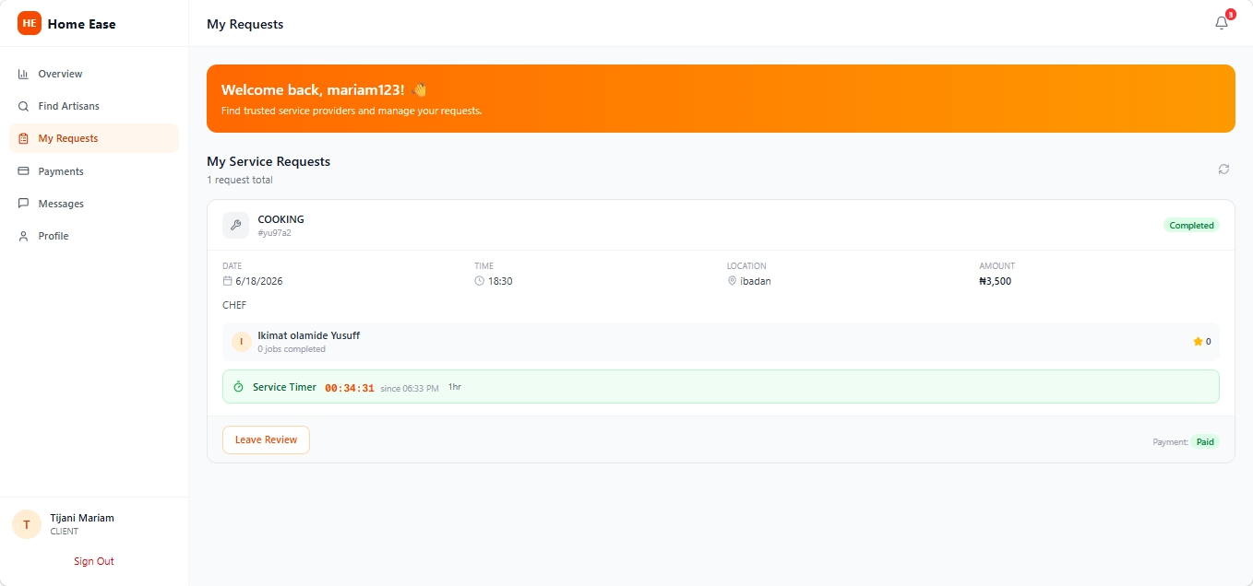
Figure 4.18: Check-Out Screen — Provider Checks Out After Completing Work
Figure 4.18 shows the check-out interface. The service provider clicks "Check Out" to indicate that the work is complete. The system captures the completion time and transitions the job to the payment-pending state.

4.3.3.6 Viewing Earnings and Transactions
Service providers can track their earnings and view transaction history through the dashboard. Each completed and paid job is recorded with the service amount, date, and payment status.
The earnings section displays the total amount earned, pending payments, and completed transactions. Providers can also view their wallet balance and request payouts to their registered bank account.

4.3.4 Administrator Manual
This section covers the administrative features of the HomeEase platform. The administrator role has full control over user management, provider verification, payment processing, and platform monitoring.

4.3.4.1 Administrator Dashboard
The Administrator dashboard provides a comprehensive overview of the platform's status, including total users, active providers, pending verifications, total transactions, and platform statistics.

4.3.4.2 Verifying Service Providers
One of the administrator's key responsibilities is verifying new service provider accounts. This ensures that only legitimate and qualified artisans are allowed to offer services on the platform.
Step 1: Sign in as an administrator.
Step 2: Navigate to the "Verify Providers" section.
Step 3: Review the list of providers with "Pending Verification" status.
Step 4: Examine the provider's profile, bio, and submitted information.
Step 5: Click "Verify" to approve the provider, or "Reject" to decline.

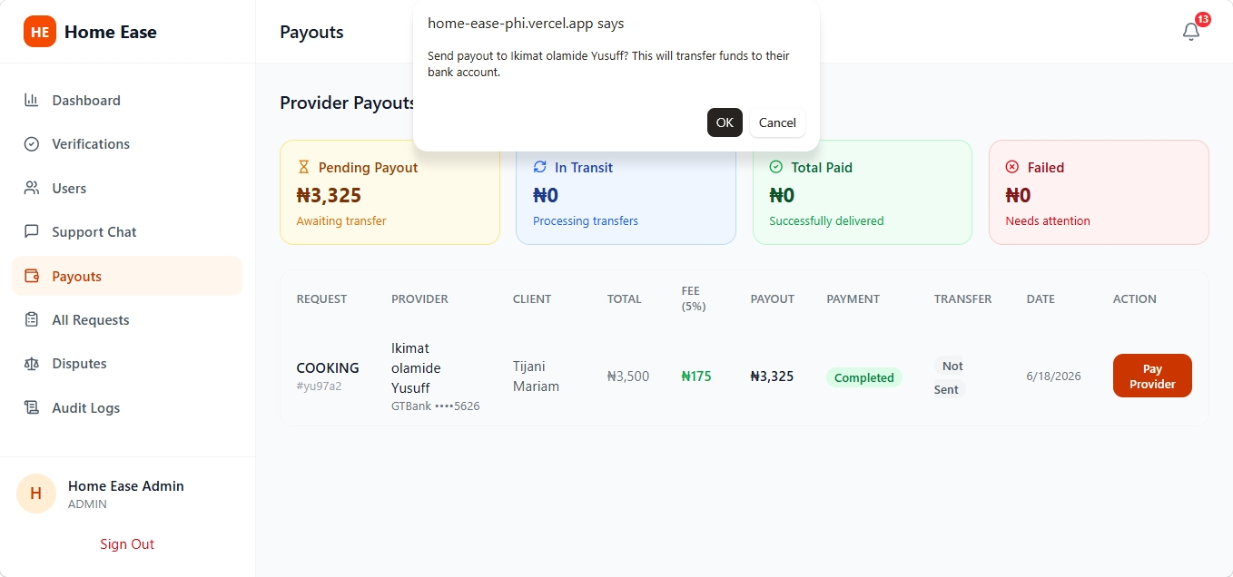
Figure 4.19: Admin — Provider Verification Interface
Figure 4.19 shows the administrator's provider verification interface. Admins can review pending provider applications and approve or reject them with appropriate action buttons.

4.3.4.3 Managing Users
The administrator can view and manage all registered users on the platform, including service seekers and service providers. User management capabilities include viewing user profiles, deactivating accounts, and monitoring user activity.
Step 1: Navigate to the "Manage Users" section in the admin dashboard.
Step 2: View the list of all registered users with their details (name, email, role, status).
Step 3: Use search and filter options to find specific users.
Step 4: Click on a user to view their full profile and activity history.
Step 5: Take administrative actions as needed (deactivate, suspend, etc.).

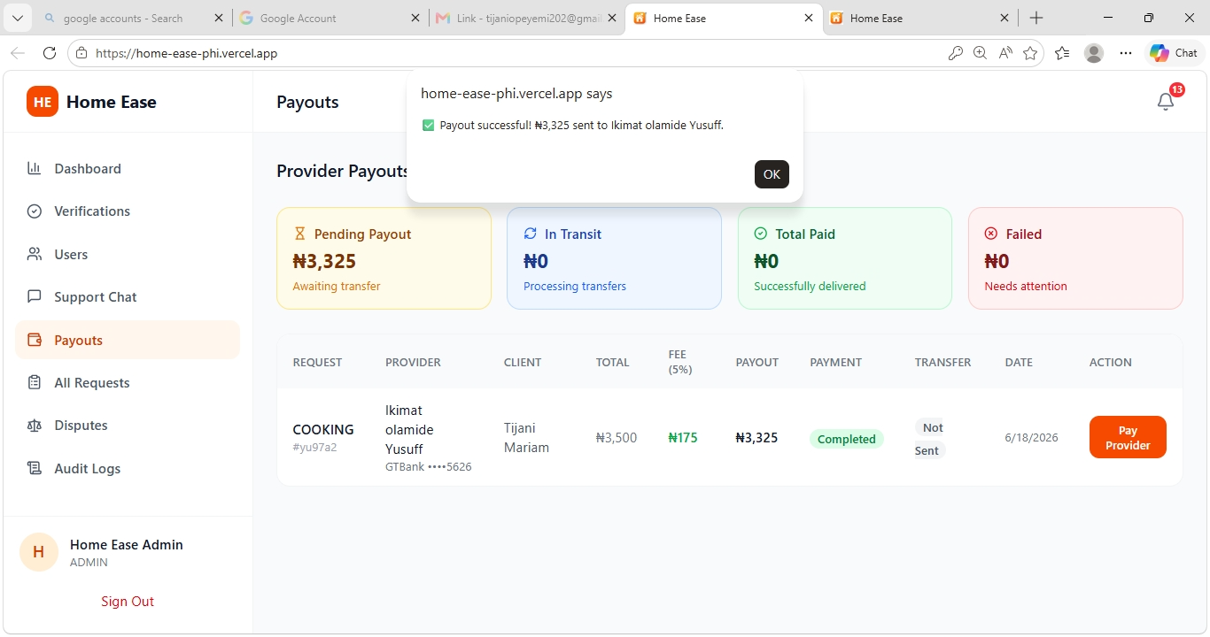
Figure 4.20: Admin — User Management Page with Search and Filter Options
Figure 4.20 displays the administrator's user management page. All registered users are listed with their details, and the admin can search, filter, and manage user accounts.

4.3.4.4 Reports and Platform Statistics
The administrator has access to detailed reports and statistics about the platform's performance. This includes charts and data visualizations showing user growth, transaction volumes, popular services, and other key performance indicators.
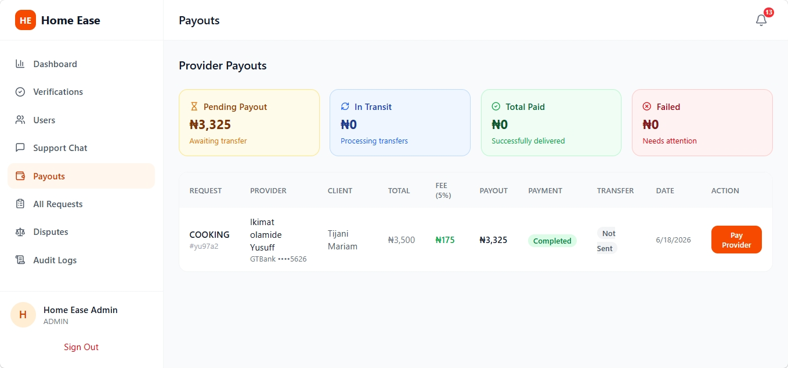
Figure 4.21: Admin — Reports Dashboard with Filter Pills and Status Badges
Figure 4.21 shows the admin reports dashboard with filter options for viewing different metrics and status badges indicating the current state of various platform operations.

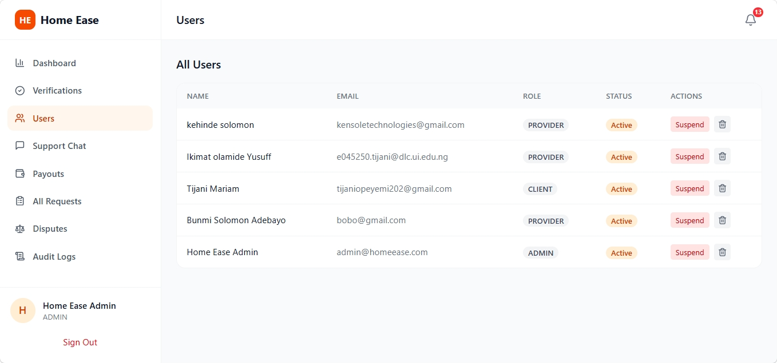
Figure 4.22: Admin — Platform Analytics and Statistics Overview
Figure 4.22 displays the platform analytics dashboard showing key statistics such as total users, revenue, active bookings, and other performance metrics.

4.4 Sample System Run
This section presents a complete end-to-end walkthrough of the HomeEase system using a realistic scenario. The scenario follows two users — Ada (a Service Seeker) and Emeka (a Service Provider) — as they navigate through the platform from registration to payment.

Scenario: Ada Needs a Plumber
Ada is a homeowner in Lagos who needs a plumber to fix a leaking pipe. She decides to use the HomeEase platform to find a reliable, verified plumber. Meanwhile, Emeka is a licensed plumber who has registered on the platform and is awaiting job offers.

Step 1: Ada opens her web browser and navigates to the HomeEase website. The landing page loads, displaying the homepage with service categories and a "Get Started" button.
Step 2: Ada clicks "Get Started" and is presented with the role selection dialog. She selects "Service Seeker."
Step 3: The Service Seeker registration form appears. Ada fills in her full name (Ada Okonkwo), email (ada@example.com), phone number (08012345678), creates a password, and confirms it.
Step 4: Ada clicks "Sign Up" and is automatically signed in. The Service Seeker dashboard is displayed, showing her account overview and navigation menu.
Step 5: Meanwhile, Emeka (a plumber) has already registered as a Service Provider and has been verified by the administrator. He signs in with his credentials.
Step 6: Emeka's Service Provider dashboard is displayed, showing his verified status, pending job offers, and earnings overview.
Step 7: Back on Ada's dashboard, she clicks on "Find Artisans" to search for a plumber.
Step 8: The Find Artisans page loads, showing a list of verified service providers. Ada uses the search filter to find plumbers specifically.
Step 9: Ada sees Emeka's profile in the search results — he is listed as a verified plumber with a good rating. She clicks "Book Now" on his profile card.
Step 10: The booking form appears. Ada enters her location (12 Admiralty Way, Lekki Phase 1, Lagos), selects tomorrow's date, and chooses 10:00 AM as the preferred time.
Step 11: Ada clicks "Confirm Booking." A confirmation message appears, and the booking request is sent to Emeka.
Step 12: Emeka receives a notification about the new job offer. He clicks on "Job Offers" in his navigation menu.
Step 13: Emeka sees Ada's booking request with all the details. He reviews the location, date, and time, then clicks "Accept."
Step 14: Ada receives a notification that Emeka has accepted her booking. The job status is now "Accepted."
Step 15: The next day at 9:55 AM, Emeka arrives at Ada's location. He opens the app and clicks "Check In." The system records his arrival and notifies Ada.
Step 16: Ada receives a notification that Emeka has checked in and is on-site.
Step 17: Emeka completes the plumbing repair work. After finishing, he clicks "Check Out." The system records the completion time and updates the status to "Completed."
Step 18: Ada receives a notification that the job has been completed and payment is pending.
Step 19: Ada signs in, goes to "My Requests," and sees the completed job. She reviews the details and clicks the payment button.
Step 20: The Paystack payment popup appears with the service charge. Ada enters her card details and completes the payment.
Step 21: Both Ada and Emeka receive payment confirmation notifications. The transaction is recorded in both their transaction histories.
Step 22: Ada is prompted to rate Emeka's service. She gives him 5 stars and writes a brief positive review.
Step 23: Emeka's dashboard reflects the new payment in his earnings summary. The complete transaction history is updated.
Step 24: The administrator can view this entire transaction in the admin dashboard, including the booking timeline, payment record, and user ratings.

Additional System Screens
The following figures provide additional screenshots of various system screens that further demonstrate the completeness of the implementation.
Figure 4.23: Admin — Transaction Management and Payout Records
Figure 4.23 shows the admin transaction management interface where administrators can view all platform transactions, process payouts, and monitor financial activity.

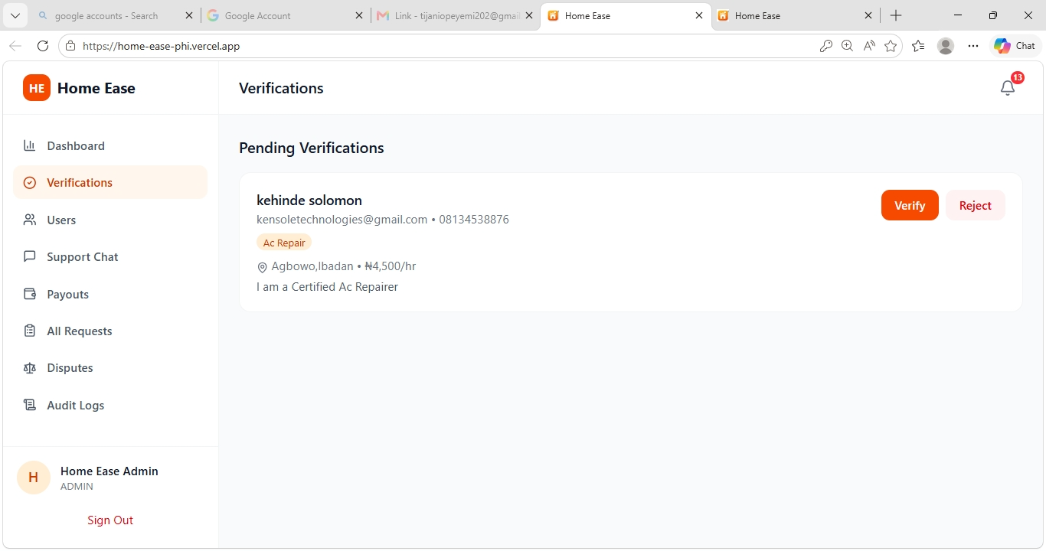
Figure 4.24: Admin — Platform Overview with User Statistics and Metrics
Figure 4.24 displays a comprehensive platform overview showing user statistics, service metrics, and other key indicators that help administrators monitor platform health.

4.5 Summary
This chapter presented a comprehensive, step-by-step walkthrough of the HomeEase system implementation. The walkthrough covered every major process and feature of the application, organized into four main areas:
- Getting Started — Covered accessing the platform, account creation for both Service Seekers and Service Providers, and the sign-in process.
- Service Seeker Manual — Covered the dashboard, finding and booking artisans, managing requests, and making payments through the integrated Paystack gateway.
- Service Provider Manual — Covered the provider dashboard, accepting job offers, the check-in/check-out workflow, and tracking earnings.
- Administrator Manual — Covered the admin dashboard, provider verification, user management, transaction monitoring, and platform statistics.
Each section was accompanied by annotated screenshots (24 figures in total) that illustrate the actual system screens at each step of the process. The screenshots confirm that all features described in the system design (Chapter 3) have been fully implemented and are functioning as intended.
The sample system run in Section 4.4 demonstrated a complete end-to-end workflow from registration through payment, proving that the system operates seamlessly across all three user roles. The HomeEase platform successfully connects service seekers with verified domestic service providers, manages the entire booking lifecycle, and processes payments securely.

