CHAPTER 4
SYSTEM IMPLEMENTATION AND USER GUIDE

4.1 Introduction
This chapter provides a comprehensive walkthrough of the HomeEase platform, detailing the system implementation environment and serving as a complete user manual for all three user roles: Service Seekers, Service Providers, and Administrators. Each section is accompanied by annotated screenshots that illustrate the key interfaces and workflows of the system. The chapter covers the hardware and software requirements, step-by-step instructions for every major feature, the underlying system architecture, and a sample end-to-end system run demonstrating a typical service booking scenario.

4.2 Implementation Environment
4.2.1 Hardware Requirements
Table 4.1 presents the hardware specifications used during the development of the HomeEase platform.

Table 4.1: Development Hardware Requirements
Component | Specification
Processor | Intel Core i5 / AMD Ryzen 5 or higher
RAM | 8 GB minimum (16 GB recommended)
Hard Disk | 256 GB SSD minimum
Display | 1366 × 768 resolution minimum
Network | Broadband internet connection

Table 4.2 shows the recommended hardware for the production server deployment.
Table 4.2: Server Hardware Requirements
Component | Specification
Processor | Intel Xeon / AMD EPYC (multi-core)
RAM | 16 GB minimum (32 GB recommended)
Hard Disk | 100 GB SSD + scalable storage
Network | Dedicated 100 Mbps+ bandwidth
Operating System | Ubuntu Server 22.04 LTS

4.2.2 Software Requirements
Table 4.3 lists the software tools and technologies used throughout the implementation of the HomeEase platform.

Table 4.3: Software Requirements
Software / Technology | Version / Details | Purpose
React.js | v18.x | Frontend framework
Node.js | v18.x LTS | Backend runtime environment
Express.js | v4.x | Backend web framework
MongoDB | v6.x | NoSQL database
Mongoose ODM | v7.x | Object data modelling for MongoDB
Tailwind CSS | v3.x | Utility-first CSS framework
Socket.IO | v4.x | Real-time bidirectional communication
Flutterwave | v3.x API | Payment processing gateway
Cloudinary | SDK | Cloud image storage and management
VS Code | Latest | Integrated development environment
Postman | Latest | API testing and documentation
Git / GitHub | Latest | Version control
npm / Yarn | v9.x / v1.22.x | Package management

4.3 System Interface and User Manual
This section provides a detailed walkthrough of every interface and feature available on the HomeEase platform. Instructions are organised by user role and cover the complete workflow from registration to service completion.
4.3.1 Getting Started (Common to All Users)
4.3.1.1 Accessing the Website
Step 1: Open any modern web browser such as Google Chrome, Mozilla Firefox, or Microsoft Edge.
Step 2: Enter the HomeEase platform URL in the browser's address bar and press **Enter**.
Step 3: The landing page loads, displaying the hero section with a brief overview of the platform, as shown in Figure 4.1.
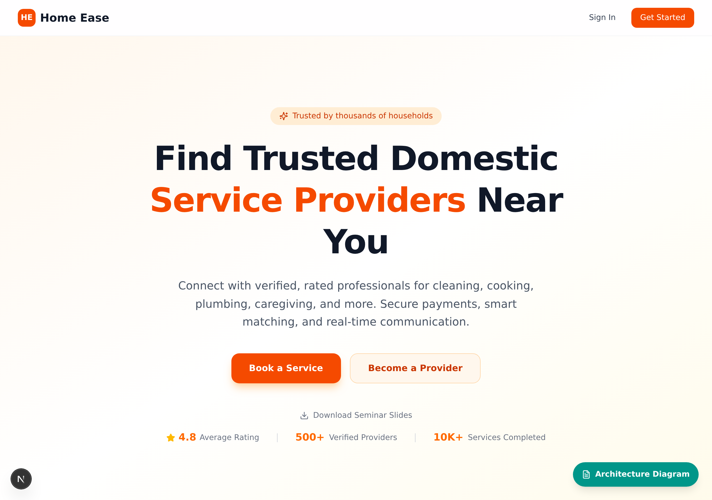
Figure 4.1: HomeEase Landing Page Hero Section
4.3.1.2 Platform Services and Features
After the hero section, users can scroll down to view the full range of services offered by the platform. The **Services** section presents a visual grid of service categories, allowing users to quickly identify the type of artisan they need. Each category is represented by an icon and label, as illustrated in Figure 4.2.
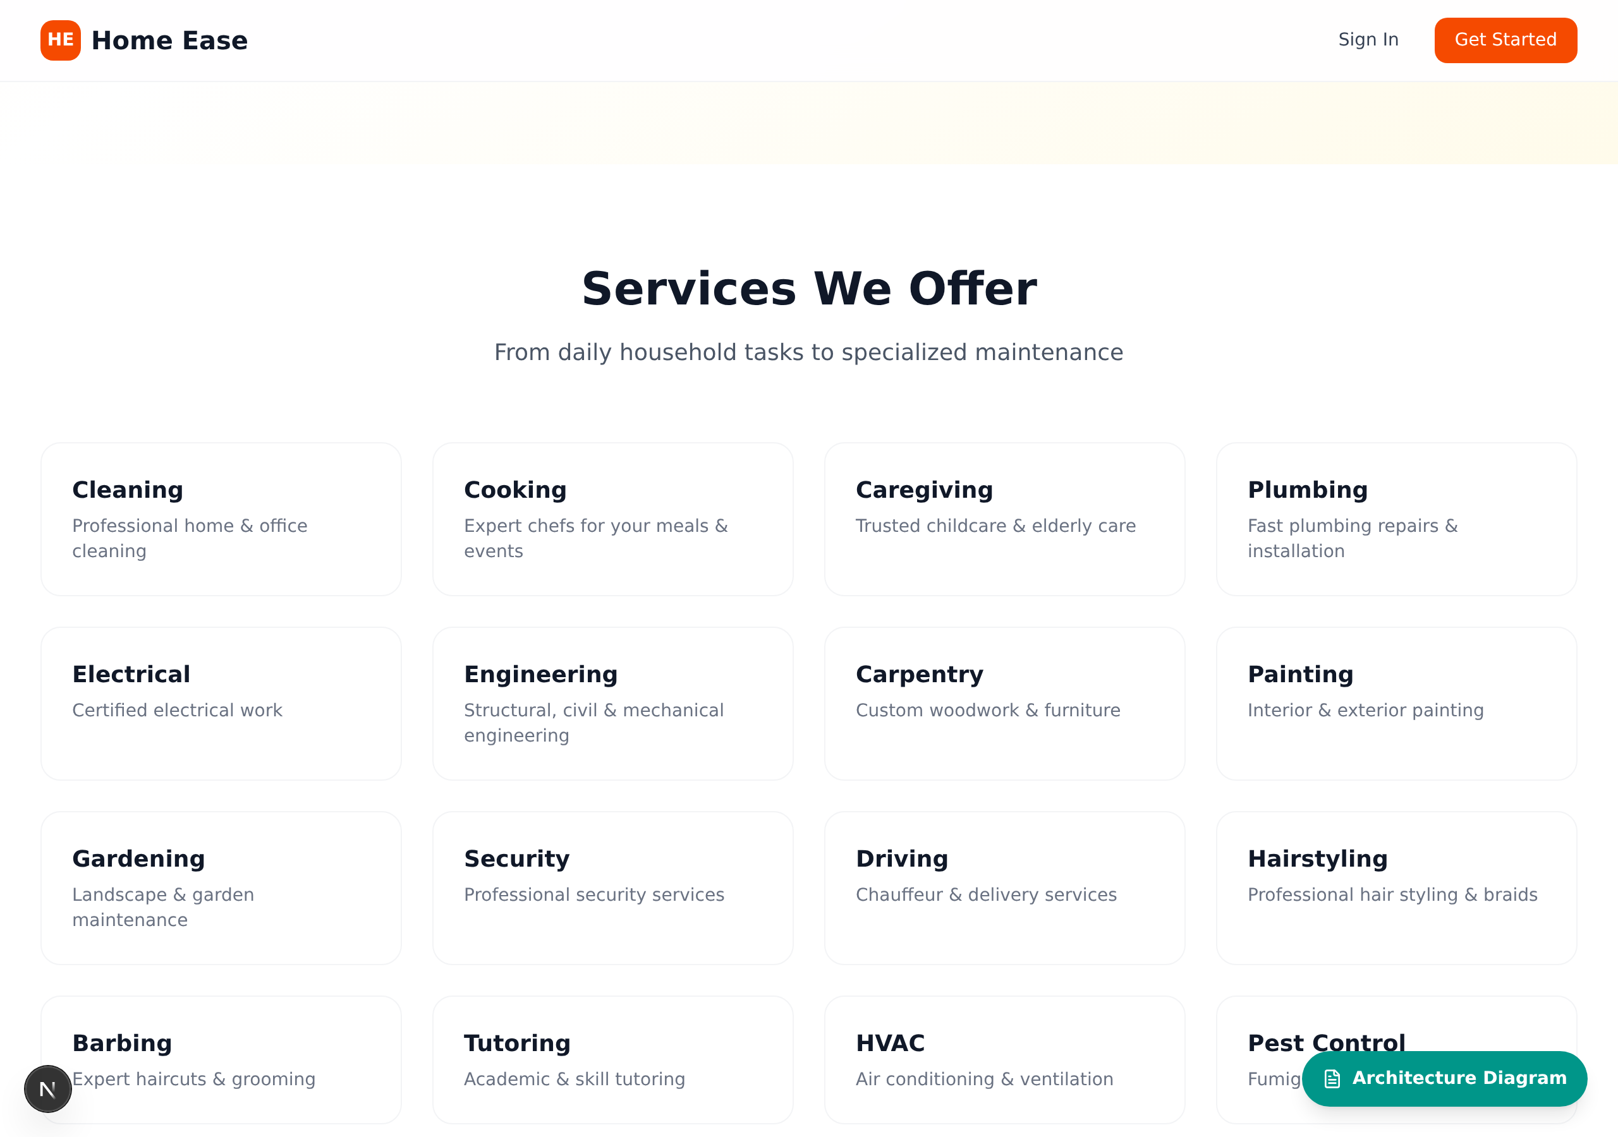
Figure 4.2: HomeEase Services Grid Display
Below the services grid, the **Features** section highlights the key benefits of using the HomeEase platform. Features such as verified artisans, secure payments, real-time messaging, and ratings and reviews are presented in an easy-to-scan card layout, as shown in Figure 4.3.
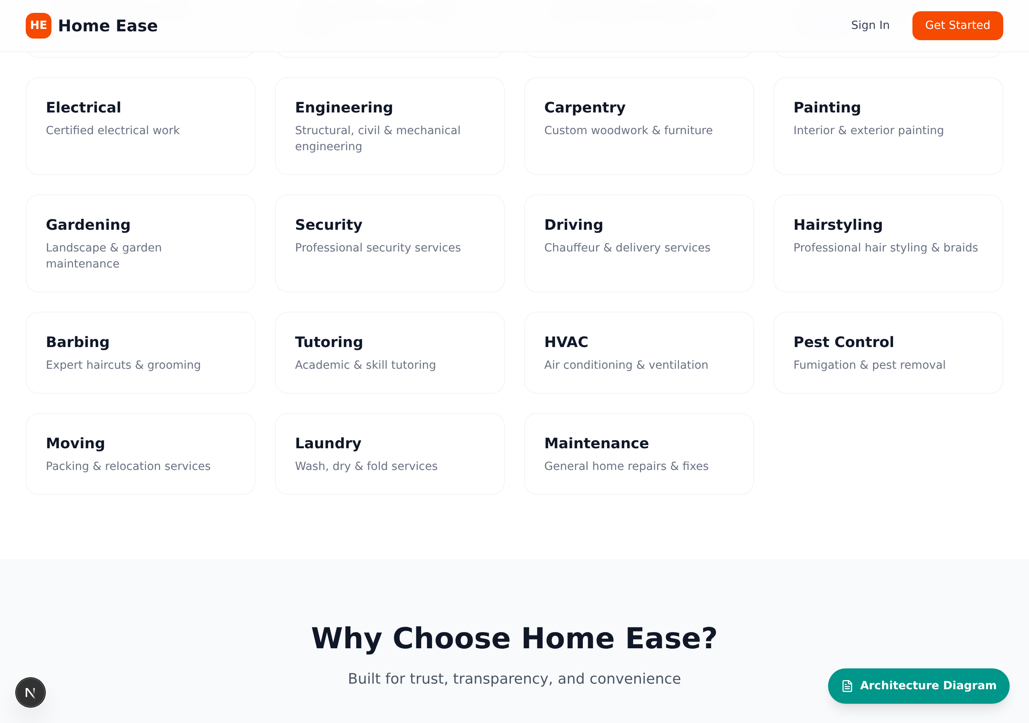
Figure 4.3: HomeEase Platform Features Overview
The **How It Works** section provides a simplified three-step guide for new users. It explains the basic workflow of searching for a service provider, booking a service, and completing the transaction. This section gives first-time visitors a clear understanding of the platform's core process, as depicted in Figure 4.4.
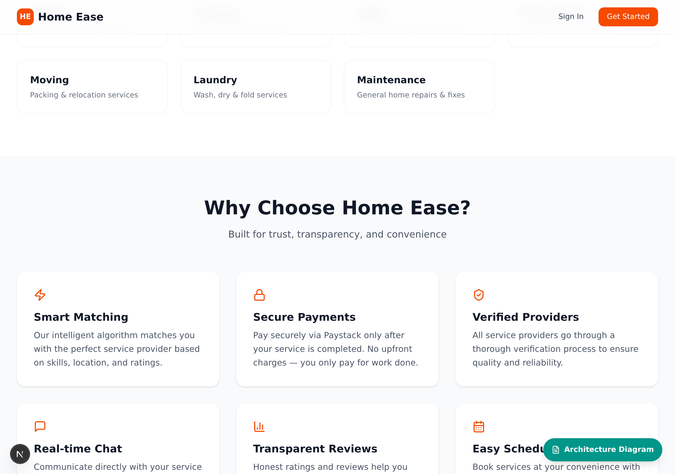
Figure 4.4: HomeEase How It Works Section
4.3.1.3 Creating an Account
HomeEase supports two primary user roles: **Service Seeker** and **Service Provider**. The registration process begins with selecting the appropriate role.
Step 1: On the landing page, click the **Get Started** or **Sign Up** button to initiate the registration process.
Step 2: The system presents a role selection screen, as shown in Figure 4.5. Choose **Service Seeker** if you need to hire artisans, or **Service Provider** if you offer services.
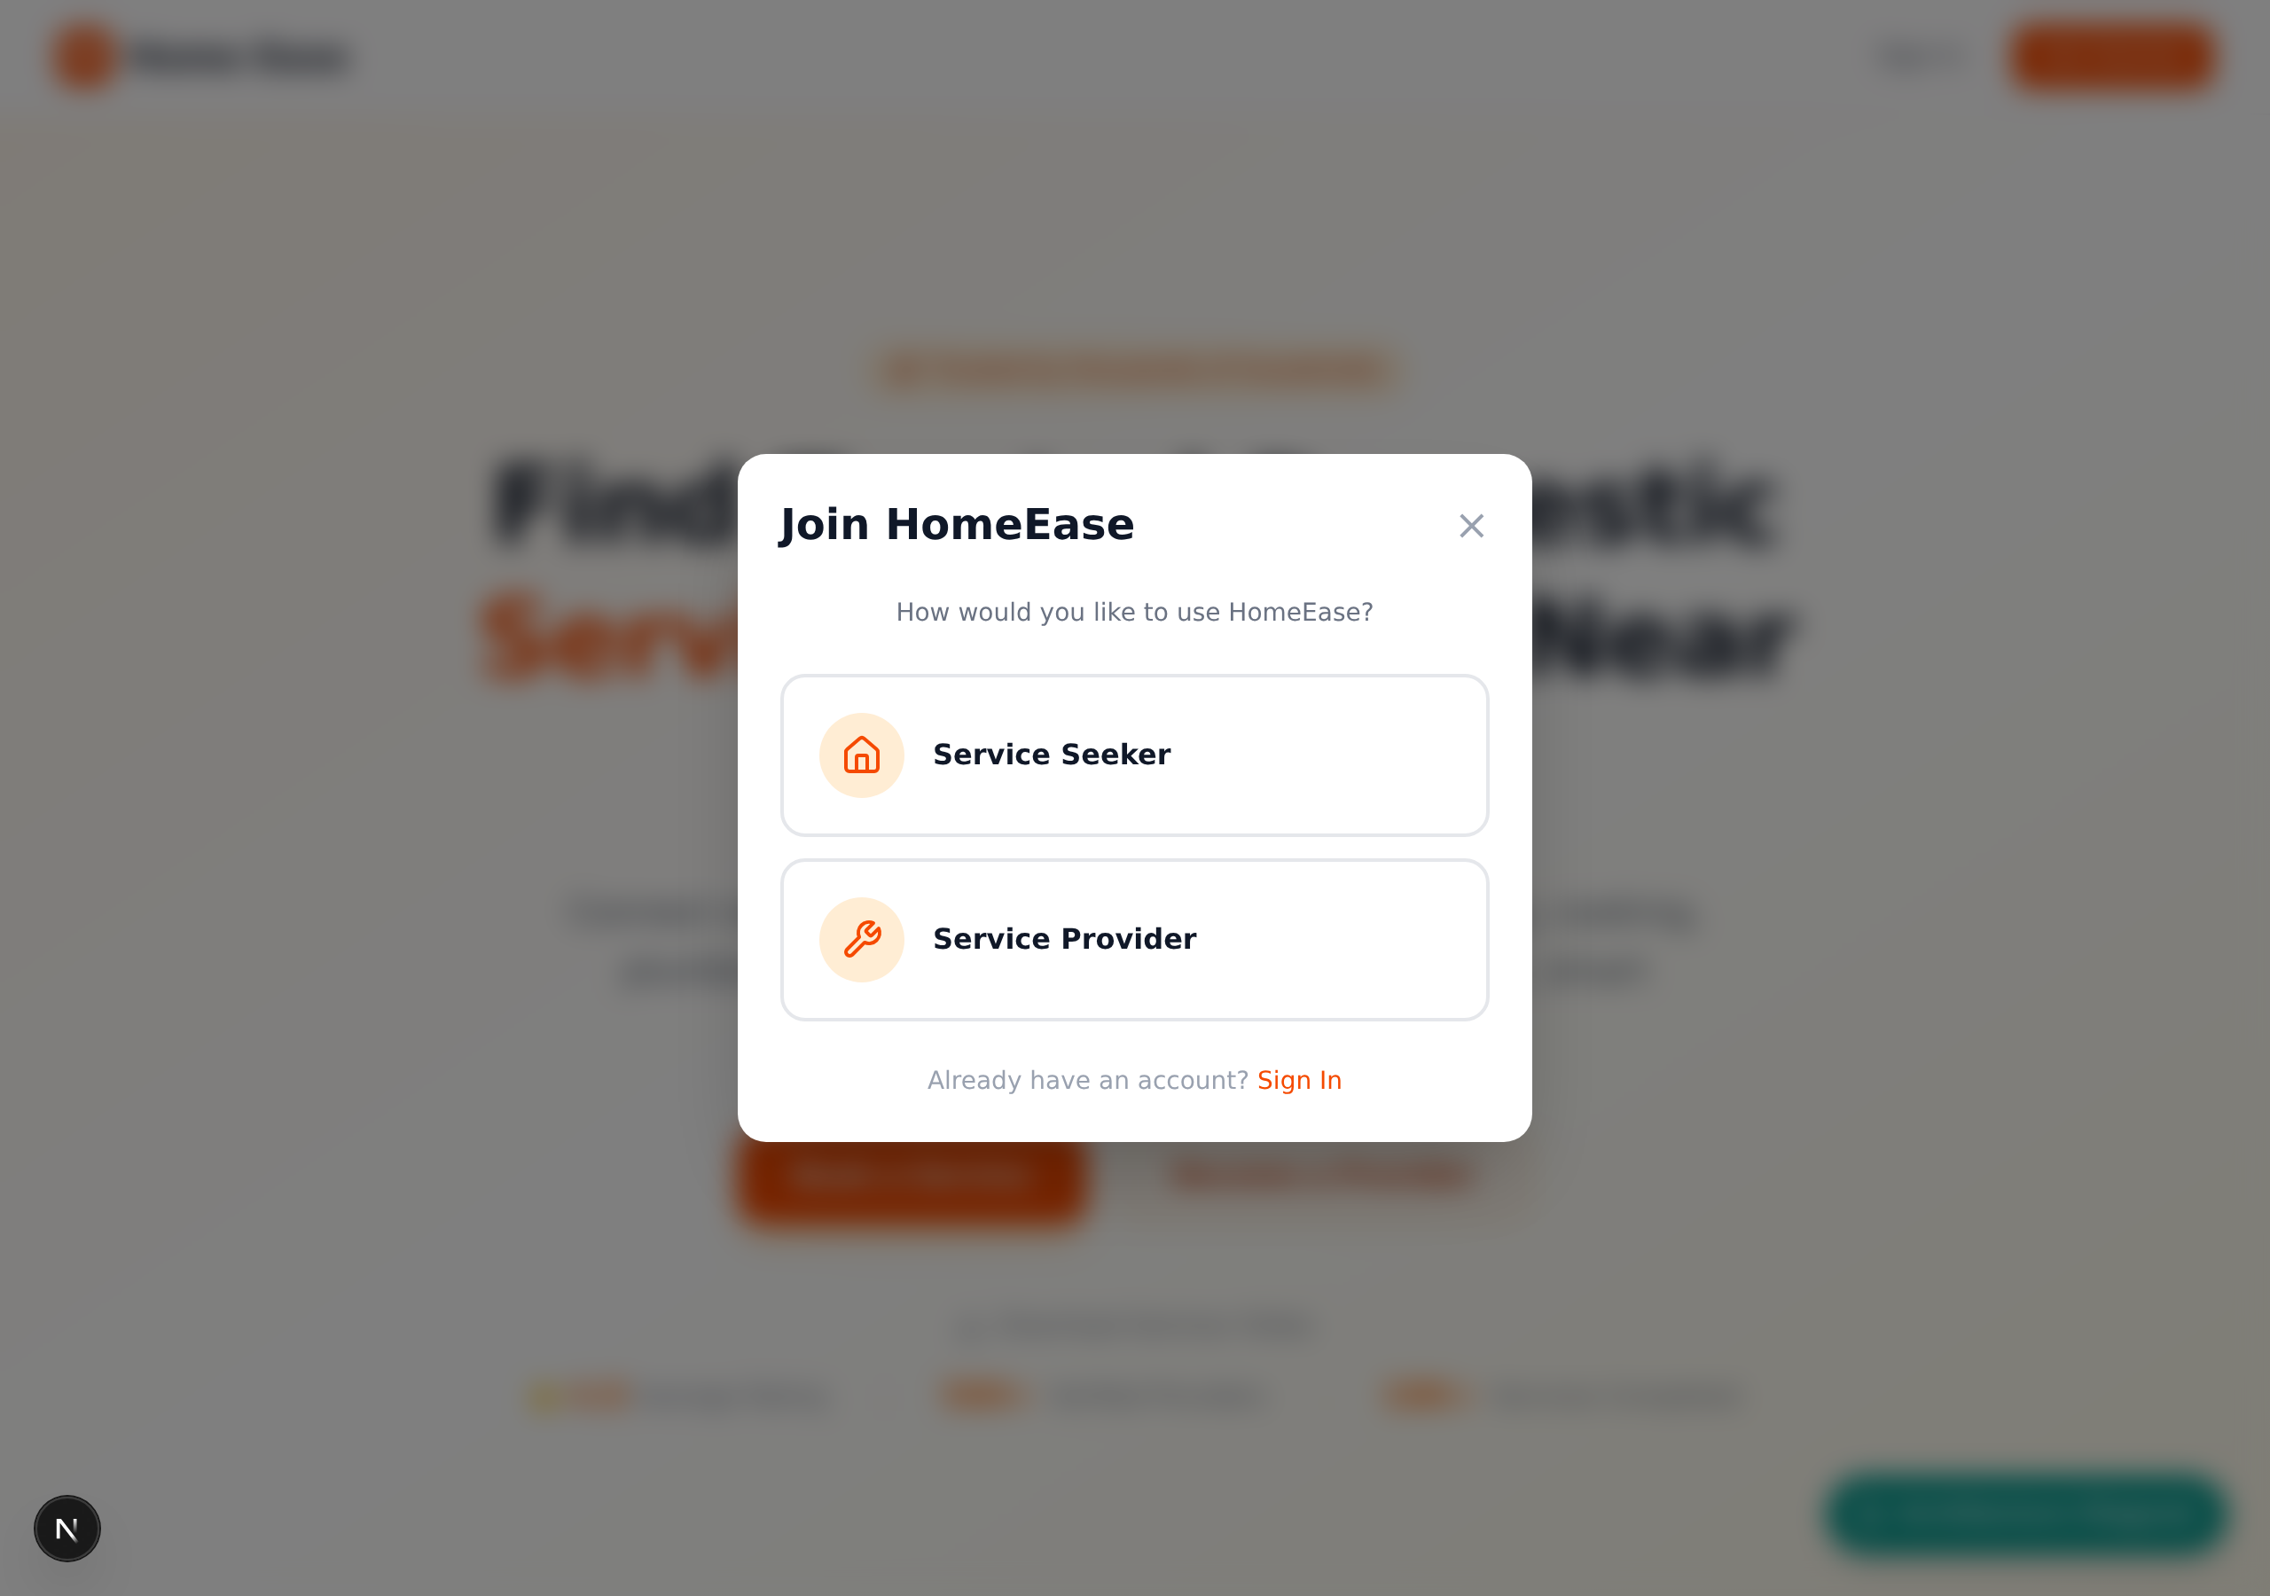
Figure 4.5: Role Selection – Service Seeker or Service Provider
Service Seeker Registration:
Step 3: After selecting **Service Seeker**, the registration form appears. Fill in the required fields: **Full Name**, **Email Address**, **Phone Number**, and **Password**.
Step 4: Click the **Sign Up** or **Create Account** button to complete registration, as shown in Figure 4.6.
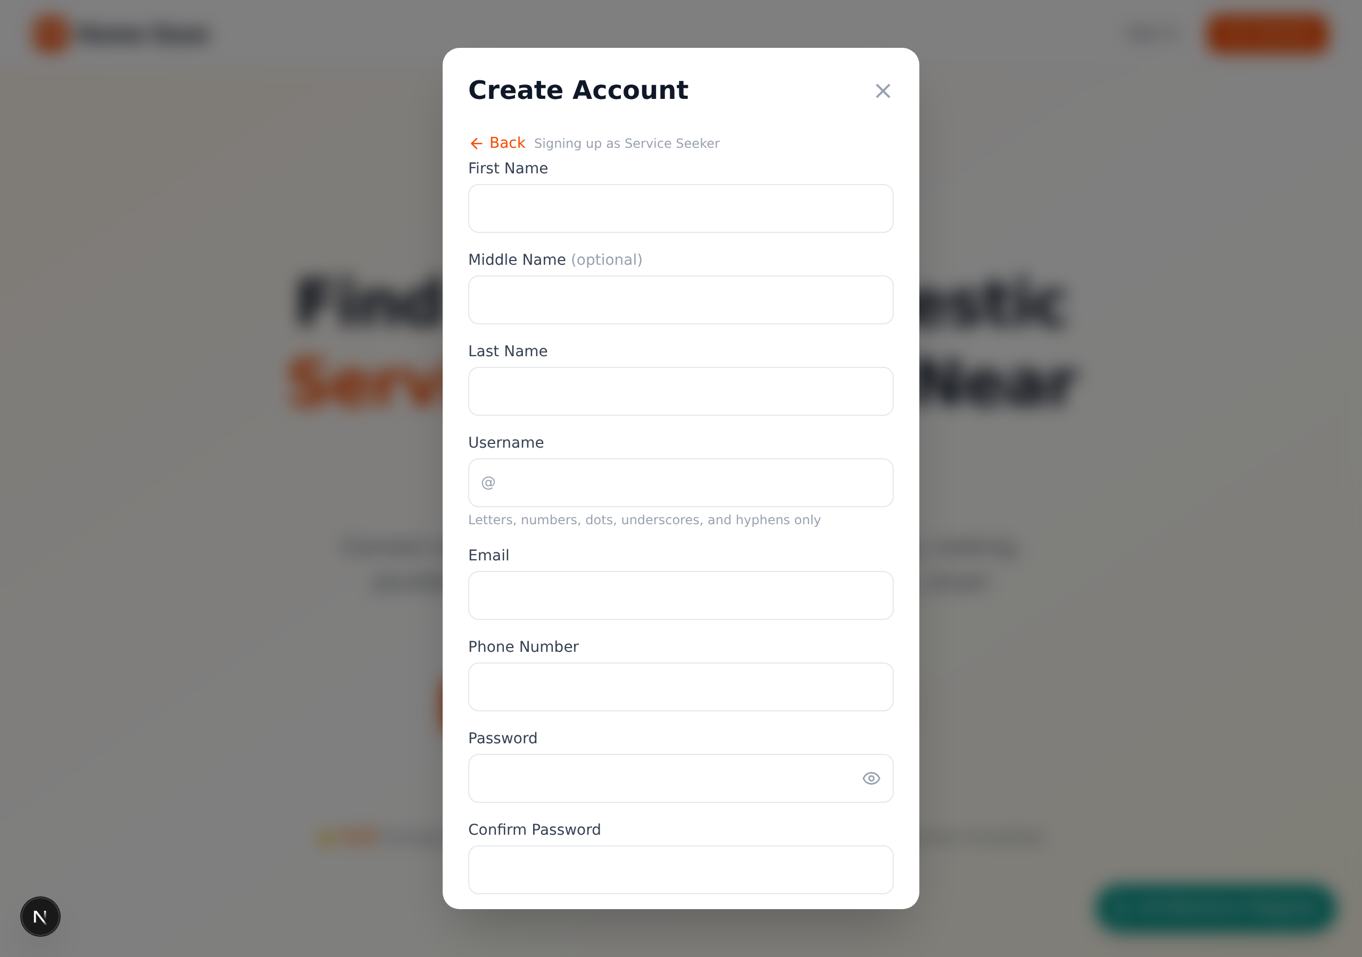
Figure 4.6: Service Seeker Registration Form
Service Provider Registration:
Step 5: After selecting **Service Provider**, a multi-section registration form is displayed. Begin by entering personal details: **Full Name**, **Email Address**, **Phone Number**, **Password**, and **Location**, as shown in Figure 4.7.
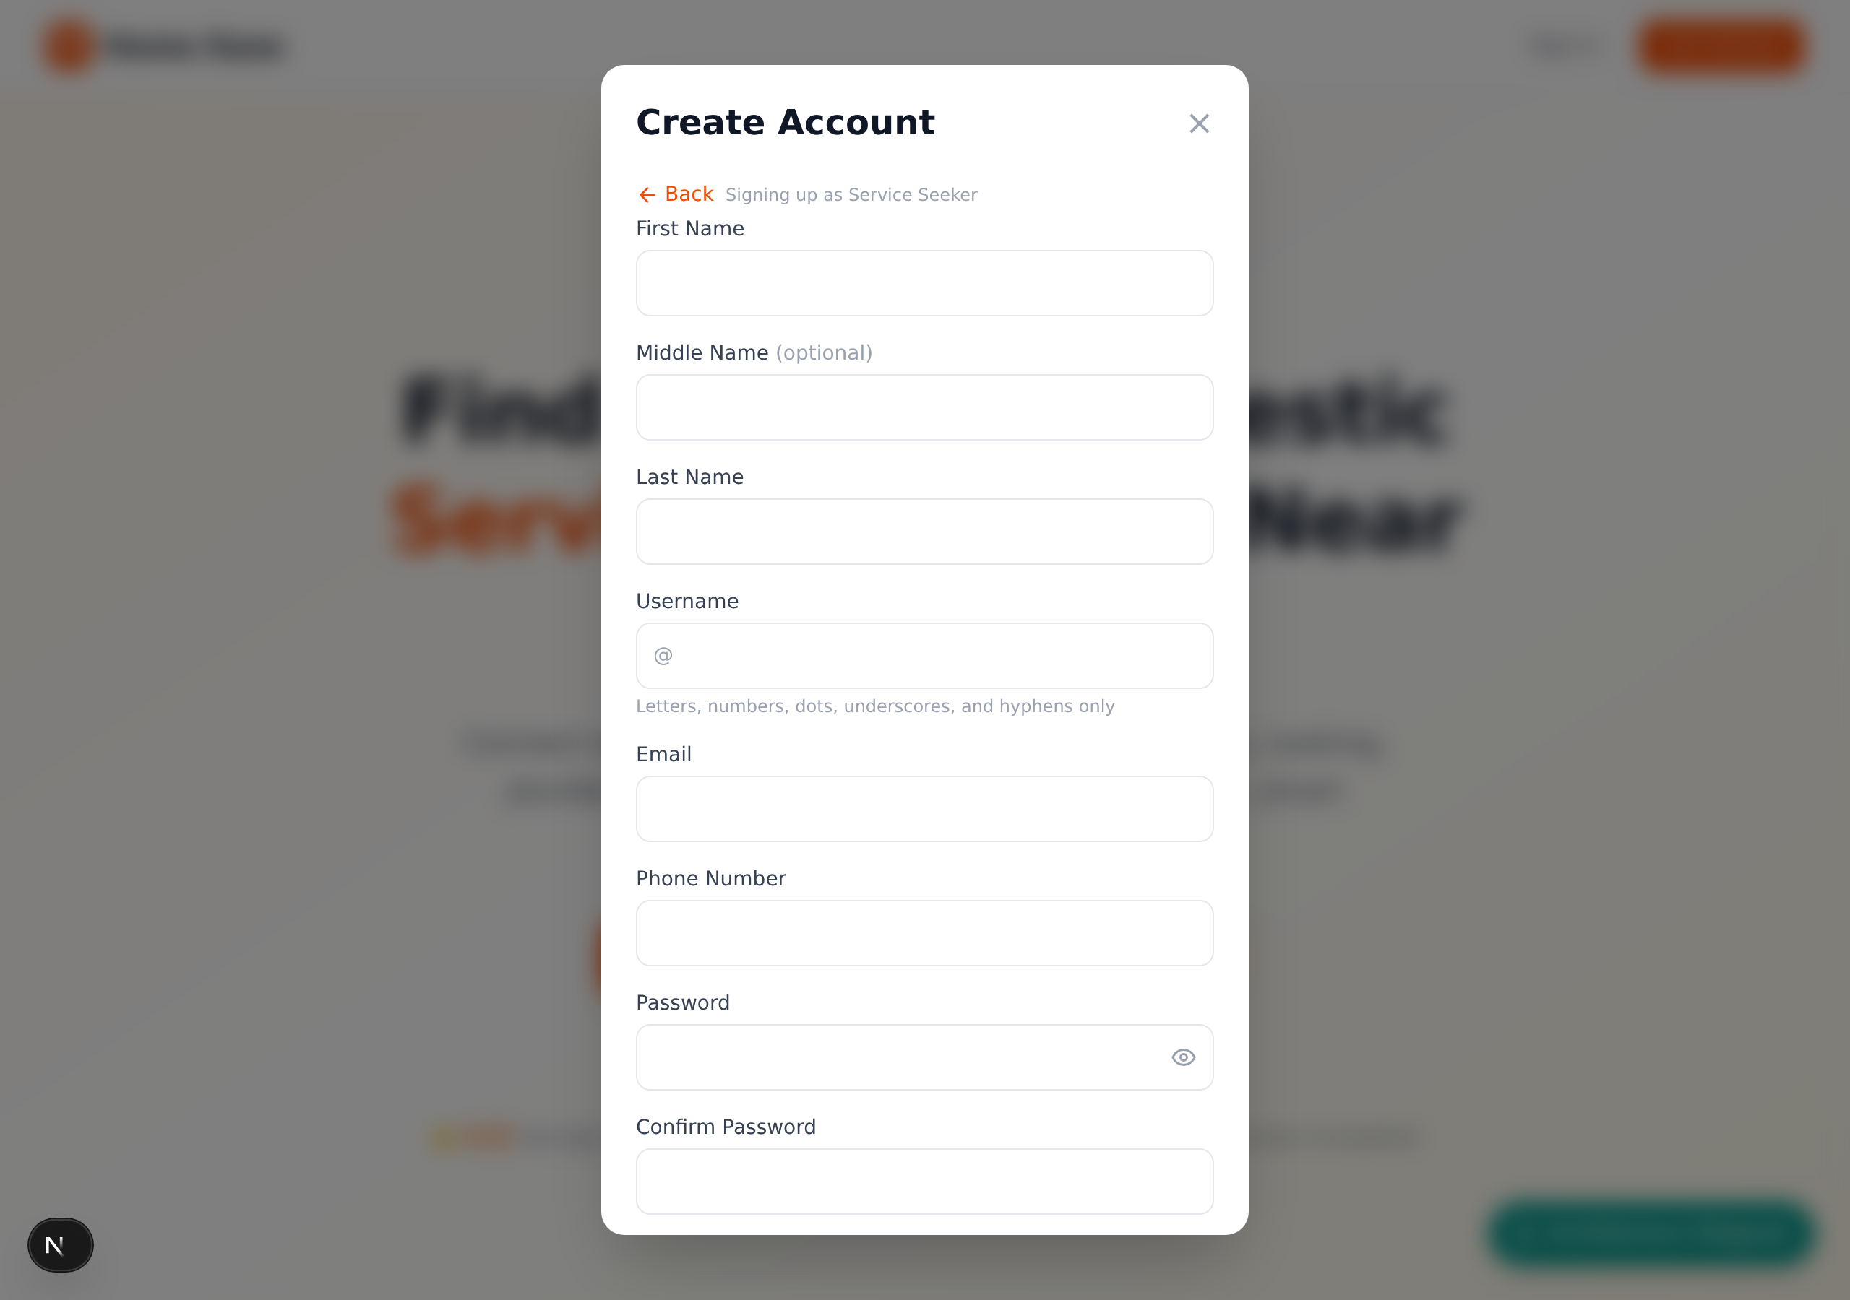
Figure 4.7: Service Provider Registration – Personal Information
Step 6: Scroll down to the **Skills and Services** section. Select the service categories you offer from the available options (e.g., Plumbing, Electrical, Cleaning, Painting). You may also add a brief description of your experience, as illustrated in Figure 4.8.
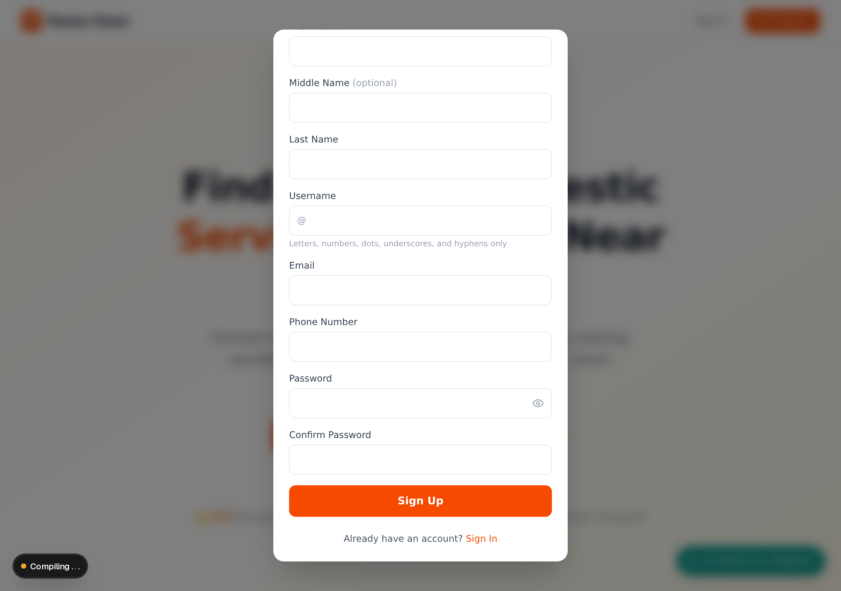
Figure 4.8: Service Provider Registration – Skills and Services
Step 7: Proceed to the **Bank Details** section. Enter your **Bank Name**, **Account Number**, and **Account Name** to enable payout processing once you start earning, as shown in Figure 4.9.
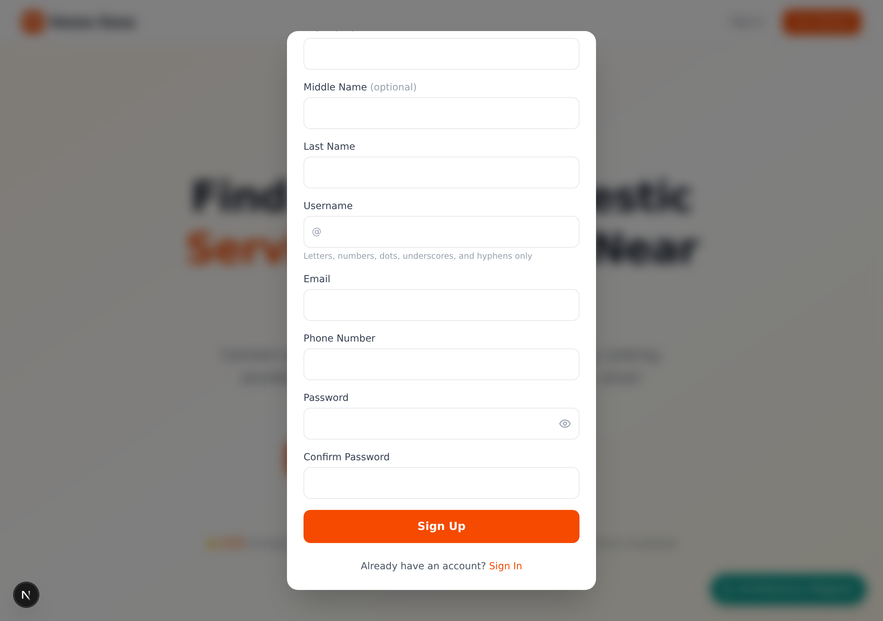
Figure 4.9: Service Provider Registration – Bank Details
Step 8: Review all entered information and click **Submit** to complete the registration. New providers are placed in a **pending verification** state until an administrator reviews and approves their profile.
4.3.1.4 Signing In
Step 1: On the landing page, click the **Login** button located in the navigation bar.
Step 2: Enter your registered **Email Address** and **Password** in the login form, as shown in Figure 4.10.

Figure 4.10: HomeEase Login Form
Step 3: Click the **Login** button. Upon successful authentication, the system redirects you to the appropriate dashboard based on your user role (Seeker, Provider, or Admin).
4.3.2 Service Seeker User Manual
This section describes the features and workflows available to users registered as Service Seekers on the HomeEase platform.
4.3.2.1 Finding and Booking a Service Provider
Step 1: After logging in as a Service Seeker, navigate to the **Find Artisans** page from the sidebar or navigation menu.
Step 2: The search page displays available service categories and a search bar. You can filter artisans by **service category**, **location**, or **rating**. The search interface is shown in Figure 4.11.
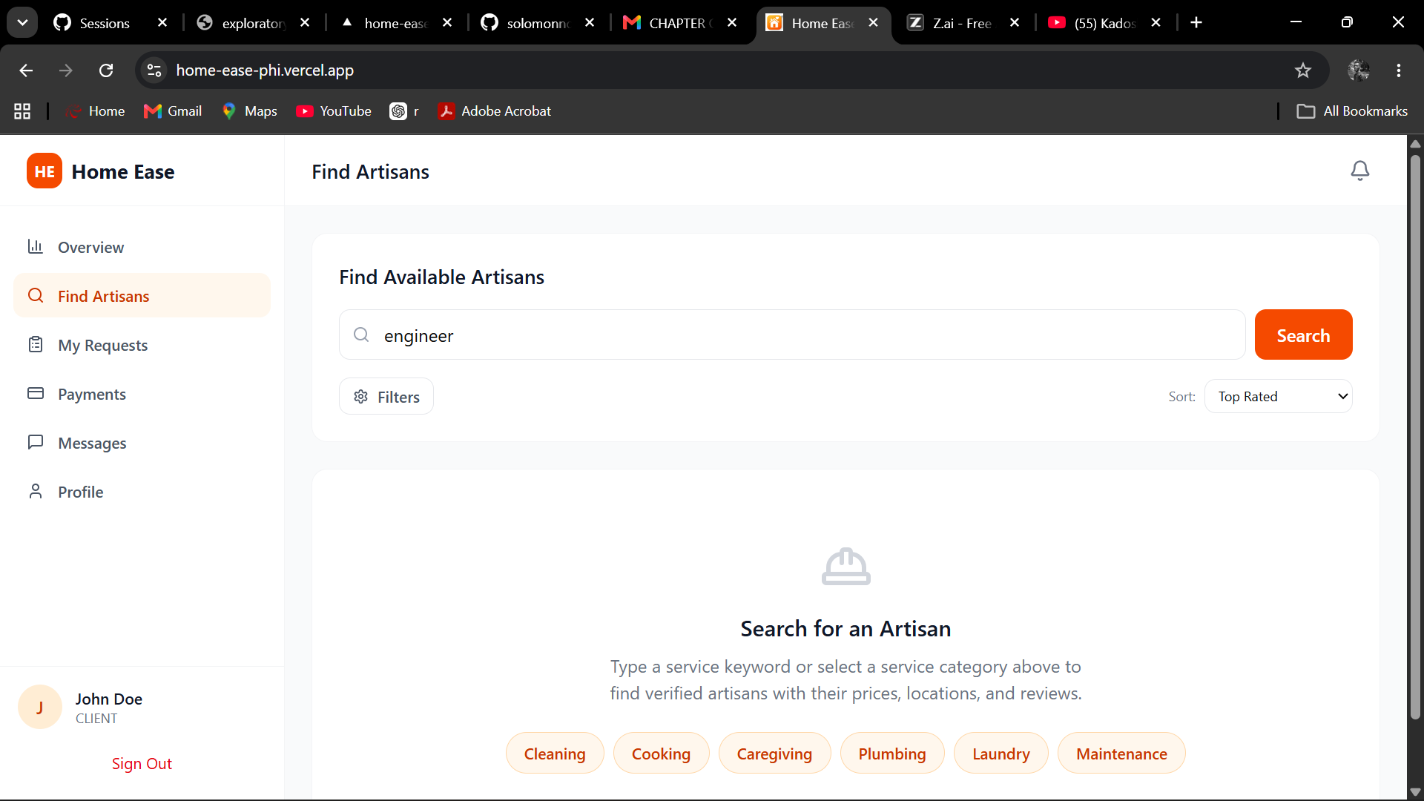
Figure 4.11: Find Artisans – Search Page
Step 3: Enter your search criteria and click **Search** or select a category to view matching service providers.
Step 4: The search results page displays a list of verified artisans matching your criteria. Each result card shows the artisan's **name**, **service category**, **rating**, **location**, and a **Book** or **Request** button, as illustrated in Figure 4.12.
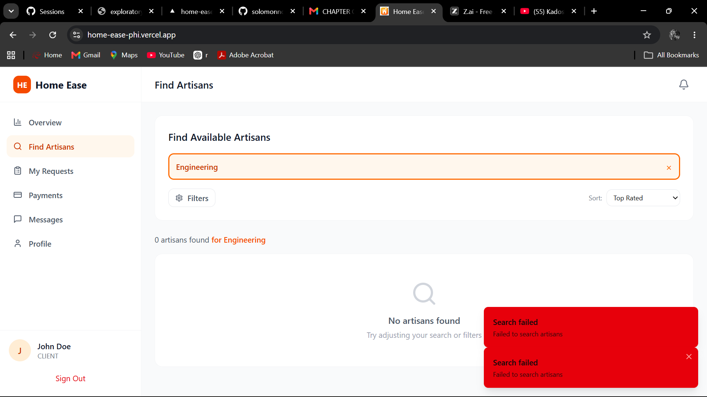
Figure 4.12: Find Artisans – Search Results
Step 5: Click the **Book** button on the desired artisan's card to initiate a service request. Fill in the required details such as **preferred date**, **time**, and a **description of the work needed**.
Step 6: Click **Submit Request** to send the booking to the service provider.
4.3.2.2 Viewing My Requests
Step 1: From the sidebar, click on **My Requests** to view all service requests you have submitted.
Step 2: The **My Requests** page displays a list of your requests along with their current status: **Pending**, **Accepted**, **In Progress**, **Completed**, or **Cancelled**. Each request card shows the **artisan name**, **service type**, **date**, and **status badge**, as shown in Figure 4.13.
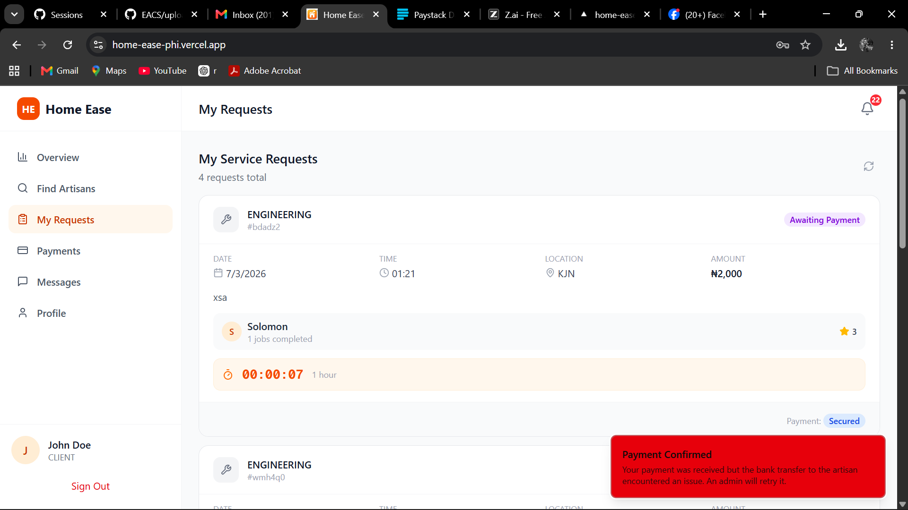
Figure 4.13: My Requests List
Step 3: Click on any request card to view the full details, including the work description and any messages exchanged with the service provider.
4.3.2.3 Making Payment
Step 1: When a service request moves to the **Completed** status, a **Make Payment** option becomes available on the request detail page.
Step 2: Click the **Make Payment** button to proceed to the payment page, as shown in Figure 4.14.
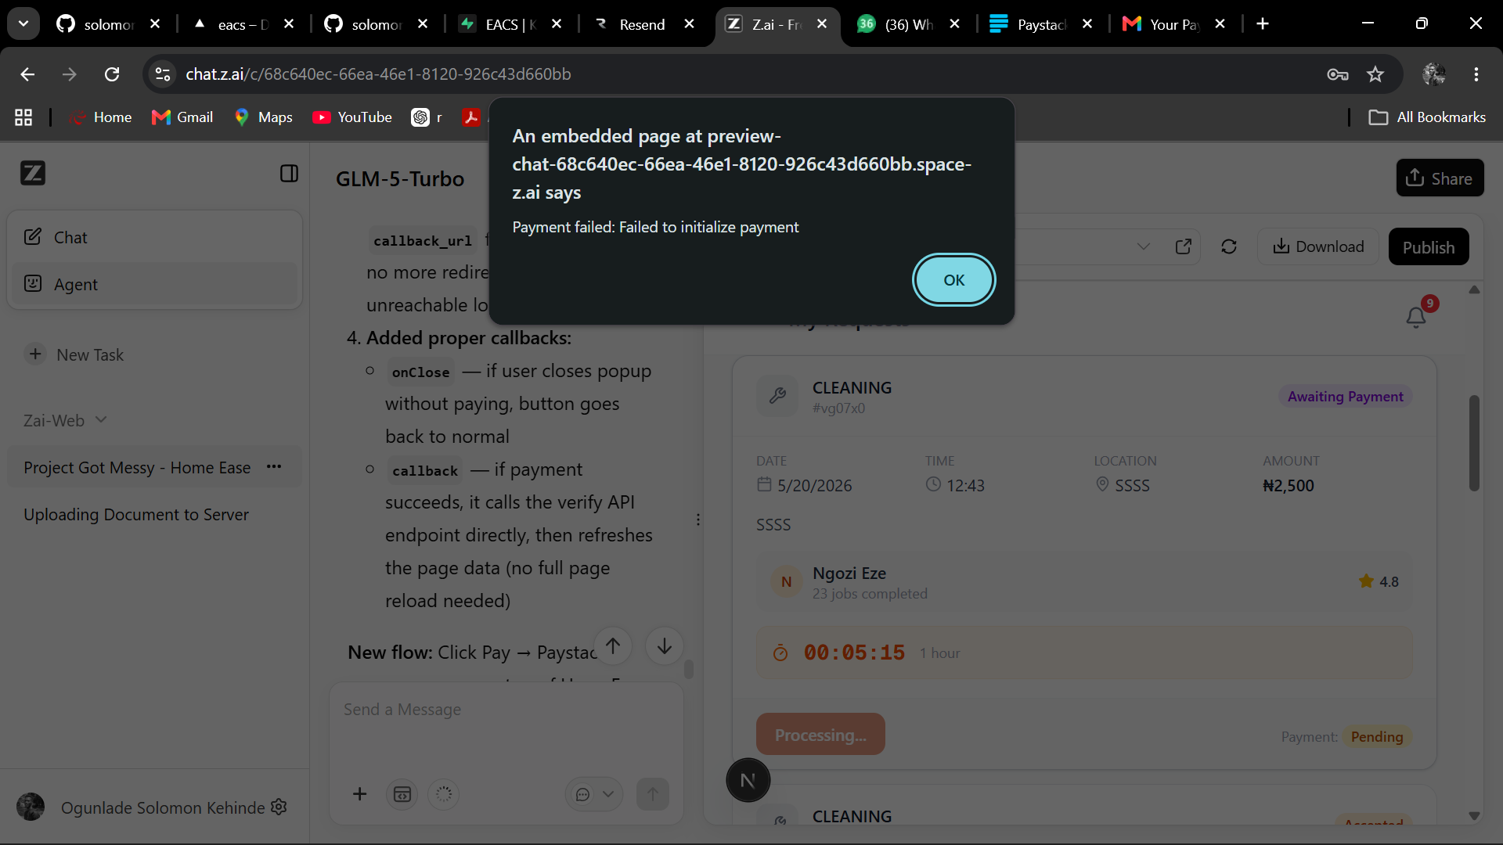
Figure 4.14: Payment Page
Step 3: On the payment page, review the **service details**, **amount**, and **payment method**. HomeEase uses the Flutterwave payment gateway for secure transactions.
Step 4: Select your preferred payment method (card, bank transfer, or mobile money) and click **Pay Now**.
Step 5: Follow the on-screen instructions to authorise the payment. Upon successful payment, a confirmation message is displayed and the request status is updated.
4.3.2.4 Rating a Service Provider
Step 1: After completing a service and making payment, navigate to **My Requests** and locate the completed service.
Step 2: Click on the completed request to open its details. A **Rate** or **Leave a Review** option will be available, as shown in Figure 4.15.
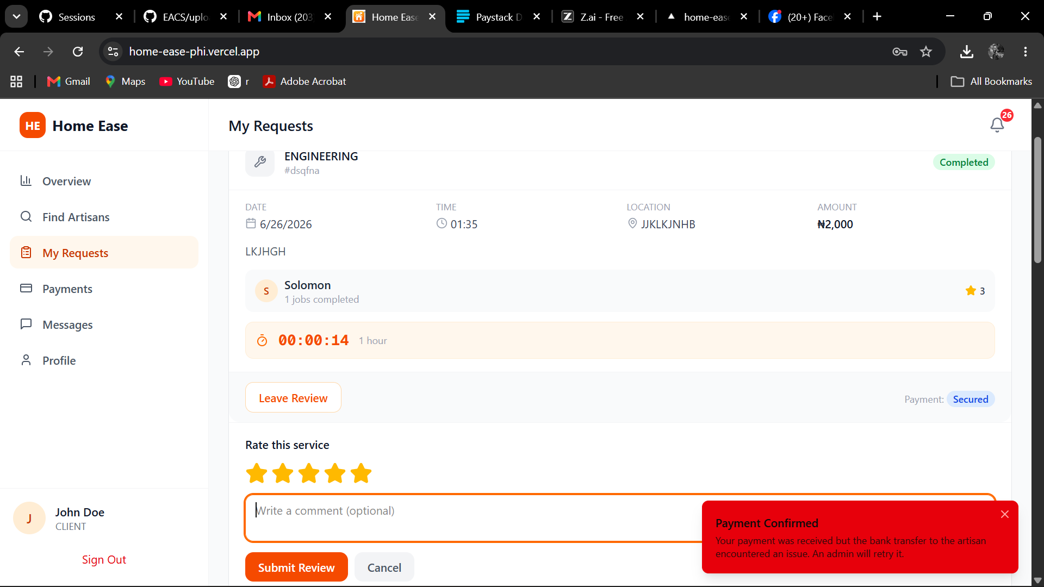
Figure 4.15: My Requests with Review and Rating
Step 3: Select a **star rating** (1 to 5 stars) based on the quality of service received.
Step 4: Optionally, write a **text review** describing your experience with the service provider.
Step 5: Click **Submit Review** to publish your rating. The review will be visible on the provider's profile and will contribute to their overall rating.
4.3.2.5 Messaging a Service Provider
Step 1: From the sidebar, click on **Messages** to open the messaging interface, as shown in Figure 4.16.
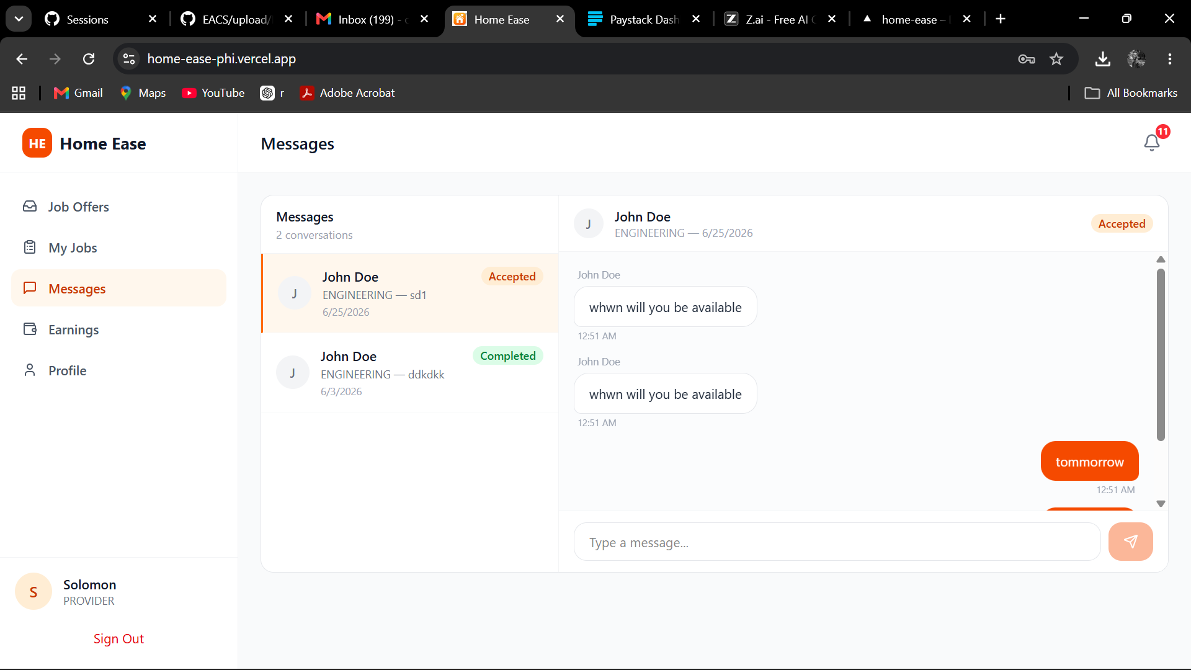
Figure 4.16: Messages / Chat Screen
Step 2: A list of your conversation threads is displayed on the left panel. Click on a thread to view the message history with a specific service provider.
Step 3: Type your message in the **message input box** at the bottom of the chat area.
Step 4: Press **Enter** or click the **Send** button to transmit your message. Messages are delivered in real time using WebSocket technology.
4.3.2.6 Managing Notifications
Step 1: Click the **Notifications** icon (bell icon) in the navigation bar to view your latest notifications.
Step 2: Notifications include updates such as **request accepted**, **request completed**, **new message received**, and **payment confirmed**.
Step 3: Click on a notification to navigate directly to the relevant page or request detail.
Step 4: Use the **Mark All as Read** option to clear unread notification badges.
4.3.2.7 Managing Profile
Step 1: From the sidebar, click on **Profile** or **Account Settings** to access your profile management page.
Step 2: You can update your **Full Name**, **Email Address**, **Phone Number**, and **Profile Picture**.
Step 3: Click **Save Changes** to update your profile information.
Step 4: To change your password, navigate to the **Change Password** section, enter your **current password** and **new password**, then click **Update Password**.
4.3.3 Service Provider User Manual
This section describes the features and workflows available to users registered as Service Providers on the HomeEase platform.
4.3.3.1 Awaiting Verification
Step 1: After completing the registration form and submitting your details, your account is placed in a **Pending Verification** state.
Step 2: Upon logging in, you will see a verification pending screen informing you that your account is awaiting administrator review, as shown in Figure 4.17.
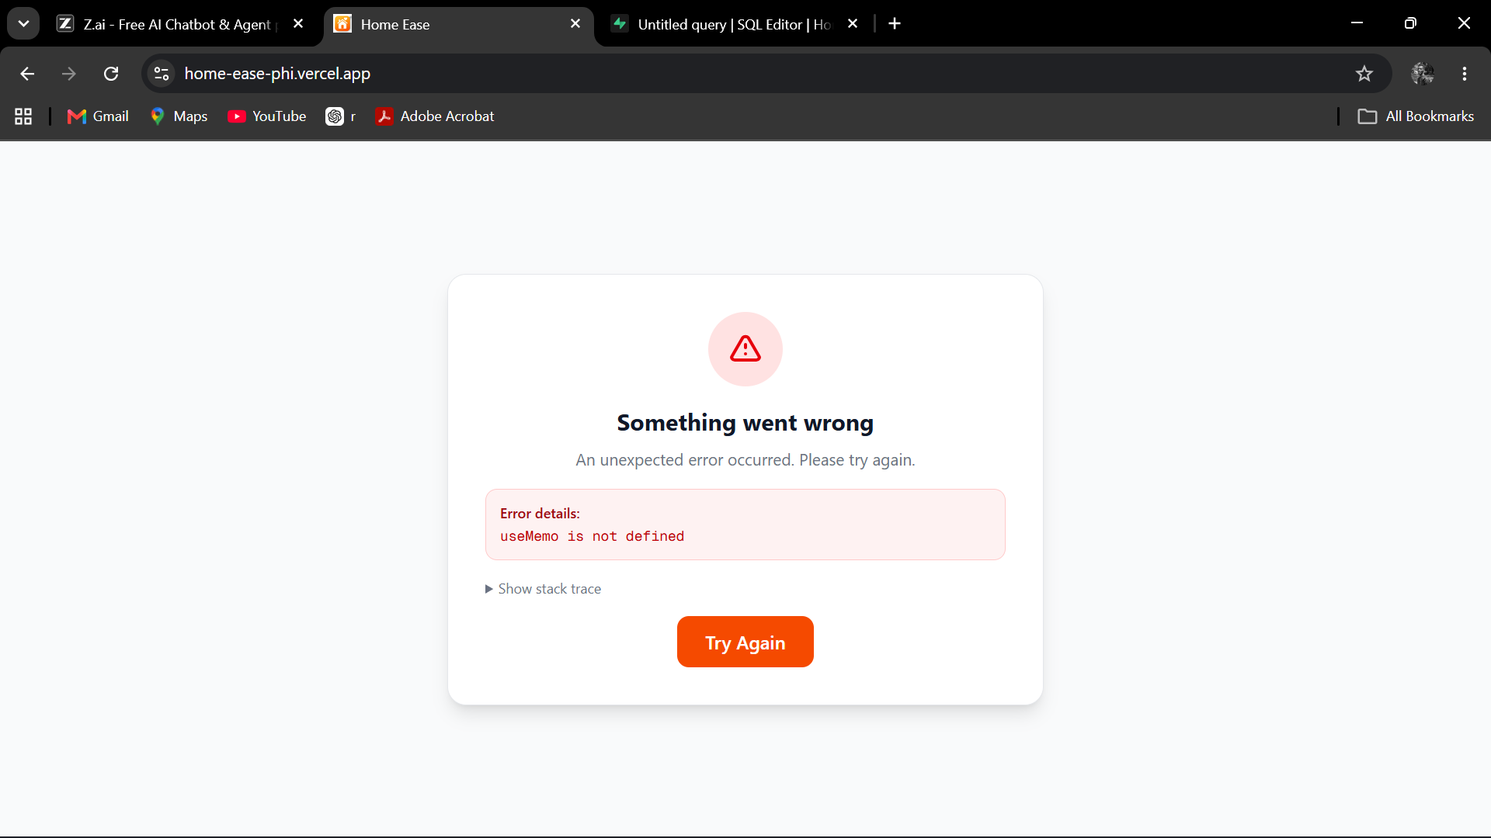
Figure 4.17: Provider Verification Pending Screen
Step 3: During this period, you cannot accept job offers or access provider-specific features.
Step 4: Once an administrator verifies your account, you will receive a notification and gain full access to the provider dashboard.
4.3.3.2 Chatting with Admin During Verification
Step 1: While your account is pending verification, a **Chat with Admin** option is available on the verification pending screen.
Step 2: Click on **Chat with Admin** to open a direct messaging thread with the platform administrator, as shown in Figure 4.18.
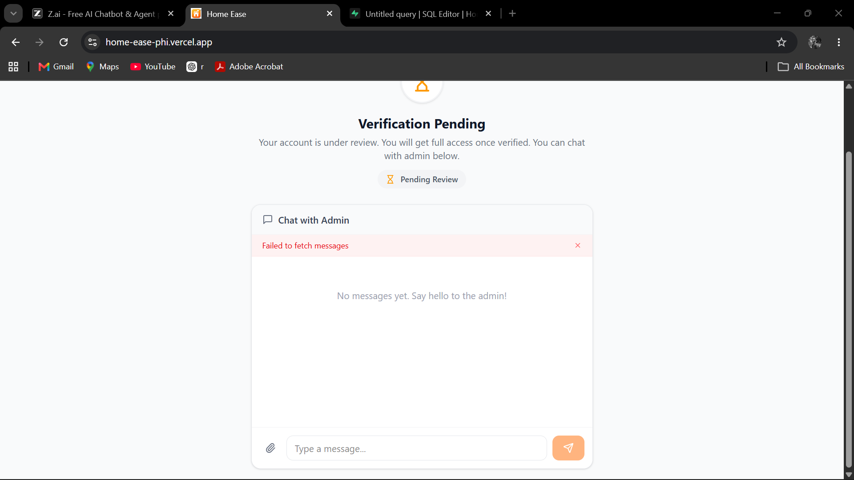
Figure 4.18: Provider Chat with Admin During Verification
Step 3: Use this channel to submit any additional documents, answer verification queries, or seek clarification about the onboarding process.
Step 4: Messages are delivered in real time, and the admin can respond directly within the same chat window.
4.3.3.3 Viewing the Provider Dashboard
Once verified, the provider dashboard becomes accessible upon login. The dashboard provides an overview of key metrics including total earnings, active jobs, completed jobs, and pending requests. The dashboard also serves as the central hub for navigating to other provider features such as **My Jobs**, **Transactions**, and **Profile** management.
4.3.3.4 Managing Job Offers
Step 1: Navigate to **My Jobs** from the sidebar to view all job offers received from service seekers.
Step 2: Each job offer displays the **seeker's name**, **service requested**, **preferred date and time**, **location**, and **job description**.
Step 3: To accept a job, click the **Accept** button on the offer card. The seeker will be notified of your acceptance.
Step 4: To decline a job, click the **Decline** button. Optionally, provide a reason for declining.
Step 5: Accepted jobs move to the **Active Jobs** section where you can manage their progress.
4.3.3.5 Checking In and Checking Out
Step 1: On the day of a scheduled job, navigate to **My Jobs** and locate the active job.
Step 2: Click the **Check In** button when you arrive at the service location. This records your start time and notifies the service seeker that you have arrived, as shown in Figure 4.19.
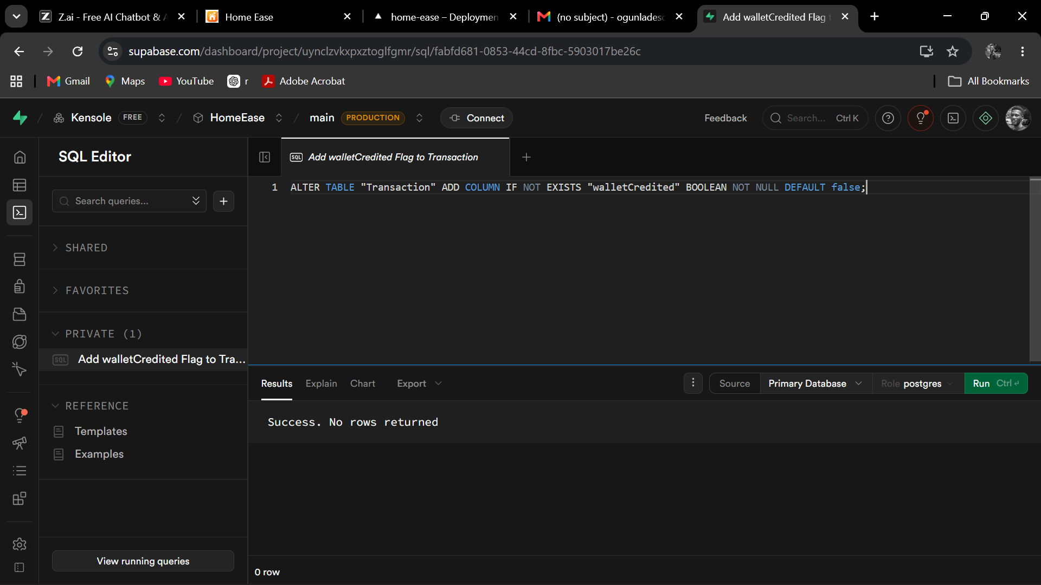
Figure 4.19: Provider My Jobs – Checking In and Out
Step 3: Upon completing the work, click the **Check Out** button to record your end time.
Step 4: The job status is automatically updated to **Completed**, and the service seeker is notified to review the service and make payment.
4.3.3.6 Viewing Transactions and Earnings
Step 1: From the sidebar, click on **Transactions** or **Earnings** to view your financial history.
Step 2: The transactions page displays a list of all payments received, including the **job description**, **amount**, **date**, and **status** (completed, pending, or processed).
Step 3: A summary of total earnings, pending payouts, and processed payouts is displayed at the top of the page.
Step 4: Click on any transaction to view additional details such as the seeker's name and the service category.
4.3.3.7 Managing Profile
Step 1: Navigate to **Profile** from the sidebar to manage your provider profile.
Step 2: Update your **personal information**, **skills and services**, **portfolio images**, and **bank details** as needed.
Step 3: Adding a professional **profile picture** and detailed **service descriptions** can help attract more service seekers.
Step 4: Click **Save Changes** to persist any updates to your profile.
4.3.4 Administrator User Manual
This section describes the administrative features available to platform administrators for managing users, verifying providers, processing payouts, and handling support requests.
4.3.4.1 Accessing the Admin Dashboard
Step 1: Navigate to the HomeEase login page and enter the administrator **Email Address** and **Password**.
Step 2: Upon successful login, the system detects the admin role and redirects to the **Admin Dashboard**.
Step 3: The admin dashboard displays an overview of key platform metrics: **total users**, **total providers**, **total service seekers**, **active jobs**, **completed transactions**, and **revenue summary**.
Step 4: The sidebar provides navigation links to all administrative sections: **Users**, **Providers**, **Payouts**, **Messages**, and **Settings**.
4.3.4.2 Verifying Service Providers
Step 1: From the admin sidebar, click on **Providers** to view the list of all registered service providers.
Step 2: Filter the list by status to show only **Pending Verification** providers.
Step 3: Click on a pending provider to review their registration details, including **personal information**, **skills**, **uploaded documents**, and **bank details**.
Step 4: If the provider meets the platform's verification criteria, click the **Verify** or **Approve** button to activate their account.
Step 5: If additional information is required, use the **Chat** feature to communicate with the provider directly.
Step 6: To reject a provider application, click **Reject** and optionally provide a reason.
4.3.4.3 Processing Payouts
Step 1: From the admin sidebar, click on **Payouts** to access the payout management screen, as shown in Figure 4.20.
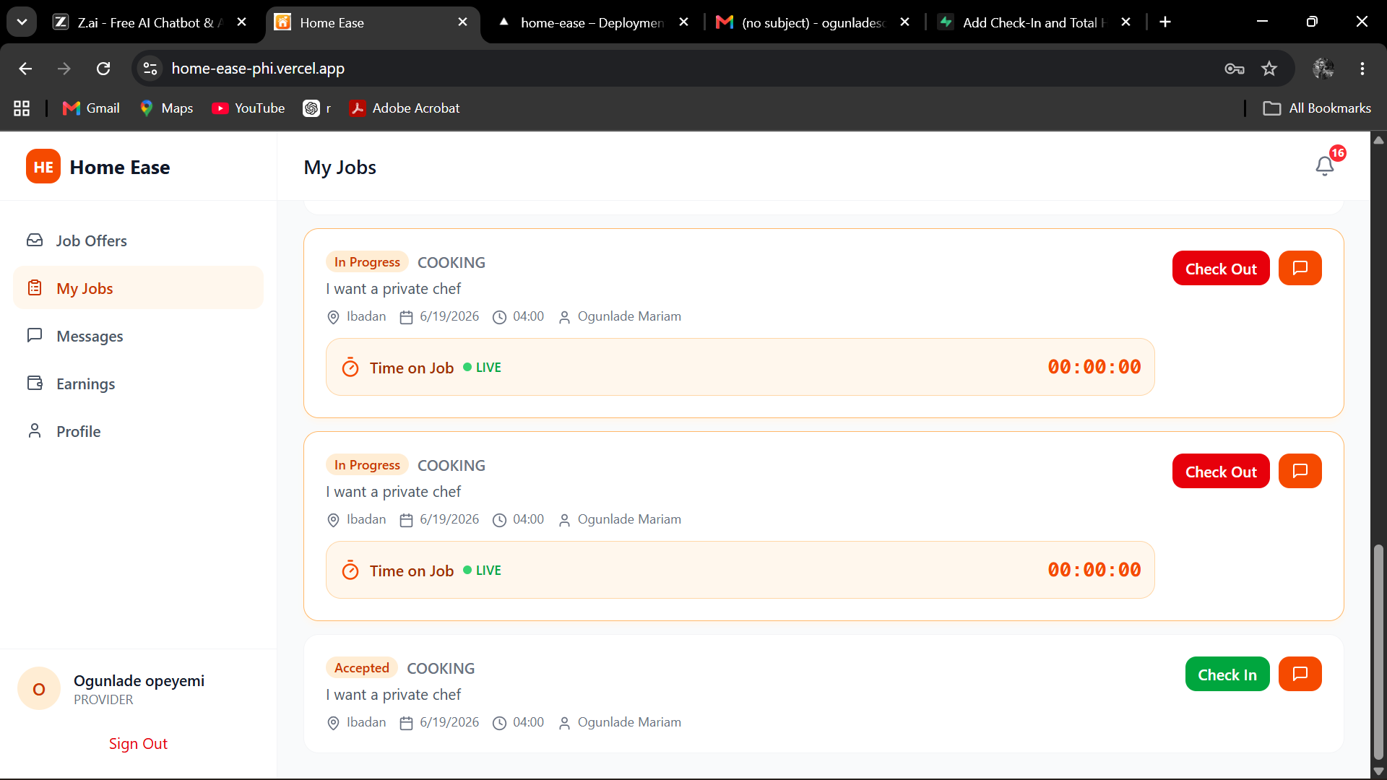
Figure 4.20: Admin Payouts Screen
Step 2: The payouts screen displays a list of all pending payout requests from service providers. Each entry shows the **provider name**, **amount**, **bank details**, **job reference**, and **request date**.
Step 3: Review each payout request to ensure the service has been completed and the amount is correct.
Step 4: Click the **Confirm** or **Process Payout** button next to a provider's entry to initiate the payout, as shown in Figure 4.21.
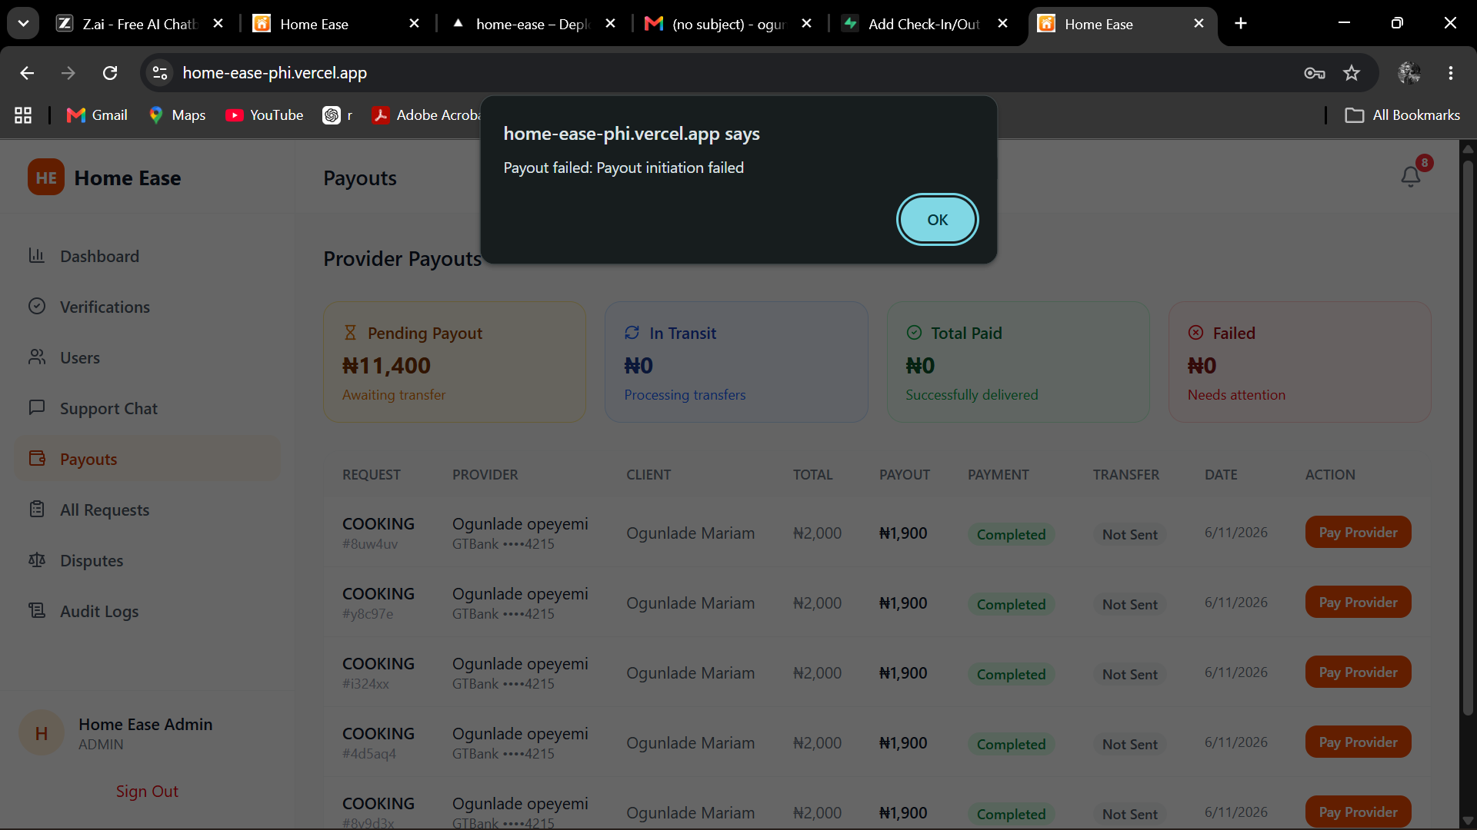
Figure 4.21: Admin Payouts Confirmation
Step 5: A confirmation dialog appears. Verify the details once more and click **Confirm Payout** to finalise the transaction.
Step 6: The provider will receive a notification that their payout has been processed, and the payout status will be updated to **Completed**.
4.3.4.4 Managing Users and Viewing Statistics
Step 1: Click on **Users** in the admin sidebar to view a comprehensive list of all registered users on the platform.
Step 2: Use the search and filter options to find specific users by **name**, **email**, **role**, or **registration date**.
Step 3: Click on a user to view their full profile, activity history, and transaction records.
Step 4: The **Statistics** section of the dashboard provides visual charts and graphs showing platform growth, service demand trends, and revenue analytics.
Step 5: Administrators can **suspend** or **deactivate** user accounts if violations of platform policies are detected.
4.3.4.5 Handling Support Messages
Step 1: From the admin sidebar, click on **Messages** or **Support** to view all incoming support messages.
Step 2: Messages are organised by user and displayed in a chat-like interface, similar to the messaging feature available to seekers and providers.
Step 3: Click on a conversation thread to read the message history and respond to the user.
Step 4: Type your response in the message input box and press **Enter** or click **Send** to deliver the message.
Step 5: Common support queries include account verification status, payment issues, and platform usage guidance.

4.4 System Architecture
The HomeEase platform follows a client-server architecture built on modern web technologies. The frontend is developed using React.js with Tailwind CSS for responsive and visually appealing user interfaces. The backend is powered by Node.js with the Express.js framework, providing RESTful API endpoints for all platform operations. Data persistence is handled by MongoDB, a NoSQL database that offers flexibility and scalability for the platform's data model. Real-time communication between clients and the server is implemented using Socket.IO, enabling instant messaging and live notifications. The Flutterwave payment gateway is integrated for secure and reliable payment processing. Cloud-based image storage is managed through Cloudinary. Figure 4.22 illustrates the complete system architecture diagram.
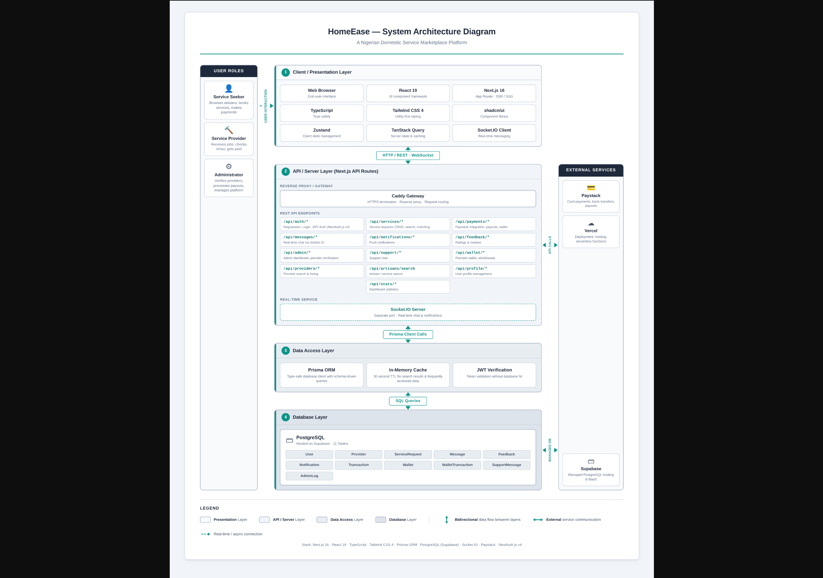
Figure 4.22: HomeEase System Architecture Diagram

4.5 Sample System Run
This section presents a complete end-to-end walkthrough of a typical service booking scenario on the HomeEase platform. The narrative follows a service seeker named Ada as she searches for, books, and pays for a plumbing service from a verified provider named Emeka.
Step 1: Ada opens her web browser and navigates to the HomeEase platform URL. The landing page loads, displaying the hero section, services grid, and feature highlights.
Step 2: Ada scrolls through the landing page to review the services offered. She sees categories such as Plumbing, Electrical, Cleaning, Painting, and more (Figure 4.2).
Step 3: H
Step 4: A
Step 5: A
Step 6: F
Step 7: A
Step 8: T
Step 9: I
Step 10: A
Step 11: A
Step 12: E
Step 13: A
Step 14: O
Step 15: E
Step 16: A
Step 17: A
Step 18: A
Step 19: A
Step 20: T
Step 21: O
Step 22: T

4.6 Summary
This chapter has provided a thorough walkthrough of the HomeEase platform's system implementation and user guide. The implementation environment, including hardware and software requirements, was documented to ensure reproducibility. Detailed step-by-step instructions were provided for all three user roles — Service Seekers, Service Providers, and Administrators — covering every major feature from registration and login to service booking, payment processing, ratings and reviews, real-time messaging, provider verification, and payout management. Twenty-two annotated screenshots were included throughout the chapter to illustrate the system's interfaces and workflows. The system architecture was presented, describing the technologies and design patterns that underpin the platform. Finally, a 22-step sample system run demonstrated a complete end-to-end service booking scenario, validating the system's functionality and usability. The HomeEase platform, as demonstrated in this chapter, provides a robust, user-friendly, and comprehensive solution for connecting service seekers with verified service providers in Nigeria.

