Algonquin College Logo

# SCHOOL OF ADVANCED TECHNOLOGY

### ICT - Applications & Programming

### Computer Engineering Technology – Computing Science



A11

Game Interface

Team:

Andrew Lorimer - Id:041056170

Game Proposal - Battleship

|  |  |
| --- | --- |
| **Part**  **1** | **GUI Definition** |

**EXPLANATION**

*The purpose of this assignment is to define the elements of the GUI application to be used in your game implementation.*

* ***Example (Prof. suggestion)****:*

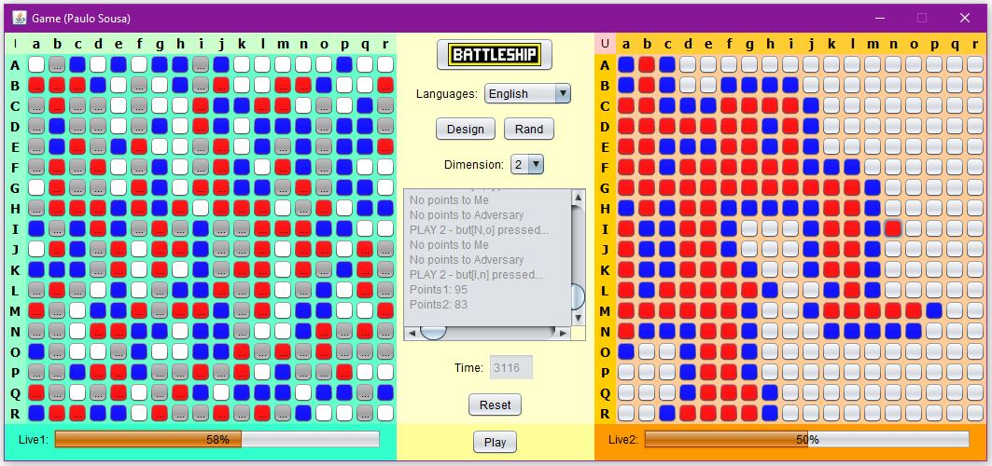

* ***Note****: The professor interface is also a proposal. It means that your own implementation can be different. What does matter is that the game functionality will be respected.*
  1. **Defining the Functionalities**

**Main Behavior**

*Include the list of functionalities that you imagine to have in the game (they can be from Swing or JavaFX).*

Allow users to create a game with a computer, selecting the game dimensions before starting game. User can randomly place their ships or manually orient their ships on the board before the game begins. After all boats are placed on the grid, players take turns attacking each other by selecting a square on the grid. Audio will play indicating a hit or miss in addition to the square being colored to indicate a hit or miss. The game ends when all boats for either the player or adversary are eliminated. After this the user has an option to reset or redraw the game.

**Functionalities and Behaviors**

*Check, for example, on-line examples (*[*https://www.battleshiponline.org/*](https://www.battleshiponline.org/)*):*

My version of the battleship games aims to make the GUI as simple as possible for users so that anyone could use it without a tutorial. The elements present are:

1. Two boards containing the current players board on the left and the adversary with a hidden (blank) board on the right.
2. A language selector for either French or English
3. A Game/History log displaying all plays including hits, misses and ships sunk
4. The option to randomly create a board or manually place ships at the game start, allow user to change orientation of ships.
5. Option to change dimensions of board.
6. A reset button to restart the game.
7. Play button to start the game.
8. Life indicator, showing the percentage of life left, in addition to a battleship display showing which ships are sunk and which are alive.

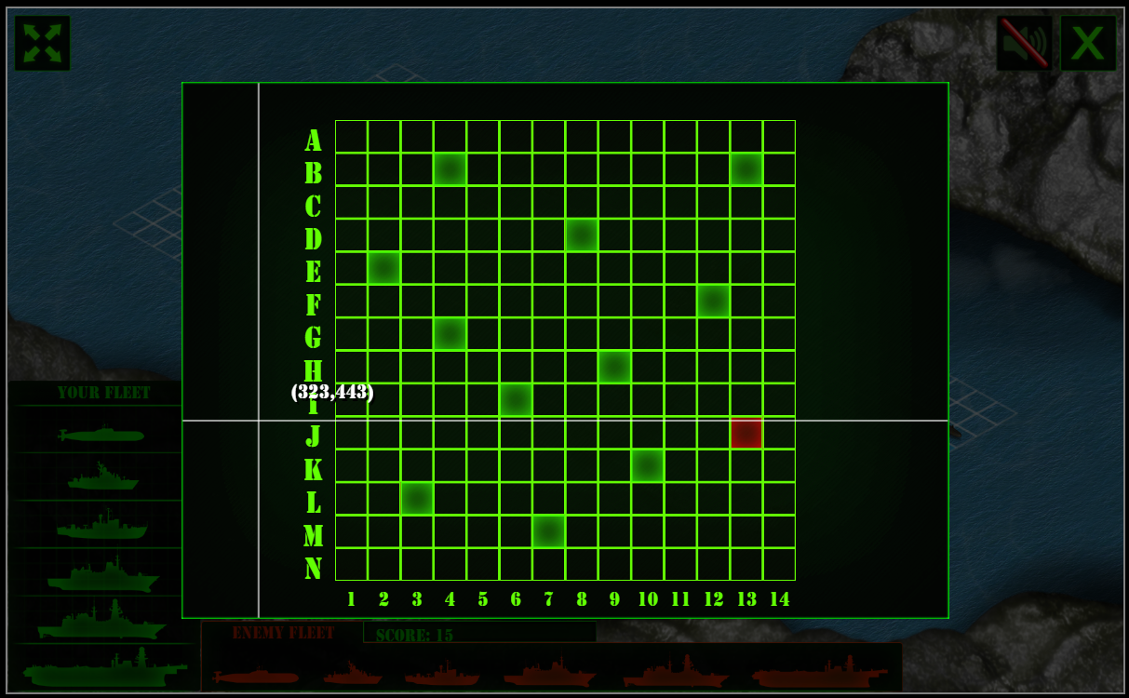

*What are the behaviors and functionalities that you will provide? How these elements are related with functionalities.*

***Example****: Answer these questions:*

* *Who are the actors (who can design / play the game)?*

The actors in this game is one player and one computer, taking turns making attacks on each other’s side of the board.

* *What are the preconditions (requirements) for some functionalities?*

Preconditions include, board dimensions are set and determines how many ships either player will have to place on each side before game is started, game is started with either a random dimension set or one selected by the user. All ships will need to be placed before starting the game.

* *And the post-conditions / results?*

Users can select squares to attack on the adversary board. Each attack can either be a hit or a miss. Game must end with one winner and allow the user to reset the game.

**Languages**

The game will come in English and French versions. I have selected these languages because I know them best and would appeal to Canadians who wish to play the game as these are the nations two official languages.

**Details**

*Drawn the UC (Use-Case) diagram (ex: in an image from Paint / Visio / Powerpoint slide, or any sketch tool), describing:*

* *Manual / automatic features (ex: user selections / time features);*
* *Relationships between actors / functionalities.*
  1. **Template Solution**

**UC Diagram**

**Actors table**

|  |  |
| --- | --- |
| **Actors** |  |
| Player | This actor represents a user selecting where they can place their ships and where they select to attack on the board resulting in either a hit or a miss |
| Computer Player | This actor a computer player which randomly selects squares on the users side of the board, resulting in either a hit or a miss. Computer players always have their ships randomly placed on the board. |

**UC table** (example):

|  |  |
| --- | --- |
| **Use Cases** |  |
| Fire shot and hit | This use case describes how the player or computer can hit a ship on a given square, changing the color of the square indicating a hit |
| Fire shot and miss | This use case describes how the player or computer can miss a ship on a given square, changing the color of the square indicating the miss |
| Place ship on board | This use case describes how the player can manually place and orient the ships on their side of the board |
| Randomly place ship on board | This use case describes how the player, or the computer can randomly place their ships on the board |
| Change Language | This use case describes how the player can change the language of the game to either French or English |
| Reset Game | This use case describes how the player can reset the game and clear the current board/score. |

**Basic cycle**

*Create a brief description about how your game can be used.*

***Example****: If you have to design the solution to be saved and played later, how are the stems. Most importantly, how someone can play the* ***Battleship****.*

Battleship will be played by first selecting the dimension of the board. The user has the option to randomly

**FINAL SUGGESTIONS**

*Here some ideas to think about your language....*

* *Try to create a game whose execution can be very intuitive (easy to be played).*
* *Remember that this game will be in fact implemented only in the next assignment.*

**References**

*[Include eventual references used here]*

* ***NOTE****: Even if you use one specific tool (ex: ChatGPT), report it here.*

Algonquin College

Summer, 2023