Algonquin College Logo

# SCHOOL OF ADVANCED TECHNOLOGY

### ICT - Applications & Programming

### Computer Engineering Technology – Computing Science



A21

Game MVC (Class Diagram)

Team:

Andrew Lorimer - Id:041056170 Solomon Thangthong – id: 041023691

Battleship Proposal

***This template is suggested (not mandatory) to answer A21 Specification.***

|  |  |
| --- | --- |
| **Part**  **1** | **GUI Definition** |

*This template is very similar to your A11, but going deeper with the components and methods descriptin and dividing them into the MVC components.*

* 1. **Classes specification**

*Describe the way you can define the MVC components in your game.*

* + - *Describe all classes that you imagine to use in your game.*

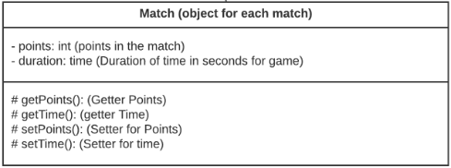GameBasic serves as the entry point for the application.Player class will be an object for each actor of the game, and each player will hold their boat object, and matches. The buttonState class will be the state of each button on the matrix, and will be called to update to 0, hit, miss, boat size, etc. The GameModel is where all the logic and data is held, GameController is where all the action listeners will call GameModel to execute the logic, and the GameView will update any component that is seen by the user.

* 1. **Class diagram**

*Describe all classes relationships that you need to define to your game.*

* + - **Example**: Basic relationship between ships and match (Design mode).
    - **Example**: Basic relationship between MVC components
    - . 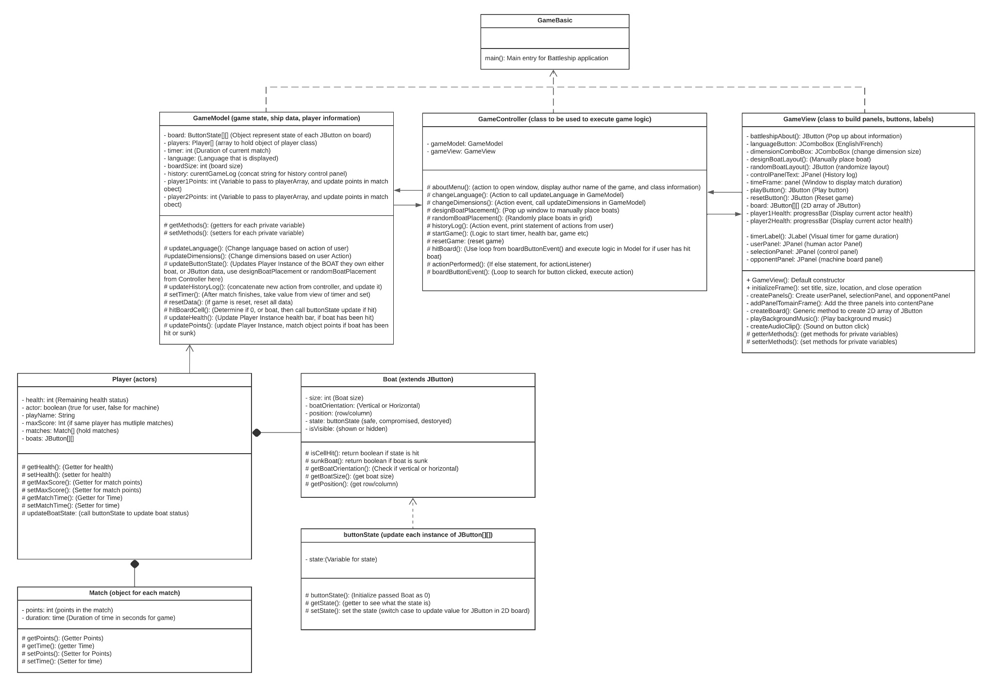
    - In the Model, detail the **entities / data** used to represent the game.
      * For instance, consider important fields such as solution, points, timer, etc.
    - In the View, emphasize all the **visual elements** that you have and needs to include.
      * For instance, what are your containers (panels / frames), and components (ex: buttons, labels, etc.).
    - In the Controller, what are the **methods / behaviors** that must happen?
      * Remember that your controller should unify all actions treated by listeners by calling proper methods[1].

**References**

*Lucid visual collaboration suite*. Lucid visual collaboration suite (n.d.) https://lucid.app/

Algonquin College

Spring, 2023

1. Remember that isolation of methods and encapsulation of entities are basic OO principles. Additionally, it is a good practice to isolate behaviors in proper functions that can be called by different actions (ex: button clicks / menu items, etc.).