Algonquin College Logo

# SCHOOL OF ADVANCED TECHNOLOGY

### ICT - Applications & Programming

### Computer Engineering Technology – Computing Science



A31

Game C/S Model – Collaboration Diagram

Team:

Andrew Lorimer - Id:041056170 Solomon Thangthong – id: 041023691

**Picross Proposal**

|  |  |
| --- | --- |
| **Part**  **1** | **C/S Architecture** |

* 1. **Server Model (UML Collaboration Diagram)**
  2. **Client Model (UML Collaboration Diagram)**

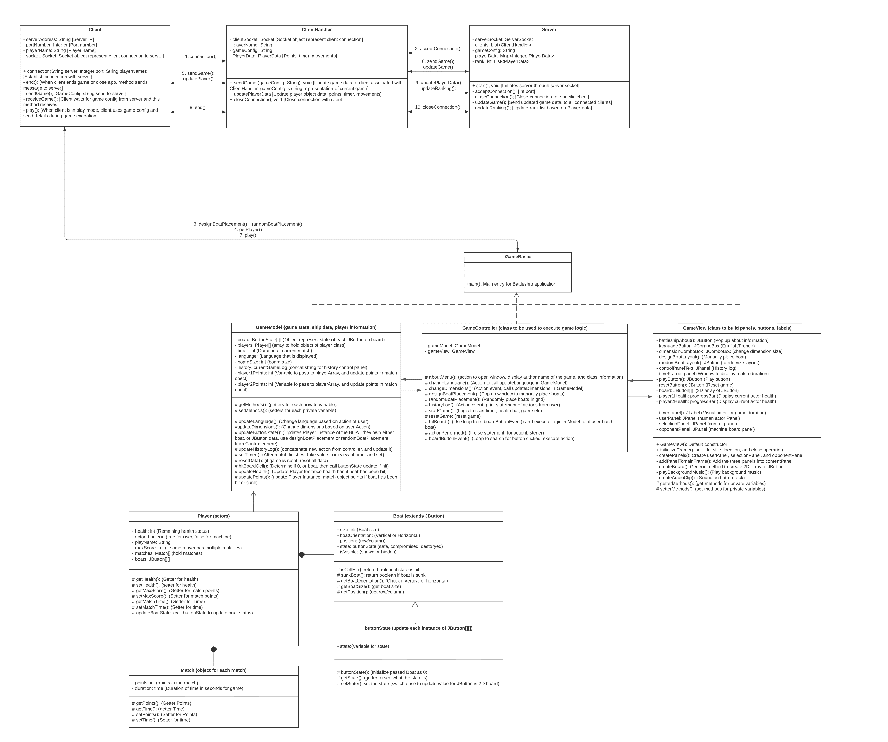

1. **Protocol Proposal**

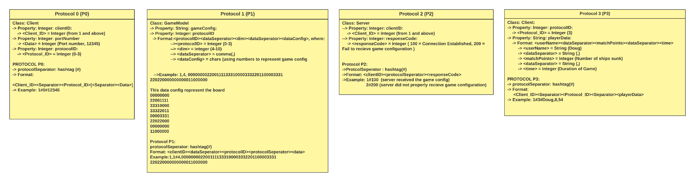

**References**

Lucid visual collaboration suite: Log in. (n.d.). https://lucid.app/

Algonquin College

Summer, 2023