COMPSYS 704 Individual Project - Milestone 1 Proposal
  - Symbolic Visualisation of the Automated Bottling System
Conceptual Design and Preliminary Implementation Framework

1. Introduction and Motivation
The COMPSYS 704 Automated Bottling System (ABS) is a distributed reactive production-line simulation in which bottle loading, transport, rotary positioning, filling, lid placement, capping and unloading may progress concurrently. This concurrency is useful for modelling a realistic automated system, but it also makes the overall plant state difficult to understand from terminal output alone. Messages generated by different Clock Domains can interleave, and a developer may need to inspect several controller states and the current product-batch progress at the same time. The proposed Individual Project therefore investigates a symbolic visualisation layer that presents the current ABS state persistently without becoming part of the machine-control logic.
The project is motivated by the need for a clearer system-wide observation method during integration, demonstration and debugging. Instead of relying only on event messages, the operator should be able to see which production units are idle, ready, busy, completed or faulty and how many bottles in the current batch have been completed. The visualisation is intentionally read-only: closing the window or changing how a symbol is drawn must not start, stop or sequence any machine.

2. Proposed Individual Project
The narrower project topic is the design of a symbolic production-line visualisation for the ABS and its integration with the existing SystemJ architecture. The work is separated into two stages. Phase 1 provides machine-level symbolic visualisation and batch progress. Phase 2 is a proposed extension toward workpiece-level representation, where individual bottles can be associated with physical or logical locations in the production process. The current Phase 1 implementation is treated as preliminary work that establishes the observation path and graphical baseline rather than as the completed Individual Project.
The Phase 1 line contains eight logical production units: Bottle Loader, Conveyor, Rotary Table, Filler A, Filler B, Lid Loader, Capper and Bottle Unloader. Filler A and Filler B are represented in parallel. Input and output Conveyor graphics may appear in more than one position in the drawing, but they reflect the state of the same Conveyor Controller rather than separate Conveyor interfaces.

3. Problem and Technical Challenges
The main challenge is keeping the visual state meaningful in a distributed GALS system. Several Controller Clock Domains may update independently, so the display must consume the latest confirmed status without imposing a new sequencing dependency. The visualisation must also distinguish between a state that has not yet been received and a genuine controller status. For this reason, the GUI uses an initial WAITING condition separately from the shared controller codes 0 = IDLE, 1 = READY, 2 = BUSY, 3 = DONE and 4 = FAULT; WAITING is not an additional machine status code.
A further challenge is the interpretation of animation. Symbolic movement can make concurrent activity easier to understand, but it must not be presented as exact physical bottle position unless the Plant or Controller provides evidence for that position. The preliminary GUI therefore uses activity animation only as a symbolic indicator when the relevant real status is BUSY (2). Future bottle tracking will require agreed arrival, departure, occupancy or transfer events so that several bottles can be represented consistently when they are at different stages at the same time.

4. Conceptual Design
The conceptual architecture keeps control and observation separate. POSCD provides order context to CoordinatorCD. The Coordinator communicates with the machine Controllers and stores the latest status information. A one-way visualisation interface then forwards machine state and batch progress to ABSVisualisationPlantCD, which calls the Java/Swing update methods used by the symbolic GUI. The visualisation neither polls the Controllers itself nor emits motor, valve, rotary or sequencing commands.
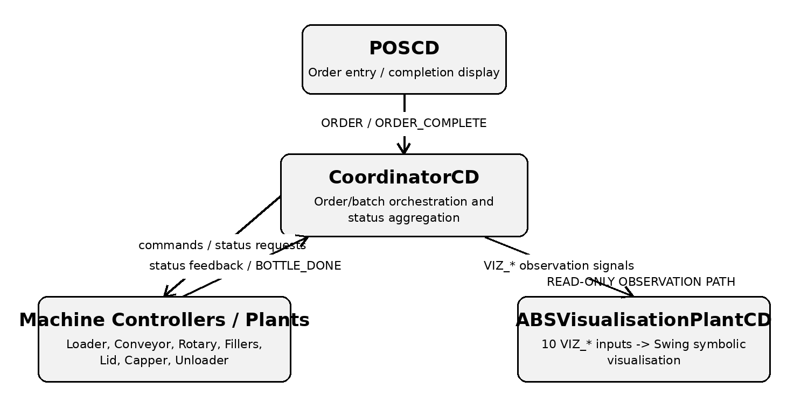
Figure 1. Conceptual architecture of the proposed ABS symbolic visualisation and its relationship with the Coordinator and machine controllers.

4.1 System Interfaces
The Coordinator-facing machine interface is the existing Group Project integration boundary. It is included here only to show where the Individual Project obtains observable state. Status requests are supervisory queries and must not advance a physical operation. The status replies and BOTTLE_DONE event return to CoordinatorCD at port 11001, while each machine has its own receiver port for Coordinator requests or configuration values.
Machine | Coordinator -> Controller | Controller -> Coordinator | Ports*
Bottle Loader | START_ORDER (Integer); LOADER_STATUS_REQUEST (pure) | LOADER_STATUS (Integer) | 11002 / 11001
Conveyor | CONVEYOR_STATUS_REQUEST (pure) | CONVEYOR_STATUS (Integer) | 11003 / 11001
Rotary Table | ROTARY_STATUS_REQUEST (pure) | ROTARY_STATUS (Integer) | 11009 / 11001
Filler A | FILL_A_RATIO (Integer); FILLER_A_STATUS_REQUEST (pure) | FILLER_A_STATUS (Integer) | 11004 / 11001
Filler B | FILL_B_RATIO (Integer); FILLER_B_STATUS_REQUEST (pure) | FILLER_B_STATUS (Integer) | 11005 / 11001
Lid Loader | LID_STATUS_REQUEST (pure) | LID_STATUS (Integer) | 11006 / 11001
Capper | CAPPER_STATUS_REQUEST (pure) | CAPPER_STATUS (Integer) | 11007 / 11001
Bottle Unloader | UNLOADER_STATUS_REQUEST (pure) | UNLOADER_STATUS (Integer); BOTTLE_DONE (pure) | 11010 / 11001
* Ports are shown as machine receiver / Coordinator receiver.

4.2 Visualisation Interface
The Individual Project consumes ten integer VIZ_* signals from CoordinatorCD. All are mapped to ABSVisualisationPlantCD at receiver port 11008. This provides one aggregation point for observation and avoids coupling Swing code directly to every machine Controller.
Visualisation signal | Type | Meaning
VIZ_LOADER_STATUS | Integer | Loader state
VIZ_CONVEYOR_STATUS | Integer | Conveyor state
VIZ_ROTARY_STATUS | Integer | Rotary Table state
VIZ_FILLER_A_STATUS | Integer | Filler A state
VIZ_FILLER_B_STATUS | Integer | Filler B state
VIZ_LID_STATUS | Integer | Lid Loader state
VIZ_CAPPER_STATUS | Integer | Capper state
VIZ_UNLOADER_STATUS | Integer | Bottle Unloader state
VIZ_REQUIRED_BOTTLES | Integer | Required bottles in current batch
VIZ_COMPLETED_BOTTLES | Integer | Completed bottles in current batch
The two Conveyor drawings used in the symbolic production-line layout are visual representations of different portions of the line, but both are driven by the same VIZ_CONVEYOR_STATUS value. This does not create a second Conveyor Controller or a second interface. Keeping this boundary one-way ensures that graphical changes remain independent of the SystemJ machine-control sequence.

5. Preliminary Work and Proposed Development
The current Phase 1 prototype uses a custom ProductionLinePanel derived from JPanel and Graphics2D drawing to present the symbolic plant layout. It shows the Loader, Conveyor sections, Rotary Table, parallel Filler A/Filler B, Lid Loader, Capper and Unloader, together with readable status text and current batch progress. Required and completed bottle counts are shown with progress text and a progress bar. Swing updates are scheduled on the event-dispatch thread, while a Swing Timer provides symbolic activity animation only when the corresponding confirmed controller state is BUSY (2). The implementation also retains an explicit “has status” condition so that initial WAITING is not confused with a genuine 0 = IDLE reply.
This prototype demonstrates that the existing Coordinator/SystemJ integration can drive a persistent symbolic view without giving the GUI control authority. The next development step for Phase 1 is to evaluate the display with real team Controller feedback as those modules become available and to confirm that delayed, missing or faulted status updates remain understandable.
[Insert current Phase 1 visualisation screenshot here]
Figure 2. Preliminary Phase 1 symbolic visualisation of the Automated Bottling System.

6. Phase 2 - Proposed Workpiece Visualisation
Phase 2 proposes a workpiece layer above the machine-level state display. Individual bottle symbols would be associated with confirmed workstations or transfer locations and the representation should support several bottles at different production stages simultaneously. Possible information includes a bottle identifier, current workstation, processing state and transfer history. The key design requirement is that bottle position must be based on meaningful Plant/Controller observations rather than GUI timing alone. This avoids showing an attractive animation that can diverge from the actual simulated plant when a machine is delayed or faulted.
[Insert proposed Phase 2 bottle/workpiece visualisation here]
Figure 3. Proposed extension for symbolic workpiece position and concurrent bottle tracking.

7. Expected Contribution and Outcomes
The expected contribution is an observation layer that makes concurrent ABS operation easier to understand without changing the distributed control architecture. At machine level, the visualisation provides a persistent view of operating state and batch progress for integration debugging and demonstration. At workpiece level, the project will investigate how bottle-location information can be represented consistently with Controller and Plant events. The resulting design should remain compatible with independently developed machine Controllers because the Individual Project consumes defined observation interfaces rather than embedding machine logic in the GUI.

8. Conclusion
This Milestone 1 proposal defines a focused Individual Project around symbolic visualisation of the ABS. The preliminary Phase 1 prototype already establishes a read-only SystemJ-to-Swing observation path for eight production units and current batch progress. The remaining research and development work is to validate this representation during wider integration and to design a trustworthy Phase 2 workpiece model that can represent several bottles without inferring physical state from animation timing. The separation between control and observation is therefore the central architectural principle of the proposed work.

References
[1] Z. Salcic, COMPSYS 704 Advanced Embedded Systems - Individual Research Project / Project 1 guidance, University of Auckland, 2026.
[2] A. Malik, Z. Salcic, P. S. Roop, and A. Girault, “SystemJ: A GALS language for system level design,” Computer Languages, Systems & Structures, vol. 36, no. 4, pp. 317-344, 2010.
[3] M. Sorouri, S. Patil, Z. Salcic, and V. Vyatkin, “Software composition and distributed operation scheduling in modular automated machines,” IEEE Transactions on Industrial Informatics, vol. 11, no. 4, pp. 865-878, 2015.

