COMPSYS 704 PROJECT 1
Interim Group Project Report
Extended Automated Bottling System (EABS)
and Purchase Order System (POS)

Group number | GROUP 6
Student names | XUQI CHEN (Member 1)  XUEYUAN YE (Member 2 Leader)  XIAOPING LIU (Member3)  CHENGGONG MA (Member4)
Student IDs | M1:730537610  M2:3079287  M3:825970177  M4:672495124
Date | 28/08/2026
Repository / version | Interim Report V1.1 - Content Synchronisation

1. Introduction
This interim report presents the current milestone design, implemented M1 integration state, and supported cross-member contracts for the Automated Bottling System (ABS). The current production sequence is empty-bottle loading, conveyor transfer, rotary-table processing, liquid-A/liquid-B filling, lid placement, capping, P6 labelling, and unloading; downstream M4 SortPack remains a proposed extension after the M2 Bottle Unloader. The system-level POS and Coordinator supervise orders and progress without taking ownership of Controller-to-Controller or Controller-to-Plant actions.
The design follows the SystemJ Globally Asynchronous, Locally Synchronous (GALS) approach. Major functions are separated into Clock Domains and communicate through typed signals. At the group-project level, the intended architecture separates system coordination from local machine control: the Coordinator manages order and batch state, whereas each Machine Controller is responsible for the behaviour of its own Plant model, sensors and actuators. This separation allows team members to develop machine modules independently while sharing a stable integration contract.
At this interim stage, the M1 POS, Coordinator, read-only Advanced Visualisation, transport-tolerance behaviour, and M1 regression tests are implemented and verified in the current repository. The shared M1-facing interface documentation is synchronised to that implementation. M2/M3/M4 peer SystemJ/XML implementations are not present in this repository and therefore remain unverified here; proposed extensions and unresolved fault-tolerance items are identified explicitly rather than presented as complete.

2. System Requirements and Scope
The core EABS is intended to produce batches of bottled products according to purchase orders received from the POS. A product instance follows the general production sequence:
The current production flow is: Empty Bottle -> Bottle Loader -> Conveyor -> P1 Rotary Load -> P2 Filling -> P3 Lid -> P4 Capping -> P6 Labelling -> Bottle Unloader -> downstream M4 SortPack (proposed). The M2 Bottle Unloader owns the Coordinator-facing BOTTLE_DONE event after verified physical removal. M4 Capper does not emit BOTTLE_DONE or ORDER_COMPLETE.
The 2026 filling requirement uses two liquids. In the current team architecture these are represented by Liquid A and Liquid B, with separate Filler A and Filler B Controller boundaries. The required proportions originate in the customer order. The current order protocol represents product quantity as the number of bottles required for a batch; it does not currently include an absolute per-bottle liquid volume field. The conceptual design must also allow several bottles to be at different stations concurrently without overloading the line.
A purchase order may contain several product records. Each product record defines a product identifier, the Liquid A/B recipe and the required quantity. The current Coordinator completes the active product batch before loading the next product record from the same purchase order. Product-batch ordering is therefore handled at the system level, while the detailed physical hand-off between adjacent machines remains the responsibility of the corresponding Controllers.

3. Overall Conceptual Design
The architecture is divided into POS, Coordinator, Machine Controller, Plant, read-only Visualisation, and supervisory Fault-Tolerance boundaries. The POS is the customer/order boundary; the Coordinator owns order and batch orchestration; Machine Controllers retain local sequencing, safety, actuator authority, and machine-to-machine hand-offs; Plants model physical/simulated machine state. The Visualisation consumes Coordinator VIZ_* information only. FaultSupervisor coordinates fault/recovery evidence without operating actuators, while M1 retains the final global RESUME/HOLD decision.
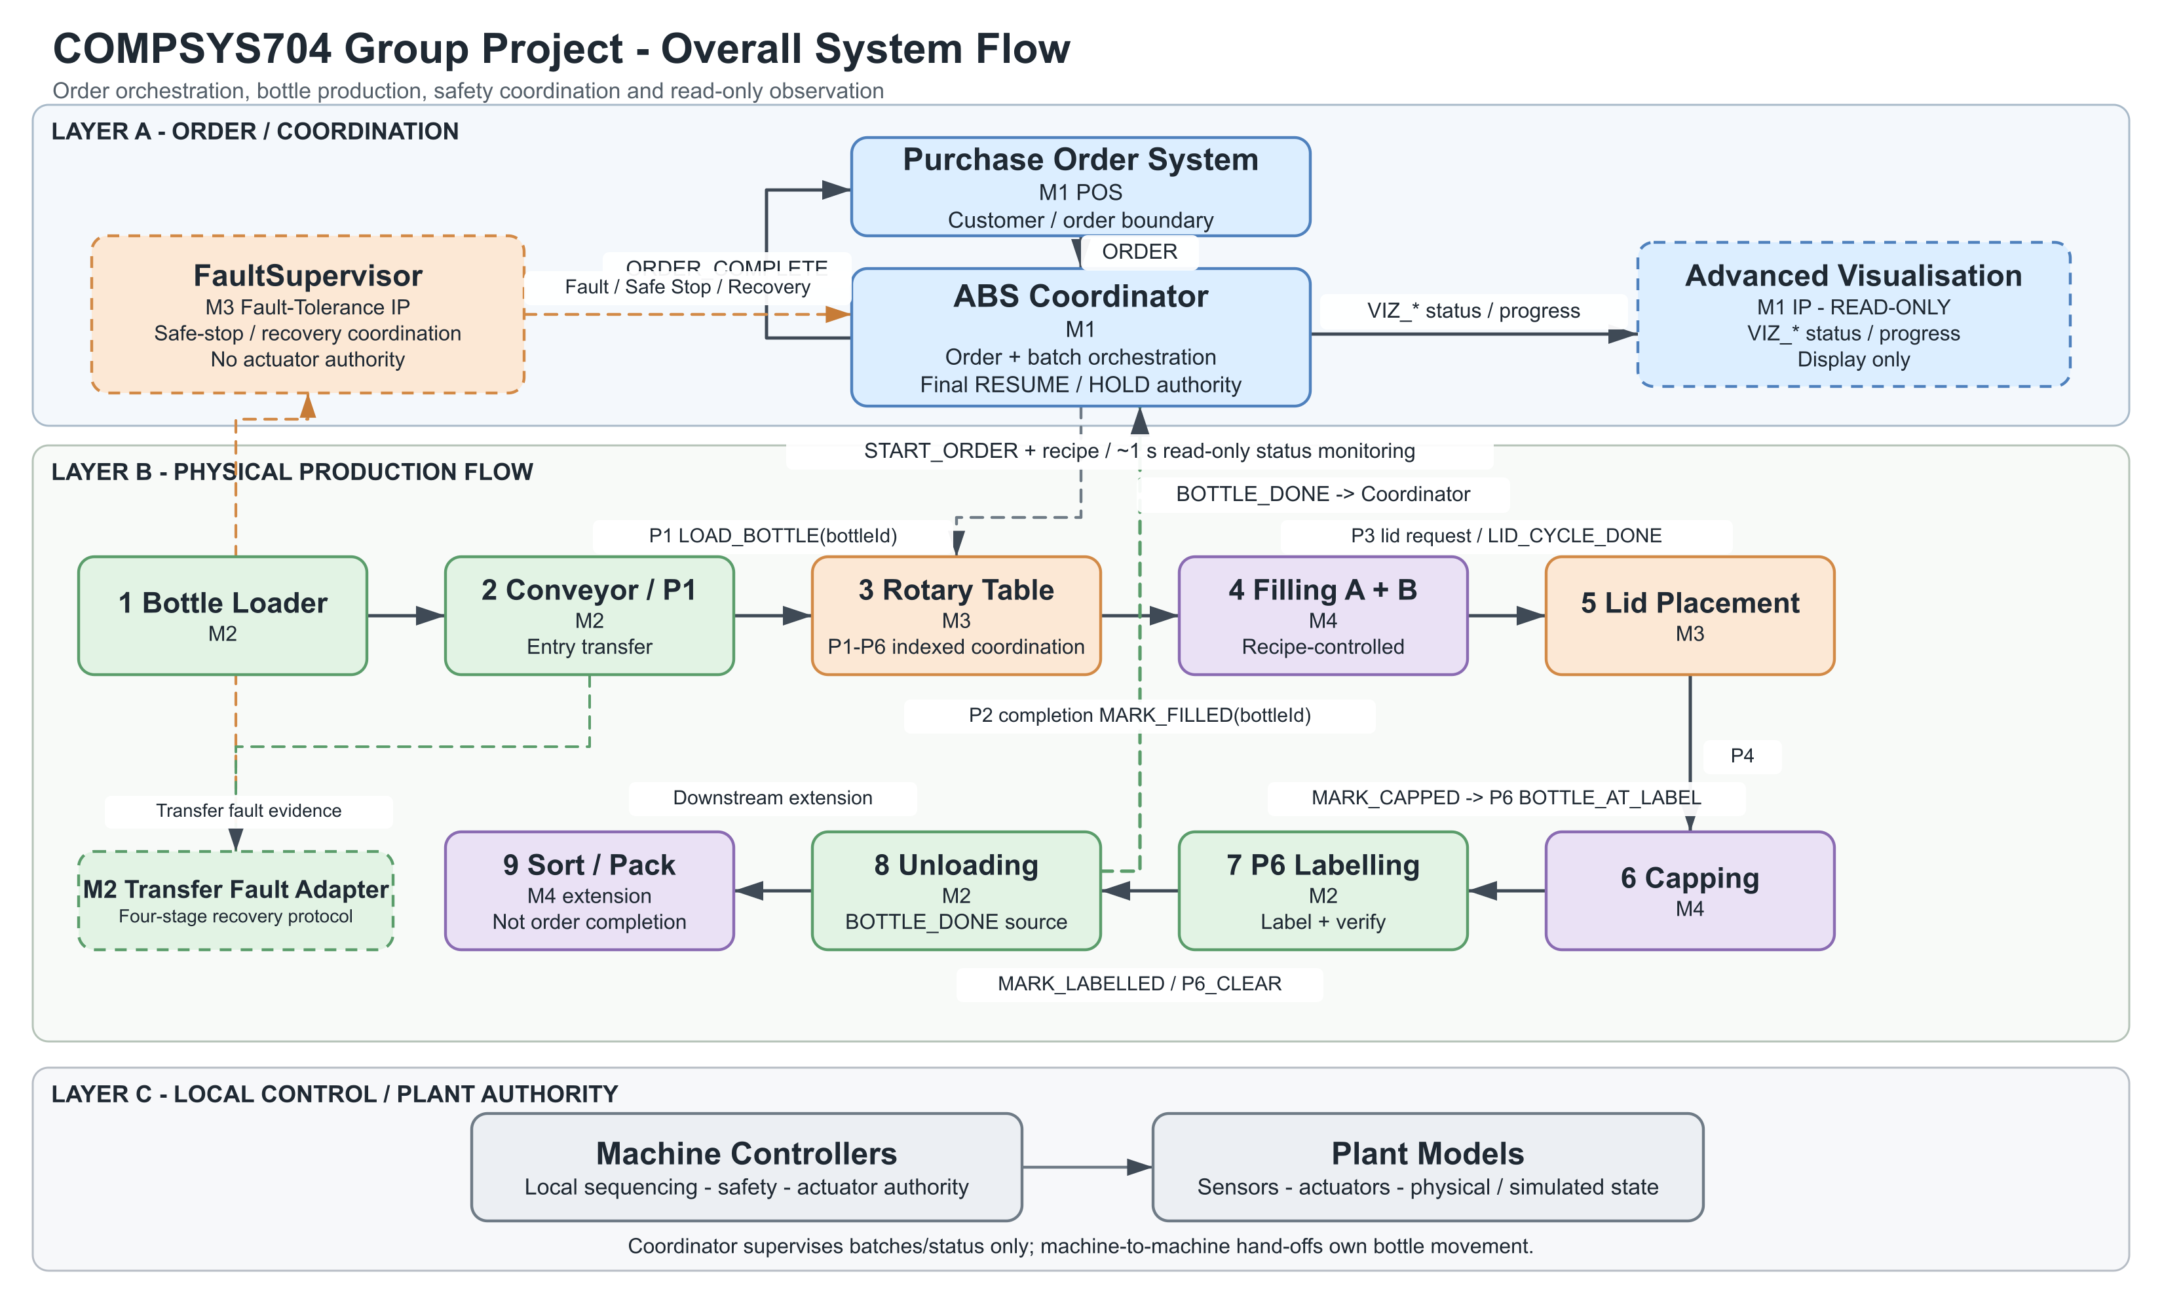
Figure 1. Overall EABS and POS system architecture.
Figure 1 presents the layered system boundary. Its embedded production path and some labels predate the accepted P6 labelling route and current Controller naming; the corrected text and Section 8 interface table are the authoritative interim description pending a later figure-only refresh.

4. Overall Control Strategy
The group design uses a mixed control strategy: centralised coordination at the order/batch level and distributed control at the machine level. The Coordinator accepts and validates purchase orders, selects the current product batch, provides the quantity and filler ratios, monitors machine state and counts completed bottles. It does not directly operate motors, valves, cylinders or rotary mechanisms.
Each Machine Controller remains responsible for safe local behaviour, including reacting to Plant sensors, issuing actuator commands, and performing bottle-correlated hand-offs with neighbouring machines. Coordinator status requests are supervisory queries only and cannot start, reset, acknowledge, or advance a physical operation. FaultSupervisor may coordinate fault/recovery information but has no actuator authority; M1 remains the final order/batch RESUME/HOLD authority.
The interface baseline supports parallel development while allowing planned, team-agreed revision. Transport tolerance is deliberately separated from business semantics: ORDER and ORDER_COMPLETE may each be sent as up to three bounded PRESENT windows with ABSENT gaps, while receiver-side de-duplication ensures one logical order and one logical completion. BOTTLE_DONE similarly uses a bounded PRESENT window and Coordinator rising-edge counting. This is not permanent signal assertion and does not change Controller behaviour.

5. Purchase Order System (POS)

5.1 Role and Order Data
The POS produces the implemented Order V1 String payload: orderId|productCount|productId,A%,B%,quantity;... . The current coded limit is one to four product records. For every product, quantity must be greater than zero, each liquid percentage must be an integer from 0 to 100 inclusive, and Liquid A + Liquid B must equal 100. GUI validation protects normal entry, and OrderV1.parse() validates the same boundary before SystemJ transmission.

5.2 Order Protocol and Validation
The validated order is encoded using the current Order V1 protocol:
orderId|productCount|productId,A%,B%,quantity;...
Order V1 supports multiple product records in one purchase order. The Coordinator processes those products sequentially at batch level while Machine Controllers retain local pipeline execution. POS also supports consecutive separate orders: completion of one accepted order releases the POS for a later order.

5.3 POS-Coordinator Communication
One logical ORDER may be transmitted as up to three bounded PRESENT windows, each separated by ABSENT, because a very short one-reaction pulse can be missed by a slower cross-process receiver. Coordinator accepts one logical order and ignores duplicate copies; the limit applies to transport copies, not to the number of orders the POS may submit. Coordinator applies the same bounded-copy approach to ORDER_COMPLETE, and POS de-duplicates repeated completion payloads, ignores stale completion for a non-active/old order, and proceeds normally with the next order.
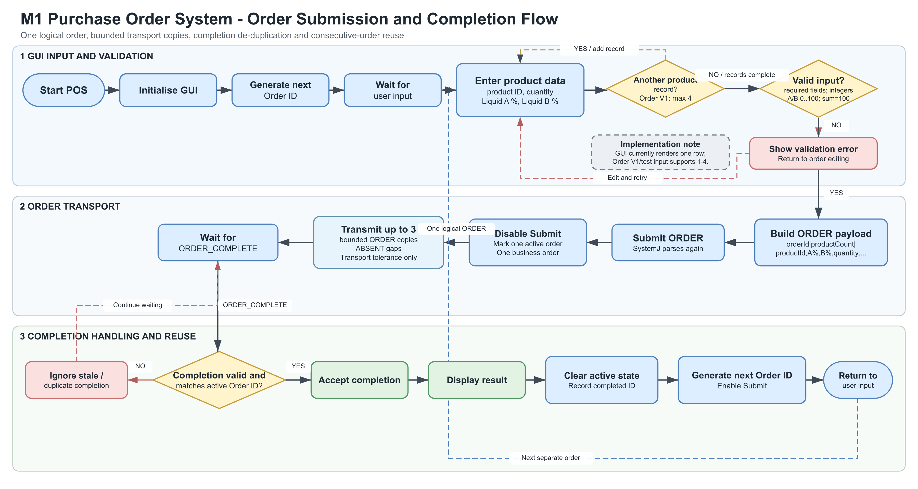
Figure 2. POS order submission and completion flow.
ORDER_COMPLETE = orderId|COMPLETED|completionTimeSeconds

6. ABS Coordinator

6.1 Role and Order Reception
Coordinator receives ORDER, validates it independently with OrderV1, and supports one to four product records per accepted purchase order. Duplicate transport copies of the last accepted order are ignored idempotently; a different ORDER cannot replace an active order. After completion, later distinct orders are accepted normally, unless the M1 fault-coordination HOLD is active. Completion retries from the prior order do not block reuse of the order slot.

6.2 Initial Batch Dispatch
After a valid order and recipe pair have been confirmed, Coordinator emits START_ORDER once for the current product quantity and emits FILL_A_RATIO and FILL_B_RATIO for that product. These are batch-level configuration values, not motor, valve, reset, or other actuator commands. A later product record is dispatched only after the preceding product reaches its required BOTTLE_DONE count.
Signal | Destination | Meaning
START_ORDER | Bottle Loader | Required bottles for current batch
FILL_A_RATIO | Filler A | Liquid A percentage
FILL_B_RATIO | Filler B | Liquid B percentage

6.3 Periodic Status Polling and Feedback
Approximately once per second, Coordinator emits read-only status requests to BottleLoaderControllerCD:11002, ConveyorControllerCD:11009, RotaryTableControllerCD:11003, FillerAControllerCD:11004, FillerBControllerCD:11005, LidLoaderControllerCD:11006, CapperControllerCD:11007, and BottleUnloaderControllerCD:11010. Polling must not start, reset, acknowledge, or advance a physical operation; all status responses return to CoordinatorCD:11001.
Controller responses update Coordinator's latest stored state using 0 = IDLE, 1 = READY, 2 = BUSY, 3 = DONE, and 4 = FAULT. Coordinator forwards the eight Integer machine statuses plus required/completed bottle counts through ten implemented VIZ_* outputs to ABSVisualisationPlantCD:11008. This path is display-only and never controls a machine.

6.4 Bottle Completion and Multiple Products
M2 Bottle Unloader owns one logical BOTTLE_DONE only after a completed bottle has been physically collected. Cross-process transport uses a bounded PRESENT window followed by ABSENT so a slower runtime can observe the event; Coordinator counts only the logical rising edge, preventing one held window from counting repeatedly. The completed-bottle count closes the current batch. If another product record exists, Coordinator loads and dispatches that next batch; otherwise it generates orderId|COMPLETED|completionTimeSeconds and starts reliable ORDER_COMPLETE transport.
The V2.1 M1/M3 boundary maps FT_FAULT_ALERT, FT_SAFE_STOP_REQUEST, FT_RECOVERY_READY, and FT_RECOVERY_FAILED from FaultSupervisorCD:13003 to CoordinatorCD:11001, and declares FT_SAFE_STOP_ACK and FT_RESUME_DECISION back to FaultSupervisorCD. A validated safe-stop request places new-order/next-batch dispatch into HOLD; recovery-ready does not auto-resume, FaultSupervisor has no actuator authority, and M1 alone owns the final RESUME/HOLD decision. M1 declarations, mappings, and HOLD handling exist; normal GP operation also works with FaultSupervisor absent because optional output transport remains non-blocking when nothing is emitted. Full FT integration is not claimed: safe-stop ACK still requires independent physical evidence and the exact RESUME-decision String payload schema remains unresolved.
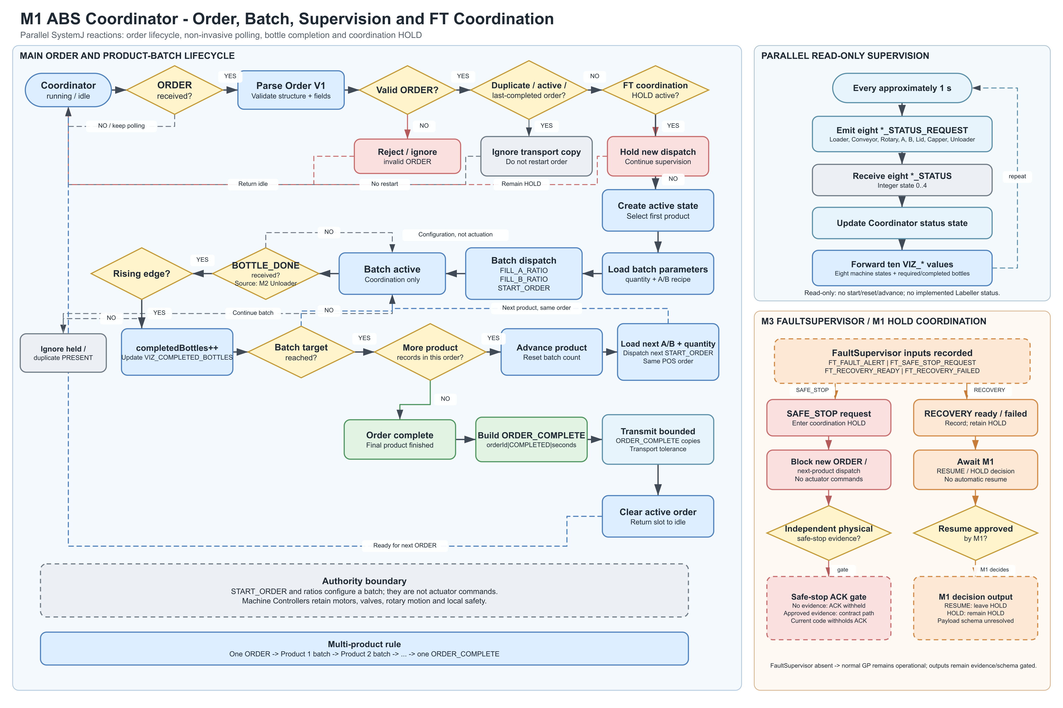
Figure 3. ABS Coordinator order and batch control flow.

7. Machine Controller and Plant Conceptual Designs
The following table summarises the current Controller/Plant responsibilities across the EABS. Each Machine Controller retains local sequencing, safety and actuator authority, while cross-machine hand-offs and Coordinator-facing monitoring interfaces integrate the modules without transferring direct machine control to the Coordinator.
Machine module | Conceptual design summary | Responsible student
Bottle Loader Controller / Plant | Introduces empty bottles into the line using local detection and loading mechanisms, then coordinates safe release toward the Conveyor. START_ORDER and status monitoring form the Coordinator boundary where applicable; loading actuators remain under the local Controller/Plant. | XUEYUAN YE (Member 2)
Conveyor Controller / Plant | Transports loaded bottles toward P1 using local bottle detection and motor sequencing, then coordinates transfer into the Rotary stage. Coordinator monitoring uses ConveyorControllerCD:11009; transfer and fault handling remain local or cross-machine rather than direct Coordinator actuator control. | XUEYUAN YE (Member 2)
Rotary Table Controller / Plant | Operates a six-position indexed Rotary Table using M3-owned local sequencing and bottle-correlated P1, P3 and P6 hand-offs. Rotation proceeds only after matching completion and clear evidence; Coordinator monitoring uses RotaryTableControllerCD:11003. | XIAOPING LIU (Member 3)
Filler A Controller / Plant | Uses the configured FILL_A_RATIO and valid bottle-present and fill conditions to control Liquid A dispensing locally. Its verified completion contributes to the bottle-correlated filling sequence; the Coordinator does not operate filling actuators. | CHENGGONG MA (Member 4)
Filler B Controller / Plant | Uses FILL_B_RATIO and local bottle and fill conditions to dispense Liquid B after the required Filler A coordination. Verified completion produces the appropriate bottle-correlated filling hand-off. | CHENGGONG MA (Member 4)
Lid Loader Controller / Plant | Receives BOTTLE_AT_LID_POSITION(bottleId), performs the local lid pick/place cycle, and returns LID_CYCLE_DONE(bottleId) after sensor confirmation. Lid inventory and timeout handling remain local; these are cross-machine rather than Coordinator signals. | XIAOPING LIU (Member 3)
Capper Controller / Plant | Performs the guarded local capping sequence after confirmed bottle positioning. Successful completion produces MARK_CAPPED(bottleId) for neighbouring-stage coordination, with local actuator and safety authority retained. | CHENGGONG MA (Member 4)
Labeller Controller / Plant | At P6, receives BOTTLE_AT_LABEL(bottleId), applies and verifies the label locally, and returns MARK_LABELLED(bottleId) before the Unloader and P6-clear sequence. Coordinator-facing Labeller status monitoring remains proposed and is not claimed as implemented. | XUEYUAN YE (Member 2)
Bottle Unloader Controller / Plant | Detects, removes and collects each completed P6 bottle, returns P6_CLEAR(bottleId) to the Rotary/Plant side, and sends exactly one logical BOTTLE_DONE to the Coordinator per collected bottle. | XUEYUAN YE (Member 2)
Sort / Pack Controller / Plant | Represents the downstream M4 extension after unloading and uses bottle/context information for sorting and packaging. It does not own BOTTLE_DONE and does not determine M1 POS order completion. | CHENGGONG MA (Member 4)
The accepted architecture supports multiple bottles in flight through bottle-correlated machine hand-offs. The Coordinator supervises order, recipe, status and completion information, while the Machine Controllers and Plants execute the physical production sequence.

7.1 Member 2: Bottle Loader, Conveyor, Labeller and Unloader
The revised M2 subsystem owns the physical entry and final handling boundary of the EABS and now also includes the labelling function. An empty bottle is admitted through the Bottle Loader and Conveyor to rotary Position 1. After filling at P2, lid placement at P3 and capping at P4, the bottle remains on the rotary table through P5 and reaches the newly assigned labelling station at P6. The M2 Labeller applies and verifies the product label before the M2 Bottle Unloader removes the labelled bottle directly from P6. The Unloader then hands the bottle to the M4 Sort/Pack extension, which separates different bottle sizes into the appropriate cartons. BottleLoaderControllerCD, ConveyorControllerCD, LabellerControllerCD and BottleUnloaderControllerCD are each paired with Plant Clock Domains. The Coordinator remains responsible for batch-level state and monitoring; it does not directly actuate these machines.
Bottle loading remains admission-controlled. After START_ORDER supplies the required batch quantity, the loader waits until an empty bottle is available and the conveyor entry is free, performs one pick/place cycle, and confirms that the bottle physically reached the load point before decrementing the remaining count. A unique workpieceId/bottleId is assigned before admission. After the 24/08 interim interview, BottleTwin and WorkpieceTwin are treated as the same digital representation of the bottle/product instance; the preferred conceptual name is WorkpieceTwin, with BottleTwin retained only as a bottle-specific alias. LoaderTwin separately represents the Loader resource itself, including availability, actuator/sensor state, fault state and the linked workpieceId. Status values remain 0=IDLE, 1=READY, 2=BUSY, 3=DONE and 4=FAULT; Coordinator status requests remain monitoring-only.
The Conveyor Controller is revised to focus on the entry transfer to P1. A safe transfer window opens only when the rotary table is aligned and P1 is available. After positive P1 detection, M2 emits LOAD_BOTTLE(workpieceId) to M3. The previous P5 outfeed path is not used in the extended route because the capped bottle must remain on the rotary table for P6 labelling. ConveyorTwin represents the Conveyor resource state such as motor state, P1 occupancy, transfer-window availability, photo-eye feedback, fault state and linked workpieceId. M3 remains the authority for rotary P1-P6 occupancy and rotation.

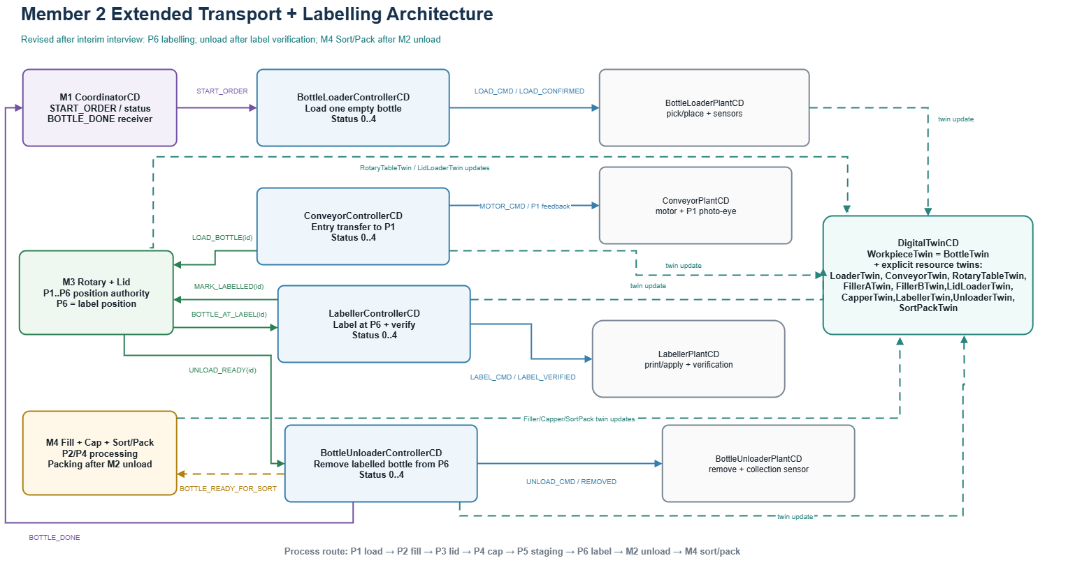
Figure 4. Revised M2 Controller/Plant architecture with P6 Labeller, post-label Unloader, downstream M4 Sort/Pack, and updated Digital Twin semantics.

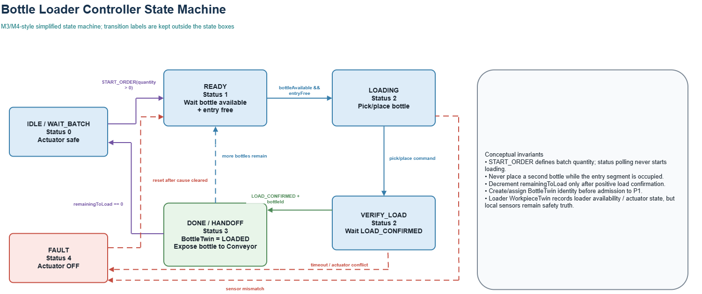
Figure 5. Bottle Loader Controller state machine.
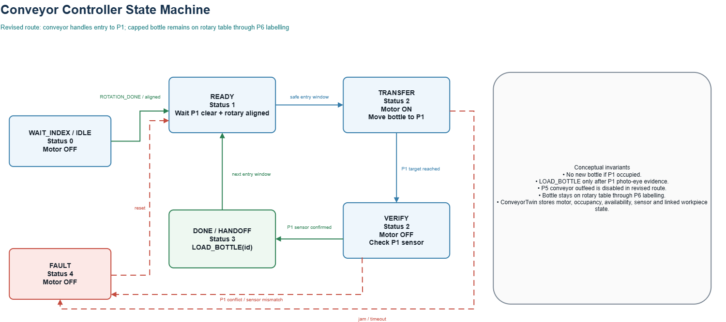
Figure 6. Conveyor Controller state machine.

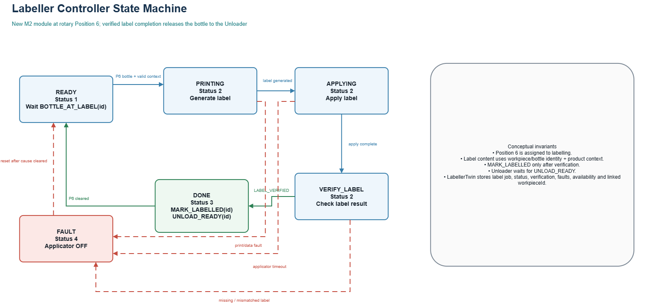
Figure 7. New Labeller Controller state machine at Rotary Position 6.
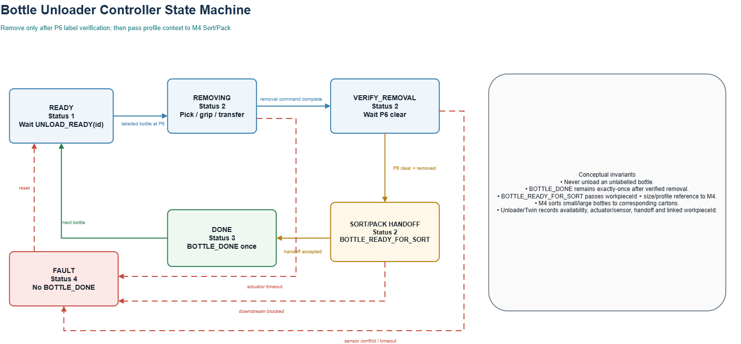
Figure 8. Revised Bottle Unloader state machine after P6 labelling.

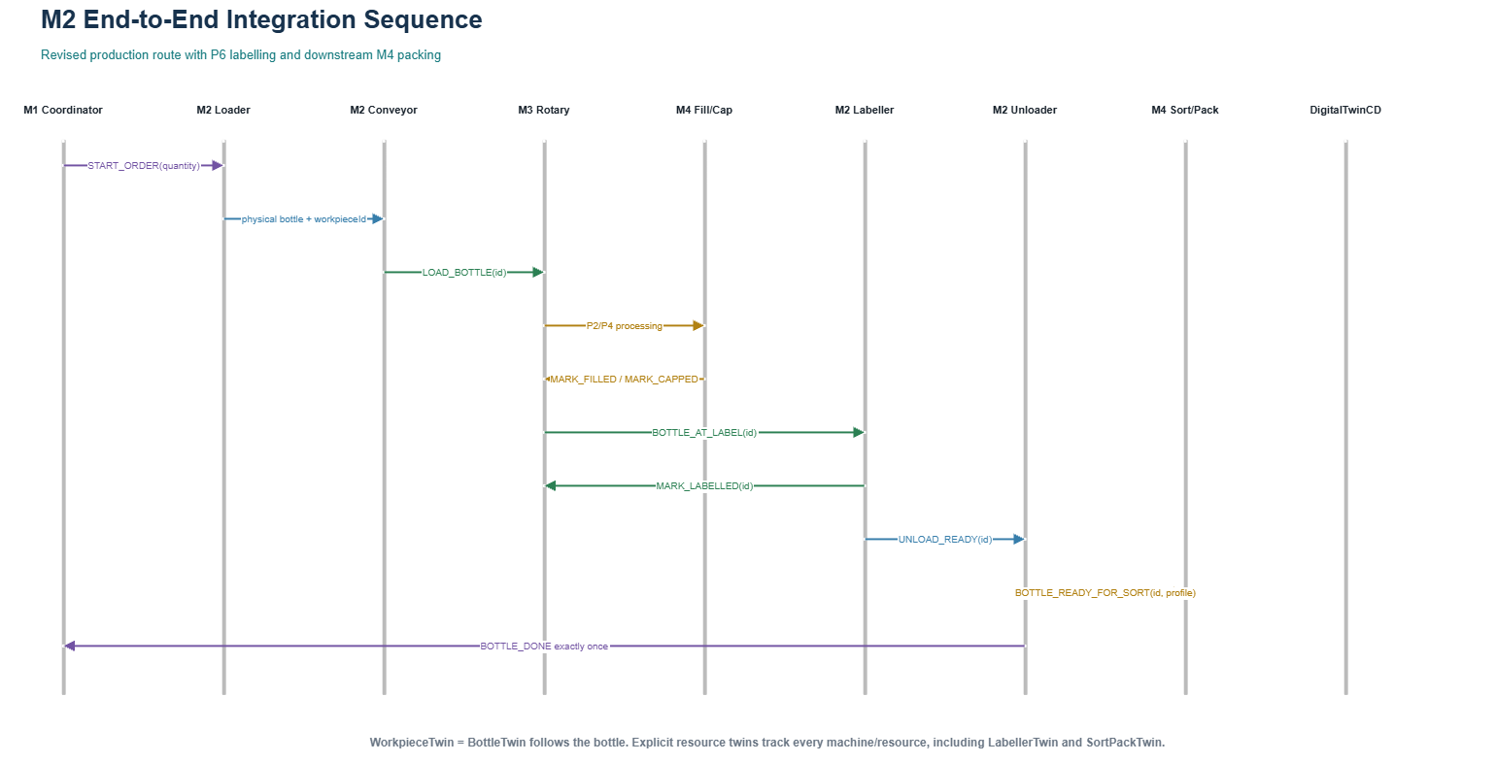
Figure 9. Revised end-to-end sequence: P6 labelling, M2 unloading and M4 size-aware sorting/packing.

7.2 Member 3 Subsystem Architecture
Member 3 is responsible for the Rotary Table and Lid Loader modules. The design uses separate SystemJ Controller and Plant clock-domains so that control decisions remain deployable without changing the logic when the simulated Plant is replaced by physical sensors and actuators. The Controllers own sequencing, safety interlocks, status publication and fault transitions; the Plant models own physical state, timing, sensor generation, actuator effects, P1-P6 bottle positions and lid inventory. An M3-owned rotary sequencing reaction evaluates the station-completion barrier and generates the internal ROTATE_REQUEST; M1, M2 and M4 never command rotary motion directly. Local Controller fault detection, actuator de-energisation and transition to FAULT remain part of the GP. Cross-subsystem fault classification, bounded recovery, evidence validation and escalation are handled by the M3 IP without taking actuator authority from the owning Controller.
M3 implements the frozen V2.1 status-interface separation agreed by the team. M2 Conveyor uses CONVEYOR_STATUS_REQUEST / CONVEYOR_STATUS, while the M3 Rotary Table uses ROTARY_STATUS_REQUEST / ROTARY_STATUS through Controller receiver port 11003. The M3 Lid Loader retains LID_STATUS_REQUEST / LID_STATUS through port 11006. These integer responses use 0 IDLE, 1 READY, 2 BUSY, 3 DONE and 4 FAULT. All status requests are read-only monitoring and cannot start, acknowledge or advance a physical operation. This M3 design no longer uses the ambiguous TRANSPORT_STATUS name. RotaryTablePlantCD and LidLoaderPlantCD retain the M3-owned Plant receiver ports 12003 and 12006. At the IP boundary, M2 sends TRANSFER_FAULT_EVENT, TRANSFER_RECOVERY_ACK and TRANSFER_RECOVERY_RESULT to FaultSupervisorCD receiver port 13003; FaultSupervisorCD sends TRANSFER_RECOVERY_REQUEST to the M2-owned Adapter receiver port. M2 retains local safety, interlock and actuator authority.
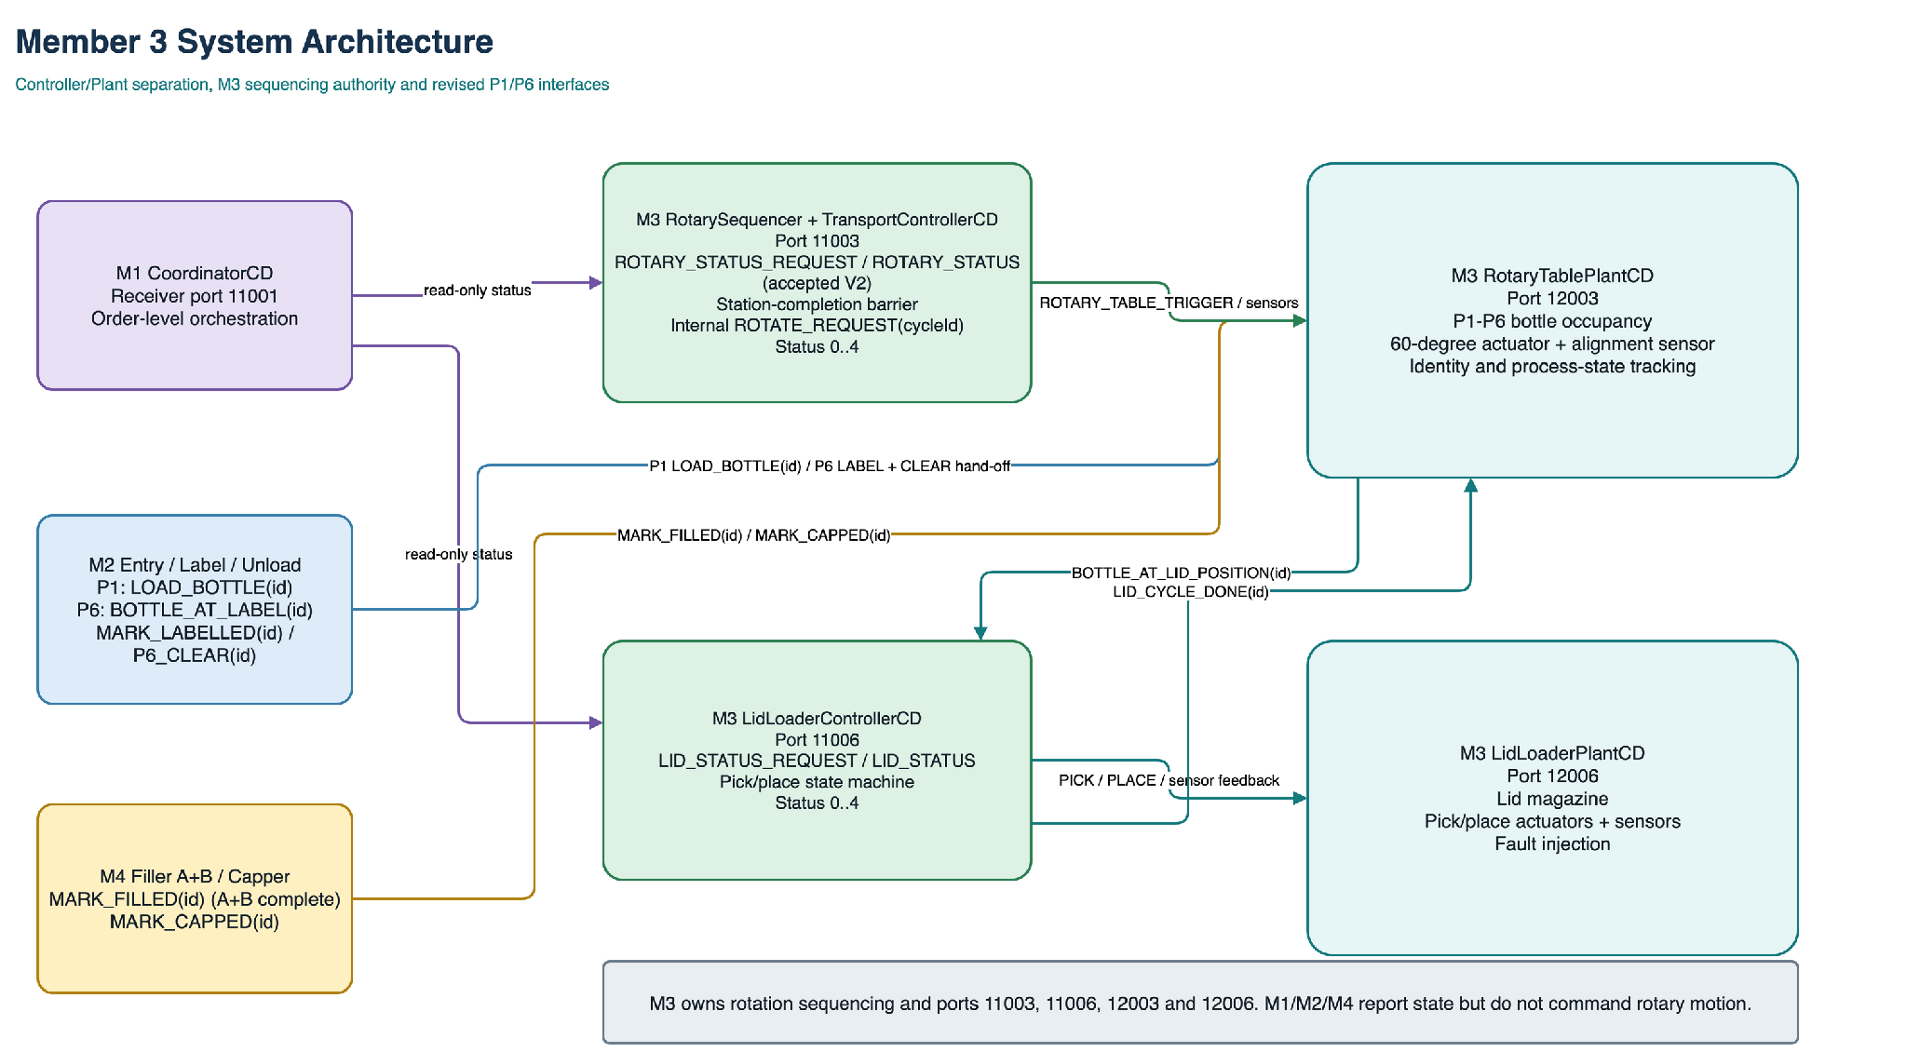
Figure 10. Member 3 Rotary Table and Lid Loader Controller/Plant architecture.

7.2.1 Rotary Table Controller and Plant
The Rotary Table Plant represents six indexed positions. Normal rotation is authorised only by the M3-owned RotarySequencer, which correlates a unique cycleId with current bottle identities and evaluates a station-completion barrier. For each occupied slot, P2 requires matching MARK_FILLED(bottleId), P3 requires matching LID_CYCLE_DONE(bottleId), and P4 requires matching MARK_CAPPED(bottleId). An occupied P6 requires both matching MARK_LABELLED(bottleId) and P6_CLEAR(bottleId) after physical unloading. When the table is aligned, no workstation is BUSY or FAULT and the barrier is satisfied, the sequencer emits one internal ROTATE_REQUEST(cycleId). The Rotary Controller accepts it only while READY, energises ROTARY_TABLE_TRIGGER for 500 ms, switches the motor off and requires TABLE_ALIGNED_WITH_SENSOR before publishing DONE.
The Plant stores six bottle slots and shifts all occupied slots atomically only after sensor-confirmed movement. Each slot retains bottleId and process state, allowing multiple bottles to occupy different stations without overwriting context. At P1, M3 accepts M2's LOAD_BOTTLE(bottleId) only under the agreed stable-P1 conditions. At P6, M3 publishes BOTTLE_AT_LABEL(bottleId); M2 returns MARK_LABELLED(bottleId) after label verification and P6_CLEAR(bottleId) only after physical removal and empty-sensor confirmation. M3 rejects stale or mismatched P6_CLEAR events and blocks the next indexed rotation until the current P6 bottle is cleared. M4 supplies MARK_FILLED(bottleId) and MARK_CAPPED(bottleId) after sensor-confirmed station completion. Duplicate or stale cycleIds and mismatched bottleIds cannot produce another indexed movement.
- Safety invariants: the motor is off outside ROTATING; only M3 sequencing logic can request rotation; all occupied P2/P3/P4 stations must report matching completion; P6 must be unloaded and clear; a FAULT or BUSY station blocks movement; missing alignment cannot be reported as DONE; and one unique cycleId advances all six slots at most once. The GP de-energises the motor and reports FAULT when alignment is uncertain; the current baseline does not perform automatic REHOME.
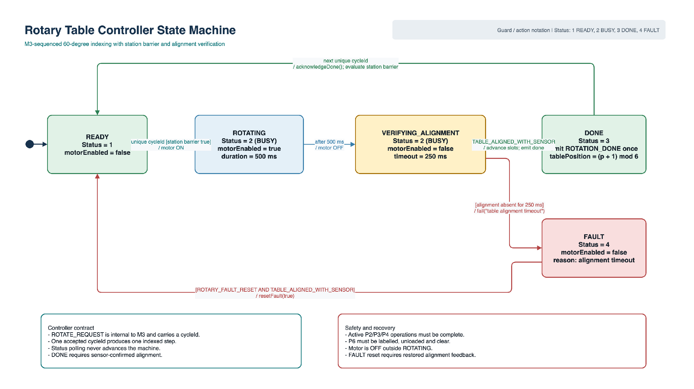
Figure 11. Rotary Table Controller state machine and safety transitions.

7.2.2 Lid Loader Controller and Plant
The Lid Loader starts only when the Rotary Table reports BOTTLE_AT_LID_POSITION(bottleId) for a filled bottle at position 3 and the lid magazine reports availability. The Controller proceeds from READY to PICKING by asserting PICK_LID_TRIGGER, waits for LID_PICKED, then enters PLACING and asserts PLACE_LID_TRIGGER. LID_PLACED_SENSOR completes the cycle and produces LID_CYCLE_DONE(bottleId) back to the Rotary Table. Completion is recorded against the same bottle before DONE can return to READY, preventing wrong-bottle completion while multiple bottles are in flight.
LidLoaderPlantCD owns the magazine count, actuator delays and sensor feedback. An empty magazine, missing pick confirmation or missing place confirmation enters FAULT and issues LID_ABORT so both actuators are de-energised. Fault reset is rejected until the corresponding physical cause has cleared, for example until the magazine has been replenished. The lid-complete event is emitted once per bottle, avoiding duplicate lid placement if a status request or neighbouring signal is repeated.
- Hand-off rule: the Rotary Plant owns bottle identity and position; the Lid Loader owns the pick/place cycle; the bottle state is updated only after confirmed placement, and rotation is released only after that update.
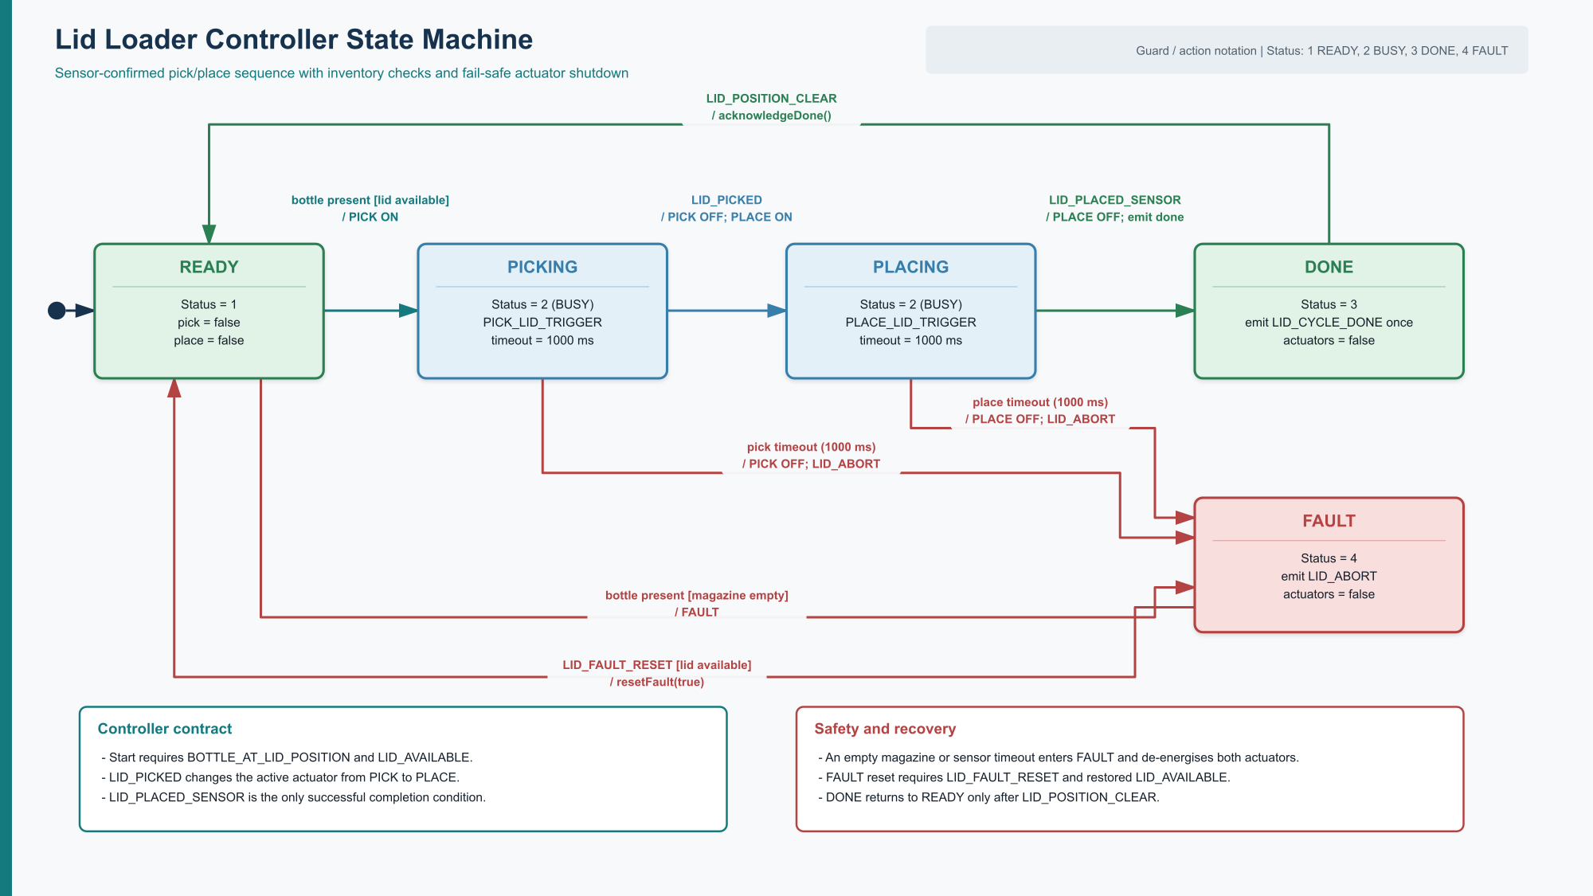
Figure 12. Lid Loader Controller state machine and fault handling.

7.2.3 Interim Verification and Remaining Integration
The M3 work is approximately one-third complete. The conceptual architecture, interface contract and initial Controller/Plant models are available, and basic deterministic model self-tests pass. These results support the interim design but do not represent a completed SystemJ integration.
This evidence validates the local conceptual design but does not claim that the complete group system is integrated. M3 now implements the frozen V2.1 status and P1/P6 bottle-correlated hand-offs. The remaining GP work is to bind the frozen mappings in SystemJ, connect the M4 completion hand-offs and implement the station barrier that generates ROTATE_REQUEST(cycleId). Final tests will cover normal concurrent flow, duplicate and stale-event rejection, wrong-bottle rejection, blocked-P6 behaviour, empty lid magazine, pick/place timeouts and rotary alignment faults.

7.3 Member 4 Subsystem Architecture
Member 4 is responsible for the Filler A, Filler B and Capper machine modules. Each module is decomposed into a SystemJ Controller Clock Domain and a separate Plant Clock Domain. The Controllers own sequencing, safety interlocks, status publication, bottle-identity checks and fault transitions. The Plant models own actuator effects, timing and sensor feedback. This separation allows the same Controller logic to be exercised with simulated Plants and later connected to physical sensors and actuators without changing the order-level Coordinator.
The core GP responsibility of Member 4 remains Filler A, Filler B and Capper. The Member 4 IP additionally introduces a validated BottleContext for 200 mL and 500 mL bottles, capacity-aware filling, geometry-profile selection within the Filler and Capper, and an independent SortPackControllerCD/SortPackPlantCD extension after the M2 Unloader transfer boundary. These additions do not change the frozen M1-facing interface.
The frozen M1-facing boundary is retained. FillerAControllerCD receives FILL_A_RATIO and FILLER_A_STATUS_REQUEST on port 11004, FillerBControllerCD receives FILL_B_RATIO and FILLER_B_STATUS_REQUEST on port 11005, and CapperControllerCD receives CAPPER_STATUS_REQUEST on port 11007. Their integer status responses are returned to CoordinatorCD on port 11001 using the common values 0 = IDLE, 1 = READY, 2 = BUSY, 3 = DONE and 4 = FAULT. A status request is a read-only observation and never starts, restarts or advances a physical operation.
The workstation hand-offs below are proposed cross-team interfaces and remain subject to approval by their M3 and M4 owners. M3 sends BOTTLE_AT_FILL when a bottle reaches Position 2. Filler A then sends FILL_A_DONE to Filler B only after its valves and dosing actuator are in a safe completed state. Filler B sends MARK_FILLED to M3 after both liquids have been verified. At Position 4, M3 sends BOTTLE_AT_CAP to the Capper, which returns MARK_CAPPED after confirmed completion.
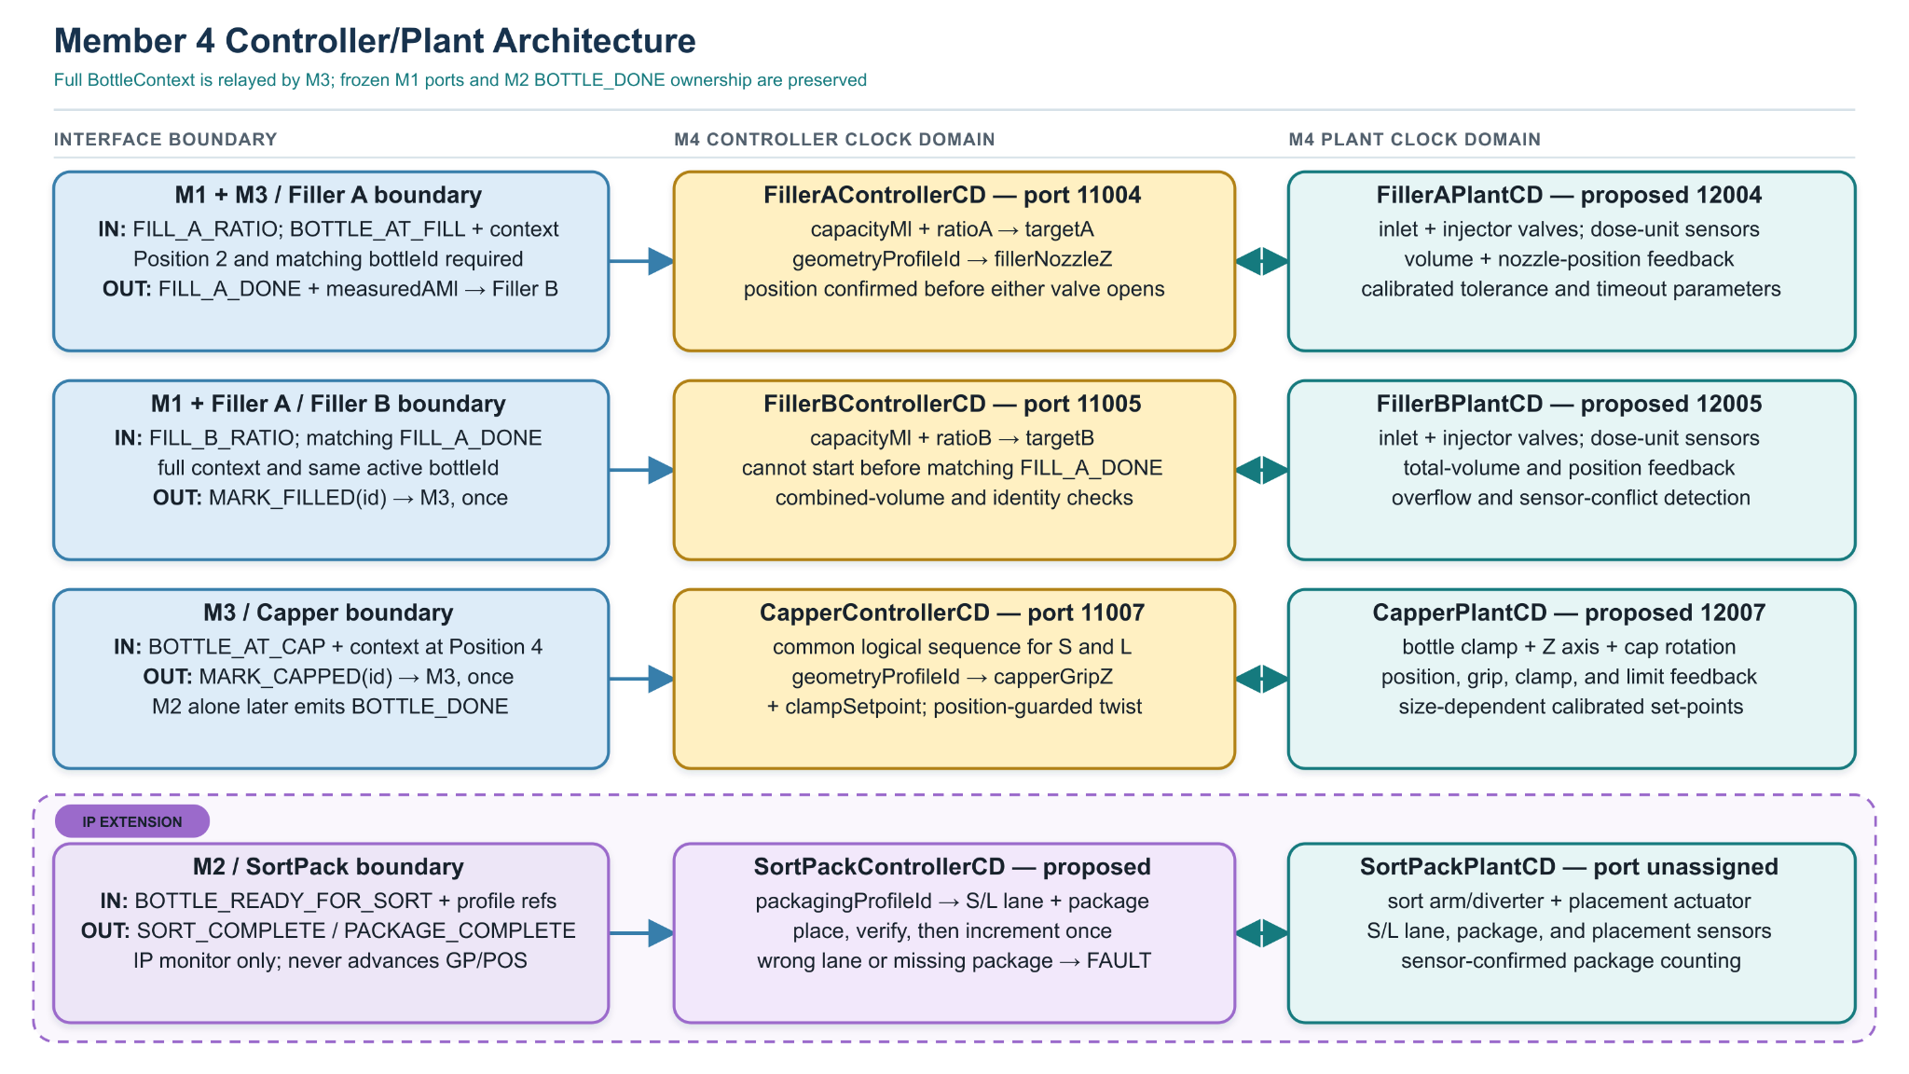
Figure 13. Member 4 Controller/Plant architecture and the proposed Sort/Pack IP extension.

7.3.1 Filler A and Filler B Controller/Plant Design
The Coordinator provides FILL_A_RATIO and FILL_B_RATIO as batch-level recipe percentages rather than direct actuator commands. In the core GP, each Filler stores its latest valid ratio and converts it to a calibrated local dose target. The capacity-aware conversion for 200 mL and 500 mL bottles is treated as the Member 4 IP extension summarised in Section 9. Filling starts only for a new bottle identity when the Rotary Table confirms that the same bottle is present at Position 2. Filler A also selects fillerNozzleZ from the bottle geometry profile and requires in-position feedback before either liquid valve can open.
Filler A first confirms that its dosing unit is in the safe initial condition through dosUnitEvac. It then opens the injector and drives the pressure canister through the dispensing stroke while monitoring Plant feedback. After the required dose is reached, the Controller closes the injector before opening the inlet valve for the refill stroke. The inlet and injector valves are never energised simultaneously. FILL_A_DONE is emitted only after the injector and inlet are closed, the refill cycle is safely completed, and the measured result is acceptable.
Filler B remains in its waiting state until it receives a matching FILL_A_DONE for the active bottle. It then performs the same guarded dispensing and refill sequence using FILL_B_RATIO. Filler B verifies the combined result before emitting MARK_FILLED once to M3. A duplicate completed bottle identifier is a no-op and cannot reopen either valve. A stale or mismatched bottle identifier, invalid recipe, timeout, contradictory top/bottom sensor state or detected overflow causes the owning Controller to de-energise its actuators, suppress the completion signal and publish FAULT. These rules enforce sequential filling and prevent Filler B from operating before Filler A is safe and complete.
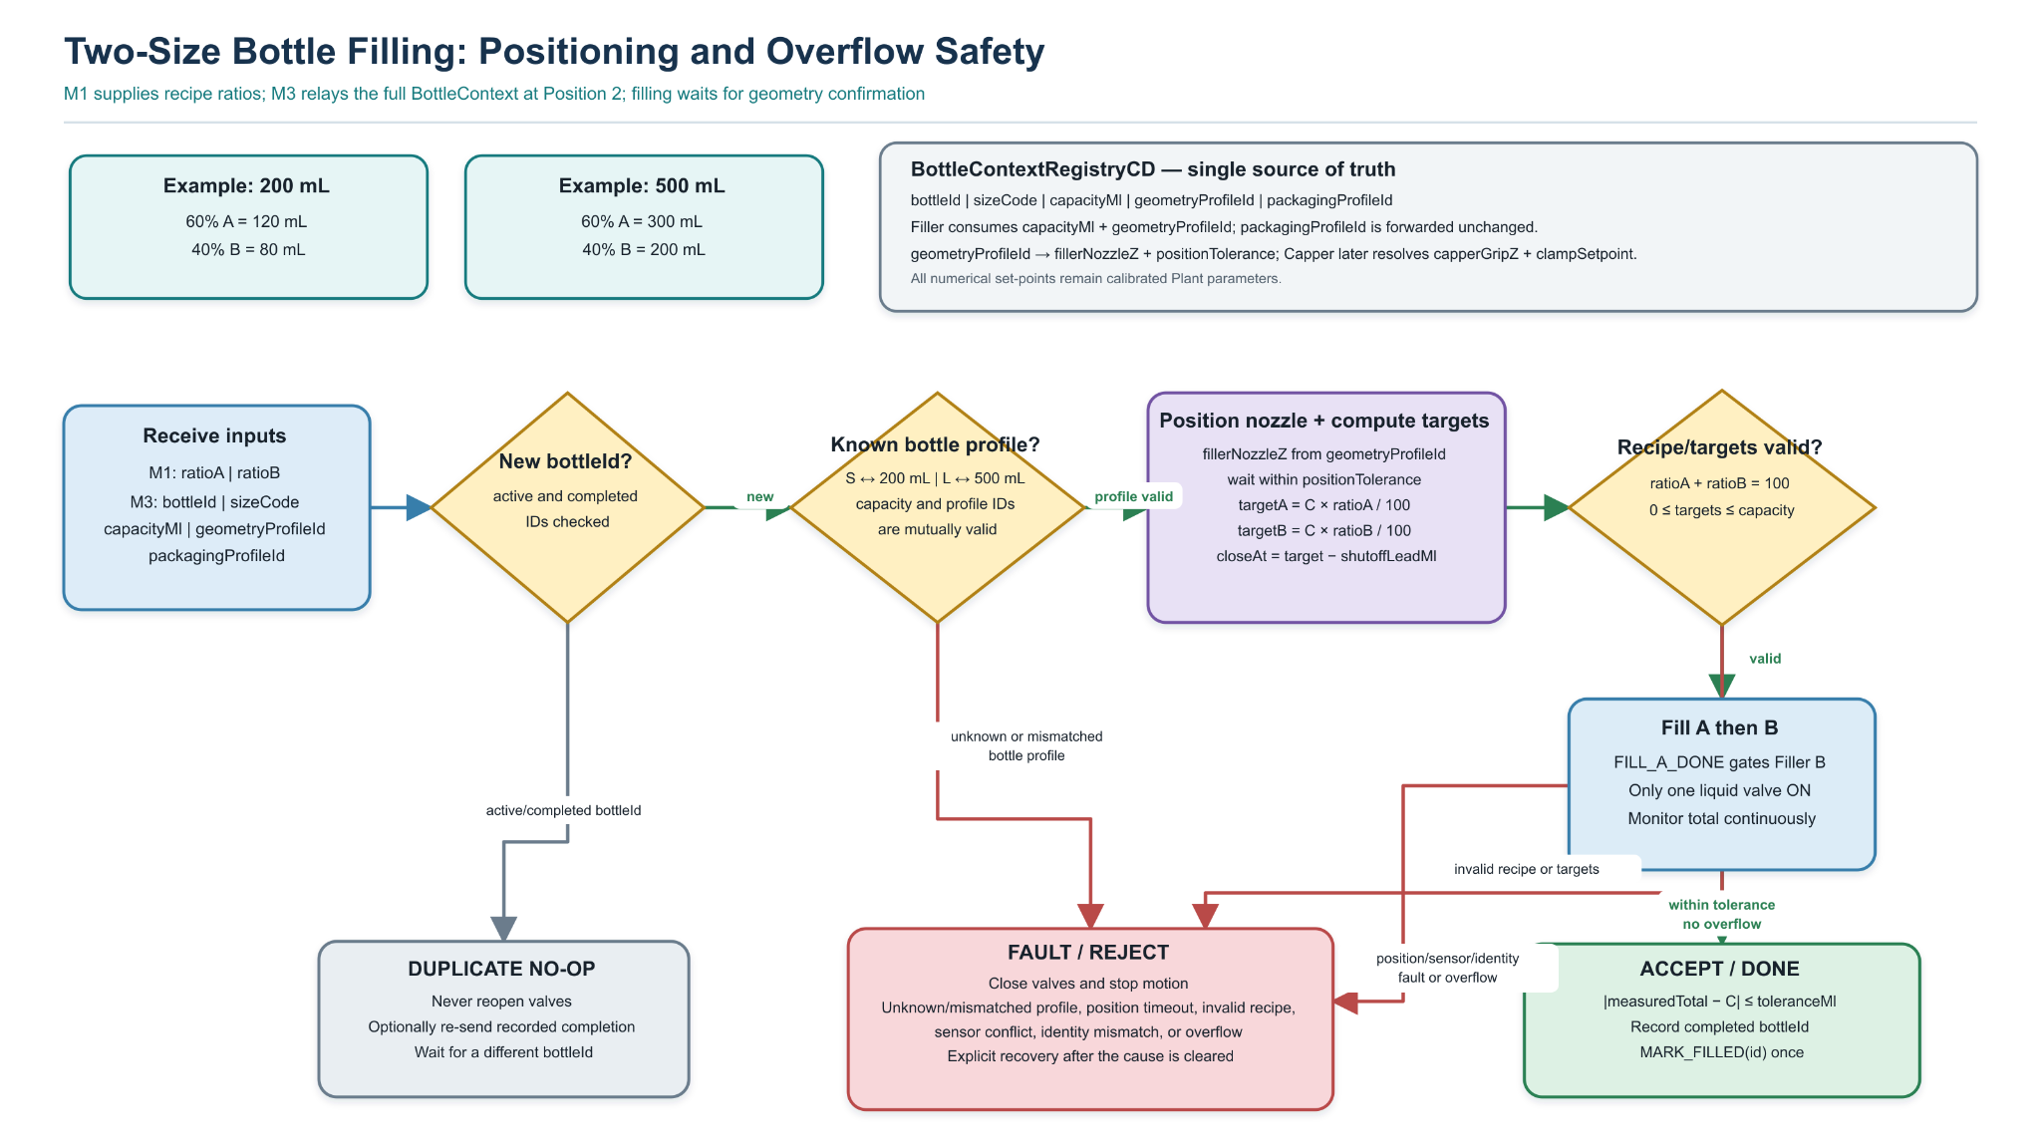
Figure 14. Capacity- and geometry-aware two-size filling workflow.

7.3.2 Capper Controller/Plant Design
The Capper starts only when a new bottle is confirmed at Position 4. The Controller clamps the bottle, lowers the gripper, grips the cap, twists it into place, releases the cap, returns the gripper to its home angle, raises the gripper and finally unclamps the bottle. Every transition waits for the corresponding Plant feedback, including bottleAtPos4, the clamp end positions, gripper Z-axis end positions, gripper rotation end positions and cap-gripper state. The logical capping sequence is shared by both bottle sizes, while capperGripZ and clampSetpoint are selected from the active geometry profile.
Safety invariants require the bottle to remain clamped during all lowering, gripping and twisting operations. The Controller cannot unclamp until the gripper is confirmed fully raised. A missing or contradictory sensor response enters FAULT and de-energises the actuators. Repeated status polling and duplicate completion events cannot restart the sequence. After successful completion, the Capper records the bottle identifier and emits the proposed MARK_CAPPED event once to M3. It never emits BOTTLE_DONE; the frozen team contract assigns that event exclusively to the M2 Bottle Unloader after successful physical collection.

7.3.3 Member 4 Sort/Pack IP Extension
SortPackControllerCD receives the proposed BOTTLE_READY_FOR_SORT payload containing the bottleId and profile references after the M2 Unloader collection or transfer boundary. It validates the active bottle context, selects the S or L destination lane, commands the sorting and placement mechanism, and increments the package count only after the expected lane and placement sensors confirm success. Invalid profiles, wrong-lane confirmation, duplicate bottle identifiers and timeouts suppress completion and enter FAULT.
SORT_COMPLETE and PACKAGE_COMPLETE are proposed IP monitoring events and do not advance the POS batch. BOTTLE_DONE remains exclusively owned by the M2 Bottle Unloader under the frozen GP contract.

8. Project-Wide Integration Interface Summary
Table 8 summarises only the key system and cross-member integration boundaries: A) POS/Coordinator, B) Coordinator/Machine Controllers, C) bottle-correlated P1/P2/P3/P4/P6 hand-offs, D) M1/M3 safety coordination, E) the M2/M3 Transfer Fault Adapter protocol, and F) the read-only Visualisation boundary. Status labels distinguish implemented M1 mappings from frozen contracts, proposed interfaces, and peer implementations that are not available for verification.
Category / direction | Signal / group | Type | Receiver / port; status and key purpose
A. POS -> Coordinator | ORDER | String | CoordinatorCD:11001. FROZEN / IMPLEMENTED. Validated OrderV1; up to three bounded transport copies are logically de-duplicated.
A. Coordinator -> POS | ORDER_COMPLETE | String | POSCD:11000. FROZEN / IMPLEMENTED. Completed-order result; bounded duplicate copies are de-duplicated and stale completions are ignored.
B. Coordinator -> M2 Loader | START_ORDER | Integer | BottleLoaderControllerCD:11002. M1 mapping FROZEN / IMPLEMENTED; peer implementation not verified. Supplies current batch quantity, not an actuator command.
B. Coordinator -> M4 Filler A | FILL_A_RATIO | Integer | FillerAControllerCD:11004. M1 mapping FROZEN / IMPLEMENTED; peer implementation not verified. Supplies validated Liquid A percentage.
B. Coordinator -> M4 Filler B | FILL_B_RATIO | Integer | FillerBControllerCD:11005. M1 mapping FROZEN / IMPLEMENTED; peer implementation not verified. Supplies validated Liquid B percentage.
B. Coordinator -> Controllers | LOADER_STATUS_REQUEST; CONVEYOR_STATUS_REQUEST; ROTARY_STATUS_REQUEST; FILLER_A_STATUS_REQUEST; FILLER_B_STATUS_REQUEST; LID_STATUS_REQUEST; CAPPER_STATUS_REQUEST; UNLOADER_STATUS_REQUEST | pure signals | Receivers: Bottle Loader 11002; Conveyor 11009; Rotary Table 11003; Filler A 11004; Filler B 11005; Lid Loader 11006; Capper 11007; Bottle Unloader 11010. M1 mappings FROZEN / IMPLEMENTED; polling is read-only; peers not verified.
B. Controllers -> Coordinator | LOADER_STATUS; CONVEYOR_STATUS; ROTARY_STATUS; FILLER_A_STATUS; FILLER_B_STATUS; LID_STATUS; CAPPER_STATUS; UNLOADER_STATUS | Integer | CoordinatorCD:11001. M1 reception FROZEN / IMPLEMENTED; peer senders not verified. Codes: 0 IDLE, 1 READY, 2 BUSY, 3 DONE, 4 FAULT.
B. M2 Unloader -> Coordinator | BOTTLE_DONE | pure signal | CoordinatorCD:11001. FROZEN CONTRACT; M1 rising-edge handling IMPLEMENTED; M2 peer not verified. One bounded event after verified physical collection.
C. P1 M2 Entry -> M3 Rotary Plant | LOAD_BOTTLE(bottleId) | String | RotaryTablePlantCD:12003. FROZEN CONTRACT; peer implementation not verified.
C. P2 M4 Filling -> M3 Rotary Plant | MARK_FILLED(bottleId) | String | RotaryTablePlantCD:12003. FROZEN CONTRACT; peer implementation not verified.
C. P3 M3 Rotary <-> M3 Lid | BOTTLE_AT_LID_POSITION(bottleId); LID_CYCLE_DONE(bottleId) | String | M3 internal receiver boundary. FROZEN CONTRACT; peer implementation not verified.
C. P4 M4 Capper -> M3 Rotary Plant | MARK_CAPPED(bottleId) | String | RotaryTablePlantCD:12003. FROZEN CONTRACT; peer implementation not verified.
C. P6 M3 Rotary / M2 Labeller / M2 Unloader | BOTTLE_AT_LABEL(bottleId); MARK_LABELLED(bottleId); P6_CLEAR(bottleId) | String | BOTTLE_AT_LABEL -> LabellerControllerCD:11013; MARK_LABELLED and P6_CLEAR -> RotaryTablePlantCD:12003. FROZEN CONTRACT; peer implementations not verified. Matching bottleId events protect P6 progression from wrong-bottle completion.
D. M3 FaultSupervisor -> M1 | FT_FAULT_ALERT; FT_SAFE_STOP_REQUEST; FT_RECOVERY_READY; FT_RECOVERY_FAILED | String | CoordinatorCD:11001. FROZEN CONTRACT; M1 declaration/mapping and HOLD handling IMPLEMENTED; FaultSupervisor peer not verified.
D. M1 -> M3 FaultSupervisor | FT_SAFE_STOP_ACK; FT_RESUME_DECISION | String | FaultSupervisorCD:13003. FROZEN CONTRACT; M1 declarations/mappings IMPLEMENTED, but emission remains blocked by independent safe-stop evidence and unresolved resume payload schema. M1 retains final RESUME/HOLD authority.
E. M2 Transfer Adapter -> M3 FaultSupervisor | TRANSFER_FAULT_EVENT; TRANSFER_RECOVERY_ACK; TRANSFER_RECOVERY_RESULT | String | FaultSupervisorCD:13003. FROZEN CONTRACT; peer implementations not verified.
E. M3 FaultSupervisor -> M2 Transfer Adapter | TRANSFER_RECOVERY_REQUEST | String | M2TransferFaultAdapterCD:13002. M2 ASSIGNED; peer implementation not verified.
F. Coordinator -> Visualisation | VIZ_LOADER_STATUS; VIZ_CONVEYOR_STATUS; VIZ_ROTARY_STATUS; VIZ_FILLER_A_STATUS; VIZ_FILLER_B_STATUS; VIZ_LID_STATUS; VIZ_CAPPER_STATUS; VIZ_UNLOADER_STATUS; VIZ_REQUIRED_BOTTLES; VIZ_COMPLETED_BOTTLES | Integer | ABSVisualisationPlantCD:11008. FROZEN / IMPLEMENTED. Read-only observer; no actuator/controller commands. Detailed animations are derived internally from the available status/progress information.
Status polling remains read-only and uses 0 IDLE, 1 READY, 2 BUSY, 3 DONE, and 4 FAULT. Bottle-correlated P1/P2/P3/P4/P6 events are Machine-to-Machine contracts, not Coordinator signals. P6 Labelling is part of the production route, but a Coordinator-facing LABELLER_STATUS_REQUEST / LABELLER_STATUS pair is not yet a verified frozen M1 boundary, and no VIZ_LABELLER_STATUS is implemented. Raw sensors, actuator commands, Digital Twin fields, BottleContext APIs, and SortPack internals remain outside this integration summary.

9. Individual Project (IP) Overview
The IP topics are separate extensions to the core GP. Only a brief group-level summary is included here; detailed IP goals, literature, methodology and evaluation belong in the corresponding individual interim reports.
IP topic | Brief concept | Responsible student
Symbolic Visualisation | Extends the baseline ABS display into a read-only hierarchical 2D visualisation. The current implementation provides a symbolic production-line overview, machine status and bottle-progress monitoring, together with clickable machine-level detail views and continuous idealised animations. All displayed information is derived from Coordinator-provided monitoring interfaces, so the visualisation does not directly control Machine Controllers or Plant actuators. Future work may improve animation fidelity and incorporate additional approved monitoring information as the system integration progresses. | XUQI CHEN(Member 1)
Digital Twin | Maintain a Digital Twin framework in which each bottle/product instance is represented by a BottleTwin, while each production resource is represented by its own dedicated twin: LoaderTwin, ConveyorTwin, RotaryTableTwin, FillerATwin, FillerBTwin, LidLoaderTwin, CapperTwin, LabellerTwin, UnloaderTwin and SortPackTwin. The bottle twin tracks product identity, recipe, position and production state, while the individual resource twins expose machine availability and operating state to support traceability, monitoring and future dynamic reconfiguration. | XUEYUAN YE (Member 2)
Context-Aware Processing for Two Bottle Sizes | Maintain a validated BottleContext containing bottleId, sizeCode, capacityMl, geometryProfileId and packagingProfileId. The context supports capacity-aware filling for 200 mL and 500 mL bottles, geometry-aware Filler/Capper set-points, and sensor-confirmed sorting and packaging. The extension preserves the frozen Coordinator-facing recipe, status and BOTTLE_DONE contract. | CHENGGONG MA (Member 4)
Fault-Tolerant | FaultSupervisorCD provides a fault-tolerant supervisory layer for Rotary Table, Lid Handling and Bottle Transfer faults. It classifies versioned fault events, applies bounded recovery policies, verifies recovery evidence and escalates unrecoverable conditions. Existing Controllers retain actuator authority, while M1 retains the global RESUME/HOLD decision. A policy-aware GUI provides traceable fault status, recovery eligibility, event history and controlled fault injection without exposing direct actuator commands. | XIAOPING LIU (Member 3)

10. Current Progress and Task Allocation
The table summarises the current interim implementation and integration status across the four member responsibilities, distinguishing implemented M1 functionality, frozen cross-member contracts, proposed extensions and work still awaiting peer SystemJ integration. It records the agreed ownership, current interim progress and remaining implementation work.

Task / component | Responsible student | Current interim status | Next design action
POS and order protocol | XUQI CHEN (Member 1) | Implemented and regression-tested: Order V1 validation, bounded ORDER transport/de-duplication, ORDER_COMPLETE validation/de-duplication, consecutive orders and multi-product support. First-order, consecutive second-order and multi-product regressions pass. | Verify against the real group runtime and retain transport/de-duplication regression coverage for final end-to-end evidence.
ABS Coordinator | XUQI CHEN (Member 1) | Implemented and regression-tested: independent Order V1 validation, duplicate suppression, batch dispatch, ~1 s polling/status storage, rising-edge BOTTLE_DONE counting, multi-product advancement, reliable ORDER_COMPLETE and the M1 Fault-Tolerance HOLD boundary. Normal GP operation also works with FaultSupervisor absent. | Verify against real M2/M3/M4 SystemJ modules, resolve Labeller-monitoring and FT evidence/payload gaps, and run end-to-end and fault-recovery tests.
Coordinator-facing interface | XUQI CHEN (Member 1) | M1-side SystemJ/XML mappings are synchronised and implemented, including ConveyorControllerCD:11009, RotaryTableControllerCD:11003 and the M3 V2.1 six-signal Fault-Tolerance boundary. Peer runtimes remain unverified; Coordinator-facing Labeller monitoring remains proposed. | Verify peer .sysj/XML conformance, resolve the Labeller and remaining FT gaps, then freeze the verified team runtime configuration.
Bottle Loader Controller / Plant | XUEYUAN YE (Member 2) | Conceptual Controller/Plant architecture, admission-controlled loading sequence, START_ORDER handling, load-confirmation sensing, status behaviour, BottleTwin creation and LoaderTwin updates prepared; SystemJ implementation remains pending. | Implement and verify the frozen P1 entry hand-off and receiver mapping; complete the Controller/Plant models and test normal loading, blocked entry, timeout and repeated status requests.
Conveyor Controller / Plant | XUEYUAN YE (Member 2) | Revised conceptual Conveyor design uses the belt for entry transfer to P1; the old P5 outfeed is bypassed so the bottle can remain on the rotary table for P6 labelling. P1 photo-eye interlock, LOAD_BOTTLE hand-off and ConveyorTwin state are defined. | Implement and verify the frozen revised M2-M3 P1/P6 route and receiver mappings; complete the Conveyor Controller/Plant and test occupancy, interlocks, timeouts and repeated loading windows.
Rotary Table Controller / Plant | XIAOPING LIU (Member 3) | Approximately one-third complete. Conceptual architecture, interfaces and initial Controller/Plant models have been prepared. | Bind the frozen V2.1 mappings, implement the station barrier and cycleId deduplication, then test normal flow, blocked P6, stale/wrong bottle events and alignment timeout without automatic REHOME.
Filler A Controller / Plant | CHENGGONG MA (Member 4) | Conceptual Controller/Plant architecture, dispensing sequence, safety interlocks and M1-facing interfaces prepared; SystemJ implementation and integration remain pending. | Resolve the remaining proposed M3-to-M4 bottle-arrival hand-off, implement the Controller/Plant models, and test normal filling, positioning, timeouts, sensor conflicts, duplicates and overflow shutdown.
Filler B Controller / Plant | CHENGGONG MA (Member 4) | Sequential hand-off from Filler A, combined-fill verification and idempotent completion behaviour defined; SystemJ implementation and integration remain pending. | Resolve the proposed FILL_A_DONE boundary, implement the Controller/Plant models, and verify the frozen MARK_FILLED hand-off and safe Filler A-to-B sequencing.
Lid Loader Controller / Plant | XIAOPING LIU (Member 3) | Approximately one-third complete. Conceptual architecture, interfaces and initial Controller/Plant models have been prepared. | Implement the frozen V2.1 bottle-correlated P3 hand-off; test normal pick/place, empty magazine, timeout, duplicate event and wrong-bottle rejection.
Capper Controller / Plant | CHENGGONG MA (Member 4) | Capping sequence, actuator/sensor boundary, fault shutdown and idempotent MARK_CAPPED behaviour defined; SystemJ implementation and integration remain pending. | Resolve the proposed BOTTLE_AT_CAP boundary, implement the Controller/Plant models, verify the frozen MARK_CAPPED hand-off, and test geometry selection, timeouts, sensor conflicts and duplicates.
Labeller Controller / Plant | XUEYUAN YE (Member 2) | Conceptual P6 Labeller design defined: label generation/application, bottleId correlation, verification, frozen BOTTLE_AT_LABEL / MARK_LABELLED hand-offs, local fault shutdown and LabellerTwin updates. Coordinator-facing Labeller monitoring remains proposed. | Implement and verify the frozen BOTTLE_AT_LABEL / MARK_LABELLED hand-offs; keep M2-internal UNLOAD_READY separate from the project-level P6_CLEAR contract; test timeout, mismatch, duplicate bottleId and verification failure.
Bottle Unloader Controller / Plant | XUEYUAN YE (Member 2) | Conceptual Unloader design revised for labelled P6 bottles: verify physical removal, return frozen P6_CLEAR(bottleId), emit one logical BOTTLE_DONE, update twin state, and hand bottle context to downstream M4 Sort/Pack. | Implement and verify frozen P6_CLEAR and BOTTLE_DONE; resolve remaining internal UNLOAD_READY and proposed BOTTLE_READY_FOR_SORT semantics; test removal faults, blockage and duplicate completion.
BottleContextRegistryCD / Profile Registry | CHENGGONG MA (Member 4) | Context schema and S/L validation rules defined | Implement registry and test unknown, stale and mismatched profiles
SortPack Controller / Plant | CHENGGONG MA (Member 4) | Controller/Plant boundary, states and safety rules defined | Implement S/L routing, placement confirmation, package counting and fault tests

11. Conclusion
This interim report establishes a coherent conceptual and partially implemented baseline for the Extended Automated Bottling System and its integration with the Purchase Order System. The architecture combines centralised order- and batch-level orchestration with distributed machine-level control. The POS validates and submits multi-product orders, the Coordinator manages the active product, recipe, quantity, machine status and completion state, and each Machine Controller retains local ownership of its Plant actuators, sensors, safety interlocks and neighbouring-machine hand-offs. This separation is consistent with the SystemJ GALS model and supports concurrent bottle processing without turning the Coordinator into a central machine controller.
At this milestone, the M1 POS and Coordinator have been implemented and regression-tested, including Order V1 validation, reliable ORDER and ORDER_COMPLETE transport, duplicate suppression, consecutive orders, multi-product batch progression, approximately one-second supervisory polling, rising-edge BOTTLE_DONE counting and the current M1-side Fault-Tolerance HOLD boundary. The M1-facing interface mappings are synchronised with the current integration contract, while the Advanced Visualisation operates as a read-only observer. Cross-member Controller/Plant designs and bottle-correlated hand-offs for M2, M3 and M4 are documented, although the corresponding peer SystemJ/XML implementations are not yet fully verified in the current integration environment.
The next stage is therefore full cross-team SystemJ integration and verification rather than initial M1 implementation. The implemented POS and Coordinator must be connected to the real M2/M3/M4 modules, the remaining proposed or unresolved interfaces—such as Coordinator-facing Labeller monitoring and the outstanding Fault-Tolerance evidence/payload details—must be resolved, and complete normal and fault-recovery scenarios must be demonstrated. End-to-end evidence should confirm valid order submission, concurrent bottle movement through the production stations, non-invasive status polling, exactly-once logical BOTTLE_DONE handling after unloading, correct multi-product progression and reliable ORDER_COMPLETE feedback to the POS.

