**CHAPTER FOUR**

**SYSTEM DESIGN AND IMPLEMENTATION**

4.1 **Introduction**

This chapter deals the system implementation, that is the actual development of the program and its documentation. The system requirements (hardware and software) are also discussed here.

**4.2 Objectives Of The New System**

The objectives of the new system are:

1. To completely automate employee performance evaluation.
2. Convenient user interface.
3. Easier and straight forward outputs for management decision making.

**4.3 Landing Page (Home Page)**

The landing page or the home page is the first page a staff sees when they enter the site address. The home page has two menu item signin for all the user roles on the plateform and the home button which just refresh page



Fig 4.1: Main Menu

**4.4 Database Specifications**

The database management system used in the design of this work is MySQL. We created a database with the name appraise, the appraisal database has has six tables; the user table for authentication, the main appraisal table,media table to hold staff passports, password reset table, employee details table, and migration table to track all the tables that have been created for the project, the database is as shown below

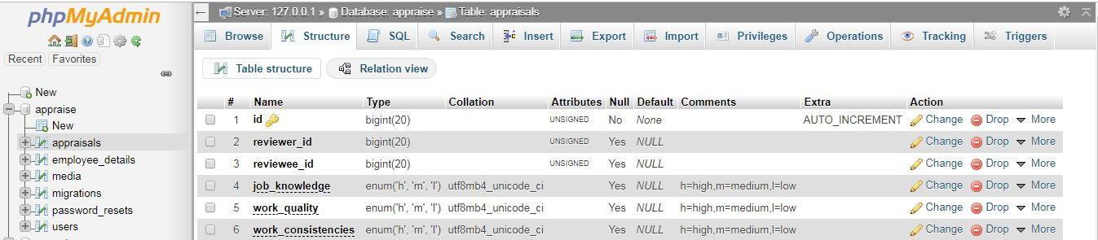

.

Fig 4.2 Database

The specification for the user table is shown in fig 4.3. In this table, the attributes used are id, email, name, and password, with data types of integer and variable character for storing alpha numeric character.

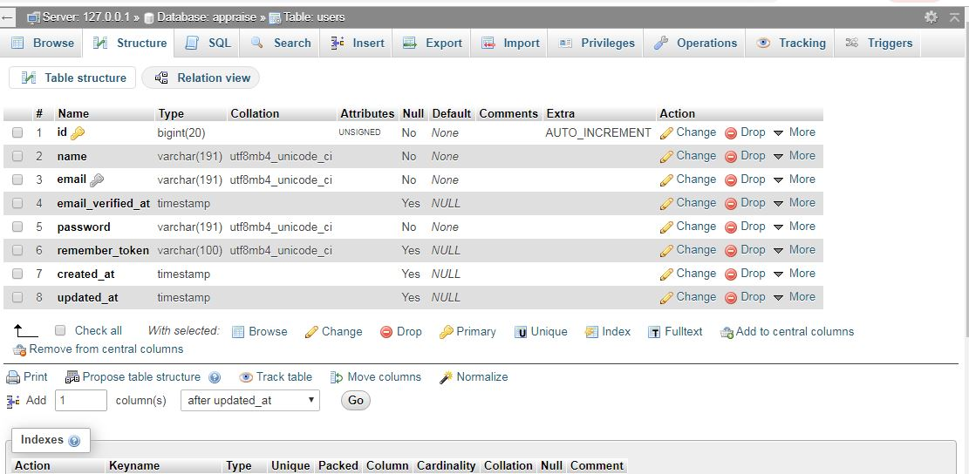

Fig 4.3 Users Table

The specification for the main ‘appraisal’ table is shown in Fig 4.4. In this table, the attributes used are id for the appraisal table as primary key and reviewer and reviewee id as foreign keys other attributes are the evaluation parameters like work quality, attitude and so on.

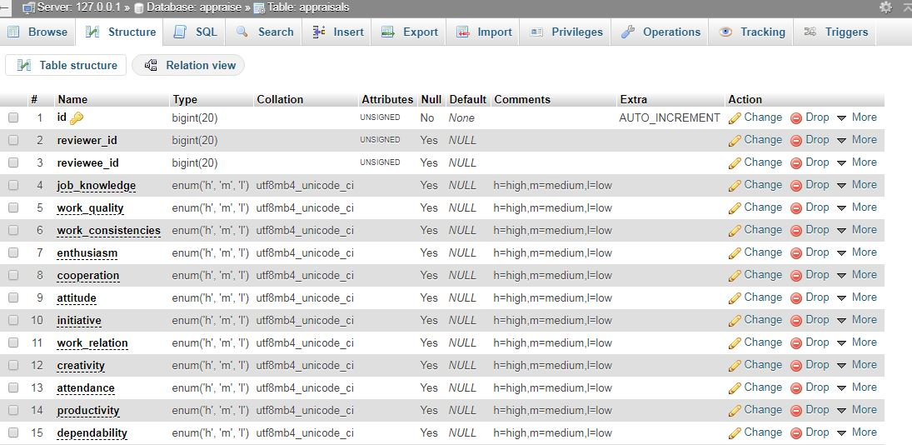

Fig 4.4 Appraisal Table

**4.5 Input/Output Screen/Format**

The input screen format shows the screen shot of the entire input format in the program. The first input screen is the login page where the user (admin or staff) login to his/her dashboard.

This is shown in figure 4.5.

4.5.1 Login Module

In other to carry out any activity on the plateform a user(admin/staff) needs to be authenticated The user is required to enter his/her username(email) and password and from here if authentication is successful, is redirected to the dashboard.

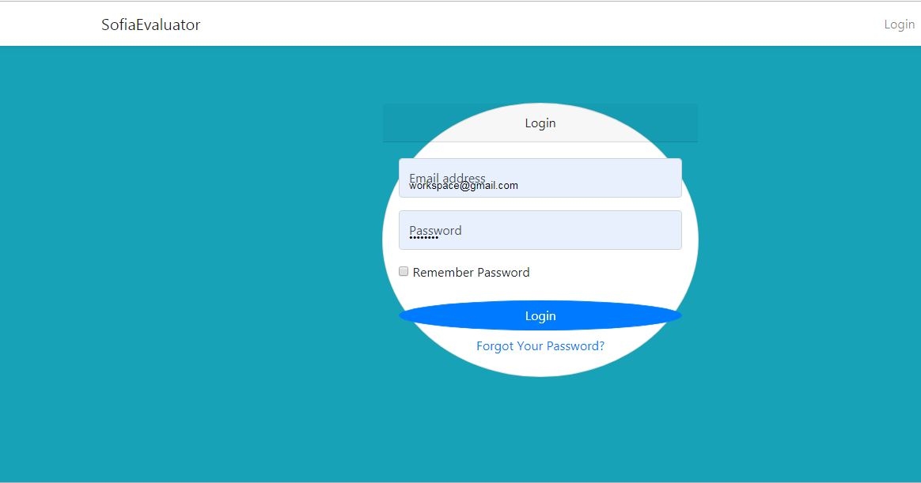

Fig 4.5 Login Module

4.5.2 Evaluation Module

This page displays the information about the staff to be evaluated and an evaluation form for the staff to be evaluated.

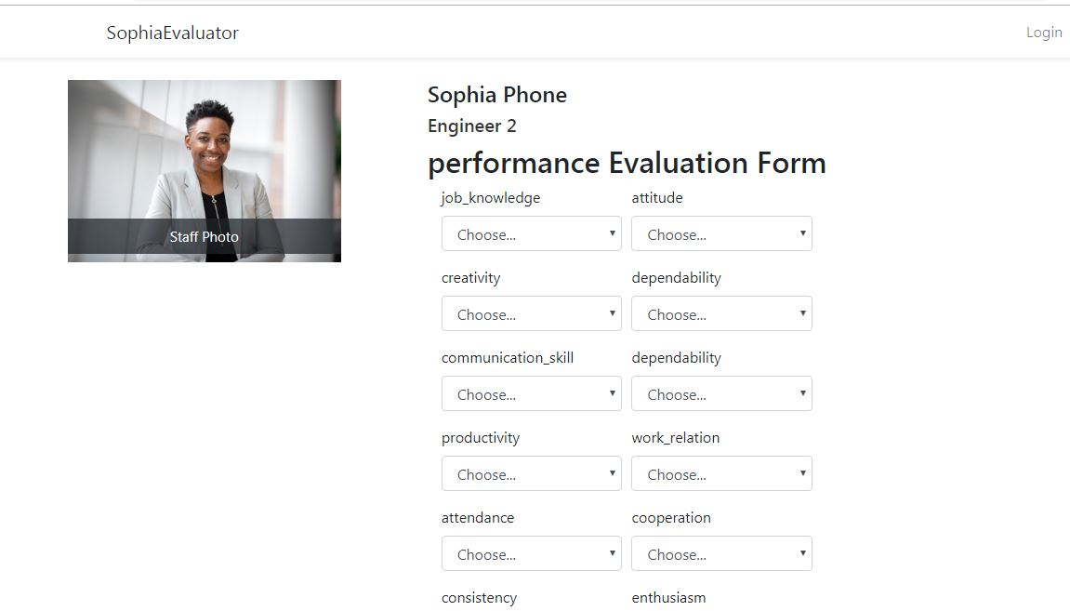

Fig 4.6 Evaluation Form

4.5.3 Registration Module

This is the form with which staffs are registered by the admin, no one except the plateform admin have access to this form.

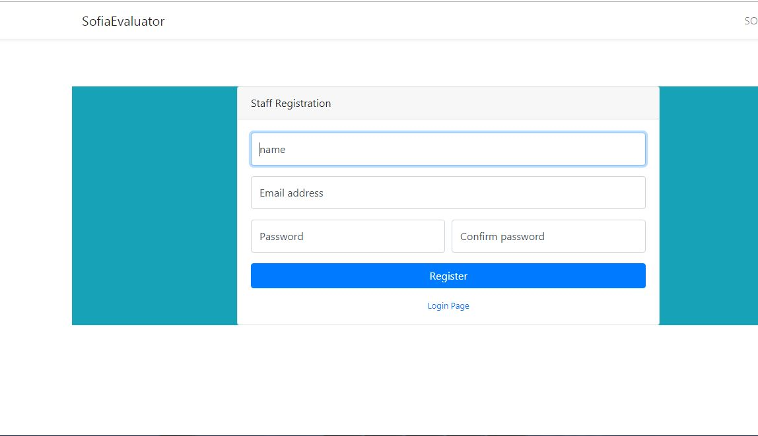

Fig 4.7 Staff Registration Form

4.5.4 Admin dashboard: Staff Table

This is the page in the admin dashboard where the admin can view the list of staff and select to view their evaluation results

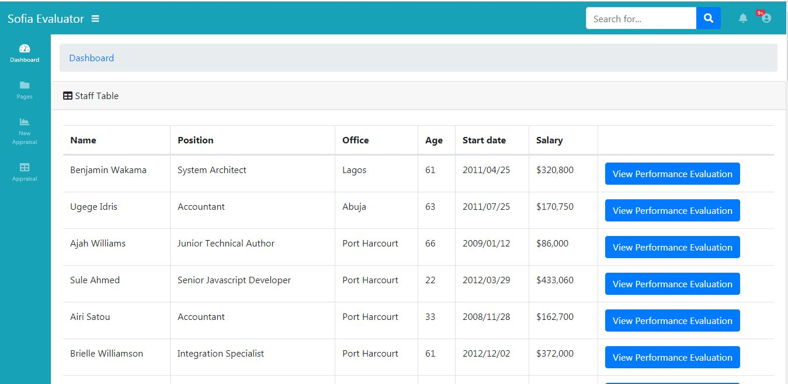

Fig 4.8 Admin Dashboard: Staff table

4.5.5 Staff Profile: Evaluation Details Page

This is the evaluation result page, the page displays the image of the user, his/her employment details and most importantly, the evaluation result for the employee

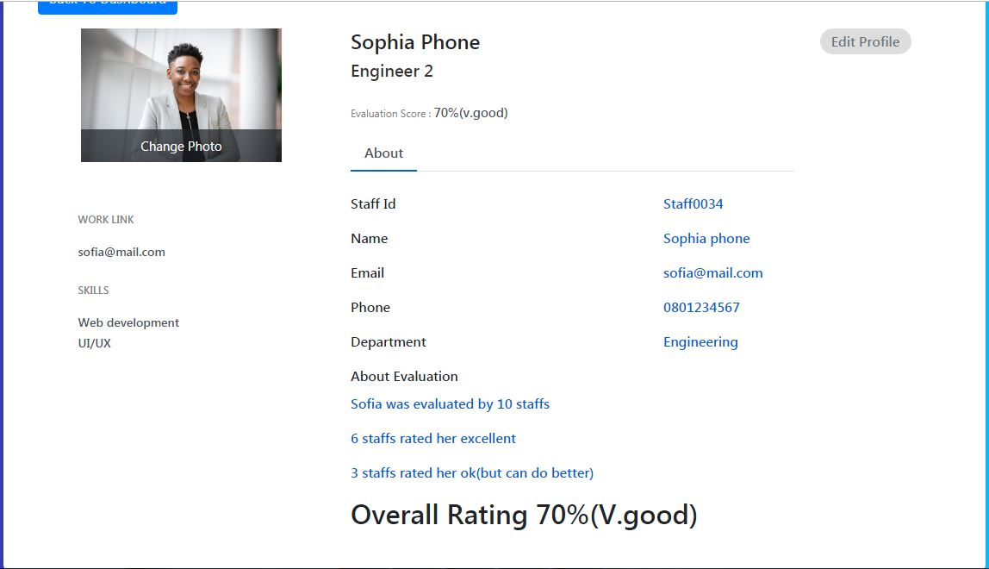

Fig 4.9 Staff Evaluation Result.

**4.6 Hardware And Operating System Requirement**

The hardware and Software system needed to run the program include

4.6.1 Hardware Specifications

1. Processor Name: Intel Dual Core / AMD
2. Processor Speed: 1.66 GHz
3. RAM: 1 GB
4. Hard Disk Capacity: 50 GB
5. Display Device: 14’ to 19’ Inch Monitor
6. Keyboard Type: PS2 or USB
7. Mouse Type: PS2 or USB

4.6.2 Software Specifications:

1. Language Used: HTML, PHP,CSS,JAVASCRIPT, SQL
2. Software Used: MySql,xampp Server ,Php
3. Operating System: Windows XP/ Windows 7/ Windows8 / windows10/Linux

**4.7 Software Testing**

Testing is the process of running a system with the intention of finding errors. Testing enhances the integrity of a system by detecting deviations in design and errors in the system. Testing aims at detecting error-prone areas. This helps in the prevention of errors in a system. Testing also adds value to the product by conforming to the user requirements. The main purpose of testing is to detect errors and error-prone areas in a system. Testing must be thorough and well-planned. A partially tested system is as bad as an untested system. And the price of an untested and under-tested system is high.

The implementation is the final and important phase. It involves user-training, system testing in order to ensure successful running of the proposed system. The user tests the system and changes are made according to their needs. The testing involves the testing of the developed system using various kinds of data. While testing, errors are noted and correctness is the made.

The objectives of testing are:

1. Testing is a process of executing a program with the intent of finding errors.
2. A successful test case is one that uncovers an as yet undiscovered error.

System testing is a stage of implementation, which is aimed at ensuring that the system works accurately and efficiently as per the user need, before the live operation commences. As stated before, testing is vital to the success of a system. System testing makes a logical assumption that if all parts of the system are correct, the goal will be successfully achieved. A series of tests are performed before the system is ready for the user acceptance test.

4.7.1 Testing Methods

System testing is the stage of implementation. This is to check whether the system works accurately and efficiently before live operation commences. Testing is vital to the success of the system. The candidate system is subject to a variety of tests: on line response, volume, stress, recovery, security and usability tests. A series of tests are performed for the proposed system is ready for user acceptance testing. The testing Steps are:

1. Unit Testing;Unit testing focuses efforts on the smallest unit of software design. This is known as module testing. The modules are tested separately. The test is carried out during programming stage itself. In this step, each module is found to be working satisfactory as regards to the expected output from the module.
2. Integration Testing

Data can be lost across an interface. One module can have an adverse effect on another, sub functions, when combined, may not be linked in desired manner in major functions. Integration testing is a systematic approach for constructing the program structure, while at the same time conducting test to uncover errors associated within the interface. The objective is to take unit tested modules and builds program structure. All the modules are combined and tested as a whole.

1. Validation

At the culmination of the integration testing, software is completely assembled as a package. Interfacing errors have been uncovered and corrected and a final series of software test begin in validation testing. Validation testing can be defined in many ways, but a simple definition is that the validation succeeds when the software functions in a manner that is expected by the customer. After validation test has been conducted, one of the three possible conditions exists.

a. The function or performance characteristics confirm to specification and are accepted.

b. A deviation from specification is uncovered and a deficiency lists is created.

c. Proposed system under consideration has been tested by using validation test and found to be working satisfactory.

1. Output Testing

After performing the validation testing, the next step is output testing of the proposed system, since no system could be useful if it does not produce the required output in a specific format. The output format on the screen is found to be correct. The format was designed in the system design time according to the user needs. For the hard copy also; the output comes as per the specified requirements by the user. Hence output testing did not result in any correction for the system.

1. User Acceptance Testing

User acceptance of a system is the key factor for the success of any system. The system under consideration is tested for the user acceptance by constantly keeping in touch with the prospective system users at the time of developing and making changes whenever required.

**CHAPTER FIVE**

**SUMMARY, CONCLUSION AND RECOMMENDATIONS**

**5.1 Summary**

In this work, the online employee performance evaluation system was developed using the fuzzy logic algorithm, the system was design to be as transparent as possible and to avoid all the loopholes in existing systems as discussed in previous chapters, the process of decision making are all encapsulated within the system’s logic and abstracted from the users, the user fill and submit the evaluation form and the system takes over from they, without any external interference. The system was proposed to work side by side the existing system that uses less advanced method for evaluation. The pros and cons of both systems were discussed and a suitable module was developed to aid in the employee performance evaluation process. An application was developed to show the proof of concept and from the result; the system is noted to have performed well.

**5.2 Conclusion**

The fuzzy logic based staff performance evaluation system was developed and from the series of test carried out on the system was proven to be an effective tool in carrying out performance evaluation of staffs.

**5.3 Recommendation**

In this work the fuzzy logic algorithm was used to perform evaluation on employee’s by collecting data input every time the evaluation is to be carried out, we recommend that in addition to carrying out just evaluation, the system can be improved upon to also predict if an employee will improve over time or not, based on previous evaluation outcomes.