Contents

CHAPTER ONE 2

INTRODUCTION 2

1.0Background Of The Study 2

1.1 Problem Statement 3

1.2 Aim And Objectives Of The Study 3

1.3 Significance Of The Study 3

1.4 Scope Of The Study 4

1.5 Limitations Of The Study 4

1.6 Definition Of Terms 5

CHAPTER TWO 6

LITERATURE REVIEW 6

2.0 Introduction 6

2.1 History Of Performance Evaluation 7

2.2 Traditional Methods Of Performance Appraisal 9

2.2.1 Rating Scales Method 9

2.2.3 Ranking Method 12

2.2.3.1 Why Ranking Method 12

2.2.4 Paired Comparison 13

2.2.5 Critical Incidents Location 13

2.2.6 Checklist Method . 13

2.3 Modern Method Of Appraisal 14

2.3.1 Assessment Centres 14

2.4 Performance Evaluation Criticism 17

2.5 Decision Support System 18

2.6 Fuzzy Logic 19

2.6.1 Fuzzy System 20

2.6.1.1 Fuzzy Inference 20

2.6.2 Early Applications Of Fuzzy Logic 21

2.6.3 Why Fuzzy Logic 22

2.6.4 Drawbacks OF Fuzzy Logic 22

2.7 Related Works 22

CHAPTER THREE 26

SYSTEM ANALYSIS, DESIGN AND METHODOLOGY 26

3.0 INTRODUCTION 26

3.1 Analysis Of The Existing System 26

3.1.2 Advantages Of The Existing System 26

3.1.3 Disadvantages Of The Existing System 27

3.2 Analysis Of The Proposed System 27

3.2.1 Advantages Of The Proposed System 28

3.2.2 Disadvantages Of The Proposed System 28

3.3 System Design 29

3.3.1 System Development Methodology 29

3.3.2 Proposed System Architecture 30

3.4 Software Requirements 34

3.4.1 Software Tools Used 34

3.5 Hardware Requirements 37

CHAPTER FOUR 38

SYSTEM DESIGN AND IMPLEMENTATION 38

4.1 Introduction 38

4.2 Objectives Of The New System 38

4.3 Landing Page (Home Page) 38

4.4 Database Specifications 39

4.5 Input/Output Screen/Format 40

4.5.1 Login Module 41

4.5.2 Evaluation Module 41

4.5.3 Registration Module 42

4.5.4 Admin dashboard: Staff Table 43

4.5.5 Staff Profile: Evaluation Details Page 43

4.6 Hardware And Operating System Requirement 44

4.6.1 Hardware Specifications 44

4.7 Software Testing 45

CHAPTER FIVE 48

SUMMARY, CONCLUSION AND RECOMMENDATIONS 48

5.1 Summary 48

5.2 Conclusion 48

5.3 Recommendation 48

References 49

Appendix 52

**CHAPTER ONE**

## **INTRODUCTION**

## **1.0Background Of The Study**

Performance evaluation refers to all the formal procedures used to evaluate an individual, his contributions and potential. In other words, it is to plan and measure the performance of an individual in terms of the requirement of the job or it is a process of finding out how effective the organization has been at hiring and placing an employee.

Performance evaluation or appraisal is a formal system of review and evaluation of individual or team task performance. While evaluation of team performance is critical when teams exist in an organization, the focus of performance appraisal in most firms remains on the individual employees. Regardless of the emphasis, an effective appraisal evaluates accomplishments and initiates plans for development, goals and objectives.

In this information technology era, employee appraisal and assessment can be evaluated using software systems. This will enable information about the performance of employees to be easily evaluated and saved to a database for future retrieval.

In this research, we are proposing a web-based performance evaluation system that is transparent and reliable. The evaluation method that we will be using is the Rating Scale Method where attributes like attitude, performance on a job, regularity, accountability, and sincerity, etc are rated on a scale of one to ten, a rating score of one indicates a very negative feedback, while ten indicates very positive feedback , the feedback will be got from the employee’s colleagues, customers, superiors and subordinates. (Archer, 2000).

## 1.1 Problem Statement

The System of evaluation currently in use by most organisations is more like an electronic equivalent of the manual method of performance evaluation, the system is basically a repository of appraisal data for management to use in decision making, the system has no internal mechanism for making sense of the data stored in its database.

## 1.2 Aim And Objectives Of The Study

The aim of the study is to develop a web-based performance evaluation system for employee management. The following are the objectives of the study:

1. To develop a computerized system to aid in the evaluation of employee performance.
2. To design a system that will make the finding of employee performance information easy.
3. To implement a database system that will maintain records of employee performance.  
     
   .

## 1.3 Significance Of The Study

The study is significant to progressive organizations because it will provide an online system that will aid in maintaining an accurate record of employee performance, it will provide a system that will enable information related to employee performance to be easily retrieved. The study will also serve as useful reference material to other researchers seeking similar information.

## 1.4 Scope Of The Study

This study covers the implementation of a performance evaluation system for employee management, the proposed system can:

1. Store staff performance information in the database.
2. Can process staff data to determine performance level.
3. Can make a decision and recommend actions to be taken based on the conclusion reached

## 1.5 Limitations Of The Study

The proposed system has the following limitations:

1. The proposed system does not enforce the auditing of performance information of the employee and hence does not totally eliminate bias in the data.
2. Very limited access to employee dataset to use as training data.
3. The time frame for start to completion of the research work is very limited and hence we could not go into some depth of the study.

## 1.6 Definition Of Terms

**Appraisal:** evaluation or judgment or opinion of something or somebody, especially one that assesses effectiveness or usefulness

**Performance Appraisal:** Performance appraisal is a review and discussion of an employee’s performance of assigned duties and responsibilities.

**Training:** The process of teaching or learning a skill or job to become more effective or productive in the execution of one or more task.

**Employees:** Refers to a paid worker in a private organization or public parastatal.

**Performance:** Pertains to working effectiveness, the way in which somebody does a job, judged by its effectiveness

**Assessment Evaluation:** a judgment about something based on an understanding of the situation.

**Decision support system:** an information system that supports business or organizational decision-making activities.

**Algorithm:** a process or set of rules to be followed in calculations or other problem-solving operations, especially by a computer.

**Decision:** a conclusion or resolution reached after consideration.

**Database:** a structured set of data held in a computer, especially one that is accessible in various ways.

**Fuzzy Logic:** this is an approach to computing based on "degrees of truth" rather than the usual "true or false" (1 or 0) Boolean logic on which the modern computer is based

**Knowledge-Base:** the underlying set of facts, assumptions, and rules which a computer system has available to solve a problem.

**Method:** a particular procedure for accomplishing or approaching something, especially a systematic or established one.

**Rating:**a measurement of how good or popular someone or something is.

**Programming:** this involves tasks such as analysis, generating algorithms, profiling algorithms' accuracy and resource consumption, and the implementation of algorithms in a chosen.

**PHP:** stands for Hypertext Preprocessor, a server-side scripting language for building dynamic web applications.

# CHAPTER TWO

## LITERATURE REVIEW

## 2.0 Introduction

A performance appraisal (PA) or performance evaluation is a systematic and periodic process that assesses an individual employee’s job performance and productivity, in relation to certain pre-established criteria and organizational objectives. Other aspects of individual employees are considered as well, such as organizational citizenship behaviour, accomplishments, potential for future improvement, strengths, and weaknesses (Manasa & Reddy, 2009). A PA is typically conducted annually. However, the frequency of evaluation, and policies concerning them, varies widely from workplace to workplace. Sometimes an evaluation will be given to a new employee when a probationary period ends, after which they may be conducted on a regular basis (such as every year). Usually, the employee’s supervisor (and frequently, a more senior manager) is responsible for evaluating the employee, and he or she does so by scheduling a private conference to discuss the evaluation. The interview functions as a way of providing feedback to employees, counselling and developing employees, and conveying and discussing compensation, job status, or disciplinary decisions.

## 2.1 History Of Performance Evaluation

The history of performance Evaluation is relatively recent. (North, Intoduction To Performance Appraisal, 2010) Its can be traced to Taylor's pioneering Time and Motion studies. But this is not very helpful, for the same may be said about almost everything in the field of modern human resources management.

As a distinct and formal management procedure used in the evaluation of work performance, appraisal really dates from the time of the Second World War - not more than 60 years ago. Yet in a broader sense, the practice of appraisal is a very ancient art. In the scale of things historical, it might well lay claim to being the world's second-oldest profession! There is, says Dulewicz (Dulewicz, 1989)"... a basic human tendency to make judgements about those one is working with, as well as about oneself."

Appraisal, it seems, is both inevitable and universal. In the absence of a carefully structured system of appraisal, people will tend to judge the work performance of others, including subordinates, naturally, informally and arbitrarily. The human inclination to judge can create serious motivational, ethical and legal problems in the workplace. Without a structured appraisal system, there is little chance of ensuring that the judgements made will be lawful, fair, defensible and accurate. Performance appraisal systems began as simple methods of income justification. That is, an appraisal was used to decide whether or not the salary or wage of an individual employee was justified.

The process was firmly linked to material outcomes. If an employee's performance was found to be less than ideal, a cut in pay would follow.

On the other hand, if their performance was better than the supervisor expected, a pay rise was in order.

Little consideration, if any, was given to the developmental possibilities of the appraisal. It was felt that a cut in pay, or rise, should provide the only required impetus for an employee to either improve or continue to perform well. Sometimes this basic system succeeded in getting the results that were intended; but more often than not, it failed.

Institutionalization of performance appraisal started as far back as the industrial revolution when it was used as a means of measuring organizational efficiency (Fandray, 2001). (Wren, 1994) affirmed that Performance appraisal was incepted when Robert Owen used a wooden coloured block to measure the achievement of employees working in the cotton Mills in Scotland at the close of work hours. During that era, it was utilized as a disciplinary mechanism for punishing poor performance (Kennedy & Dresser, 2001). This resulted in the negative notation of the appraisal system which turned out to be despised by both the appraiser and the appraisee. As confirmed by (Robert & Pregitzer, 2007) “performance appraisal is a yearly rite of passage in organizations that triggers dread and apprehension in the most experienced, battle-hardened manager”. The above quote summarizes the extent to which the appraisal process is disliked by the evaluators. Subsequently, organizations tried to refine the methods linking it to other administrative matters including reward, promotion, training and so forth, arguing that employees achievements should not only be measured but evaluated and managed (Kennedy & Dresser, 2001). Despite the historical perspective, an appraisal is both inevitable and universal. There has been much analysis and wide criticisms of the effectiveness and use of performance appraisal within the organizational context but up to recent times, the issue is still being debated among scholars, academicians and professionals.

## 2.2 Traditional Methods Of Performance Appraisal

### 2.2.1 Rating Scales Method

Rating Scales Method is a commonly used method for assessing the performance of the employees and well-known traditional method of performance appraisal of employees (Archer, performance-appraisal.com, 2000). Many corporations and companies example in the country India, telecommunications company likely airtel and US IT companies like Dell Corporation are using this method for evaluating the employees and subsequently take decisions on the concerned employee.

Depending upon the job of an employee under this method of appraisal traits like attitude, performance, regularity, accountability, and sincerity, etc, are rated with the scale from 1 to 10. 1 indicates negative feedback and 10 indicates positive feedback as shown below.

The attitude of the employee towards his superiors, colleagues, and customers

|  |  |  |  |  |  |  |  |  |  |
| --- | --- | --- | --- | --- | --- | --- | --- | --- | --- |
| 1 | 2 | 3 | 4 | 5 | 6 | 7 | 8 | 9 | 10 |

Extremely Excellent poor

Regularity in the job

|  |  |  |  |  |  |  |  |  |  |
| --- | --- | --- | --- | --- | --- | --- | --- | --- | --- |
| 1 | 2 | 3 | 4 | 5 | 6 | 7 | 8 | 9 | 10 |

Extremely                                                                                    Excellent

poor

Under this method of performance appraisal, an employee may be assessed by his superiors, colleagues, subordinates or sometimes by his customers which all depends on nature of the company or job which is added where the employee. An appraiser is a person who appraises employee will give a rating for every trait given by marking or choosing a number based on his observation and satisfaction. ultimately all numbers chosen or marked will be added to determine the highest score gained by an employee. An employee who scored more points will be treated as a top performer following  descending scored employees will be treated as a low performer and the least scored employee will be treated as non-performers

### 2.2.2 Essay Appraisal Method

This traditional form of appraisal, also known as “Free Form method” involves a description of the performance of an employee by his superior. The description is an evaluation of the performance of any individual based on the facts and often includes examples and shreds of evidence to support the information. A major drawback of the method is the inseparability of the bias of the evaluator.   
  
Under this method, the rater is asked to express the strong as well as weak points of the employee’s behaviour. This technique is normally used with a combination of the graphics rating scale because the rater can elaborately present the scale by substantiating an explanation for his rating. While preparing the essay on the employee, the rater considers the following factors: 

1. Job knowledge and potential of the employee;
2. Employee’s understanding of the company’s programmes, policies, objectives, etc.;
3. The employee’s relations with co-workers and superiors.

How is technology helping transform performance appraisal and management?  
The most common cliché is “performance appraisal is dead“. What it means is the annual performance appraisal is dead and most organizations today are adopting regular, real-time, anecdotal and casual feedback. Just as young people do not write e-mails anymore they WhatsApp similarly we don't have to write a long performance appraisal at the end of the year. Companies are moving to real-time performance appraisal and that is why in our system everything is shareable and real-time. And technology plays the most crucial role in providing the platform to have fast and quick and informal communication.

1. The employee’s general planning, organizing and controlling ability;
2. The attitudes and perceptions of the employee, in general.

Essay evaluation is a non-quantitative technique. This method is advantageous in at least one sense, i.e., the essay provides a good deal of information about the employee and also reveals more about the evaluator. The essay evaluation method, however, suffers from the following limitations:

1. It is highly subjective; the supervisor may write a biased essay. The employees who are sycophants will be evaluated more favourably than other employees.
2. Some evaluators may be poor in writing essays on employee performance. Others may be superficial in explanation and use flowery language which may not reflect the actual performance of the employee. It is very difficult to find effective writers nowadays.

The appraiser is required to find time to prepare the essay. A busy appraiser may write the essay hurriedly without properly assessing the actual performance of the worker. On the other hand, the appraiser takes a long time, this becomes uneconomical from the viewpoint of the firm, because the time of the evaluator (supervisor) is costly.

### 2.2.3 Ranking Method

Under the ranking method, the manager compares an employee to other similar employees, rather than to a standard measurement. An offshoot of ranking is the forced distribution method, which is similar to grading on a curve. Predetermined percentages of employees are placed in various performance categories, for example, excellent, above average, average, below average, and poor, The employees ranked in the top group usually get the rewards (raise, bonus, promotion), those not at the top tend to have the reward withheld, and those at the bottom sometimes get punished.

### 2.2.3.1 Why Ranking Method

Managers have to make evaluative decisions, such as who is the employee of the month, who gets a raise or promotion, and who gets laid off. So when we have to make evaluative decisions, we generally have to use ranking. However, our ranking can, and when possible should be based on other methods and forms. Ranking can also be used for developmental purposes by letting employees know where they stand in comparison to their peers—they can be motivated to improve performance (Archer, performance-appraisal.com, 2000).

### 2.2.4 Paired Comparison

A better technique of comparison than the straight ranking method, this method compares each employee with all others in the group, one at a time. After all the comparisons on the basis of the overall comparisons, the employees are given the final rankings.

### 2.2.5 Critical Incidents Location

This technique of performance appraisal was developed by Flanagan and Burns (Flanagan, 1954). The manager prepares lists of statements of very effective and ineffective behaviour of an employee. These critical incidents or events represent the outstanding or poor behaviour of employees on the job. The manager maintains logs on each employee, whereby he periodically records critical incidents of the workers' behaviour. At the end of the rating period, these recorded critical incidents are used in the evaluation of the workers’ performance.

### 2.2.6 Checklist Method The rater is given a checklist of the descriptions of the behaviour of the employees on the job. The checklist contains a list of statements on the basis of which the rater describes the on the job performance of the employees.

1. Another simple type of individual evaluation method is the checklist. A checklist represents, in its simplest form, a set of objectives or descriptive statements about the employee and his behaviour. If the rater believes strongly that the employee possesses a particular listed trait, he checks the item; otherwise, he leaves the item blank. A more recent variation of the checklist method is the weighted list. Under this, the value of each question may be weighted equally or certain questions may be weighted more heavily than others. The following are some of the sample questions in the checklist.
2. Is the employee really interested in the task assigned?
3. Is he/she respected by his colleagues (co-workers)
4. Does he/she give respect to his superiors?
5. Does he/she follow instructions properly?
6. Does he/she make mistakes frequently?

## 2.3 Modern Method Of Appraisal

With time and technology, workplaces have evolved drastically and needed better appraisal methods than the traditional methods of performance appraisal. It’s been observed that traditional methods lay more emphasis on rating individual’s personality traits, whereas the modern methods of performance appraisal lay more emphasis on the evaluation of job achievements, which is more objective and worthwhile.

### 2.3.1 Assessment Centres

An assessment centre is a place to evaluate an individual potentiality and performance, so as to position he/she in the core functional areas in an organisation. normally, organisations outsource assessment centres instead of making them on their own.

This method of performance appraisal is being opted by the RBI (Reserve Bank of India) for assessment of its officers (Saumya, 2019).

An assessment centre typically involves the use of methods like social/informal events, tests and exercises, assignments being given to a group of employees to assess their competencies to take higher responsibilities in the future. Generally, employees are given an assignment similar to the job they would be expected to perform if promoted. The trained evaluators observe and evaluate employees as they perform the assigned jobs and are evaluated on job-related characteristics.   
  
The major competencies that are judged in assessment centres are interpersonal skills, intellectual capability, planning and organizing capabilities, motivation, career orientation etc. assessment centres are also an effective way to determine the training and development needs of the targeted employees.   
  
Nearly 30% of companies seek assessment centre services while moving an employee from an executive position to a managerial position. 20% of companies said they use the centre's services when seeking a position on senior management level (North, 2000).

**2.3.2** Behaviourally **Anchored Rating Scales**  
  
Behaviorally Anchored Rating Scales (BARS) is a relatively new technique which combines the graphic rating scale and critical incidents method. It consists of predetermined critical areas of job performance or sets of behavioural statements describing important job performance qualities as good or bad (for example the qualities like inter-personal relationships, adaptability and reliability, job knowledge etc). These statements are developed from critical incidents.   
  
In this method, an employee’s actual job behaviour is judged against the desired behaviour by recording and comparing the behaviour with BARS. Developing and practising BARS requires expert knowledge.  
  
A behaviorally anchored rating scale is an employee appraisal system where raters distinguish between successful and unsuccessful job performance by collecting and listing critical job factors. These critical behaviours are categorized and appointed a numerical value which is used as the basis for rating performance.

**2.3.3 Human** Resource **Accounting Method**  
  
Human Resource Accounting is a method to measure the effectiveness of personnel management activities and the use of people in an organization.HRA is the process of Assigning, budgeting, and reporting the cost of human resources incurred in an organization, including wages and salaries and training expenses.  
  
Human resources are valuable assets for every organization. Human resource accounting method tries to find the relative worth of these assets in terms of money. In this method, the Performance appraisal of the employees is judged in terms of the cost and contribution of the employees. The cost of employees include all the expenses incurred on them like their compensation, recruitment and selection costs, induction and training costs etc whereas their contribution includes the total value added (in monetary terms). The difference between the cost and the contribution will be the performance of the employees. Ideally, the contribution of the employees should be greater than the cost incurred on them.

**2.3.4 Customer** Feedback **Method**

This method is truly one of the modern methods of the performance appraisal system. Customer feedback method is used, especially for sales staff who deal with sales activity in the organisation. Under this method of appraisal system, customer feedback is directly linked with employee performance. This method of assessment could be unbiased and reliable since customers who are outsiders may give correct judgement about employee performance than the insiders who are superiors.  
  
Companies like Cognizant and Wipro software solutions (North, 2000) are using customer feedback method to assess the performance of their sales staff in order to hike salaries.

Some industry experts say placing a higher weightage on customer feedback may fail to motivate employees because customer feedback may vary from customer to customer. Depending on the current state of mind, psychology and perception of the customers may give different feedback for the same degree of sales service.

## 2.4 Performance Evaluation Criticism

An issue with performance appraisals is that differentiating individual and organizational performance can be difficult. And if the evaluation's construction doesn't reflect the culture of a company or organization, it can be detrimental. Employees report general dissatisfaction with their performance appraisal processes (Gary Roberts, 2007). Other potential issues include:

1. Distrust of the appraisal can lead to issues between subordinates and supervisors or a situation in which employees merely tailor their input to please their employer.
2. Performance appraisals can lead to the adoption of unreasonable goals that demoralize workers or incentivize them to engage in unethical practices.
3. Some labour experts believe that the use of performance appraisals has led to lower use of merit- and performance-based compensation (Chen, 2018).
4. Performance appraisals may lead to unfair evaluations in which employees are judged not by their accomplishments but by their likeability. They can also lead to managers giving underperforming staff a good evaluation to avoid souring their relationship.
5. Unreliable raters can introduce a number of biases that skew appraisal results toward preferred characteristics or ones that reflect the rater's preferences.
6. Performance appraisals that work well in one culture or job function may not be useful in another.

## 2.5 Decision Support System

decision support system (DSS) is an information system that supports business or organizational decision-making activities. DSSs serve the management, operations and planning levels of an organization (usually mid and higher management) and help people make decisions about problems that may be rapidly changing and not easily specified in advance—i.e. unstructured and semi-structured decision problems. Decision support systems can be either fully computerized or human-powered or a combination of both.

While academics have perceived DSS as a tool to support decision-making processes, DSS users see DSS as a tool to facilitate organizational processes (Keen & Peter G, 1980). Some authors have extended the definition of DSS to include any system that might support decision making and some DSS include a decision-making software component; (Ralph H. Sprague, 1908) Ralph H. Sprague defines a properly termed DSS as follows:

1. DSS tends to be aimed at the less well structured, underspecified problem that upper-level managers typically face;
2. DSS attempts to combine the use of models or analytic techniques with traditional data access and retrieval functions;
3. DSS specifically focuses on features which make them easy to use by non-computer-proficient people in an interactive mode; and
4. DSS emphasizes flexibility and adaptability to accommodate changes in the environment and the decision making approach of the user.

## 2.6 Fuzzy Logic

Fuzzy logic is a form of many-valued logic in which the truth values of variables may be any real number between 0 and 1 inclusive. It is employed to handle the concept of partial truth, where the truth value may range between completely true and completely false (Novák, Perfilieva, & Močkoř, 1999). By contrast, in Boolean logic, the truth values of variables may only be the integer values 0 or 1.

The term fuzzy logic was introduced with the 1965 proposal of fuzzy set theory by Lotfi Zadeh (Petr, Christian, Fermüller, & Carles, 2006). Fuzzy logic had however been studied since the 1920s, as infinite-valued logic—notably by Łukasiewicz and Tarski (Pelletier & Francis, 2000).

It is based on the observation that people make decisions based on imprecise and non-numerical information, fuzzy models or sets are mathematical means of representing vagueness and imprecise information, hence the term fuzzy. These models have the capability of recognising, representing, manipulating, interpreting, and utilising data and information that are vague and lack certainty (About fuzzy logic, 2018).

### 2.6.1 Fuzzy System

The fuzzy system generally involves three phases of fuzzification, fuzzy inference and defuzzification.

### 2.6.1.1 Fuzzy Inference

Fuzzy inference engine resembles human reasoning in its use of approximate information and uncertainty to generate decisions. It consists of rules, facts and conclusions. The fuzzy production rules connect premises with conclusions, condition with action. In this inference, expert's knowledge and experience was acquired and formulate accordingly to develop the appropriate rule to perform the system. The fuzzy inference can be implemented using the if-then statements. The if-then implementation is the same as that executed in expert systems except that it involves the linguistic variables.

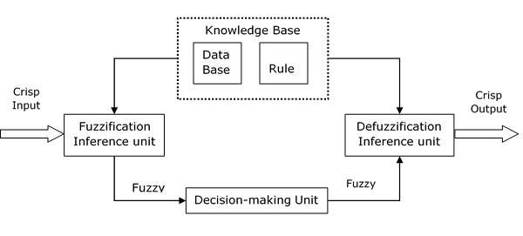

Figure 2.1 Fuzzy Logic Inference System.

#### 2.6.1.2 Fuzzification

Fuzzification is the process of assigning the numerical input of a system to fuzzy sets with some degree of membership. This degree of membership may be anywhere within the interval [0,1]. If it is 0 then the value does not belong to the given fuzzy set, and if it is 1 then the value completely belongs within the fuzzy set. Any value between 0 and 1 represents the degree of uncertainty that the value belongs in the set. These fuzzy sets are typically described by words, and so by assigning the system input to fuzzy sets, we can reason with it in a linguistically natural manner.

#### 2.6.1.3 Defuzzification

Defuzzificationor decomposition involves finding a value that best represents the information contained in the fuzzy set. The implementation of defuzzification is important in order to transform the linguistic terms back into the crisp interpretation. The Defuzzification process yields the expected value of the variable for a particular execution of a fuzzy model.

### 2.6.2 Early Applications Of Fuzzy Logic

Many of the early successful applications of fuzzy logic were implemented in Japan. The first notable application was on the subway train in Sendai, in which fuzzy logic was able to improve the economy, comfort, and precision of the ride (Kosko, 1994). It has also been used in recognition of hand-written symbols in Sony pocket computers, flight aid for helicopters, controlling of subway systems in order to improve driving comfort, precision of halting, and power economy, improved fuel consumption for automobiles, single-button control for washing machines, automatic motor control for vacuum cleaners with recognition of surface condition and degree of soiling, and prediction systems for early recognition of earthquakes through the Institute of Seismology Bureau of Meteorology, Japan (Bansod, Kulkarni, & Patil, 2005).

### 2.6.3 Why Fuzzy Logic

The major advantages of the fuzzy logic system over other decision support logic are:

1. Similar to human reasoning
2. Based on the linguistic model
3. Using simple mathematics for nonlinear, integrated and complex systems
4. High precision
5. The ease of implementation
6. Able to manage troubles associated with inaccurate data

### 2.6.4 Drawbacks OF Fuzzy Logic

1. For more accuracy, you need more fuzzy grades, which results in an exponential increase in the rule.
2. Usually lacks real-time responds.
3. A restricted number of usage of input variables

## 2.7 Related Works

Jayanthi et al (Jayanthi, Goyal, & Ahson, 2008) presented the role of data mining in Human Resource Management Systems (HRMS). A deep understanding of the knowledge hidden in Human Resource (HR) data is vital to a firm's competitive position and organizational decision making. Analyzing the patterns and relationships in HR data is quite rare. The HR data is usually treated to answer queries. Because HR data primarily concerns transactional processing (getting data into the system, recording it for reporting purposes) it is necessary for HRMS to become more concerned with the quantifiable data. They show how data mining discovers and extracts useful patterns from this large data set to find observable patterns in HR. The paper demonstrates the ability of data mining in improving the quality of the decision-making process in HRMS and gives propositions regarding whether data-mining capabilities should lead to increased performance to sustain competitive advantage.

Hamidah et al (Hamidah, AbdulRazak, & O, 2009), in their work, described the background of data mining, data mining in human resource application and an overview of talent management. Their literature study reveals that most researchers have discussed HR applications from a different type of application. However, there should be more HR applications and Data Mining techniques applied to different problem domains in HRM field research in order to broaden our horizon of academic and practice work on HR applications using Data Mining techniques. Due to these reasons, they proposed the suitable Data Mining techniques for performance prediction based on an initial experiment. They suggested for future work that the data in HR can be tested using other Data Mining techniques to find out the best accuracy of the techniques, especially for talent management data. Besides that, the relevance of attributes should be considered as a factor to the accuracy of the classifier. It was also suggested that in future experiment, attribute reduction experiment should take place in order to choose the relevant attributes for each of the factor. Once the relevant attributes are attained, the next modelling steps can be established to recommend. Finally, the ability to continuously change and obtain new understanding is the power of HR application, and this can be the HR applications of future work.

Nagadevara et al (Nagadevara, Srinivasan, & Valk, 2008), explored the relationship of withdrawal behaviours like lateness and absenteeism, job content, tenure and demographics on employee turnover in a rapidly growing sector like the Indian software industry. The unique aspect of this research was the use of five predictive data mining techniques (artificial neural networks, logistic regression, classification and regression trees, classification trees (C5.0), and discriminant analysis) on a sample data of 150 employees in a large software organization. The results of the study clearly show a relationship between withdrawal behaviours and employee turnover. This study raised several issues for future research. First, further research could explicitly collect data on demographic variables across a large sample of organizations to examine the relationship between demographic variables and turnover. Second, large scale data on variables in the past academic research which have a relationship with turnover can be collected longitudinally.

Such a data set will allow for more rigorous analysis and also a refined prediction model. Third, the context-specific variables of employee turnover which emerged from this study would warrant a deeper understanding of the phenomena. There is a need for more empirical research and in particular, longitudinal research using data within corporations to refine the model. Last, more research needs to be conducted on various samples to confirm the validation of the theoretical model and the prediction model proposed in the study.

Wei-Chiang and Ruey-Ming (Wie-Chiang & Ruey-Ming, 2007), in their work explored the feasibility of applying the *Logit* and *Probit* (Moore, 2007)models, which have been successfully applied to solve nonlinear classification and regression problems, to employee voluntary turnover predictions. A numerical example involving voluntary turnover data of 150 professional employees drawn from a motor marketing enterprise in central Taiwan was used with a usable sample size of 132. The data set was divided into two parts, the modelling dataset and the testing data set. The modelling data set was used to test the *logit* and *probit* models. The testing data set was not used for either model building or selection and was used for estimating model performance when applied to future data. The empirical results of their investigation revealed that the proposed models have high prediction capabilities and that the two (*logit* and *probit) models* also provide a promising alternative for predicting employee turnover in human resource management. The authors suggested that turnover research should move in new directions based on new assumptions and methodologies, which would raise new issues and problems (such as the use of neural networks and support vector machines to conduct classification problem for detecting stayer or leaver).

# CHAPTER THREE

## SYSTEM ANALYSIS, DESIGN AND METHODOLOGY

## 3.0 INTRODUCTION

This chapter is dedicated to the overview of the system design and the entire research work; the design patterns and methodologies used to implement the system will be discussed in clear enough details.

System analysis is a process of collecting and interpreting facts, identifying the problems, and decomposition of a system into its components

## 3.1 Analysis Of The Existing System

The existing system of performance evaluation is an electronic system just like the proposed system, but unlike the proposed system the existing system is very rigid and most of the system is still controlled by the management of organizations.

The existing system is more of a direct electronics equivalent of the manual system where paper forms are used, the current system mainly serves as the repository for the various appraisals, the system does not give recommendations based on the analysis of data collected, in most cases, the system does not analyze the data at all it mostly provides a way of visualizing the inputted data.

### 3.1.2 Advantages Of The Existing System

1. Easy access as it is web-based
2. Allows the organisation to use one rating system for all employees.
3. Quicker to fill out than paper appraisal form, which can require having a supervisor answer question from a human resources team member.
4. Is less biased compared to non-electronics methods

### 3.1.3 Disadvantages Of The Existing System

1. What to make out of the appraisal-related data is still very much dependent on management and so still very much prone to bias.
2. The existing system does not provide a mechanism for analysing data and giving feedback based on the analysis, all that is still mostly done manually.
3. Transparency is still an issue as the data from which the employee is ranked may not be disclosed.

## 3.2 Analysis Of The Proposed System

The proposed system will use a Fuzzy Logic to try and make sense of the data stored in the knowledge base (database), the system will use a normal web form to collect evaluation data from management, staffs and customers about a particular staff, the data is stored in the database using a scripting language (PHP in this case), the form fields will be in a questioner with the following questions

1. Is the employee really interested in the task assigned?
2. Is he/she respected by his colleagues (co-workers)?
3. Does he/she give respect to his superiors?
4. Does he/she follow instructions properly?
5. Does he/she make mistakes frequently?
6. Are customers satisfied with his/her service rendered?

The questioner will have responds sections of yes, no, not sure and skip, the response will be of varying weight, we will apply fuzzy logic to the response data to reach some reasonable conclusion, the system will display a recommendation that will be used by management, to know the next line of action as it has to do with the employee.

### 3.2.1 Advantages Of The Proposed System

1. The proposed system will more transparent than the existing system as all logic that leads to the system's recommendations are within the system and are not subject to external interference.
2. The proposed system will much more easy to use compared to the existing system, as the system does not only collect and output data but also has a built-in recommendation system that makes decision making a breeze.
3. The use of fuzzy logic also means that the system can handle problems with imprecise and incomplete data
4. The use of fuzzy logic means the system can cover a wider range of operating conditions and can be more readily customizable in natural language terms.

### 3.2.2 Disadvantages Of The Proposed System

1. The proposed system may have some precision related issues, the fuzzy logic may have to deal with a lot of imprecise data and hence only generate an approximate solution
2. The proposed system will not work without internet access
3. The proposed system is quite complex to implement and so require more
4. time and resources than most other decision support systems

## 3.3 System Design

The system design pertains to the layout of the system and it consists of the input and output layout.

We are going to deploy the proposed methodology in developing an online performance evaluation system using Fuzzy Logic which will receive inputs from users and use that data to reach a conclusion about an employee and give a necessary recommendation to management on actions to take.

### 3.3.1 System Development Methodology

A system development methodology (SMD) refers to the framework that is used to structure, plan, and control the process of developing an information system. In this study, we adopted the Object-Oriented Analysis and Design Methodology (OOD). The methodology employed for the development of the system is the OOAD. The OOAD development model comprises the elements of both design and prototyping. The model has four stages namely:

* Planning
* Analysis
* Evaluation
* Development

Object-oriented analysis (OOA): This is the process of defining the problem in terms of an object: a real-world with which the system must interact, and candidate software objects used to explore various solution alternative. The natural fit of programming objects to real-world objects has a big impact here in all real-world objects can be defined in terms of their classes, attribute and operations. Moreover, object-oriented design (OOD) is the process of defining the component, interfaces, objects, classes, attributes, and operations that will satisfy the requirement. You typically start with the candidate object defined during analysis but add much more rigour to their definitions, then you add or change objects as needed to refine a solution.

### 3.3.2 Proposed System Architecture



**Figure3.1 proposed system architecture diagram**

From the above figure, the proposed system will have five key components

1. The appraisal parameter setting: this enables the admin to define the appraisal criteria, criteria like attendance, training attended, conference

conducted etc

1. The Employee appraisal: a user interface, where the evaluation-related data is inputted into the system for evaluation.
2. The employee profile where employee’s detail is displayed and appraisal results.
3. The inference engine system: this consists of several sub-parts, each sub-parts computes one step in order to get the final result of the appraisal process. The sub-processes are:
4. Fuzzification: this were the inputs are change to fuzzy values for manipulations by the inference engine and the fuzzy rule base.
5. Defuzzification: This process computes the final output and change the fuzzy values back to normal human relatable values.
6. An admin backend where the final analysis and result of the fuzzy process are presented for evaluation by management.

**3.3.3** Proposed **system use case diagram**

Management

Employee

**Fig 3.2 Use Case Diagram of the Proposed System**

The Use Case Diagram represents the employee and Admin behaviour. It defines the behaviour of both while using the system. The admin can log in, view the content of the database and the appraisal result, the employee can appraise other employee’s and can be appraised by them as well, he can view his/her own appraisal result, both user types will need to login to the system to carry out any activity on the platform.

**3.3.4** Proposed **System Flow Chart**

**No Yes**

If: Admin

Admin Login

Admin Dashboard

Staff Login

**No Yes**

If: Appraiser

View Appraiser’s input

Manage Users

View Result

databasew

Fill Evaluation Form

View recommendation/ results

Logout

Stop

**Fig 3.3 Proposed System Flow Chart**

Flowcharts are used in designing and documenting complex processes. Like other types of diagrams, they help visualize what is going on and thereby help the viewer to understand a process and perhaps also find flaws, bottlenecks, and other less obvious features within it. The flow chart indicates a step-wise transition of the actions and decisions taken.

## 3.4 Software Requirements

1. Operating system- Windows and mobile operating system is used as the operating system as it is stable and supports more features and is more users friendly.
2. Database MySQL: MySQL is used as the database as it easy to maintain and retrieve records by simple queries which are in English language and easy to understand and to write.
3. Development tools and Programming language- HTML and is used to write the whole code and develop webpages with cascading style sheet, java script for manipulating the document object model(DOM) and hypertext pre-processor (PHP) for sever side scripting.

### 3.4.1 Software Tools Used

The whole Project is divided in two parts the front end and the back end.

**FRONT END:** The front end is designed using of HTML, CSS, and JavaScript

1. **HTML**: Hyper Text Mark-up Language is the main mark-up language for creating web pages and other information that can be displayed in a web browser.HTML is written in the form of HTML elements consisting of tags enclosed in angle brackets (like <html>), within the web page content. The purpose of a web browser is to read HTML documents and compose them into visible or audible web pages. It provides a means to create structured documents by denoting structural semantics for text such as headings, paragraphs, lists, links, quotes and other items. It can embed scripts written in languages such as JavaScript which affect the behaviour of HTML web pages.
2. **CSS**: Cascading Style Sheets (CSS) is a style sheet language used for describing the look and formatting of a document written in a mark-up language. While most often used to style web pages and interfaces written in HTML and XHTML, the language can be applied to any kind of XML document, including plain XML, SVG and XUL. CSS is a cornerstone specification of the web and almost all web pages use CSS style sheets to describe their presentation.CSS is designed primarily to enable the separation of document content from document presentation, including elements such as the layout, colours, and fonts. It can also be used to allow the web page to display differently depending on the screen size or device on which it is being viewed.
3. **JAVASCRIPT**: JavaScript (JS) is a dynamic computer programming language. It is most commonly used as part of web browsers, whose implementations allow client side scripts to interact with the user, control the browser, communicate asynchronously, and alter the document content that is displayed. It is also being used in server-side programming, game development and the creation of desktop and mobile applications. JavaScript is a prototype-based scripting language with dynamic typing and has first- class functions. Its syntax was influenced by C. JavaScript copies many names and naming conventions from Java, but the two languages are otherwise unrelated and have very different semantics. The key design principles within JavaScript are taken from the self and Scheme programming languages. It is a meta-paradigm language, supporting object-oriented, imperative, and functional programming styles.

**BACK END-** The back end is designed using MySQL which is used to design the databases and PHP which is a scripting language for server side.

1. **MYSQL**- MySQL ("My S-Q-L", officially, but also called "My Sequel") is (as of July 2013) the world's second most widely used open-source relational database management system (RDBMS). It is named after co-founder Michael Widenius daughter, My. The SQL phrase stands for Structured Query Language. The MySQL development project has made its source code available under the terms of the GNU General Public License, as well as under a variety of proprietary agreements. MySQL was owned and sponsored by a single for- profit firm, the Swedish company MySQLAB, now owned by Oracle Corporation. MySQL is a popular choice of database for use in web applications, and is a central component of the widely used LAMP open source web application software stack (and other 'AMP' stacks). LAMP is an acronym for "Linux, Apache, MySQL, Perl/PHP/Python." Free-software-open source projects that require a full-featured database management system often use MySQL. For commercial use, several paid editions are available, and offer additional functionality. Applications which use MySQL databases include: TYPO3, MODx, Joomla, WordPress, phpBB, MyBB, Drupal and other software. MySQL is also used in many high-profile, large-scale websites, including Wikipedia, Google (though not for searches), Facebook, Twitter, Flickr, and YouTube.
2. **PHP**- PHP is a server-side scripting language designed for web development but also used as a general-purpose programming language. PHP is now installed on more than 244 million websites and 2.1 million web servers. Originally created by Rasmus Lerdorf in 1995, the reference implementation of PHP is now produced by The PHP Group. While PHP originally stood for Personal Home Page, it now stands for PHP: Hypertext Pre-processor, a recursive backronym.PHP code is interpreted by a web server with a PHP processor module, which generates the resulting web page: PHP commands can be embedded directly into an HTML source document rather than calling an external file to process data. It has also evolved to include a command-line interface capability and can be used in standalone graphical applications. PHP is free software released under the PHP License. PHP can be deployed on most web servers and also as a standalone shell on almost every operating system and platform, free of charge.

## 3.5 Hardware Requirements

A laptop, desktop, tablet or mobile device with at least 1gigabyte RAM and a functioning web browser e.g. Firefox and Chrome.

# CHAPTER FOUR

## SYSTEM DESIGN AND IMPLEMENTATION

## 4.1 Introduction

This chapter deals the system implementation, that is the actual development of the program and its documentation. The system requirements (hardware and software) are also discussed here.

## 4.2 Objectives Of The New System

The objectives of the new system are:

1. To completely automate employee performance evaluation.
2. Convenient user interface.
3. Easier and straight forward outputs for management decision making.

## 4.3 Landing Page (Home Page)

The landing page or the home page is the first page a staff sees when they enter the site address. The home page has two menu item sign in for all the user roles on the platform and the home button which just refresh page



**Fig 4.1: Main Menu**

## 4.4 Database Specifications

The database management system used in the design of this work is MySQL. We created a database with the name appraise, the appraisal database has has six tables; the user table for authentication, the main appraisal table, media table to hold staff passports, password reset table, employee details table, and migration table to track all the tables that have been created for the project, the database is as shown below

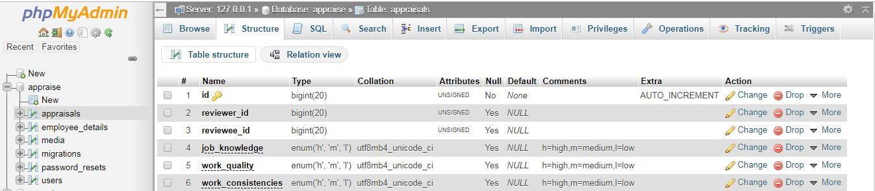

.

**Fig 4.2 Database**

The specification for the user table is shown in fig 4.3. In this table, the attributes used are id, email, name, and password, with data types of integer and variable character for storing alpha numeric character.

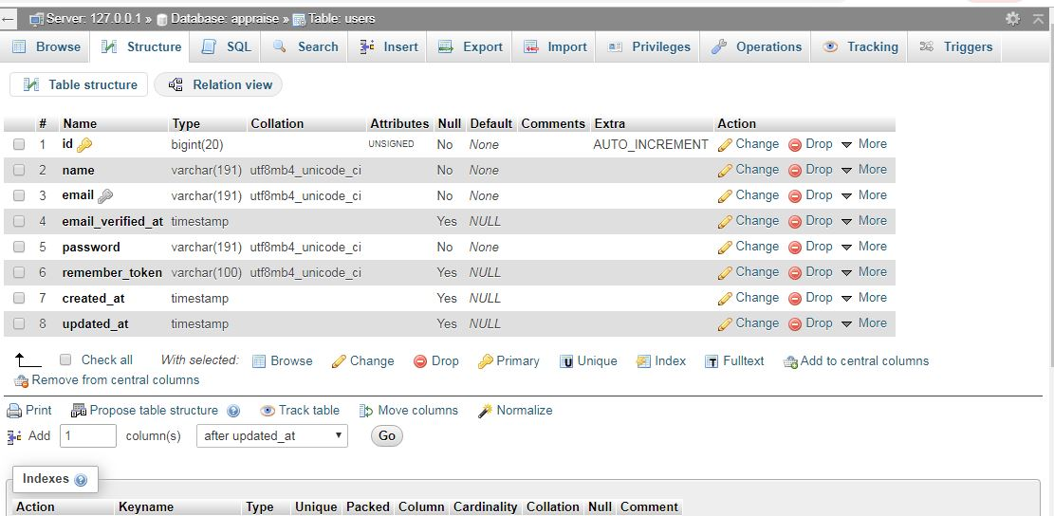

**Fig 4.3 Users Table**

The specification for the main ‘appraisal’ table is shown in Fig 4.4. In this table, the attributes used are id for the appraisal table as primary key and reviewer and reviewee id as foreign keys other attributes are the evaluation parameters like work quality, attitude and so on.

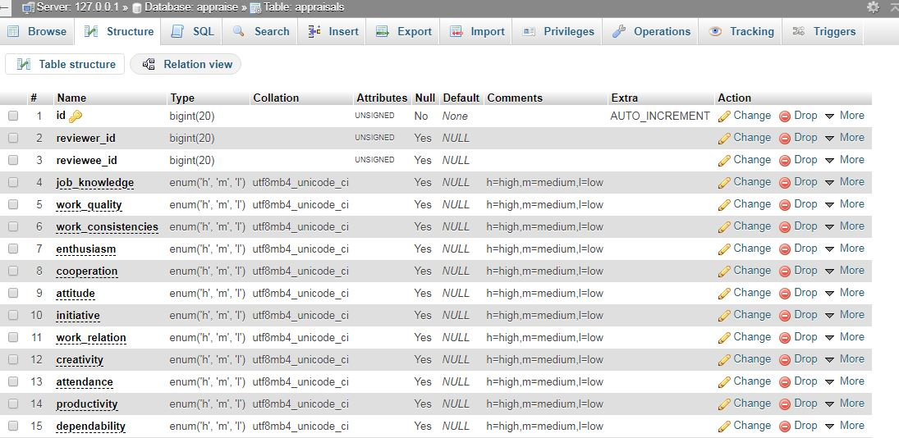

**Fig 4.4 Appraisal Table**

## 4.5 Input/Output Screen/Format

The input screen format shows the screen shot of the entire input format in the program. The first input screen is the login page where the user (admin or staff) login to his/her dashboard.

This is shown in figure 4.5.

### 4.5.1 Login Module

In other to carry out any activity on the platform a user (admin/staff) needs to be authenticated The user is required to enter his/her username (email) and password and from here if authentication is successful, is redirected to the dashboard.

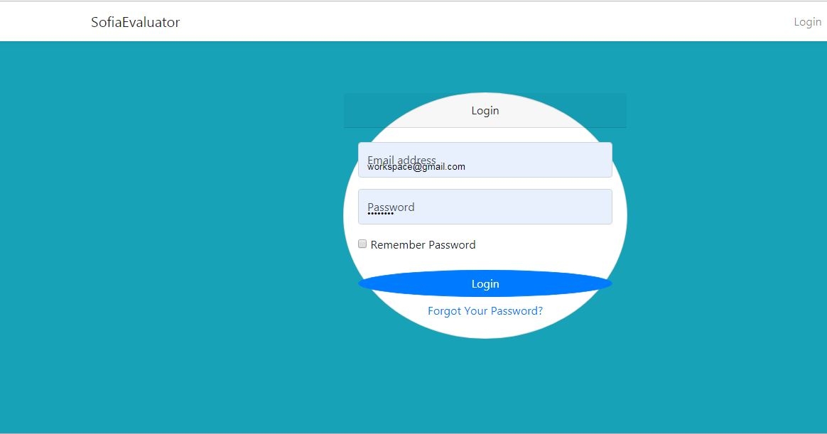

**Fig 4.5 Login Module**

### 4.5.2 Evaluation Module

This page displays the information about the staff to be evaluated and an evaluation form for the staff to be evaluated.

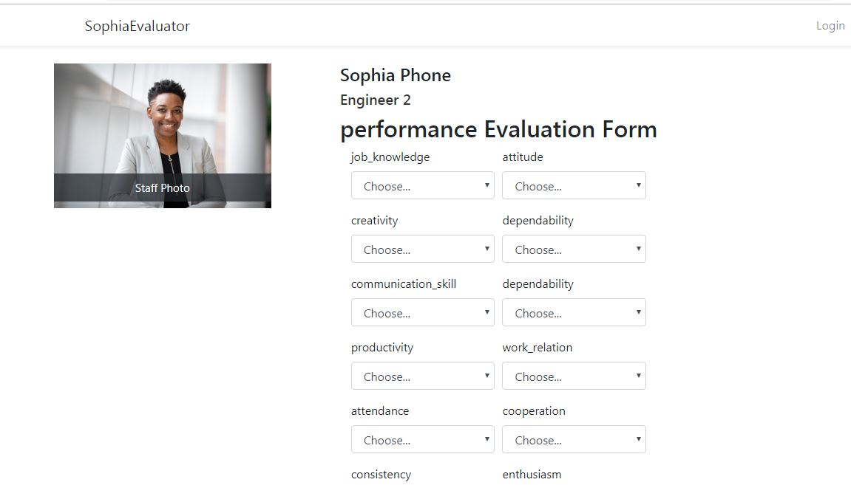

**Fig 4.6 Evaluation Form**

### 4.5.3 Registration Module

This is the form with which staffs are registered by the admin, no one except the plateform admin have access to this form.

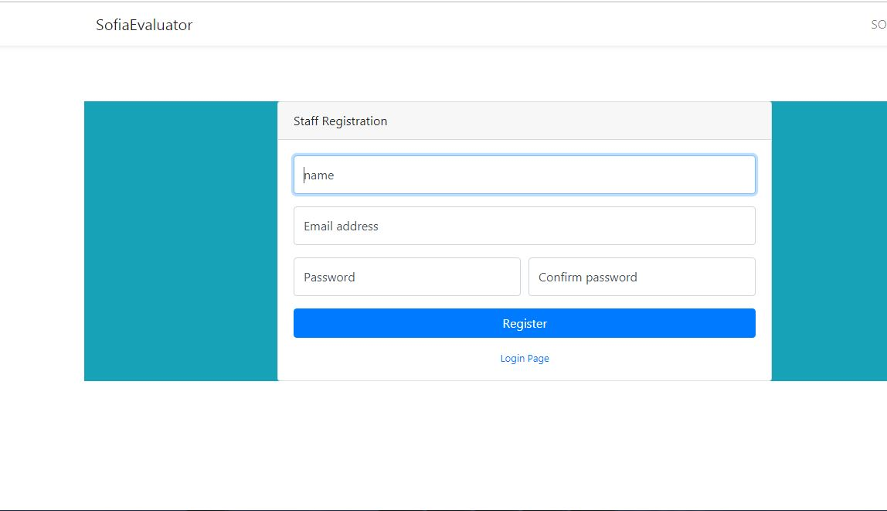

**Fig 4.7 Staff Registration Form**

### 4.5.4 Admin dashboard: Staff Table

This is the page in the admin dashboard where the admin can view the list of staff and select to view their evaluation results

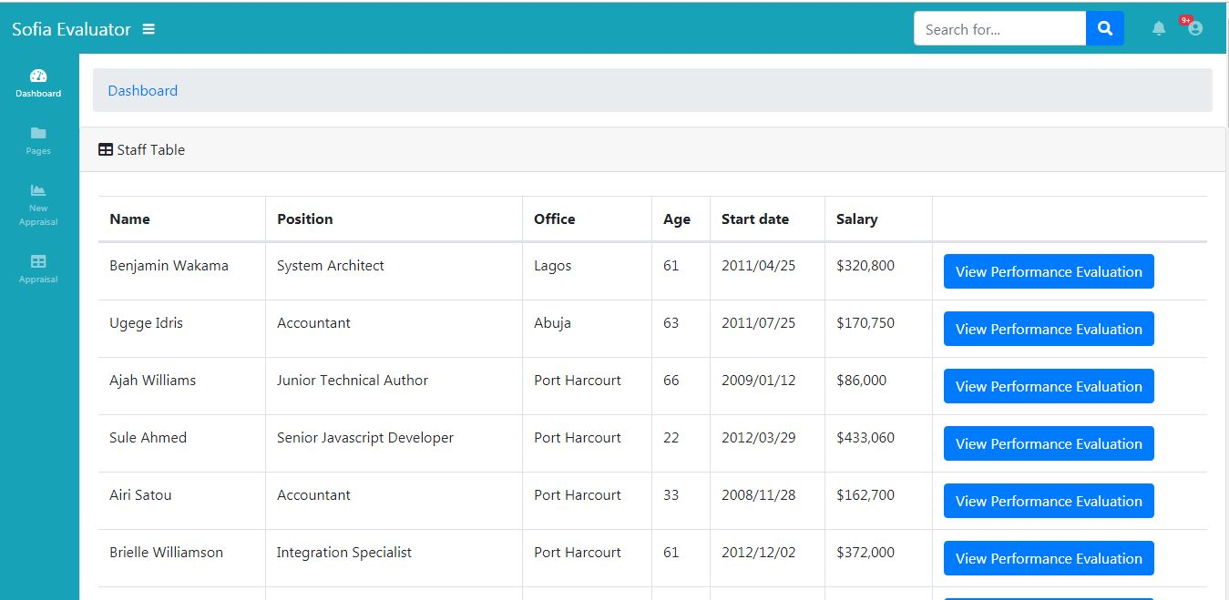

**Fig 4.8 Admin Dashboard: Staff table**

### 4.5.5 Staff Profile: Evaluation Details Page

This is the evaluation result page, the page displays the image of the user, his/her employment details and most importantly, the evaluation result for the employee

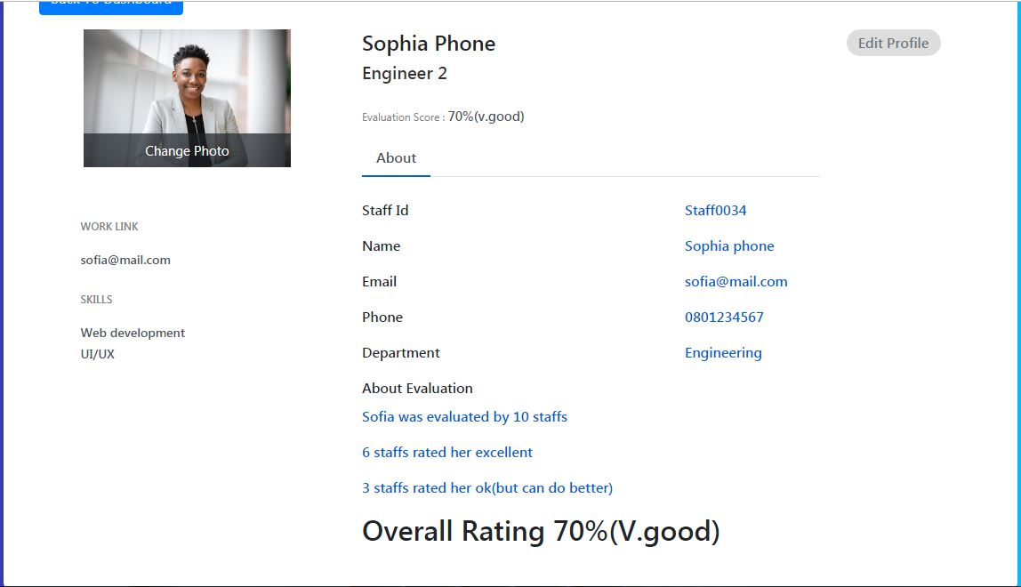

**Fig 4.9 Staff Evaluation Result.**

## 4.6 Hardware And Operating System Requirement

The hardware and Software system needed to run the program include

### 4.6.1 Hardware Specifications

1. Processor Name: Intel Dual Core / AMD
2. Processor Speed: 1.66 GHz
3. RAM: 1 GB
4. Hard Disk Capacity: 50 GB
5. Display Device: 14’ to 19’ Inch Monitor
6. Keyboard Type: PS2 or USB
7. Mouse Type: PS2 or USB

4.6.2 Software Specifications:

1. Language Used: HTML, PHP,CSS,JAVASCRIPT, SQL
2. Software Used: MySql,xampp Server ,Php
3. Operating System: Windows XP/ Windows 7/ Windows8 / windows10/Linux

## 4.7 Software Testing

Testing is the process of running a system with the intention of finding errors. Testing enhances the integrity of a system by detecting deviations in design and errors in the system. Testing aims at detecting error-prone areas. This helps in the prevention of errors in a system. Testing also adds value to the product by conforming to the user requirements. The main purpose of testing is to detect errors and error-prone areas in a system. Testing must be thorough and well-planned. A partially tested system is as bad as an untested system. And the price of an untested and under-tested system is high.

The implementation is the final and important phase. It involves user-training, system testing in order to ensure successful running of the proposed system. The user tests the system and changes are made according to their needs. The testing involves the testing of the developed system using various kinds of data. While testing, errors are noted and correctness is the made.

The objectives of testing are:

1. Testing is a process of executing a program with the intent of finding errors.
2. A successful test case is one that uncovers an as yet undiscovered error.

System testing is a stage of implementation, which is aimed at ensuring that the system works accurately and efficiently as per the user need, before the live operation commences. As stated before, testing is vital to the success of a system. System testing makes a logical assumption that if all parts of the system are correct, the goal will be successfully achieved. A series of tests are performed before the system is ready for the user acceptance test.

4.7.1 Testing Methods

System testing is the stage of implementation. This is to check whether the system works accurately and efficiently before live operation commences. Testing is vital to the success of the system. The candidate system is subject to a variety of tests: on line response, volume, stress, recovery, security and usability tests. A series of tests are performed for the proposed system is ready for user acceptance testing. The testing Steps are:

1. Unit Testing;Unit testing focuses efforts on the smallest unit of software design. This is known as module testing. The modules are tested separately. The test is carried out during programming stage itself. In this step, each module is found to be working satisfactory as regards to the expected output from the module.
2. Integration Testing

Data can be lost across an interface. One module can have an adverse effect on another, sub functions, when combined, may not be linked in desired manner in major functions. Integration testing is a systematic approach for constructing the program structure, while at the same time conducting test to uncover errors associated within the interface. The objective is to take unit tested modules and builds program structure. All the modules are combined and tested as a whole.

1. Validation

At the culmination of the integration testing, software is completely assembled as a package. Interfacing errors have been uncovered and corrected and a final series of software test begin in validation testing. Validation testing can be defined in many ways, but a simple definition is that the validation succeeds when the software functions in a manner that is expected by the customer. After validation test has been conducted, one of the three possible conditions exists.

a. The function or performance characteristics confirm to specification and are accepted.

b. A deviation from specification is uncovered and a deficiency lists is created.

c. Proposed system under consideration has been tested by using validation test and found to be working satisfactory.

1. Output Testing

After performing the validation testing, the next step is output testing of the proposed system, since no system could be useful if it does not produce the required output in a specific format. The output format on the screen is found to be correct. The format was designed in the system design time according to the user needs. For the hard copy also; the output comes as per the specified requirements by the user. Hence output testing did not result in any correction for the system.

1. User Acceptance Testing

User acceptance of a system is the key factor for the success of any system. The system under consideration is tested for the user acceptance by constantly keeping in touch with the prospective system users at the time of developing and making changes whenever required.

# CHAPTER FIVE

## SUMMARY, CONCLUSION AND RECOMMENDATIONS

## 5.1 Summary

In this work, the online employee performance evaluation system was developed using the fuzzy logic algorithm, the system was design to be as transparent as possible and to avoid all the loopholes in existing systems as discussed in previous chapters, the process of decision making are all encapsulated within the system’s logic and abstracted from the users, the user fill and submit the evaluation form and the system takes over from they, without any external interference. The system was proposed to work side by side the existing system that uses less advanced method for evaluation. The pros and cons of both systems were discussed and a suitable module was developed to aid in the employee performance evaluation process. An application was developed to show the proof of concept and from the result; the system is noted to have performed well.

## 5.2 Conclusion

The fuzzy logic based staff performance evaluation system was developed and from the series of test carried out on the system was proven to be an effective tool in carrying out performance evaluation of staffs.

## 5.3 Recommendation

In this work the fuzzy logic algorithm was used to perform evaluation on employees by collecting data input every time the evaluation is to be carried out, we recommend that in addition to carrying out just evaluation, the system can be improved upon to also predict if an employee will improve over time or not, based on previous evaluation outcomes.

# References

Archer, N. (2000). Retrieved 04 15, 2019, from performance-appraisal.com: performance-appraisal.com

Archer, N. (2000). *https://sites.google.com/site/whatishumanresource/traditional-methods-of-performance-appraisal*. Retrieved 04 15, 2019, from https://sites.google.com/site/whatishumanresource: https://sites.google.com/site/whatishumanresource/traditional-methods-of-performance-appraisal

Bansod, N. A., Kulkarni, M., & Patil, S. (2005). Soft Computing- A Fuzzy Logic Approach. *Allied Publishers*, p. 73.

Chen, J. (2018, January 22). *Performance-Based Compensation*. Retrieved from www.investopedia.com: https://www.investopedia.com/terms/p/performancecompensation.asp

Dulewicz, V. (1989). Performance appraisal and counselling. In V. Dulewicz, *Performance appraisal and counselling* (pp. 645-649). New York: John Wiley & Sons.

Flanagan, J. C. (1954). The critical incident technique. *Psychological Bulletin*, 327-358.

Gary Roberts, M. P. (2007, May). Why Employees Dislike Performance Appraisals. *Regent Global Business Review*, p. 8. Retrieved from www.regent.edu.

Hamidah, J., AbdulRazak, H., & O, Z. A. (2009). Towards Applying Data Mining Techniques for Talent Managements, 2009. *International Conference on Computer Engineering and Applications.* *volume 2.* Singapore: IACSIT Press.

Jayanthi, R., Goyal, D., & Ahson, S. (2008). Data Mining Techniques for Better Decisions. *International Journal of Business Information Systems*, 464-481.

Keen, & Peter G, W. (1980). *Decision support systems : a research perspective.* Cambridge, Massachusetts: Center for Information Systems Research, Alfred P. Sloan School of Managementdle.

Kosko, B. (1994). Fuzzy Thinking: The New Science of Fuzzy Logic. *Hyperion*.

Manasa, K., & Reddy, N. (2009). Role of Training in Improving Performance. *The IUP Journal of Soft Skills,* , 72-80. Retrieved from lumenlearning.com: https://courses.lumenlearning.com/wmintrobusiness/chapter/reading-performance-appraisals/

Moore, C. (2007). An Introduction to Logistic and Probit Regression Models. Texas, United States of America.

Nagadevara, V., Srinivasan, V., & Valk, R. (2008). Establishing a Link between Employee Turnover and Withdrawal Behaviours. *Application of Data Mining Techniques ,Research and Practice in Human Resource Management,*, 81-99.

North, A. (2000, june). *modern methods of performance appraisal*. Retrieved from whatishumanresource.com: https://sites.google.com/site/whatishumanresource/modern-methods-of-performance-appraisal

North, A. (2010, 04 12). *Intoduction To Performance Appraisal*. Retrieved 04 12, 2019, from perfomance-appraisal.com: http://www.performance-appraisal.com/intro.htm

Novák, V., Perfilieva, I., & Močkoř, J. (1999). *Mathematical principles of fuzzy logic.* Kluwer Academic. Retrieved August 2019

Pelletier, & Francis, J. (2000). Review of Metamathematics of fuzzy logics. *The Bulletin of Symbolic Logic.*, pp. 342-346.

Petr, C., Christian, G., Fermüller, & Carles, N. (2006, 07 23). Fuzzy Logic. *Stanford Encyclopedia of Philosophy*. USA: Stanford Centre For The Study Of Language And Information.

Ralph H. Sprague, J. (1908). *A Framework for the development of decision support system.* Management Information Systems Research Center, University of Minnesota.

Saumya, B. (2019, Feb). *Performance appraisals: What India Inc. plans to offer to its employees*. Retrieved from timesjobs.com: https://content.timesjobs.com/performance-appraisals-what-india-inc-plans-to-offer-to-its-employees/articleshow/68112507.cms

Wie-Chiang, H., & Ruey-Ming, C. (2007). A Comparative Test of Two Employee Turnover Prediction Models. *International Journal of Management, Vol.24 No.2*, 216-229.

# Appendix