UNIVERSITY OF PORTHARCOURT

FACULTY OF SCIENCES

DEPARTMENT OF COMPUTER SCIENCE

REPORT OF

STUDENT INDUSTRIAL WORK EXPERIENCE SCHEME (SIWES)

AT BIT-HUB
CHOBA.

BY
AJAH ONYEBUCHI|U2014/5570118
DECEMBER 27TH 2017

i.
DEDICATION

This report is dedicated to God Almighty for his protection, provision, wisdom and sustenance throughout my Industrial Training. I dedicate this also to my parents, and all my lecturers.

ii.
ACKNOWLEDGEMENT
I will like to acknowledge my elder brother Mr Shadrach Ajah, for his persistent support.
My IT supervisors, Dr. Azubuike I.I, Mr. Lewis Ugege for their guidance and assistance.
To my institution, my H.O.D Dr Onyejegbu, Laeticia Nneka, IT coordinator Mrs. Musa and the entire staff of the Department of Computer Science for their support and directions in my pursuit for a first degree program.

TABLE OF CONTENT
- Dedication.
- Acknowledgement.
- Chapter One
  - Introduction
  - Brief history of BITHUB IT Place.
  - Organisation Chart.
  - Departments and Functions.
- Chapter Two : Activities during SIWES
  - Introduction.
  - Introduction to HTML.
  - Introduction to CSS.
  - BOOTSTRAP.
  - PHP.
  - MYSQL.
  - Project during IT: AJAH GRAINS.
- Chapter Three
  - Problems encountered during SIWES.
  - Relevance of the SIWES PROGRAM.
  - SUMMARY
- Chapter Four
  - Conclusion And general Appraisal.
  - Ways to improve SIWES.
  - Advice for future participants.
  - Advice for SIWES officials.
  - References
Appendix

CHAPTER ONE
  - INTRODUCTION
For any practice to be considered holistic, the importance of training and internship cannot be overemphasised. It is for this very reason the Nigerian Universities Commission has made it a prerequisite for the award of degrees especially in fields of science and technology.
The SIWES program is the vehicle by which the above objective is achieved.
SIWES is an acronym for students industrial work experience schemes, where students of especially science and engineering faculties are sent on attachment to industries related to their fields of studies to gain hands-on practical experience
This SIWES programme has also doubled as a medium for preparing students for the life after school, to learn practical applications of the theories learnt in school and expose them to industry standards on these theories.

  - BRIEF HISTORY OF BITHUB
BitHub is an information technology start-up that was hatched by two purposeful information technology personnel. With their vast experience in developing usable information systems, they came up with the idea of improving the current brain gap between tertiary institutions and the work force in terms of application development technologies. The company is registered with the corporate affairs commission and has overseen several application development and training. Some of our clients include Institute of Petroleum Studies (IPS, University of Port Harcourt), Trinity Communications Ltd (Lagos State), Spinlets Financing Ltd (Port Harcourt), Redeemed Peoples Academy, Jos; to mention but a few. We offer qualitative training with a hands-on approach to learning and a top notch application development experience.

1.3 Organizational Chart
MANAGER
(HEAD, ADMIN)
.
DIRECTOR
Head, Marketing

Head, Web Applications and Graphics
Head, Mobile App Development

Training / Internship

  - DEPARTMENTS AND FUNCTIONS
- Mobile App Development: This department is saddled with the responsibility of creating content for the Internship programme on Android App Development and also providing solutions for clients as regards android applications.
- Web Application and Graphics: This department is responsible for building content for the Web Application Internship program on web design technologies like: html, CSS and JavaScript ; database management technology: MySQL, NoSQL, SQLite; backend technologies including: native php (laravel framework) and nodejs. Also gathering information on industry standards and trends on web application development.

CHAPTER TWO
ACTIVITIES DURING SIWES

2.1 INTRODUCTION
In this chapter, I will be detailing the activities I took part in during the trainer. These packages were on offer during the training, Web designing using HTML, CSS, BOOTSTRAP, JAVA/ANDROID, MYSQL AND PHP (NOTE: I did not do JAVA/ANDROID).

2.2 INTRODUCTION TO HTML
This is a basic skeletal html page tags
<!doctype html>
<html>
<head>

<meta charset="utf-8">
<title></title>
<meta name="viewport" content="width=device-width, initial-scale=1.0">
<link …….>
</head>
<body>
//main code goes here
….
….
</body>
</html>

HTML stands for hypertext mark-up language. It is a mark-up language used to specify the structure of a webpage.
Basic Html Tags
- HEADER TAGS
<h1>BIGGEST</h1>
<h2></h2>
<h3></h3>
<h4></h4>
<h5></h5>
<h6>SMALLEST</h6>
<h1> tag is the largest and the subsequent ones reduces till <h6> tag which is the smallest
- PARAGRAPH: This is usually written in the body tag i.e.
<body>
<p>This is some content which I want to appear on</br >two lines. </p>

<p>This is a second paragraph with a neat horizontal ruled line underneath. </p>
</body>
- FORMATTING TEXTS: This is used to change the format of whatever text that is used within the webpage.
<p>The the next word will be dark and thicker than others <strong>bold</strong>, <em>italic</em>, <u>underlined</u> and <strike>struck through</strike> text. </p>
- UNORDERED LISTS
<p>This is an unordered :</p>
<ul>
<li>AJAH</li>
<li>ONYEBUCHI</li>
<li>JAMES</li>
</ul>
- ORDERED LISTS
<p>This is an ordered list this one numbers the list items:</p>
<ol>
<li>Port Harcourt</li>
<li>Lagos </li>
<li>Abuja</li>
</ol>
- IMAGES: This is how to import an image into your webpage.
<img src="anyimage.jpg" >
- TABLES
<!DOCTYPE html>
<html>
<head>
<title>staff salary</title>
</head>
<body>

<h1>Staff Salary</h1>

<p>Below table shows staff salary in USD(&dollar;).</p>

<table border="1px" >

<thead>

<tr>

<th>S.No</th>
<th>Name</th>
<th>Department</th>
<th>Monthly Salary</th>

</tr>
</thead>
<tbody>
<tr>
<td>1</td>
<td>John</td>
<td>Finance</td>
<td>&dollar;2500</td>
</tr>

<tr>
<td>2</td>
<td>Smith</td>
<td>Sales</td>
<td>&dollar;2200</td>
</tr>

<tr>
<td>3</td>
<td>Adams</td>
<td>HR</td>
<td>&dollar;2000</td>
</tr>
</tbody>
</table>

<p>Below table shows staff salary in GBP(&pound;)</p>

<table border="1px" >

<thead>

<tr>
<th>S.No</th>
<th>Name</th>
<th>Department</th>
<th>Monthly Salary</th>
</tr>
</thead>
<tbody>
<tr>
<td>1</td>
<td>John</td>
<td>Finance</td>
<td>&pound;1650</td>
</tr>

<tr>
<td>2</td>
<td>Smith</td>
<td>Sales</td>
<td>&pound;1450</td>
</tr>

<tr>
<td>3</td>
<td>Adams</td>
<td>HR</td>
<td>&pound;1320</td>
</tr>
</tbody>
</table>

<p>Staff salary in USD &amp; GBP</p>

<footer>Copyright &copy; 2017</footer>

</body>
</html>

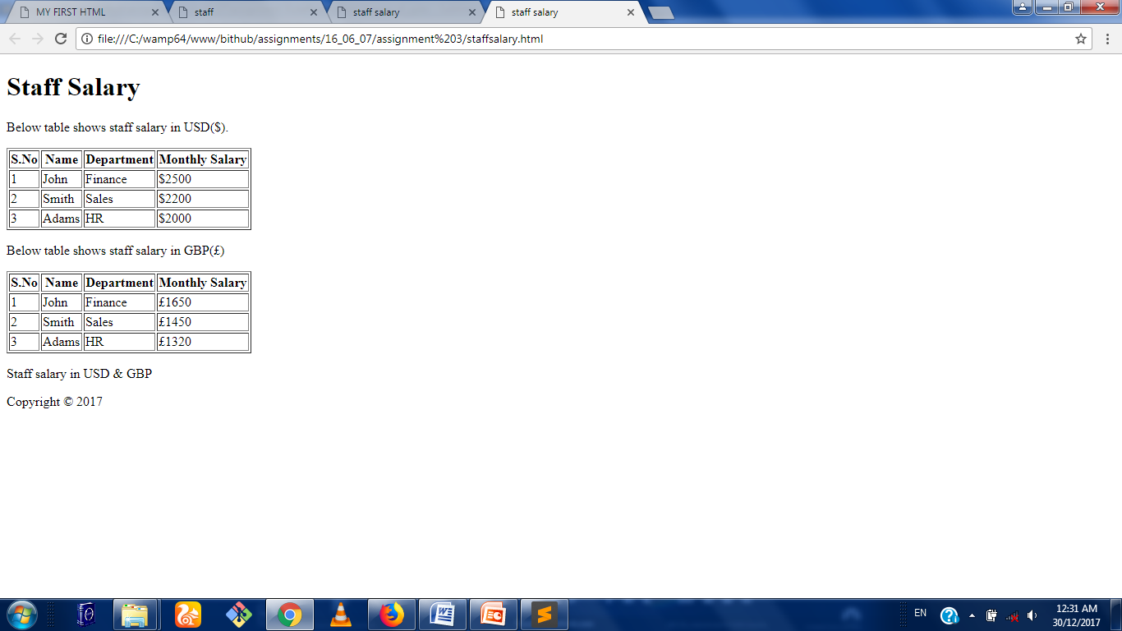

FIG 2.1:An html table
- LINKS: it is used to redirect to corresponding webpages.
<a href="pageName.html">checkout</a>

- FORMS: This is used to create forms.
Here are some html form elements
- <input />
  - radio button (same name but different values),
  - checkbox,
  - password,
  - text,
  - number,
  - tel,
  - email,
  - submit,
  - File
  - date
- <textarea></textarea>
- <select>
- <button></button>
- EXAMPLE

<!doctype html>
<html>
<head>
<title></title>
<meta charset='utf-8'>
<meta name='viewport' content='width=device-width initial-scale=1.0'>
<link rel="stylesheet" href="css/bootstrap.min.css">
</head>

<body>
<div class="container">

<header class='row'>
<nav>
<div>
<button>
<span class='sr-only'>Toggle Navigation</span>
<span class='icon-bar'></span>
<span class='icon-bar'></span>
<span class='icon-bar'></span>
</button>
<a href="" class='navbar-brand'>Laundry</a>
</div>
<div>
<ul>

</ul>
</div>
</nav>
</header>
<div class='row'>

</div>

<div class='row'>

<aside class='col col-lg-3 col-md-4 col-sm-3'>
<h3><span class='glyphicon glyphicon-user'></span> Side Nav</h3>
<ul class='nav nav-stacked nav-pills'>
<li><a href="#"><span class='glyphicon glyphicon-home'></span> Home</a></li>
<li><a href="#">About Us</a></li>
<li><a href="#">Services</a></li>
<li><a href="#">Contact Us</a></li>
</ul>
</aside>

<article class='col col-lg-9 col-md-8 col-sm-9'>
<div class='row'>
<h3>Customer Form</h3>
</div>
<section class='row'>
<form class='form-horizontal' action='customer_form.php' method='post'>
<div class='form-group'>
<label class='control-label col col-lg-4'>First Name</label>
<div class='col col-lg-6'>
<input class='form-control' name='first_name' type='text'>
</div>
</div>
<div class='form-group'>
<label class='control-label col col-lg-4'>Last Name</label>
<div class='col col-lg-6'>
<input class='form-control' name='last_name' type='text'>
</div>
</div>
<div class='form-group'>
<label class='control-label col col-lg-4'>DOB</label>
<div class='col col-lg-6'>
<input class='form-control' name='dob' type='date'>
</div>
</div>

<div class='form-group'>
<label class='control-label col col-lg-4'>Email</label>
<div class='col col-lg-6'>
<input required class='form-control' name='email' type='email'>
</div>
</div>
<div class='form-group'>
<label class='control-label col col-lg-4'>Phone</label>
<div class='col col-lg-6'>
<input required class='form-control' name='phone' type='text'>
</div>
</div>
<div class='form-group'>
<label class='control-label col col-lg-4'>Address</label>
<div class='col col-lg-6'>
<textarea class='form-control ' name='address'></textarea>
</div>
</div>
<div class='form-group'>
<label class='control-label col col-lg-4'>Password</label>
<div class='col col-lg-6'>
<input class='form-control' name='password' type='password'>
</div>
</div>

<div class='col col-lg-6 col-lg-offset-4'>
<button type='submit' name='create' class ='btn btn-primary'>Submit Form</button>
</div>

</form>
</section>

</article>
</div>

<footer class='row'><p>&copy; AJAH1</p></footer>

</div>
<script type="text/javascript" src="js/jquery.js"></script>
<script type="text/javascript" src="js/bootstrap.min.js"></script>
</body>
</html>
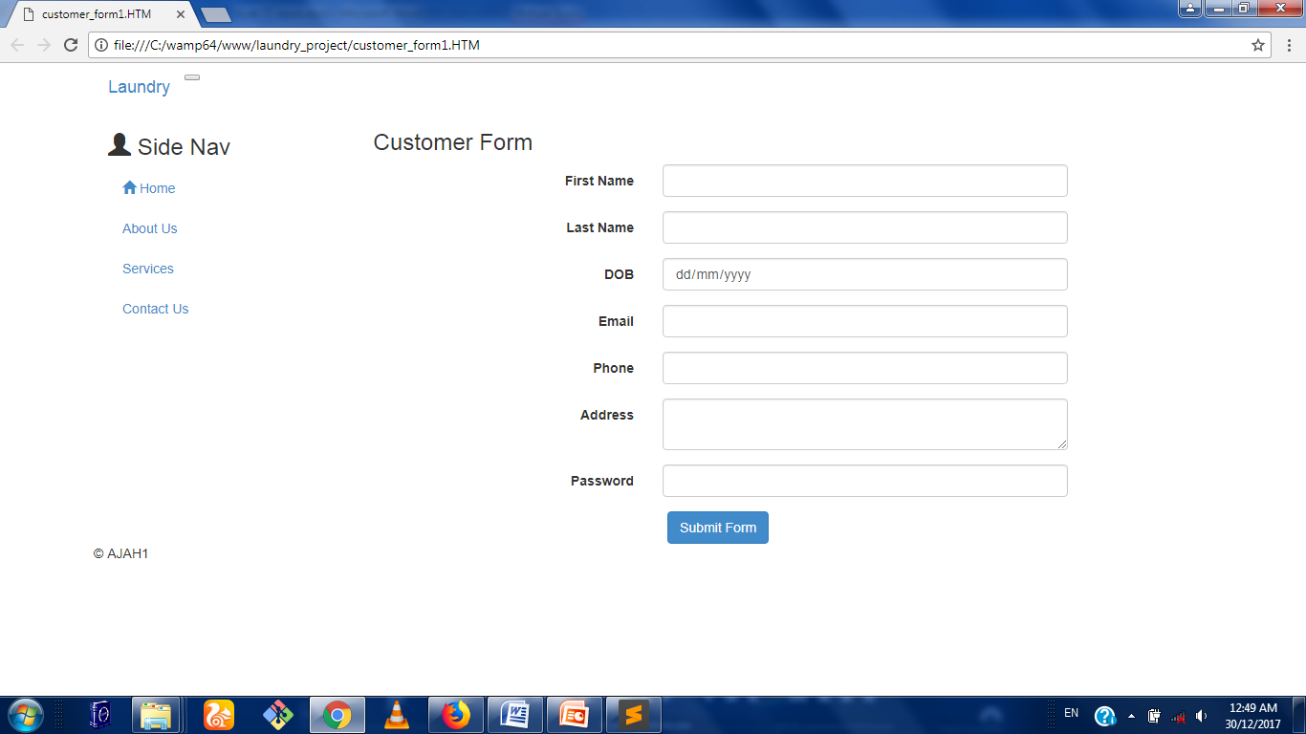
Fig 2.2: HTML form

2.3 INTRODUCTION TO CSS
CSS is an acronym for cascading style sheet and it file with a list of formatting instructions is a programming language used to style a webpage after the structure has been developed with HTML. CSS is a standard for defining visual presentation of webpages and this concept separates design from content which aids faster download of sites.
The stylesheet(CSS) consists of a number of rules which defines how various webpage elements should be displayed
- Selector rule: This rule specifies which part of the html document the rule will be applied to.
Types of selector
1.By tag
h1{
Color: blue;
}
2.By class
Header{
Width:400px;
}
3.Direct Child Selector
#header>h1{
Font-family: magneta;
}
4.Descendant Selector: This is done using div tags
Html format: <div id =” menu”>
<div id = “sub-menu”>
<ul>
<li>…. </li>
</ul>
</div>
</div>
Css format: #menu li {
background: orange;
}
5. Attribute Selector: input [type = “radio”]{
Width:20px;
Height:20px;
}
6. Group Selector
h1, h2, h3, h4 {
color: green;
}
h1 {
font-size: 1.5em;
}

N:B The tag name is used to access multiple elements of the same name and type.
- Declaration rule: This rule consists of a number of value/property pairs such as column, background color, width, border, font size etc.
- It is important to note that the CSS syntax is made up of five parts namely: selector, properties/value, declaration, declaration block and curly braces

There are three ways of inserting CSS style inside an html document
- Inline method
In this method, you write inside the <head> tag.
<html lang =” en”>
<head>
<title> CSS FILE </title>
<metacharset = “utf-8”>
<style>
<p style="color: blue; font-size:200%">
This webpage is for amateur bakers. Registration is free and the good news is that our team will be sending newsletters to you weekly to help develop your baking skills.
</p>
</style>
</head>
- Internal method: It is also written in the head tag.
<html>
<head>
<title>Implementation</title>
<meta charset="utf-8" />
<meta http-equiv="Content-type" content="text/html; charset=utf-8" />
<meta name="viewport" content="width=device-width, initial-scale=1" />
<style>
.large {font-size:200%}
#padded {padding:50px;}

</style>
</head>
<body>
<p class="large">This is some larger text.</p>

<p id="padded">This text has some padding.</p>

</body>

- External method: This method is the most preferred and you either use the import tag or the link tag to reference it which must also be written inside the head tag.
<head>
<title> css implementation</title>
<metacharset = ”utf-8”
<link type = “text/css” rel= ”style sheet” href=” css/style.css”>
</head>
CLASSES AND ID
A class is a name of a certain type of text. An id is a very similar thing with the class the only difference is that the id is used for a single element within a page but classes can be used many times in a page. The convention is that an id can only appear once in a page while a class can appear severally. We use a dot(.) to represent a class and we use hash (#) to represent an id in the CSS styling. If it is an inline styling, it can be written in the head tag but it is always advised to have a separate page for our CSS styling.

Example:
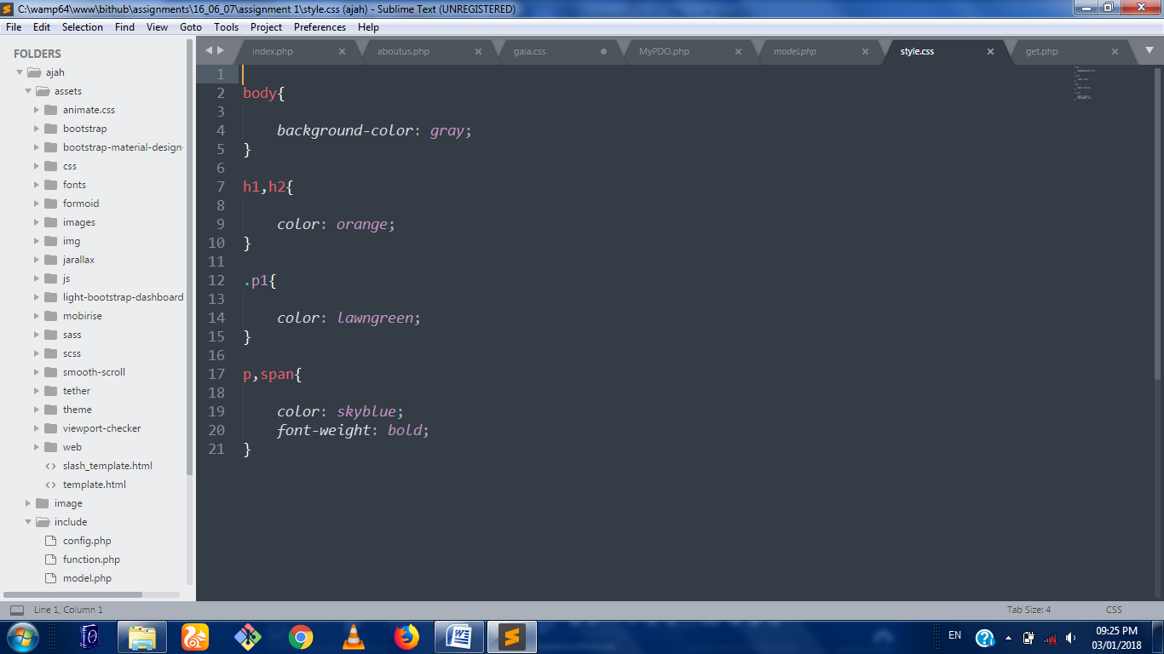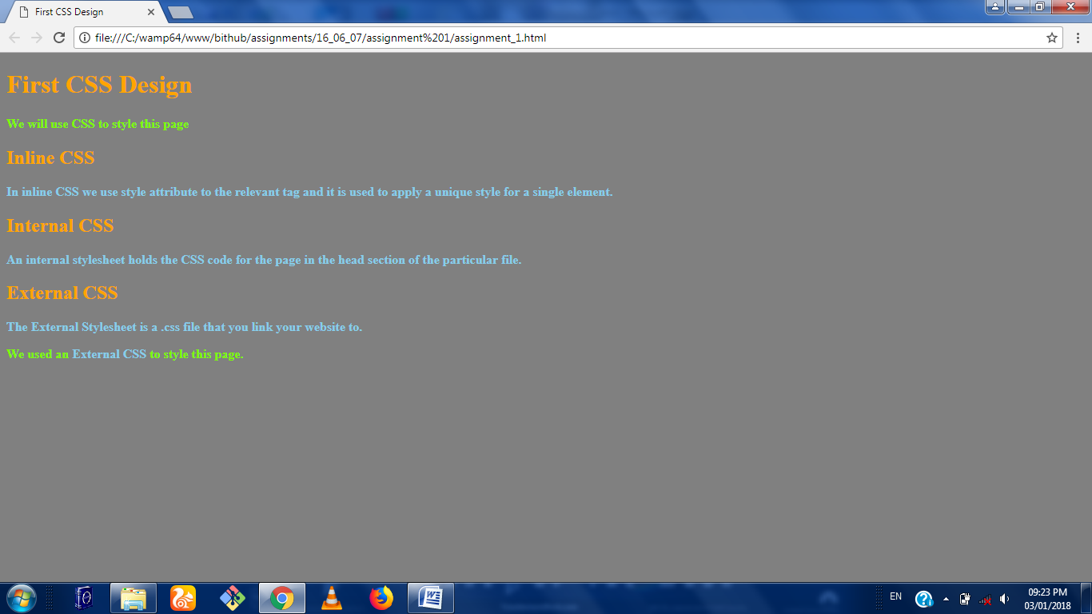FIG 2.3: SIMPLE CSS STYLING

DIV: The Div tag is just a division of the webpage. Most webpages are divided into two i.e. the header area and the main text area and each of these can be defined by a separate div. Within each div, you can have smaller divs that divides it into smaller sections. A div is just a way to separate your contents into logical sections and to make it easier to keep your contents organized and display the webpage that we want.
Example:
<div class="greenarea">
<p class="large"> I love my brother. </p>
</div>
Other important features of CSS are:
- Colors
- Positioning
- Margins
- Paddings
- Borders
- Fonts
- Styling texts
- Aligning texts
- Styling links

2.4 BOOTSTRAP: This is a sleek, intuitive and powerful mobile first front-end framework for faster and easier web development. It uses HTML, CSS and JavaScript.
It is supported by all browsers and it has a responsive design
The Grid System – To put it simple words grids in web design organize and structure content, makes websites easy to scan and reduces cognitive load on users.
Basic grid structure:
<div class="container">

<div class="row">

<div class="col-md-6 box">Content</div>

<div class="col-md-6 box">Content</div>

</div>

</div>
Side Bar Styling:
<aside class="col-lg-3 col-sm-4">
<h3><span class="glyphicon glyphicon-list"></span>Menus</h3>
<ul class="nav nav-pills nav-stacked">
<li>
<a href="#">Home</a>
</li>
<li>
<a href="#">Events</a>
</li>
<li>
<a href="#">Contact</a>
</li>

<li>
<a href="logout.php>Logout</a>
</li>
</ul>
</aside>
Column Form Structure:
<article class="col-lg-8">
<form class="form-horizontal" method="post" enctype="multipart/form-data">
<div class="form-group">
<label class="col-sm-3 control-label">DOI:</label>
<div class="col-sm-4">
<input type="text" class="form-control" name ="doi">
</div>
</div>
</form>
</article>

Radio Button Structure:
<div class="form-group">
<label class="col-sm-3 control-label">Gender:</label>
<div class="col-sm-4">
<div>
<label>
<input name="gender" value="Male" type="radio">
<span class="labels"> Male</span>
</label>
</div>
<div>
<label>
<input name="gender" value="Female" type="radio">
<span class="labels"> Female</span>
</label>
</div>
</div>
</div>
Top Nav Bar:
<div class="row">
<nav class="navbar navbar-default navbar-fixed-top navbar-inverse">
<div class="navbar-header">
<button type="button" class="navbar-toggle" data-toggle="collapse" data-target="#collapse">
<span class="sr-only">Toggle navigation</span>
<span class="glyphicon glyphicon-arrow-down"></span>
MENU
</button>
<a class="navbar-brand" href="#"><img src="img/logo1.png" height="30" width="30"/> Kitchen network services</a>
</div>
<div class="collapse navbar-collapse" id="collapse">
<ul class="nav navbar-nav">
<li><a href="project.php">Home</a></li>
<li><a href="#" id="contact.php">Contact</a></li>
<li><a href="#" id ="investments.php">Investments</a></li>
<li><a href="logout.php">Logout</a></li>
</ul>
</div>
</nav>
</div>
Carousel Slider:
<div class="container">
<div id="myCarousel" class="carousel slide" data-ride="carousel" style="width:650px; margin:0 auto">
<ol class="carousel-indicators">
<li data-target="#myCarousel" data-slide-to="0" class="active"></li>
<li data-target="#myCarousel" data-slide-to="1" class="active"></li>
<li data-target="#myCarousel" data-slide-to="2" class="active"></li>
<li data-target="#myCarousel" data-slide-to="3" class="active"></li>
<li data-target="#myCarousel" data-slide-to="4" class="active"></li>
<li data-target="#myCarousel" data-slide-to="5" class="active"></li>
<li data-target="#myCarousel" data-slide-to="6" class="active"></li>
</ol>

<!--slides-->
<div class="carousel-inner" role="listbox">
<div class="item active">
<img src="img/play01.jpg" class="img-responsive img-thumbnail" alt="">
</div>

<div class="item">
<img src="img/play02.jpg" class="img-responsive img-rounded"alt="">
</div>
<div class="item">
<img src="img/play03.jpg" class="img-responsive img-rounded" alt="">
</div>
<div class="item">
<img src="img/play04.jpg" class="img-responsive img-rounded" alt="">
</div>
<div class="item">
<img src="img/play05.jpg"class="img-responsive img-rounded" alt="">
</div>
<div class="item">
<img src="img/play06.jpg" class="img-responsive img-thumbnail" alt="">
</div>
<div class="item active">
<img src="img/play07.jpg" class="img-responsive img-rounded" alt="">
</div>
</div>

<!--left and right controls-->
<a class="left carousel-control" href="#myCarousel" role="button" data-slide="prev">
<span class="glyphicon glyphicon-chevron-left" aria-hidden="true"></span>
<span class="sr-only">Previous</span>
</a>

<a class="right carousel-control" href="#myCarousel" role="button" data-slide="next">
<span class="glyphicon glyphicon-chevron-right" aria-hidden="true"></span>
<span class="sr-only">Next</span>
</a>
</div>

2.5 PHP
Php is an acronym for hypertext processor and it was initially developed by RASMUS LEIDORF IN 1994 and was originally used for tracking visits to his online resume. Overtime more functionality was desired and the PHP-tools were rewritten producing a much larger and richer implementation. This new model was capable of database interaction and more, providing a framework upon which users could develop simple dynamic web applications. It is a server-side application. The default syntax is:
<?php
?>
The Short Tag is:
<?
?>
This syntax is used to embed php codes.
COMMENTING CODES IN PHP
1.Single-Line Syntax
//....
2.Shell Syntax
#...
3.Multiple-Line Syntax
/*
...
...
*/
OUTPUTTING DATA ON BROWSER
1.Print () Statement
int print (argument);
print (“... Statement that displays”);
2.Echo Statement
void echo (String arg1[,..., String argN);
echo (“... Statement that displays”);
Echo $var1, “ and “, $var2, “ .”;
Echo “$var1 and $var2 .”;
3.Printf Statement: Ideal for outputing a blend of static text and dynamic information stored within one or more variable.
Example
Int printf (String format [, mixed args]);
printf (“Book cost: %d”, 100);

%d – Integer Value (placeholder = type specifier)
Common type specifiers include:
%f – float;
%s – String;
%u???
%c???
Printf(“%d books at a cost of: %.2f”, 100, 234.4894);
DATA TYPES:
A data type is a generic name for any data sharing a common set of characteristics. The different data types are listed below
- Boolean
- Integer
- Float
- String
- Array

Scalar Data Types
Single valued: boolean, integer, float, string
Compound Data Types:Allows multiple items of same type to be aggregated under a single representative entity.
Array:An Indexed collection of data values.
Object: An object is an entity of a data structure.
VARIABLES: Variables are symbols that can store data and they are named memory location that contains data and may be manipulated throughout the execution of the program.
Variable Declaration: It always begin with a dollar sign ($) followed by the variable name. It may begin with letters or underscore or it may consist of letters, numbers, underscore or ASCII(127-255) and it is case sensitive.
VARIABLE ASSIGNMENT
1.By Value:
$var = 10;
2.By Reference: This is when a variable is referring to the same content of another variable.
$var1 = 1;
Echo $var1;
$var2 =& $var1;
$var2 = 5;
$var2 = &$var1;
VARIABLE SCOPE
Local Variables: They are variables declared in a function and can only be referenced in that function.
<?php
$count = 1;
function increase(){
$count = 5;
$count++;
echo “<br/>Local Variable Count = “.$count.”<br/>”;
}
increase();
echo $count;
?>
Global Variables: They are variables that can be accessed in any part of the program.
In functions,it is important to append “global” to the variable declaration inside the function.
<? php
$count = 1;
function increase(){
global $count;
//GLOBALS[“count”];
$count++;
}
echo $count;

?>
FUNCTION PARAMETERS
Function Parameters comes in the function header. When passed by value, it is no longer accessible when the function is exited. But when passed by reference, it can be accessed even outside.
<?php
$count = 5;
function increase($count){
$count++;
}
increase($count);
echo $count;
?>
STATIC VARIABLES: They still hold value when the function is exited and will still give same value when called upon again. Append “static”
Function keep_track(){
static $count = 0;
$count++;
echo $count.”<br/>”;
}
keep_track();
keep_track();
keep_track();
CONSTANTS: They cannot be modified throughout program execution. The syntax is:
boolean define (String name, mixed value [, Boolean case_insensitive]);
Example:
define ("MAX", 500000);
CONTROL STRUCTURE: It determines the flow of the code within an application, how many times a statement executes (loop) and when a code block relinquishes execution control (condition).
Conditional Statements: These are statements that uses logic to discern between various conditions based on input value.The various types of conditional statements are listed below:
- If statement
- Else statement
- Elseif Statement
- Switch Statement

2.6 MYSQL:
This is the world’s popular open source database. It is a relational database system and it reduces data redundancy and makes viewing and manipulation of data efficient. The model states that data is stored in one or more tables and each table can be viewed as a 2-D matrix consisting of rows and columns. In practice, the rows and columns are referred to as records and fields
Each table is modeled after a real-world entity such as a customer receipt.Columns of the table represents attributes of the entity. Row stands as an instance of the entity while a cell which is the intersection of the row and column is used to store a value.
Primary key is the column which uniquely identifies a row in a table(A composite primary key means one or more columns).“Unique Key” is not a primary key but it contains unique values.

SQL:
SQL statements are the same in each dialect.Although SQL is a standard dialect: each vendor has its own (variant).
It is important to note that the most basic SQL statements are the same for every dialect. Examples of other database are ORACLE, DB2, Microsoft SQL Server, MySQL.
Data Manipulation Language

- SELECT
- INSERT
- UPDATE
- DELETE
Data Definition Language

- CREATE DATABASE
- CREATE TABLE
- ALTER TABLE
- DROP DATABASE
- DROP TABLE
Creating database with MYSQL
- Define DB-SERVER (database server)
- Define DB-USER (database user)
- Define DB-PASS (database password)
- Define DB-NAME (database name)
It is important to note that you must open connection, close connection and query the database.
<?php
include_once ("config3.php");

class MySQLDatabase {
public $connection;

function __construct(){
$this->open_connection();
}

public function open_connection(){
$this->connection = mysql_connect(DB_SERVER, DB_USER, DB_PASSWORD);
if(!$this->connection){
//connection failed report error
die("DBase connection failed: ".mysql_error());
} else {
//select a database
$db_select = mysql_select_db(DB_NAME);
if(!$db_select){
die("Dbase selection failed: ".mysql_error());
}
}
}

public function close_connection(){
if(isset($this->connection)){
mysql_close($this->connection);
unset($this->connection);
}
}

public function query ($sql){
$result = mysql_query($sql);
$this->confirm_query($result);
return $result;
}

public function confirm_query($result){
if(!$result){
die("DB query failed: ".mysql_error());
}
}
}
$database = new MySQLDatabase();

?>
INSERTING INTO DATABASE
The syntax for inserting into database is
INSERT INTO table_name VALUES (column1, column2, ...);

Example
INSERT INTO SSCE VALUES (UPH/2015/0001,'Neco','2009');
SELECTING FROM DATABASE

The SELECT statement is used to retrieve data from a database. The syntax for SELECT is:
SELECT* column_name, column_name,...
FROM table_name
WHERE conditions;
The WHERE clause can use the comparison operators such as =,!=, <, >, <=,and >=, as well as the BETWEEN and LIKE operators.

Example
SELECT* FROM ‘JAMB_COURSES’
INNER JOIN ‘JAMB_SCORES’
ON JAMB_COURSES.PUME_ID = JAMB_SCORE.PUME_ID
WHERE JAMB_COURSES.PUME_ID LIKE ‘%25%’

UPDATING DATABASE:
The UPDATE statement is used to update data. The syntax for UPDATE is:
UPDATE table_name
SET column_name= value,column_name= value,...
WHERE conditions;
The WHERE clause can use the comparison operators such as =,!=, <, >, <=, and >=,as well as the BETWEEN and LIKE operators.
Example:
The following SQL UPDATE statement changes the age column of the employee whose id is 100:
SQL> UPDATE Employees SET age=20 WHERE id=100;
DELETING DATA FROM THE DATABASE:
The DELETE statement is used to delete data from tables. The syntax for DELETE is:
SQL> DELETE FROM table_name WHERE conditions;
The WHERE clause can use the comparison operators such as =, !=, <, >, <=,and >=, as well as the BETWEEN and LIKE operators.
Example:
The following SQL DELETE statement delete the record of the employee whose id is 100:
SQL> DELETE FROM Employees WHERE id=100;

2.7 PROJECT DURING I.T: AJAH GRAINS
This website is designed to link buyers of grains all over the country to the supplier “Ajah grains limited” .
- To access the website, you go to www.ajahgrains.ng. you will land on the home page from where you can navigate to place order or view available products.
- If you choose to place an order, you will fill the order form and will be contacted immediately
- The admin constantly updates the in stock list.
- The admin can monitor messages sent and those responded to
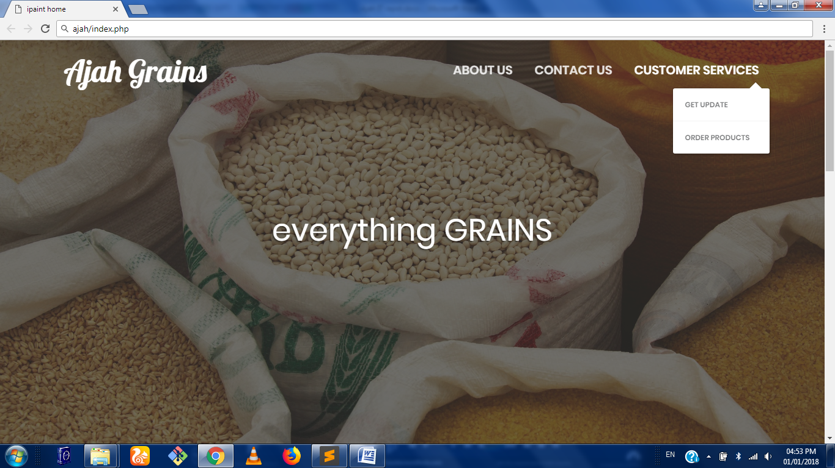
Fig: 2.4: Home page

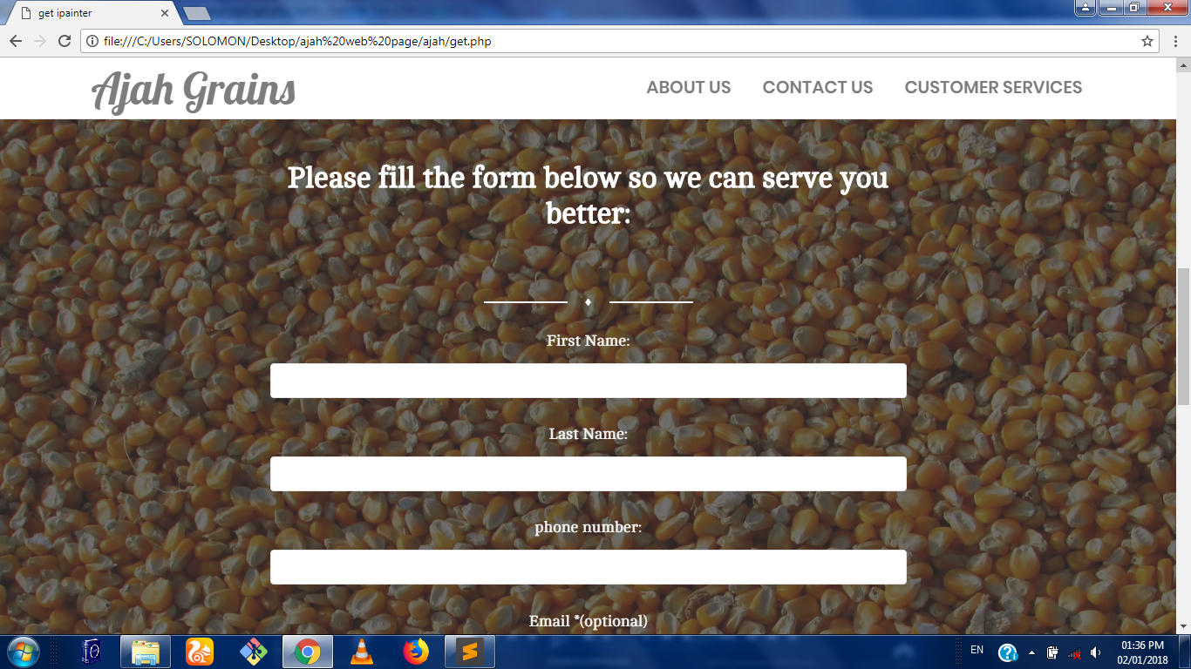
Fig 2.5: Product Order page

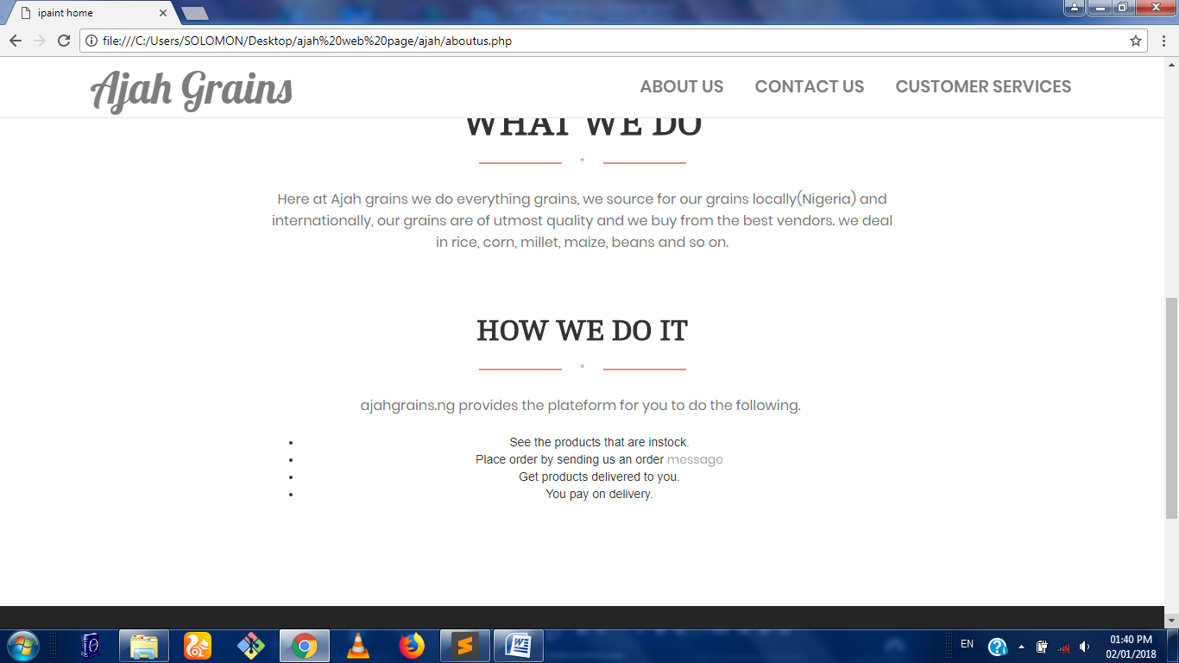
Fig 2.6: About Us page

CHAPTER THREE
3.1. PROBLEMS ENCOUNTERED DURING SIWES
This chapter discusses the challenges I encountered during the just concluded students’ industrial work experience scheme.
The challenges include:
- No allowances all through my six months.
- Power failure

3.2. Relevance of the SIWES program
Some of the relevance of SIWES are as stated below:
- Provides an avenue for students in Nigerian universities to acquire industrial skills and experience in their course of study.
- Makes the transition from university to place of work easier.
- It helps broaden the scope of the students in terms of their industrial experience.
3.3. SUMMARY
This chapter outlined the challenges faced during the just concluded SIWES program. It also includes the relevance of the SIWES program in our educational curriculum. The discussions in this report also include the training received at BIT-HUB I.T Place.

CHAPTER FOUR
4.1. CONCLUSION AND GENERAL APPRAISAL
The Php Programming Languages is an outstanding object oriented language in developing good websites. Its proper understanding is based on the concept of OOP (Object Oriented Programming). Its platform independence also gives it an edge over other OOP (Object Oriented Programming) Languages.
Solving logical problems using a program based orientation is now easy because of the Industrial Training experience. This makes a lot of routine jobs easier because a system can now be written to handle that in a work environment.
Writing solutions to solve problems always taught in school is now understood and can be used. Also, handling projects and appreciating the use of management by using software tools to create work breakdown structure for any project to be started makes ICT a global village.
4.2 WAYS OF IMPROVING SIWES
I think the SIWES program should be made compulsory to all faculties and not sciences and technology related disciplines alone. More visitation to the training firm by the supervisors should be implemented as it helps with better assessment of the students involved.
This is because some students still do not really understand the whole idea of having a work experience before graduating from school and they feel the time stipulated for the industrial training is for holiday.

4.3 ADVISE TO FUTURE PARTICIPANTS
My advice to future participant is simple. The SIWES programme is for your good so give it your all within the stipulated duration of your training.

4.4 ADVICE FOR SIWES OFFICIALS
The SIWES program should be enforced in every tertiary institution as it is an avenue for the student’s to obtain relevant industrial skills. SIWES officials should also ensure that the different IT centres are well equipped and have an adequate workforce to help increase the productivity of the Nigerian student.

4.5 REFERENCES
BITHUB IT Place tutorial manual.
SIWES Training Log book manual.

APPENDIX
A
HOME

<!DOCTYPE html>
<html lang="en">

<head>
<meta charset="utf-8" />
<link rel="apple-touch-icon" sizes="76x76" href="assets/img/apple-icon.png">
<link rel="icon" type="image/png" sizes="96x96" href="assets/img/favicon.png">

<meta http-equiv="X-UA-Compatible" content="IE=edge,chrome=1" />
<title>ipaint home</title>
<meta content='width=device-width, initial-scale=1.0, maximum-scale=1.0, user-scalable=0' name='viewport' />
<link href="assets/css/bootstrap.css" rel="stylesheet" />

<!-- Fonts and icons -->
<link href='https://fonts.googleapis.com/css?family=Cambo|Poppins:400,600' rel='stylesheet' type='text/css'>
<link href="http://maxcdn.bootstrapcdn.com/font-awesome/latest/css/font-awesome.min.css" rel="stylesheet">
<link href="assets/css/gaia.css" rel="stylesheet"/>
<link href="assets/css/fonts/pe-icon-7-stroke.css" rel="stylesheet">
<link href="https://fonts.googleapis.com/css?family=Lobster" rel="stylesheet">
</head>

<body>

<nav class="navbar navbar-default navbar-transparent navbar-fixed-top" color-on-scroll="200">
<!-- if you want to keep the navbar hidden you can add this class to the navbar "navbar-burger"-->
<div class="container">
<div class="navbar-header">
<button id="menu-toggle" type="button" class="navbar-toggle" data-toggle="collapse" data-target="#example">
<span class="sr-only">Toggle navigation</span>
<span class="icon-bar bar1"></span>
<span class="icon-bar bar2"></span>
<span class="icon-bar bar3"></span>
</button>
<a href="index.php" class="navbar-brand active" style="font-size: 1em; font-family: 'Lobster', cursive;" id="ipaint">
Ajah Grains
</a>
</div>
<div class="collapse navbar-collapse">
<ul class="nav navbar-nav navbar-right navbar-uppercase">
<li>
<a href="aboutus.php" id="menu" >About Us</a>
</li>

<li>
<a href="contac.html" id="menu" >Contact Us</a>
</li>

<li class="dropdown">
<a href="get.php" class="dropdown-toggle" data-toggle="dropdown" id="menu">
Customer services
</a>
<ul class="dropdown-menu dropdown-danger">
<li>
<a href="newsletter.php">get update</a>
</li>
<li>
<a href="get.php">order products</a>
</li>
</ul>
</li>
</ul>
</div>
<!-- /.navbar-collapse -->
</div>
</nav>

<div class="section section-header">
<div class="parallax filter filter-color-white">
<div class="image"
style="background-image: url('assets/img/sac.jpg')">
</div>
<div class="container">
<div class="content">
<div class="title-area">
<p style="margin-top: 4 0px;"></p>
<h1 class="title-modern">everything GRAINS</h1>
</div>
</div>

</div>
</div>
</div>

<div class="section">

<div class="container">

<div class="row" >
<div class="title-area">

<h2>WE DO GRAINS</h2>
<div class="separator separator-danger">*</div>
<p class="description">Here at Ajah grains we do everything grains, we source for our grains locally(Nigeria) and internationally, our grains are of utmost quality and we buy from the best vendors. we deal in rice, corn, millet, maize, beans and so on. </p>
</div>
</div>
</div>
</div>

<div class="section section-our-team-freebie">
<div class="parallax filter">
<div class="image"
style="background-image: url('assets/img/bowl.jpg')">
</div>
<div class="container">
<div class="title-area">
<h2 class="text-white">We will Like To Hear From You</h2>
<div class="separator line-separator">♦</div>
<p class="description">We will love to get a feedback from you on our service delivery and products, so fill the form below to send us a message thanks</p>
</div>
<div class="col-md-offset-2 col-md-8 col-sm-4 col-md-offset-2" style="text-align: center;">
<div class="input-group input-lg">
<span class="input-group-addon">
<i class="fa fa-user-circle-o" aria-hidden="true"></i>
</span>
<input type="text" class="form-control" placeholder="Name">
</div>
<div class="input-group input-lg">
<span class="input-group-addon">
<i class="fa fa-envelope" aria-hidden="true"></i>
</span>
<input type="text" class="form-control" placeholder="Email">
</div>
<div class="input-group input-lg">
<span class="input-group-addon">
</span>
<textarea class="form-control" placeholder="Message" rows="5"></textarea>
</div>
<div class="button-get-started">
<a href="#" class="btn btn-danger btn-fill btn-lg">Contact Us</a>
</div>
</div>
</div>
</div>
</div>

<footer class="footer footer-big footer-color-black" data-color="black">
<div class="container">
<div class="row">
<div class="col-md-5 col-sm-5">
<div class="info">
<h5 class="title" style="text-align: center;">Navigate</h5>
<nav>
<ul style="text-align: center;">
<li>
<a href="index.php">Home</a></li>
<li>
<a href="aboutus.php">About Us</a>
</li>
<li>
<a href="get.php">customer services</a>
</li>
</ul>
</nav>
</div>
</div>
<div class="col-md-5 col-md-offset-1 col-sm-5">
<div class="info">
<h5 class="title" style="text-align: center;">Follow us on</h5>
<nav>
<ul style="text-align: center;">
<li>
<a href="#" class="btn btn-social btn-reddit btn-simple">
<i class="fa fa-google-plus-square"></i> Google+
</a>

</li>
<li>
<a href="#" class="btn btn-social btn-twitter btn-simple">
<i class="fa fa-twitter"></i> Twitter
</a>

</li>
<li>
<a href="#" class="btn btn-social btn-facebook btn-simple">
<i class="fa fa-facebook-square"></i> Facebook
</a>

</li>
<li>
<a href="#" class="btn btn-social btn-dribbble btn-simple">
<i class="fa fa-instagram"></i> Instagram
</a>
</li>
</ul>
</nav>
</div>
</div>
</div>
<hr>
<div class="copyright">
© <script> document.write(new Date().getFullYear()) </script> Ajah grains Team .
</div>
</div>
</footer>

</body>

<!-- core js files -->
<script src="assets/js/jquery.min.js" type="text/javascript"></script>
<script src="assets/js/bootstrap.js" type="text/javascript"></script>

<!-- js library for devices recognition -->
<script type="text/javascript" src="assets/js/modernizr.js"></script>

<!-- script for google maps -->
<script type="text/javascript" src="https://maps.googleapis.com/maps/api/js"></script>

<!-- file where we handle all the script from the Gaia - Bootstrap Template -->
<script type="text/javascript" src="assets/js/gaia.js"></script>

</html>

ABOUT US

<!DOCTYPE html>
<html lang="en">

<head>

<link href="assets/css/bootstrap.css" rel="stylesheet" />

<!-- Fonts and icons -->
<link href='https://fonts.googleapis.com/css?family=Cambo|Poppins:400,600' rel='stylesheet' type='text/css'>
<link href="http://maxcdn.bootstrapcdn.com/font-awesome/latest/css/font-awesome.min.css" rel="stylesheet">
<link href="assets/css/gaia.css" rel="stylesheet"/>
<link href="assets/css/fonts/pe-icon-7-stroke.css" rel="stylesheet">
<link href="https://fonts.googleapis.com/css?family=Lobster" rel="stylesheet">
</head>

<body>

<nav class="navbar navbar-default navbar-transparent navbar-fixed-top" color-on-scroll="200">
<!-- if you want to keep the navbar hidden you can add this class to the navbar "navbar-burger"-->
<div class="container">
<div class="navbar-header">
<button id="menu-toggle" type="button" class="navbar-toggle" data-toggle="collapse" data-target="#example">
<span class="sr-only">Toggle navigation</span>
<span class="icon-bar bar1"></span>
<span class="icon-bar bar2"></span>
<span class="icon-bar bar3"></span>
</button>
<a href="index.php" class="navbar-brand active" style="font-size: 1em; font-family: 'Lobster', cursive;" id="ipaint">
Ajah Grains
</a>
</div>
<div class="collapse navbar-collapse">
<ul class="nav navbar-nav navbar-right navbar-uppercase">
<li>
<a href="aboutus.php" id="menu" >About Us</a>
</li>

<li>
<a href="contac.html" id="menu" >Contact Us</a>
</li>

<li class="dropdown">
<a href="get.php" class="dropdown-toggle" data-toggle="dropdown" id="menu">
Customer services
</a>
<ul class="dropdown-menu dropdown-danger">
<li>
<a href="newsletter.php">get update</a>
</li>
<li>
<a href="get.php">order products</a>
</li>
</ul>
</li>
</ul>
</div>
<!-- /.navbar-collapse -->
</div>
</nav>

<div class="section section-header">
<div class="parallax filter filter-color-white">
<div class="image"
style="background-image: url('assets/img/bowl.jpg')">
</div>
<div class="container">
<div class="content">
<div class="title-area">
<p style="margin-top: 4 0px;"></p>
<h1 class="title-modern">About AJAH Grains</h1>
</div>
</div>

</div>
</div>
</div>

<div class="section">

<div class="container">

<div class="row" >
<div class="title-area">

<h1>WHAT WE DO</h1>
<div class="separator separator-danger">*</div>
<p class="description">
Here at Ajah grains we do everything grains, we source for our grains locally(Nigeria) and internationally, our grains are of utmost quality and we buy from the best vendors. we deal in rice, corn, millet, maize, beans and so on.
</p>
</div>
<div class="title-area">
<h2>HOW WE DO IT</h2>
<div class="separator separator-danger">*</div>
<p class="description">
ajahgrains.ng provides the plateform for you to do the following.
<br>
<ul>
<li>See the products that are instock.</li>
<li>Place order by sending us an order <a href="get.php">message</a></li>
<li>Get products delivered to you.</li>
<li>You pay on delivery.</li>
</ul>
</p>

</div>
</div>
</div>
</div>

<footer class="footer footer-big footer-color-black" data-color="black">
<div class="container">
<div class="row">
<div class="col-md-5 col-sm-5">
<div class="info">
<h5 class="title" style="text-align: center;">Navigate</h5>
<nav>
<ul style="text-align: center;">
<li>
<a href="index.php">Home</a></li>
<li>
<a href="aboutus.php">About Us</a>
</li>
<li>
<a href="get.php">customer services</a>
</li>
</ul>
</nav>
</div>
</div>
<div class="col-md-5 col-md-offset-1 col-sm-5">
<div class="info">
<h5 class="title" style="text-align: center;">Follow us on</h5>
<nav>
<ul style="text-align: center;">
<li>
<a href="#" class="btn btn-social btn-reddit btn-simple">
<i class="fa fa-google-plus-square"></i> Google+
</a>

</li>
<li>
<a href="#" class="btn btn-social btn-twitter btn-simple">
<i class="fa fa-twitter"></i> Twitter
</a>

</li>
<li>
<a href="#" class="btn btn-social btn-facebook btn-simple">
<i class="fa fa-facebook-square"></i> Facebook
</a>

</li>
<li>
<a href="#" class="btn btn-social btn-dribbble btn-simple">
<i class="fa fa-instagram"></i> Instagram
</a>
</li>
</ul>
</nav>
</div>
</div>
</div>
<hr>
<div class="copyright">
© <script> document.write(new Date().getFullYear()) </script> Ajah grains Team .
</div>
</div>
</footer>

</body>

<!-- core js files -->
<script src="assets/js/jquery.min.js" type="text/javascript"></script>
<script src="assets/js/bootstrap.js" type="text/javascript"></script>

<!-- js library for devices recognition -->
<script type="text/javascript" src="assets/js/modernizr.js"></script>

<!-- script for google maps -->
<script type="text/javascript" src="https://maps.googleapis.com/maps/api/js"></script>

<!-- file where we handle all the script from the Gaia - Bootstrap Template -->
<script type="text/javascript" src="assets/js/gaia.js"></script>

</html>
STYLES(CSS)

html {
font-size: 14px;
-ms-text-size-adjust: 100%;
-webkit-text-size-adjust: 100%;
}

body {
-moz-osx-font-smoothing: grayscale;
-webkit-font-smoothing: antialiased;
font-size: 100%;
}
@media (min-width: 58em) {
body {
font-size: 100%;
}
}
@media (min-width: 115em) {
body {
font-size: 110%;
}
}
@media (min-width: 125em) {
body {
font-size: 115%;
}
}
@media (min-width: 145em) {
body {
font-size: 120%;
}
}
@media all and (-ms-high-contrast: none), (-ms-high-contrast: active) {
body {
font-feature-settings: normal;
/* Internet Explorer fix */
}
}

h1,
.h1,
h2,
.h2,
h3,
.h3,
h4,
.h4,
h5,
.h5,
h6,
.h6,
.content-blog p {
-moz-osx-font-smoothing: grayscale;
-webkit-font-smoothing: antialiased;
font-family: "Cambo", "Times New Roman", serif;
}
cofig.ph
<?php
defined('DNS') ? null : define ('DNS', 'mysql:host=localhost;dbname=slash_hack;charset=utf8');

defined('DB_USER') ? null : define ('DB_USER','root');

defined('DB_PASS') ? null : define ('DB_PASS','');

?>

myPDO.php(database file)

<?php
include_once ('config.php');
class MyPDO {

protected $connection;

function __construct (){
$this->open_connection();
}

protected function open_connection(){
try {
$this->connection = new PDO (DNS,DB_USER,DB_PASS);
} catch (PDOException $e){
echo $e->getMessage();
}
}

protected function close_connection(){
$this->connection = null;
}

}

?>
model.php(staff class)
<?php
include_once 'MyPDO.php';
class Model extends MyPDO{

protected static $class_name;
protected static $primary_key;
protected static $table_name;
protected static $table_name1;
protected static $table_fields;

public function __construct(){
parent::__construct();
}

public static function findBySql($sql){
$obj = new static();
$objects = $obj->connection->query($sql)->fetchALL(PDO::FETCH_CLASS,static::$class_name);
return ($objects) ? $objects : false;
}

public static function last(){
$sql = " SELECT * FROM " .static::$table_name. " ORDER BY " .static::$primary_key." DESC LIMIT 1 ";
$obj = new static();
$objects = $obj->connection->query($sql)->fetchAll(PDO::FETCH_CLASS,static::$class_name);

return ($objects) ? array_shift($objects) : false;

}

public static function all(){
$sql ="SELECT * from ".static::$table_name;
echo($sql);
$obj = new static();
$objects = $obj->connection->query($sql)->fetchALL(PDO::FETCH_CLASS,static::$class_name);
return ($objects) ? $objects : false;
}

public static function find($id){
$sql = "SELECT * FROM " .static::$table_name. " WHERE " .static::$primary_key." = '$id'";
$obj = new static();
$objects = $obj->connection->query($sql)->fetchAll(PDO::FETCH_CLASS,static::$class_name);

return ($objects) ? array_shift($objects) : false;

}

public static function instantiate ($record){
$obj = new static();
foreach ($record as $key => $value) {
if(in_array($key, static::$table_fields))
$obj->$key=$value;
}
return $obj;
}

private function attributes(){
$attributes = array();
foreach (static::$table_fields as $field) {
if ($this->$field != Null) {
$attributes[$field] = $this->$field;
}
}
return $attributes;
}

public function create(){
$obj_attributes_array = $this-> attributes();

$obj_attributes_array_keys = array_keys($obj_attributes_array);

$sql = "INSERT INTO ".static::$table_name;
$sql .= " (" .join(',',$obj_attributes_array_keys).")";
$sql .= "VALUES ('" .join("','",$obj_attributes_array)."')";
//echo $sql;
return ($this->connection->query($sql)) ? true : false;
}

public function update(){
$sql = "UPDATE ".static::$table_name." SET ";
$attributes = $this->attributes();

$attribute_pairs = array();
foreach ($attributes as $field => $value) {
$attribute_pairs[] = "$field = '$value'";
}
$primary_key = static::$primary_key;
$sql.= join (',', $attribute_pairs);
$sql.= " WHERE $primary_key = '{$this->$primary_key}'";
return $this->connection->query($sql);

}

}
?>

