# ORGANIZATION OF TRAIL OPERATIONS OVERALL ENVIRONMENTAL PROGRAMS

The programs that address environmental concerns related to the Trail smelter can generally be categorized into four main programs, summarized in Figure 1 as follows:

1. Trail Health and Environment Program (THEP), is designed and overseen by the Trail Health and Environment Committee, and primarily addresses human health concerns within the Community Program Area (Figure 1). THEP has five main areas of activity: Family Health, Home & Garden, Air Quality, Parks & Wildlands, and Property Development(Figure 2).
2. Lower Columbia Ecosystem Management Program (LCEMP) ), is designed and overseen by the LCEMP Steering Committee in partnership with other stakeholders, and primarily addresses terrestrial ecological concerns – including wetlands- within the LCEMP Program Area in the Lower Columbia Valley (Figure 2). The program includes all lands within the 7,900 ha area identified in [Ecological Risk Assessment reports](http://www.teck.com/Generic.aspx?PAGE=Teck+Site%2fDiversified+Mining+Pages%2fZinc+Pages%2fTrail+Pages%2fEcological+Risk+Assessment&portalName=tc) as potentially at risk. It also includes other lands owned either by Teck, the Crown, & interested landowners. By adopting this broader scale approach, Teck feels the plan can more effectively address issues related to ecosystem integrity and health, and habitat connectivity and suitability for a wider range of biodiversity.
3. The Aquatic Receiving Environment Monitoring Program (AREMP) is on ongoing program that monitors the ecological health of the Columbia River as part of an Permit requirement for Trail Operations effluent discharge. It also carries on from the Wide Area Aquatic Ecological Risk Assessment, which did not identify unacceptable aquatic impacts on the wide area scale.
4. Trail Operations Soil and Groundwater Management Program (SGM Program) addresses soil and groundwater conditions within the Operational Site footprint (Figure 4), as well as groundwater migration off-site, including localized areas of ecological impact in the Columbia River. This work is steered through regular correspondence between Trail Operations and the Ministry of Environment.

Only the THEP and LCEMP are the subject of this report. The SGM and AREMP programs are managed separately in consultation with the Ministry of Environment.

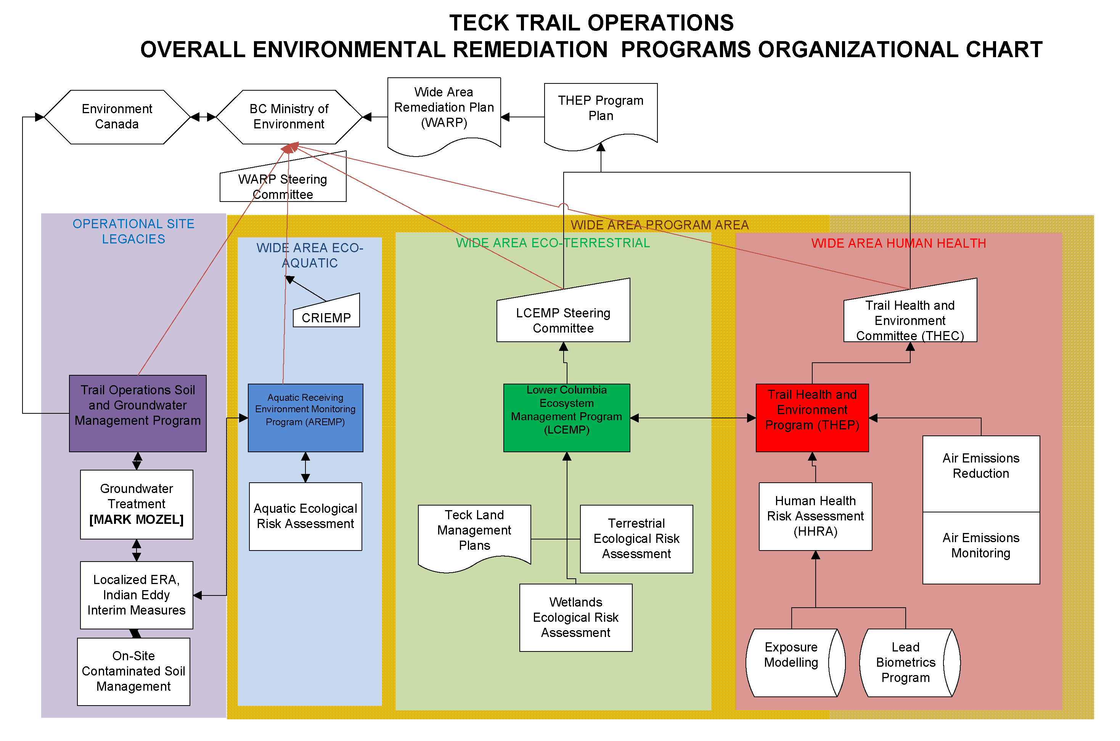

Figure 1: Overall Environmental Remediation Programs Organizational Chart

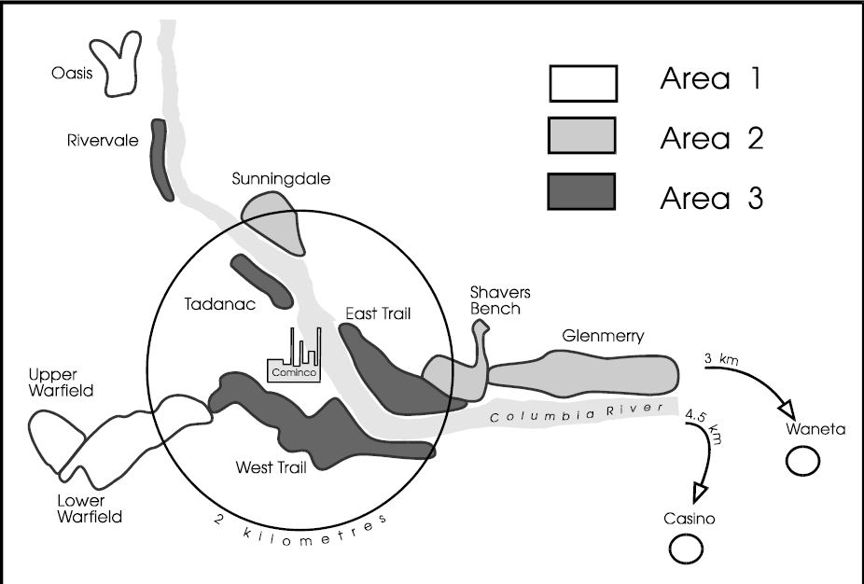

Figure : Community Program Areas



Figure : Overall THEP Program Schematic

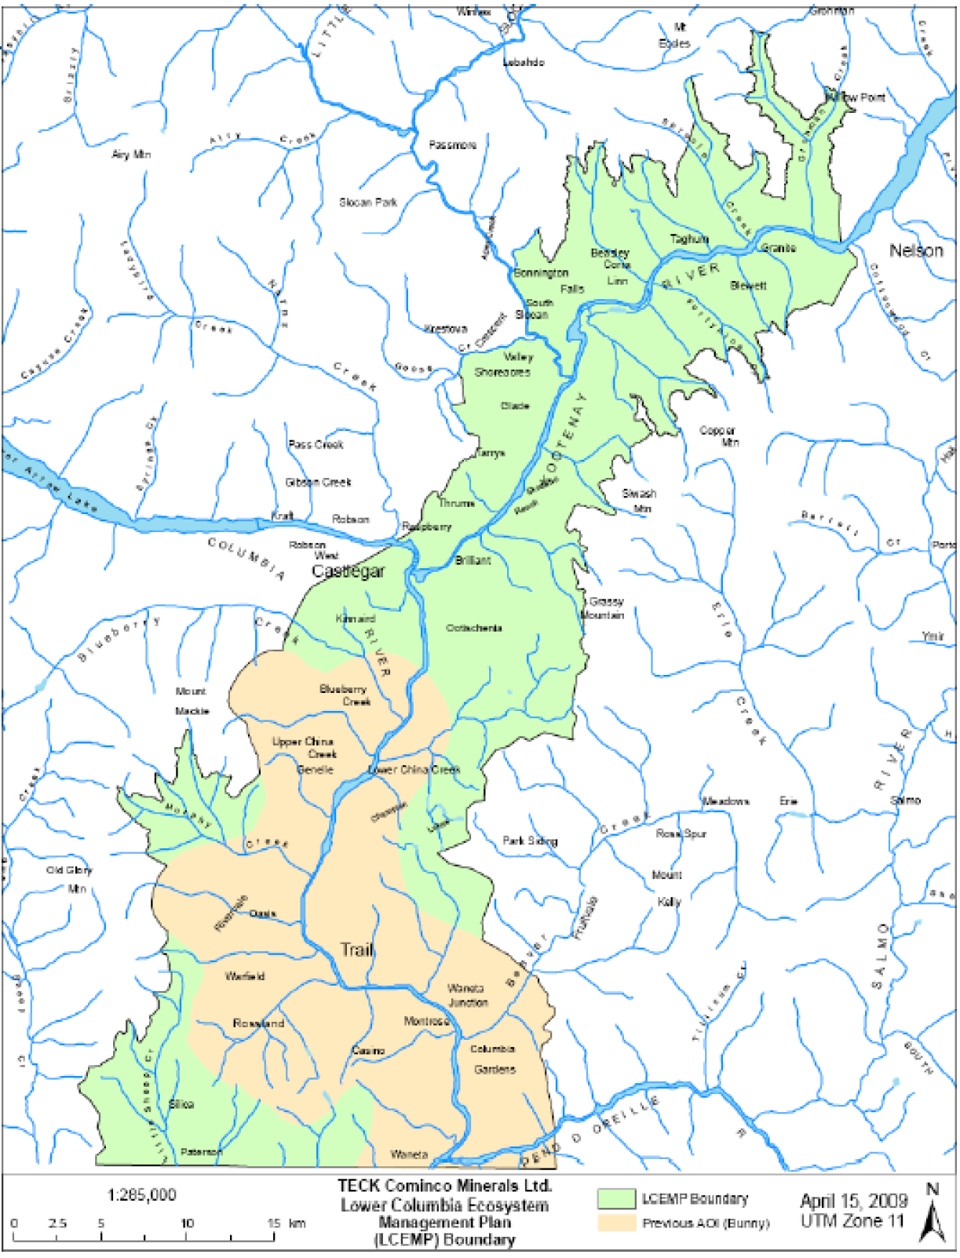

Figure : LCEMP Area

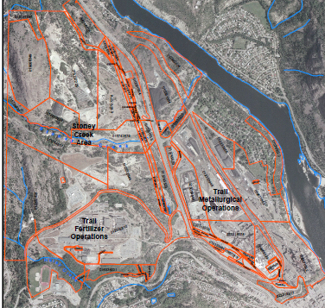

Figure : Trail Operations Operational Site

# 