Parks & Wildlands

The Parks & Wildlands Program addresses both human health and ecological issues. Planting to cover bare soil in parks and other green spaces decreases exposure of people to metals in soils. Treatment of soils in parks and wildland areas by adding soil, organic material, lime and/or nutrients can bind the metals in soil and decrease metal exposure of people, plants and wildlife.

The goal of the Parks & Wildlands Program within the THE Program Plan is to decrease human and ecological exposures and risks by two main approaches:
- Community greening (covering of bare soil); and,
- Terrestrial ecosystem management, to assess, rehabilitate, conserve and enhance terrestrial and wetland wildland ecosystems, via the Lower Columbia Ecosystem Management Program.

These two approaches are described in detail below.

Community Greening

Community Greening Projects within the City of Trail are primarily driven by the THEP objective of suppressing dust through the greening of bare soil locations. This serves to reduce peoples’ direct contact with contaminated soil and decreases the movement and thus availability of contaminated soil to transport or re-suspend in the community.

In 2001, as part of a public consultation process, Teck (then Cominco) agreed to continue greening in the community by improving the buffer between the industrial site and the community, and by continuing other re-vegetation efforts around the community. Community greening projects have been ongoing since 1996 (Table 1-1), although most pre-2001 projects were on-site and directed towards research around soil augmentation (using biosolids and lime) and trials with various plant species.

Table 1-1 List of Historical Community Greening Projects, 2001-2012
Year | Location | Project Scope
1992-96 | City of Trail | Various Rotary Club projects which included hydro-seeding, application of turf, and paving or gravel applications to cover bare soil
Pre-2001 | Tadanac | Approximately 300 conifer and 20 deciduous trees planted in community.
2001 | Tadanac | 80 large trees planted on Teck private lots, along buffer, end of soccer field; bare soil seeded with grass. Total area ~1.8 ha.
2001 | Shaver’s Bench | Biosolid and grass seed applied.
2001 | Trail Airport | Biosolids transported to site and trees planted by Trail Model Flyers organization.
2002 | Shaver’s Bench | Biosolid and grass seed applied.
2002 | Tadanac | Plant 30 trees to extend row planted in 2001.
2003 | City of Trail | Supply biosolids for Shavers Bench and Columbia River bank stabilization.
2004 | Glenmerry | Supply biosolids to greening project by Glenwood Motel
2005 | Teck site | Most work done in and around Industrial site
2005-2012 | Riverbank | Teck Riverbank restoration work

Community Greening Projects are reviewed annually between Teck and the City of Trail. A list of eligible locations is generated each year in consultation with the City of Trail staff. Sites are situated within Trail city limits (see Figure 1-1). Projects are given a ranking value based on their ability to meet objectives in the following categories: dust control; sustainability; aesthetics; erosion control; biodiversity (Table 1-2). The highest ranking project is then planned in more detail, available resources required are determined, and a consultant is contracted to implement the project. The consultant reviews the draft plan, the project objectives and then provides a more detailed plan, including plant species and overall planting configuration. Final approval is provided by Teck and City of Trail personnel. The contractor then conducts the planting and the first year’s watering maintenance requirements. The project sites are generally dry, south facing slopes that can lose moisture very rapidly. Variable weather patterns each year can also determine the extent of effort allocated to watering. Once plants are considered established, manual watering of the site is ceased.

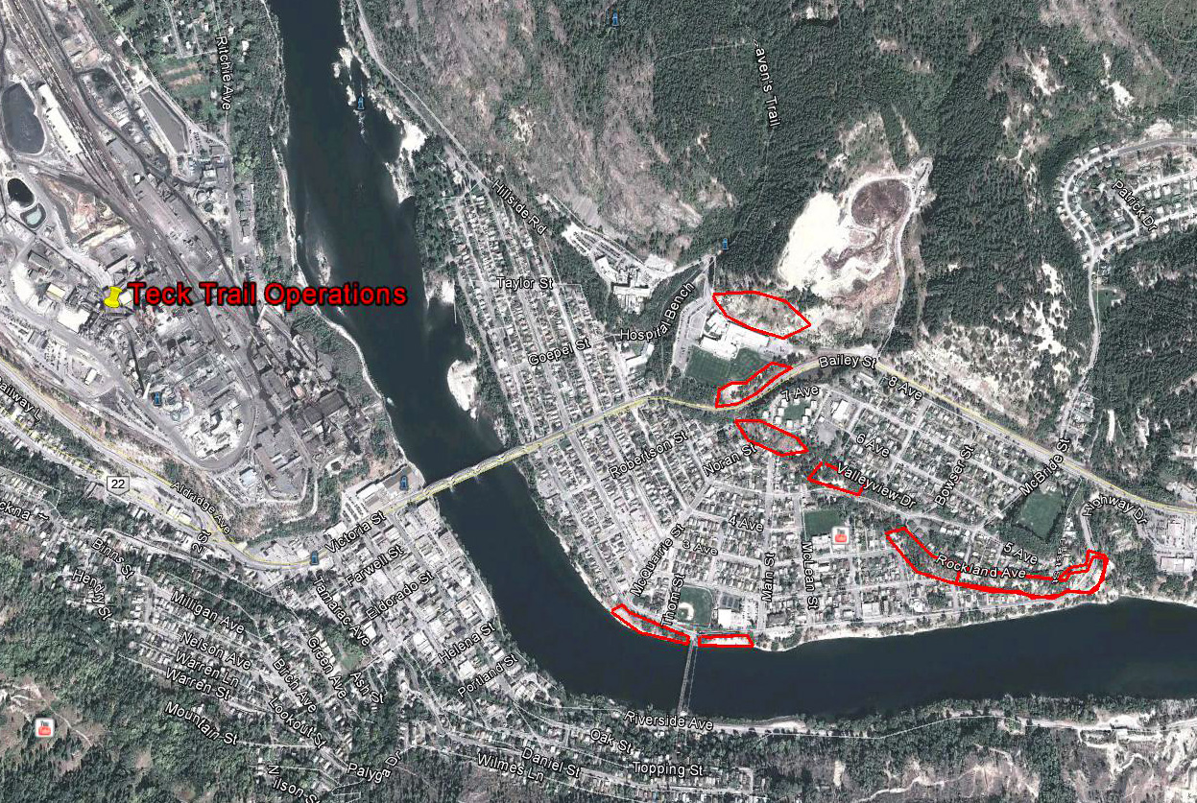
Figure 1-1 Potential Community Greening Locations (outlined in red) Determined through
Consultation with City of Trail

Table 1-2 Prioritized List of 2013 Community Greening Projects with Greening Objectives Rankings
Greening Objectives | Dust Control | Sustainability | Aesthetics | Erosion Control | Biodiversity | TOTAL SCORE
East Trail—North Shavers Bench road towards dump | 9 | 7 | 10 | 7 | 7 | 40
*West Trail--Highway Approach to Trail | 9 | 6 | 10 | 8 | 8 | 41
East Trail--Riverbank on both sides of Old Bridge | 7 | 6 | 10 | 7 | 9 | 39
East Trail—West Shavers Bench below Townhouses | 9 | 7 | 9 | 7 | 7 | 39
East Trail--Shavers Bench at Stewart Street | 8 | 7 | 9 | 7 | 7 | 38
*Deferred in 2013 to allow more time for planning and determination of infrastructure requirements.

Success is determined by size of area planted each year and by success of survival of plants after two years of growth. At least 50% survival of plants is considered a success. Generally speaking, the greater the area covered and the greater the plant survival, then the greater the success of the project.

Endogenous plants are sourced from a number of locations including commercial greenhouses, private tree and shrub farms and from the JL Crowe High School greenhouse and community garden. The high school has partnered with Teck to produce tall rooted deciduous trees (see Figure 1-2), and, in the Fall of 2013, students will collect seed from shrubs in the area and propagate them in the school’s indoor greenhouse for Spring 2014 community planting.

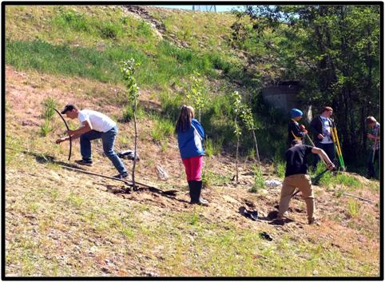
Figure 1-2 JL Crowe Outdoor Education Students Planting Cottonwood Trees Grown in the High School Community Garden

A related Teck initiative within the THEC Program is the greening of buffer zones around the smelter, via tree and shrub planting around the perimeter of the Teck facility. Community projects are proposed by groups such as Trail’s Communities in Bloom and the Tadanac Community Association. Each group has provided a wish-list of prioritized projects with their main objective being community esthetics and a secondary objective of dust suppression. Esthetic appeal can provide, mainly along the perimeter of the Industrial site, a green visual backdrop between the community and the Teck industrial site. Dust suppression will be enhanced by either planting on bare soil or by increasing the density of plantings in an area (in-fill planting). Although not a primary objective, ecological enhancements will be created simply by providing green structure, in the form of trees or shrubs, on the landscape.

Lower Columbia Ecosystem Management Program

The Lower Columbia Ecosystem Management Program (LCEMP) is a collaborative approach to assess, rehabilitate, conserve and enhance terrestrial wildland ecosystems (including wetland and riparian areas) in the Program area.

Scope of LCEMP

The LCEMP arose out of the need for Teck to address potential ecological risks in a portion of the study area around the Trail smelter. The terrestrial ecological risk assessment (ERA) (Intrinsik et al., 2011) concluded that the plant communities in wildland areas may be at risk in up to 7,900 ha (Figure 1-3). Wildlife may be affected when there are changes in their habitat, so changes in the plant communities also can affect wildlife diversity.

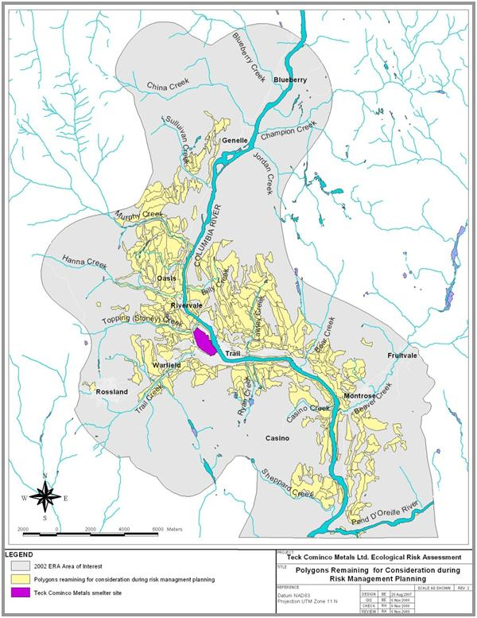

Figure 1-3 Areas Potentially “At Risk” based on the Ecological Risk Assessment Results

The scope of LCEMP and the relationship between LCEMP, other programs and the BC Ministry of Environment are illustrated in Figure 1-4. The scope of LCEMP does not include issues or activities related to the Columbia River, as these are being addressed by the Aquatic Receiving Environment Monitoring Program (AREMP), as well as the Columbia River Integrated Environmental Monitoring Program (CRIEMP). The scope also does not include operational issues within the Teck industrial site, including those related to groundwater.

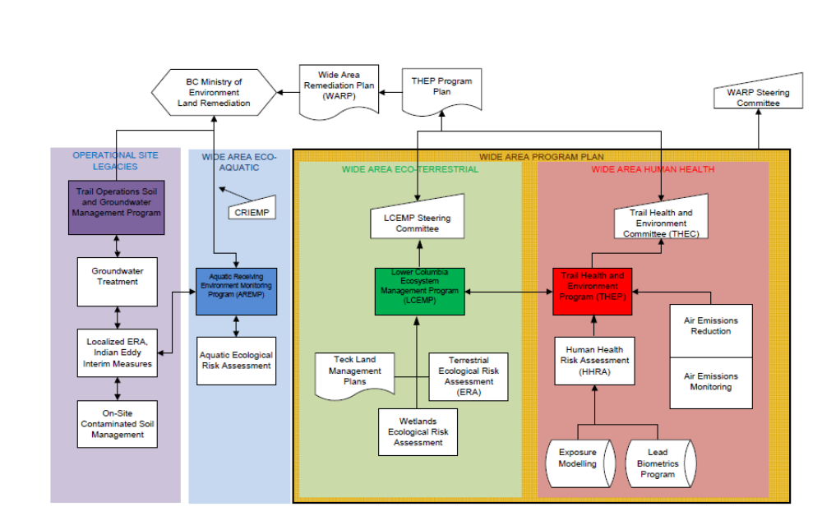

Figure 1-4 Relationship Between LCEMP and other Program Areas

According to the Contaminated Sites Regulation, Teck must address areas that have both concentrations of metals in soil that exceed soil standards, and potential unacceptable risks to plants, invertebrates or wildlife, as determined by the ecological risk assessment. Teck also agreed to address areas where concentrations of metals in soil do not exceed soil standards, but where potential unacceptable ecological risks exist due to historical smelter emissions, primarily sulphur dioxide (SO₂). Historically, SO₂ concentrations were high enough to kill the plant communities directly, which also resulted in erosion of the soil. This has left some areas with little soil, and low concentrations of metals in that soil, but plant communities that are not as diverse as they could be, and which do not offer the same habitat value to wildlife. These areas also were considered in the ERA.

Teck must submit a Remediation Plan to the Ministry of Environmental for approval. The Plan will present the proposed approaches to management of areas identified as impacted by smelter emissions. There are three main approaches to management that will be documented in the Remediation Plan: 1) no active management; 2) remediation and rehabilitation of impacted areas; 3) offsetting of impacts via remediation, rehabilitation or enhancement in other areas. No active management may be recommended for areas where management activities are not necessary or would offer little-to-no benefit for biodiversity or conservation. Remediation and rehabilitation will be recommended for areas impacted by smelter emissions where it is practicable to do so. Where remediation or rehabilitation is not feasible, either because the area is inaccessible (e.g., has a steep grade, there are no roads to the area), or where remediation and rehabilitation activities may not be successful (there is a high probability of failure due to the site conditions), Teck will propose these areas to become part of LCEMP; these areas may need to be offset by biodiversity or conservation gains in other areas. The proposed plans for areas with no active management, or where remediation and rehabilitation are practicable, as well as the identification of areas to be considered for offsetting and associated potential offset projects are all within the scope of LCEMP. LCEMP will make recommendations to the Ministry of Environment, who have ultimate authority for approval.

The LCEMP Program Area includes all lands identified in the Terrestrial Ecological Risk Assessment reports as potentially at risk. It also includes other lands owned either by Teck, the Crown, and interested landowners over a broader area (Figure 1-5). The boundary within which potential projects would be considered was determined by the LCEMP Steering Committee at the September 30, 2008 meeting, was discussed again at the April 29, 2010 meeting, and was confirmed at the May 1 2013 meeting. Projects would be considered outside of the Risk Assessment Area of Interest but within the LCEMP Program Area, to take advantage of opportunities for adjacency and connectivity, to provide opportunity to include high value riparian lands, and to include Teck land holdings along the lower Columbia and Kootenay Rivers, from Genelle to Nelson. Projects may be considered outside of the LCEMP Program Area on a case-by-case basis, but because it is preferable to find like-for-like offsets, the focus will be within the LCEMP Program Area.

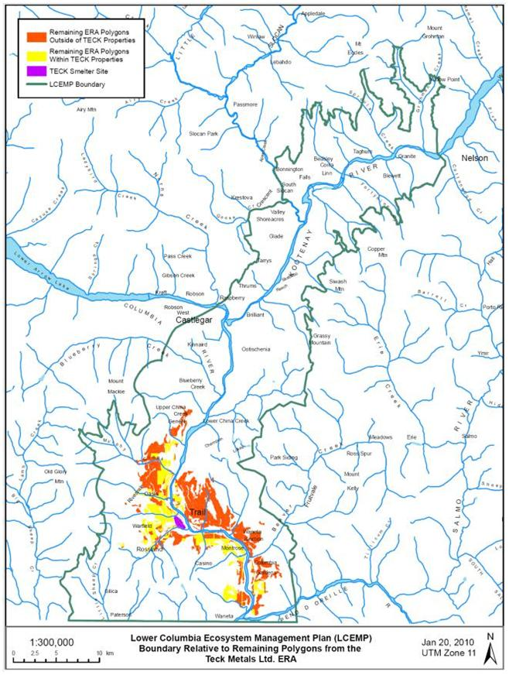

Figure 1-5 LCEMP Program Area Boundary

The Guiding Principles developed for LCEMP are:
- The program will focus on ecological values and associated risks;
- The program will consider impacts of habitat management on the socio-economic and cultural well-being of surrounding areas;
- The program will strive for consensus among stakeholders while recognizing landowner and statutory rights and responsibilities; and,
- Management actions will cause “no net harm”, and are intended to yield a net benefit, as confirmed through effectiveness monitoring and adaptive management.

Structure and Oversight of the Program

In 2008, Teck met with BC Government representatives (Ministry of Environment; Ministry of Forests) to present the concept of an LCEMP. A Steering Committee then was formed that includes participation by BC Ministry of Environment, Ministry of Forests, Lands and Natural Resource Operations, local Regional Districts (Kootenay-Boundary and Central Kootenay), Kootenay Conservation Program, the Fish and Wildlife Compensation Program, as well as Teck and its consultants. The purpose of the Steering Committee, as outlined in its Terms of Reference (LCEMP SC, 2013; attached in Appendix X), is to oversee and provide technical assistance and recommendations regarding LCEMP through the development, implementation and subsequent performance monitoring phases of the program; and, to support the Ministry of Environment approval process under the Contaminated Sites Regulation (CSR). Steering Committee meetings were held in April 2010, June 2012, and May 2013, and moving forward, two meetings per year are planned.

In addition to the Steering Committee, there is a Core Working Group, other Resources, Sponsors, and Stakeholders (Figure 1-6). The Core Working Group develops the LCEMP and reports to the Steering Committee. It includes Teck and its consultants, and may include other participants as specific projects are identified. Other Resources include technical specialists who will assist the Core Working Group by addressing particular issues as they arise. Sponsors are senior government representatives who are able to take issues and requests to the appropriate senior government officials for feedback. Two groups of Stakeholders were identified: Advisory Stakeholders, who are consulted regularly; and, Information Stakeholders, who are provided information but from whom input is not actively solicited.

The LCEMP Steering Committee members are consulting with a variety of stakeholders to identify opportunities for conservation partnerships with these other landowners. By adopting this landscape-scale approach, Teck feels the program can more effectively address issues related to ecosystem function, biodiversity, habitat connectivity and suitability for a wider range of species.

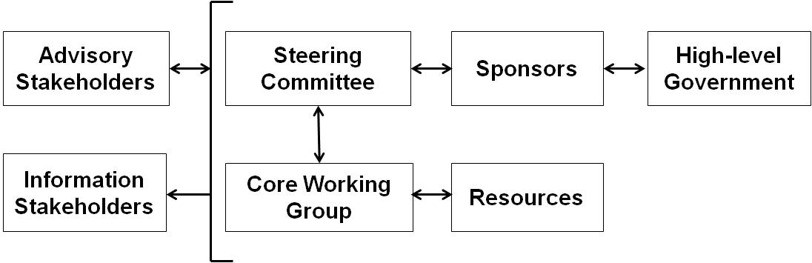
Figure 1-6 LCEMP Structure and Working Relationships

Teck has committed to funding and participating in the development and implementation of the LCEMP. Teck will integrate management recommendations from the LCEMP on its own lands on a prioritization and budget-allocation basis, and consistent with overall Teck principles, policies and procedures. Teck also will collaborate with other landowners and managers to meet shared objectives. Teck will consider opportunities to contribute financially to habitat restoration and enhancement initiatives on crown and private lands in the LCEMP area, contingent on such actions being recognized by BC Ministry of Environment as a contribution to their remediation and rehabilitation obligations (Teck, 2013). Funding will be allocated annually, as determined by Teck, and may vary between years.

BC Ministry of Environment has provided a Letter of Agreement (dated XXX, 2013; attached in Appendix X) that indicates that the LCEMP process provides a sufficient mechanism to meet Teck’s obligations for remediation of its smelter impacts in the wide area site, under the Environmental Management Act, and the associated Contaminated Sites Regulation.

The comment and approvals process for LCEMP is illustrated in Figure 1-7. Briefly, the remediation and rehabilitation plans for areas identified in the ERA will be submitted to Ministry of Environment for approval. Proposed offset plans will be submitted to the LCEMP Steering Committee first. Once any questions or issues are clarified with the Steering Committee, there will be communication with Stakeholders, prior to submission of the proposed plans to Ministry of Environment. Final approval will be obtained from Ministry of Environment in Victoria, based on input from regional Ministry staff.

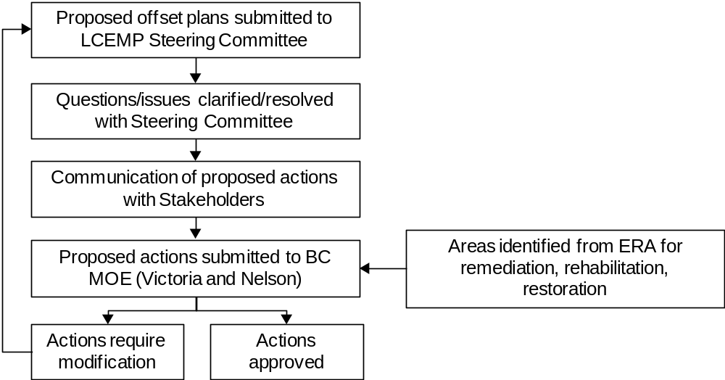

Figure 1-7 Comment and Approval Process for LCEMP Projects

Linkages between the ERA, Land Management Activities and LCEMP

There are several activities ongoing by Teck that connect to the LCEMP:

- Re-assessment of the ERA lands and consideration of remediation and rehabilitation potential;
- Assessment of wetlands within the ERA area;
- Development of Land Management Plans; and,
- Development of an approach to incorporate biodiversity offsetting into the remediation planning process.

The linkages between the ERA, including the re-assessment of the ERA lands, Teck Land Management activities and LCEMP, including offsetting, and outreach to other stakeholders are described briefly below, and illustrated in Figure 1-8:
- The ERA (Intrinsik et al., 2011) concluded that the plant communities in wildland areas may be at risk in up to 7,900 ha (Figure 1-3). Because this conclusion was based on data from 1999-2001, the impacted areas are being re-evaluated in 2013 to determine whether plant communities have continued to develop over the past 10-12 years. This will be done using aerial photography from 2012 and field data from 2013 to confirm which areas should be considered for remediation, mitigation, rehabilitation or offsetting. In addition, wetlands are being assessed external to the aquatic and terrestrial risk assessments, and will be considered for remediation, mitigation, rehabilitation or offsetting.
- Teck has been developing Land Management Plans for their own lands. These plans identify routine or regular land management activities (e.g., removal of noxious weeds, wildfire control), as well as opportunities for rehabilitation, enhancement and conservation initiatives that go beyond routine obligations. Although these Land Management Plans are internal Teck documents, information from these plans may be made available to the LCEMP Steering Committee related to specific potential offset opportunities. These conservation gains may be considered as offsets for areas of the valley that have been impacted by the smelter but for which remediation or rehabilitation is not feasible or considered likely to succeed.
- There also are other public and private stakeholders in the area that own or manage lands that are not within the 7900 ha ERA area, who may wish to partner with Teck in conservation initiatives on their lands. It is hoped that communication and consultation with a variety of stakeholders will encourage partnerships in conservation with area landowners.
- The offsetting approach being developed by Teck outlines a method for documenting potential offset opportunities, which will facilitate the identification of like-for-like (no net loss), or trade-up (net gain) conservation of habitat, or specific features within an ecosystem.

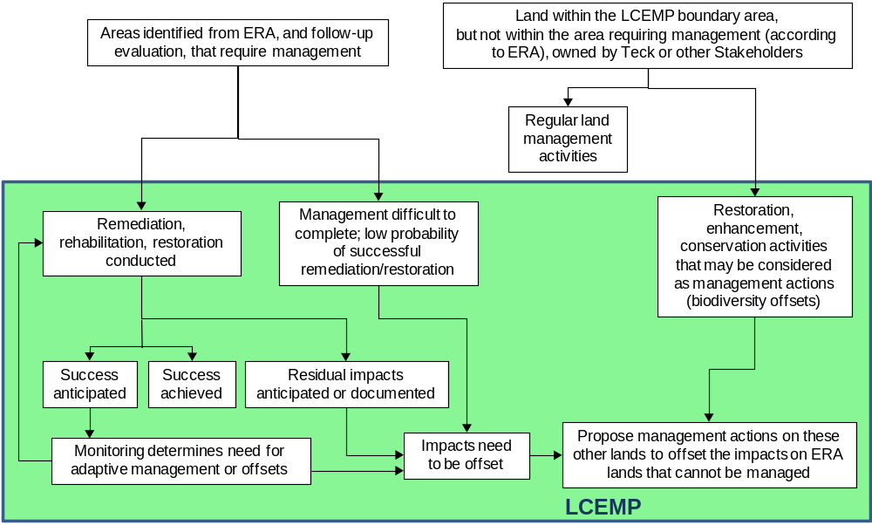

Figure 1-8 Linkages between LCEMP and the ERA and
Land Management Activities

Re-assessment of ERA Lands and Consideration of Remediation and Rehabilitation Potential

In 2012, Teck initiated a re-assessment of the areas for which impacts to the plant community could not be ruled out in the ERA (Intrinsik et al., 2011). The re-assessment is being done because, although the ERA was completed in 2011, it used data from 1999-2001, and there may be areas that have continued to develop over the past 10 to 12 years. This is important because KIVCET became operational only in 1997, and there may not have been time between 1997 and 1999 for plant communities to respond to the decreased emissions. Areas with confirmed impacts will require remediation, rehabilitation or offsetting.

Aerial photographs of the 7,900 ha ERA area were taken in August 2012. In 2013, comparisons will be made between the aerial photographs from 1999 and 2012, to evaluate changes in the vegetation. The analysis will be verified by conducting field work in selected locations, and making corrections as warranted. Rehabilitation potential will be described for areas with confirmed impacts.

Assessment of Wetlands

Wetlands are being assessed external to the aquatic and terrestrial ecological risk assessments, based on an agreement between Teck and BC Ministry of Environment. A preliminary characterization of wetlands was completed in 2004/2005 to evaluate metal concentrations in water and sediment of five wetlands in the ERA study area (Golder and Intrinsik, 2007). Metal concentrations exceeded water and sediment quality standards and guidelines. Modelling of metal exposure to the mallard did not suggest potential impacts to this representative wetland species. However, because only five wetlands were studied, and very little biological characterization was completed, additional work on area wetlands was initiated in 2012. In 2012, metal concentrations in water and sediment from 10 wetlands were analyzed. These data will be evaluated, and additional biological characterization completed for selected wetlands. Because few wetlands exist in the area, they offer unique opportunities for habitat enhancement and rehabilitation. The Oasis Wetland (Figure 1-9), in particular, is the subject of a feasibility study to evaluate options for enhancement and rehabilitation, as well as creation of an educational area.

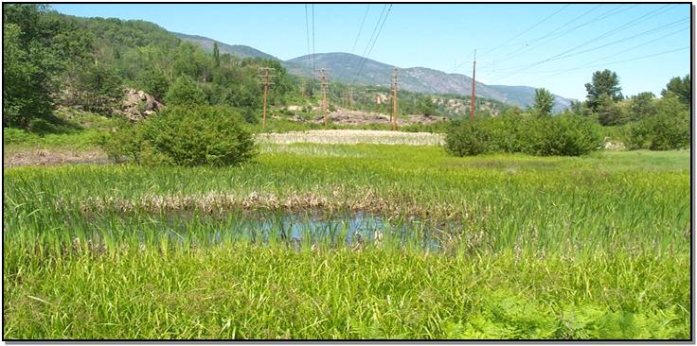
Figure 1-9 Oasis Wetland

Development of Teck Land Management Plans

Teck is in the process of developing Land Management Plans for all of their land holdings in the LCEMP area. These plans identify opportunities for rehabilitation and conservation initiatives that may be considered as offsets for areas of the valley that have been impacted by the smelter but for which remediation or rehabilitation is not feasible.

Two plans have been completed thus far:

- Teck Lands in the Rossland Area (2010); and,
- Teck Lands in the ERA South (Trail to the US Border) Area (2013).

Five additional plans are scheduled for completion within the next couple of years:
- Teck Lands from Glade to Nelson (2013);
- Teck Lands in the ERA North (Trail to Genelle) Area (2013/2014);
- Teck Lands from Genelle to Thrums (2014);
- Teck Lands in the Kootenay Lake (Riondel) Area (2014); and,
- Teck Lands in the Christina Lake Area (2014).

These plans identify activities that should be conducted as a normal component of responsible land management, such as:
- Noxious weed control consistent with the Weed Control Act; and,
- Posting signs on private property consistent with the Occupiers’ Liability Act.

These plans also identify management actions to maintain, rehabilitate or enhance the ecological value of their lands. Those actions that are not considered routine land management, or fulfill regulatory requirements may be considered as offsets. Examples of such actions would include:
- Habitat or habitat element inventory, protection, enhancement or creation (in upland, wetland and riparian settings);
- Establishment of wildlife nest or roost boxes, platforms, lodges, dens, basking sites, etc.;
- Weed inventory and control of species not designated as noxious;
- Ecosystem rehabilitation through soil amendments and/or forestry treatments (e.g., prescribed fire, selective tree thinning);
- Forest health and disease management, research and monitoring;
- Access control and use restrictions and monitoring;
- Listed animal or plant species inventories, research and monitoring;
- Interpretive signage or public education/awareness initiatives; and,
- Establishment of conservation covenants, stewardship agreements or other conservation approaches.

Conservation gains by implementing these activities on Teck lands may be considered as offsets for areas of the valley that have been impacted by the smelter but for which remediation or rehabilitation is not feasible or considered likely to succeed.

Biodiversity Offsetting Approach

Biodiversity offsets are gains in ecological conservation in a location other than that which has been impacted by a project. These conservation gains may result from activities such as: intervention to stop ecosystem degradation; restoration or creation of habitat; and protection of areas of biodiversity. The biodiversity offsetting approach was developed for use with new development projects, where there will be a known impact on the ecosystem caused by the project, but it can also be applied to sites with existing impacts (BBOP, 2012a). According to this approach, the company must first try to avoid significant environmental impacts. Where impacts are unavoidable, they must take steps to minimize the impacts (to reduce the duration, intensity and/or extent of impacts), and then attempt to rehabilitate degraded ecosystems. If there are impacts that cannot be avoided, minimized, or rehabilitated, then offsetting is used to ensure there is no net loss of biodiversity, and preferably a net gain (BBOP, 2012b), by undertaking conservation activities in nearby locations.

As noted in Figure 1-5, there may be areas where Teck is committed to do remediation or rehabilitation, but where it is not feasible to do so, either because the area is inaccessible (e.g., has a steep grade, there are no roads to the area), or where remediation and rehabilitation activities may not be successful (there is a high probability of failure due to the site conditions). These areas are the ones that may need to be offset by conservation gains in other areas.

In 2011, Teck submitted to BC MOE a draft Offsetting Discussion paper to introduce the concept of offsetting in the context of a remediation plan. The draft document provided a brief review of offsetting literature available at that time, introduced how offsetting could be applied to the Trail situation, and identified several issues that required more detailed documentation and development before offsetting could be applied as part of LCEMP. In spring 2013, Teck submitted to BC MOE an updated document that summarized new literature on offsetting, and included a framework for the use of offsetting within LCEMP (Teck, 2013). This document is attached in Appendix X.

Because there are so many potential offset projects, LCEMP will need a strategic approach for evaluating options to determine which project would best serve as an offset for a particular impact. Development of a prioritization scheme will be a focus of the LCEMP Steering Committee meeting scheduled for fall 2013. Other issues that remain to be worked out as we move forward with LCEMP include:
- How to determine like-for-like offsets;
- How to account for Teck donating money for initiatives, rather than (or in addition to) having an “area” offset;
- Determining effectiveness monitoring requirements.

Effectiveness Monitoring and Adaptive Management

An Effectiveness Monitoring Plan will be written to describe the monitoring requirements for different types of projects that are conducts under LCEMP, such as Teck internal covenants, weed management, other types of habitat management or enhancement actions, etc. Monitoring programs and results will be reviewed periodically to determine the need for adaptive management (i.e., changes in management actions if results do not meet expectations).

Summary of LCEMP

The LCEMP is a collaborative approach to assess, rehabilitate, conserve and enhance terrestrial wildland (including wetland and riparian) ecosystems in the area. The program addresses the obligation Teck has to remediate and rehabilitate areas that have been affected by smelter emissions under the Contaminated Sites Regulation. It builds on work Teck is already doing on their own lands, but it also creates opportunities for additional conservation gains by encouraging collaboration with other area stakeholders and landowners to identify and implement activities that result in the greatest environmental benefit.

Summary and Conclusions

The goal of the Parks & Wildlands Program is to decrease human and ecological exposures and risks by three main approaches:
- The Community Greening program which works to suppress dust through the greening of bare soil locations;
- The LCEMP is a collaborative approach to assess, rehabilitate, conserve and enhance terrestrial wildland (including wetland and riparian) ecosystems in the area. The program addresses the obligation Teck has to remediate and rehabilitate areas that have been affected by smelter emissions under the Contaminated Sites Regulation. It builds on work Teck is already doing on their own lands, but it also creates opportunities for additional conservation gains by encouraging collaboration with other area stakeholders and landowners to identify and implement activities that result in the greatest environmental benefit.

References

BBOP. 2012a. Standard on Biodiversity Offsets. Business and Biodiversity Offsets Programme. Available on-line at http://bbop.forest-trends.org/pages/guidelines.

BBOP. 2012b. Guidance Notes to the Standard on Biodiversity Offsets. Business and Biodiversity Offsets Programme. Available on-line at http://bbop.forest-trends.org/pages/guideline.

BC Ministry of Environment. 2013. Letter of Agreement regarding LCEMP Process. XXX, 2013 [attached in Appendix X]

Golder and Intrinsik. 2007. Summary of Wetlands Investigations for the Teck Cominco Area of Interest. Final Report. August 2007. Prepared by Golder Associates Ltd. (Calgary, AB) and Intrinsik Environmental Sciences Inc. (Mississauga, ON). Prepared for Teck Cominco Metals Ltd. (Trail, BC).

Intrinsik Environmental Sciences Inc. 2007. Ecological Risk Assessment for Teck Cominco Operations at Trail, British Columbia. Terrestrial Risk Modelling Level of Refinement #3. Final Report. August 2007.

Intrinsik Environmental Sciences Inc., Swanson Environmental Strategies, Delphinium Holdings Ltd. and Teck. 2011. Terrestrial Ecological Risk Assessment for the Teck Metals Ltd. Smelter at Trail, BC. Main Report. Revised. May 2011. Available on-line at www.teck.com.

LCEMP SC (LCEMP Steering Committee). 2012. Terms of Reference – Steering Committee. Lower Columbia Ecosystem Management Program. April 2013. [attached in Appendix X]

Teck. 2013. Offsetting Approach for the Lower Columbia Ecosystem Management Program. Teck Metals Ltd., Trail BC. April, 2013. [attached in Appendix X]

Contacts

Please refer to Table 1-1 for more information or to obtain copies of the referenced documents.

Table 1-1 Contact Information for the Parks & Wildlands Program
Program Area | Contact Person | Contact Phone Number | Contact Email
Trail Health and Environment Program General Information | Mark Tinholt | 250-364-4385 | Mark.Tinholt@Teck.com
Community Greening | David DeRosa | 250-364-4336 | David.DeRosa@Teck.com
LCEMP | David DeRosa | 250-364-4336 | David.DeRosa@Teck.com

