|  |
| --- |
| Welcome to Word  6 tips for a simpler way to work |

# Quick access to commands

At the top of your document, the **Quick Access Toolbar** puts the commands you use frequently just one click away.

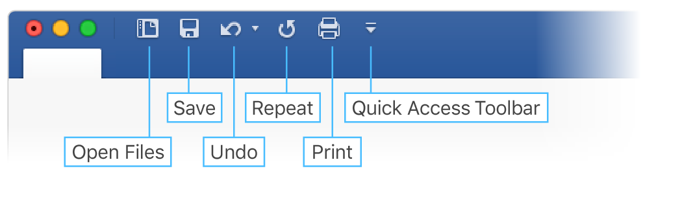

If the commands currently shown aren’t quite what you need, customize the **Quick Access Toolbar**.

Try it:

Select the **Customize Quick Access Toolbar** button and select command names to add or remove them from the **Quick Access Toolbar**.

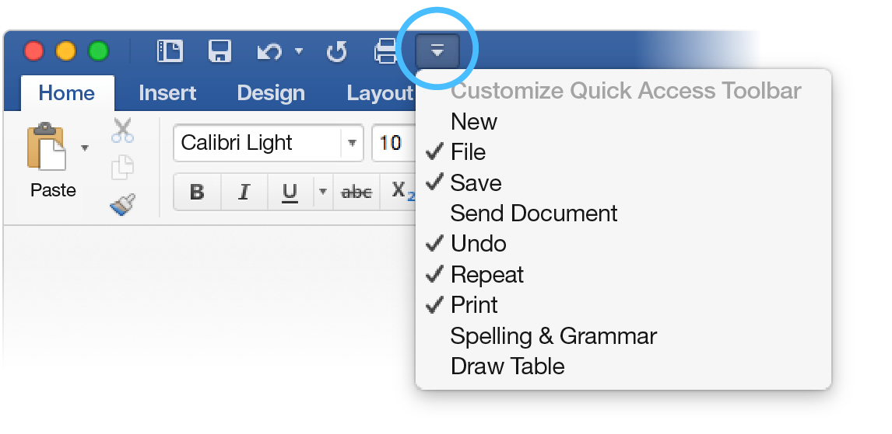

# Look professional, your way

In this document, styles like **Heading 1** and **Title** have been applied to text (**Home** tab, **Styles** gallery). That lets you quickly overhaul the look of the whole document.

Try it:

1. On the **Design** tab, select the different **Style Sets** and watch the formatting change automatically.  
   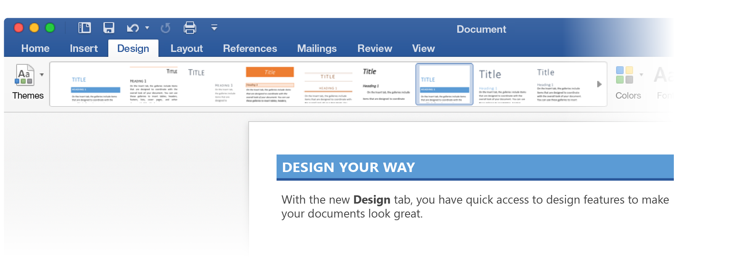
2. Go to **Themes** and watch how colors and fonts change with the various choices.  
   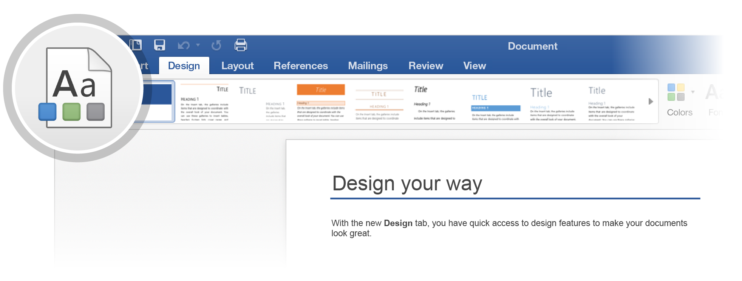
3. The **Design** tab also provides choices for fine-tuning colors, fonts, or paragraph spacing. You can also add a watermark or page border, or change the color of the page.  
   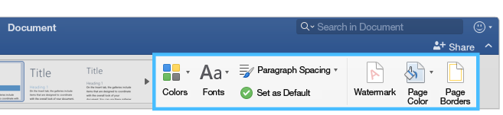

# Edit pictures without leaving Word

When it comes to pictures, Word includes options for adjusting color, cropping, removing the background, applying artistic effects, and more.

Try it:

1. Select this photograph of an otter:  
   
2. Select **Picture Format** tab, and then select **Artistic** **Effects** and select an effect, like **Mosaic** **Bubbles**.
3. To see all the formatting options, select **Picture Format** tab, and then select **Format Pane** on the right side of the app.  
   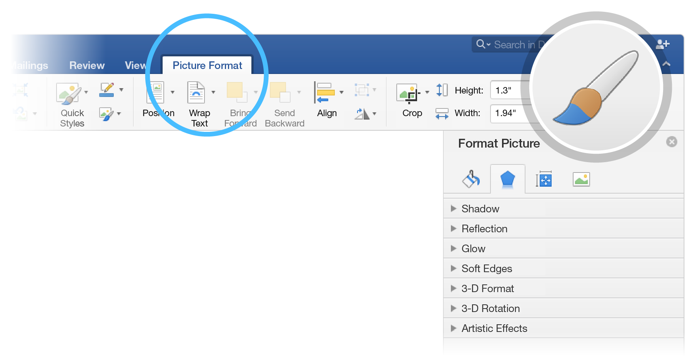
4. If you apply formatting you don’t like, press F1 to undo it, or select **Reset** under **Artistic** **Effects** in the **Format Pane** to go back to the original picture.

**Hint:** To open the **Format Pane** quickly, press Command+Shift+1.

# Explore without leaving your doc

**Smart Lookup** brings research from the web directly into Word.

Try it:

1. Select the word “Otter”
2. Go to the **Review** tab and select **Smart Lookup**  
   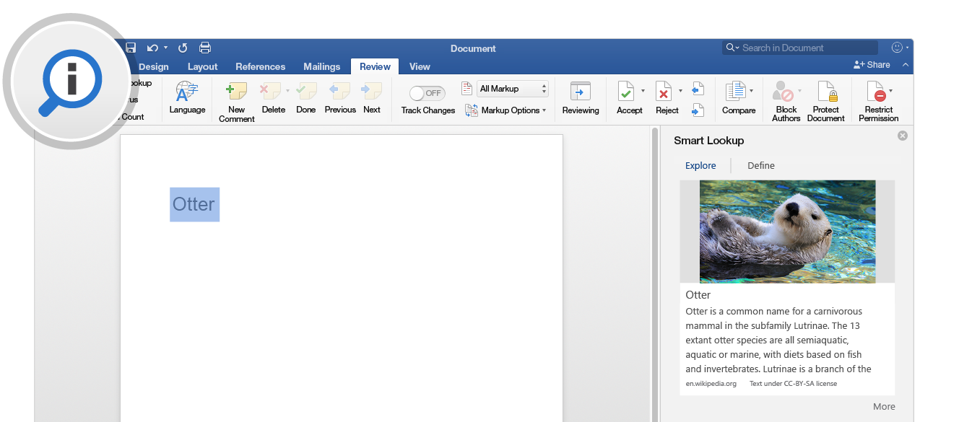

Source: Wikipedia CC-by-SA – <https://en.wikipedia.org>

1. To close out of the **Smart Lookup** pane, select the **Close** button at the top of the pane.  
   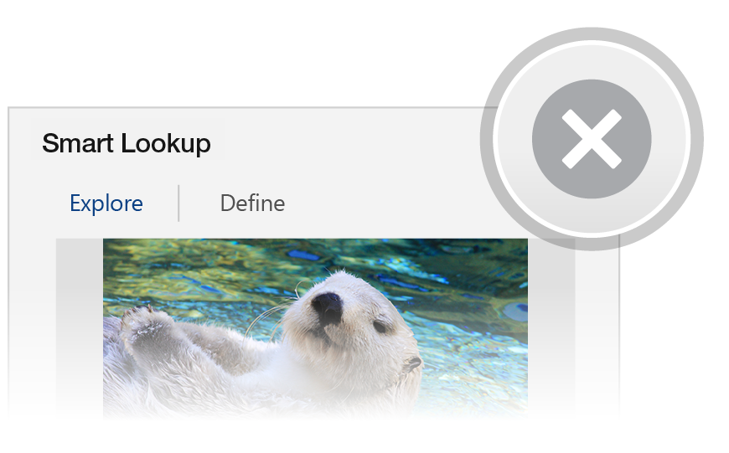

# Designed for teamwork

With your document stored online, your group can work on it together at the same time.

How it works:

1. Save your document in an online location, like OneDrive.
2. Select **Share** button from above the ribbon.  
   
3. Invite people or send a link so they can edit with you.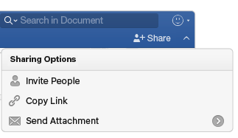

# Give feedback in comments

Comments are threaded, so you can have a conversation right next to relevant text. This is a great way to quickly add your feedback.

Try it:

1. Select somewhere in this paragraph, and then select the **Review** tab.
2. Select **New Comment**, and type something.  
   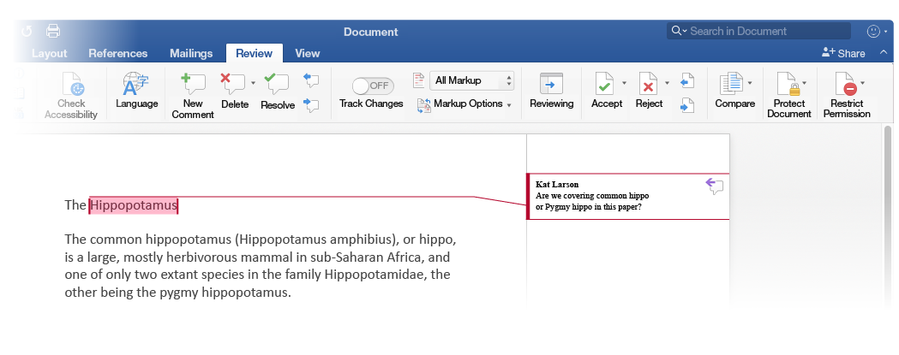
3. Notice that your comment includes a **Reply** button. Use it to respond to a comment.  
   

**Hint:** When you’ve taken care of feedback, get the comment out of your way without losing it: Select the comment and then select **Done** on the **Review** tab.

# More questions about Word?

|  |  |  |
| --- | --- | --- |
| Visit the Word team blog. | [Arrow pointing right with a hyperlink to the Word team blog. Select the image to visit the Word team blog](http://go.microsoft.com/fwlink/?LinkId=617174) | |
| Get help with Word for Mac. | | [Arrow pointing right with a hyperlink to help with Word for Mac. Select the image to access help with Word for Mac](http://go.microsoft.com/fwlink/?LinkId=746226) |