OAS Algorithm #1 – VIX Volatility Strategy

Theory:

Numerous studies have shown a negative correlation between stock market prices and volatility. Simply put, higher volatility corresponds to a higher probability of a declining market and lower volatility corresponds to a higher probability of an increasing market. We believe that we can develop a trading algorithm that can take advantage of this correlation. While increased volatility can create many opportunities for day and swing traders, the client is looking to initiate and hold medium to long term positions. Therefore this algorithm will attempt to find good points of entry/exits over periods of a few months to a couple of years. The Chicago Board Options Exchange’s CBOE Volatility Index (VIX) is a popular measure of the stock market’s expectation of volatility (based on stock options from the S&P 500 index) 30 days from the price date. The closing prices for VIX will be used as input for our algorithm. The other tickers we will be interested in testing as input are the VXNSM (NASDAQ) and RVXSM (Russell 2000); all are associated with the universe of indices that our client would like to trade, but for simplicity VIX will be our initial focus.

Method:

The closing price of VIX will be analyzed in a rolling one year window (253 trading days). Prices will be segregated into percentiles which will be used to make trading insights for market decisions. The one year rolling window would help to align with the historical price action of VIX; volatility tends to spike upwards over the span of < 1 month. Algorithm will be back-tested starting from the year 2006, to the present, to test for resiliency through two black swan events (2008 housing crisis and 2020 COVID crash).

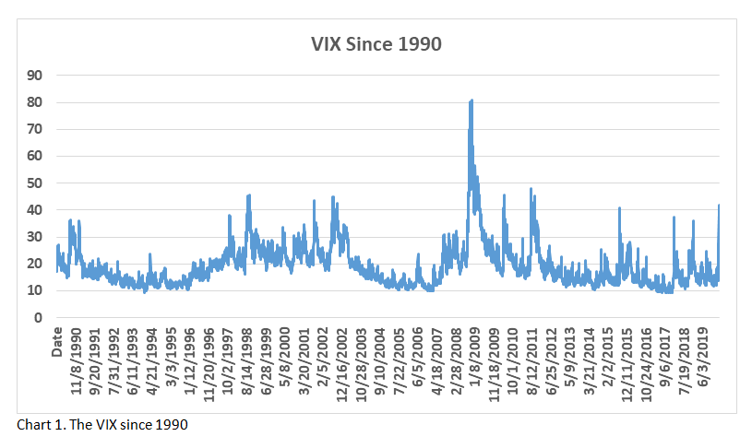

1. First iteration
2. Hypothesis:

Initiating a long position in the S&P 500 when volatility spikes will align with the theory that increased volatility creates buying opportunities due to market sell offs. Likewise, decreased volatility will offer opportunities to sell at higher profit.

1. Implementation:

If the closing price of VIX rises above the 90th percentile for prices in the last 253 days, initiate a purchase of the S&P500 index through UPRO (ProShares UltraPro S&P500). If it falls below the 80th percentile, sell all shares of UPRO.

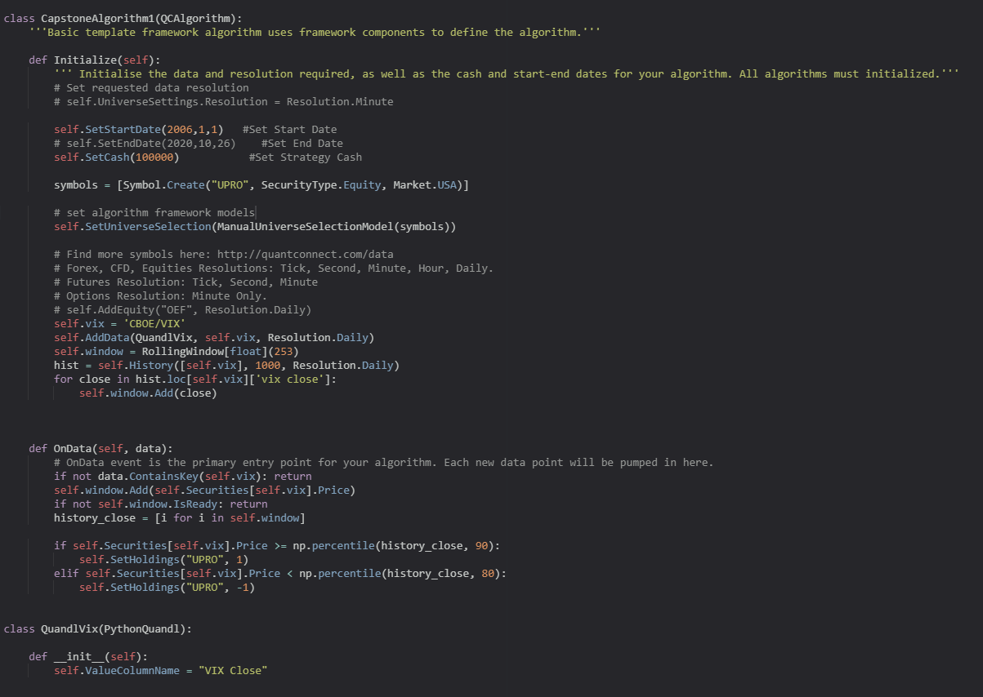

1. Results:

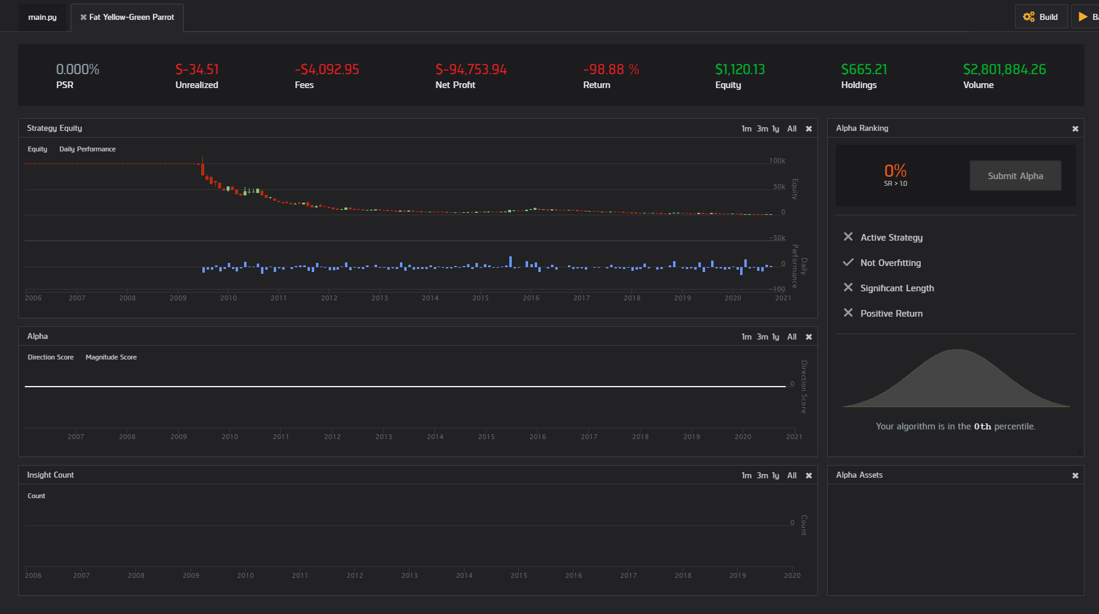

1. Conclusion:

Buying during periods of increased volatility and selling during periods of low volatility did not yield profitable results. This could be due to a lag in the algorithm insights. Since VIX is a leading indicator, there may be a possibility that buying and selling were occurring too soon, leading to the purchase of assets as they were beginning to decline, and selling before they had matured in profitability.

1. Second Iteration
2. Hypothesis

If the poor performance was due to lag, a counter strategy, where the selling of assets as the VIX is increasing, and purchasing as VIX is decreasing, may show better performance. The asset that will be purchased will be SPXU (ProShares UltraPro Short S&P500), the short position counter of UPRO.

1. Implementation (Iteration 2):

If the closing price of VIX rises above the 90th percentile for prices in the last 253 days, initiate a short of the S&P500 index through SPXU (ProShares UltraPro Short S&P500). If it falls below the 80th percentile, sell all shares of SPXU.

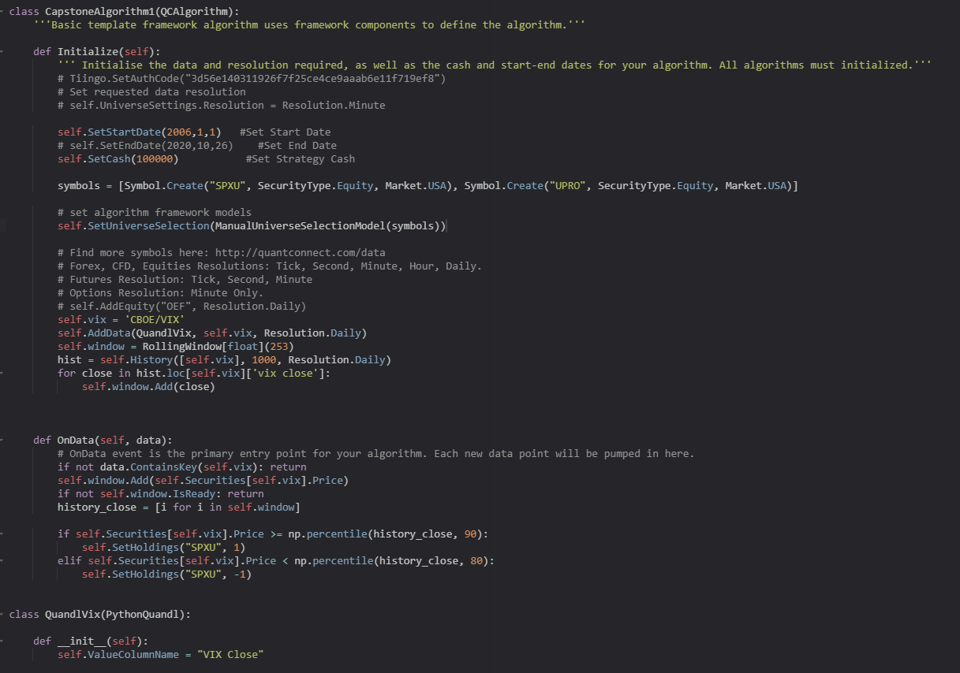

1. Results:

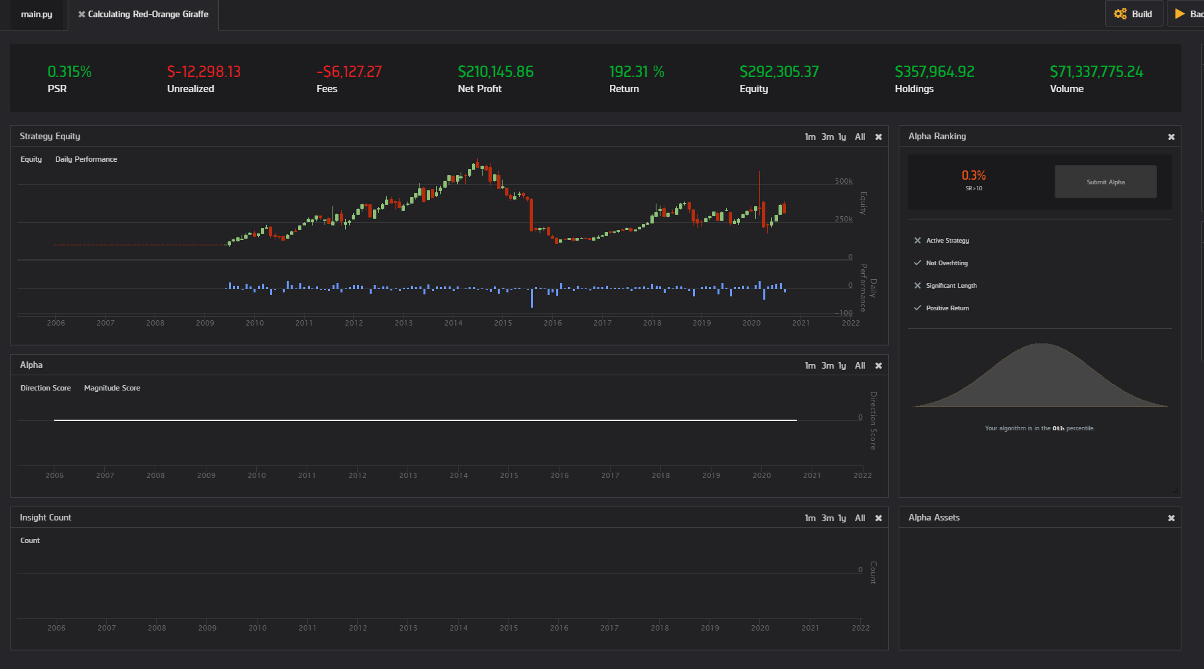

1. Conclusion:

There was a noticeable increase in performance when compared to the first iteration, where a long position was initiated versus a short. There were significant phases where the algorithm didn’t perform well, namely between 2015-2017, and remained stagnant afterwards. Considering these were time frames that the economy was doing well as a whole, initiating a short position would have been costly without proper risk management.

1. Third Iteration
2. Hypothesis:

Proper risk management following the purchasing strategy outlined in the second iteration could result in less periods of high risk and drawdown, effectively increasing algorithm performance in terms of total market return.

1. Implementation (Iteration 3):

If the closing price of VIX rises above the 90th percentile for prices in the last 253 days, initiate a short of the S&P500 index through SPXU (ProShares UltraPro Short S&P500). If it falls below the 80th percentile, sell all shares of SPXU. Add a trailing stop risk management model set at 20%.

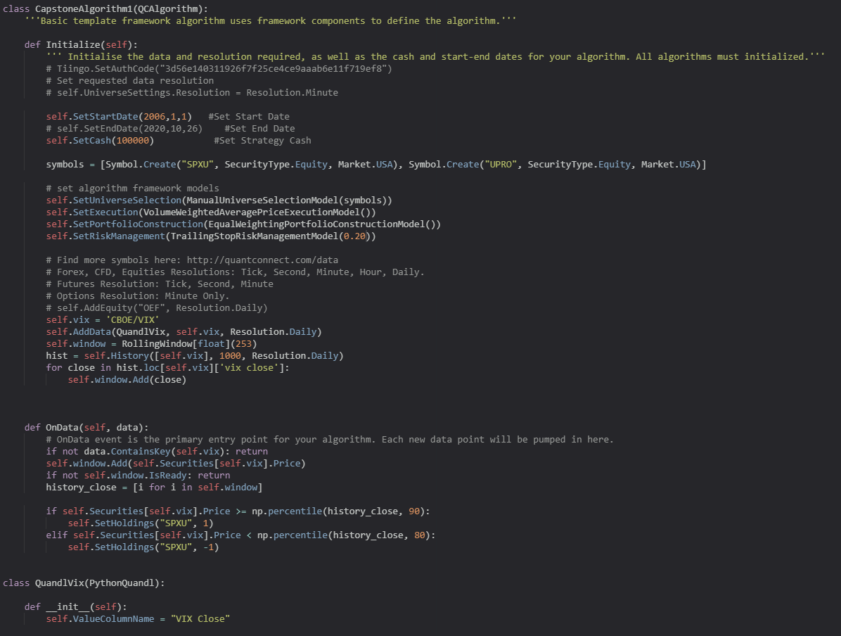

1. Results:

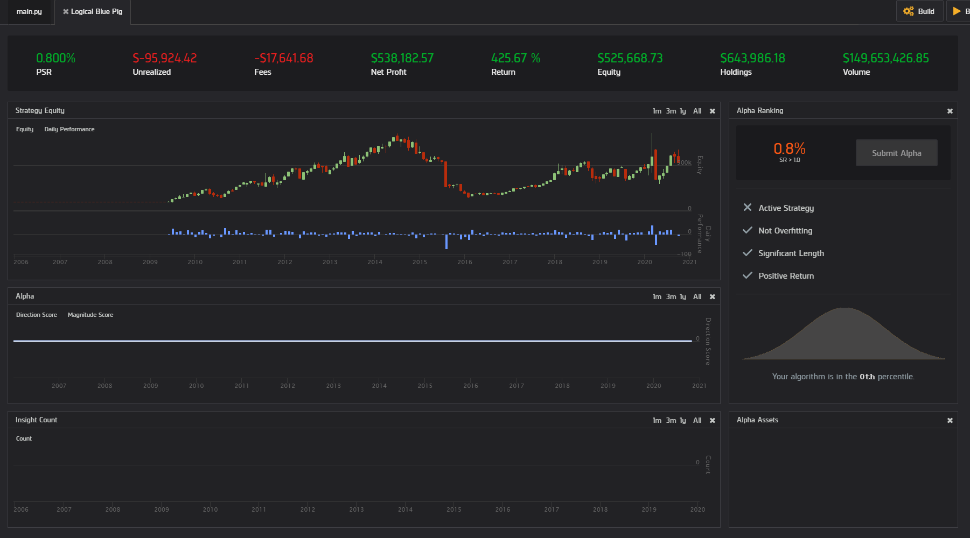

1. Conclusion:

The addition of a trailing stop loss increased returns by about 2x, but didn’t resolve the issue of large drawdowns and stagnancy from 2015 and onwards. This suggests that the current strategy might have just been suited for 2009-2015, due to unique market conditions. An alternative “dual-strategy” may be to go long on the S&P 500 during periods of great economic growth, instead of solely implementing a short strategy.

1. Fourth Iteration
   1. Hypothesis:

Implementing the inverse of the current strategy (going long on the S&P 500), when volatility is decreasing, and selling when volatility hits new lows, will result in greater market returns.

* 1. Implementation (Iteration 4):

If the closing price of the VIX falls below the 80th percentile, buy UPRO (go long on S&P 500). If it falls below the 10th percentile, sell all shares of UPRO.

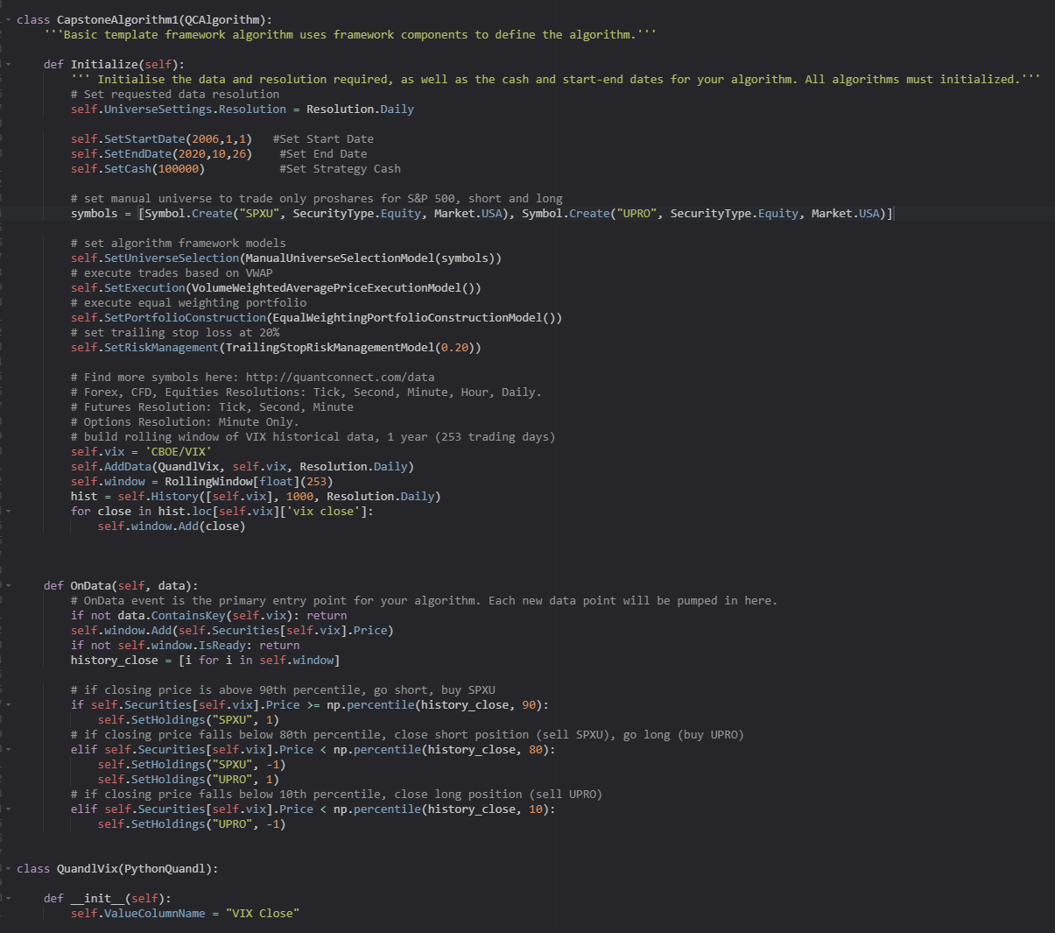

* 1. Results:

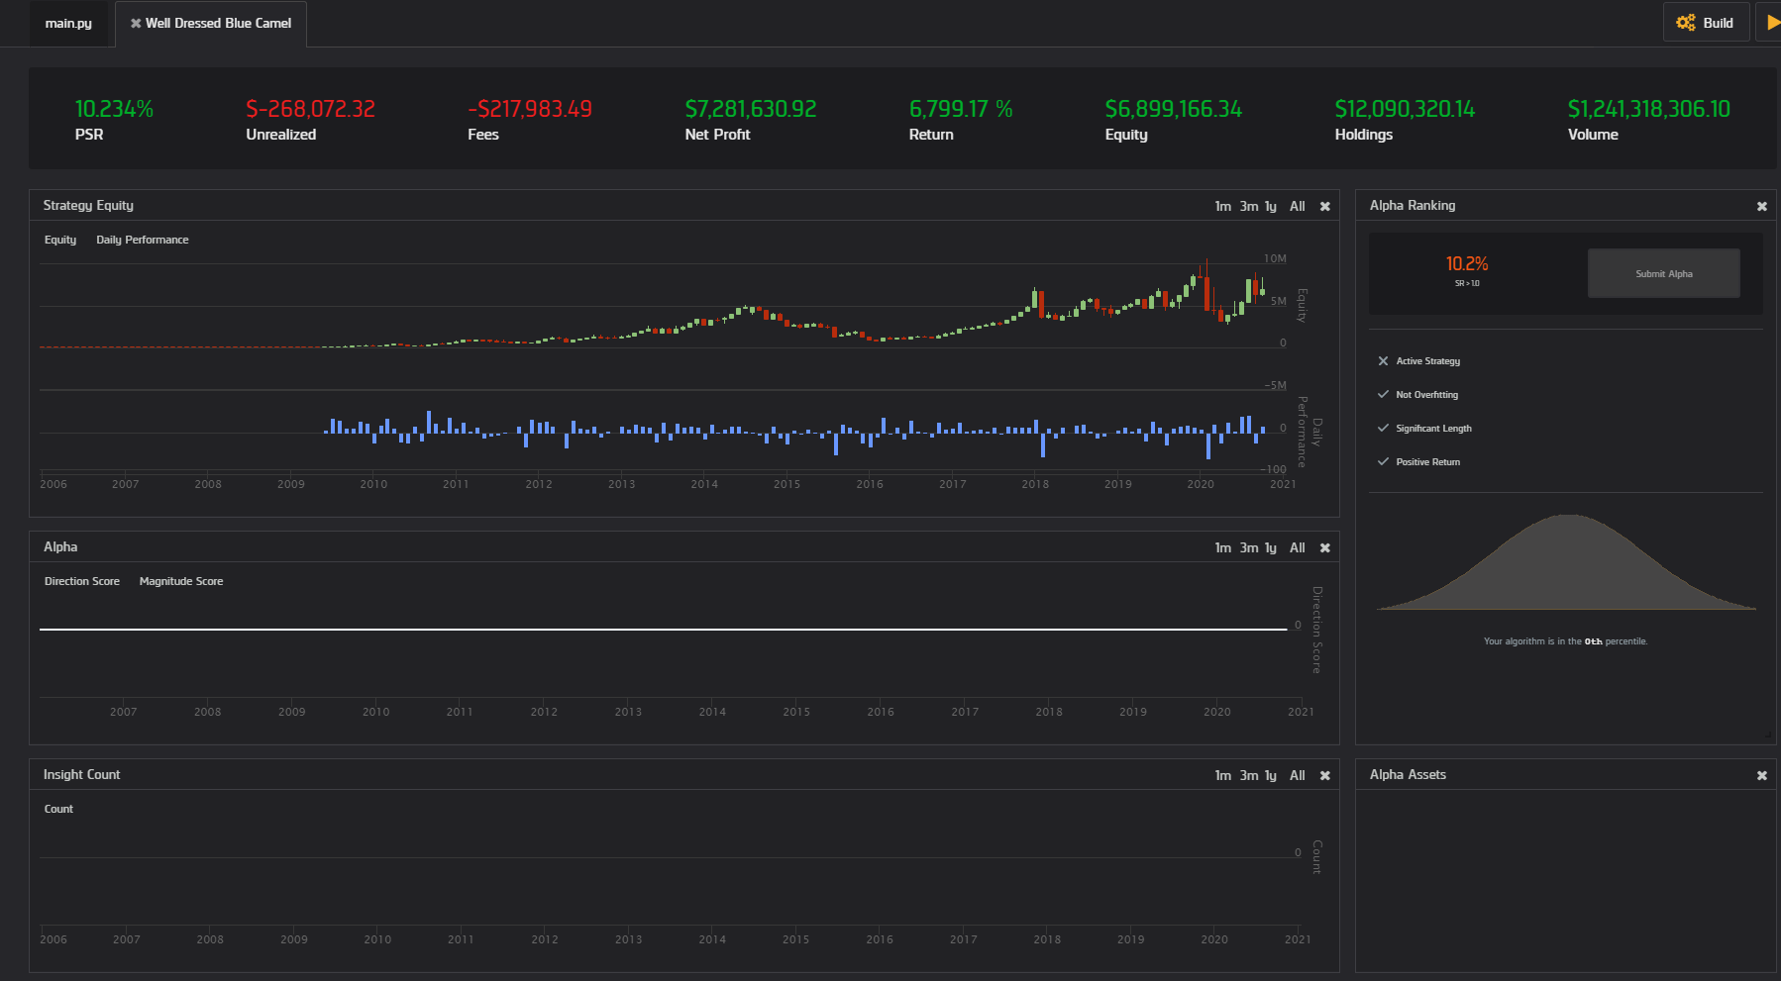

* 1. Conclusion:

Implementing the dual-strategy of going short and long resulted in a huge increase in returns, suggesting that the algorithm is vastly improved. There are still regions of major drawdowns, which are hindering overall return, so other risk management models will be explored to increase performance.

1. Fifth Iteration
   1. Hypothesis:

In order to increase returns/performance of the algorithm, the order executions will be fine tuned. There are currently three conditions in which orders are placed, all conditions aren’t equal however, in the expectation of return. Once a price crosses the 90th percentile for volatility, chances for market decline increase, so a short position is more profitable. Likewise, when volatility is declining from recent highs, the chances for market increase go up. More leverage/buying power should be allocated for these conditions.

* 1. Implementation (Iteration 5):

The conditions will be modified so that in the occasion one of these is reached, more buying power is allocated to execution and thus, higher returns. When SPXU is purchased, all other holdings will be liquidated, and the same will occur when UPRO goes long.

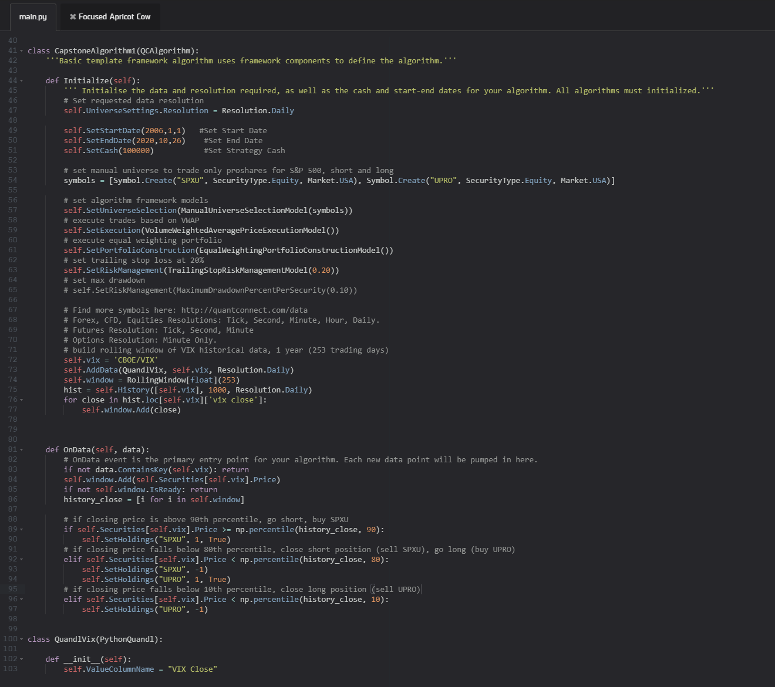

* 1. Results:

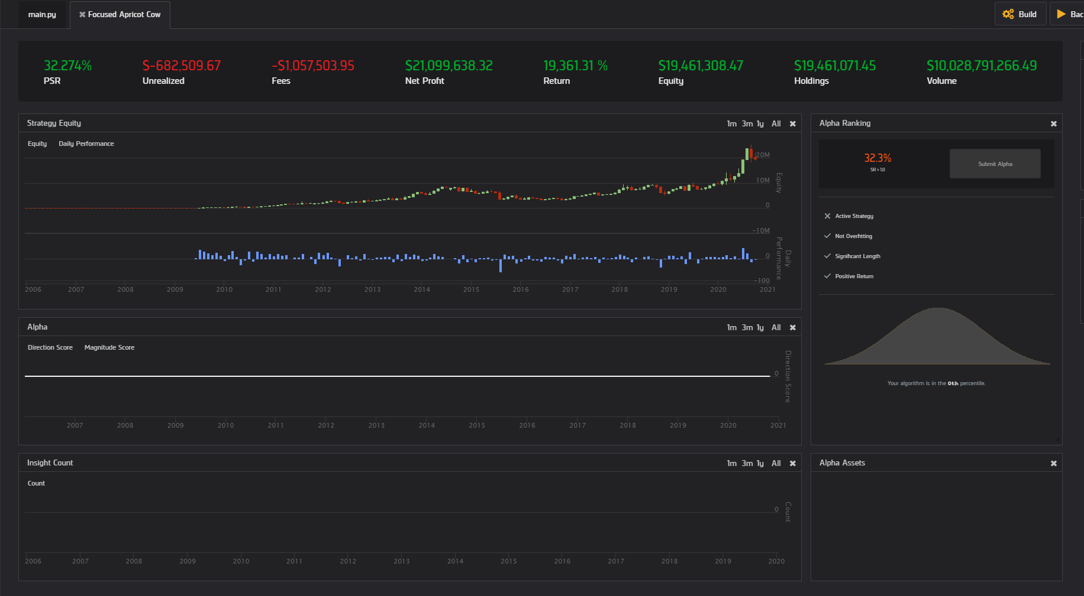

* 1. Conclusion:

Leveraging more capital towards the more favorable situations resulted in increased returns, as well as a higher probabilistic sharpe ratio. The issue of large drawdowns still stands, as well as the frequent orders (averaging ~560 orders/year). The client would like to steer away from high frequency trading. The areas for improvement are risk management and trading frequency.

1. Final Iteration
   1. Hypothesis:

In order to decrease trading frequency to meet client demands, the data will be consolidated to weekly bars, resulting in less price fluctuation and therefore less trades.

* 1. Implementation (Iteration 6):

Set timedelta to 7 on the daily resolution, change rolling window to 52 (for weeks in a year).

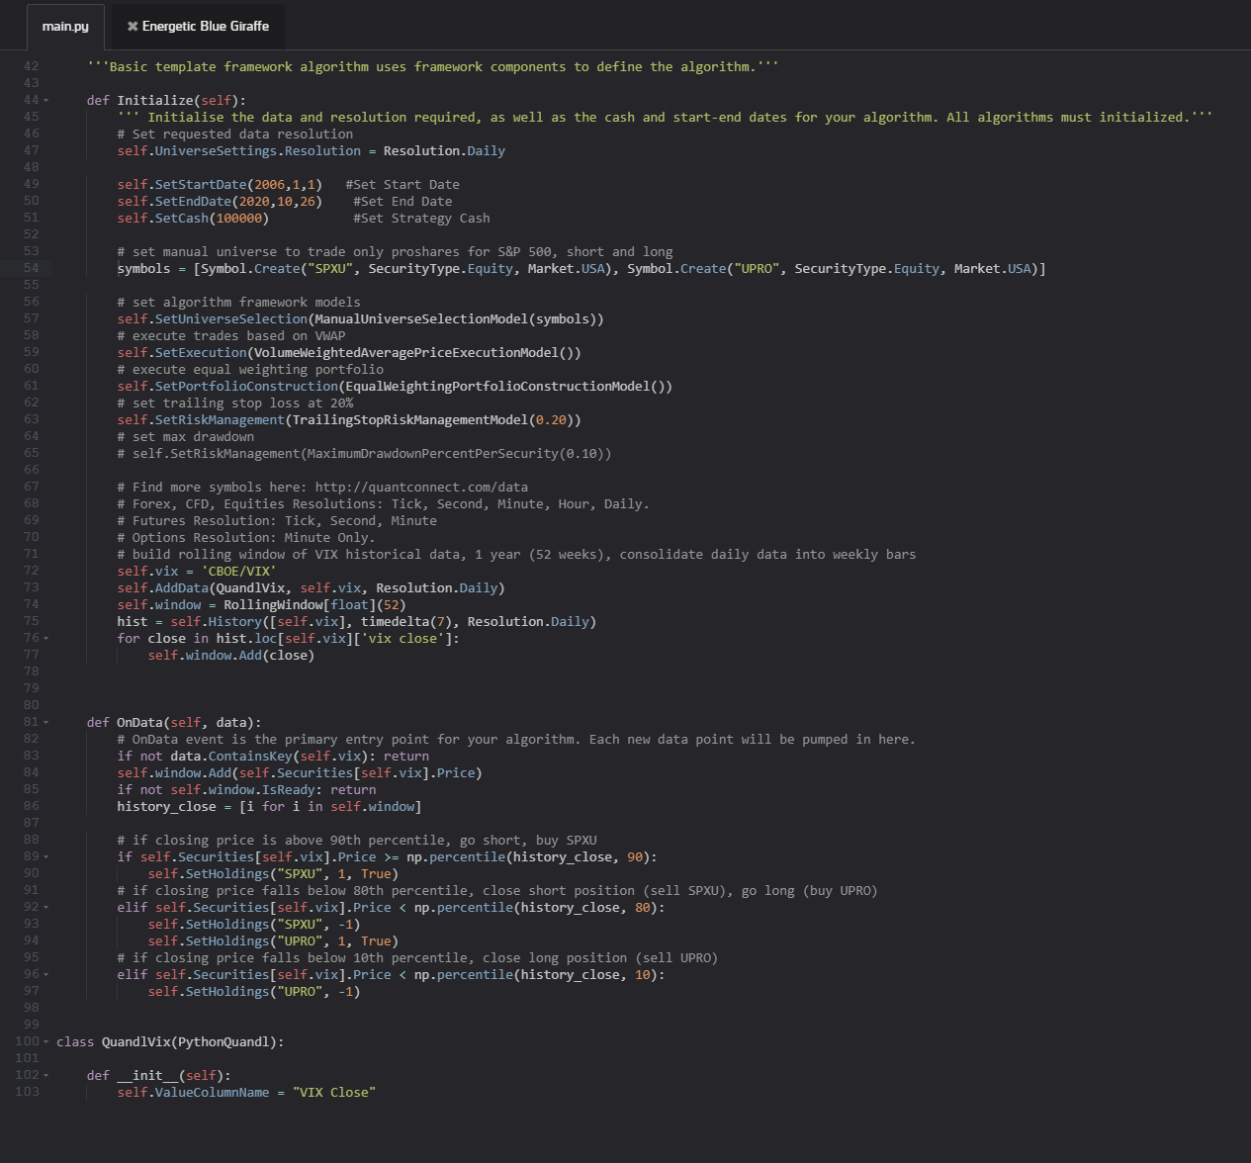

* 1. Results:

* 1. Conclusion:

Performance/returns increased dramatically, but trading frequency only dropped about 10%, which remains a problem. Other statistics, however, improved as drawdown percentage decreased and other factors like win ratio/returns increased. While a more positive return was expected, the reasons for this dramatic change are still not well understood. Will continue to focus on decreasing trading frequency and understanding the factors behind the performance change.

Final Metrics:

Total Trades

3875

Average Win

1.43%

Average Loss

-1.33%

Compounding Annual Return

67.755%

Drawdown

50.000%

Expectancy

0.279

Net Profit

214646.353%

Sharpe Ratio

1.539

PSR

77.073%

Loss Rate

38%

Win Rate

62%

Profit-Loss Ratio

1.07

Alpha

0.676

Beta

0.16

Annual Standard Deviation

0.449

Annual Variance

0.202

Information Ratio

1.266

Tracking Error

0.473

Treynor Ratio

4.32

Total Fees

$15536870.43

Summary:

After researching and brainstorming ideas to modify the algorithm for decreased trading, no alternative avenues were found. Volatility itself is an indicator favored by day/swing traders because it often presents short term buying opportunities. Therefore, an algorithm based solely on volatility would be difficult to implement as a passive strategy. In conclusion, this algorithm is only recommended as a swing/day trade strategy. In the final metrics, the algorithm showed impressive statistics including, but not limited to: 214,646.35% total return over a 10-yr period, a 62% win rate, positive profit/loss ratio of 1.07, 67% compounding annual return, and a 1.53 Sharpe Ratio; this effectively outperformed benchmarks set by the buy-and-hold strategy for the same equity (UPRO, 2809% return over the same time period).

Algorithm Continuance/Guidance:

The main area in which this algorithm could use improvement is risk management. Over every iteration, large market drawdowns continued to decrease capital substantially and therefore affected overall gains. This algorithm has also yet to be tested under various sectors, stocks, and different ETFs within the same universe (TQQQ, UDOW, URTY). Additional testing may provide insights into how volatility can serve as a better indicator in certain conditions over others. The core of this algorithm could also be used for buy/sell signals or confirmation in other market strategies. Regardless, volatility has proven to be an extremely useful indicator of market conditions and it’s correlation to prices would be an asset to the alpha of most algorithms.