AI Coursework: CSCM035
Plant Leaf Disease Identification
Sangeeth Joseph Puthussery 21012690

Introduction
Agriculture remains one of the fundamental industries necessary for sustaining human life. According to the report on Agriculture in the United Kingdom in 2020, 71% of the total land area is used for agriculture. It is reported that global agricultural production needs to be nearly doubled by 2050 to fulfil the food demand due to the increasing world population (Deepak K Ray et al., 2013). Studies have put forward strategies to meet the demand by increasing global crop production, increasing the area of agricultural land, or increasing the yield from existing lands through practices such as vertical farming. However, Plant diseases threaten our food supplies, and sufficient resources are devoted to their control (Strange et al., 2005). The first step of the solution is the quick and precise identification of plant diseases. Initially, plant diseases were identified by sight by experts. However, as the agricultural area widened, the availability of experts decreased. In order to decrease human dependence, sensor-based techniques such as thermography were used to monitor the health of crops Bravo. These techniques are precise, but they are also time-consuming and expensive. Modern-day computer vision advancements have paved the way for identifying plant diseases using image data (Mahlein et al., 2012)
In this work Deep learning is used with transfer learning. Four models are built using VGG16, ResNet50, InceptionV3 and EfficientNetB0 as the base. The models were- pretrained using ‘imagenet’ dataset. The different models are compared together based on model loss and accuracy obtained during testing. The model built using EfficientNetB0 achieved the best results with an accuracy of 98%.

Literature review
According to the available literature, disease identification is made using machine learning and deep learning. (Zhang et al., 2017) proposed a cucumber disease identification by segmenting the diseased leaf imaged by K-means clustering, extracting shape and colour features from lesion information, and classifying the diseases using sparse representation with a recognition rate of 85.7%. (Kurmi et al.,2020) designed a technique that localises the diseased region by model-based county expansion. (Mohanty et al.,2016) used transfer learning from pre-trained GoogleNet to identify plant diseases. (Sing et al., 2022) used AlexNet for quick and accurate identification of lead disease in maize plants. CNN-based Visual Geometry Group(VGG-16) was utilsed by (Paymode and Malode, 2022) to improve the model's performance. Abd Algani, Y.M. et al. (2023) designed an ant colony optimization with Convolution Neural Network (ACO-CNN) for noise removal and classification. Chen, R. et al. (2022) propose a model combining channel attention and channel pruning called CAPNET to reduce computation requirements. The accuracy of the model reached 99.7% on the PlantVillage dataset and 97.7% on the local peanut leaf disease dataset. A comparative study of four pre-trained models (AlexNet, VGG16, ResNet50 and DenseNet121) is done by Wei, S.J. et al., (2022). DenseNet 121 was selected as the best model as it had the best accuracy (96.4%). Khamparia, A. et al. (2019) trained CNN from scratch using autoencoders for identifying five leaf diseases of three crops. Ten tomato leaf diseases were classified by Mohit Agarwal et al., (2020) using multi layered CNN. Esgario et al.,(2020) used a multi task system based on CNN to identify the biotic stress in coffee leaves. Ferentinos (2018) used deep learning models for identification and classification of plant diseases in an database of 58 different classes of [plant,disease] with 25 plant species. A novel deep learning model utilising inception layer and the residual connection is designed by n Hassan and Maji (2022). The performance of the model on PlantVillage dataset is 99.39%, and the rice disease dataset is 99.66%. An CNN model called EfficientNet was designed by Atila et al. (2021) to classify leaf images from PlantVillage Dataset.

Themes and research gaps
Deep learning-based techniques provide more accurate results when compared to machine learning methods. Pretrained CNN models have lower training time but suffer from overfitting. Most models are restricted to the laboratory environment and do not account for real-world scenarios.
Method
The advancements in Deep learning have made artificial neural networks really efficient in computer vision as compared to other machine learning algorithms. In Artificial Neural Networks does not need a separate Feature extractor and image classifier. These activities are solely done by artificial neural networks.
Transfer learning approach is used to reduce the learning time and computation resources. The models build using transfer learning already has pretrained weights, which are produced by training the model on a large dataset. The training is done on CPU only and as such the models chosen to build the base layers were chosen such moderately simple. The VSCode is used as IDE. The models are run locally in using Ryzen 5500 CPU.
For this work the Pretrained model were build using the VGG16, ResNet50, InceptionV3 and EfficientNetB0. Keras library is used for loading the models.
For image classification the general pipeline is composed of four steps: image input, image pre-processing, feature extraction and a machine learning model to classify the image.

Image Input
The data consist of images of Tomato leaves of size (256 x 256), they are divided into 9 classes. The dataset contains sample images of 8 different diseases and images of healthy plant leaves. The image classes are
- Tomato_Bacterial_spot
- Tomato___Early_blight
- Tomato___healthy
- Tomato___Late_blight
- Tomato___Leaf_Mold
- Tomato___Septoria_leaf_spot
- Tomato___Spider_mites_Two spotted_spider_mite
- Tomato___Target_Spot
- Tomato___Tomato_mosaic_virus'
As all images are in the same size resizing was not necessary. The dataset is divided into training set and test set in the ratio 85:15. The train dataset is further split in the ratio 7:3 for creating the validation dataset.

Image preprocessing
ImageDataGenerator is used to load and pre-process the data. The data is normalized using rescale. The images were not turned into gray scale as the colour of the leaf is an important factor in disease identification.

Feature extraction and machine learning:
Transfer learning is used to create the deep learning model to reduce the training time. The base model from five different CNN architecture is used. The weights used in the pre-trained model are from the ‘ImageNet’ dataset.
The following CNN Architectures are used to create the different models.
- VGG16
VGGNet was developed by the Visual Geometry Group at Oxford. It has 13 convolutional layers and 3 fully connected layers. It is very easy to understand as it has a uniform architecture One of the novel features of VGGNet is that it used a smaller 3 x 3 kernel to extract finer details as compared to it other pre-existing models like AlexNET. For the base model, only the 13 convolutional layers are included. All the pre-trained weights are frozen.
- ResNet
The Residual Neural Network was developed by Microsoft Research Team. It performs better than pre-existing architecture with lower complexity. Resnet50 is used here.
- InceptionV3
InceptionvV3 is the third iteration of the Googles Inception Convolutional Neural Network. In inceptionV3 computing resources are more efficiently utilized inside the network. It consists of 22 weighted layers. It uses inception modules with a dimensionality reduction layer to achieve better results. While building the model all the weights of belonging to the inceptionV3 were frozen.
- EfficientNetB0
It is based on MobileNetV2. EfficientNetB0 has good performance for transfer learning The weights of first 20 layers are frozen. Other layers remain trainable
To the base model Two fully connected layers are added. The first layer 1000 neurons and uses ReLU(Rectified Linear Unit) activation. It is a non linear function which directly outputs the input if its positive or the output will be zero. The second layer has SoftMax activation. The output of the first fully connected layer is normalized using batch normalization to balance for any covariance shift in the data. A Dropout rate of 20% is used to reduce overfitting (Team, K., 2022). The second layer is fully connected and has SoftMax activation. Stochastic Gradient Descent is used to optimize the objective function. As it is a multi-class Classification problem Categorical cross entropy is used the loss function. The learning rate is set as 0.1 initially. ExponentialDecay is used to reduce the learning rate as training progresses. This function is used to reduce the learning rate exponentially. To compare the models effectively equal number of epochs are run for each model. Five number of epochs are run for each model and compared. The model loss and model accuracy obtained in each model is compared.

Evaluation
The model loss and accuracy are plotted for each epoch. The training time and accuracy obtained for each model is compared taking into account the complexity of the model.
VGG16
The training time required for VGG16 is 5385 seconds. VGG16 achieved an accuracy of 86.30. Figure 1 and Figure 2 illustrates the change in model loss and model accuracy through each epoch. The model is improving through epoch and better accuracy is attainable if trained for longer time.
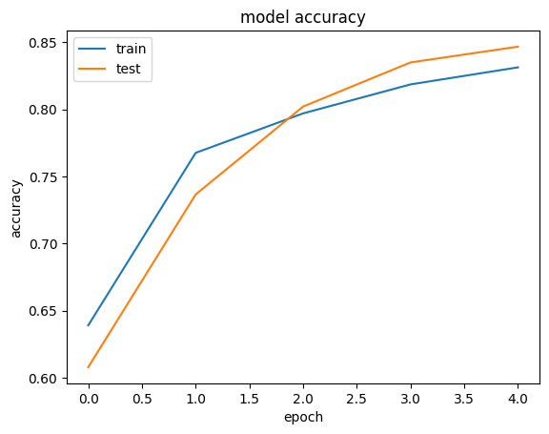
Figure 1 Accuracy for Model using VGG16
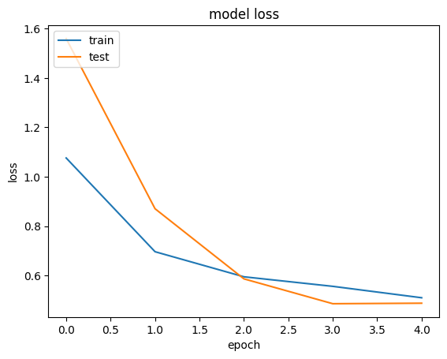
Figure 2 Loss for Model using VGG16

ResNet50
ResNet50 Required a training time of 3356 seconds for 5 epochs. Figure 3 and Figure 4 illustrates the change in model loss and model accuracy as training progresses. The validation accuracy is low as compared to the train data. The model is overfitting the data.
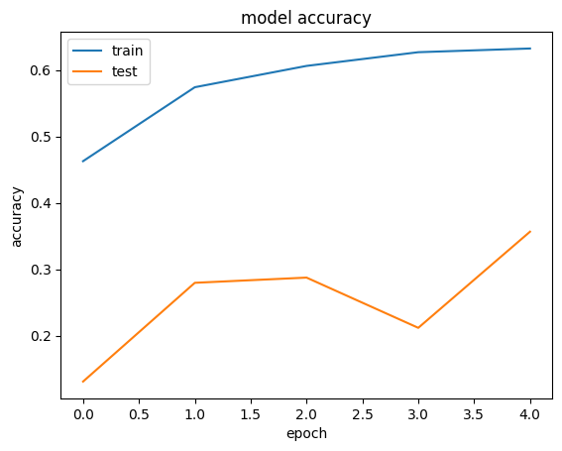
Figure 3 Model accuracy while using ResNet50
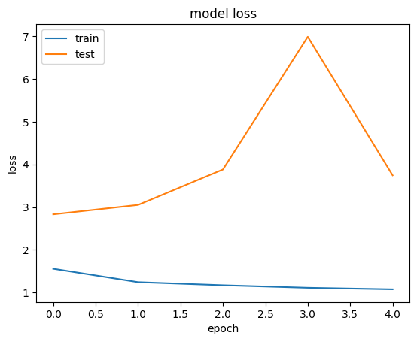
Figure 4 model loss while using ResNet50
InceptionV3
InceptionV3 Required a training time of 1505 seconds. The model loss and accuracy reached 0.4822 and 85.30 % respectively for 5 epochs. On testing the model achieved an accuracy rate of 83.79%. The model accuracy is increasing at the 5th epoch. As seen in Figure 5 the accuracy of the model can be increased by training the model for longer time.
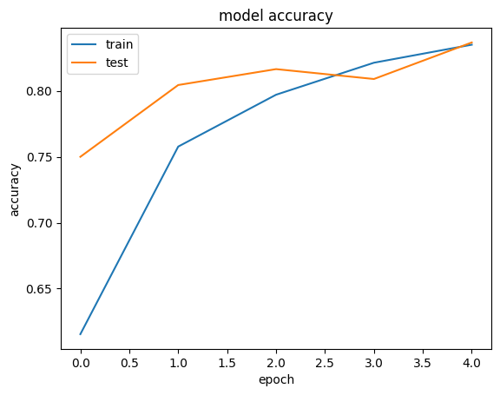
Figure 5 Accuracy of modle using InceptionV3
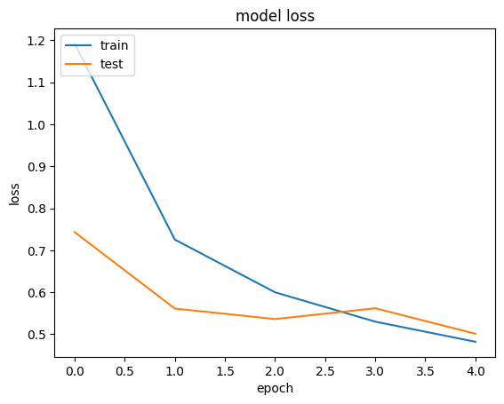
Figure 6 Loss in model using InceptionV3

EfficientNetB0
The model has high accuracy of 97.99 while training but has very low-test accuracy, this is may be due to overfitting.
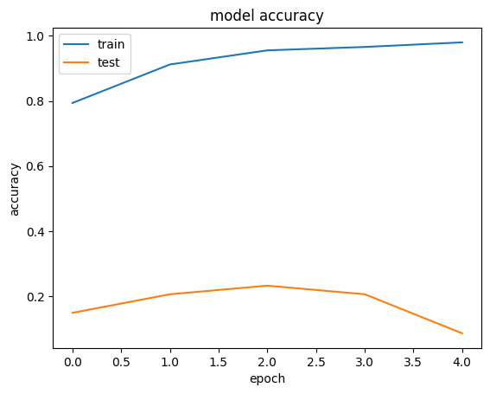
Figure 7 Accuracy of model based on EfficientNetB0
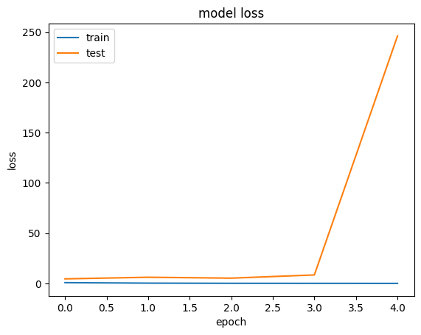
Figure 8 Loss while using EfficientNetB0
Comparison
Figure 7 shows the accuracy achieved by different model during testing. The accuracy of the models built using VGG16 and InceptionV3 showed an increasing trend at the end. Thus, their accuracy may be increased by increasing the number of epochs. The models built using ResNet50 and EfficientNetB50 overfitted the data. The model with efficientNetB0 had the highest accuracy and InceptionV3 has the lowest training time.

Figure 9 Comparison of accuracy of all models

Figure 10 Comparison of Training time of models

Conclusion and Further work
The model build using InceptionV3 has the lowest training time owing to its lower complexity. The Model using EffiecientNetB0 has the most accuracy at 98%, with almost the same training time as VGG16 which only achieved 86% accuracy. Thus, adding complexity to the network does not necessarily mean that the network will perform better. Same performance can be achieved by using a simpler architecture, which reduces computation resources. In Future To achieve more accurate results more complicated model using various architectures like ResNet152V2 is proposed. Deep learning with high level GPU is necessary to perform such comparisons. The training time required for such comparisons will also be large.

References
Abd Algani, Y.M. et al. (2023) “Leaf disease identification and classification using optimized deep learning,” Measurement: Sensors, 25, p. 100643. Available at: https://doi.org/10.1016/j.measen.2022.100643.
Agriculture in the United Kingdom 2020, Department for Environment, Food and Rural Affairs
Atila, U., Ucar, M., Akyol, K., Ucar, E., 2021. Plant leaf disease classification using EfficientNet deep learning model. Ecol. Inform. 61, 101182.
Chen, R. et al. (2022) “Identification of plant leaf diseases by deep learning based on channel attention and channel pruning,” Frontiers in Plant Science, 13. Available at: https://doi.org/10.3389/fpls.2022.1023515.
Deepak K Ray and Jonathan A Foley 2013 Environ. Res. Lett. 8 044041
Esgario, J.G., Krohling, R.A., Ventura, J.A., 2020. Deep learning for classification and severity estimation of coffee leaf biotic stress. Comput. Electron. Agric. 169, 105162.
Ferentinos, K.P., 2018. Deep learning models for plant disease detection and diagnosis. Comput. Electron. Agric. 145, 311–318.
Khamparia, A. et al. (2019) “Seasonal crops disease prediction and classification using deep convolutional encoder network,” Circuits, Systems, and Signal Processing, 39(2), pp. 818–836. Available at: https://doi.org/10.1007/s00034-019-01041-0.
Kurmi, Y. et al. (2020) “Leaf image analysis-based crop diseases classification,” Signal, Image and Video Processing, 15(3), pp. 589–597. Available at: https://doi.org/10.1007/s11760-020-01780-7.
Mahlein, AK., Oerke, EC., Steiner, U. et al. Recent advances in sensing plant diseases for precision crop protection. Eur J Plant Pathol 133,197–209 (2012). https://doi.org/10.1007/s10658-011-9878-z
Mohanty, S.P., Hughes, D.P. and Salathé, M. (2016) “Using deep learning for image-based plant disease detection,” Frontiers in Plant Science, 7. Available at: https://doi.org/10.3389/fpls.2016.01419.
Mohit Agarwal, Abhishek Singh, Siddhartha Arjaria, Amit Sinha, Suneet Gupta (2020),ToLeD: “Tomato Leaf Disease Detection using Convolution Neural Network”, Procedia Computer Science, Volume 167,2020,Pages 293-301,ISSN 1877-0509, available at https://doi.org/10.1016/j.procs.2020.03.225.
Paymode, A.S. and Malode, V.B. (2022) “Transfer learning for multi-crop leaf disease image classification using convolutional neural network VGG,” Artificial Intelligence in Agriculture, 6, pp. 23–33. Available at: https://doi.org/10.1016/j.aiia.2021.12.002.
Ray DK, Mueller ND, West PC, Foley JA (2013) Yield Trends Are Insufficient to Double Global Crop Production by 2050. PLoS ONE 8(6): e66428. https://doi.org/10.1371/journal.pone.0066428
Singh, R.K., Tiwari, A. and Gupta, R.K. (2022) “Deep transfer modeling for classification of Maize Plant Leaf Disease,” Multimedia Tools and Applications, 81(5), pp. 6051–6067. Available at: https://doi.org/10.1007/s11042-021-11763-6.
Strange RN, Scott PR. Plant disease: a threat to global food security. Annu Rev Phytopathol. 2005;43:83-116. doi:10.1146/annurev.phyto.43.113004.133839
Team, K. (2022) Simple. flexible. powerful., Keras. Available at: https://keras.io/ (Accessed: January 25, 2023).
Wei, S.J., Al Riza, D.F. and Nugroho, H. (2022) “Comparative study on the performance of Deep Learning Implementation in the edge computing: Case study on the plant leaf disease identification,” Journal of Agriculture and Food Research, 10, p. 100389. Available at: https://doi.org/10.1016/j.jafr.2022.100389.
Strange, R.N. and Scott, P.R. (2005) “Plant disease: A threat to Global Food Security,” Annual Review of Phytopathology, 43(1), pp. 83–116. Available at: https://doi.org/10.1146/annurev.phyto.43.113004.133839.
Zhang, J. et al. (2019) “Attention residual learning for skin lesion classification,” IEEE Transactions on Medical Imaging, 38(9), pp. 2092–2103. Available at: https://doi.org/10.1109/tmi.2019.2893944.

